# Install neccessary packages

""" %pip install pandas   
%pip install numpy   
%pip install ipywidgets   
%pip install matplotlib   
%pip install seaborn   
%pip install sklearn   
%pip install pyarrow  
 """

' %pip install pandas \n%pip install numpy \n%pip install ipywidgets \n%pip install matplotlib \n%pip install seaborn \n%pip install sklearn \n%pip install pyarrow\n '

## Import packages

from urllib import request as rq  
import pandas as pd  
import os  
import pyarrow as pa # this is needed for the parquet file  
import numpy as np  
import ipywidgets  
from ipywidgets import widgets  
from ipywidgets import interact, interactive, fixed, VBox  
import scipy.stats as stats  
import matplotlib.pyplot as plt  
import matplotlib  
import seaborn as sns  
from sklearn.preprocessing import OrdinalEncoder  
from sklearn.svm import SVC  
from sklearn.model_selection import train_test_split  
from sklearn import metrics  
from sklearn.metrics import confusion_matrix  
from sklearn.model_selection import KFold  
from sklearn.model_selection import cross_val_score  
from sklearn.model_selection import GridSearchCV  
from sklearn import linear_model  
from sklearn.linear_model import LinearRegression  
from sklearn.linear_model import Ridge  
from sklearn.linear_model import Lasso

## Set up functions

in the end I did not use the function to load csv files for the weather stations.

# Function to load the Dublin bus gz files   
def load_Files(direc, files, comtype):  
 columns = ['Timestamp', 'LineID', 'Direction', 'JourneyPatternID', 'TimeFrame', 'VehicleJourneyID', 'Operator', 'Congestion', 'LonWGS84', 'LatWGS84', 'Delay', 'BlockID', 'VehicleID', 'StopID', 'AtStop']  
 for f in files:  
 print(f)  
 yield pd.read_csv(direc + f, compression=comtype, delimiter=',', header=0, names=columns, parse_dates=True, low_memory=True)  
  
def crackit_open(busFile):  
 import zipfile as zip  
 # Zip creates its own folders - no need to check for folder existence  
 with zip.ZipFile(busFile, mode='r') as arc:   
 arc.extractall('./Data/Bus/Gz/')   
 files = os.listdir('./Data/Bus/Gz/')  
 DBfiles = [f for f in files if f.endswith('.gz')]  
 df = pd.concat(load_Files('./Data/Bus/Gz/', DBfiles, 'gzip'), copy = False)  
 return df  
  
def shapiro_test(x):  
 p_val = stats.shapiro(x)[1]  
 status = 'passed'  
 color = 'blue'  
 if p_val < 0.05:  
 status = 'failed'  
 color = 'red'  
 return status, color, p_val  
  
def custom_scatterplot(df1, col1=''):  
 df1 = df1[df1["LineID"]==col1]  
 f = plt.figure()  
 f, ax = plt.subplots(figsize=(11.5, 11.5))  
 ax = f.add_subplot(projection='3d')  
 ax.scatter(df1['LonWGS84'], df1['LatWGS84'], df1['Hour'], alpha=0.6, color=df1['Colour'])  
 ax.set_xlabel('Longitude')  
 ax.set_ylabel('Latitude')  
 ax.set_zlabel('Hour')  
 dcol = str(col1)  
 plt.savefig('./Images/Img_' + dcol + '_Longitude_Latitude_Hour.svg')  
 df1.to_parquet('./Data/Bus/LineID_' + dcol + '.parquet')  
   
   
def custom_barplot(df1, col1=''):  
 if len(df1[col1]) > 5000: # added this to the function because of warnings about the size of data being used with shapiro test  
 sampleSize = 5000  
 else:  
 sampleSize = len(df1[col1])  
 df1 = df1.sample(sampleSize) #shapiro test is unreliable over 5000 https://en.wikipedia.org/wiki/Shapiro%E2%80%93Wilk_test and performance reasons  
 f, ax = plt.subplots(2,2, figsize=(11.5, 11.5))  
 ax = ax.reshape(-1)  
 df1[col1].plot(ax=ax[0], kind='hist')  
 ax[0].set_title('Histogram of {}'.format(col1))  
 df1[col1].plot(ax=ax[1], kind='kde')  
 ax[1].set_title('Density Plot of {}'.format(col1))  
 ax3 = plt.subplot(223)  
 stats.probplot(df[col1], plot=plt)  
 ax[2].set_title('QQ Plot of {}'.format(col1))  
 df1[col1].plot(ax=ax[3], kind='box')  
 ax[3].set_title('Box Plot of {}'.format(col1))  
 status, color, p_val = shapiro_test(df1[col1])   
 f.suptitle('Normality test for {} {} (p_value = {})'.format(col1, status, p_val), color=color, fontsize=12)  
  
def num_missing(x):  
 return len(x.index)-x.count()  
  
def num_unique(x):  
 return len(np.unique(x))  
  
def load_csv_Files(direc, files):  
  
 for f in files:  
 # need to get number of rows to skip   
 temp=pd.read_csv(direc + f,sep='^',header=None,prefix='X')  
 temp2=temp.X0.str.split(',',expand=True)  
 del temp['X0']  
 temp=pd.concat([temp,temp2],axis=1)  
 cols = list(range(0,temp.shape[1]))  
  
 print(f)  
 yield pd.read_csv(direc + f, delimiter=',', header=0, parse_dates=True, low_memory=True, skiprows=14, usecols=cols, na_values='NAN')

## Ensure that the folder structure is present in the workspace

if os.path.exists('./Data'):  
 print('Data folder exists')  
  
if os.path.exists('./Data/Bus'):  
 print('Bus Data folder exists')  
else:  
 os.makedirs('./Data/Bus')  
  
if os.path.exists('./Data/MetEirrean/'):  
 print('Weather data folder exists')  
else:  
 os.makedirs('./Data/MetEirrean/')  
  
if os.path.exists('./Zips/MetEirrean'):  
 print('Weather folder exisits')  
else:  
 os.makedirs('./Zips/MetEirrean/')  
  
if os.path.exists('./Images/'):  
 print('Images folder exists')  
else:  
 os.makedirs('./Images/')

Data folder exists  
Bus Data folder exists  
Weather data folder exists  
Weather folder exisits  
Images folder exists

## Download the Dublin Bus data

from https://data.gov.ie/organization/dublin-city-council?tags=Transport+and+Infrastructure  
Decompress the zip file into the zips/Bus folder  
Use a generator to load the data into pandas data frame https://pandasninja.com/2019/04/how-to-read-lots-of-csv-files-easily-into-pandas/#:~:text=How%20to%20read%20lots%20of%20csv%20files%20easily,need%20...%204%204.%20Leverage%20regular%20expressions%20

## Loop through the gz files and decompress them in to the Data/Bus folder

# Check parquet file existence before downloading - iof starting from afresh this takes a long time  
if os.path.exists('./Data/CleanedBusData.parquet'):  
 print("Parquest file exists, means the Bus data has been downloaded already ")  
 df = pd.read_parquet('./Data/CleanedBusData.parquet')  
 if os.path.exists('./Data/WeatherandBusData.parquet'):  
 print('Weather and bus data combined exists')  
 mdf = pd.read_parquet('./Data/WeatherandBusData.parquet')  
elif os.path.exists('./Zips/Bus/DublinBusdata.zip'):  
 print("Zip file exists, we have already downloaded the Dublin Bus Zip data, crack it open")  
 df = crackit_open('./Zips/Bus/DublinBusdata.zip')  
else:  
 os.makedirs('./Zips/Bus/', exist_ok = True)  
 url = "https://opendata.dublincity.ie/TrafficOpenData/sir010113-310113.zip"  
 busFile = rq.urlretrieve(url, './Zips/Bus/DublinBusdata.zip' )   
 df = crackit_open('./Zips/Bus/DublinBusdata.zip')  
  
#df = df.sample(20000)  
### Read the Bus data in to a Pandas dataframe - done

Zip file exists, we have already downloaded the Dublin Bus Zip data, crack it open  
siri.20130101.csv.gz  
siri.20130102.csv.gz  
siri.20130103.csv.gz  
siri.20130104.csv.gz  
siri.20130105.csv.gz  
siri.20130106.csv.gz  
siri.20130107.csv.gz  
siri.20130108.csv.gz  
siri.20130109.csv.gz  
siri.20130110.csv.gz  
siri.20130111.csv.gz  
siri.20130112.csv.gz  
siri.20130113.csv.gz  
siri.20130114.csv.gz  
siri.20130115.csv.gz  
siri.20130116.csv.gz  
siri.20130117.csv.gz  
siri.20130118.csv.gz  
siri.20130119.csv.gz  
siri.20130120.csv.gz  
siri.20130121.csv.gz  
siri.20130122.csv.gz  
siri.20130123.csv.gz  
siri.20130124.csv.gz  
siri.20130125.csv.gz  
siri.20130126.csv.gz  
siri.20130127.csv.gz  
siri.20130128.csv.gz  
siri.20130129.csv.gz  
siri.20130130.csv.gz  
siri.20130131.csv.gz

### Check for missing and have a brief look at the data

The Temp_df contains the output of a pandas description function. The missing_ df contains the output of function which counts missing values in a column.

temp_df = df.describe().T  
missing_df = pd.DataFrame(df.apply(num_missing, axis=0))   
missing_df.columns = ['missing'] # type: ignore  
  
display(temp_df)  
  
display(missing_df)

count mean std min \  
Timestamp 44455102.0 1.358318e+15 7.394928e+11 1.356998e+15   
LineID 44453044.0 7.796879e+01 1.146419e+02 1.000000e+00   
Direction 44455102.0 0.000000e+00 0.000000e+00 0.000000e+00   
VehicleJourneyID 44455102.0 9.417122e+03 6.159844e+04 1.000000e+00   
Congestion 44455102.0 1.163261e-02 1.072254e-01 0.000000e+00   
LonWGS84 44455102.0 -6.272803e+00 8.389025e-02 -6.617517e+00   
LatWGS84 44455102.0 5.334513e+01 5.488354e-02 5.306802e+01   
Delay 44455102.0 -2.816513e+01 4.729678e+02 -1.504500e+04   
BlockID 44455102.0 1.092438e+05 1.921244e+05 3.900000e+02   
VehicleID 44455102.0 3.542925e+04 3.281093e+03 2.804700e+04   
StopID 41952926.0 2.791465e+03 2.204841e+03 2.000000e+00   
AtStop 44455102.0 2.335773e-01 4.231063e-01 0.000000e+00   
  
 25% 50% 75% max   
Timestamp 1.357679e+15 1.358327e+15 1.358955e+15 1.359633e+15   
LineID 2.500000e+01 4.000000e+01 8.300000e+01 7.470000e+02   
Direction 0.000000e+00 0.000000e+00 0.000000e+00 0.000000e+00   
VehicleJourneyID 2.536000e+03 4.718000e+03 6.769000e+03 9.998560e+05   
Congestion 0.000000e+00 0.000000e+00 0.000000e+00 1.000000e+00   
LonWGS84 -6.308650e+00 -6.261600e+00 -6.233166e+00 -6.052917e+00   
LatWGS84 5.332005e+01 5.334645e+01 5.337533e+01 5.360873e+01   
Delay -2.090000e+02 0.000000e+00 1.040000e+02 1.161220e+05   
BlockID 1.602000e+04 4.020500e+04 8.400400e+04 8.350020e+05   
VehicleID 3.330800e+04 3.352500e+04 3.802500e+04 4.307800e+04   
StopID 8.450000e+02 2.159000e+03 4.465000e+03 7.552000e+03   
AtStop 0.000000e+00 0.000000e+00 0.000000e+00 1.000000e+00

missing  
Timestamp 0  
LineID 2058  
Direction 0  
JourneyPatternID 6649915  
TimeFrame 0  
VehicleJourneyID 0  
Operator 0  
Congestion 0  
LonWGS84 0  
LatWGS84 0  
Delay 0  
BlockID 0  
VehicleID 0  
StopID 2502176  
AtStop 0

## Remove unwanted columns

At this stage we will drop Direction as it has only value 0 And we will drop TimeFrame as it relates to the time that the data was collected and its information is duplicated in the TimeStamp field

if 'Direction' in df.columns:  
 df = df.drop(['Direction'], axis='columns')  
if 'TimeFrame' in df.columns:  
 df = df.drop(['TimeFrame'], axis='columns')  
""" if {'VehicleJourneyID', 'JourneyPatternID'}.issubset(df.columns):   
 df['VehicleJourneyID'] = df['JourneyPatternID'] + '_' + df['VehicleJourneyID'].astype('str')  
 df = df.drop(['JourneyPatternID','VehicleJourneyID'], axis='columns') """

" if {'VehicleJourneyID', 'JourneyPatternID'}.issubset(df.columns): \n df['VehicleJourneyID'] = df['JourneyPatternID'] + '_' + df['VehicleJourneyID'].astype('str')\n df = df.drop(['JourneyPatternID','VehicleJourneyID'], axis='columns') "

temp_df = df.describe().T  
missing_df = pd.DataFrame(df.apply(num_missing, axis=0))   
missing_df.columns = ['missing'] # type: ignore  
  
display(temp_df)  
  
display(missing_df)

count mean std min \  
Timestamp 44455102.0 1.358318e+15 7.394928e+11 1.356998e+15   
LineID 44453044.0 7.796879e+01 1.146419e+02 1.000000e+00   
VehicleJourneyID 44455102.0 9.417122e+03 6.159844e+04 1.000000e+00   
Congestion 44455102.0 1.163261e-02 1.072254e-01 0.000000e+00   
LonWGS84 44455102.0 -6.272803e+00 8.389025e-02 -6.617517e+00   
LatWGS84 44455102.0 5.334513e+01 5.488354e-02 5.306802e+01   
Delay 44455102.0 -2.816513e+01 4.729678e+02 -1.504500e+04   
BlockID 44455102.0 1.092438e+05 1.921244e+05 3.900000e+02   
VehicleID 44455102.0 3.542925e+04 3.281093e+03 2.804700e+04   
StopID 41952926.0 2.791465e+03 2.204841e+03 2.000000e+00   
AtStop 44455102.0 2.335773e-01 4.231063e-01 0.000000e+00   
  
 25% 50% 75% max   
Timestamp 1.357679e+15 1.358327e+15 1.358955e+15 1.359633e+15   
LineID 2.500000e+01 4.000000e+01 8.300000e+01 7.470000e+02   
VehicleJourneyID 2.536000e+03 4.718000e+03 6.769000e+03 9.998560e+05   
Congestion 0.000000e+00 0.000000e+00 0.000000e+00 1.000000e+00   
LonWGS84 -6.308650e+00 -6.261600e+00 -6.233166e+00 -6.052917e+00   
LatWGS84 5.332005e+01 5.334645e+01 5.337533e+01 5.360873e+01   
Delay -2.090000e+02 0.000000e+00 1.040000e+02 1.161220e+05   
BlockID 1.602000e+04 4.020500e+04 8.400400e+04 8.350020e+05   
VehicleID 3.330800e+04 3.352500e+04 3.802500e+04 4.307800e+04   
StopID 8.450000e+02 2.159000e+03 4.465000e+03 7.552000e+03   
AtStop 0.000000e+00 0.000000e+00 0.000000e+00 1.000000e+00

missing  
Timestamp 0  
LineID 2058  
JourneyPatternID 6649915  
VehicleJourneyID 0  
Operator 0  
Congestion 0  
LonWGS84 0  
LatWGS84 0  
Delay 0  
BlockID 0  
VehicleID 0  
StopID 2502176  
AtStop 0

### Drop nas and duplicates - there are no duplicates but there are na's

This drops the rows with empty LineID and empty Journey Pattern ID values and the times that bus is not reporting a bus stop id. The journey pattern id is an identifier for the particular bus route

df = df.dropna()   
df = df.drop_duplicates()  
  
temp_df = df.describe().T  
missing_df = pd.DataFrame(df.apply(num_missing, axis=0))   
missing_df.columns = ['missing'] # type: ignore  
  
display(temp_df)  
  
display(missing_df)

count mean std min \  
Timestamp 37804234.0 1.358318e+15 7.384109e+11 1.356998e+15   
LineID 37804234.0 7.844526e+01 1.195265e+02 1.000000e+00   
VehicleJourneyID 37804234.0 1.025672e+04 6.670851e+04 1.000000e+00   
Congestion 37804234.0 1.367897e-02 1.161545e-01 0.000000e+00   
LonWGS84 37804234.0 -6.270782e+00 8.182094e-02 -6.617517e+00   
LatWGS84 37804234.0 5.334426e+01 5.436382e-02 5.306802e+01   
Delay 37804234.0 -5.325867e+01 4.843254e+02 -1.504500e+04   
BlockID 37804234.0 1.027329e+05 1.823164e+05 3.900000e+02   
VehicleID 37804234.0 3.548130e+04 3.307965e+03 2.804700e+04   
StopID 37804234.0 2.647623e+03 2.126684e+03 2.000000e+00   
AtStop 37804234.0 2.724945e-01 4.452429e-01 0.000000e+00   
  
 25% 50% 75% max   
Timestamp 1.357680e+15 1.358328e+15 1.358955e+15 1.359633e+15   
LineID 1.800000e+01 4.000000e+01 8.300000e+01 7.470000e+02   
VehicleJourneyID 2.744000e+03 4.814000e+03 6.863000e+03 9.998560e+05   
Congestion 0.000000e+00 0.000000e+00 0.000000e+00 1.000000e+00   
LonWGS84 -6.306750e+00 -6.261670e+00 -6.232100e+00 -6.053033e+00   
LatWGS84 5.331952e+01 5.334611e+01 5.337347e+01 5.360873e+01   
Delay -2.660000e+02 -2.000000e+01 1.140000e+02 1.161220e+05   
BlockID 1.601400e+04 4.010800e+04 8.301200e+04 8.350020e+05   
VehicleID 3.331500e+04 3.352900e+04 3.803000e+04 4.307800e+04   
StopID 8.100000e+02 2.039000e+03 4.320000e+03 7.552000e+03   
AtStop 0.000000e+00 0.000000e+00 1.000000e+00 1.000000e+00

missing  
Timestamp 0  
LineID 0  
JourneyPatternID 0  
VehicleJourneyID 0  
Operator 0  
Congestion 0  
LonWGS84 0  
LatWGS84 0  
Delay 0  
BlockID 0  
VehicleID 0  
StopID 0  
AtStop 0

# Exploratory data analysis on the Bus Data

## Display the shape and types of data in the Bus data frame

print ('The data has {} Rows and {} columns'.format(df.shape[0],df.shape[1]))  
print("The types of columns are:")  
display(df.dtypes)

The data has 37804234 Rows and 13 columns  
The types of columns are:

Timestamp int64  
LineID float64  
JourneyPatternID object  
VehicleJourneyID int64  
Operator object  
Congestion int64  
LonWGS84 float64  
LatWGS84 float64  
Delay int64  
BlockID int64  
VehicleID int64  
StopID float64  
AtStop int64  
dtype: object

### Describe the numerical data in the Bus data set

#### Display the summary Data about the Numerical columns

unq_df = pd.DataFrame(df.apply(num_unique, axis=0))  
unq_df.columns = ['unique'] # type: ignore  
types_df = pd.DataFrame(df.dtypes)  
types_df.columns = ['DataType'] # type: ignore

summary_df = temp_df.join(missing_df).join(unq_df).join(types_df)  
display(summary_df) # Numerical Data

count mean std min \  
Timestamp 37804234.0 1.358318e+15 7.384109e+11 1.356998e+15   
LineID 37804234.0 7.844526e+01 1.195265e+02 1.000000e+00   
VehicleJourneyID 37804234.0 1.025672e+04 6.670851e+04 1.000000e+00   
Congestion 37804234.0 1.367897e-02 1.161545e-01 0.000000e+00   
LonWGS84 37804234.0 -6.270782e+00 8.182094e-02 -6.617517e+00   
LatWGS84 37804234.0 5.334426e+01 5.436382e-02 5.306802e+01   
Delay 37804234.0 -5.325867e+01 4.843254e+02 -1.504500e+04   
BlockID 37804234.0 1.027329e+05 1.823164e+05 3.900000e+02   
VehicleID 37804234.0 3.548130e+04 3.307965e+03 2.804700e+04   
StopID 37804234.0 2.647623e+03 2.126684e+03 2.000000e+00   
AtStop 37804234.0 2.724945e-01 4.452429e-01 0.000000e+00   
  
 25% 50% 75% max \  
Timestamp 1.357680e+15 1.358328e+15 1.358955e+15 1.359633e+15   
LineID 1.800000e+01 4.000000e+01 8.300000e+01 7.470000e+02   
VehicleJourneyID 2.744000e+03 4.814000e+03 6.863000e+03 9.998560e+05   
Congestion 0.000000e+00 0.000000e+00 0.000000e+00 1.000000e+00   
LonWGS84 -6.306750e+00 -6.261670e+00 -6.232100e+00 -6.053033e+00   
LatWGS84 5.331952e+01 5.334611e+01 5.337347e+01 5.360873e+01   
Delay -2.660000e+02 -2.000000e+01 1.140000e+02 1.161220e+05   
BlockID 1.601400e+04 4.010800e+04 8.301200e+04 8.350020e+05   
VehicleID 3.331500e+04 3.352900e+04 3.803000e+04 4.307800e+04   
StopID 8.100000e+02 2.039000e+03 4.320000e+03 7.552000e+03   
AtStop 0.000000e+00 0.000000e+00 1.000000e+00 1.000000e+00   
  
 missing unique DataType   
Timestamp 0 802838 int64   
LineID 0 66 float64   
VehicleJourneyID 0 18608 int64   
Congestion 0 2 int64   
LonWGS84 0 452502 float64   
LatWGS84 0 130321 float64   
Delay 0 12635 int64   
BlockID 0 1217 int64   
VehicleID 0 911 int64   
StopID 0 4727 float64   
AtStop 0 2 int64

### Set the Numerical and Categorical columns

# Getting the list of column Types  
  
  
CategoricalColumns = ['AtStop','BlockID','Congestion','Operator','StopID','VehicleID', 'VehicleJourneyID']  
NumericalColumns = [ 'Delay', 'LatWGS84', 'LonWGS84']  
DateColumns = list(set(list(df.select_dtypes([np.datetime64]).columns)))  
ColumnsToExclude = ('Month', 'Year', 'Direction')  
  
  
  
CategoricalColumns = list(set(CategoricalColumns) - set(ColumnsToExclude)-set(DateColumns))  
NumericalColumns = list(set(NumericalColumns)-set(ColumnsToExclude)-set(DateColumns))  
  
print(CategoricalColumns)  
print(NumericalColumns)  
print(DateColumns)

['VehicleJourneyID', 'VehicleID', 'Congestion', 'AtStop', 'StopID', 'BlockID', 'Operator']  
['LonWGS84', 'LatWGS84', 'Delay']  
[]

b: Describe the categoric data - done

col_names = list(types_df.index)  
num_cols = len(col_names)  
index = range(num_cols)  
cat_index = []  
for i in index:  
 if col_names[i] in CategoricalColumns:  
 cat_index.append(i)  
summary_df_cat = missing_df.join(unq_df).join(types_df.iloc[cat_index], how='inner') #Only summarize categorical columns  
print(summary_df_cat)

missing unique DataType  
VehicleJourneyID 0 18608 int64  
Operator 0 8 object  
Congestion 0 2 int64  
BlockID 0 1217 int64  
VehicleID 0 911 int64  
StopID 0 4727 float64  
AtStop 0 2 int64

## Add time columns to the Bus Data

# Deal with the timestamp and make it human readable and i will use this to merge datasets later   
# we might be using a saved data set from before, check that the Timestamp is in the dataset  
if 'Timestamp' in df.columns:  
 df['datetime'] = pd.to_datetime(df['Timestamp'], unit='us')  
 df['Day'] = df['datetime'].dt.day  
 df['Hour'] = df['datetime'].dt.hour  
 df['Minute'] = df['datetime'].dt.minute  
 df['DayofWeek'] = df['datetime'].dt.day_of_week  
 df = df.drop(['Timestamp', 'datetime'], axis='columns')

# Check the outcome of adding time and day data  
df.head()

LineID JourneyPatternID VehicleJourneyID Operator Congestion LonWGS84 \  
2 7.0 00071003 6106 D1 0 -6.231633   
3 747.0 07471001 3531 SL 0 -6.254617   
4 56.0 056A1001 1830 RD 0 -6.233183   
5 25.0 025A0001 2866 CD 0 -6.296867   
6 747.0 07470001 3493 SL 0 -6.238668   
  
 LatWGS84 Delay BlockID VehicleID StopID AtStop Day Hour Minute \  
2 53.317768 0 7019 43004 3222.0 1 1 0 0   
3 53.355484 -454 747007 40039 1445.0 0 1 0 0   
4 53.342201 0 56001 33488 2379.0 0 1 0 0   
5 53.347500 0 25007 33604 4604.0 0 1 0 0   
6 53.425789 -687 747006 40040 7411.0 0 1 0 0   
  
 DayofWeek   
2 1   
3 1   
4 1   
5 1   
6 1

# save work done so far   
df.to_parquet('./Data/CleanedBusData.parquet')

# Display Histograms from the Data set

%matplotlib inline  
df.hist(figsize=(25,25));  
plt.savefig('./Images/Img_1_BusDataframe_histogram.svg')

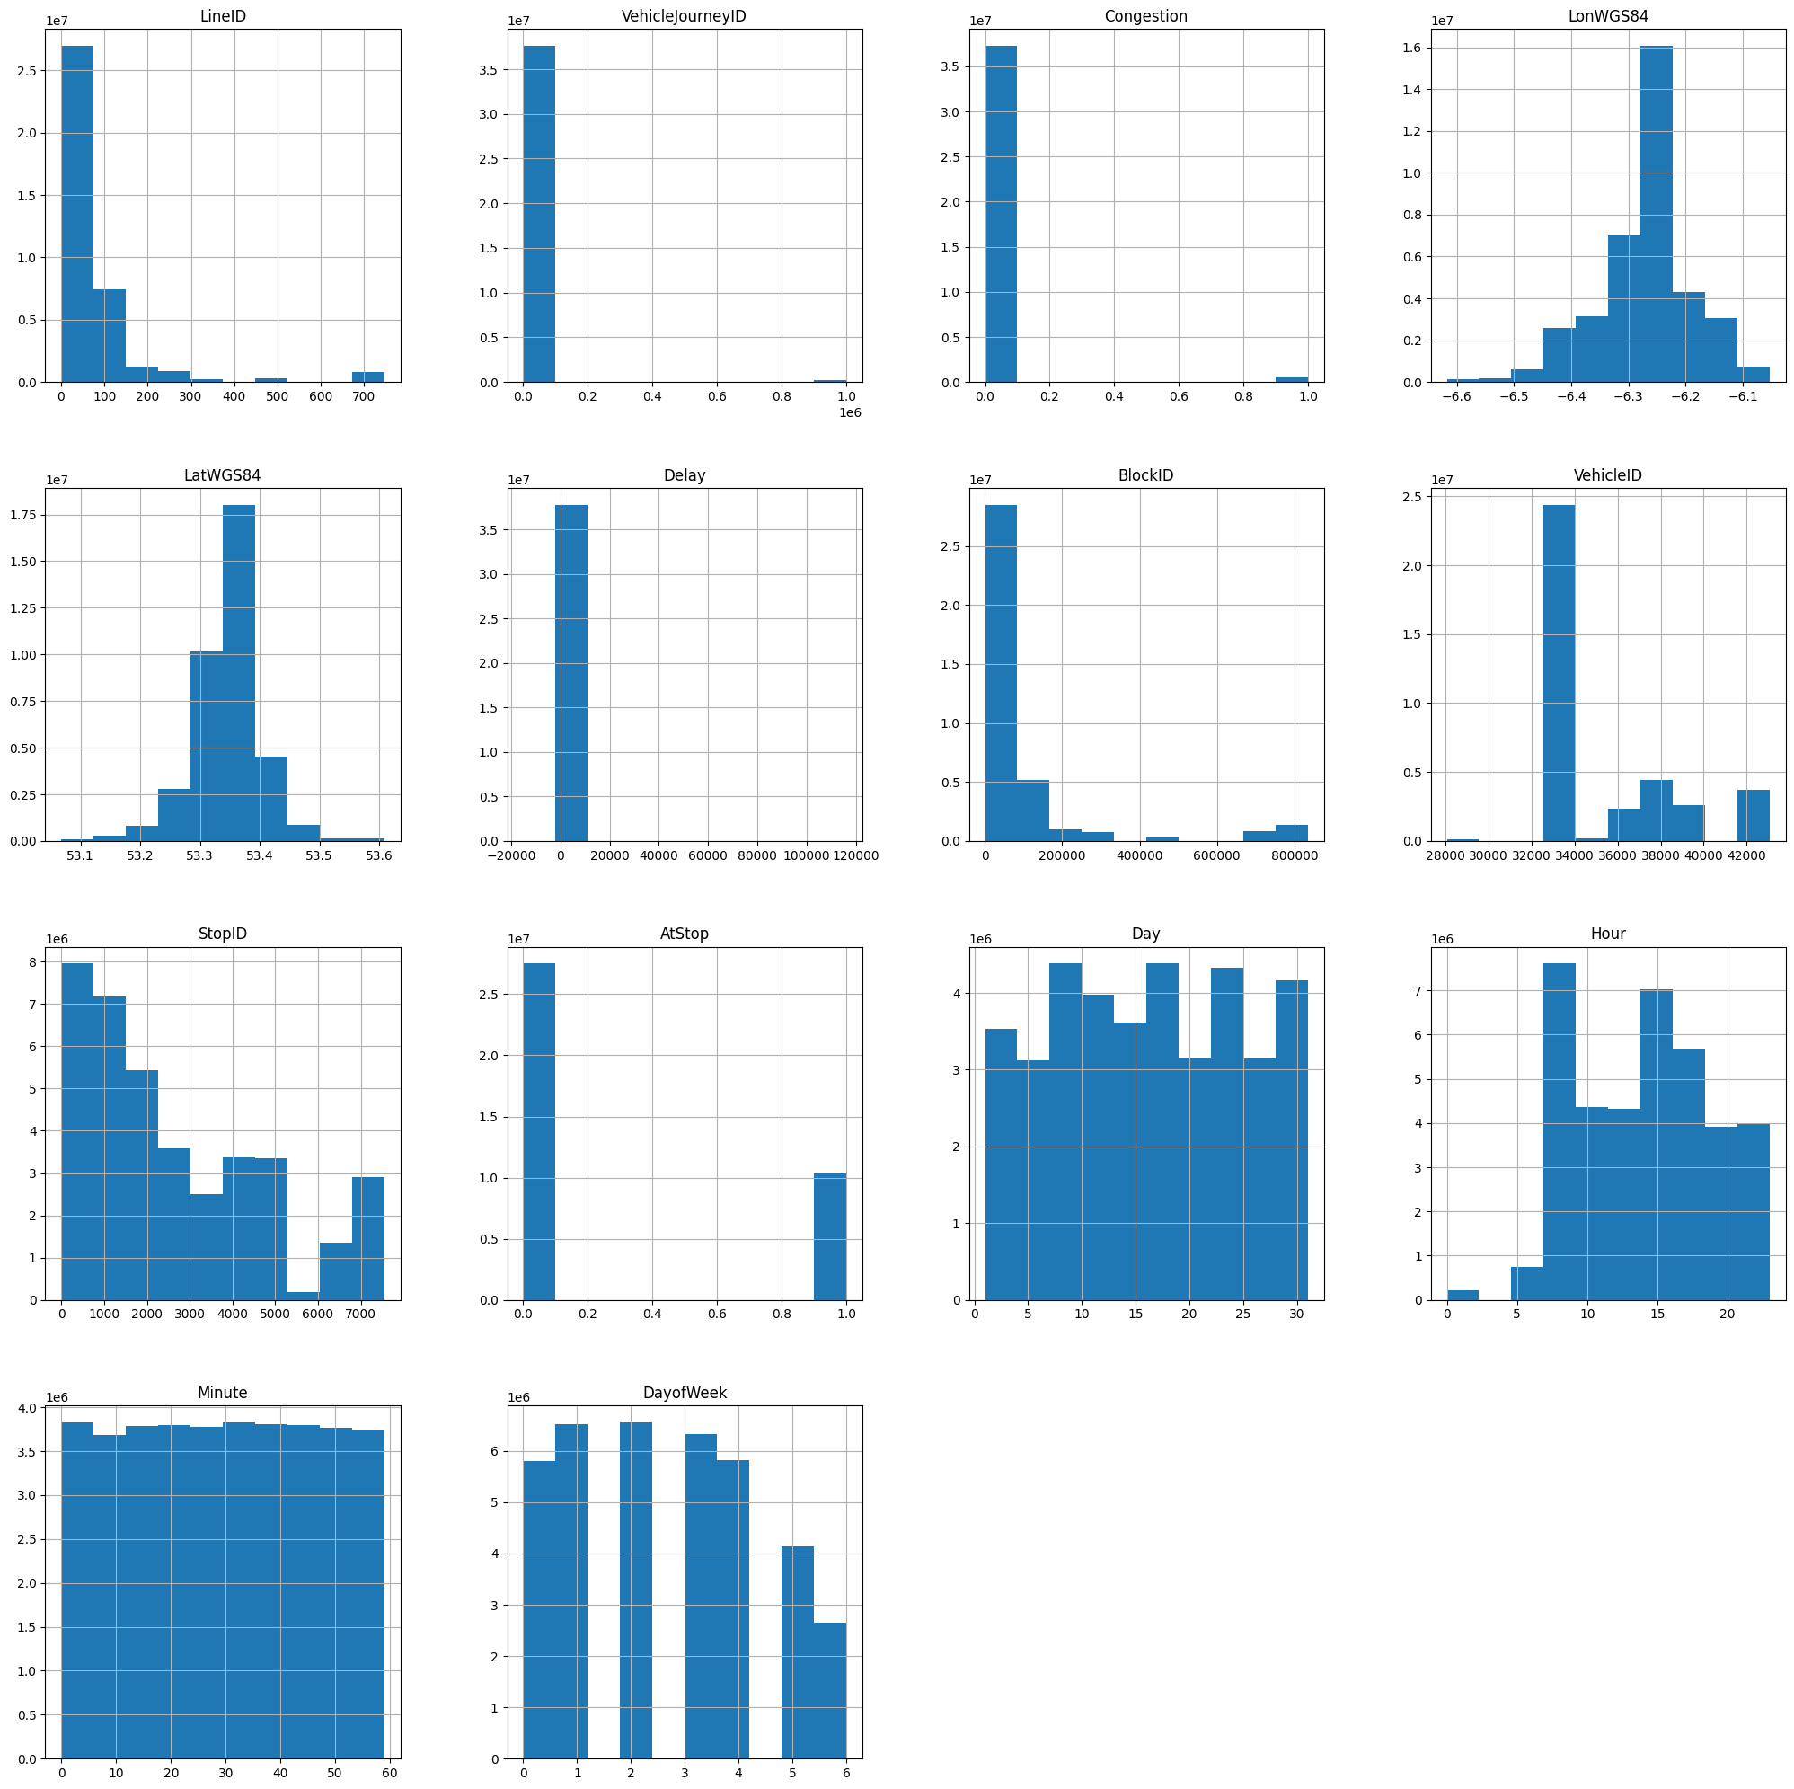

df.hist(['LineID'], bins= 66, figsize=(8,8))  
plt.savefig('./Images/Img_1a_lineID_histogram.svg')

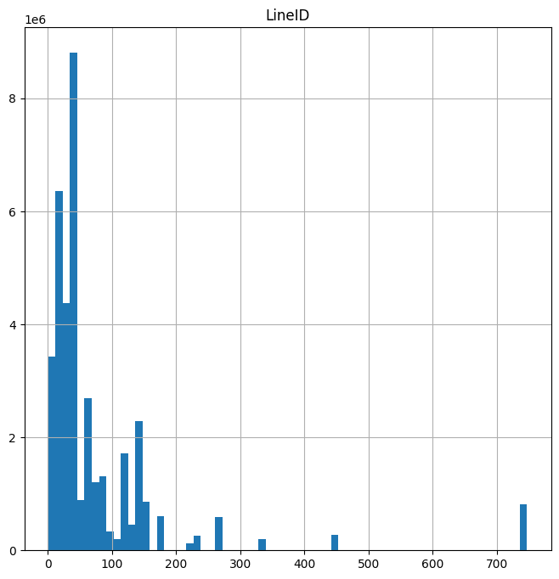

df.hist(['Delay'], bins= 100, figsize=(8,8))  
plt.savefig('./Images/Img_1b_Delay_histogram.svg')

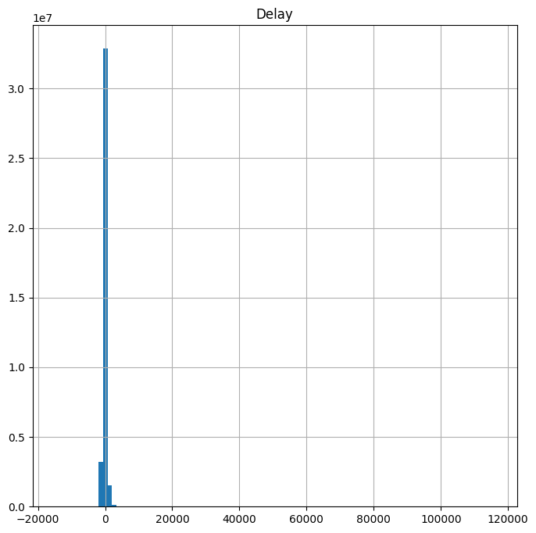

## Display boxplots of some of the numeric data

Note we have outliers in the Delay value for one bus operator, on a Friday the 11'th of January, these look like a mistake as 120,000 seconds is equal to circa 1.4 days, anything above 20,000 seconds is circa 5.5 hours late.

sns.set(color_codes=True)  
sns.catplot(data=df, x='Operator', y = 'Delay' , kind='box', height=12, aspect=1.618);  
plt.savefig('./Images/Img_2_Operator_Delay.svg')

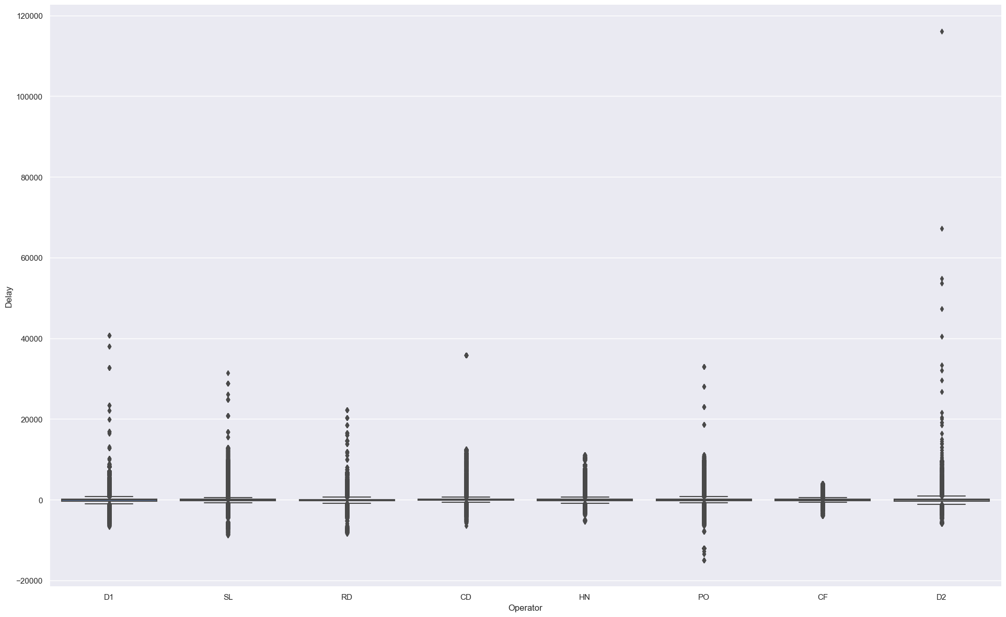

sns.catplot(data=df, x='DayofWeek', y = 'Delay' , kind='box', height=12, aspect=1.618);  
plt.savefig('./Images/Img_3_DayofWeek_Delay.svg')

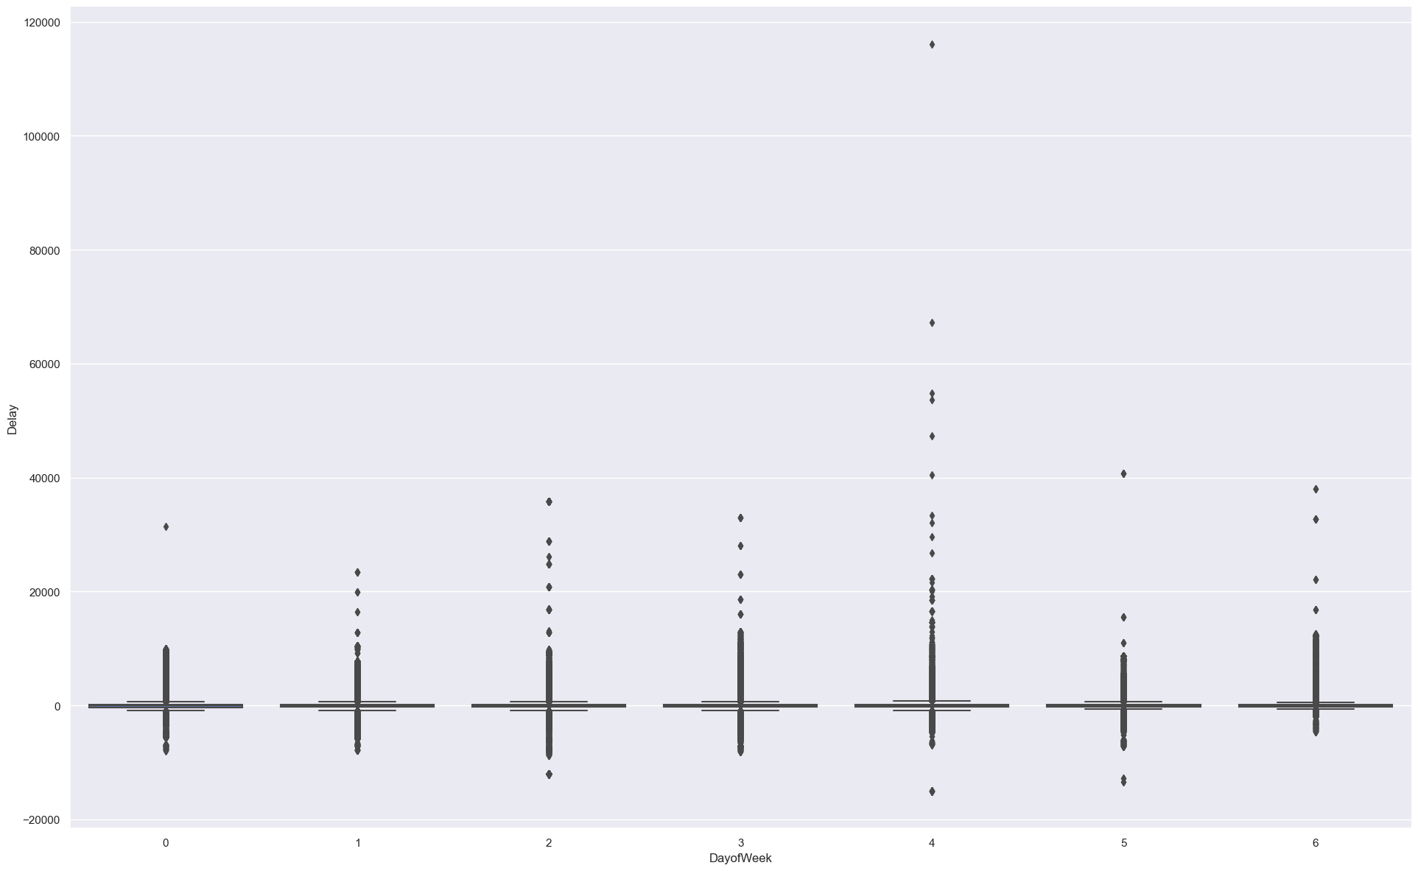

sns.catplot(data=df, x='Day', y = 'Delay' , kind='box', height=12, aspect=1.618);  
plt.savefig('./Images/Img_4_Day_Delay.svg')

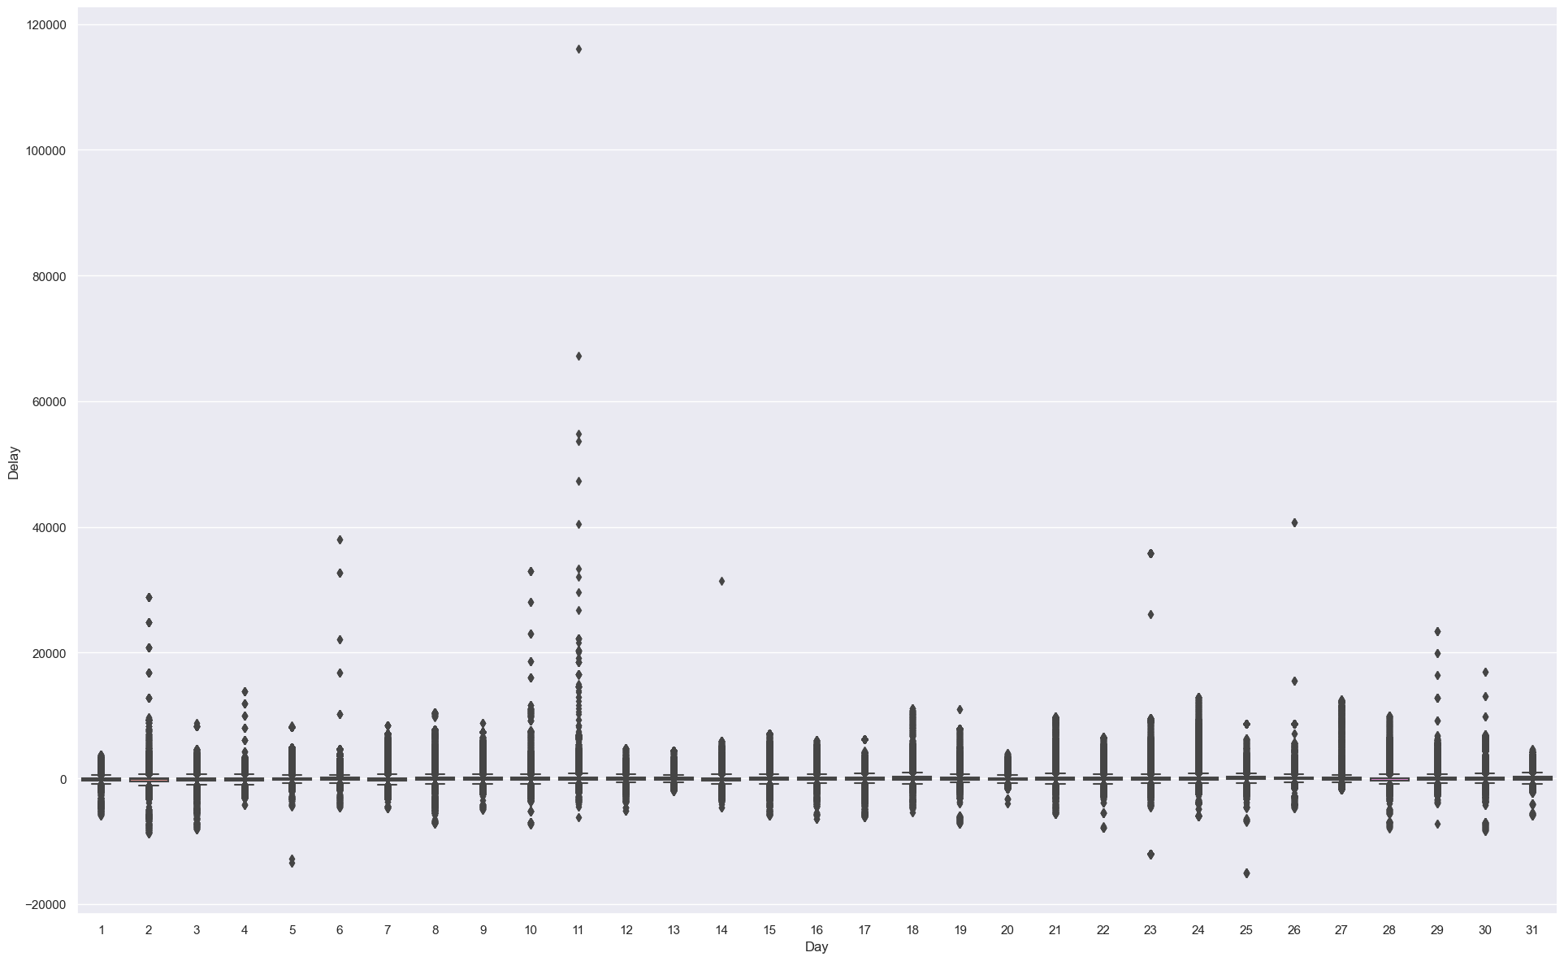

Set the Upper and Lower bounds based on IRQ and also using Z scores to filter the data later

display(temp_df.head(7))  
Q1 = temp_df.iat[6,4]  
Q3 = temp_df.iat[6,6]  
print(Q1, Q3)  
  
IQR = Q3 - Q1  
uppr = (Q3+(1.5*IQR))  
lwr = (Q1-(1.5*IQR))  
  
print(lwr, uppr)  
z = np.abs(stats.zscore(df['Delay']))  
df['Zscore'] = z

count mean std min \  
Timestamp 37804234.0 1.358318e+15 7.384109e+11 1.356998e+15   
LineID 37804234.0 7.844526e+01 1.195265e+02 1.000000e+00   
VehicleJourneyID 37804234.0 1.025672e+04 6.670851e+04 1.000000e+00   
Congestion 37804234.0 1.367897e-02 1.161545e-01 0.000000e+00   
LonWGS84 37804234.0 -6.270782e+00 8.182094e-02 -6.617517e+00   
LatWGS84 37804234.0 5.334426e+01 5.436382e-02 5.306802e+01   
Delay 37804234.0 -5.325867e+01 4.843254e+02 -1.504500e+04   
  
 25% 50% 75% max   
Timestamp 1.357680e+15 1.358328e+15 1.358955e+15 1.359633e+15   
LineID 1.800000e+01 4.000000e+01 8.300000e+01 7.470000e+02   
VehicleJourneyID 2.744000e+03 4.814000e+03 6.863000e+03 9.998560e+05   
Congestion 0.000000e+00 0.000000e+00 0.000000e+00 1.000000e+00   
LonWGS84 -6.306750e+00 -6.261670e+00 -6.232100e+00 -6.053033e+00   
LatWGS84 5.331952e+01 5.334611e+01 5.337347e+01 5.360873e+01   
Delay -2.660000e+02 -2.000000e+01 1.140000e+02 1.161220e+05

-266.0 114.0  
-836.0 684.0

#### Box plots of the Buses that are later than the upper bound 684 seconds

df_late = df[df['Delay'].astype('int64') > uppr] # buses 2 hours late :)  
  
if df_late.shape[0] > 0:  
 sns.catplot(data=df_late, x='LineID', y = 'Delay' , kind='box', height=12, aspect=1.618);  
 plt.savefig('./Images/Img_5_LineID_Delay_Late.svg')  
 sns.catplot(data=df_late, x='Hour', y = 'Delay' , hue='Operator' , kind='box', height=12, aspect=1.618);  
 plt.savefig('./Images/Img_6_Hour_Delay_Late.svg')  
 sns.catplot(data=df_late, x='Day', y = 'Delay' , hue='Operator', kind='box', height=12, aspect=1.618);  
 plt.savefig('./Images/Img_7_Day_Delay_Late.svg')  
 df_late.to_parquet('./Data/lateOutlierBusData.parquet')

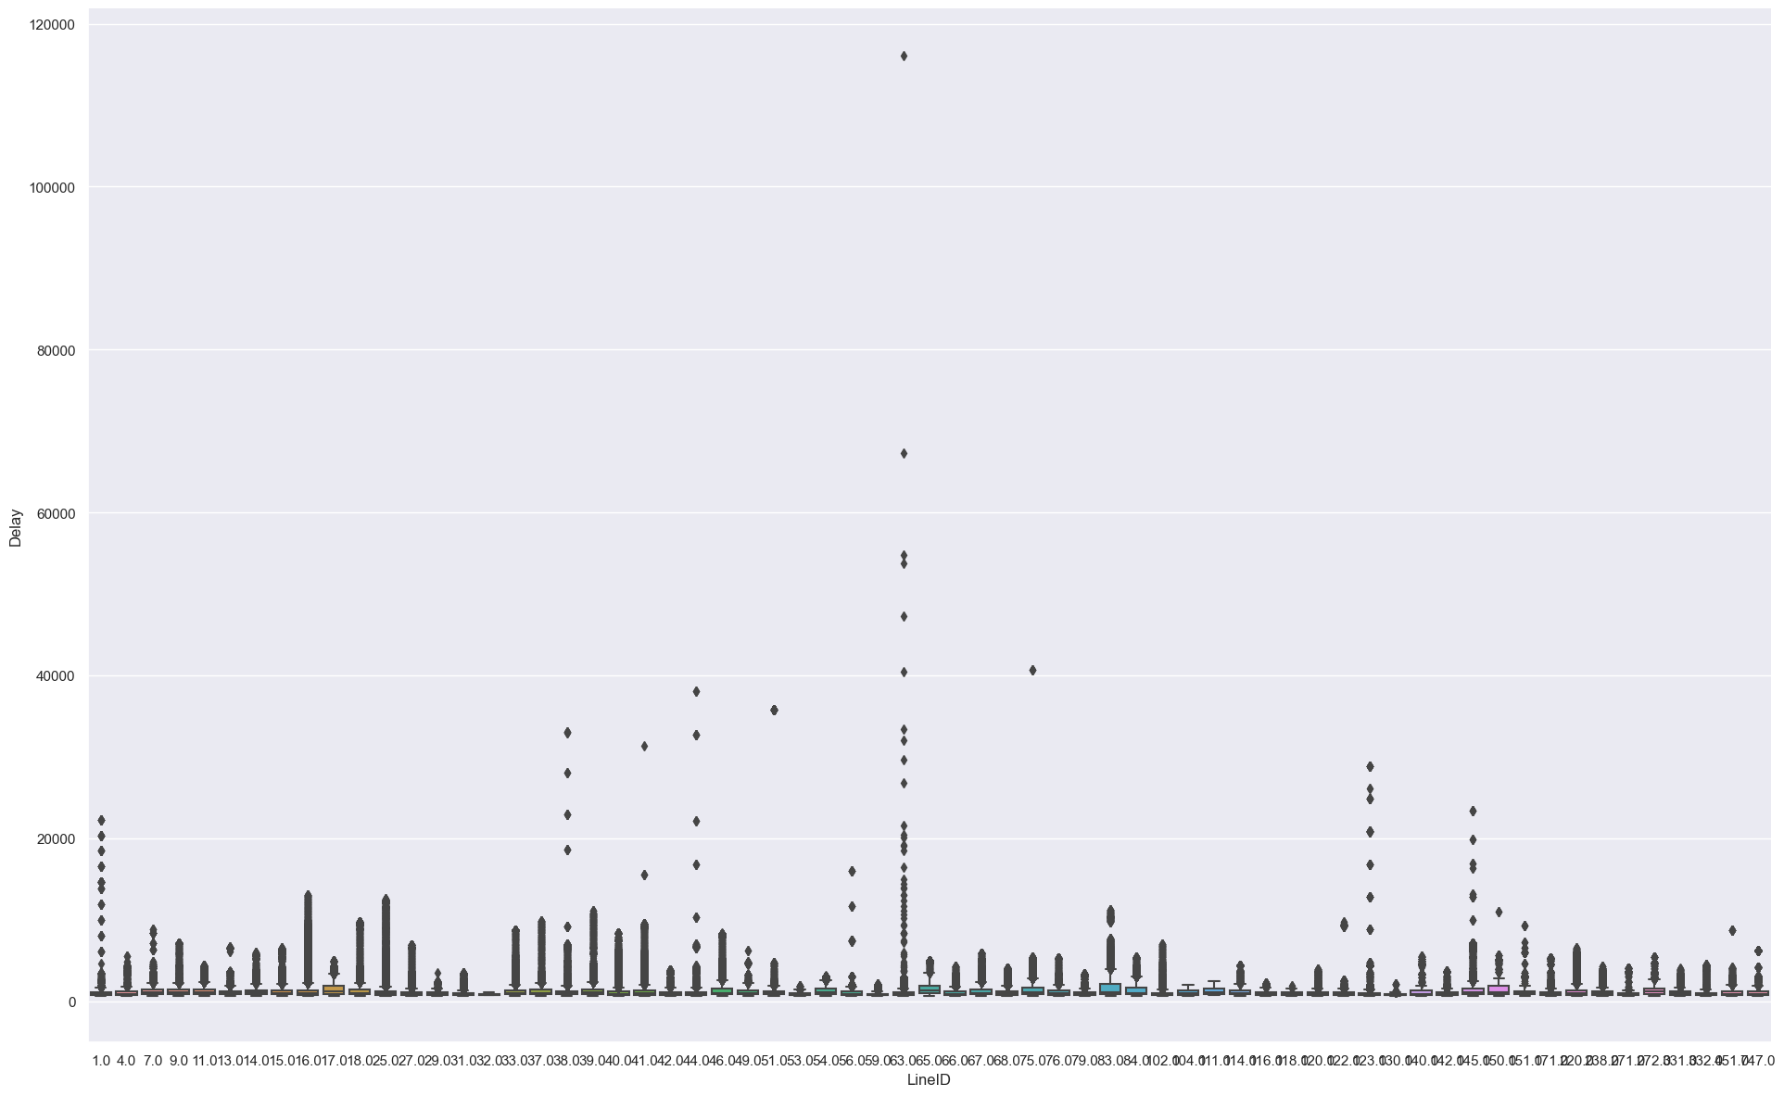

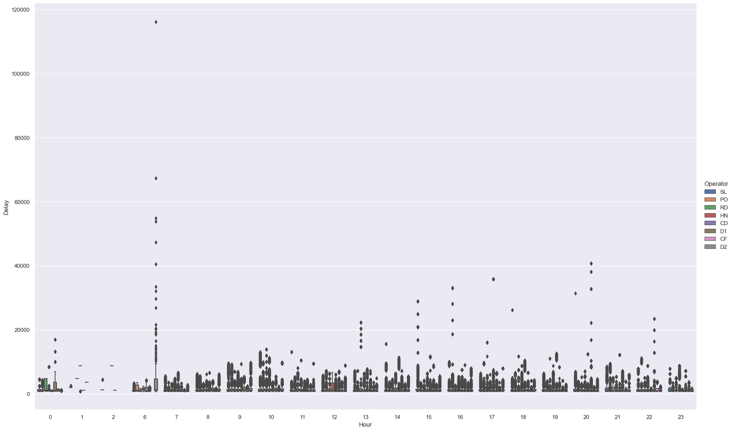

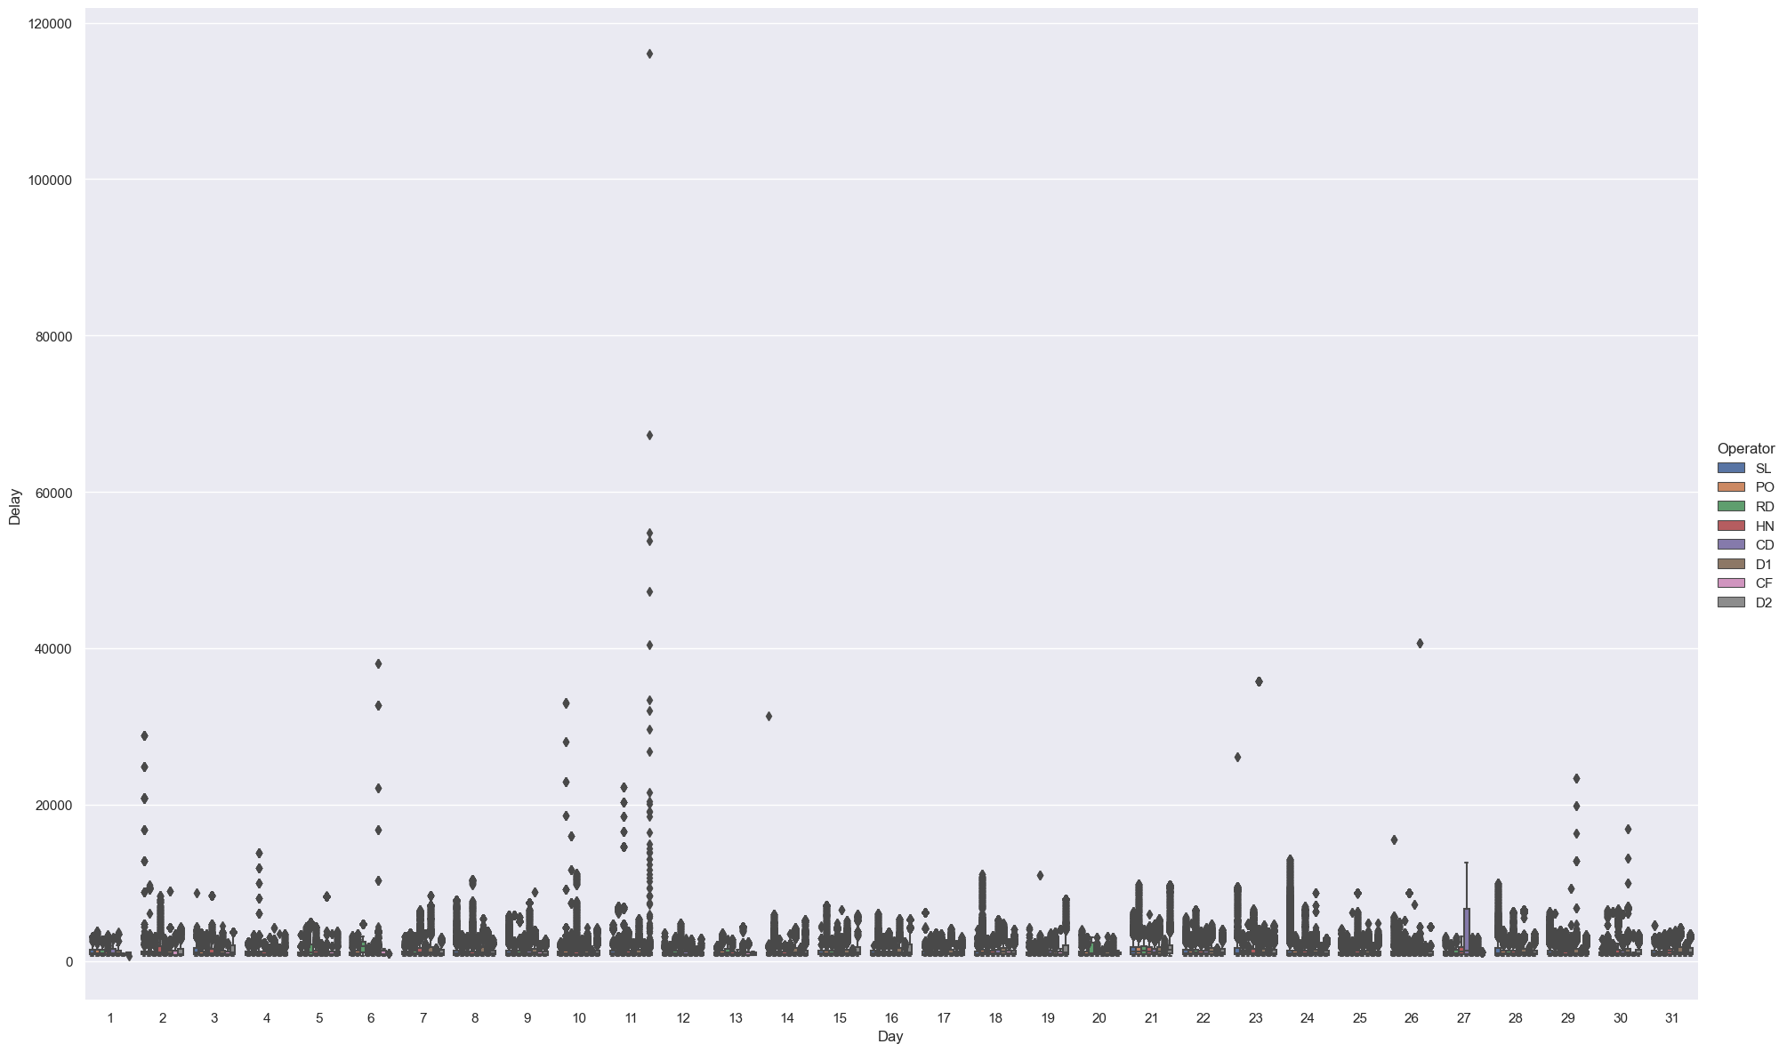

#### Box plots of the Buses that are earlier than the lower bound -836 seconds

df_early = df[df['Delay'].astype('int64') < lwr]   
if df_early.shape[0] > 0:  
 sns.catplot(data=df_early, x='LineID', y = 'Delay' , kind='box', height=12, aspect=1.618);  
 plt.savefig('./Images/Img_8_LineID_Delay_Early.svg')  
 sns.catplot(data=df_early, x='Hour', y = 'Delay' , hue='Operator' , kind='box', height=12, aspect=1.618);  
 plt.savefig('./Images/Img_9_Hour_Delay_Early.svg')  
 sns.catplot(data=df_early, x='Day', y = 'Delay' , hue='Operator', kind='box', height=12, aspect=1.618);  
 plt.savefig('./Images/Img_10_Day_Delay_Early.svg')  
 df_early.to_parquet('./Data/EarlyOutlierBusData.parquet')

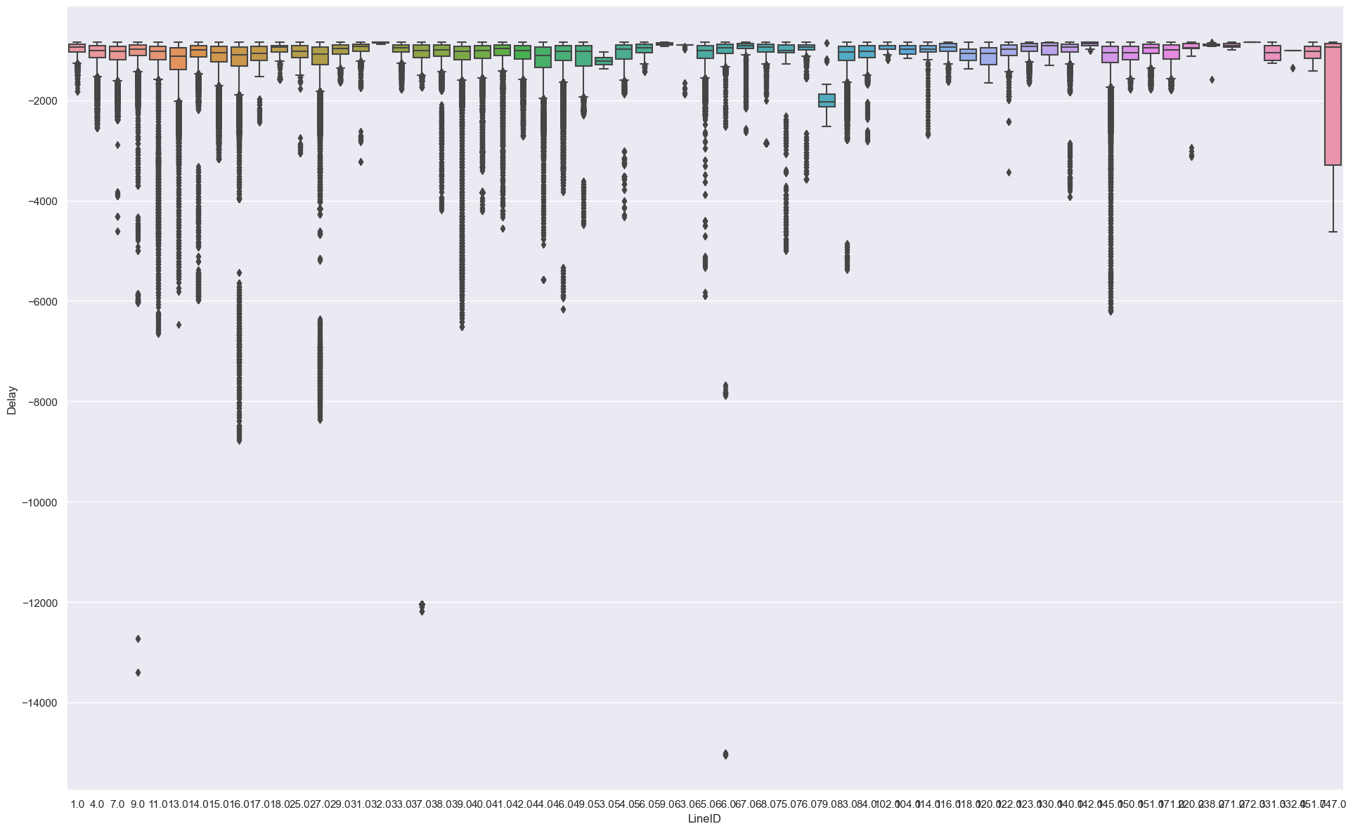

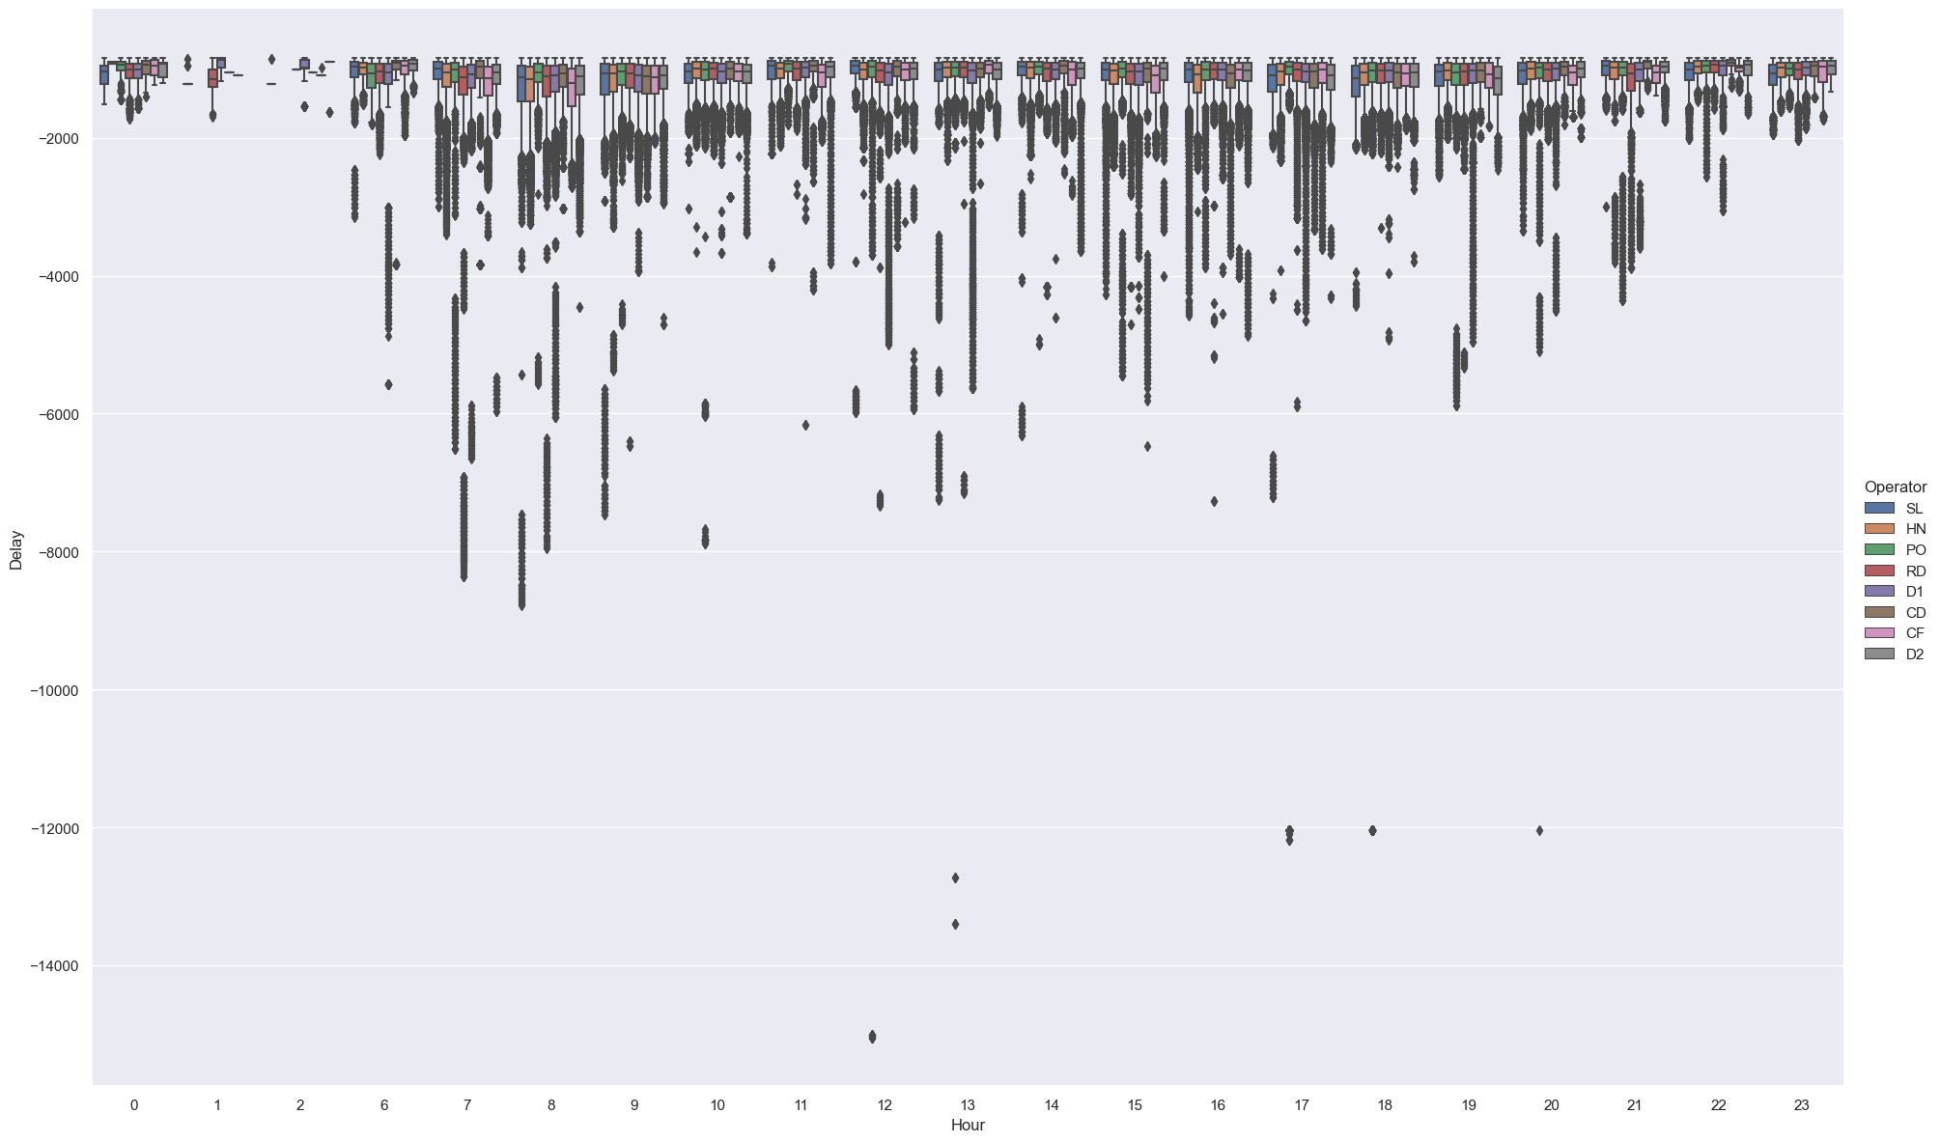

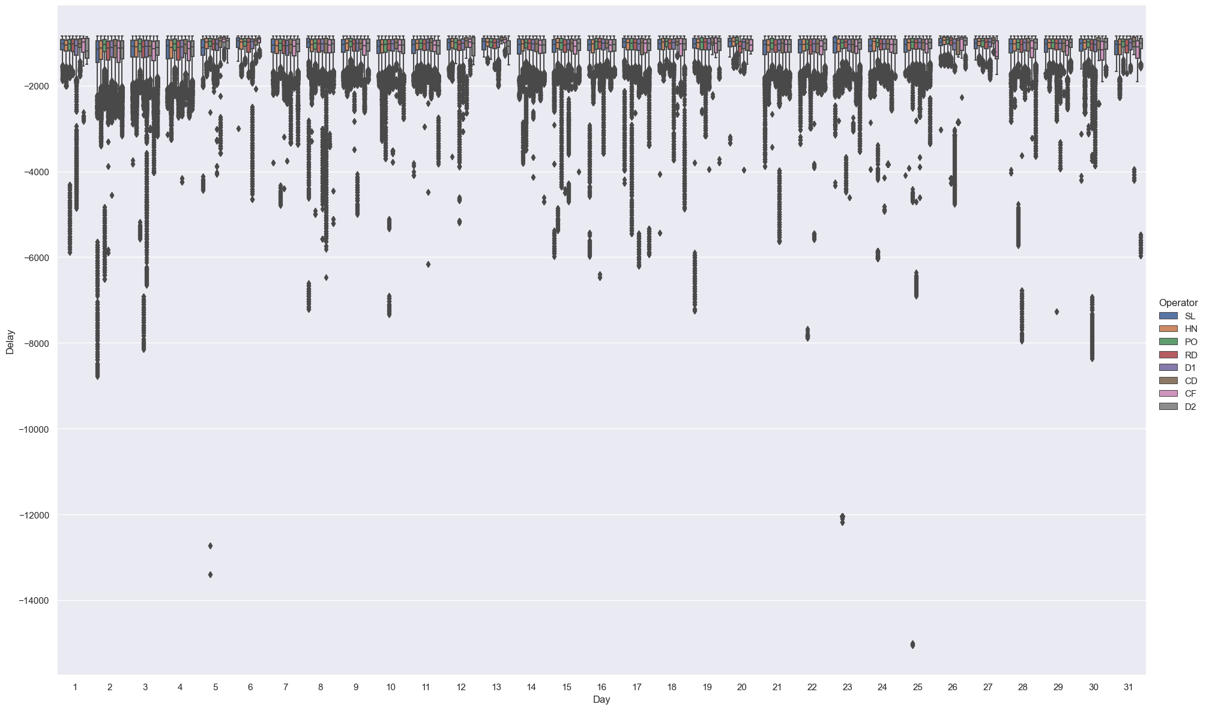

### Remove outliers from the Delay

Decided to focus the data set on buses that have a Z score less than or equal to 3, went with the zscore as it removed least rows

print("old shape: ", df.shape)  
# df = df[df['Delay'].astype('int64') <= uppr]  
# df = df[df['Delay'].astype('int64') >= lwr]  
df = df[df['Zscore'] <= 3]  
df = df.drop(['Zscore'], axis='columns')  
print("New Shape: ", df.shape)

old shape: (37804234, 17)  
New Shape: (37316138, 16)

# save work done so far   
df.to_parquet('./Data/CleanedBusData.parquet')

sns.catplot(data=df, x='Operator', y = 'Delay' , kind='box', height=12, aspect=1.618);  
plt.savefig('./Images/Img_11_Operator_Delay.svg')

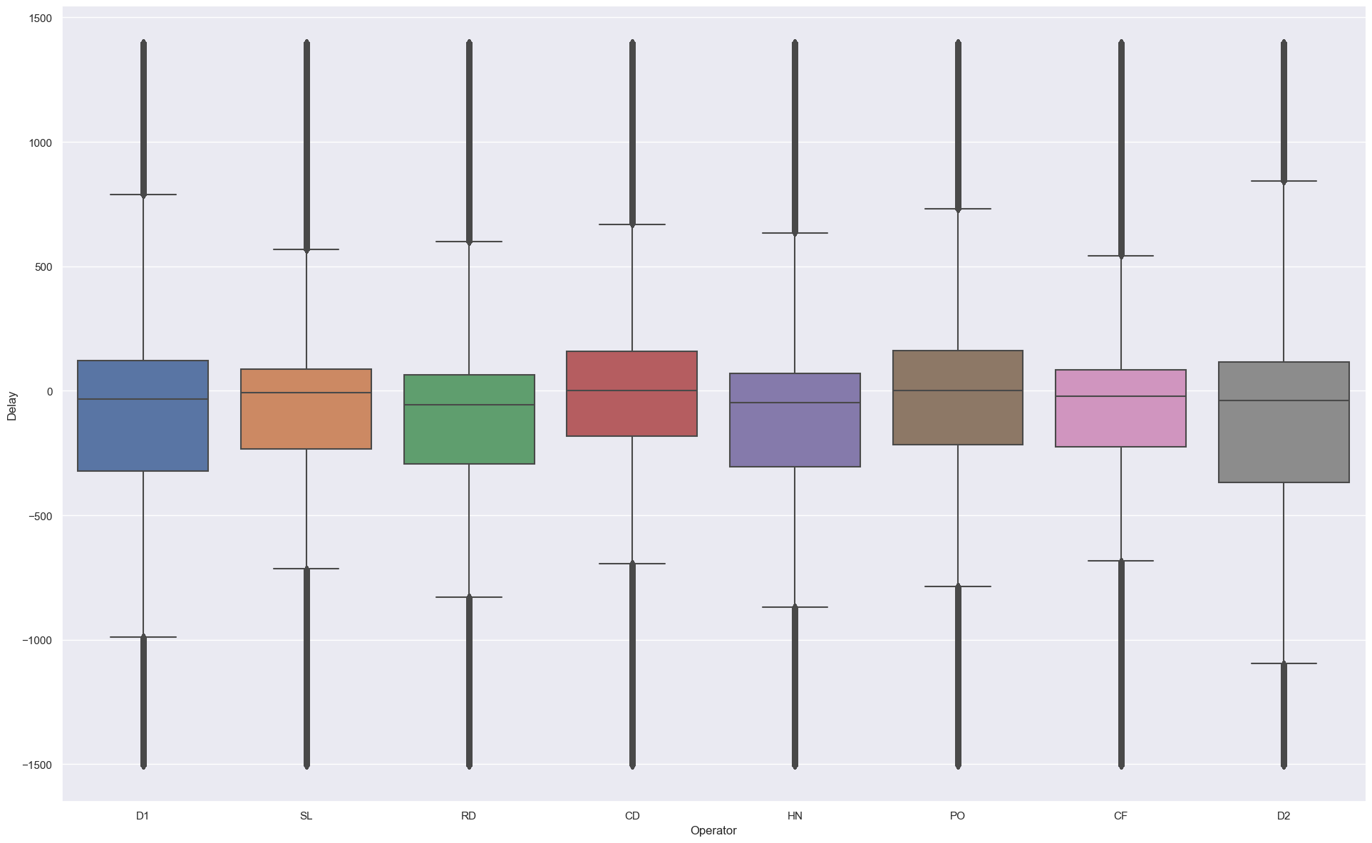

sns.catplot(data=df, x='DayofWeek', y = 'Delay' , kind='box', height=12, aspect=1.618);  
plt.savefig('./Images/Img_12_DayofWeek_Delay.svg')

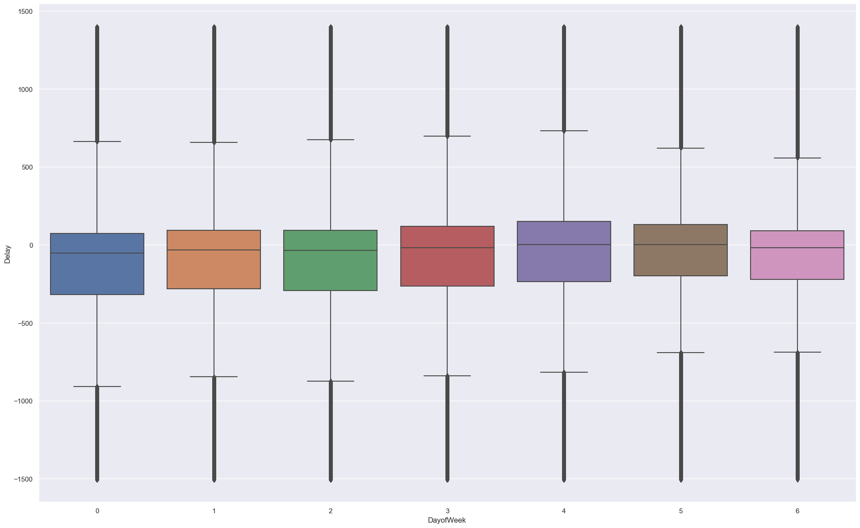

We can see from the Correlation matrix that none of the variables in the Bus data is stronlgy correlated to either Delay or Congestion variables

c_df = df.corr('pearson', numeric_only=True)  
fig, ax = plt.subplots(figsize=(20,15))  
sns.set_style("whitegrid")  
sns.set_context("notebook", font_scale=1.2, rc={"lines.linewidth": 2.5})  
sns.heatmap(c_df, cmap="YlGnBu", annot=True)  
plt.savefig('./Images/Img_13_BusDataframeCorHeatmap.svg')  
plt.show()

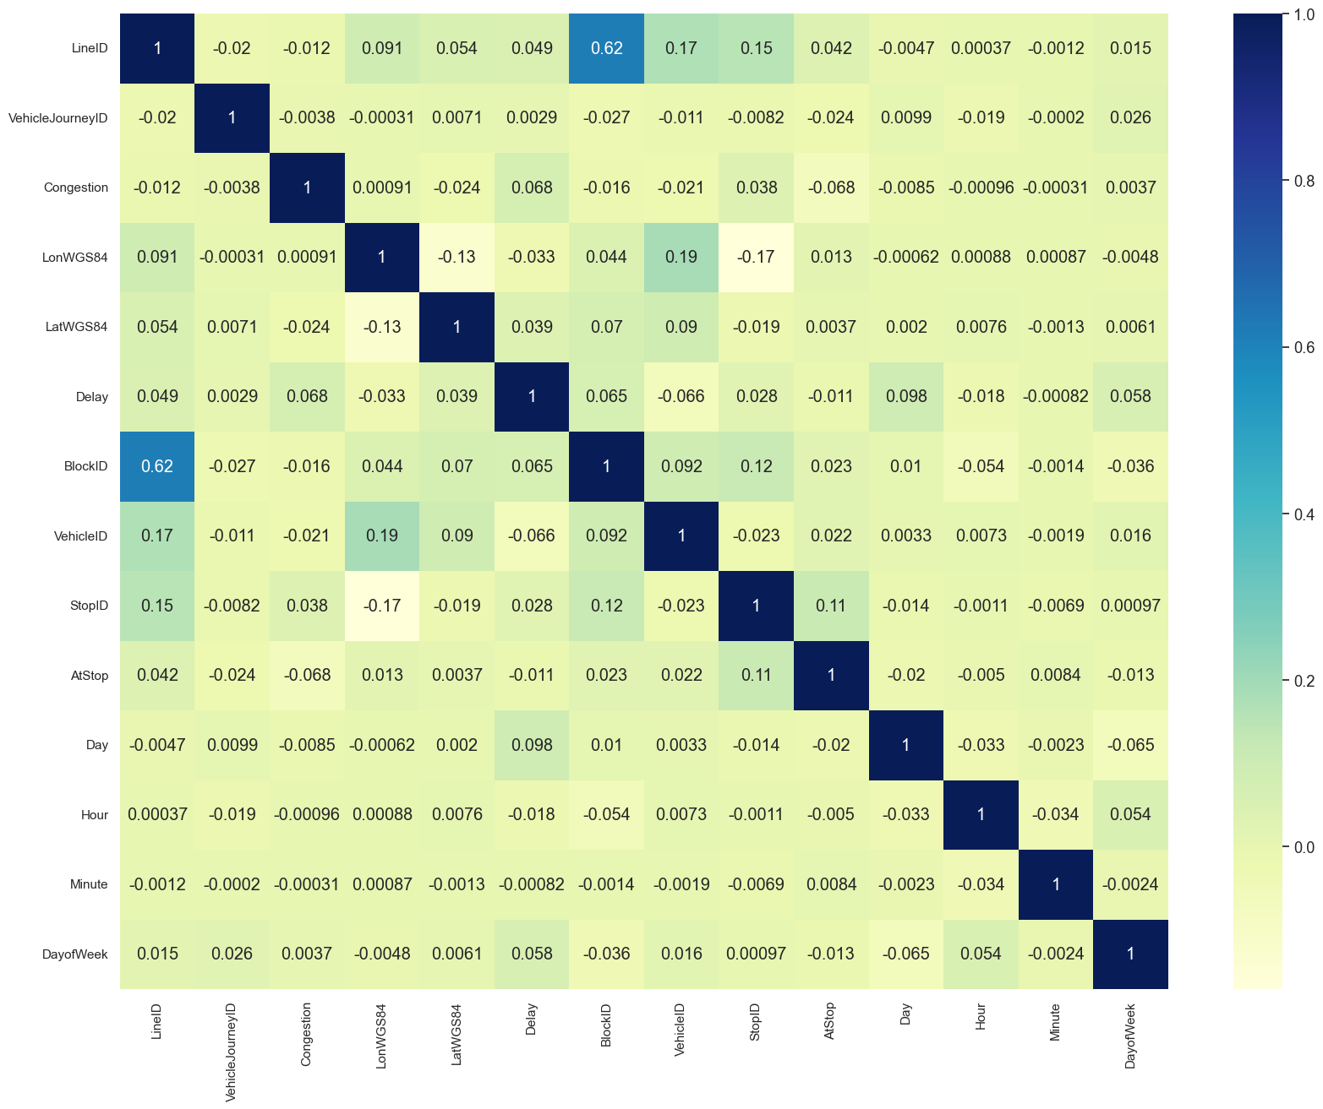

## Display Numerical Columns

if len(df) > 5000: # limiting the amount of data that is being sent to the function because of memory issues   
 sampleSize = 5000  
else:  
 sampleSize = len(df)  
for f in NumericalColumns:  
 custom_barplot( df1=df.sample(sampleSize), col1=f)

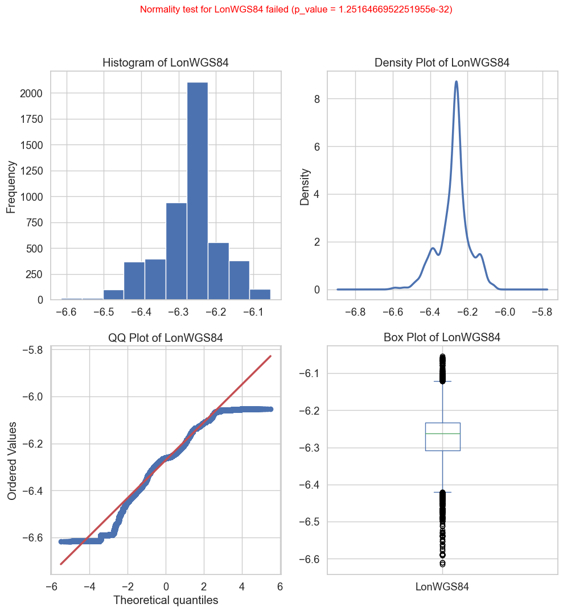

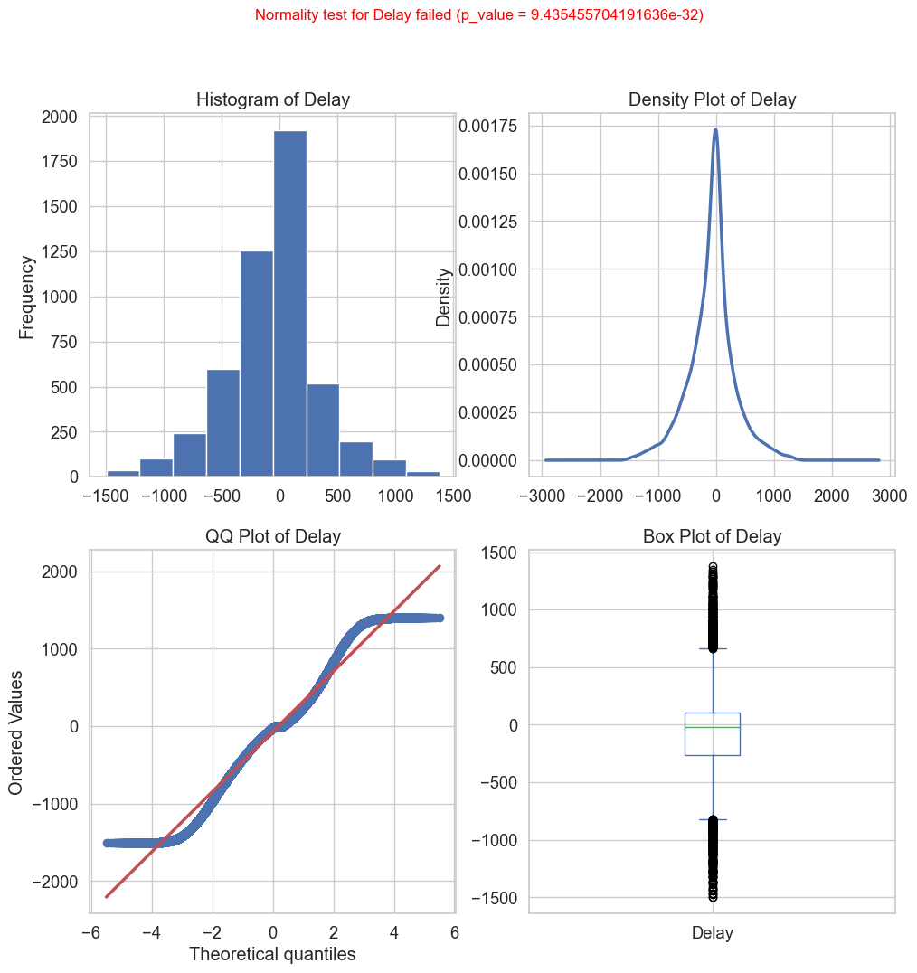

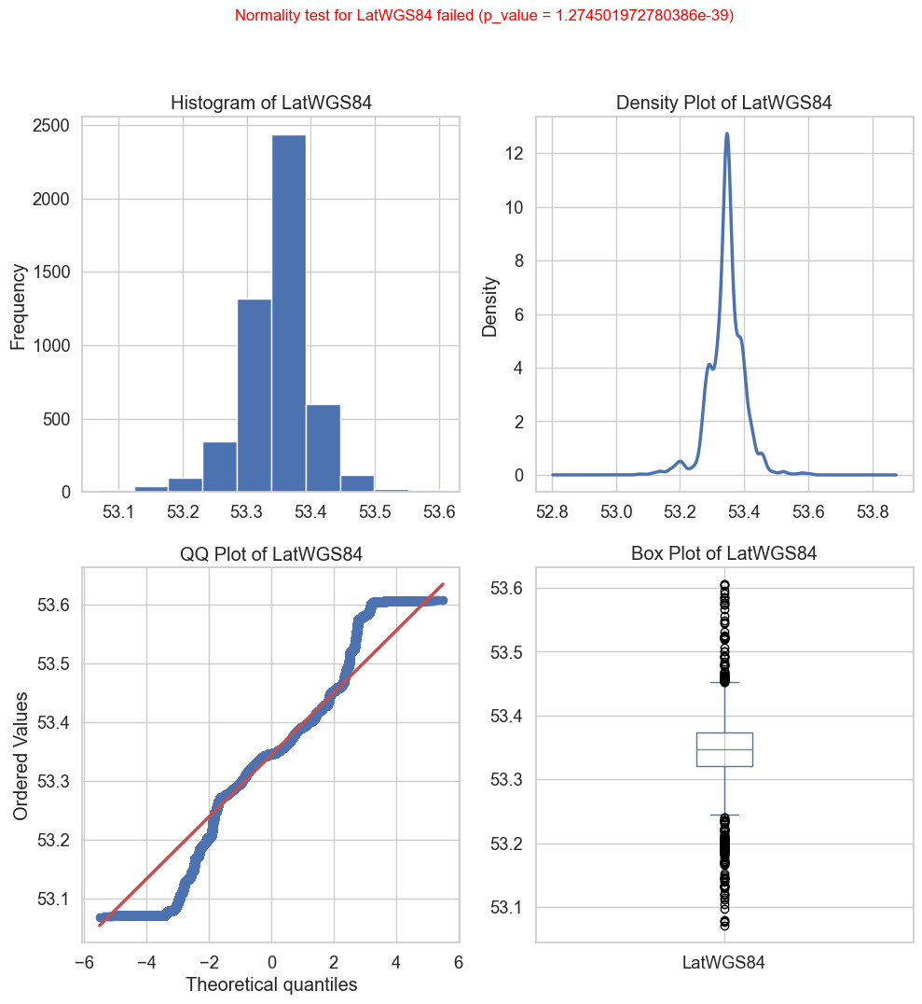

df['Colour'] = df['Delay'].apply(lambda x: 'Black' if (x < -300) else 'Red' if (x > 300) else 'Yellow')

df['Ontime'] = df['Delay'].apply(lambda x: 0 if (x < -300) or (x > 300) else 1)

# save work done so far   
df.to_parquet('./Data/CleanedBusData.parquet')

df = pd.read_parquet('./Data/CleanedBusData.parquet')

fig, ax = plt.subplots(figsize=(15,12))  
ax.scatter(df['LineID'],df['Delay'], c=df['Colour'])  
plt.ylabel('Delay')  
plt.xlabel('Bus Route')  
#plt.savefig('./Images/Img_14_Delay_BusRoute.svg')  
plt.show()

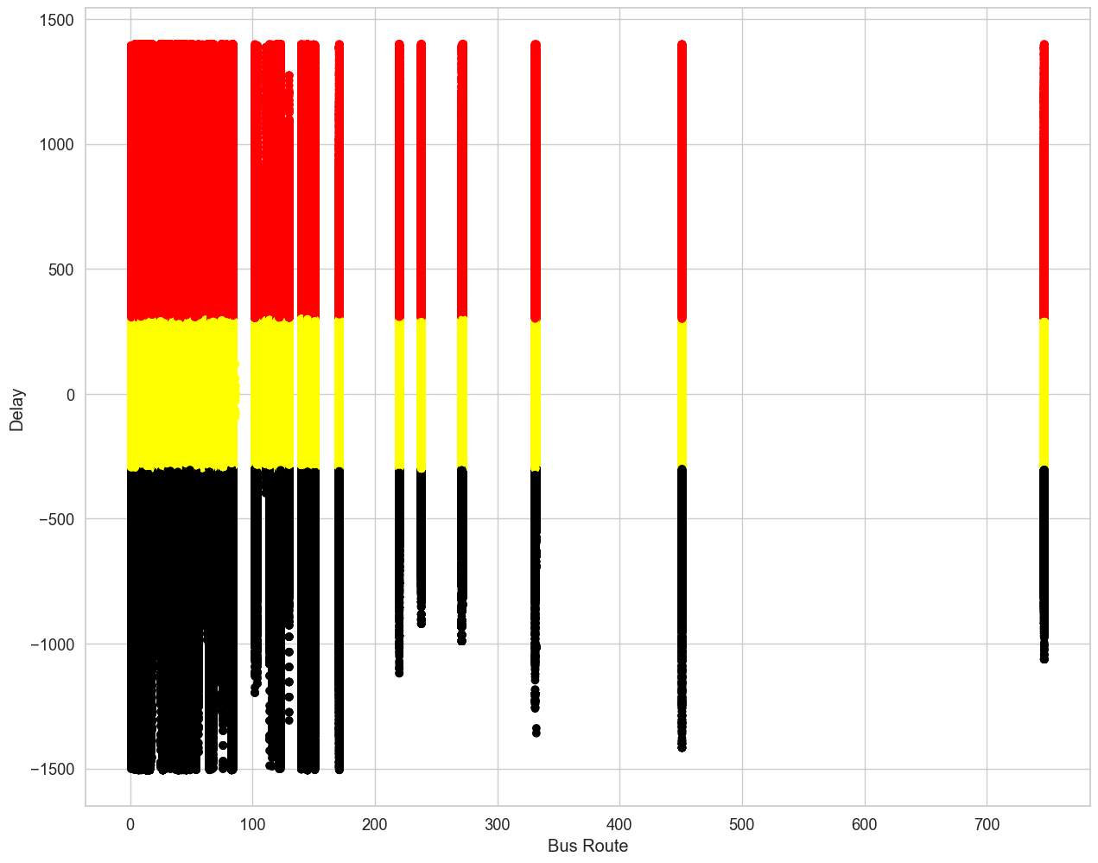

fig, ax = plt.subplots(figsize=(15,12))  
ax.scatter(df['Hour'],df['Delay'], c=df['Colour'])  
plt.ylabel('Delay')  
plt.xlabel('Hour of Day')  
#plt.savefig('./Images/Img_15_Delay_HourofDay.svg')  
plt.show()

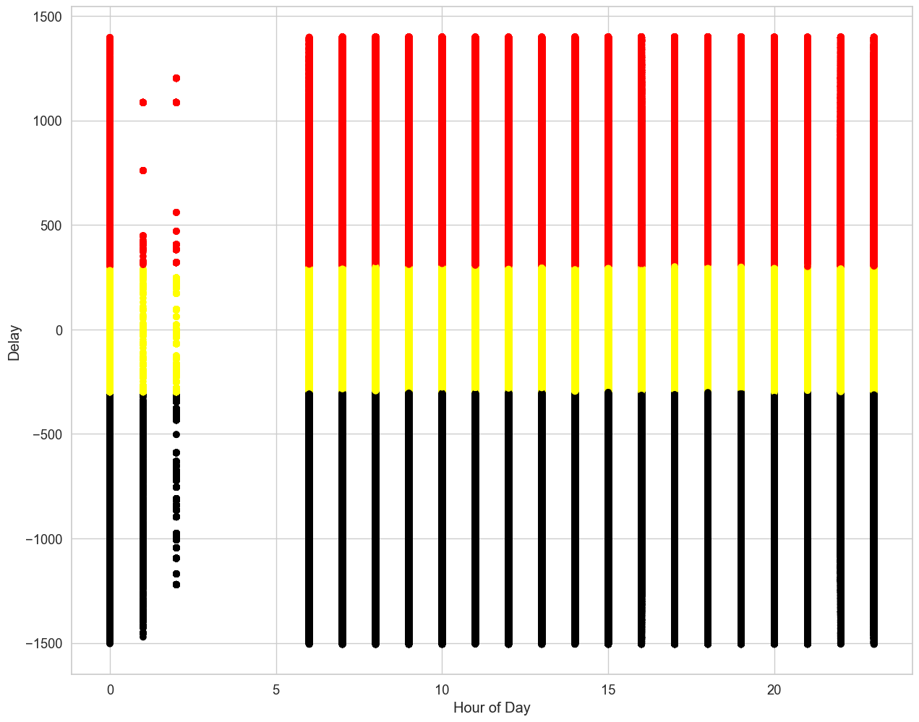

fig, ax = plt.subplots(figsize=(15,12))  
ax.scatter(df['Day'],df['Delay'], c=df['Colour'])  
plt.ylabel('Delay')  
plt.xlabel('Day of Month')  
#plt.savefig('./Images/Img_16_Delay_DayofMonth.svg')  
plt.show()

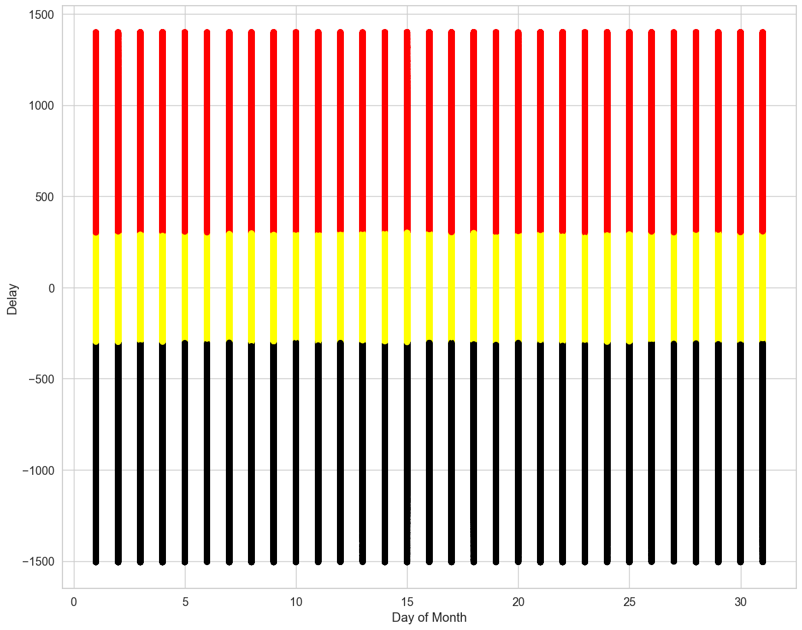

fig, ax = plt.subplots(figsize=(15,12))  
ax.scatter(df['DayofWeek'],df['Delay'], c=df['Colour'])  
plt.ylabel('Delay')  
plt.xlabel('Day of Week')  
#plt.savefig('./Images/Img_17_Delay_DayofWeek.svg')  
plt.show()

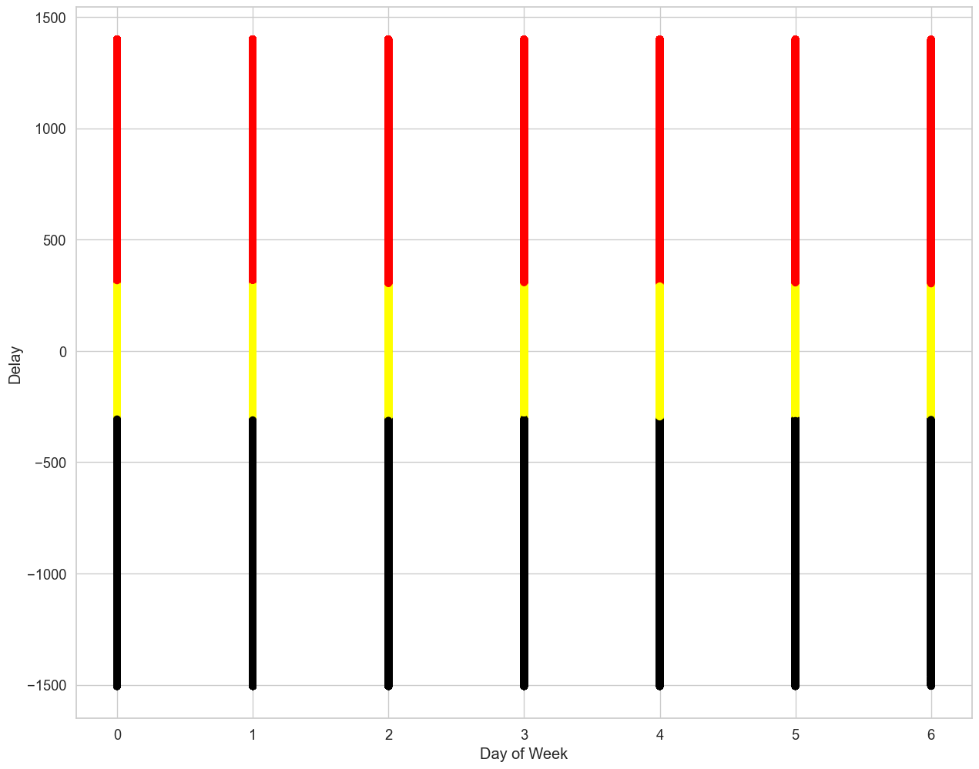

### A look at Congestion variable

df.hist(by = 'Congestion', column= 'Hour', figsize=(15,12));  
plt.savefig('./Images/Img_18_Congestion_Hour.svg')

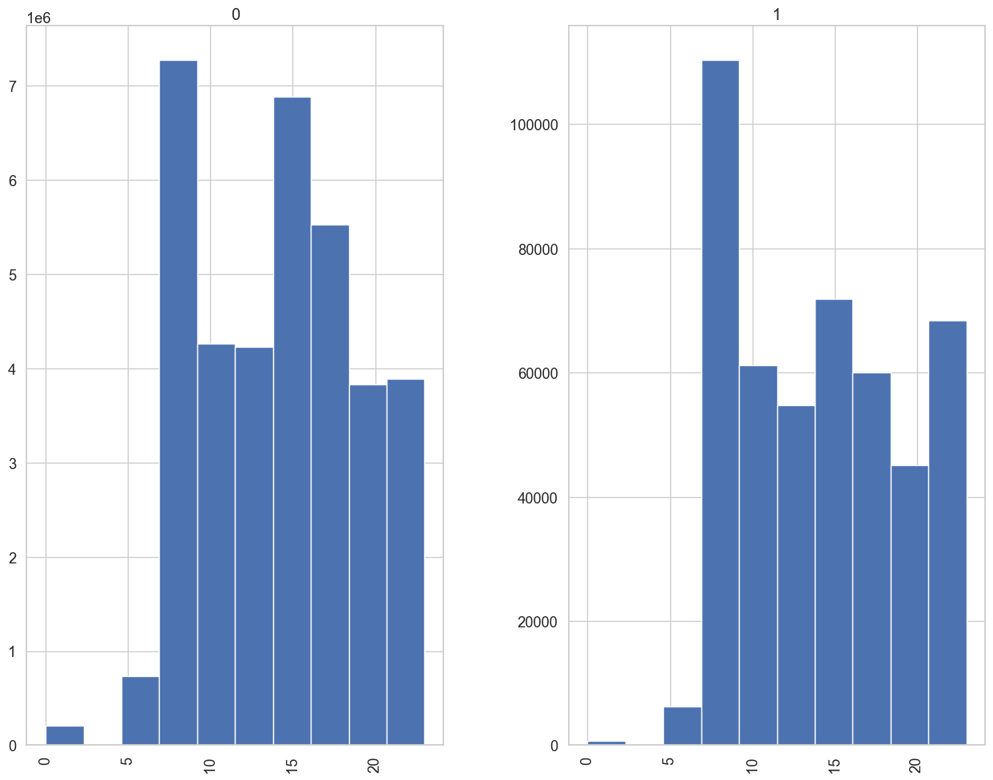

df.hist(by = 'Congestion', column= 'DayofWeek',figsize=(15,12));  
plt.savefig('./Images/Img_19_Congestion_DayofWeek.svg')

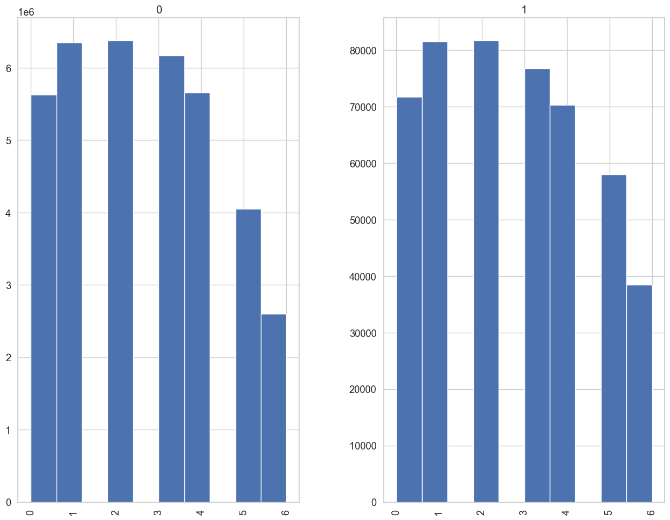

df.hist(by = 'Congestion', column= 'Day',figsize=(15,12));  
plt.savefig('./Images/Img_20_Congestion_Day.svg')

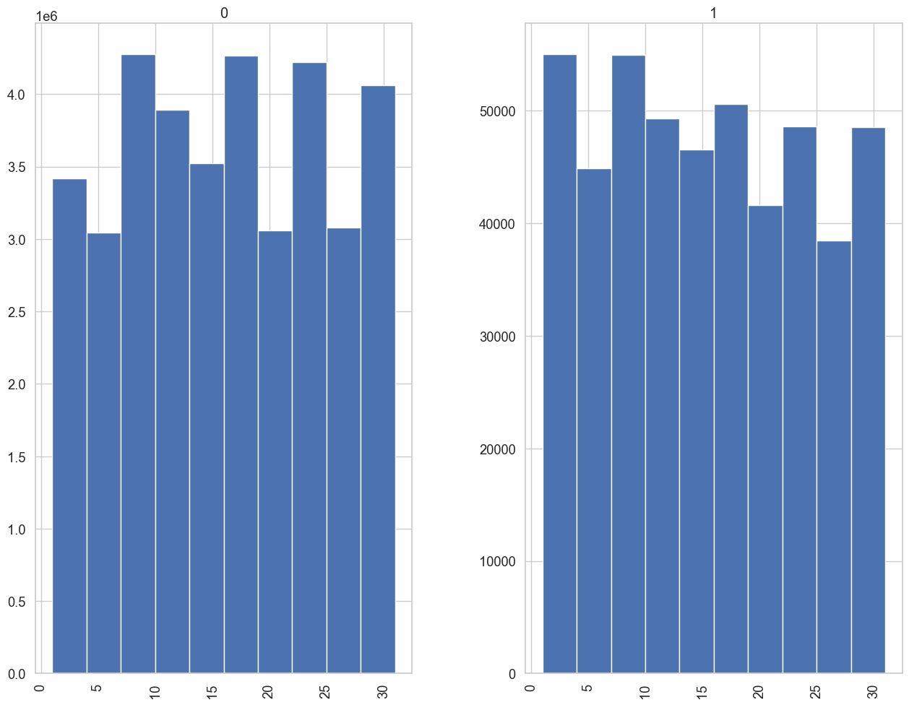

df.hist(by = 'Congestion', column= 'Operator',figsize=(15,12),sharey=True);  
plt.savefig('./Images/Img_21_Congestion_Operator.svg')

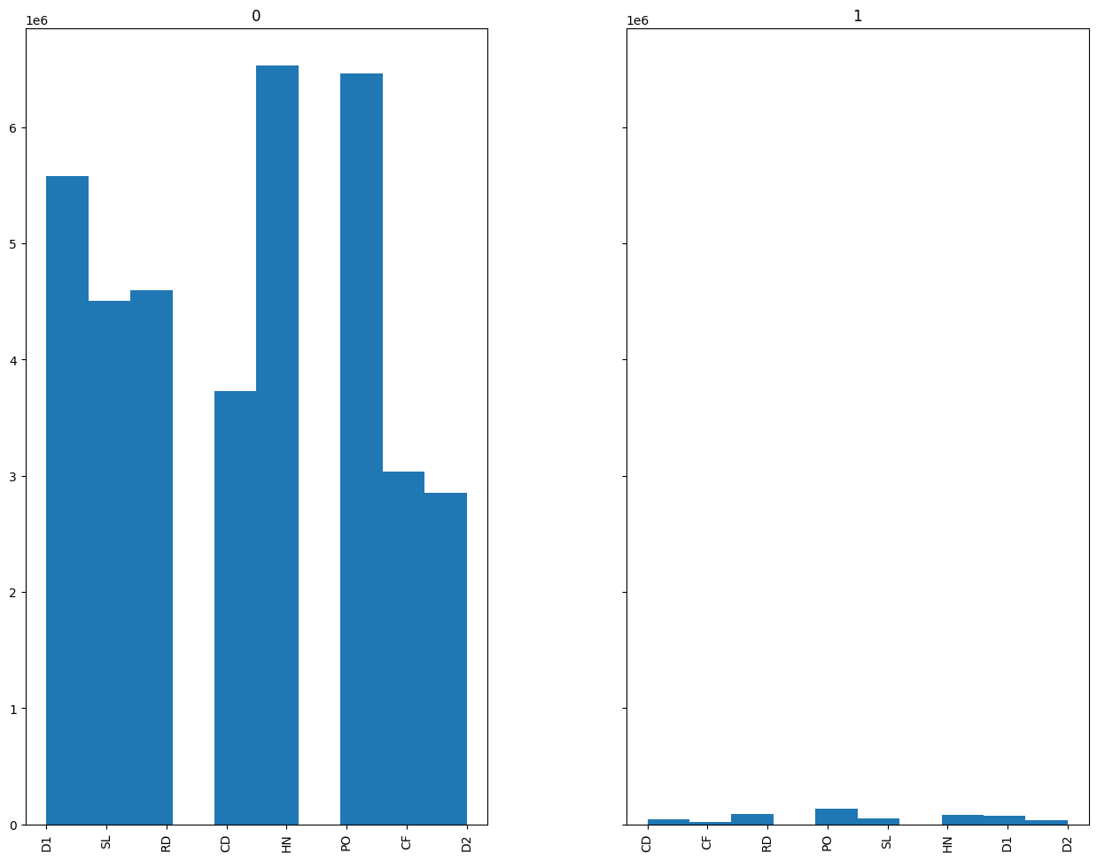

### Individual Bus Routes displayed

Black if the bus is early, Red if it is late and yellow if it is within a 5 minute window of its scheduled time

busRoutes = sorted(df['LineID'].unique())  
  
w1_value = ''  
w1 = None  
w1 = widgets.Dropdown(  
 options= busRoutes,  
 value= busRoutes[0],  
 description = 'LineID',  
 )  
  
i = interactive(custom_scatterplot, df1 =fixed(df), col1=w1)  
hbox = widgets.HBox(i.children)  
display(hbox)

" busRoutes = sorted(df['LineID'].unique())\n\nw1_value = ''\nw1 = None\nw1 = widgets.Dropdown(\n options= busRoutes,\n value= busRoutes[0],\n description = 'LineID',\n )\n\ni = interactive(custom_scatterplot, df1 =fixed(df), col1=w1)\nhbox = widgets.HBox(i.children)\ndisplay(hbox)\n "

# Download the weather station details <https://cli.fusio.net/cli/climate_data/webdata/StationDetails.csv>

## Download the weather stations csv file

df.to_parquet('./Data/CleanedBusData.parquet')

df.shape

(37316138, 18)

url = 'https://cli.fusio.net/cli/climate_data/webdata/StationDetails.csv'

### Load the weather statio details for Dublin

Get the information for the Dublin weather stations -done

weatherStations = pd.read_csv(url)  
weatherStations = weatherStations[weatherStations['county'].str.contains('Dublin')]  
weatherStations.head(10)  
dublinStations = weatherStations[["station name", "name"]]  
dublinStations.columns = [x.strip().replace(' ', '') for x in dublinStations.columns]

### Loop through this data and download the hourly weather data into Data/Weather folder - done

for rows in dublinStations.itertuples():  
 # get hourly weather data  
 url = "http://cli.fusio.net/cli/climate_data/webdata/hly" + str(rows.stationname) + ".zip"  
 print(url)  
 dest = './Zips/MetEirrean/hly' + str(rows.stationname) + ".zip"  
 try:  
 weatherFile = rq.urlretrieve(url, dest)  
 continue  
 except Exception:  
 print('No file exists')   
 # # get the daily weather data - ONLY USING THE HOURLY DATA FOR NOW  
 # url = "http://cli.fusio.net/cli/climate_data/webdata/dly" + str(rows.stationname) + ".zip"  
 # print(url)  
 # dest = './Zips/MetEirrean/dly' + str(rows.stationname) + ".zip"  
 # try:  
 # weatherFile = rq.urlretrieve(url, dest)  
 # continue  
 # except Exception:  
 # print('No file exists')

http://cli.fusio.net/cli/climate_data/webdata/hly10323.zip  
No file exists  
http://cli.fusio.net/cli/climate_data/webdata/hly10123.zip  
No file exists  
http://cli.fusio.net/cli/climate_data/webdata/hly10223.zip  
No file exists  
http://cli.fusio.net/cli/climate_data/webdata/hly1223.zip  
No file exists  
http://cli.fusio.net/cli/climate_data/webdata/hly632.zip  
No file exists  
http://cli.fusio.net/cli/climate_data/webdata/hly1232.zip  
No file exists  
http://cli.fusio.net/cli/climate_data/webdata/hly2523.zip  
No file exists  
http://cli.fusio.net/cli/climate_data/webdata/hly2623.zip  
No file exists  
http://cli.fusio.net/cli/climate_data/webdata/hly2723.zip  
No file exists  
http://cli.fusio.net/cli/climate_data/webdata/hly2732.zip  
No file exists  
http://cli.fusio.net/cli/climate_data/webdata/hly1323.zip  
No file exists  
http://cli.fusio.net/cli/climate_data/webdata/hly2823.zip  
No file exists  
http://cli.fusio.net/cli/climate_data/webdata/hly1332.zip  
No file exists  
http://cli.fusio.net/cli/climate_data/webdata/hly2832.zip  
No file exists  
http://cli.fusio.net/cli/climate_data/webdata/hly2923.zip  
No file exists  
http://cli.fusio.net/cli/climate_data/webdata/hly232.zip  
No file exists  
http://cli.fusio.net/cli/climate_data/webdata/hly723.zip  
No file exists  
http://cli.fusio.net/cli/climate_data/webdata/hly3023.zip  
No file exists  
http://cli.fusio.net/cli/climate_data/webdata/hly1423.zip  
No file exists  
http://cli.fusio.net/cli/climate_data/webdata/hly732.zip  
No file exists  
http://cli.fusio.net/cli/climate_data/webdata/hly3423.zip  
No file exists  
http://cli.fusio.net/cli/climate_data/webdata/hly1523.zip  
No file exists  
http://cli.fusio.net/cli/climate_data/webdata/hly3524.zip  
No file exists  
http://cli.fusio.net/cli/climate_data/webdata/hly1532.zip  
No file exists  
http://cli.fusio.net/cli/climate_data/webdata/hly432.zip  
No file exists  
http://cli.fusio.net/cli/climate_data/webdata/hly3723.zip  
http://cli.fusio.net/cli/climate_data/webdata/hly823.zip  
No file exists  
http://cli.fusio.net/cli/climate_data/webdata/hly1624.zip  
No file exists  
http://cli.fusio.net/cli/climate_data/webdata/hly1623.zip  
No file exists  
http://cli.fusio.net/cli/climate_data/webdata/hly3923.zip  
No file exists  
http://cli.fusio.net/cli/climate_data/webdata/hly4023.zip  
No file exists  
http://cli.fusio.net/cli/climate_data/webdata/hly150.zip  
No file exists  
http://cli.fusio.net/cli/climate_data/webdata/hly832.zip  
No file exists  
http://cli.fusio.net/cli/climate_data/webdata/hly4123.zip  
No file exists  
http://cli.fusio.net/cli/climate_data/webdata/hly4223.zip  
No file exists  
http://cli.fusio.net/cli/climate_data/webdata/hly124.zip  
No file exists  
http://cli.fusio.net/cli/climate_data/webdata/hly4323.zip  
No file exists  
http://cli.fusio.net/cli/climate_data/webdata/hly175.zip  
http://cli.fusio.net/cli/climate_data/webdata/hly1723.zip  
No file exists  
http://cli.fusio.net/cli/climate_data/webdata/hly1732.zip  
No file exists  
http://cli.fusio.net/cli/climate_data/webdata/hly4823.zip  
No file exists  
http://cli.fusio.net/cli/climate_data/webdata/hly1823.zip  
No file exists  
http://cli.fusio.net/cli/climate_data/webdata/hly932.zip  
No file exists  
http://cli.fusio.net/cli/climate_data/webdata/hly1923.zip  
No file exists  
http://cli.fusio.net/cli/climate_data/webdata/hly5523.zip  
No file exists  
http://cli.fusio.net/cli/climate_data/webdata/hly5580.zip  
No file exists  
http://cli.fusio.net/cli/climate_data/webdata/hly5623.zip  
No file exists  
http://cli.fusio.net/cli/climate_data/webdata/hly5680.zip  
No file exists  
http://cli.fusio.net/cli/climate_data/webdata/hly5723.zip  
No file exists  
http://cli.fusio.net/cli/climate_data/webdata/hly532.zip  
http://cli.fusio.net/cli/climate_data/webdata/hly1023.zip  
No file exists  
http://cli.fusio.net/cli/climate_data/webdata/hly5823.zip  
No file exists  
http://cli.fusio.net/cli/climate_data/webdata/hly2024.zip  
No file exists  
http://cli.fusio.net/cli/climate_data/webdata/hly2023.zip  
No file exists  
http://cli.fusio.net/cli/climate_data/webdata/hly5923.zip  
No file exists  
http://cli.fusio.net/cli/climate_data/webdata/hly5985.zip  
No file exists  
http://cli.fusio.net/cli/climate_data/webdata/hly6023.zip  
No file exists  
http://cli.fusio.net/cli/climate_data/webdata/hly6185.zip  
No file exists  
http://cli.fusio.net/cli/climate_data/webdata/hly6223.zip  
No file exists  
http://cli.fusio.net/cli/climate_data/webdata/hly6323.zip  
No file exists  
http://cli.fusio.net/cli/climate_data/webdata/hly324.zip  
No file exists  
http://cli.fusio.net/cli/climate_data/webdata/hly6423.zip  
No file exists  
http://cli.fusio.net/cli/climate_data/webdata/hly6523.zip  
No file exists  
http://cli.fusio.net/cli/climate_data/webdata/hly2123.zip  
No file exists  
http://cli.fusio.net/cli/climate_data/webdata/hly2124.zip  
No file exists  
http://cli.fusio.net/cli/climate_data/webdata/hly6623.zip  
No file exists  
http://cli.fusio.net/cli/climate_data/webdata/hly2132.zip  
No file exists  
http://cli.fusio.net/cli/climate_data/webdata/hly6823.zip  
No file exists  
http://cli.fusio.net/cli/climate_data/webdata/hly6923.zip  
No file exists  
http://cli.fusio.net/cli/climate_data/webdata/hly7023.zip  
No file exists  
http://cli.fusio.net/cli/climate_data/webdata/hly7123.zip  
No file exists  
http://cli.fusio.net/cli/climate_data/webdata/hly7223.zip  
No file exists  
http://cli.fusio.net/cli/climate_data/webdata/hly7323.zip  
No file exists  
http://cli.fusio.net/cli/climate_data/webdata/hly1123.zip  
No file exists  
http://cli.fusio.net/cli/climate_data/webdata/hly7423.zip  
No file exists  
http://cli.fusio.net/cli/climate_data/webdata/hly2232.zip  
No file exists  
http://cli.fusio.net/cli/climate_data/webdata/hly7523.zip  
No file exists  
http://cli.fusio.net/cli/climate_data/webdata/hly7623.zip  
No file exists  
http://cli.fusio.net/cli/climate_data/webdata/hly2223.zip  
No file exists  
http://cli.fusio.net/cli/climate_data/webdata/hly7823.zip  
No file exists  
http://cli.fusio.net/cli/climate_data/webdata/hly7923.zip  
No file exists  
http://cli.fusio.net/cli/climate_data/webdata/hly8023.zip  
No file exists  
http://cli.fusio.net/cli/climate_data/webdata/hly8223.zip  
No file exists  
http://cli.fusio.net/cli/climate_data/webdata/hly8723.zip  
No file exists  
http://cli.fusio.net/cli/climate_data/webdata/hly9023.zip  
No file exists  
http://cli.fusio.net/cli/climate_data/webdata/hly332.zip  
No file exists  
http://cli.fusio.net/cli/climate_data/webdata/hly9223.zip  
No file exists  
http://cli.fusio.net/cli/climate_data/webdata/hly9423.zip  
No file exists  
http://cli.fusio.net/cli/climate_data/webdata/hly9523.zip  
No file exists  
http://cli.fusio.net/cli/climate_data/webdata/hly9623.zip  
No file exists  
http://cli.fusio.net/cli/climate_data/webdata/hly9723.zip  
No file exists  
http://cli.fusio.net/cli/climate_data/webdata/hly623.zip  
No file exists  
http://cli.fusio.net/cli/climate_data/webdata/hly9823.zip  
No file exists  
http://cli.fusio.net/cli/climate_data/webdata/hly2423.zip  
No file exists

import zipfile as zip  
 # Zip creates its own folders - no need to check for folder existence  
files = os.listdir('./Zips/MetEirrean/')  
WDfiles = [f for f in files if f.startswith('hly')]  
for f in WDfiles:  
 fp = './Zips/MetEirrean/' + f  
 with zip.ZipFile(fp, mode='r') as arc:   
 arc.extractall('./Data/MetEirrean/')

### Read the weather data and load in the hourly weather data between the min and max dates - done

Phoenix_wdf = pd.read_csv('./Data/MetEirrean/hly175.csv', delimiter=',', header=0, parse_dates=True, low_memory=True, skiprows=14, na_values='NAN')  
  
  
  
Phoenix_wdf['datetime'] = pd.to_datetime(Phoenix_wdf['date'])  
Phoenix_wdf['Year'] = Phoenix_wdf['datetime'].dt.year  
Phoenix_wdf['Month'] = Phoenix_wdf['datetime'].dt.month  
Phoenix_wdf['Day'] = Phoenix_wdf['datetime'].dt.day  
Phoenix_wdf['Time'] = Phoenix_wdf['datetime'].dt.time  
Phoenix_wdf['Hour'] = Phoenix_wdf['datetime'].dt.hour  
Phoenix_wdf['Minute'] = Phoenix_wdf['datetime'].dt.minute  
Phoenix_wdf['DayofWeek'] = Phoenix_wdf['datetime'].dt.day_of_week  
#Filter the weather data to January 2013  
Phoenix_wdf = Phoenix_wdf[Phoenix_wdf['Year'] == 2013]  
Phoenix_wdf = Phoenix_wdf[Phoenix_wdf['Month'] == 1]  
# remove unwanted columns, the indicator columns all show 0, the other vappr wetb and dewpt are all closely related to temp  
Phoenix_wdf = Phoenix_wdf.drop(['date','Year','Month', 'ind', 'ind.1', 'ind.2', 'vappr', 'wetb', 'dewpt','datetime', 'Time'], axis='columns')  
Phoenix_wdf = Phoenix_wdf.astype({"rain": float})  
Phoenix_wdf = Phoenix_wdf.astype({"temp": float})  
Phoenix_wdf = Phoenix_wdf.astype({"rhum": float})  
Phoenix_wdf = Phoenix_wdf.astype({"msl": float})  
  
Phoenix_wdf.dtypes

C:\Users\stehayes\AppData\Local\Temp\ipykernel_20896\4269745701.py:1: DtypeWarning: Columns (2,4,6,7,8,9,10) have mixed types. Specify dtype option on import or set low_memory=False.  
 Phoenix_wdf = pd.read_csv('./Data/MetEirrean/hly175.csv', delimiter=',', header=0, parse_dates=True, low_memory=True, skiprows=14, na_values='NAN')

rain float64  
temp float64  
rhum float64  
msl float64  
Day int64  
Hour int64  
Minute int64  
DayofWeek int64  
dtype: object

Phoenix_wdf.head()

rain temp rhum msl Day Hour Minute DayofWeek  
82223 0.0 3.1 88.0 1000.2 1 0 0 1  
82224 0.0 3.3 85.0 1000.8 1 1 0 1  
82225 0.0 2.9 88.0 1001.2 1 2 0 1  
82226 0.0 2.7 89.0 1001.8 1 3 0 1  
82227 0.1 2.5 90.0 1002.5 1 4 0 1

# Brief look at corelated variables in the weather data.

Temperature is strongly corelated to wetb, dewpt and vappr measurements meaning that multicollinearity might be an issue with any regression models

sns.pairplot(Phoenix_wdf);  
plt.savefig('./Images/Img_22_WeatherDistributionPlot.svg')

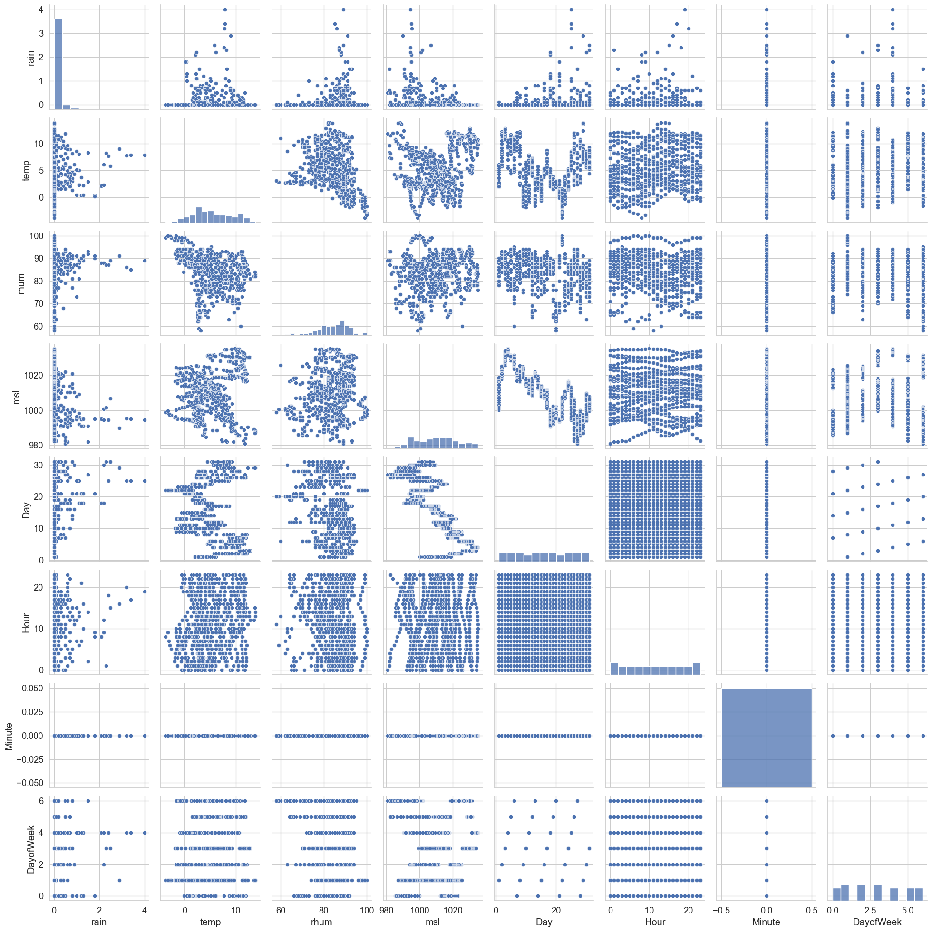

c_wd = Phoenix_wdf.corr('pearson', numeric_only=True)

fig, ax = plt.subplots(figsize=(20,15))  
sns.set_style("whitegrid")  
sns.set_context("notebook", font_scale=1.2, rc={"lines.linewidth": 2.5})  
sns.heatmap(c_wd, cmap="YlGnBu", annot=True)  
plt.savefig('./Images/Img_23_WeatherCorHeatmap.svg')  
plt.show()

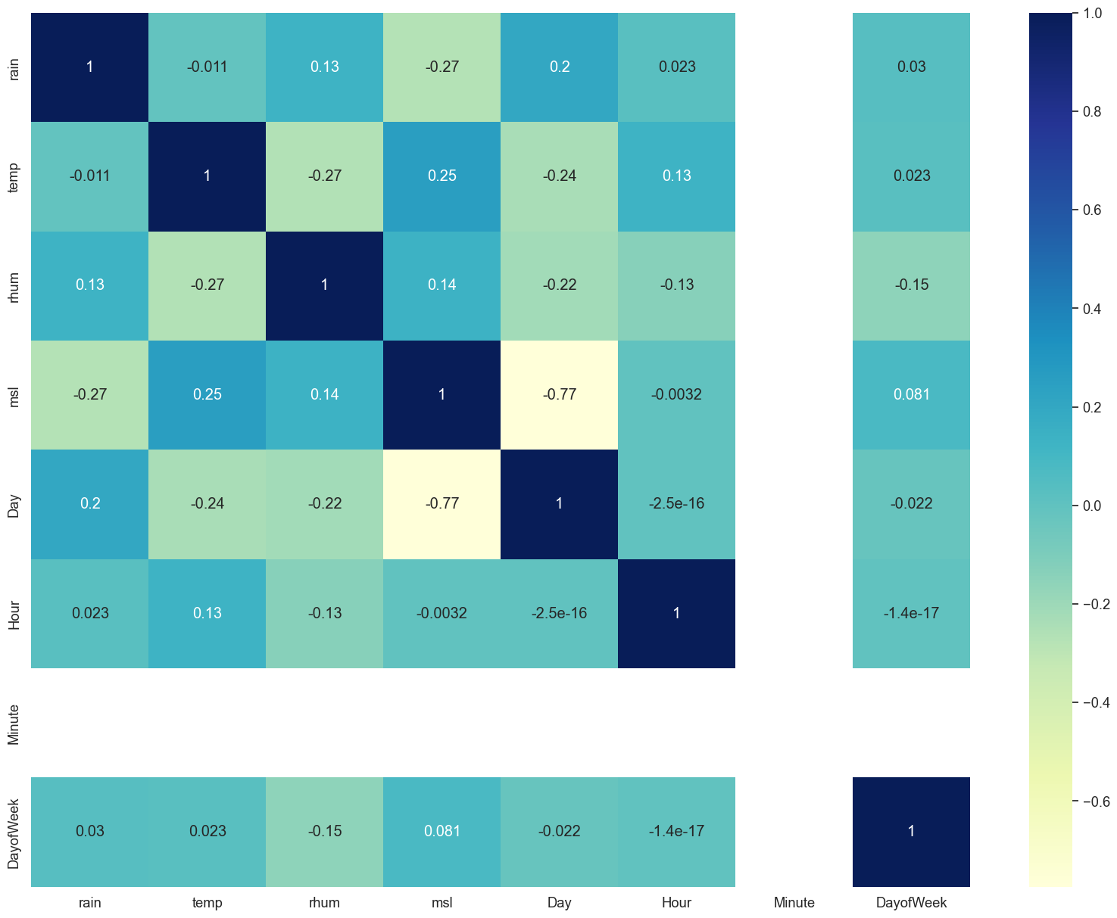

#join weather and bus   
mdf = pd.merge(df, Phoenix_wdf, how='inner', on=['DayofWeek','Day', 'Hour', 'Minute'])

mdf.head()

LineID JourneyPatternID VehicleJourneyID Operator Congestion LonWGS84 \  
0 7.0 00071003 6106 D1 0 -6.231633   
1 747.0 07471001 3531 SL 0 -6.254617   
2 56.0 056A1001 1830 RD 0 -6.233183   
3 25.0 025A0001 2866 CD 0 -6.296867   
4 747.0 07470001 3493 SL 0 -6.238668   
  
 LatWGS84 Delay BlockID VehicleID ... Day Hour Minute DayofWeek \  
0 53.317768 0 7019 43004 ... 1 0 0 1   
1 53.355484 -454 747007 40039 ... 1 0 0 1   
2 53.342201 0 56001 33488 ... 1 0 0 1   
3 53.347500 0 25007 33604 ... 1 0 0 1   
4 53.425789 -687 747006 40040 ... 1 0 0 1   
  
 Colour Ontime rain temp rhum msl   
0 Yellow 1 0.0 3.1 88.0 1000.2   
1 Black 0 0.0 3.1 88.0 1000.2   
2 Yellow 1 0.0 3.1 88.0 1000.2   
3 Yellow 1 0.0 3.1 88.0 1000.2   
4 Black 0 0.0 3.1 88.0 1000.2   
  
[5 rows x 22 columns]

mdf.shape

(629550, 22)

In the image below we can see that there seems to be more delayed buses in the suburbs of Dublin than there are in the center

Black if the bus is early, Red if it is late and yellow if it is within a 5 minute window of its scheduled time

fig, ax = plt.subplots(figsize=(15,12))  
plt.scatter(x=mdf['LonWGS84'], y=mdf['LatWGS84'], alpha=0.25, c=mdf['Colour'] )  
plt.title('Buses by schedule status')  
plt.xlabel('Longitude')  
plt.ylabel('Latitude')  
plt.savefig('./Images/Img_24_BusbySchedule.svg')  
plt.show();

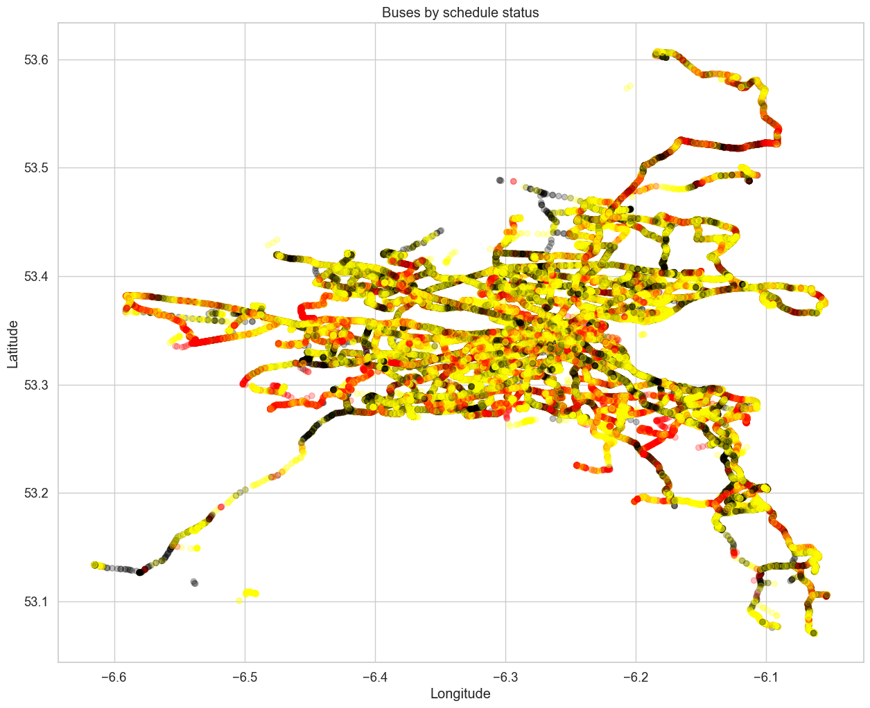

### Correlation Plot of Bus and Weather data

c_df = mdf.corr('pearson', numeric_only=True)  
ffig, ax = plt.subplots(figsize=(20,15))  
sns.set_style("whitegrid")  
sns.set_context("notebook", font_scale=1.2, rc={"lines.linewidth": 2.5})  
sns.heatmap(c_df, cmap="YlGnBu", annot=True)  
plt.savefig('./Images/Img_25_MergedCorHeatmap.svg')  
plt.show()

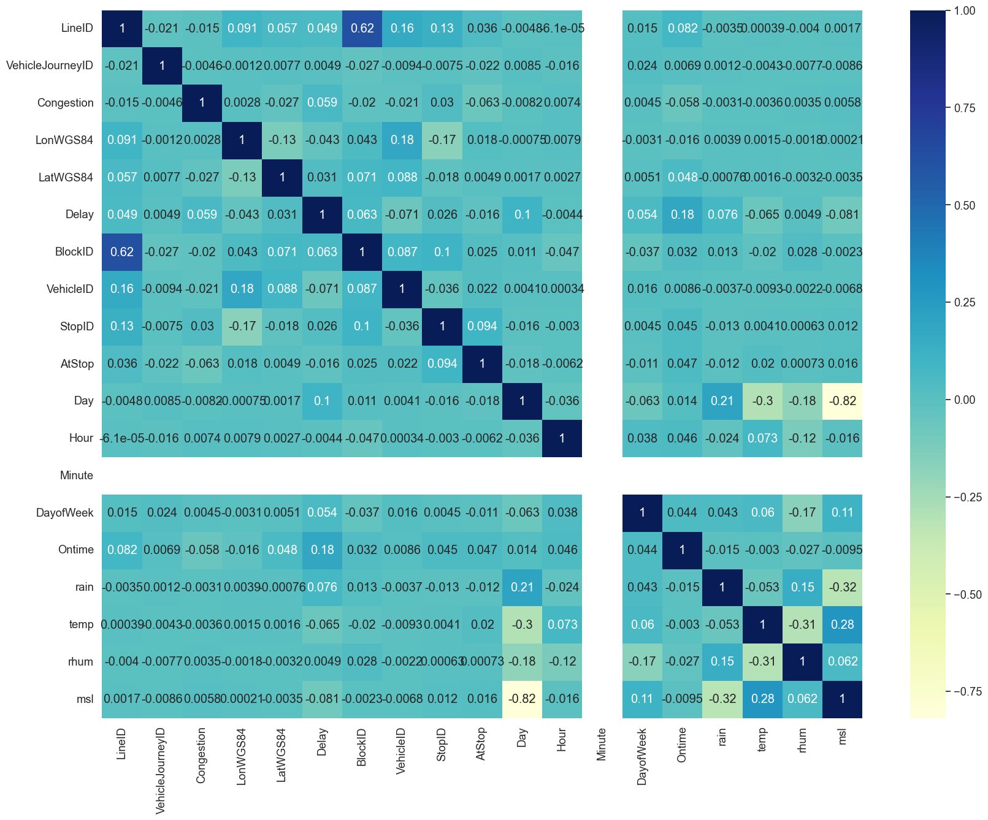

sns.pairplot(mdf)

<seaborn.axisgrid.PairGrid at 0x1f600d9a670>

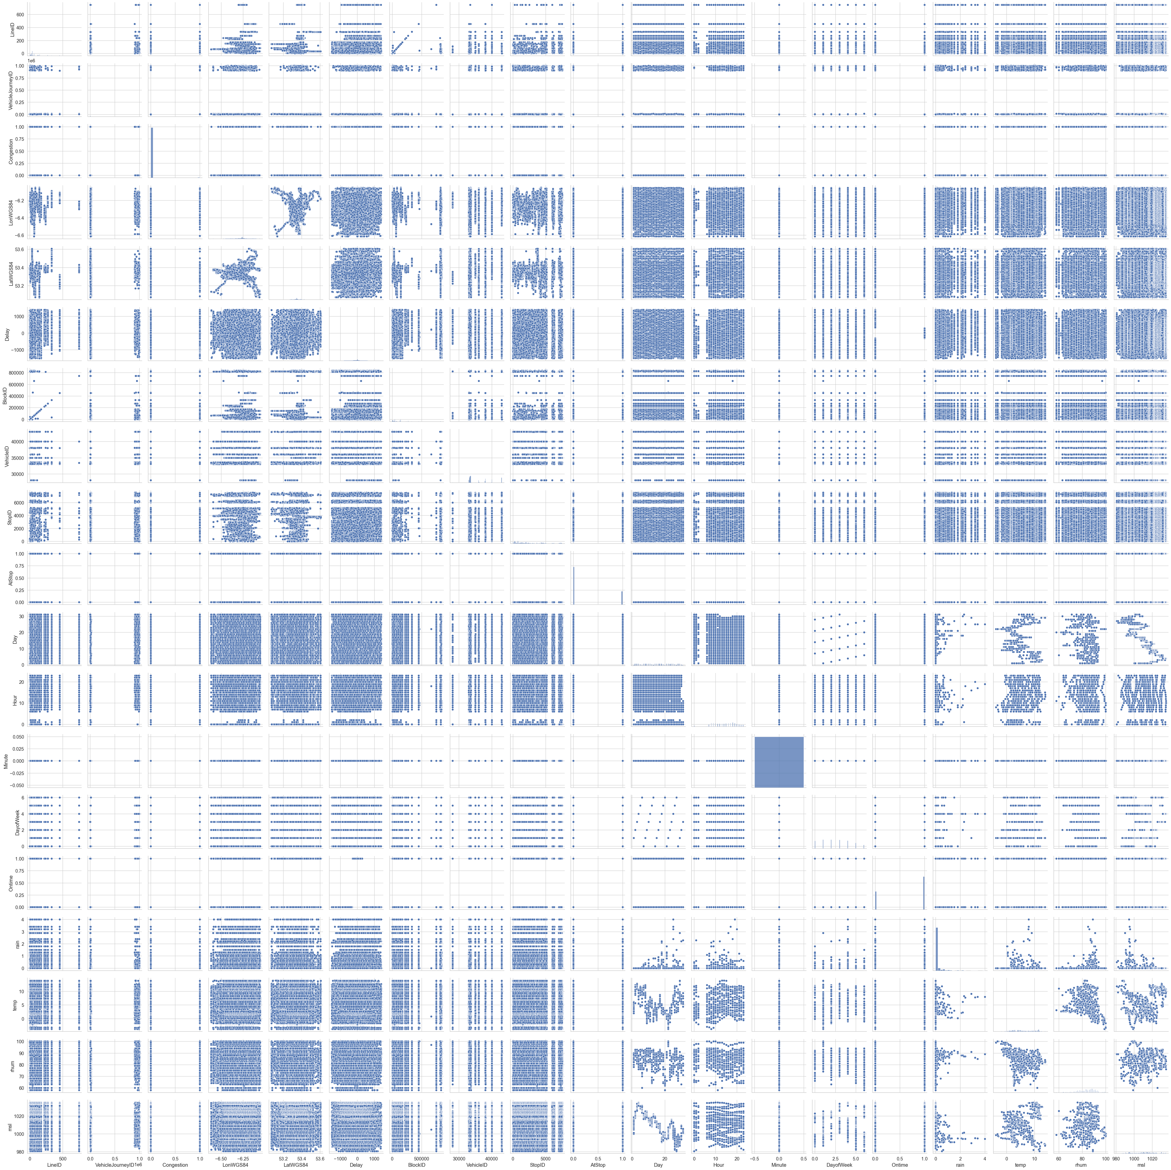

### display histogram of the new data set

mdf.hist(figsize=(25,25));  
plt.savefig('./Images/Img_27_MergedDistPlot.svg')

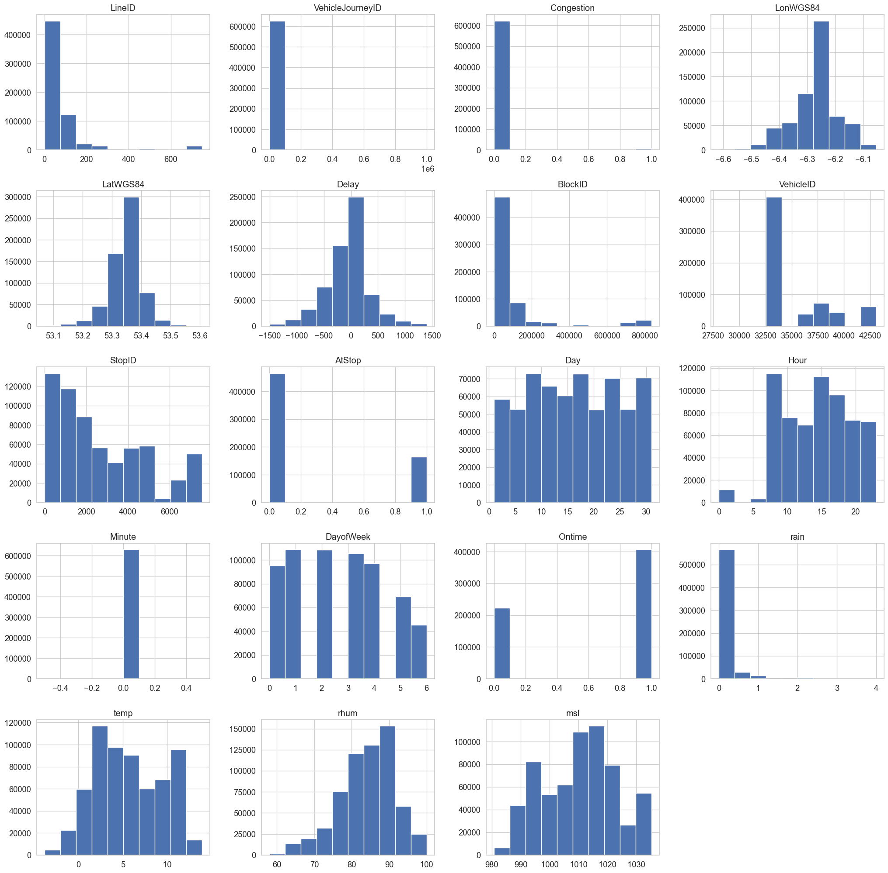

custom_barplot( df1=mdf.sample(5000), col1='Delay')

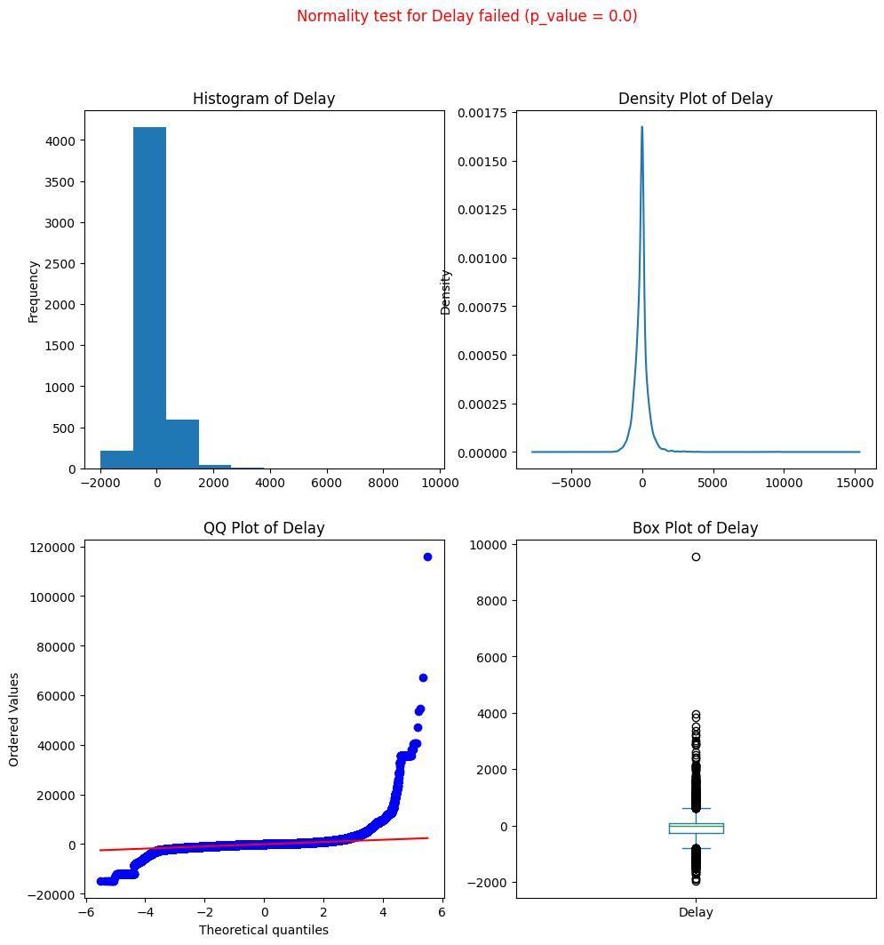

### Seaborn reg plots checking to see if the linear regression line is flat or at an angle.

fig, ax = plt.subplots(figsize=(15,12))  
sns.regplot(mdf, x = 'rain' , y = 'Delay');  
plt.savefig('./Images/Img_28_Rain_Delay_reg.svg')

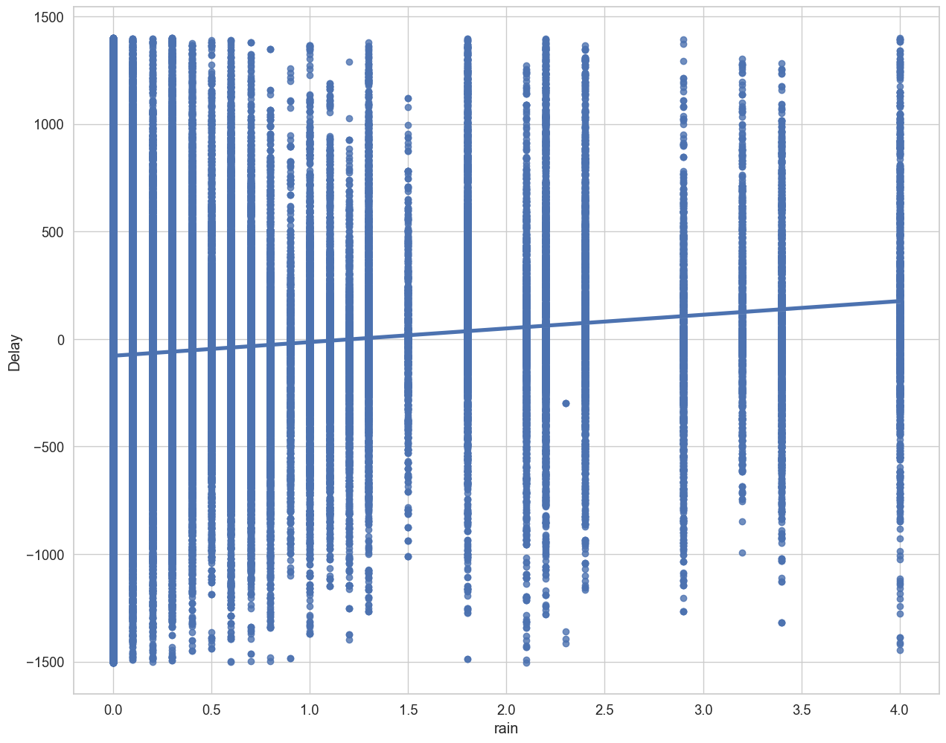

fig, ax = plt.subplots(figsize=(15,12))  
sns.regplot(mdf, x = 'temp' , y = 'Delay')  
plt.savefig('./Images/Img_29_temp_Delay_reg.svg')

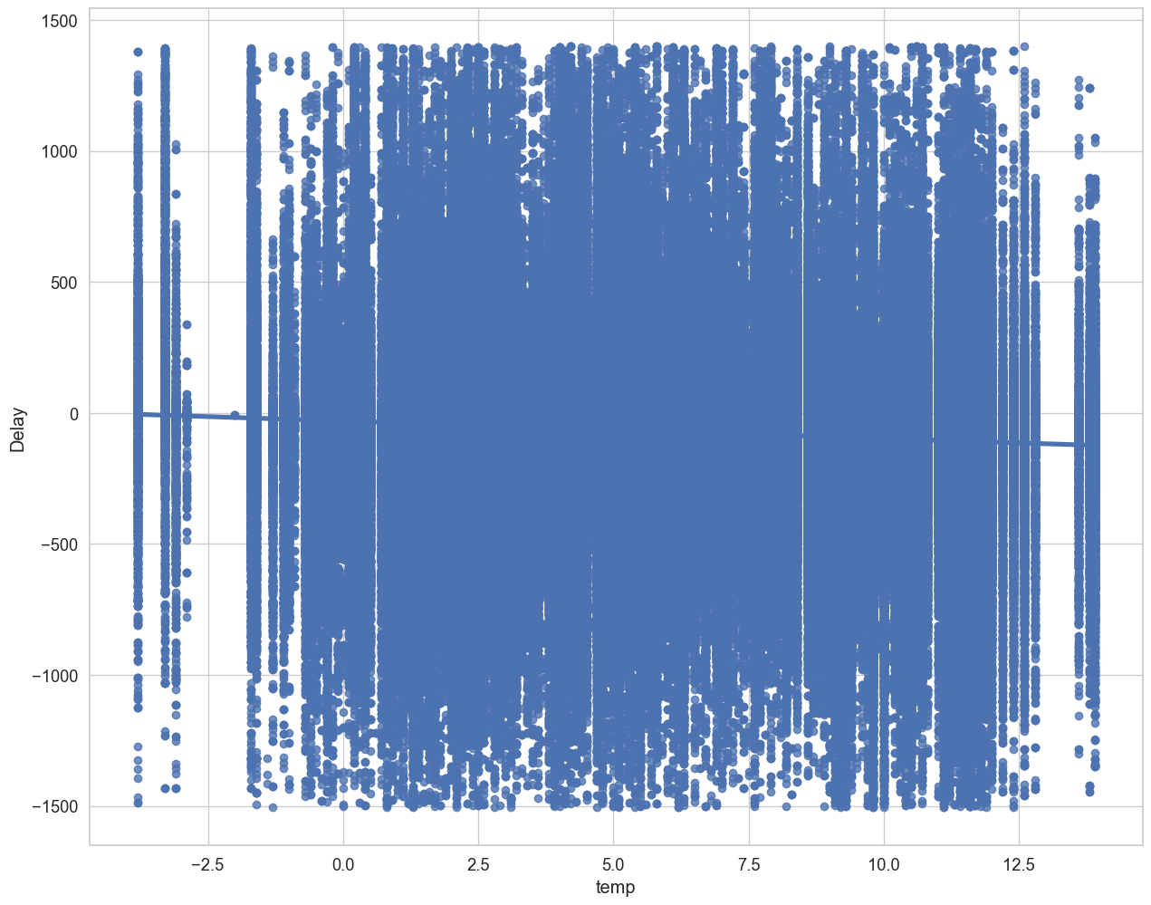

fig, ax = plt.subplots(figsize=(15,12))  
sns.regplot(mdf, x = 'rain', y = 'Ontime', logistic = True)  
plt.savefig('./Images/Img_30_rain_ontime_reg.svg')

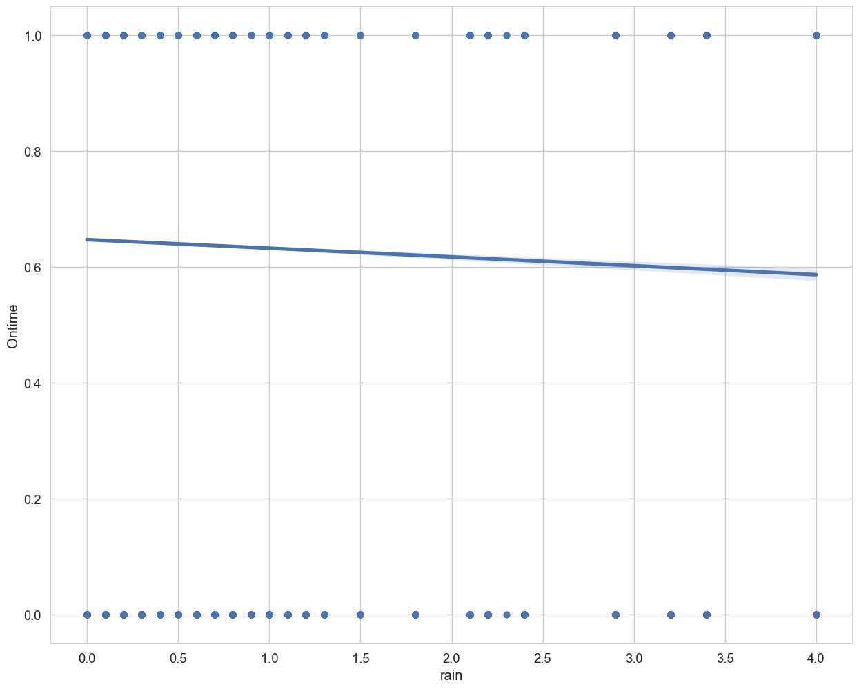

fig, ax = plt.subplots(figsize=(15,12))  
sns.regplot(mdf, x = 'temp', y = 'Ontime', logistic = True)  
plt.savefig('./Images/Img_31_temp_ontime_reg.svg')

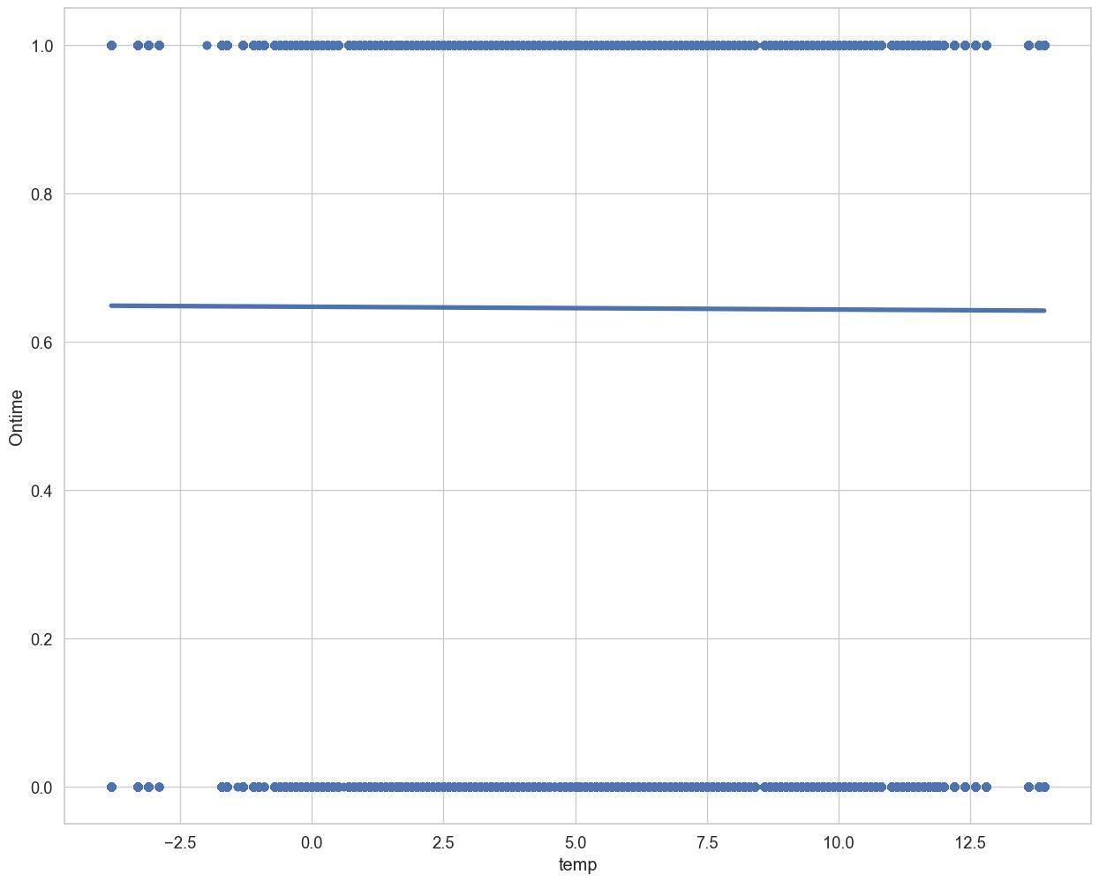

mdf.to_parquet('./Data/WeatherandBusData.parquet')

# Start building models

## Start with just the Dublin Bus data on its own

### then use the merged data set

Split into x and y

mdf = pd.read_parquet('./Data/WeatherandBusData.parquet')  
mdf.info() # this is too big

<class 'pandas.core.frame.DataFrame'>  
Int64Index: 629550 entries, 0 to 629549  
Data columns (total 22 columns):  
 # Column Non-Null Count Dtype   
--- ------ -------------- -----   
 0 LineID 629550 non-null float64  
 1 JourneyPatternID 629550 non-null object   
 2 VehicleJourneyID 629550 non-null int64   
 3 Operator 629550 non-null object   
 4 Congestion 629550 non-null int64   
 5 LonWGS84 629550 non-null float64  
 6 LatWGS84 629550 non-null float64  
 7 Delay 629550 non-null int64   
 8 BlockID 629550 non-null int64   
 9 VehicleID 629550 non-null int64   
 10 StopID 629550 non-null float64  
 11 AtStop 629550 non-null int64   
 12 Day 629550 non-null int64   
 13 Hour 629550 non-null int64   
 14 Minute 629550 non-null int64   
 15 DayofWeek 629550 non-null int64   
 16 Colour 629550 non-null object   
 17 Ontime 629550 non-null int64   
 18 rain 629550 non-null float64  
 19 temp 629550 non-null float64  
 20 rhum 629550 non-null float64  
 21 msl 629550 non-null float64  
dtypes: float64(8), int64(11), object(3)  
memory usage: 110.5+ MB

busRoutes = sorted(mdf['LineID'].unique())  
  
w1_value = ''  
w1 = None  
w1 = widgets.Dropdown(  
 options= busRoutes,  
 value= busRoutes[0],  
 description = 'LineID',  
 )  
  
i = interactive(custom_scatterplot, df1 =fixed(mdf), col1=w1)  
hbox = widgets.HBox(i.children)  
display(hbox)

{"model_id":"2eb873a995ba48f2aad741e381706f2a","version_major":2,"version_minor":0}

df17 = pd.read_parquet('./Data/Bus/LineID_17.0.parquet')  
c_df = df17.corr('pearson', numeric_only=True)  
ffig, ax = plt.subplots(figsize=(20,15))  
sns.set_style("whitegrid")  
sns.set_context("notebook", font_scale=1.2, rc={"lines.linewidth": 2.5})  
sns.heatmap(c_df, cmap="YlGnBu", annot=True)  
plt.show()

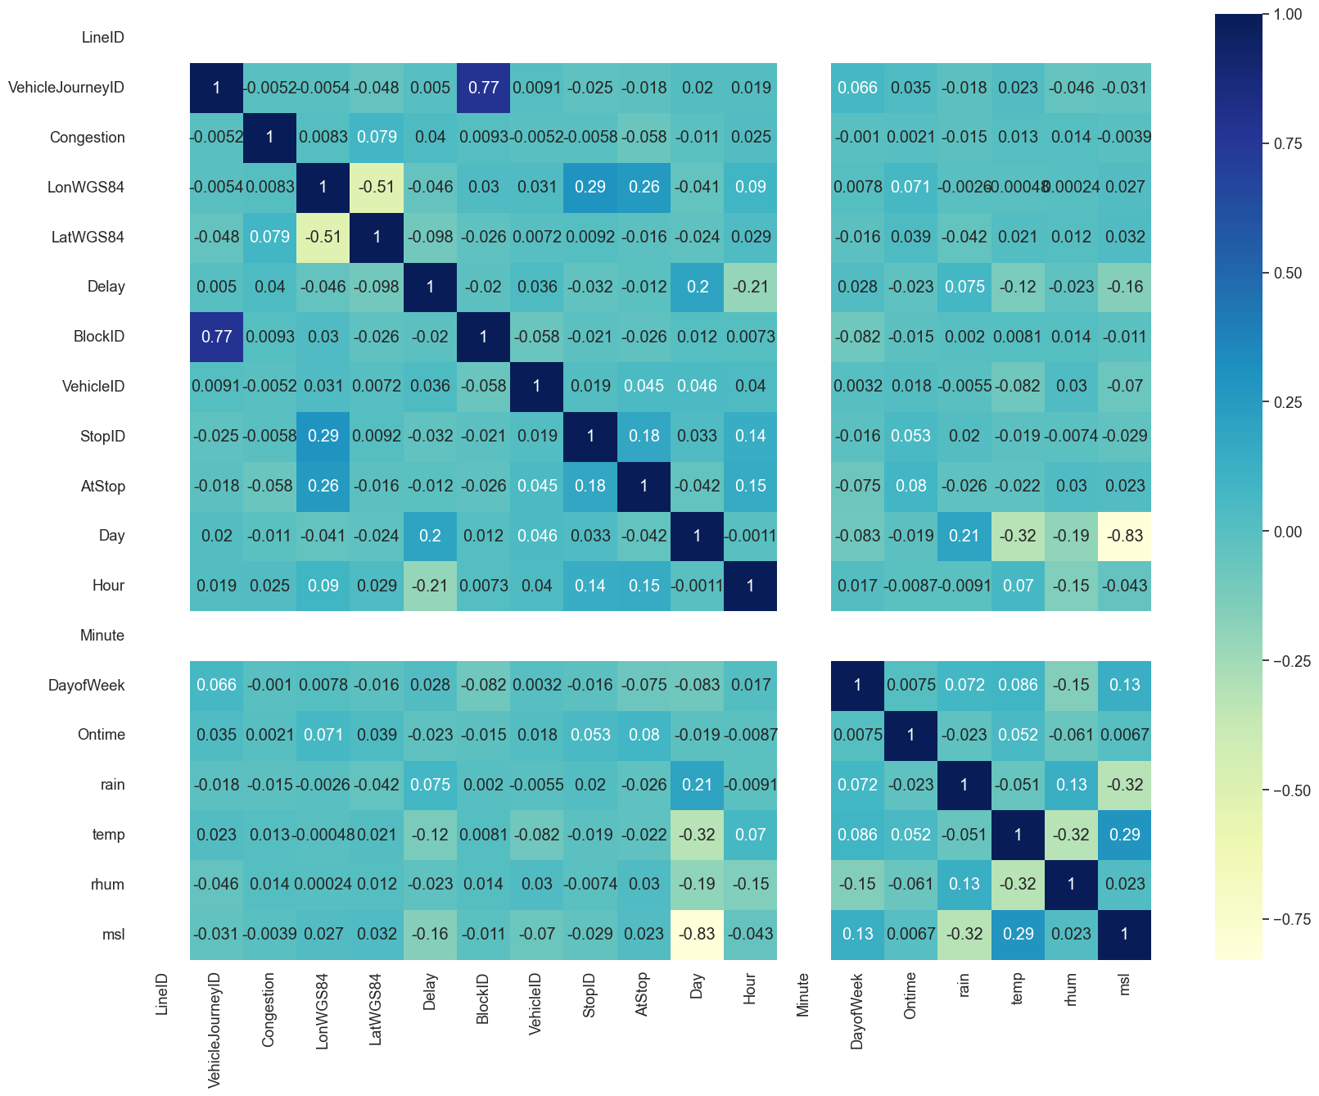

### A smaller merged data set (mdf) - using a subset of the bus and weather data

df1 = pd.read_parquet('./Data/Bus/LineID_1.0.parquet')  
df7 = pd.read_parquet('./Data/Bus/LineID_7.0.parquet')  
df11 = pd.read_parquet('./Data/Bus/LineID_11.0.parquet')  
df14 = pd.read_parquet('./Data/Bus/LineID_14.0.parquet')  
df16 = pd.read_parquet('./Data/Bus/LineID_16.0.parquet')  
df17 = pd.read_parquet('./Data/Bus/LineID_17.0.parquet')  
df37 = pd.read_parquet('./Data/Bus/LineID_37.0.parquet')  
df41 = pd.read_parquet('./Data/Bus/LineID_41.0.parquet')  
df44 = pd.read_parquet('./Data/Bus/LineID_44.0.parquet')  
df84 = pd.read_parquet('./Data/Bus/LineID_84.0.parquet')  
  
mdf = df1.append([df7, df11, df14, df16, df17, df37, df41, df44, df84])  
mdf = mdf.drop([ 'Colour', 'Minute' ], axis = 'columns') # dropping minute because it has only one value 0, dropping Colour as it is a calculated value based on Delay which we want to predict.   
  
mdf.head()

C:\Users\stehayes\AppData\Local\Temp\ipykernel_34564\3295498075.py:12: FutureWarning: The frame.append method is deprecated and will be removed from pandas in a future version. Use pandas.concat instead.  
 mdf = df1.append([df7, df11, df14, df16, df17, df37, df41, df44, df84])

LineID JourneyPatternID VehicleJourneyID Operator Congestion LonWGS84 \  
751 1.0 00011001 15593 RD 0 -6.214600   
798 1.0 00010001 15579 RD 0 -6.262050   
929 1.0 00011001 15580 RD 0 -6.212467   
962 1.0 00010001 15607 RD 0 -6.214097   
965 1.0 00011001 15621 RD 0 -6.249745   
  
 LatWGS84 Delay BlockID VehicleID StopID AtStop Day Hour \  
751 53.327168 0 1002 43075 381.0 0 1 10   
798 53.391899 0 1001 43072 226.0 0 1 10   
929 53.324749 0 1001 33384 381.0 1 1 11   
962 53.333351 -534 1003 43074 375.0 0 1 11   
965 53.390820 -751 1004 43077 222.0 0 1 11   
  
 DayofWeek Ontime rain temp rhum msl   
751 1 1 0.0 2.7 86.0 1008.2   
798 1 1 0.0 2.7 86.0 1008.2   
929 1 1 0.0 3.6 84.0 1009.0   
962 1 0 0.0 3.6 84.0 1009.0   
965 1 0 0.0 3.6 84.0 1009.0

# X is is the data set with out the potential targets  
X = mdf.drop(['Delay', 'Ontime'], axis = 1)

X.head()

LineID JourneyPatternID VehicleJourneyID Operator Congestion LonWGS84 \  
751 1.0 00011001 15593 RD 0 -6.214600   
798 1.0 00010001 15579 RD 0 -6.262050   
929 1.0 00011001 15580 RD 0 -6.212467   
962 1.0 00010001 15607 RD 0 -6.214097   
965 1.0 00011001 15621 RD 0 -6.249745   
  
 LatWGS84 BlockID VehicleID StopID AtStop Day Hour DayofWeek \  
751 53.327168 1002 43075 381.0 0 1 10 1   
798 53.391899 1001 43072 226.0 0 1 10 1   
929 53.324749 1001 33384 381.0 1 1 11 1   
962 53.333351 1003 43074 375.0 0 1 11 1   
965 53.390820 1004 43077 222.0 0 1 11 1   
  
 rain temp rhum msl   
751 0.0 2.7 86.0 1008.2   
798 0.0 2.7 86.0 1008.2   
929 0.0 3.6 84.0 1009.0   
962 0.0 3.6 84.0 1009.0   
965 0.0 3.6 84.0 1009.0

X['LineID'] = X['LineID'].astype('object')  
X['JourneyPatternID'] = X['JourneyPatternID'].astype('object')  
X['VehicleJourneyID'] = X['VehicleJourneyID'].astype('object')  
X['Operator'] = X['Operator'].astype('object')  
X['BlockID'] = X['BlockID'].astype('object')  
X['VehicleID'] = X['VehicleID'].astype('object')  
X['StopID'] = X['StopID'].astype('object')  
X['DayofWeek'] = X['DayofWeek'].astype('object')

X.info()

<class 'pandas.core.frame.DataFrame'>  
Int64Index: 113705 entries, 751 to 629482  
Data columns (total 18 columns):  
 # Column Non-Null Count Dtype   
--- ------ -------------- -----   
 0 LineID 113705 non-null object   
 1 JourneyPatternID 113705 non-null object   
 2 VehicleJourneyID 113705 non-null object   
 3 Operator 113705 non-null object   
 4 Congestion 113705 non-null int64   
 5 LonWGS84 113705 non-null float64  
 6 LatWGS84 113705 non-null float64  
 7 BlockID 113705 non-null object   
 8 VehicleID 113705 non-null object   
 9 StopID 113705 non-null object   
 10 AtStop 113705 non-null int64   
 11 Day 113705 non-null int64   
 12 Hour 113705 non-null int64   
 13 DayofWeek 113705 non-null object   
 14 rain 113705 non-null float64  
 15 temp 113705 non-null float64  
 16 rhum 113705 non-null float64  
 17 msl 113705 non-null float64  
dtypes: float64(6), int64(4), object(8)  
memory usage: 16.5+ MB

Y = mdf['Ontime']  
bus_categorical = X.loc[:, ['LineID','JourneyPatternID', 'VehicleJourneyID', 'Operator', 'BlockID', 'VehicleID', 'StopID','DayofWeek' ]]  
bus_dummies = pd.get_dummies(bus_categorical, drop_first=True)  
bus_dummies.head()

C:\Users\stehayes\AppData\Local\Temp\ipykernel_34564\3947614242.py:3: FutureWarning: In a future version, the Index constructor will not infer numeric dtypes when passed object-dtype sequences (matching Series behavior)  
 bus_dummies = pd.get_dummies(bus_categorical, drop_first=True)

LineID_7.0 LineID_11.0 LineID_14.0 LineID_16.0 LineID_17.0 \  
751 0 0 0 0 0   
798 0 0 0 0 0   
929 0 0 0 0 0   
962 0 0 0 0 0   
965 0 0 0 0 0   
  
 LineID_37.0 LineID_41.0 LineID_44.0 LineID_84.0 \  
751 0 0 0 0   
798 0 0 0 0   
929 0 0 0 0   
962 0 0 0 0   
965 0 0 0 0   
  
 JourneyPatternID_00010002 ... StopID_7449.0 StopID_7472.0 \  
751 0 ... 0 0   
798 0 ... 0 0   
929 0 ... 0 0   
962 0 ... 0 0   
965 0 ... 0 0   
  
 StopID_7511.0 StopID_7528.0 DayofWeek_1 DayofWeek_2 DayofWeek_3 \  
751 0 0 1 0 0   
798 0 0 1 0 0   
929 0 0 1 0 0   
962 0 0 1 0 0   
965 0 0 1 0 0   
  
 DayofWeek_4 DayofWeek_5 DayofWeek_6   
751 0 0 0   
798 0 0 0   
929 0 0 0   
962 0 0 0   
965 0 0 0   
  
[5 rows x 5524 columns]

### Drop categorical variables

X = X.drop(list(bus_categorical.columns), axis=1  
)  
X = pd.concat([X, bus_dummies], axis=1)

X.head()

Congestion LonWGS84 LatWGS84 AtStop Day Hour rain temp rhum \  
751 0 -6.214600 53.327168 0 1 10 0.0 2.7 86.0   
798 0 -6.262050 53.391899 0 1 10 0.0 2.7 86.0   
929 0 -6.212467 53.324749 1 1 11 0.0 3.6 84.0   
962 0 -6.214097 53.333351 0 1 11 0.0 3.6 84.0   
965 0 -6.249745 53.390820 0 1 11 0.0 3.6 84.0   
  
 msl ... StopID_7449.0 StopID_7472.0 StopID_7511.0 StopID_7528.0 \  
751 1008.2 ... 0 0 0 0   
798 1008.2 ... 0 0 0 0   
929 1009.0 ... 0 0 0 0   
962 1009.0 ... 0 0 0 0   
965 1009.0 ... 0 0 0 0   
  
 DayofWeek_1 DayofWeek_2 DayofWeek_3 DayofWeek_4 DayofWeek_5 \  
751 1 0 0 0 0   
798 1 0 0 0 0   
929 1 0 0 0 0   
962 1 0 0 0 0   
965 1 0 0 0 0   
  
 DayofWeek_6   
751 0   
798 0   
929 0   
962 0   
965 0   
  
[5 rows x 5534 columns]

# split into train and test  
from sklearn.model_selection import train_test_split  
X_train, X_test, y_train, y_test = train_test_split(X, Y,   
 train_size=0.7,  
 test_size = 0.3, random_state=100)

### Decision Tree model first

from sklearn.tree import DecisionTreeClassifier  
DT_classifier = DecisionTreeClassifier(max_depth = 30, random_state = 0)  
DT_classifier.fit(X_train, y_train)  
  
# predicting test results   
  
y_pred = DT_classifier.predict(X_test)

#### Making the Confusion Matrix

from sklearn.metrics import classification_report, confusion_matrix  
import seaborn as sns  
  
# Calculate cm by calling a method named as 'confusion_matrix'  
cm = confusion_matrix(y_test, y_pred)  
  
# Call a method heatmap() to plot confusion matrix  
sns.heatmap(cm, annot = True)  
  
# print the classification_report based on y_test and y_predict  
print(classification_report(y_test, y_pred))

precision recall f1-score support  
  
 0 0.78 0.63 0.69 12671  
 1 0.80 0.89 0.84 21441  
  
 accuracy 0.79 34112  
 macro avg 0.79 0.76 0.77 34112  
weighted avg 0.79 0.79 0.79 34112

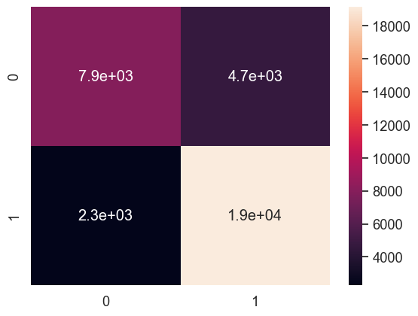

from sklearn import metrics # Import scikit-learn metrics module for accuracy calculation  
import warnings  
warnings.filterwarnings('ignore') # We can suppress the warnings  
  
# Model Accuracy, how often is the classifier correct?  
print("Accuracy:",metrics.accuracy_score(y_test, y_pred))

Accuracy: 0.7940607410881801

import matplotlib.pyplot as plt  
feature_names = X.columns   
cn = ['0','1']  
fig, axes = plt.subplots(nrows = 1,ncols = 1, figsize=(25,25), dpi=300)  
  
from sklearn import tree  
  
tree.plot_tree(DT_classifier.fit(X_train, y_train), feature_names=feature_names, class_names=cn )   
# fig.savefig('./Images/Img_32_DecisionTree.svg') saved a tree of depth 6 to give a feel of the decision tree

[Text(0.8370165211015727, 0.9838709677419355, 'LatWGS84 <= 53.386\ngini = 0.47\nsamples = 79593\nvalue = [29983, 49610]\nclass = 1'),  
 Text(0.7479993655559513, 0.9516129032258065, 'StopID_381.0 <= 0.5\ngini = 0.481\nsamples = 63616\nvalue = [25664, 37952]\nclass = 1'),  
 Text(0.729583536295181, 0.9193548387096774, 'StopID_5171.0 <= 0.5\ngini = 0.483\nsamples = 62761\nvalue = [25663, 37098]\nclass = 1'),  
 Text(0.694455969368564, 0.8870967741935484, 'StopID_288.0 <= 0.5\ngini = 0.485\nsamples = 62076\nvalue = [25660, 36416]\nclass = 1'),  
 Text(0.6323662744076702, 0.8548387096774194, 'StopID_3222.0 <= 0.5\ngini = 0.487\nsamples = 60719\nvalue = [25490, 35229]\nclass = 1'),  
 Text(0.5623852283643345, 0.8225806451612904, 'JourneyPatternID_00160001 <= 0.5\ngini = 0.488\nsamples = 60218\nvalue = [25488, 34730]\nclass = 1'),  
 Text(0.4241272278725863, 0.7903225806451613, 'StopID_6041.0 <= 0.5\ngini = 0.485\nsamples = 55165\nvalue = [22749, 32416]\nclass = 1'),  
 Text(0.30969050793297764, 0.7580645161290323, 'LonWGS84 <= -6.275\ngini = 0.486\nsamples = 54742\nvalue = [22744, 31998]\nclass = 1'),  
 Text(0.11304424702671519, 0.7258064516129032, 'JourneyPatternID_00370001 <= 0.5\ngini = 0.439\nsamples = 7440\nvalue = [2417, 5023]\nclass = 1'),  
 Text(0.08317105540516553, 0.6935483870967742, 'JourneyPatternID_00171001 <= 0.5\ngini = 0.396\nsamples = 5612\nvalue = [1527, 4085]\nclass = 1'),  
 Text(0.05987188803585693, 0.6612903225806451, 'Hour <= 9.5\ngini = 0.353\nsamples = 4992\nvalue = [1144, 3848]\nclass = 1'),  
 Text(0.03653812017395935, 0.6290322580645161, 'LatWGS84 <= 53.373\ngini = 0.471\nsamples = 1554\nvalue = [589, 965]\nclass = 1'),  
 Text(0.027633797816632645, 0.5967741935483871, 'StopID_1380.0 <= 0.5\ngini = 0.491\nsamples = 1285\nvalue = [558, 727]\nclass = 1'),  
 Text(0.02706576728499157, 0.5645161290322581, 'VehicleJourneyID_708 <= 0.5\ngini = 0.497\nsamples = 1208\nvalue = [558, 650]\nclass = 1'),  
 Text(0.026497736753350494, 0.532258064516129, 'BlockID_16009 <= 0.5\ngini = 0.493\nsamples = 1163\nvalue = [513, 650]\nclass = 1'),  
 Text(0.014369397355107836, 0.5, 'LatWGS84 <= 53.278\ngini = 0.498\nsamples = 1078\nvalue = [504, 574]\nclass = 1'),  
 Text(0.01380136682346676, 0.46774193548387094, 'gini = 0.0\nsamples = 45\nvalue = [0, 45]\nclass = 1'),  
 Text(0.014937427886748914, 0.46774193548387094, 'LatWGS84 <= 53.303\ngini = 0.5\nsamples = 1033\nvalue = [504, 529]\nclass = 1'),  
 Text(0.009656519037898287, 0.43548387096774194, 'VehicleJourneyID_4728 <= 0.5\ngini = 0.445\nsamples = 224\nvalue = [149, 75]\nclass = 0'),  
 Text(0.009088488506257212, 0.4032258064516129, 'BlockID_16014 <= 0.5\ngini = 0.4\nsamples = 206\nvalue = [149, 57]\nclass = 0'),  
 Text(0.00795242744297506, 0.3709677419354839, 'BlockID_14012 <= 0.5\ngini = 0.309\nsamples = 178\nvalue = [144, 34]\nclass = 0'),  
 Text(0.0073843969113339845, 0.3387096774193548, 'VehicleID_33419 <= 0.5\ngini = 0.266\nsamples = 171\nvalue = [144, 27]\nclass = 0'),  
 Text(0.006816366379692908, 0.3064516129032258, 'VehicleID_33079 <= 0.5\ngini = 0.238\nsamples = 167\nvalue = [144, 23]\nclass = 0'),  
 Text(0.006248335848051833, 0.27419354838709675, 'VehicleID_33634 <= 0.5\ngini = 0.214\nsamples = 164\nvalue = [144, 20]\nclass = 0'),  
 Text(0.0051122747847696815, 0.24193548387096775, 'VehicleID_33084 <= 0.5\ngini = 0.181\nsamples = 159\nvalue = [143, 16]\nclass = 0'),  
 Text(0.004544244253128606, 0.20967741935483872, 'VehicleID_33426 <= 0.5\ngini = 0.153\nsamples = 156\nvalue = [143, 13]\nclass = 0'),  
 Text(0.00397621372148753, 0.1774193548387097, 'VehicleJourneyID_8059 <= 0.5\ngini = 0.133\nsamples = 154\nvalue = [143, 11]\nclass = 0'),  
 Text(0.003408183189846454, 0.14516129032258066, 'StopID_1332.0 <= 0.5\ngini = 0.111\nsamples = 152\nvalue = [143, 9]\nclass = 0'),  
 Text(0.002272122126564303, 0.11290322580645161, 'VehicleJourneyID_931924 <= 0.5\ngini = 0.055\nsamples = 141\nvalue = [137, 4]\nclass = 0'),  
 Text(0.001704091594923227, 0.08064516129032258, 'StopID_2921.0 <= 0.5\ngini = 0.028\nsamples = 139\nvalue = [137, 2]\nclass = 0'),  
 Text(0.0011360610632821515, 0.04838709677419355, 'VehicleJourneyID_8068 <= 0.5\ngini = 0.014\nsamples = 138\nvalue = [137, 1]\nclass = 0'),  
 Text(0.0005680305316410757, 0.016129032258064516, 'gini = 0.0\nsamples = 137\nvalue = [137, 0]\nclass = 0'),  
 Text(0.001704091594923227, 0.016129032258064516, 'gini = 0.0\nsamples = 1\nvalue = [0, 1]\nclass = 1'),  
 Text(0.002272122126564303, 0.04838709677419355, 'gini = 0.0\nsamples = 1\nvalue = [0, 1]\nclass = 1'),  
 Text(0.0028401526582053785, 0.08064516129032258, 'gini = 0.0\nsamples = 2\nvalue = [0, 2]\nclass = 1'),  
 Text(0.004544244253128606, 0.11290322580645161, 'rhum <= 87.5\ngini = 0.496\nsamples = 11\nvalue = [6, 5]\nclass = 0'),  
 Text(0.00397621372148753, 0.08064516129032258, 'gini = 0.0\nsamples = 5\nvalue = [0, 5]\nclass = 1'),  
 Text(0.0051122747847696815, 0.08064516129032258, 'gini = 0.0\nsamples = 6\nvalue = [6, 0]\nclass = 0'),  
 Text(0.004544244253128606, 0.14516129032258066, 'gini = 0.0\nsamples = 2\nvalue = [0, 2]\nclass = 1'),  
 Text(0.0051122747847696815, 0.1774193548387097, 'gini = 0.0\nsamples = 2\nvalue = [0, 2]\nclass = 1'),  
 Text(0.005680305316410757, 0.20967741935483872, 'gini = 0.0\nsamples = 3\nvalue = [0, 3]\nclass = 1'),  
 Text(0.0073843969113339845, 0.24193548387096775, 'VehicleJourneyID_4888 <= 0.5\ngini = 0.32\nsamples = 5\nvalue = [1, 4]\nclass = 1'),  
 Text(0.006816366379692908, 0.20967741935483872, 'gini = 0.0\nsamples = 4\nvalue = [0, 4]\nclass = 1'),  
 Text(0.00795242744297506, 0.20967741935483872, 'gini = 0.0\nsamples = 1\nvalue = [1, 0]\nclass = 0'),  
 Text(0.0073843969113339845, 0.27419354838709675, 'gini = 0.0\nsamples = 3\nvalue = [0, 3]\nclass = 1'),  
 Text(0.00795242744297506, 0.3064516129032258, 'gini = 0.0\nsamples = 4\nvalue = [0, 4]\nclass = 1'),  
 Text(0.008520457974616136, 0.3387096774193548, 'gini = 0.0\nsamples = 7\nvalue = [0, 7]\nclass = 1'),  
 Text(0.010224549569539363, 0.3709677419354839, 'LatWGS84 <= 53.296\ngini = 0.293\nsamples = 28\nvalue = [5, 23]\nclass = 1'),  
 Text(0.009656519037898287, 0.3387096774193548, 'gini = 0.0\nsamples = 23\nvalue = [0, 23]\nclass = 1'),  
 Text(0.010792580101180439, 0.3387096774193548, 'gini = 0.0\nsamples = 5\nvalue = [5, 0]\nclass = 0'),  
 Text(0.010224549569539363, 0.4032258064516129, 'gini = 0.0\nsamples = 18\nvalue = [0, 18]\nclass = 1'),  
 Text(0.02021833673559954, 0.43548387096774194, 'LatWGS84 <= 53.313\ngini = 0.493\nsamples = 809\nvalue = [355, 454]\nclass = 1'),  
 Text(0.014768793822667969, 0.4032258064516129, 'BlockID_17008 <= 0.5\ngini = 0.354\nsamples = 183\nvalue = [42, 141]\nclass = 1'),  
 Text(0.014200763291026893, 0.3709677419354839, 'BlockID_815008 <= 0.5\ngini = 0.295\nsamples = 172\nvalue = [31, 141]\nclass = 1'),  
 Text(0.013632732759385816, 0.3387096774193548, 'JourneyPatternID_00160002 <= 0.5\ngini = 0.263\nsamples = 167\nvalue = [26, 141]\nclass = 1'),  
 Text(0.012212656430283127, 0.3064516129032258, 'msl <= 1026.65\ngini = 0.199\nsamples = 152\nvalue = [17, 135]\nclass = 1'),  
 Text(0.011076595367000976, 0.27419354838709675, 'Operator_HN <= 0.5\ngini = 0.154\nsamples = 143\nvalue = [12, 131]\nclass = 1'),  
 Text(0.0105085648353599, 0.24193548387096775, 'StopID_1301.0 <= 0.5\ngini = 0.132\nsamples = 141\nvalue = [10, 131]\nclass = 1'),  
 Text(0.009940534303718825, 0.20967741935483872, 'StopID_1318.0 <= 0.5\ngini = 0.12\nsamples = 140\nvalue = [9, 131]\nclass = 1'),  
 Text(0.00937250377207775, 0.1774193548387097, 'VehicleID_33636 <= 0.5\ngini = 0.108\nsamples = 139\nvalue = [8, 131]\nclass = 1'),  
 Text(0.00795242744297506, 0.14516129032258066, 'Hour <= 7.5\ngini = 0.085\nsamples = 135\nvalue = [6, 129]\nclass = 1'),  
 Text(0.006816366379692908, 0.11290322580645161, 'LatWGS84 <= 53.306\ngini = 0.257\nsamples = 33\nvalue = [5, 28]\nclass = 1'),  
 Text(0.006248335848051833, 0.08064516129032258, 'gini = 0.0\nsamples = 4\nvalue = [4, 0]\nclass = 0'),  
 Text(0.0073843969113339845, 0.08064516129032258, 'VehicleID_33089 <= 0.5\ngini = 0.067\nsamples = 29\nvalue = [1, 28]\nclass = 1'),  
 Text(0.006816366379692908, 0.04838709677419355, 'gini = 0.0\nsamples = 27\nvalue = [0, 27]\nclass = 1'),  
 Text(0.00795242744297506, 0.04838709677419355, 'LatWGS84 <= 53.309\ngini = 0.5\nsamples = 2\nvalue = [1, 1]\nclass = 0'),  
 Text(0.0073843969113339845, 0.016129032258064516, 'gini = 0.0\nsamples = 1\nvalue = [0, 1]\nclass = 1'),  
 Text(0.008520457974616136, 0.016129032258064516, 'gini = 0.0\nsamples = 1\nvalue = [1, 0]\nclass = 0'),  
 Text(0.009088488506257212, 0.11290322580645161, 'VehicleID_33127 <= 0.5\ngini = 0.019\nsamples = 102\nvalue = [1, 101]\nclass = 1'),  
 Text(0.008520457974616136, 0.08064516129032258, 'gini = 0.0\nsamples = 99\nvalue = [0, 99]\nclass = 1'),  
 Text(0.009656519037898287, 0.08064516129032258, 'DayofWeek_2 <= 0.5\ngini = 0.444\nsamples = 3\nvalue = [1, 2]\nclass = 1'),  
 Text(0.009088488506257212, 0.04838709677419355, 'gini = 0.0\nsamples = 2\nvalue = [0, 2]\nclass = 1'),  
 Text(0.010224549569539363, 0.04838709677419355, 'gini = 0.0\nsamples = 1\nvalue = [1, 0]\nclass = 0'),  
 Text(0.010792580101180439, 0.14516129032258066, 'LonWGS84 <= -6.284\ngini = 0.5\nsamples = 4\nvalue = [2, 2]\nclass = 0'),  
 Text(0.010224549569539363, 0.11290322580645161, 'gini = 0.0\nsamples = 2\nvalue = [0, 2]\nclass = 1'),  
 Text(0.011360610632821514, 0.11290322580645161, 'gini = 0.0\nsamples = 2\nvalue = [2, 0]\nclass = 0'),  
 Text(0.0105085648353599, 0.1774193548387097, 'gini = 0.0\nsamples = 1\nvalue = [1, 0]\nclass = 0'),  
 Text(0.011076595367000976, 0.20967741935483872, 'gini = 0.0\nsamples = 1\nvalue = [1, 0]\nclass = 0'),  
 Text(0.011644625898642052, 0.24193548387096775, 'gini = 0.0\nsamples = 2\nvalue = [2, 0]\nclass = 0'),  
 Text(0.013348717493565278, 0.27419354838709675, 'Hour <= 7.5\ngini = 0.494\nsamples = 9\nvalue = [5, 4]\nclass = 0'),  
 Text(0.012780686961924203, 0.24193548387096775, 'gini = 0.0\nsamples = 3\nvalue = [3, 0]\nclass = 0'),  
 Text(0.013916748025206354, 0.24193548387096775, 'VehicleJourneyID_4799 <= 0.5\ngini = 0.444\nsamples = 6\nvalue = [2, 4]\nclass = 1'),  
 Text(0.013348717493565278, 0.20967741935483872, 'gini = 0.0\nsamples = 4\nvalue = [0, 4]\nclass = 1'),  
 Text(0.014484778556847431, 0.20967741935483872, 'gini = 0.0\nsamples = 2\nvalue = [2, 0]\nclass = 0'),  
 Text(0.015052809088488507, 0.3064516129032258, 'Day <= 23.5\ngini = 0.48\nsamples = 15\nvalue = [9, 6]\nclass = 0'),  
 Text(0.014484778556847431, 0.27419354838709675, 'gini = 0.0\nsamples = 9\nvalue = [9, 0]\nclass = 0'),  
 Text(0.015620839620129582, 0.27419354838709675, 'gini = 0.0\nsamples = 6\nvalue = [0, 6]\nclass = 1'),  
 Text(0.014768793822667969, 0.3387096774193548, 'gini = 0.0\nsamples = 5\nvalue = [5, 0]\nclass = 0'),  
 Text(0.015336824354309045, 0.3709677419354839, 'gini = 0.0\nsamples = 11\nvalue = [11, 0]\nclass = 0'),  
 Text(0.02566787964853111, 0.4032258064516129, 'Hour <= 7.5\ngini = 0.5\nsamples = 626\nvalue = [313, 313]\nclass = 0'),  
 Text(0.020307091506168457, 0.3709677419354839, 'VehicleJourneyID_4710 <= 0.5\ngini = 0.373\nsamples = 133\nvalue = [33, 100]\nclass = 1'),  
 Text(0.0187450075441555, 0.3387096774193548, 'rain <= 0.05\ngini = 0.231\nsamples = 105\nvalue = [14, 91]\nclass = 1'),  
 Text(0.01732493121505281, 0.3064516129032258, 'StopID_1705.0 <= 0.5\ngini = 0.089\nsamples = 86\nvalue = [4, 82]\nclass = 1'),  
 Text(0.016756900683411735, 0.27419354838709675, 'VehicleID_40002 <= 0.5\ngini = 0.068\nsamples = 85\nvalue = [3, 82]\nclass = 1'),  
 Text(0.016188870151770656, 0.24193548387096775, 'StopID_1706.0 <= 0.5\ngini = 0.046\nsamples = 84\nvalue = [2, 82]\nclass = 1'),  
 Text(0.015620839620129582, 0.20967741935483872, 'StopID_1711.0 <= 0.5\ngini = 0.024\nsamples = 83\nvalue = [1, 82]\nclass = 1'),  
 Text(0.015052809088488507, 0.1774193548387097, 'gini = 0.0\nsamples = 80\nvalue = [0, 80]\nclass = 1'),  
 Text(0.016188870151770656, 0.1774193548387097, 'LatWGS84 <= 53.353\ngini = 0.444\nsamples = 3\nvalue = [1, 2]\nclass = 1'),  
 Text(0.015620839620129582, 0.14516129032258066, 'gini = 0.0\nsamples = 1\nvalue = [1, 0]\nclass = 0'),  
 Text(0.016756900683411735, 0.14516129032258066, 'gini = 0.0\nsamples = 2\nvalue = [0, 2]\nclass = 1'),  
 Text(0.016756900683411735, 0.20967741935483872, 'gini = 0.0\nsamples = 1\nvalue = [1, 0]\nclass = 0'),  
 Text(0.01732493121505281, 0.24193548387096775, 'gini = 0.0\nsamples = 1\nvalue = [1, 0]\nclass = 0'),  
 Text(0.017892961746693886, 0.27419354838709675, 'gini = 0.0\nsamples = 1\nvalue = [1, 0]\nclass = 0'),  
 Text(0.02016508387325819, 0.3064516129032258, 'LonWGS84 <= -6.309\ngini = 0.499\nsamples = 19\nvalue = [10, 9]\nclass = 0'),  
 Text(0.019029022809976037, 0.27419354838709675, 'StopID_1701.0 <= 0.5\ngini = 0.198\nsamples = 9\nvalue = [8, 1]\nclass = 0'),  
 Text(0.01846099227833496, 0.24193548387096775, 'gini = 0.0\nsamples = 8\nvalue = [8, 0]\nclass = 0'),  
 Text(0.019597053341617113, 0.24193548387096775, 'gini = 0.0\nsamples = 1\nvalue = [0, 1]\nclass = 1'),  
 Text(0.02130114493654034, 0.27419354838709675, 'rain <= 0.85\ngini = 0.32\nsamples = 10\nvalue = [2, 8]\nclass = 1'),  
 Text(0.020733114404899264, 0.24193548387096775, 'gini = 0.0\nsamples = 7\nvalue = [0, 7]\nclass = 1'),  
 Text(0.021869175468181415, 0.24193548387096775, 'JourneyPatternID_00371001 <= 0.5\ngini = 0.444\nsamples = 3\nvalue = [2, 1]\nclass = 0'),  
 Text(0.02130114493654034, 0.20967741935483872, 'gini = 0.0\nsamples = 1\nvalue = [0, 1]\nclass = 1'),  
 Text(0.02243720599982249, 0.20967741935483872, 'gini = 0.0\nsamples = 2\nvalue = [2, 0]\nclass = 0'),  
 Text(0.021869175468181415, 0.3387096774193548, 'LatWGS84 <= 53.323\ngini = 0.436\nsamples = 28\nvalue = [19, 9]\nclass = 0'),  
 Text(0.02130114493654034, 0.3064516129032258, 'gini = 0.0\nsamples = 9\nvalue = [0, 9]\nclass = 1'),  
 Text(0.02243720599982249, 0.3064516129032258, 'gini = 0.0\nsamples = 19\nvalue = [19, 0]\nclass = 0'),  
 Text(0.03102866779089376, 0.3709677419354839, 'StopID_1381.0 <= 0.5\ngini = 0.491\nsamples = 493\nvalue = [280, 213]\nclass = 0'),  
 Text(0.030460637259252684, 0.3387096774193548, 'temp <= 3.9\ngini = 0.482\nsamples = 470\nvalue = [280, 190]\nclass = 0'),  
 Text(0.02627141208839975, 0.3064516129032258, 'VehicleID_33153 <= 0.5\ngini = 0.386\nsamples = 195\nvalue = [144, 51]\nclass = 0'),  
 Text(0.025703381556758675, 0.27419354838709675, 'VehicleJourneyID_1908 <= 0.5\ngini = 0.363\nsamples = 189\nvalue = [144, 45]\nclass = 0'),  
 Text(0.0251353510251176, 0.24193548387096775, 'VehicleJourneyID_4718 <= 0.5\ngini = 0.34\nsamples = 184\nvalue = [144, 40]\nclass = 0'),  
 Text(0.02357326706310464, 0.20967741935483872, 'JourneyPatternID_00160002 <= 0.5\ngini = 0.31\nsamples = 177\nvalue = [143, 34]\nclass = 0'),  
 Text(0.022153190734001953, 0.1774193548387097, 'DayofWeek_5 <= 0.5\ngini = 0.282\nsamples = 171\nvalue = [142, 29]\nclass = 0'),  
 Text(0.0210171296707198, 0.14516129032258066, 'VehicleJourneyID_1865 <= 0.5\ngini = 0.238\nsamples = 159\nvalue = [137, 22]\nclass = 0'),  
 Text(0.020449099139078726, 0.11290322580645161, 'VehicleID_33305 <= 0.5\ngini = 0.214\nsamples = 156\nvalue = [137, 19]\nclass = 0'),  
 Text(0.01988106860743765, 0.08064516129032258, 'VehicleJourneyID_4810 <= 0.5\ngini = 0.187\nsamples = 153\nvalue = [137, 16]\nclass = 0'),  
 Text(0.019313038075796575, 0.04838709677419355, 'VehicleID_33228 <= 0.5\ngini = 0.168\nsamples = 151\nvalue = [137, 14]\nclass = 0'),  
 Text(0.0187450075441555, 0.016129032258064516, 'gini = 0.148\nsamples = 149\nvalue = [137, 12]\nclass = 0'),  
 Text(0.01988106860743765, 0.016129032258064516, 'gini = 0.0\nsamples = 2\nvalue = [0, 2]\nclass = 1'),  
 Text(0.020449099139078726, 0.04838709677419355, 'gini = 0.0\nsamples = 2\nvalue = [0, 2]\nclass = 1'),  
 Text(0.0210171296707198, 0.08064516129032258, 'gini = 0.0\nsamples = 3\nvalue = [0, 3]\nclass = 1'),  
 Text(0.021585160202360877, 0.11290322580645161, 'gini = 0.0\nsamples = 3\nvalue = [0, 3]\nclass = 1'),  
 Text(0.023289251797284104, 0.14516129032258066, 'LatWGS84 <= 53.355\ngini = 0.486\nsamples = 12\nvalue = [5, 7]\nclass = 1'),  
 Text(0.022721221265643028, 0.11290322580645161, 'gini = 0.0\nsamples = 5\nvalue = [0, 5]\nclass = 1'),  
 Text(0.02385728232892518, 0.11290322580645161, 'VehicleID_33597 <= 0.5\ngini = 0.408\nsamples = 7\nvalue = [5, 2]\nclass = 0'),  
 Text(0.023289251797284104, 0.08064516129032258, 'gini = 0.0\nsamples = 5\nvalue = [5, 0]\nclass = 0'),  
 Text(0.024425312860566255, 0.08064516129032258, 'gini = 0.0\nsamples = 2\nvalue = [0, 2]\nclass = 1'),  
 Text(0.02499334339220733, 0.1774193548387097, 'msl <= 1014.95\ngini = 0.278\nsamples = 6\nvalue = [1, 5]\nclass = 1'),  
 Text(0.024425312860566255, 0.14516129032258066, 'gini = 0.0\nsamples = 4\nvalue = [0, 4]\nclass = 1'),  
 Text(0.025561373923848406, 0.14516129032258066, 'LatWGS84 <= 53.329\ngini = 0.5\nsamples = 2\nvalue = [1, 1]\nclass = 0'),  
 Text(0.02499334339220733, 0.11290322580645161, 'gini = 0.0\nsamples = 1\nvalue = [1, 0]\nclass = 0'),  
 Text(0.02612940445548948, 0.11290322580645161, 'gini = 0.0\nsamples = 1\nvalue = [0, 1]\nclass = 1'),  
 Text(0.026697434987130557, 0.20967741935483872, 'LonWGS84 <= -6.279\ngini = 0.245\nsamples = 7\nvalue = [1, 6]\nclass = 1'),  
 Text(0.02612940445548948, 0.1774193548387097, 'gini = 0.0\nsamples = 1\nvalue = [1, 0]\nclass = 0'),  
 Text(0.027265465518771632, 0.1774193548387097, 'gini = 0.0\nsamples = 6\nvalue = [0, 6]\nclass = 1'),  
 Text(0.02627141208839975, 0.24193548387096775, 'gini = 0.0\nsamples = 5\nvalue = [0, 5]\nclass = 1'),  
 Text(0.026839442620040826, 0.27419354838709675, 'gini = 0.0\nsamples = 6\nvalue = [0, 6]\nclass = 1'),  
 Text(0.03464986243010562, 0.3064516129032258, 'Hour <= 8.5\ngini = 0.5\nsamples = 275\nvalue = [136, 139]\nclass = 1'),  
 Text(0.030957663974438627, 0.27419354838709675, 'LonWGS84 <= -6.332\ngini = 0.471\nsamples = 137\nvalue = [85, 52]\nclass = 0'),  
 Text(0.029537587645335938, 0.24193548387096775, 'LonWGS84 <= -6.355\ngini = 0.391\nsamples = 30\nvalue = [8, 22]\nclass = 1'),  
 Text(0.028969557113694862, 0.20967741935483872, 'temp <= 4.55\ngini = 0.32\nsamples = 10\nvalue = [8, 2]\nclass = 0'),  
 Text(0.028401526582053787, 0.1774193548387097, 'gini = 0.0\nsamples = 2\nvalue = [0, 2]\nclass = 1'),  
 Text(0.029537587645335938, 0.1774193548387097, 'gini = 0.0\nsamples = 8\nvalue = [8, 0]\nclass = 0'),  
 Text(0.030105618176977014, 0.20967741935483872, 'gini = 0.0\nsamples = 20\nvalue = [0, 20]\nclass = 1'),  
 Text(0.03237774030354131, 0.24193548387096775, 'StopID_1341.0 <= 0.5\ngini = 0.404\nsamples = 107\nvalue = [77, 30]\nclass = 0'),  
 Text(0.03180970977190024, 0.20967741935483872, 'DayofWeek_5 <= 0.5\ngini = 0.37\nsamples = 102\nvalue = [77, 25]\nclass = 0'),  
 Text(0.03067364870861809, 0.1774193548387097, 'VehicleJourneyID_1870 <= 0.5\ngini = 0.312\nsamples = 93\nvalue = [75, 18]\nclass = 0'),  
 Text(0.030105618176977014, 0.14516129032258066, 'VehicleID_43047 <= 0.5\ngini = 0.278\nsamples = 90\nvalue = [75, 15]\nclass = 0'),  
 Text(0.029537587645335938, 0.11290322580645161, 'VehicleID_33550 <= 0.5\ngini = 0.238\nsamples = 87\nvalue = [75, 12]\nclass = 0'),  
 Text(0.028969557113694862, 0.08064516129032258, 'LonWGS84 <= -6.276\ngini = 0.191\nsamples = 84\nvalue = [75, 9]\nclass = 0'),  
 Text(0.027833496050412708, 0.04838709677419355, 'VehicleID_33513 <= 0.5\ngini = 0.121\nsamples = 77\nvalue = [72, 5]\nclass = 0'),  
 Text(0.027265465518771632, 0.016129032258064516, 'gini = 0.077\nsamples = 75\nvalue = [72, 3]\nclass = 0'),  
 Text(0.028401526582053787, 0.016129032258064516, 'gini = 0.0\nsamples = 2\nvalue = [0, 2]\nclass = 1'),  
 Text(0.030105618176977014, 0.04838709677419355, 'BlockID_16011 <= 0.5\ngini = 0.49\nsamples = 7\nvalue = [3, 4]\nclass = 1'),  
 Text(0.029537587645335938, 0.016129032258064516, 'gini = 0.0\nsamples = 4\nvalue = [0, 4]\nclass = 1'),  
 Text(0.03067364870861809, 0.016129032258064516, 'gini = 0.0\nsamples = 3\nvalue = [3, 0]\nclass = 0'),  
 Text(0.030105618176977014, 0.08064516129032258, 'gini = 0.0\nsamples = 3\nvalue = [0, 3]\nclass = 1'),  
 Text(0.03067364870861809, 0.11290322580645161, 'gini = 0.0\nsamples = 3\nvalue = [0, 3]\nclass = 1'),  
 Text(0.031241679240259165, 0.14516129032258066, 'gini = 0.0\nsamples = 3\nvalue = [0, 3]\nclass = 1'),  
 Text(0.03294577083518239, 0.1774193548387097, 'LatWGS84 <= 53.354\ngini = 0.346\nsamples = 9\nvalue = [2, 7]\nclass = 1'),  
 Text(0.03237774030354131, 0.14516129032258066, 'gini = 0.0\nsamples = 7\nvalue = [0, 7]\nclass = 1'),  
 Text(0.03351380136682347, 0.14516129032258066, 'gini = 0.0\nsamples = 2\nvalue = [2, 0]\nclass = 0'),  
 Text(0.03294577083518239, 0.20967741935483872, 'gini = 0.0\nsamples = 5\nvalue = [0, 5]\nclass = 1'),  
 Text(0.03834206088577261, 0.27419354838709675, 'LonWGS84 <= -6.283\ngini = 0.466\nsamples = 138\nvalue = [51, 87]\nclass = 1'),  
 Text(0.03692198455666992, 0.24193548387096775, 'temp <= 7.05\ngini = 0.488\nsamples = 78\nvalue = [45, 33]\nclass = 0'),  
 Text(0.03578592349338777, 0.20967741935483872, 'VehicleJourneyID_1866 <= 0.5\ngini = 0.45\nsamples = 38\nvalue = [13, 25]\nclass = 1'),  
 Text(0.0352178929617467, 0.1774193548387097, 'VehicleJourneyID_1897 <= 0.5\ngini = 0.342\nsamples = 32\nvalue = [7, 25]\nclass = 1'),  
 Text(0.03464986243010562, 0.14516129032258066, 'gini = 0.0\nsamples = 19\nvalue = [0, 19]\nclass = 1'),  
 Text(0.03578592349338777, 0.14516129032258066, 'temp <= 5.75\ngini = 0.497\nsamples = 13\nvalue = [7, 6]\nclass = 0'),  
 Text(0.0352178929617467, 0.11290322580645161, 'gini = 0.0\nsamples = 7\nvalue = [7, 0]\nclass = 0'),  
 Text(0.03635395402502885, 0.11290322580645161, 'gini = 0.0\nsamples = 6\nvalue = [0, 6]\nclass = 1'),  
 Text(0.03635395402502885, 0.1774193548387097, 'gini = 0.0\nsamples = 6\nvalue = [6, 0]\nclass = 0'),  
 Text(0.038058045619952074, 0.20967741935483872, 'LatWGS84 <= 53.367\ngini = 0.32\nsamples = 40\nvalue = [32, 8]\nclass = 0'),  
 Text(0.037490015088311, 0.1774193548387097, 'gini = 0.0\nsamples = 25\nvalue = [25, 0]\nclass = 0'),  
 Text(0.03862607615159315, 0.1774193548387097, 'Day <= 7.5\ngini = 0.498\nsamples = 15\nvalue = [7, 8]\nclass = 1'),  
 Text(0.038058045619952074, 0.14516129032258066, 'VehicleID_33590 <= 0.5\ngini = 0.219\nsamples = 8\nvalue = [7, 1]\nclass = 0'),  
 Text(0.037490015088311, 0.11290322580645161, 'gini = 0.0\nsamples = 7\nvalue = [7, 0]\nclass = 0'),  
 Text(0.03862607615159315, 0.11290322580645161, 'gini = 0.0\nsamples = 1\nvalue = [0, 1]\nclass = 1'),  
 Text(0.039194106683234226, 0.14516129032258066, 'gini = 0.0\nsamples = 7\nvalue = [0, 7]\nclass = 1'),  
 Text(0.0397621372148753, 0.24193548387096775, 'Day <= 3.5\ngini = 0.18\nsamples = 60\nvalue = [6, 54]\nclass = 1'),  
 Text(0.039194106683234226, 0.20967741935483872, 'gini = 0.0\nsamples = 4\nvalue = [4, 0]\nclass = 0'),  
 Text(0.04033016774651638, 0.20967741935483872, 'VehicleID_33123 <= 0.5\ngini = 0.069\nsamples = 56\nvalue = [2, 54]\nclass = 1'),  
 Text(0.0397621372148753, 0.1774193548387097, 'gini = 0.0\nsamples = 54\nvalue = [0, 54]\nclass = 1'),  
 Text(0.04089819827815745, 0.1774193548387097, 'gini = 0.0\nsamples = 2\nvalue = [2, 0]\nclass = 0'),  
 Text(0.03159669832253484, 0.3387096774193548, 'gini = 0.0\nsamples = 23\nvalue = [0, 23]\nclass = 1'),  
 Text(0.03862607615159315, 0.5, 'LonWGS84 <= -6.279\ngini = 0.189\nsamples = 85\nvalue = [9, 76]\nclass = 1'),  
 Text(0.038058045619952074, 0.46774193548387094, 'StopID_7068.0 <= 0.5\ngini = 0.136\nsamples = 82\nvalue = [6, 76]\nclass = 1'),  
 Text(0.037490015088311, 0.43548387096774194, 'StopID_1302.0 <= 0.5\ngini = 0.095\nsamples = 80\nvalue = [4, 76]\nclass = 1'),  
 Text(0.03635395402502885, 0.4032258064516129, 'StopID_1324.0 <= 0.5\ngini = 0.051\nsamples = 77\nvalue = [2, 75]\nclass = 1'),  
 Text(0.03578592349338777, 0.3709677419354839, 'StopID_1304.0 <= 0.5\ngini = 0.026\nsamples = 76\nvalue = [1, 75]\nclass = 1'),  
 Text(0.0352178929617467, 0.3387096774193548, 'gini = 0.0\nsamples = 73\nvalue = [0, 73]\nclass = 1'),  
 Text(0.03635395402502885, 0.3387096774193548, 'LatWGS84 <= 53.298\ngini = 0.444\nsamples = 3\nvalue = [1, 2]\nclass = 1'),  
 Text(0.03578592349338777, 0.3064516129032258, 'gini = 0.0\nsamples = 2\nvalue = [0, 2]\nclass = 1'),  
 Text(0.03692198455666992, 0.3064516129032258, 'gini = 0.0\nsamples = 1\nvalue = [1, 0]\nclass = 0'),  
 Text(0.03692198455666992, 0.3709677419354839, 'gini = 0.0\nsamples = 1\nvalue = [1, 0]\nclass = 0'),  
 Text(0.03862607615159315, 0.4032258064516129, 'msl <= 1014.75\ngini = 0.444\nsamples = 3\nvalue = [2, 1]\nclass = 0'),  
 Text(0.038058045619952074, 0.3709677419354839, 'gini = 0.0\nsamples = 1\nvalue = [0, 1]\nclass = 1'),  
 Text(0.039194106683234226, 0.3709677419354839, 'gini = 0.0\nsamples = 2\nvalue = [2, 0]\nclass = 0'),  
 Text(0.03862607615159315, 0.43548387096774194, 'gini = 0.0\nsamples = 2\nvalue = [2, 0]\nclass = 0'),  
 Text(0.039194106683234226, 0.46774193548387094, 'gini = 0.0\nsamples = 3\nvalue = [3, 0]\nclass = 0'),  
 Text(0.027633797816632645, 0.532258064516129, 'gini = 0.0\nsamples = 45\nvalue = [45, 0]\nclass = 0'),  
 Text(0.02820182834827372, 0.5645161290322581, 'gini = 0.0\nsamples = 77\nvalue = [0, 77]\nclass = 1'),  
 Text(0.045442442531286056, 0.5967741935483871, 'VehicleJourneyID_1870 <= 0.5\ngini = 0.204\nsamples = 269\nvalue = [31, 238]\nclass = 1'),  
 Text(0.04487441199964498, 0.5645161290322581, 'StopID_4575.0 <= 0.5\ngini = 0.149\nsamples = 259\nvalue = [21, 238]\nclass = 1'),  
 Text(0.044306381468003905, 0.532258064516129, 'VehicleJourneyID_1868 <= 0.5\ngini = 0.124\nsamples = 255\nvalue = [17, 238]\nclass = 1'),  
 Text(0.04373835093636283, 0.5, 'VehicleJourneyID_1908 <= 0.5\ngini = 0.105\nsamples = 252\nvalue = [14, 238]\nclass = 1'),  
 Text(0.04260228987308068, 0.46774193548387094, 'VehicleID_43040 <= 0.5\ngini = 0.043\nsamples = 226\nvalue = [5, 221]\nclass = 1'),  
 Text(0.0420342593414396, 0.43548387096774194, 'VehicleID_33375 <= 0.5\ngini = 0.026\nsamples = 224\nvalue = [3, 221]\nclass = 1'),  
 Text(0.04089819827815745, 0.4032258064516129, 'VehicleID_33163 <= 0.5\ngini = 0.009\nsamples = 220\nvalue = [1, 219]\nclass = 1'),  
 Text(0.04033016774651638, 0.3709677419354839, 'gini = 0.0\nsamples = 218\nvalue = [0, 218]\nclass = 1'),  
 Text(0.04146622880979853, 0.3709677419354839, 'LonWGS84 <= -6.37\ngini = 0.5\nsamples = 2\nvalue = [1, 1]\nclass = 0'),  
 Text(0.04089819827815745, 0.3387096774193548, 'gini = 0.0\nsamples = 1\nvalue = [0, 1]\nclass = 1'),  
 Text(0.0420342593414396, 0.3387096774193548, 'gini = 0.0\nsamples = 1\nvalue = [1, 0]\nclass = 0'),  
 Text(0.043170320404721754, 0.4032258064516129, 'DayofWeek_3 <= 0.5\ngini = 0.5\nsamples = 4\nvalue = [2, 2]\nclass = 0'),  
 Text(0.04260228987308068, 0.3709677419354839, 'gini = 0.0\nsamples = 2\nvalue = [0, 2]\nclass = 1'),  
 Text(0.04373835093636283, 0.3709677419354839, 'gini = 0.0\nsamples = 2\nvalue = [2, 0]\nclass = 0'),  
 Text(0.043170320404721754, 0.43548387096774194, 'gini = 0.0\nsamples = 2\nvalue = [2, 0]\nclass = 0'),  
 Text(0.04487441199964498, 0.46774193548387094, 'LonWGS84 <= -6.368\ngini = 0.453\nsamples = 26\nvalue = [9, 17]\nclass = 1'),  
 Text(0.044306381468003905, 0.43548387096774194, 'gini = 0.0\nsamples = 9\nvalue = [9, 0]\nclass = 0'),  
 Text(0.045442442531286056, 0.43548387096774194, 'gini = 0.0\nsamples = 17\nvalue = [0, 17]\nclass = 1'),  
 Text(0.04487441199964498, 0.5, 'gini = 0.0\nsamples = 3\nvalue = [3, 0]\nclass = 0'),  
 Text(0.045442442531286056, 0.532258064516129, 'gini = 0.0\nsamples = 4\nvalue = [4, 0]\nclass = 0'),  
 Text(0.04601047306292713, 0.5645161290322581, 'gini = 0.0\nsamples = 10\nvalue = [10, 0]\nclass = 0'),  
 Text(0.0832056558977545, 0.6290322580645161, 'BlockID_14009 <= 0.5\ngini = 0.271\nsamples = 3438\nvalue = [555, 2883]\nclass = 1'),  
 Text(0.0709821824798083, 0.5967741935483871, 'LatWGS84 <= 53.329\ngini = 0.254\nsamples = 3368\nvalue = [502, 2866]\nclass = 1'),  
 Text(0.05662554362296973, 0.5645161290322581, 'BlockID_17003 <= 0.5\ngini = 0.157\nsamples = 1938\nvalue = [166, 1772]\nclass = 1'),  
 Text(0.05445992722108813, 0.532258064516129, 'VehicleJourneyID_1583 <= 0.5\ngini = 0.146\nsamples = 1923\nvalue = [153, 1770]\nclass = 1'),  
 Text(0.05183278601224816, 0.5, 'JourneyPatternID_00610001 <= 0.5\ngini = 0.138\nsamples = 1911\nvalue = [142, 1769]\nclass = 1'),  
 Text(0.048282595189491434, 0.46774193548387094, 'VehicleID_33272 <= 0.5\ngini = 0.116\nsamples = 1825\nvalue = [113, 1712]\nclass = 1'),  
 Text(0.04771456465785036, 0.43548387096774194, 'VehicleJourneyID_4841 <= 0.5\ngini = 0.111\nsamples = 1819\nvalue = [107, 1712]\nclass = 1'),  
 Text(0.04657850359456821, 0.4032258064516129, 'BlockID_16019 <= 0.5\ngini = 0.097\nsamples = 1781\nvalue = [91, 1690]\nclass = 1'),  
 Text(0.04601047306292713, 0.3709677419354839, 'VehicleJourneyID_718 <= 0.5\ngini = 0.092\nsamples = 1776\nvalue = [86, 1690]\nclass = 1'),  
 Text(0.045442442531286056, 0.3387096774193548, 'StopID_2970.0 <= 0.5\ngini = 0.087\nsamples = 1771\nvalue = [81, 1690]\nclass = 1'),  
 Text(0.04487441199964498, 0.3064516129032258, 'BlockID_16015 <= 0.5\ngini = 0.084\nsamples = 1768\nvalue = [78, 1690]\nclass = 1'),  
 Text(0.04373835093636283, 0.27419354838709675, 'VehicleJourneyID_723 <= 0.5\ngini = 0.078\nsamples = 1751\nvalue = [71, 1680]\nclass = 1'),  
 Text(0.043170320404721754, 0.24193548387096775, 'VehicleJourneyID_11226 <= 0.5\ngini = 0.076\nsamples = 1749\nvalue = [69, 1680]\nclass = 1'),  
 Text(0.04260228987308068, 0.20967741935483872, 'VehicleID_33538 <= 0.5\ngini = 0.074\nsamples = 1747\nvalue = [67, 1680]\nclass = 1'),  
 Text(0.0420342593414396, 0.1774193548387097, 'VehicleJourneyID_4840 <= 0.5\ngini = 0.072\nsamples = 1745\nvalue = [65, 1680]\nclass = 1'),  
 Text(0.04047217537942664, 0.14516129032258066, 'StopID_2981.0 <= 0.5\ngini = 0.064\nsamples = 1716\nvalue = [57, 1659]\nclass = 1'),  
 Text(0.039904144847785566, 0.11290322580645161, 'VehicleJourneyID_5347 <= 0.5\ngini = 0.062\nsamples = 1714\nvalue = [55, 1659]\nclass = 1'),  
 Text(0.03848406851868288, 0.08064516129032258, 'VehicleID_33081 <= 0.5\ngini = 0.058\nsamples = 1703\nvalue = [51, 1652]\nclass = 1'),  
 Text(0.03734800745540073, 0.04838709677419355, 'VehicleJourneyID_8085 <= 0.5\ngini = 0.055\nsamples = 1696\nvalue = [48, 1648]\nclass = 1'),  
 Text(0.03677997692375965, 0.016129032258064516, 'gini = 0.052\nsamples = 1689\nvalue = [45, 1644]\nclass = 1'),  
 Text(0.0379160379870418, 0.016129032258064516, 'gini = 0.49\nsamples = 7\nvalue = [3, 4]\nclass = 1'),  
 Text(0.03962012958196503, 0.04838709677419355, 'rain <= 0.15\ngini = 0.49\nsamples = 7\nvalue = [3, 4]\nclass = 1'),  
 Text(0.03905209905032395, 0.016129032258064516, 'gini = 0.0\nsamples = 4\nvalue = [0, 4]\nclass = 1'),  
 Text(0.040188160113606104, 0.016129032258064516, 'gini = 0.0\nsamples = 3\nvalue = [3, 0]\nclass = 0'),  
 Text(0.041324221176888255, 0.08064516129032258, 'LonWGS84 <= -6.281\ngini = 0.463\nsamples = 11\nvalue = [4, 7]\nclass = 1'),  
 Text(0.04075619064524718, 0.04838709677419355, 'gini = 0.0\nsamples = 4\nvalue = [4, 0]\nclass = 0'),  
 Text(0.04189225170852933, 0.04838709677419355, 'gini = 0.0\nsamples = 7\nvalue = [0, 7]\nclass = 1'),  
 Text(0.04104020591106772, 0.11290322580645161, 'gini = 0.0\nsamples = 2\nvalue = [2, 0]\nclass = 0'),  
 Text(0.04359634330345256, 0.14516129032258066, 'LatWGS84 <= 53.304\ngini = 0.4\nsamples = 29\nvalue = [8, 21]\nclass = 1'),  
 Text(0.04302831277181148, 0.11290322580645161, 'gini = 0.0\nsamples = 15\nvalue = [0, 15]\nclass = 1'),  
 Text(0.04416437383509363, 0.11290322580645161, 'StopID_1338.0 <= 0.5\ngini = 0.49\nsamples = 14\nvalue = [8, 6]\nclass = 0'),  
 Text(0.04359634330345256, 0.08064516129032258, 'rhum <= 76.0\ngini = 0.32\nsamples = 10\nvalue = [8, 2]\nclass = 0'),  
 Text(0.04302831277181148, 0.04838709677419355, 'gini = 0.0\nsamples = 1\nvalue = [0, 1]\nclass = 1'),  
 Text(0.04416437383509363, 0.04838709677419355, 'LonWGS84 <= -6.282\ngini = 0.198\nsamples = 9\nvalue = [8, 1]\nclass = 0'),  
 Text(0.04359634330345256, 0.016129032258064516, 'gini = 0.0\nsamples = 7\nvalue = [7, 0]\nclass = 0'),  
 Text(0.044732404366734715, 0.016129032258064516, 'gini = 0.5\nsamples = 2\nvalue = [1, 1]\nclass = 0'),  
 Text(0.044732404366734715, 0.08064516129032258, 'gini = 0.0\nsamples = 4\nvalue = [0, 4]\nclass = 1'),  
 Text(0.043170320404721754, 0.1774193548387097, 'gini = 0.0\nsamples = 2\nvalue = [2, 0]\nclass = 0'),  
 Text(0.04373835093636283, 0.20967741935483872, 'gini = 0.0\nsamples = 2\nvalue = [2, 0]\nclass = 0'),  
 Text(0.044306381468003905, 0.24193548387096775, 'gini = 0.0\nsamples = 2\nvalue = [2, 0]\nclass = 0'),  
 Text(0.04601047306292713, 0.27419354838709675, 'LatWGS84 <= 53.306\ngini = 0.484\nsamples = 17\nvalue = [7, 10]\nclass = 1'),  
 Text(0.045442442531286056, 0.24193548387096775, 'gini = 0.0\nsamples = 8\nvalue = [0, 8]\nclass = 1'),  
 Text(0.04657850359456821, 0.24193548387096775, 'StopID_1345.0 <= 0.5\ngini = 0.346\nsamples = 9\nvalue = [7, 2]\nclass = 0'),  
 Text(0.04601047306292713, 0.20967741935483872, 'gini = 0.0\nsamples = 7\nvalue = [7, 0]\nclass = 0'),  
 Text(0.04714653412620928, 0.20967741935483872, 'gini = 0.0\nsamples = 2\nvalue = [0, 2]\nclass = 1'),  
 Text(0.04601047306292713, 0.3064516129032258, 'gini = 0.0\nsamples = 3\nvalue = [3, 0]\nclass = 0'),  
 Text(0.04657850359456821, 0.3387096774193548, 'gini = 0.0\nsamples = 5\nvalue = [5, 0]\nclass = 0'),  
 Text(0.04714653412620928, 0.3709677419354839, 'gini = 0.0\nsamples = 5\nvalue = [5, 0]\nclass = 0'),  
 Text(0.04885062572113251, 0.4032258064516129, 'LatWGS84 <= 53.305\ngini = 0.488\nsamples = 38\nvalue = [16, 22]\nclass = 1'),  
 Text(0.048282595189491434, 0.3709677419354839, 'gini = 0.0\nsamples = 15\nvalue = [0, 15]\nclass = 1'),  
 Text(0.049418656252773585, 0.3709677419354839, 'rhum <= 85.0\ngini = 0.423\nsamples = 23\nvalue = [16, 7]\nclass = 0'),  
 Text(0.04885062572113251, 0.3387096774193548, 'Day <= 23.5\ngini = 0.486\nsamples = 12\nvalue = [5, 7]\nclass = 1'),  
 Text(0.048282595189491434, 0.3064516129032258, 'gini = 0.0\nsamples = 7\nvalue = [0, 7]\nclass = 1'),  
 Text(0.049418656252773585, 0.3064516129032258, 'gini = 0.0\nsamples = 5\nvalue = [5, 0]\nclass = 0'),  
 Text(0.04998668678441466, 0.3387096774193548, 'gini = 0.0\nsamples = 11\nvalue = [11, 0]\nclass = 0'),  
 Text(0.04885062572113251, 0.43548387096774194, 'gini = 0.0\nsamples = 6\nvalue = [6, 0]\nclass = 0'),  
 Text(0.05538297683500488, 0.46774193548387094, 'DayofWeek_5 <= 0.5\ngini = 0.447\nsamples = 86\nvalue = [29, 57]\nclass = 1'),  
 Text(0.053394869974261114, 0.43548387096774194, 'DayofWeek_6 <= 0.5\ngini = 0.301\nsamples = 65\nvalue = [12, 53]\nclass = 1'),  
 Text(0.05225880891097896, 0.4032258064516129, 'VehicleID_33079 <= 0.5\ngini = 0.087\nsamples = 44\nvalue = [2, 42]\nclass = 1'),  
 Text(0.05169077837933789, 0.3709677419354839, 'VehicleJourneyID_4852 <= 0.5\ngini = 0.045\nsamples = 43\nvalue = [1, 42]\nclass = 1'),  
 Text(0.05112274784769681, 0.3387096774193548, 'gini = 0.0\nsamples = 42\nvalue = [0, 42]\nclass = 1'),  
 Text(0.05225880891097896, 0.3387096774193548, 'gini = 0.0\nsamples = 1\nvalue = [1, 0]\nclass = 0'),  
 Text(0.05282683944262004, 0.3709677419354839, 'gini = 0.0\nsamples = 1\nvalue = [1, 0]\nclass = 0'),  
 Text(0.054530931037543265, 0.4032258064516129, 'LatWGS84 <= 53.286\ngini = 0.499\nsamples = 21\nvalue = [10, 11]\nclass = 1'),  
 Text(0.05396290050590219, 0.3709677419354839, 'gini = 0.0\nsamples = 8\nvalue = [0, 8]\nclass = 1'),  
 Text(0.05509896156918434, 0.3709677419354839, 'rhum <= 71.0\ngini = 0.355\nsamples = 13\nvalue = [10, 3]\nclass = 0'),  
 Text(0.05396290050590219, 0.3387096774193548, 'LatWGS84 <= 53.296\ngini = 0.444\nsamples = 3\nvalue = [1, 2]\nclass = 1'),  
 Text(0.053394869974261114, 0.3064516129032258, 'gini = 0.0\nsamples = 1\nvalue = [1, 0]\nclass = 0'),  
 Text(0.054530931037543265, 0.3064516129032258, 'gini = 0.0\nsamples = 2\nvalue = [0, 2]\nclass = 1'),  
 Text(0.0562350226324665, 0.3387096774193548, 'Hour <= 14.5\ngini = 0.18\nsamples = 10\nvalue = [9, 1]\nclass = 0'),  
 Text(0.055666992100825416, 0.3064516129032258, 'gini = 0.0\nsamples = 8\nvalue = [8, 0]\nclass = 0'),  
 Text(0.056803053164107574, 0.3064516129032258, 'StopID_2919.0 <= 0.5\ngini = 0.5\nsamples = 2\nvalue = [1, 1]\nclass = 0'),  
 Text(0.0562350226324665, 0.27419354838709675, 'gini = 0.0\nsamples = 1\nvalue = [1, 0]\nclass = 0'),  
 Text(0.05737108369574865, 0.27419354838709675, 'gini = 0.0\nsamples = 1\nvalue = [0, 1]\nclass = 1'),  
 Text(0.05737108369574865, 0.43548387096774194, 'temp <= 10.9\ngini = 0.308\nsamples = 21\nvalue = [17, 4]\nclass = 0'),  
 Text(0.056803053164107574, 0.4032258064516129, 'LatWGS84 <= 53.283\ngini = 0.105\nsamples = 18\nvalue = [17, 1]\nclass = 0'),  
 Text(0.0562350226324665, 0.3709677419354839, 'gini = 0.0\nsamples = 1\nvalue = [0, 1]\nclass = 1'),  
 Text(0.05737108369574865, 0.3709677419354839, 'gini = 0.0\nsamples = 17\nvalue = [17, 0]\nclass = 0'),  
 Text(0.057939114227389725, 0.4032258064516129, 'gini = 0.0\nsamples = 3\nvalue = [0, 3]\nclass = 1'),  
 Text(0.05708706842992811, 0.5, 'VehicleID_33256 <= 0.5\ngini = 0.153\nsamples = 12\nvalue = [11, 1]\nclass = 0'),  
 Text(0.056519037898287036, 0.46774193548387094, 'gini = 0.0\nsamples = 11\nvalue = [11, 0]\nclass = 0'),  
 Text(0.05765509896156919, 0.46774193548387094, 'gini = 0.0\nsamples = 1\nvalue = [0, 1]\nclass = 1'),  
 Text(0.05879116002485134, 0.532258064516129, 'msl <= 986.95\ngini = 0.231\nsamples = 15\nvalue = [13, 2]\nclass = 0'),  
 Text(0.05822312949321026, 0.5, 'gini = 0.0\nsamples = 2\nvalue = [0, 2]\nclass = 1'),  
 Text(0.059359190556492414, 0.5, 'gini = 0.0\nsamples = 13\nvalue = [13, 0]\nclass = 0'),  
 Text(0.08533882133664684, 0.5645161290322581, 'DayofWeek_5 <= 0.5\ngini = 0.36\nsamples = 1430\nvalue = [336, 1094]\nclass = 1'),  
 Text(0.07908271944617024, 0.532258064516129, 'DayofWeek_6 <= 0.5\ngini = 0.317\nsamples = 1221\nvalue = [241, 980]\nclass = 1'),  
 Text(0.0743809354752818, 0.5, 'LatWGS84 <= 53.375\ngini = 0.276\nsamples = 1091\nvalue = [180, 911]\nclass = 1'),  
 Text(0.06866956598917191, 0.46774193548387094, 'LonWGS84 <= -6.386\ngini = 0.341\nsamples = 793\nvalue = [173, 620]\nclass = 1'),  
 Text(0.06340640809443508, 0.43548387096774194, 'Hour <= 13.0\ngini = 0.427\nsamples = 42\nvalue = [29, 13]\nclass = 0'),  
 Text(0.062838377562794, 0.4032258064516129, 'gini = 0.0\nsamples = 10\nvalue = [0, 10]\nclass = 1'),  
 Text(0.06397443862607616, 0.4032258064516129, 'LatWGS84 <= 53.375\ngini = 0.17\nsamples = 32\nvalue = [29, 3]\nclass = 0'),  
 Text(0.062838377562794, 0.3709677419354839, 'VehicleID_33314 <= 0.5\ngini = 0.067\nsamples = 29\nvalue = [28, 1]\nclass = 0'),  
 Text(0.062270347031152924, 0.3387096774193548, 'gini = 0.0\nsamples = 28\nvalue = [28, 0]\nclass = 0'),  
 Text(0.06340640809443508, 0.3387096774193548, 'gini = 0.0\nsamples = 1\nvalue = [0, 1]\nclass = 1'),  
 Text(0.06511049968935831, 0.3709677419354839, 'temp <= 4.55\ngini = 0.444\nsamples = 3\nvalue = [1, 2]\nclass = 1'),  
 Text(0.06454246915771723, 0.3387096774193548, 'gini = 0.0\nsamples = 1\nvalue = [1, 0]\nclass = 0'),  
 Text(0.06567853022099938, 0.3387096774193548, 'gini = 0.0\nsamples = 2\nvalue = [0, 2]\nclass = 1'),  
 Text(0.07393272388390876, 0.43548387096774194, 'VehicleJourneyID_1931 <= 0.5\ngini = 0.31\nsamples = 751\nvalue = [144, 607]\nclass = 1'),  
 Text(0.07336469335226768, 0.4032258064516129, 'VehicleJourneyID_4833 <= 0.5\ngini = 0.296\nsamples = 741\nvalue = [134, 607]\nclass = 1'),  
 Text(0.07061329546463123, 0.3709677419354839, 'BlockID_16019 <= 0.5\ngini = 0.281\nsamples = 728\nvalue = [123, 605]\nclass = 1'),  
 Text(0.06681459128428154, 0.3387096774193548, 'LatWGS84 <= 53.365\ngini = 0.267\nsamples = 717\nvalue = [114, 603]\nclass = 1'),  
 Text(0.06092127451850537, 0.3064516129032258, 'LonWGS84 <= -6.285\ngini = 0.181\nsamples = 487\nvalue = [49, 438]\nclass = 1'),  
 Text(0.0585071447590308, 0.27419354838709675, 'VehicleJourneyID_1940 <= 0.5\ngini = 0.039\nsamples = 304\nvalue = [6, 298]\nclass = 1'),  
 Text(0.057939114227389725, 0.24193548387096775, 'VehicleID_40002 <= 0.5\ngini = 0.026\nsamples = 302\nvalue = [4, 298]\nclass = 1'),  
 Text(0.056803053164107574, 0.20967741935483872, 'VehicleJourneyID_1953 <= 0.5\ngini = 0.007\nsamples = 296\nvalue = [1, 295]\nclass = 1'),  
 Text(0.0562350226324665, 0.1774193548387097, 'gini = 0.0\nsamples = 295\nvalue = [0, 295]\nclass = 1'),  
 Text(0.05737108369574865, 0.1774193548387097, 'gini = 0.0\nsamples = 1\nvalue = [1, 0]\nclass = 0'),  
 Text(0.059075175290671876, 0.20967741935483872, 'DayofWeek_3 <= 0.5\ngini = 0.5\nsamples = 6\nvalue = [3, 3]\nclass = 0'),  
 Text(0.0585071447590308, 0.1774193548387097, 'gini = 0.0\nsamples = 3\nvalue = [0, 3]\nclass = 1'),  
 Text(0.05964320582231295, 0.1774193548387097, 'gini = 0.0\nsamples = 3\nvalue = [3, 0]\nclass = 0'),  
 Text(0.059075175290671876, 0.24193548387096775, 'gini = 0.0\nsamples = 2\nvalue = [2, 0]\nclass = 0'),  
 Text(0.06333540427797994, 0.27419354838709675, 'JourneyPatternID_00371001 <= 0.5\ngini = 0.36\nsamples = 183\nvalue = [43, 140]\nclass = 1'),  
 Text(0.061915327948877254, 0.24193548387096775, 'VehicleID_33396 <= 0.5\ngini = 0.119\nsamples = 79\nvalue = [5, 74]\nclass = 1'),  
 Text(0.06134729741723618, 0.20967741935483872, 'VehicleJourneyID_4813 <= 0.5\ngini = 0.075\nsamples = 77\nvalue = [3, 74]\nclass = 1'),  
 Text(0.0607792668855951, 0.1774193548387097, 'VehicleID_33630 <= 0.5\ngini = 0.026\nsamples = 75\nvalue = [1, 74]\nclass = 1'),  
 Text(0.06021123635395403, 0.14516129032258066, 'gini = 0.0\nsamples = 74\nvalue = [0, 74]\nclass = 1'),  
 Text(0.06134729741723618, 0.14516129032258066, 'gini = 0.0\nsamples = 1\nvalue = [1, 0]\nclass = 0'),  
 Text(0.061915327948877254, 0.1774193548387097, 'gini = 0.0\nsamples = 2\nvalue = [2, 0]\nclass = 0'),  
 Text(0.06248335848051833, 0.20967741935483872, 'gini = 0.0\nsamples = 2\nvalue = [2, 0]\nclass = 0'),  
 Text(0.06475548060708262, 0.24193548387096775, 'Hour <= 21.5\ngini = 0.464\nsamples = 104\nvalue = [38, 66]\nclass = 1'),  
 Text(0.06418745007544155, 0.20967741935483872, 'Hour <= 14.5\ngini = 0.499\nsamples = 73\nvalue = [38, 35]\nclass = 0'),  
 Text(0.0630513890121594, 0.1774193548387097, 'temp <= 4.75\ngini = 0.219\nsamples = 24\nvalue = [3, 21]\nclass = 1'),  
 Text(0.06248335848051833, 0.14516129032258066, 'gini = 0.0\nsamples = 3\nvalue = [3, 0]\nclass = 0'),  
 Text(0.06361941954380047, 0.14516129032258066, 'gini = 0.0\nsamples = 21\nvalue = [0, 21]\nclass = 1'),  
 Text(0.0653235111387237, 0.1774193548387097, 'LatWGS84 <= 53.351\ngini = 0.408\nsamples = 49\nvalue = [35, 14]\nclass = 0'),  
 Text(0.06475548060708262, 0.14516129032258066, 'Day <= 1.5\ngini = 0.219\nsamples = 40\nvalue = [35, 5]\nclass = 0'),  
 Text(0.06418745007544155, 0.11290322580645161, 'gini = 0.0\nsamples = 3\nvalue = [0, 3]\nclass = 1'),  
 Text(0.0653235111387237, 0.11290322580645161, 'VehicleID_40001 <= 0.5\ngini = 0.102\nsamples = 37\nvalue = [35, 2]\nclass = 0'),  
 Text(0.06475548060708262, 0.08064516129032258, 'msl <= 1032.2\ngini = 0.054\nsamples = 36\nvalue = [35, 1]\nclass = 0'),  
 Text(0.06418745007544155, 0.04838709677419355, 'gini = 0.0\nsamples = 34\nvalue = [34, 0]\nclass = 0'),  
 Text(0.0653235111387237, 0.04838709677419355, 'Day <= 3.5\ngini = 0.5\nsamples = 2\nvalue = [1, 1]\nclass = 0'),  
 Text(0.06475548060708262, 0.016129032258064516, 'gini = 0.0\nsamples = 1\nvalue = [0, 1]\nclass = 1'),  
 Text(0.06589154167036478, 0.016129032258064516, 'gini = 0.0\nsamples = 1\nvalue = [1, 0]\nclass = 0'),  
 Text(0.06589154167036478, 0.08064516129032258, 'gini = 0.0\nsamples = 1\nvalue = [0, 1]\nclass = 1'),  
 Text(0.06589154167036478, 0.14516129032258066, 'gini = 0.0\nsamples = 9\nvalue = [0, 9]\nclass = 1'),  
 Text(0.0653235111387237, 0.20967741935483872, 'gini = 0.0\nsamples = 31\nvalue = [0, 31]\nclass = 1'),  
 Text(0.0727079080500577, 0.3064516129032258, 'Hour <= 14.5\ngini = 0.405\nsamples = 230\nvalue = [65, 165]\nclass = 1'),  
 Text(0.0704357859234934, 0.27419354838709675, 'VehicleJourneyID_1940 <= 0.5\ngini = 0.246\nsamples = 160\nvalue = [23, 137]\nclass = 1'),  
 Text(0.06929972486021124, 0.24193548387096775, 'VehicleID_33597 <= 0.5\ngini = 0.107\nsamples = 123\nvalue = [7, 116]\nclass = 1'),  
 Text(0.06873169432857017, 0.20967741935483872, 'StopID_1702.0 <= 0.5\ngini = 0.064\nsamples = 120\nvalue = [4, 116]\nclass = 1'),  
 Text(0.06759563326528802, 0.1774193548387097, 'LatWGS84 <= 53.374\ngini = 0.017\nsamples = 116\nvalue = [1, 115]\nclass = 1'),  
 Text(0.06702760273364694, 0.14516129032258066, 'gini = 0.0\nsamples = 114\nvalue = [0, 114]\nclass = 1'),  
 Text(0.06816366379692909, 0.14516129032258066, 'temp <= 6.45\ngini = 0.5\nsamples = 2\nvalue = [1, 1]\nclass = 0'),  
 Text(0.06759563326528802, 0.11290322580645161, 'gini = 0.0\nsamples = 1\nvalue = [0, 1]\nclass = 1'),  
 Text(0.06873169432857017, 0.11290322580645161, 'gini = 0.0\nsamples = 1\nvalue = [1, 0]\nclass = 0'),  
 Text(0.06986775539185232, 0.1774193548387097, 'Hour <= 13.0\ngini = 0.375\nsamples = 4\nvalue = [3, 1]\nclass = 0'),  
 Text(0.06929972486021124, 0.14516129032258066, 'gini = 0.0\nsamples = 3\nvalue = [3, 0]\nclass = 0'),  
 Text(0.0704357859234934, 0.14516129032258066, 'gini = 0.0\nsamples = 1\nvalue = [0, 1]\nclass = 1'),  
 Text(0.06986775539185232, 0.20967741935483872, 'gini = 0.0\nsamples = 3\nvalue = [3, 0]\nclass = 0'),  
 Text(0.07157184698677554, 0.24193548387096775, 'LonWGS84 <= -6.333\ngini = 0.491\nsamples = 37\nvalue = [16, 21]\nclass = 1'),  
 Text(0.07100381645513447, 0.20967741935483872, 'gini = 0.0\nsamples = 21\nvalue = [0, 21]\nclass = 1'),  
 Text(0.07213987751841662, 0.20967741935483872, 'gini = 0.0\nsamples = 16\nvalue = [16, 0]\nclass = 0'),  
 Text(0.074980030176622, 0.27419354838709675, 'LonWGS84 <= -6.313\ngini = 0.48\nsamples = 70\nvalue = [42, 28]\nclass = 0'),  
 Text(0.07441199964498092, 0.24193548387096775, 'LatWGS84 <= 53.372\ngini = 0.388\nsamples = 57\nvalue = [42, 15]\nclass = 0'),  
 Text(0.07327593858169877, 0.20967741935483872, 'rhum <= 79.0\ngini = 0.048\nsamples = 41\nvalue = [40, 1]\nclass = 0'),  
 Text(0.0727079080500577, 0.1774193548387097, 'gini = 0.0\nsamples = 1\nvalue = [0, 1]\nclass = 1'),  
 Text(0.07384396911333985, 0.1774193548387097, 'gini = 0.0\nsamples = 40\nvalue = [40, 0]\nclass = 0'),  
 Text(0.07554806070826307, 0.20967741935483872, 'VehicleJourneyID_907732 <= 0.5\ngini = 0.219\nsamples = 16\nvalue = [2, 14]\nclass = 1'),  
 Text(0.074980030176622, 0.1774193548387097, 'gini = 0.0\nsamples = 14\nvalue = [0, 14]\nclass = 1'),  
 Text(0.07611609123990415, 0.1774193548387097, 'gini = 0.0\nsamples = 2\nvalue = [2, 0]\nclass = 0'),  
 Text(0.07554806070826307, 0.24193548387096775, 'gini = 0.0\nsamples = 13\nvalue = [0, 13]\nclass = 1'),  
 Text(0.07441199964498092, 0.3387096774193548, 'LatWGS84 <= 53.332\ngini = 0.298\nsamples = 11\nvalue = [9, 2]\nclass = 0'),  
 Text(0.07384396911333985, 0.3064516129032258, 'gini = 0.0\nsamples = 9\nvalue = [9, 0]\nclass = 0'),  
 Text(0.074980030176622, 0.3064516129032258, 'gini = 0.0\nsamples = 2\nvalue = [0, 2]\nclass = 1'),  
 Text(0.07611609123990415, 0.3709677419354839, 'DayofWeek_4 <= 0.5\ngini = 0.26\nsamples = 13\nvalue = [11, 2]\nclass = 0'),  
 Text(0.07554806070826307, 0.3387096774193548, 'gini = 0.0\nsamples = 11\nvalue = [11, 0]\nclass = 0'),  
 Text(0.07668412177154522, 0.3387096774193548, 'gini = 0.0\nsamples = 2\nvalue = [0, 2]\nclass = 1'),  
 Text(0.07450075441554983, 0.4032258064516129, 'gini = 0.0\nsamples = 10\nvalue = [10, 0]\nclass = 0'),  
 Text(0.08009230496139168, 0.46774193548387094, 'BlockID_37007 <= 0.5\ngini = 0.046\nsamples = 298\nvalue = [7, 291]\nclass = 1'),  
 Text(0.0795242744297506, 0.43548387096774194, 'VehicleJourneyID_1946 <= 0.5\ngini = 0.033\nsamples = 296\nvalue = [5, 291]\nclass = 1'),  
 Text(0.07895624389810953, 0.4032258064516129, 'VehicleJourneyID_14174 <= 0.5\ngini = 0.02\nsamples = 294\nvalue = [3, 291]\nclass = 1'),  
 Text(0.07838821336646845, 0.3709677419354839, 'LonWGS84 <= -6.406\ngini = 0.007\nsamples = 292\nvalue = [1, 291]\nclass = 1'),  
 Text(0.07782018283482738, 0.3387096774193548, 'msl <= 992.6\ngini = 0.444\nsamples = 3\nvalue = [1, 2]\nclass = 1'),  
 Text(0.0772521523031863, 0.3064516129032258, 'gini = 0.0\nsamples = 1\nvalue = [1, 0]\nclass = 0'),  
 Text(0.07838821336646845, 0.3064516129032258, 'gini = 0.0\nsamples = 2\nvalue = [0, 2]\nclass = 1'),  
 Text(0.07895624389810953, 0.3387096774193548, 'gini = 0.0\nsamples = 289\nvalue = [0, 289]\nclass = 1'),  
 Text(0.0795242744297506, 0.3709677419354839, 'gini = 0.0\nsamples = 2\nvalue = [2, 0]\nclass = 0'),  
 Text(0.08009230496139168, 0.4032258064516129, 'gini = 0.0\nsamples = 2\nvalue = [2, 0]\nclass = 0'),  
 Text(0.08066033549303275, 0.43548387096774194, 'gini = 0.0\nsamples = 2\nvalue = [2, 0]\nclass = 0'),  
 Text(0.08378450341705866, 0.5, 'LonWGS84 <= -6.372\ngini = 0.498\nsamples = 130\nvalue = [61, 69]\nclass = 1'),  
 Text(0.08236442708795598, 0.46774193548387094, 'temp <= 11.1\ngini = 0.091\nsamples = 42\nvalue = [40, 2]\nclass = 0'),  
 Text(0.0817963965563149, 0.43548387096774194, 'VehicleJourneyID_14192 <= 0.5\ngini = 0.048\nsamples = 41\nvalue = [40, 1]\nclass = 0'),  
 Text(0.08122836602467383, 0.4032258064516129, 'gini = 0.0\nsamples = 40\nvalue = [40, 0]\nclass = 0'),  
 Text(0.08236442708795598, 0.4032258064516129, 'gini = 0.0\nsamples = 1\nvalue = [0, 1]\nclass = 1'),  
 Text(0.08293245761959706, 0.43548387096774194, 'gini = 0.0\nsamples = 1\nvalue = [0, 1]\nclass = 1'),  
 Text(0.08520457974616136, 0.46774193548387094, 'Hour <= 20.5\ngini = 0.363\nsamples = 88\nvalue = [21, 67]\nclass = 1'),  
 Text(0.0840685186828792, 0.43548387096774194, 'StopID_1703.0 <= 0.5\ngini = 0.231\nsamples = 75\nvalue = [10, 65]\nclass = 1'),  
 Text(0.08350048815123813, 0.4032258064516129, 'LonWGS84 <= -6.37\ngini = 0.176\nsamples = 72\nvalue = [7, 65]\nclass = 1'),  
 Text(0.08236442708795598, 0.3709677419354839, 'BlockID_37005 <= 0.5\ngini = 0.49\nsamples = 7\nvalue = [3, 4]\nclass = 1'),  
 Text(0.0817963965563149, 0.3387096774193548, 'msl <= 995.9\ngini = 0.375\nsamples = 4\nvalue = [3, 1]\nclass = 0'),  
 Text(0.08122836602467383, 0.3064516129032258, 'gini = 0.0\nsamples = 1\nvalue = [0, 1]\nclass = 1'),  
 Text(0.08236442708795598, 0.3064516129032258, 'gini = 0.0\nsamples = 3\nvalue = [3, 0]\nclass = 0'),  
 Text(0.08293245761959706, 0.3387096774193548, 'gini = 0.0\nsamples = 3\nvalue = [0, 3]\nclass = 1'),  
 Text(0.08463654921452028, 0.3709677419354839, 'StopID_1702.0 <= 0.5\ngini = 0.116\nsamples = 65\nvalue = [4, 61]\nclass = 1'),  
 Text(0.0840685186828792, 0.3387096774193548, 'StopID_3362.0 <= 0.5\ngini = 0.089\nsamples = 64\nvalue = [3, 61]\nclass = 1'),  
 Text(0.08350048815123813, 0.3064516129032258, 'VehicleID_33426 <= 0.5\ngini = 0.061\nsamples = 63\nvalue = [2, 61]\nclass = 1'),  
 Text(0.08293245761959706, 0.27419354838709675, 'StopID_1701.0 <= 0.5\ngini = 0.032\nsamples = 62\nvalue = [1, 61]\nclass = 1'),  
 Text(0.08236442708795598, 0.24193548387096775, 'gini = 0.0\nsamples = 61\nvalue = [0, 61]\nclass = 1'),  
 Text(0.08350048815123813, 0.24193548387096775, 'gini = 0.0\nsamples = 1\nvalue = [1, 0]\nclass = 0'),  
 Text(0.0840685186828792, 0.27419354838709675, 'gini = 0.0\nsamples = 1\nvalue = [1, 0]\nclass = 0'),  
 Text(0.08463654921452028, 0.3064516129032258, 'gini = 0.0\nsamples = 1\nvalue = [1, 0]\nclass = 0'),  
 Text(0.08520457974616136, 0.3387096774193548, 'gini = 0.0\nsamples = 1\nvalue = [1, 0]\nclass = 0'),  
 Text(0.08463654921452028, 0.4032258064516129, 'gini = 0.0\nsamples = 3\nvalue = [3, 0]\nclass = 0'),  
 Text(0.08634064080944351, 0.43548387096774194, 'VehicleID_33585 <= 0.5\ngini = 0.26\nsamples = 13\nvalue = [11, 2]\nclass = 0'),  
 Text(0.08577261027780243, 0.4032258064516129, 'gini = 0.0\nsamples = 11\nvalue = [11, 0]\nclass = 0'),  
 Text(0.08690867134108458, 0.4032258064516129, 'gini = 0.0\nsamples = 2\nvalue = [0, 2]\nclass = 1'),  
 Text(0.09159492322712345, 0.532258064516129, 'LonWGS84 <= -6.365\ngini = 0.496\nsamples = 209\nvalue = [95, 114]\nclass = 1'),  
 Text(0.09102689269548238, 0.5, 'gini = 0.0\nsamples = 17\nvalue = [17, 0]\nclass = 0'),  
 Text(0.09216295375876453, 0.5, 'LatWGS84 <= 53.357\ngini = 0.482\nsamples = 192\nvalue = [78, 114]\nclass = 1'),  
 Text(0.08974882399928996, 0.46774193548387094, 'LonWGS84 <= -6.281\ngini = 0.495\nsamples = 105\nvalue = [58, 47]\nclass = 0'),  
 Text(0.08861276293600781, 0.43548387096774194, 'JourneyPatternID_00170001 <= 0.5\ngini = 0.457\nsamples = 85\nvalue = [55, 30]\nclass = 0'),  
 Text(0.08804473240436674, 0.4032258064516129, 'Hour <= 21.0\ngini = 0.408\nsamples = 77\nvalue = [55, 22]\nclass = 0'),  
 Text(0.08690867134108458, 0.3709677419354839, 'VehicleID_33567 <= 0.5\ngini = 0.245\nsamples = 56\nvalue = [48, 8]\nclass = 0'),  
 Text(0.08634064080944351, 0.3387096774193548, 'VehicleID_40011 <= 0.5\ngini = 0.171\nsamples = 53\nvalue = [48, 5]\nclass = 0'),  
 Text(0.08577261027780243, 0.3064516129032258, 'temp <= 1.75\ngini = 0.111\nsamples = 51\nvalue = [48, 3]\nclass = 0'),  
 Text(0.08520457974616136, 0.27419354838709675, 'gini = 0.0\nsamples = 1\nvalue = [0, 1]\nclass = 1'),  
 Text(0.08634064080944351, 0.27419354838709675, 'VehicleID_33442 <= 0.5\ngini = 0.077\nsamples = 50\nvalue = [48, 2]\nclass = 0'),  
 Text(0.08577261027780243, 0.24193548387096775, 'BlockID_37002 <= 0.5\ngini = 0.04\nsamples = 49\nvalue = [48, 1]\nclass = 0'),  
 Text(0.08520457974616136, 0.20967741935483872, 'gini = 0.0\nsamples = 43\nvalue = [43, 0]\nclass = 0'),  
 Text(0.08634064080944351, 0.20967741935483872, 'LonWGS84 <= -6.285\ngini = 0.278\nsamples = 6\nvalue = [5, 1]\nclass = 0'),  
 Text(0.08577261027780243, 0.1774193548387097, 'gini = 0.0\nsamples = 5\nvalue = [5, 0]\nclass = 0'),  
 Text(0.08690867134108458, 0.1774193548387097, 'gini = 0.0\nsamples = 1\nvalue = [0, 1]\nclass = 1'),  
 Text(0.08690867134108458, 0.24193548387096775, 'gini = 0.0\nsamples = 1\nvalue = [0, 1]\nclass = 1'),  
 Text(0.08690867134108458, 0.3064516129032258, 'gini = 0.0\nsamples = 2\nvalue = [0, 2]\nclass = 1'),  
 Text(0.08747670187272566, 0.3387096774193548, 'gini = 0.0\nsamples = 3\nvalue = [0, 3]\nclass = 1'),  
 Text(0.08918079346764889, 0.3709677419354839, 'LonWGS84 <= -6.294\ngini = 0.444\nsamples = 21\nvalue = [7, 14]\nclass = 1'),  
 Text(0.08861276293600781, 0.3387096774193548, 'temp <= 3.3\ngini = 0.219\nsamples = 8\nvalue = [7, 1]\nclass = 0'),  
 Text(0.08804473240436674, 0.3064516129032258, 'gini = 0.0\nsamples = 1\nvalue = [0, 1]\nclass = 1'),  
 Text(0.08918079346764889, 0.3064516129032258, 'gini = 0.0\nsamples = 7\nvalue = [7, 0]\nclass = 0'),  
 Text(0.08974882399928996, 0.3387096774193548, 'gini = 0.0\nsamples = 13\nvalue = [0, 13]\nclass = 1'),  
 Text(0.08918079346764889, 0.4032258064516129, 'gini = 0.0\nsamples = 8\nvalue = [0, 8]\nclass = 1'),  
 Text(0.09088488506257211, 0.43548387096774194, 'BlockID_16020 <= 0.5\ngini = 0.255\nsamples = 20\nvalue = [3, 17]\nclass = 1'),  
 Text(0.09031685453093104, 0.4032258064516129, 'gini = 0.0\nsamples = 17\nvalue = [0, 17]\nclass = 1'),  
 Text(0.09145291559421319, 0.4032258064516129, 'gini = 0.0\nsamples = 3\nvalue = [3, 0]\nclass = 0'),  
 Text(0.09457708351823911, 0.46774193548387094, 'VehicleJourneyID_9138 <= 0.5\ngini = 0.354\nsamples = 87\nvalue = [20, 67]\nclass = 1'),  
 Text(0.09400905298659804, 0.43548387096774194, 'VehicleJourneyID_9145 <= 0.5\ngini = 0.323\nsamples = 84\nvalue = [17, 67]\nclass = 1'),  
 Text(0.09344102245495696, 0.4032258064516129, 'VehicleID_33590 <= 0.5\ngini = 0.286\nsamples = 81\nvalue = [14, 67]\nclass = 1'),  
 Text(0.09287299192331588, 0.3709677419354839, 'VehicleJourneyID_9071 <= 0.5\ngini = 0.242\nsamples = 78\nvalue = [11, 67]\nclass = 1'),  
 Text(0.09145291559421319, 0.3387096774193548, 'StopID_1700.0 <= 0.5\ngini = 0.173\nsamples = 73\nvalue = [7, 66]\nclass = 1'),  
 Text(0.09031685453093104, 0.3064516129032258, 'VehicleID_33442 <= 0.5\ngini = 0.133\nsamples = 70\nvalue = [5, 65]\nclass = 1'),  
 Text(0.08974882399928996, 0.27419354838709675, 'VehicleJourneyID_9092 <= 0.5\ngini = 0.109\nsamples = 69\nvalue = [4, 65]\nclass = 1'),  
 Text(0.08918079346764889, 0.24193548387096775, 'rhum <= 70.0\ngini = 0.084\nsamples = 68\nvalue = [3, 65]\nclass = 1'),  
 Text(0.08861276293600781, 0.20967741935483872, 'BlockID_37006 <= 0.5\ngini = 0.397\nsamples = 11\nvalue = [3, 8]\nclass = 1'),  
 Text(0.08804473240436674, 0.1774193548387097, 'LatWGS84 <= 53.374\ngini = 0.32\nsamples = 10\nvalue = [2, 8]\nclass = 1'),  
 Text(0.08747670187272566, 0.14516129032258066, 'StopID_1705.0 <= 0.5\ngini = 0.198\nsamples = 9\nvalue = [1, 8]\nclass = 1'),  
 Text(0.08690867134108458, 0.11290322580645161, 'gini = 0.0\nsamples = 7\nvalue = [0, 7]\nclass = 1'),  
 Text(0.08804473240436674, 0.11290322580645161, 'BlockID_37003 <= 0.5\ngini = 0.5\nsamples = 2\nvalue = [1, 1]\nclass = 0'),  
 Text(0.08747670187272566, 0.08064516129032258, 'gini = 0.0\nsamples = 1\nvalue = [0, 1]\nclass = 1'),  
 Text(0.08861276293600781, 0.08064516129032258, 'gini = 0.0\nsamples = 1\nvalue = [1, 0]\nclass = 0'),  
 Text(0.08861276293600781, 0.14516129032258066, 'gini = 0.0\nsamples = 1\nvalue = [1, 0]\nclass = 0'),  
 Text(0.08918079346764889, 0.1774193548387097, 'gini = 0.0\nsamples = 1\nvalue = [1, 0]\nclass = 0'),  
 Text(0.08974882399928996, 0.20967741935483872, 'gini = 0.0\nsamples = 57\nvalue = [0, 57]\nclass = 1'),  
 Text(0.09031685453093104, 0.24193548387096775, 'gini = 0.0\nsamples = 1\nvalue = [1, 0]\nclass = 0'),  
 Text(0.09088488506257211, 0.27419354838709675, 'gini = 0.0\nsamples = 1\nvalue = [1, 0]\nclass = 0'),  
 Text(0.09258897665749534, 0.3064516129032258, 'VehicleID_33307 <= 0.5\ngini = 0.444\nsamples = 3\nvalue = [2, 1]\nclass = 0'),  
 Text(0.09202094612585426, 0.27419354838709675, 'gini = 0.0\nsamples = 2\nvalue = [2, 0]\nclass = 0'),  
 Text(0.09315700718913641, 0.27419354838709675, 'gini = 0.0\nsamples = 1\nvalue = [0, 1]\nclass = 1'),  
 Text(0.09429306825241857, 0.3387096774193548, 'VehicleID_33598 <= 0.5\ngini = 0.32\nsamples = 5\nvalue = [4, 1]\nclass = 0'),  
 Text(0.09372503772077749, 0.3064516129032258, 'gini = 0.0\nsamples = 4\nvalue = [4, 0]\nclass = 0'),  
 Text(0.09486109878405964, 0.3064516129032258, 'gini = 0.0\nsamples = 1\nvalue = [0, 1]\nclass = 1'),  
 Text(0.09400905298659804, 0.3709677419354839, 'gini = 0.0\nsamples = 3\nvalue = [3, 0]\nclass = 0'),  
 Text(0.09457708351823911, 0.4032258064516129, 'gini = 0.0\nsamples = 3\nvalue = [3, 0]\nclass = 0'),  
 Text(0.09514511404988019, 0.43548387096774194, 'gini = 0.0\nsamples = 3\nvalue = [3, 0]\nclass = 0'),  
 Text(0.09542912931570072, 0.5967741935483871, 'temp <= 6.2\ngini = 0.368\nsamples = 70\nvalue = [53, 17]\nclass = 0'),  
 Text(0.09400905298659804, 0.5645161290322581, 'StopID_2965.0 <= 0.5\ngini = 0.051\nsamples = 38\nvalue = [37, 1]\nclass = 0'),  
 Text(0.09344102245495696, 0.532258064516129, 'gini = 0.0\nsamples = 37\nvalue = [37, 0]\nclass = 0'),  
 Text(0.09457708351823911, 0.532258064516129, 'gini = 0.0\nsamples = 1\nvalue = [0, 1]\nclass = 1'),  
 Text(0.09684920564480341, 0.5645161290322581, 'rhum <= 86.5\ngini = 0.5\nsamples = 32\nvalue = [16, 16]\nclass = 0'),  
 Text(0.09571314458152126, 0.532258064516129, 'DayofWeek_4 <= 0.5\ngini = 0.388\nsamples = 19\nvalue = [5, 14]\nclass = 1'),  
 Text(0.09514511404988019, 0.5, 'gini = 0.0\nsamples = 12\nvalue = [0, 12]\nclass = 1'),  
 Text(0.09628117511316234, 0.5, 'LonWGS84 <= -6.288\ngini = 0.408\nsamples = 7\nvalue = [5, 2]\nclass = 0'),  
 Text(0.09571314458152126, 0.46774193548387094, 'gini = 0.0\nsamples = 4\nvalue = [4, 0]\nclass = 0'),  
 Text(0.09684920564480341, 0.46774193548387094, 'LatWGS84 <= 53.28\ngini = 0.444\nsamples = 3\nvalue = [1, 2]\nclass = 1'),  
 Text(0.09628117511316234, 0.43548387096774194, 'gini = 0.0\nsamples = 2\nvalue = [0, 2]\nclass = 1'),  
 Text(0.09741723617644449, 0.43548387096774194, 'gini = 0.0\nsamples = 1\nvalue = [1, 0]\nclass = 0'),  
 Text(0.09798526670808556, 0.532258064516129, 'LonWGS84 <= -6.292\ngini = 0.26\nsamples = 13\nvalue = [11, 2]\nclass = 0'),  
 Text(0.09741723617644449, 0.5, 'gini = 0.0\nsamples = 2\nvalue = [0, 2]\nclass = 1'),  
 Text(0.09855329723972664, 0.5, 'gini = 0.0\nsamples = 11\nvalue = [11, 0]\nclass = 0'),  
 Text(0.10647022277447413, 0.6612903225806451, 'LatWGS84 <= 53.303\ngini = 0.472\nsamples = 620\nvalue = [383, 237]\nclass = 0'),  
 Text(0.1028135262270347, 0.6290322580645161, 'Hour <= 10.5\ngini = 0.446\nsamples = 116\nvalue = [39, 77]\nclass = 1'),  
 Text(0.10224549569539362, 0.5967741935483871, 'gini = 0.0\nsamples = 12\nvalue = [12, 0]\nclass = 0'),  
 Text(0.10338155675867577, 0.5967741935483871, 'VehicleJourneyID_741 <= 0.5\ngini = 0.384\nsamples = 104\nvalue = [27, 77]\nclass = 1'),  
 Text(0.1028135262270347, 0.5645161290322581, 'Hour <= 17.5\ngini = 0.307\nsamples = 95\nvalue = [18, 77]\nclass = 1'),  
 Text(0.10082541936629094, 0.532258064516129, 'VehicleJourneyID_762 <= 0.5\ngini = 0.14\nsamples = 79\nvalue = [6, 73]\nclass = 1'),  
 Text(0.09968935830300879, 0.5, 'VehicleJourneyID_8073 <= 0.5\ngini = 0.03\nsamples = 66\nvalue = [1, 65]\nclass = 1'),  
 Text(0.09912132777136771, 0.46774193548387094, 'gini = 0.0\nsamples = 65\nvalue = [0, 65]\nclass = 1'),  
 Text(0.10025738883464987, 0.46774193548387094, 'gini = 0.0\nsamples = 1\nvalue = [1, 0]\nclass = 0'),  
 Text(0.10196148042957309, 0.5, 'LonWGS84 <= -6.283\ngini = 0.473\nsamples = 13\nvalue = [5, 8]\nclass = 1'),  
 Text(0.10139344989793202, 0.46774193548387094, 'gini = 0.0\nsamples = 5\nvalue = [5, 0]\nclass = 0'),  
 Text(0.10252951096121417, 0.46774193548387094, 'gini = 0.0\nsamples = 8\nvalue = [0, 8]\nclass = 1'),  
 Text(0.10480163308777847, 0.532258064516129, 'VehicleID_33079 <= 0.5\ngini = 0.375\nsamples = 16\nvalue = [12, 4]\nclass = 0'),  
 Text(0.1042336025561374, 0.5, 'StopID_1329.0 <= 0.5\ngini = 0.142\nsamples = 13\nvalue = [12, 1]\nclass = 0'),  
 Text(0.10366557202449632, 0.46774193548387094, 'gini = 0.0\nsamples = 12\nvalue = [12, 0]\nclass = 0'),  
 Text(0.10480163308777847, 0.46774193548387094, 'gini = 0.0\nsamples = 1\nvalue = [0, 1]\nclass = 1'),  
 Text(0.10536966361941955, 0.5, 'gini = 0.0\nsamples = 3\nvalue = [0, 3]\nclass = 1'),  
 Text(0.10394958729031685, 0.5645161290322581, 'gini = 0.0\nsamples = 9\nvalue = [9, 0]\nclass = 0'),  
 Text(0.11012691932191356, 0.6290322580645161, 'VehicleJourneyID_760 <= 0.5\ngini = 0.433\nsamples = 504\nvalue = [344, 160]\nclass = 0'),  
 Text(0.10835182391053519, 0.5967741935483871, 'rhum <= 71.5\ngini = 0.413\nsamples = 481\nvalue = [341, 140]\nclass = 0'),  
 Text(0.1065057246827017, 0.5645161290322581, 'msl <= 988.9\ngini = 0.18\nsamples = 20\nvalue = [2, 18]\nclass = 1'),  
 Text(0.10593769415106062, 0.532258064516129, 'gini = 0.0\nsamples = 2\nvalue = [2, 0]\nclass = 0'),  
 Text(0.10707375521434277, 0.532258064516129, 'gini = 0.0\nsamples = 18\nvalue = [0, 18]\nclass = 1'),  
 Text(0.11019792313836868, 0.5645161290322581, 'StopID_2327.0 <= 0.5\ngini = 0.389\nsamples = 461\nvalue = [339, 122]\nclass = 0'),  
 Text(0.10820981627762492, 0.532258064516129, 'VehicleJourneyID_735 <= 0.5\ngini = 0.373\nsamples = 443\nvalue = [333, 110]\nclass = 0'),  
 Text(0.10707375521434277, 0.5, 'VehicleJourneyID_8095 <= 0.5\ngini = 0.353\nsamples = 420\nvalue = [324, 96]\nclass = 0'),  
 Text(0.1065057246827017, 0.46774193548387094, 'VehicleJourneyID_709 <= 0.5\ngini = 0.342\nsamples = 415\nvalue = [324, 91]\nclass = 0'),  
 Text(0.1042336025561374, 0.43548387096774194, 'msl <= 1033.6\ngini = 0.314\nsamples = 384\nvalue = [309, 75]\nclass = 0'),  
 Text(0.10309754149285524, 0.4032258064516129, 'VehicleJourneyID_710 <= 0.5\ngini = 0.296\nsamples = 371\nvalue = [304, 67]\nclass = 0'),  
 Text(0.10252951096121417, 0.3709677419354839, 'VehicleID_33150 <= 0.5\ngini = 0.287\nsamples = 368\nvalue = [304, 64]\nclass = 0'),  
 Text(0.10196148042957309, 0.3387096774193548, 'VehicleJourneyID_8073 <= 0.5\ngini = 0.278\nsamples = 365\nvalue = [304, 61]\nclass = 0'),  
 Text(0.10139344989793202, 0.3064516129032258, 'VehicleJourneyID_8075 <= 0.5\ngini = 0.269\nsamples = 362\nvalue = [304, 58]\nclass = 0'),  
 Text(0.10082541936629094, 0.27419354838709675, 'VehicleID_33330 <= 0.5\ngini = 0.259\nsamples = 359\nvalue = [304, 55]\nclass = 0'),  
 Text(0.09897932013845744, 0.24193548387096775, 'StopID_1090.0 <= 0.5\ngini = 0.247\nsamples = 354\nvalue = [303, 51]\nclass = 0'),  
 Text(0.09699121327771368, 0.20967741935483872, 'VehicleID_33078 <= 0.5\ngini = 0.229\nsamples = 342\nvalue = [297, 45]\nclass = 0'),  
 Text(0.09585515221443153, 0.1774193548387097, 'VehicleID_33348 <= 0.5\ngini = 0.211\nsamples = 333\nvalue = [293, 40]\nclass = 0'),  
 Text(0.09528712168279045, 0.14516129032258066, 'VehicleID_33617 <= 0.5\ngini = 0.203\nsamples = 331\nvalue = [293, 38]\nclass = 0'),  
 Text(0.09471909115114938, 0.11290322580645161, 'Hour <= 8.5\ngini = 0.195\nsamples = 329\nvalue = [293, 36]\nclass = 0'),  
 Text(0.0941510606195083, 0.08064516129032258, 'gini = 0.0\nsamples = 2\nvalue = [0, 2]\nclass = 1'),  
 Text(0.09528712168279045, 0.08064516129032258, 'StopID_2464.0 <= 0.5\ngini = 0.186\nsamples = 327\nvalue = [293, 34]\nclass = 0'),  
 Text(0.0941510606195083, 0.04838709677419355, 'msl <= 993.1\ngini = 0.17\nsamples = 320\nvalue = [290, 30]\nclass = 0'),  
 Text(0.09358303008786722, 0.016129032258064516, 'gini = 0.408\nsamples = 28\nvalue = [20, 8]\nclass = 0'),  
 Text(0.09471909115114938, 0.016129032258064516, 'gini = 0.139\nsamples = 292\nvalue = [270, 22]\nclass = 0'),  
 Text(0.0964231827460726, 0.04838709677419355, 'Hour <= 19.5\ngini = 0.49\nsamples = 7\nvalue = [3, 4]\nclass = 1'),  
 Text(0.09585515221443153, 0.016129032258064516, 'gini = 0.375\nsamples = 4\nvalue = [3, 1]\nclass = 0'),  
 Text(0.09699121327771368, 0.016129032258064516, 'gini = 0.0\nsamples = 3\nvalue = [0, 3]\nclass = 1'),  
 Text(0.09585515221443153, 0.11290322580645161, 'gini = 0.0\nsamples = 2\nvalue = [0, 2]\nclass = 1'),  
 Text(0.0964231827460726, 0.14516129032258066, 'gini = 0.0\nsamples = 2\nvalue = [0, 2]\nclass = 1'),  
 Text(0.09812727434099583, 0.1774193548387097, 'msl <= 1009.25\ngini = 0.494\nsamples = 9\nvalue = [4, 5]\nclass = 1'),  
 Text(0.09755924380935475, 0.14516129032258066, 'gini = 0.0\nsamples = 3\nvalue = [3, 0]\nclass = 0'),  
 Text(0.0986953048726369, 0.14516129032258066, 'Hour <= 11.0\ngini = 0.278\nsamples = 6\nvalue = [1, 5]\nclass = 1'),  
 Text(0.09812727434099583, 0.11290322580645161, 'LatWGS84 <= 53.336\ngini = 0.375\nsamples = 4\nvalue = [1, 3]\nclass = 1'),  
 Text(0.09755924380935475, 0.08064516129032258, 'gini = 0.5\nsamples = 2\nvalue = [1, 1]\nclass = 0'),  
 Text(0.0986953048726369, 0.08064516129032258, 'gini = 0.0\nsamples = 2\nvalue = [0, 2]\nclass = 1'),  
 Text(0.09926333540427798, 0.11290322580645161, 'gini = 0.0\nsamples = 2\nvalue = [0, 2]\nclass = 1'),  
 Text(0.1009674269992012, 0.20967741935483872, 'BlockID_17002 <= 0.5\ngini = 0.5\nsamples = 12\nvalue = [6, 6]\nclass = 0'),  
 Text(0.10039939646756013, 0.1774193548387097, 'VehicleID_33083 <= 0.5\ngini = 0.245\nsamples = 7\nvalue = [1, 6]\nclass = 1'),  
 Text(0.09983136593591906, 0.14516129032258066, 'gini = 0.0\nsamples = 6\nvalue = [0, 6]\nclass = 1'),  
 Text(0.1009674269992012, 0.14516129032258066, 'gini = 0.0\nsamples = 1\nvalue = [1, 0]\nclass = 0'),  
 Text(0.10153545753084228, 0.1774193548387097, 'gini = 0.0\nsamples = 5\nvalue = [5, 0]\nclass = 0'),  
 Text(0.10267151859412443, 0.24193548387096775, 'LatWGS84 <= 53.308\ngini = 0.32\nsamples = 5\nvalue = [1, 4]\nclass = 1'),  
 Text(0.10210348806248336, 0.20967741935483872, 'gini = 0.0\nsamples = 1\nvalue = [1, 0]\nclass = 0'),  
 Text(0.10323954912576551, 0.20967741935483872, 'gini = 0.0\nsamples = 4\nvalue = [0, 4]\nclass = 1'),  
 Text(0.10196148042957309, 0.27419354838709675, 'gini = 0.0\nsamples = 3\nvalue = [0, 3]\nclass = 1'),  
 Text(0.10252951096121417, 0.3064516129032258, 'gini = 0.0\nsamples = 3\nvalue = [0, 3]\nclass = 1'),  
 Text(0.10309754149285524, 0.3387096774193548, 'gini = 0.0\nsamples = 3\nvalue = [0, 3]\nclass = 1'),  
 Text(0.10366557202449632, 0.3709677419354839, 'gini = 0.0\nsamples = 3\nvalue = [0, 3]\nclass = 1'),  
 Text(0.10536966361941955, 0.4032258064516129, 'LatWGS84 <= 53.319\ngini = 0.473\nsamples = 13\nvalue = [5, 8]\nclass = 1'),  
 Text(0.10480163308777847, 0.3709677419354839, 'gini = 0.0\nsamples = 3\nvalue = [3, 0]\nclass = 0'),  
 Text(0.10593769415106062, 0.3709677419354839, 'LatWGS84 <= 53.336\ngini = 0.32\nsamples = 10\nvalue = [2, 8]\nclass = 1'),  
 Text(0.10536966361941955, 0.3387096774193548, 'gini = 0.0\nsamples = 7\nvalue = [0, 7]\nclass = 1'),  
 Text(0.1065057246827017, 0.3387096774193548, 'gini = 0.444\nsamples = 3\nvalue = [2, 1]\nclass = 0'),  
 Text(0.108777846809266, 0.43548387096774194, 'Day <= 20.0\ngini = 0.499\nsamples = 31\nvalue = [15, 16]\nclass = 1'),  
 Text(0.10764178574598385, 0.4032258064516129, 'msl <= 1017.6\ngini = 0.42\nsamples = 20\nvalue = [14, 6]\nclass = 0'),  
 Text(0.10707375521434277, 0.3709677419354839, 'gini = 0.0\nsamples = 11\nvalue = [11, 0]\nclass = 0'),  
 Text(0.10820981627762492, 0.3709677419354839, 'LatWGS84 <= 53.336\ngini = 0.444\nsamples = 9\nvalue = [3, 6]\nclass = 1'),  
 Text(0.10764178574598385, 0.3387096774193548, 'LatWGS84 <= 53.336\ngini = 0.5\nsamples = 6\nvalue = [3, 3]\nclass = 0'),  
 Text(0.10707375521434277, 0.3064516129032258, 'LonWGS84 <= -6.295\ngini = 0.375\nsamples = 4\nvalue = [1, 3]\nclass = 1'),  
 Text(0.1065057246827017, 0.27419354838709675, 'gini = 0.0\nsamples = 2\nvalue = [0, 2]\nclass = 1'),  
 Text(0.10764178574598385, 0.27419354838709675, 'gini = 0.5\nsamples = 2\nvalue = [1, 1]\nclass = 0'),  
 Text(0.10820981627762492, 0.3064516129032258, 'gini = 0.0\nsamples = 2\nvalue = [2, 0]\nclass = 0'),  
 Text(0.108777846809266, 0.3387096774193548, 'gini = 0.0\nsamples = 3\nvalue = [0, 3]\nclass = 1'),  
 Text(0.10991390787254815, 0.4032258064516129, 'rhum <= 86.5\ngini = 0.165\nsamples = 11\nvalue = [1, 10]\nclass = 1'),  
 Text(0.10934587734090707, 0.3709677419354839, 'gini = 0.0\nsamples = 10\nvalue = [0, 10]\nclass = 1'),  
 Text(0.11048193840418923, 0.3709677419354839, 'gini = 0.0\nsamples = 1\nvalue = [1, 0]\nclass = 0'),  
 Text(0.10764178574598385, 0.46774193548387094, 'gini = 0.0\nsamples = 5\nvalue = [0, 5]\nclass = 1'),  
 Text(0.10934587734090707, 0.5, 'LatWGS84 <= 53.327\ngini = 0.476\nsamples = 23\nvalue = [9, 14]\nclass = 1'),  
 Text(0.108777846809266, 0.46774193548387094, 'gini = 0.0\nsamples = 9\nvalue = [9, 0]\nclass = 0'),  
 Text(0.10991390787254815, 0.46774193548387094, 'gini = 0.0\nsamples = 14\nvalue = [0, 14]\nclass = 1'),  
 Text(0.11218602999911245, 0.532258064516129, 'Hour <= 18.5\ngini = 0.444\nsamples = 18\nvalue = [6, 12]\nclass = 1'),  
 Text(0.11161799946747138, 0.5, 'BlockID_17003 <= 0.5\ngini = 0.375\nsamples = 8\nvalue = [6, 2]\nclass = 0'),  
 Text(0.1110499689358303, 0.46774193548387094, 'gini = 0.0\nsamples = 6\nvalue = [6, 0]\nclass = 0'),  
 Text(0.11218602999911245, 0.46774193548387094, 'gini = 0.0\nsamples = 2\nvalue = [0, 2]\nclass = 1'),  
 Text(0.11275406053075353, 0.5, 'gini = 0.0\nsamples = 10\nvalue = [0, 10]\nclass = 1'),  
 Text(0.11190201473329192, 0.5967741935483871, 'rain <= 0.15\ngini = 0.227\nsamples = 23\nvalue = [3, 20]\nclass = 1'),  
 Text(0.11133398420165083, 0.5645161290322581, 'gini = 0.0\nsamples = 20\nvalue = [0, 20]\nclass = 1'),  
 Text(0.112470045264933, 0.5645161290322581, 'gini = 0.0\nsamples = 3\nvalue = [3, 0]\nclass = 0'),  
 Text(0.14291743864826484, 0.6935483870967742, 'LatWGS84 <= 53.357\ngini = 0.5\nsamples = 1828\nvalue = [890, 938]\nclass = 1'),  
 Text(0.11775982959084051, 0.6612903225806451, 'Hour <= 15.5\ngini = 0.375\nsamples = 492\nvalue = [123, 369]\nclass = 1'),  
 Text(0.11360610632821515, 0.6290322580645161, 'LatWGS84 <= 53.345\ngini = 0.044\nsamples = 224\nvalue = [5, 219]\nclass = 1'),  
 Text(0.11303807579657407, 0.5967741935483871, 'gini = 0.0\nsamples = 2\nvalue = [2, 0]\nclass = 0'),  
 Text(0.11417413685985622, 0.5967741935483871, 'StopID_1655.0 <= 0.5\ngini = 0.027\nsamples = 222\nvalue = [3, 219]\nclass = 1'),  
 Text(0.11360610632821515, 0.5645161290322581, 'gini = 0.0\nsamples = 216\nvalue = [0, 216]\nclass = 1'),  
 Text(0.1147421673914973, 0.5645161290322581, 'msl <= 1010.4\ngini = 0.5\nsamples = 6\nvalue = [3, 3]\nclass = 0'),  
 Text(0.11417413685985622, 0.532258064516129, 'gini = 0.0\nsamples = 2\nvalue = [2, 0]\nclass = 0'),  
 Text(0.11531019792313837, 0.532258064516129, 'Hour <= 14.5\ngini = 0.375\nsamples = 4\nvalue = [1, 3]\nclass = 1'),  
 Text(0.1147421673914973, 0.5, 'gini = 0.0\nsamples = 3\nvalue = [0, 3]\nclass = 1'),  
 Text(0.11587822845477945, 0.5, 'gini = 0.0\nsamples = 1\nvalue = [1, 0]\nclass = 0'),  
 Text(0.12191355285346588, 0.6290322580645161, 'LatWGS84 <= 53.348\ngini = 0.493\nsamples = 268\nvalue = [118, 150]\nclass = 1'),  
 Text(0.11815035058134375, 0.5967741935483871, 'Day <= 2.5\ngini = 0.128\nsamples = 116\nvalue = [8, 108]\nclass = 1'),  
 Text(0.11758232004970268, 0.5645161290322581, 'gini = 0.0\nsamples = 5\nvalue = [5, 0]\nclass = 0'),  
 Text(0.11871838111298483, 0.5645161290322581, 'VehicleJourneyID_1861 <= 0.5\ngini = 0.053\nsamples = 111\nvalue = [3, 108]\nclass = 1'),  
 Text(0.11815035058134375, 0.532258064516129, 'VehicleID_40002 <= 0.5\ngini = 0.036\nsamples = 110\nvalue = [2, 108]\nclass = 1'),  
 Text(0.1170142895180616, 0.5, 'VehicleID_33562 <= 0.5\ngini = 0.019\nsamples = 107\nvalue = [1, 106]\nclass = 1'),  
 Text(0.11644625898642053, 0.46774193548387094, 'gini = 0.0\nsamples = 101\nvalue = [0, 101]\nclass = 1'),  
 Text(0.11758232004970268, 0.46774193548387094, 'LatWGS84 <= 53.347\ngini = 0.278\nsamples = 6\nvalue = [1, 5]\nclass = 1'),  
 Text(0.1170142895180616, 0.43548387096774194, 'gini = 0.0\nsamples = 4\nvalue = [0, 4]\nclass = 1'),  
 Text(0.11815035058134375, 0.43548387096774194, 'temp <= 10.4\ngini = 0.5\nsamples = 2\nvalue = [1, 1]\nclass = 0'),  
 Text(0.11758232004970268, 0.4032258064516129, 'gini = 0.0\nsamples = 1\nvalue = [1, 0]\nclass = 0'),  
 Text(0.11871838111298483, 0.4032258064516129, 'gini = 0.0\nsamples = 1\nvalue = [0, 1]\nclass = 1'),  
 Text(0.1192864116446259, 0.5, 'LatWGS84 <= 53.347\ngini = 0.444\nsamples = 3\nvalue = [1, 2]\nclass = 1'),  
 Text(0.11871838111298483, 0.46774193548387094, 'gini = 0.0\nsamples = 2\nvalue = [0, 2]\nclass = 1'),  
 Text(0.11985444217626698, 0.46774193548387094, 'gini = 0.0\nsamples = 1\nvalue = [1, 0]\nclass = 0'),  
 Text(0.1192864116446259, 0.532258064516129, 'gini = 0.0\nsamples = 1\nvalue = [1, 0]\nclass = 0'),  
 Text(0.125676755125588, 0.5967741935483871, 'BlockID_37001 <= 0.5\ngini = 0.4\nsamples = 152\nvalue = [110, 42]\nclass = 0'),  
 Text(0.12411467116357504, 0.5645161290322581, 'LatWGS84 <= 53.353\ngini = 0.498\nsamples = 86\nvalue = [46, 40]\nclass = 0'),  
 Text(0.12269459483447236, 0.532258064516129, 'rhum <= 88.5\ngini = 0.408\nsamples = 42\nvalue = [12, 30]\nclass = 1'),  
 Text(0.1215585337711902, 0.5, 'DayofWeek_4 <= 0.5\ngini = 0.225\nsamples = 31\nvalue = [4, 27]\nclass = 1'),  
 Text(0.12099050323954913, 0.46774193548387094, 'VehicleID_33555 <= 0.5\ngini = 0.128\nsamples = 29\nvalue = [2, 27]\nclass = 1'),  
 Text(0.12042247270790805, 0.43548387096774194, 'temp <= 11.5\ngini = 0.069\nsamples = 28\nvalue = [1, 27]\nclass = 1'),  
 Text(0.11985444217626698, 0.4032258064516129, 'gini = 0.0\nsamples = 25\nvalue = [0, 25]\nclass = 1'),  
 Text(0.12099050323954913, 0.4032258064516129, 'gini = 0.444\nsamples = 3\nvalue = [1, 2]\nclass = 1'),  
 Text(0.1215585337711902, 0.43548387096774194, 'gini = 0.0\nsamples = 1\nvalue = [1, 0]\nclass = 0'),  
 Text(0.12212656430283128, 0.46774193548387094, 'gini = 0.0\nsamples = 2\nvalue = [2, 0]\nclass = 0'),  
 Text(0.12383065589775451, 0.5, 'AtStop <= 0.5\ngini = 0.397\nsamples = 11\nvalue = [8, 3]\nclass = 0'),  
 Text(0.12326262536611343, 0.46774193548387094, 'Operator_PO <= 0.5\ngini = 0.198\nsamples = 9\nvalue = [8, 1]\nclass = 0'),  
 Text(0.12269459483447236, 0.43548387096774194, 'gini = 0.0\nsamples = 1\nvalue = [0, 1]\nclass = 1'),  
 Text(0.12383065589775451, 0.43548387096774194, 'gini = 0.0\nsamples = 8\nvalue = [8, 0]\nclass = 0'),  
 Text(0.12439868642939558, 0.46774193548387094, 'gini = 0.0\nsamples = 2\nvalue = [0, 2]\nclass = 1'),  
 Text(0.12553474749267773, 0.532258064516129, 'Operator_PO <= 0.5\ngini = 0.351\nsamples = 44\nvalue = [34, 10]\nclass = 0'),  
 Text(0.12496671696103666, 0.5, 'gini = 0.0\nsamples = 7\nvalue = [0, 7]\nclass = 1'),  
 Text(0.1261027780243188, 0.5, 'VehicleID_33582 <= 0.5\ngini = 0.149\nsamples = 37\nvalue = [34, 3]\nclass = 0'),  
 Text(0.12553474749267773, 0.46774193548387094, 'VehicleJourneyID_9146 <= 0.5\ngini = 0.105\nsamples = 36\nvalue = [34, 2]\nclass = 0'),  
 Text(0.12496671696103666, 0.43548387096774194, 'BlockID_37009 <= 0.5\ngini = 0.056\nsamples = 35\nvalue = [34, 1]\nclass = 0'),  
 Text(0.12439868642939558, 0.4032258064516129, 'gini = 0.0\nsamples = 32\nvalue = [32, 0]\nclass = 0'),  
 Text(0.12553474749267773, 0.4032258064516129, 'gini = 0.444\nsamples = 3\nvalue = [2, 1]\nclass = 0'),  
 Text(0.1261027780243188, 0.43548387096774194, 'gini = 0.0\nsamples = 1\nvalue = [0, 1]\nclass = 1'),  
 Text(0.12667080855595989, 0.46774193548387094, 'gini = 0.0\nsamples = 1\nvalue = [0, 1]\nclass = 1'),  
 Text(0.12723883908760095, 0.5645161290322581, 'VehicleID_33442 <= 0.5\ngini = 0.059\nsamples = 66\nvalue = [64, 2]\nclass = 0'),  
 Text(0.12667080855595989, 0.532258064516129, 'gini = 0.0\nsamples = 64\nvalue = [64, 0]\nclass = 0'),  
 Text(0.12780686961924204, 0.532258064516129, 'gini = 0.0\nsamples = 2\nvalue = [0, 2]\nclass = 1'),  
 Text(0.16807504770568918, 0.6612903225806451, 'DayofWeek_5 <= 0.5\ngini = 0.489\nsamples = 1336\nvalue = [767, 569]\nclass = 0'),  
 Text(0.14713793600781042, 0.6290322580645161, 'Hour <= 9.5\ngini = 0.477\nsamples = 1193\nvalue = [724, 469]\nclass = 0'),  
 Text(0.13192509097363983, 0.5967741935483871, 'Day <= 5.0\ngini = 0.482\nsamples = 210\nvalue = [85, 125]\nclass = 1'),  
 Text(0.12951096121416525, 0.5645161290322581, 'VehicleJourneyID_1895 <= 0.5\ngini = 0.353\nsamples = 35\nvalue = [27, 8]\nclass = 0'),  
 Text(0.1289429306825242, 0.532258064516129, 'VehicleID_33580 <= 0.5\ngini = 0.18\nsamples = 30\nvalue = [27, 3]\nclass = 0'),  
 Text(0.1283749001508831, 0.5, 'VehicleID_33570 <= 0.5\ngini = 0.069\nsamples = 28\nvalue = [27, 1]\nclass = 0'),  
 Text(0.12780686961924204, 0.46774193548387094, 'gini = 0.0\nsamples = 25\nvalue = [25, 0]\nclass = 0'),  
 Text(0.1289429306825242, 0.46774193548387094, 'LatWGS84 <= 53.38\ngini = 0.444\nsamples = 3\nvalue = [2, 1]\nclass = 0'),  
 Text(0.1283749001508831, 0.43548387096774194, 'gini = 0.0\nsamples = 1\nvalue = [0, 1]\nclass = 1'),  
 Text(0.12951096121416525, 0.43548387096774194, 'gini = 0.0\nsamples = 2\nvalue = [2, 0]\nclass = 0'),  
 Text(0.12951096121416525, 0.5, 'gini = 0.0\nsamples = 2\nvalue = [0, 2]\nclass = 1'),  
 Text(0.13007899174580634, 0.532258064516129, 'gini = 0.0\nsamples = 5\nvalue = [0, 5]\nclass = 1'),  
 Text(0.1343392207331144, 0.5645161290322581, 'LatWGS84 <= 53.379\ngini = 0.443\nsamples = 175\nvalue = [58, 117]\nclass = 1'),  
 Text(0.1329191444040117, 0.532258064516129, 'VehicleJourneyID_1930 <= 0.5\ngini = 0.392\nsamples = 153\nvalue = [41, 112]\nclass = 1'),  
 Text(0.13235111387237064, 0.5, 'VehicleJourneyID_1883 <= 0.5\ngini = 0.363\nsamples = 147\nvalue = [35, 112]\nclass = 1'),  
 Text(0.1312150528090885, 0.46774193548387094, 'StopID_1660.0 <= 0.5\ngini = 0.254\nsamples = 114\nvalue = [17, 97]\nclass = 1'),  
 Text(0.1306470222774474, 0.43548387096774194, 'StopID_1661.0 <= 0.5\ngini = 0.208\nsamples = 110\nvalue = [13, 97]\nclass = 1'),  
 Text(0.13007899174580634, 0.4032258064516129, 'temp <= -3.2\ngini = 0.155\nsamples = 106\nvalue = [9, 97]\nclass = 1'),  
 Text(0.12951096121416525, 0.3709677419354839, 'gini = 0.0\nsamples = 3\nvalue = [3, 0]\nclass = 0'),  
 Text(0.1306470222774474, 0.3709677419354839, 'VehicleID_33590 <= 0.5\ngini = 0.11\nsamples = 103\nvalue = [6, 97]\nclass = 1'),  
 Text(0.12951096121416525, 0.3387096774193548, 'rain <= 2.15\ngini = 0.059\nsamples = 98\nvalue = [3, 95]\nclass = 1'),  
 Text(0.1289429306825242, 0.3064516129032258, 'StopID_1674.0 <= 0.5\ngini = 0.04\nsamples = 97\nvalue = [2, 95]\nclass = 1'),  
 Text(0.12780686961924204, 0.27419354838709675, 'VehicleID_40011 <= 0.5\ngini = 0.021\nsamples = 95\nvalue = [1, 94]\nclass = 1'),  
 Text(0.12723883908760095, 0.24193548387096775, 'gini = 0.0\nsamples = 93\nvalue = [0, 93]\nclass = 1'),  
 Text(0.1283749001508831, 0.24193548387096775, 'DayofWeek_6 <= 0.5\ngini = 0.5\nsamples = 2\nvalue = [1, 1]\nclass = 0'),  
 Text(0.12780686961924204, 0.20967741935483872, 'gini = 0.0\nsamples = 1\nvalue = [1, 0]\nclass = 0'),  
 Text(0.1289429306825242, 0.20967741935483872, 'gini = 0.0\nsamples = 1\nvalue = [0, 1]\nclass = 1'),  
 Text(0.13007899174580634, 0.27419354838709675, 'temp <= -0.95\ngini = 0.5\nsamples = 2\nvalue = [1, 1]\nclass = 0'),  
 Text(0.12951096121416525, 0.24193548387096775, 'gini = 0.0\nsamples = 1\nvalue = [0, 1]\nclass = 1'),  
 Text(0.1306470222774474, 0.24193548387096775, 'gini = 0.0\nsamples = 1\nvalue = [1, 0]\nclass = 0'),  
 Text(0.13007899174580634, 0.3064516129032258, 'gini = 0.0\nsamples = 1\nvalue = [1, 0]\nclass = 0'),  
 Text(0.13178308334072955, 0.3387096774193548, 'BlockID_37004 <= 0.5\ngini = 0.48\nsamples = 5\nvalue = [3, 2]\nclass = 0'),  
 Text(0.1312150528090885, 0.3064516129032258, 'gini = 0.0\nsamples = 3\nvalue = [3, 0]\nclass = 0'),  
 Text(0.13235111387237064, 0.3064516129032258, 'gini = 0.0\nsamples = 2\nvalue = [0, 2]\nclass = 1'),  
 Text(0.1312150528090885, 0.4032258064516129, 'gini = 0.0\nsamples = 4\nvalue = [4, 0]\nclass = 0'),  
 Text(0.13178308334072955, 0.43548387096774194, 'gini = 0.0\nsamples = 4\nvalue = [4, 0]\nclass = 0'),  
 Text(0.1334871749356528, 0.46774193548387094, 'LonWGS84 <= -6.322\ngini = 0.496\nsamples = 33\nvalue = [18, 15]\nclass = 0'),  
 Text(0.1329191444040117, 0.43548387096774194, 'gini = 0.0\nsamples = 18\nvalue = [18, 0]\nclass = 0'),  
 Text(0.13405520546729388, 0.43548387096774194, 'gini = 0.0\nsamples = 15\nvalue = [0, 15]\nclass = 1'),  
 Text(0.1334871749356528, 0.5, 'gini = 0.0\nsamples = 6\nvalue = [6, 0]\nclass = 0'),  
 Text(0.1357592970622171, 0.532258064516129, 'DayofWeek_4 <= 0.5\ngini = 0.351\nsamples = 22\nvalue = [17, 5]\nclass = 0'),  
 Text(0.13519126653057603, 0.5, 'VehicleID_33594 <= 0.5\ngini = 0.105\nsamples = 18\nvalue = [17, 1]\nclass = 0'),  
 Text(0.13462323599893494, 0.46774193548387094, 'gini = 0.0\nsamples = 17\nvalue = [17, 0]\nclass = 0'),  
 Text(0.1357592970622171, 0.46774193548387094, 'gini = 0.0\nsamples = 1\nvalue = [0, 1]\nclass = 1'),  
 Text(0.13632732759385818, 0.5, 'gini = 0.0\nsamples = 4\nvalue = [0, 4]\nclass = 1'),  
 Text(0.162350781041981, 0.5967741935483871, 'VehicleJourneyID_1917 <= 0.5\ngini = 0.455\nsamples = 983\nvalue = [639, 344]\nclass = 0'),  
 Text(0.1552975503683323, 0.5645161290322581, 'Day <= 8.5\ngini = 0.446\nsamples = 955\nvalue = [635, 320]\nclass = 0'),  
 Text(0.1428951806159581, 0.532258064516129, 'StopID_1662.0 <= 0.5\ngini = 0.308\nsamples = 247\nvalue = [200, 47]\nclass = 0'),  
 Text(0.14232715008431704, 0.5, 'StopID_1648.0 <= 0.5\ngini = 0.287\nsamples = 242\nvalue = [200, 42]\nclass = 0'),  
 Text(0.14175911955267595, 0.46774193548387094, 'VehicleJourneyID_1887 <= 0.5\ngini = 0.268\nsamples = 238\nvalue = [200, 38]\nclass = 0'),  
 Text(0.1406230584893938, 0.43548387096774194, 'VehicleID_33586 <= 0.5\ngini = 0.244\nsamples = 232\nvalue = [199, 33]\nclass = 0'),  
 Text(0.14005502795775274, 0.4032258064516129, 'BlockID_37008 <= 0.5\ngini = 0.228\nsamples = 229\nvalue = [199, 30]\nclass = 0'),  
 Text(0.13753439247359545, 0.3709677419354839, 'VehicleID_33046 <= 0.5\ngini = 0.17\nsamples = 202\nvalue = [183, 19]\nclass = 0'),  
 Text(0.13590130469512737, 0.3387096774193548, 'VehicleID_33572 <= 0.5\ngini = 0.149\nsamples = 198\nvalue = [182, 16]\nclass = 0'),  
 Text(0.1343392207331144, 0.3064516129032258, 'VehicleJourneyID_1956 <= 0.5\ngini = 0.126\nsamples = 193\nvalue = [180, 13]\nclass = 0'),  
 Text(0.1329191444040117, 0.27419354838709675, 'VehicleID_33313 <= 0.5\ngini = 0.101\nsamples = 187\nvalue = [177, 10]\nclass = 0'),  
 Text(0.13178308334072955, 0.24193548387096775, 'StopID_1664.0 <= 0.5\ngini = 0.083\nsamples = 184\nvalue = [176, 8]\nclass = 0'),  
 Text(0.1312150528090885, 0.20967741935483872, 'StopID_1647.0 <= 0.5\ngini = 0.074\nsamples = 183\nvalue = [176, 7]\nclass = 0'),  
 Text(0.1306470222774474, 0.1774193548387097, 'VehicleJourneyID_14154 <= 0.5\ngini = 0.064\nsamples = 182\nvalue = [176, 6]\nclass = 0'),  
 Text(0.12908493831543447, 0.14516129032258066, 'VehicleID_40004 <= 0.5\ngini = 0.044\nsamples = 177\nvalue = [173, 4]\nclass = 0'),  
 Text(0.12766486198633176, 0.11290322580645161, 'VehicleJourneyID_14169 <= 0.5\ngini = 0.023\nsamples = 171\nvalue = [169, 2]\nclass = 0'),  
 Text(0.1265288009230496, 0.08064516129032258, 'StopID_1665.0 <= 0.5\ngini = 0.012\nsamples = 169\nvalue = [168, 1]\nclass = 0'),  
 Text(0.12596077039140854, 0.04838709677419355, 'gini = 0.0\nsamples = 164\nvalue = [164, 0]\nclass = 0'),  
 Text(0.1270968314546907, 0.04838709677419355, 'VehicleJourneyID_1900 <= 0.5\ngini = 0.32\nsamples = 5\nvalue = [4, 1]\nclass = 0'),  
 Text(0.1265288009230496, 0.016129032258064516, 'gini = 0.0\nsamples = 4\nvalue = [4, 0]\nclass = 0'),  
 Text(0.12766486198633176, 0.016129032258064516, 'gini = 0.0\nsamples = 1\nvalue = [0, 1]\nclass = 1'),  
 Text(0.1288009230496139, 0.08064516129032258, 'LatWGS84 <= 53.379\ngini = 0.5\nsamples = 2\nvalue = [1, 1]\nclass = 0'),  
 Text(0.12823289251797285, 0.04838709677419355, 'gini = 0.0\nsamples = 1\nvalue = [0, 1]\nclass = 1'),  
 Text(0.129368953581255, 0.04838709677419355, 'gini = 0.0\nsamples = 1\nvalue = [1, 0]\nclass = 0'),  
 Text(0.13050501464453715, 0.11290322580645161, 'msl <= 1032.7\ngini = 0.444\nsamples = 6\nvalue = [4, 2]\nclass = 0'),  
 Text(0.12993698411289606, 0.08064516129032258, 'gini = 0.0\nsamples = 4\nvalue = [4, 0]\nclass = 0'),  
 Text(0.1310730451761782, 0.08064516129032258, 'gini = 0.0\nsamples = 2\nvalue = [0, 2]\nclass = 1'),  
 Text(0.13220910623946036, 0.14516129032258066, 'DayofWeek_6 <= 0.5\ngini = 0.48\nsamples = 5\nvalue = [3, 2]\nclass = 0'),  
 Text(0.1316410757078193, 0.11290322580645161, 'gini = 0.0\nsamples = 3\nvalue = [3, 0]\nclass = 0'),  
 Text(0.13277713677110145, 0.11290322580645161, 'gini = 0.0\nsamples = 2\nvalue = [0, 2]\nclass = 1'),  
 Text(0.13178308334072955, 0.1774193548387097, 'gini = 0.0\nsamples = 1\nvalue = [0, 1]\nclass = 1'),  
 Text(0.13235111387237064, 0.20967741935483872, 'gini = 0.0\nsamples = 1\nvalue = [0, 1]\nclass = 1'),  
 Text(0.13405520546729388, 0.24193548387096775, 'LonWGS84 <= -6.393\ngini = 0.444\nsamples = 3\nvalue = [1, 2]\nclass = 1'),  
 Text(0.1334871749356528, 0.20967741935483872, 'gini = 0.0\nsamples = 1\nvalue = [1, 0]\nclass = 0'),  
 Text(0.13462323599893494, 0.20967741935483872, 'gini = 0.0\nsamples = 2\nvalue = [0, 2]\nclass = 1'),  
 Text(0.1357592970622171, 0.27419354838709675, 'LonWGS84 <= -6.36\ngini = 0.5\nsamples = 6\nvalue = [3, 3]\nclass = 0'),  
 Text(0.13519126653057603, 0.24193548387096775, 'gini = 0.0\nsamples = 2\nvalue = [2, 0]\nclass = 0'),  
 Text(0.13632732759385818, 0.24193548387096775, 'rhum <= 85.0\ngini = 0.375\nsamples = 4\nvalue = [1, 3]\nclass = 1'),  
 Text(0.1357592970622171, 0.20967741935483872, 'gini = 0.5\nsamples = 2\nvalue = [1, 1]\nclass = 0'),  
 Text(0.13689535812549924, 0.20967741935483872, 'gini = 0.0\nsamples = 2\nvalue = [0, 2]\nclass = 1'),  
 Text(0.13746338865714033, 0.3064516129032258, 'StopID_1670.0 <= 0.5\ngini = 0.48\nsamples = 5\nvalue = [2, 3]\nclass = 1'),  
 Text(0.13689535812549924, 0.27419354838709675, 'gini = 0.0\nsamples = 3\nvalue = [0, 3]\nclass = 1'),  
 Text(0.1380314191887814, 0.27419354838709675, 'gini = 0.0\nsamples = 2\nvalue = [2, 0]\nclass = 0'),  
 Text(0.13916748025206355, 0.3387096774193548, 'LatWGS84 <= 53.382\ngini = 0.375\nsamples = 4\nvalue = [1, 3]\nclass = 1'),  
 Text(0.13859944972042249, 0.3064516129032258, 'gini = 0.0\nsamples = 3\nvalue = [0, 3]\nclass = 1'),  
 Text(0.13973551078370464, 0.3064516129032258, 'gini = 0.0\nsamples = 1\nvalue = [1, 0]\nclass = 0'),  
 Text(0.14257566344191, 0.3709677419354839, 'LatWGS84 <= 53.376\ngini = 0.483\nsamples = 27\nvalue = [16, 11]\nclass = 0'),  
 Text(0.14143960237862785, 0.3387096774193548, 'temp <= 11.7\ngini = 0.375\nsamples = 20\nvalue = [15, 5]\nclass = 0'),  
 Text(0.1408715718469868, 0.3064516129032258, 'gini = 0.0\nsamples = 13\nvalue = [13, 0]\nclass = 0'),  
 Text(0.14200763291026894, 0.3064516129032258, 'temp <= 12.4\ngini = 0.408\nsamples = 7\nvalue = [2, 5]\nclass = 1'),  
 Text(0.14143960237862785, 0.27419354838709675, 'gini = 0.0\nsamples = 5\nvalue = [0, 5]\nclass = 1'),  
 Text(0.14257566344191, 0.27419354838709675, 'gini = 0.0\nsamples = 2\nvalue = [2, 0]\nclass = 0'),  
 Text(0.14371172450519215, 0.3387096774193548, 'Hour <= 13.5\ngini = 0.245\nsamples = 7\nvalue = [1, 6]\nclass = 1'),  
 Text(0.1431436939735511, 0.3064516129032258, 'gini = 0.0\nsamples = 6\nvalue = [0, 6]\nclass = 1'),  
 Text(0.14427975503683324, 0.3064516129032258, 'gini = 0.0\nsamples = 1\nvalue = [1, 0]\nclass = 0'),  
 Text(0.1411910890210349, 0.4032258064516129, 'gini = 0.0\nsamples = 3\nvalue = [0, 3]\nclass = 1'),  
 Text(0.1428951806159581, 0.43548387096774194, 'StopID_1675.0 <= 0.5\ngini = 0.278\nsamples = 6\nvalue = [1, 5]\nclass = 1'),  
 Text(0.14232715008431704, 0.4032258064516129, 'gini = 0.0\nsamples = 5\nvalue = [0, 5]\nclass = 1'),  
 Text(0.1434632111475992, 0.4032258064516129, 'gini = 0.0\nsamples = 1\nvalue = [1, 0]\nclass = 0'),  
 Text(0.1428951806159581, 0.46774193548387094, 'gini = 0.0\nsamples = 4\nvalue = [0, 4]\nclass = 1'),  
 Text(0.1434632111475992, 0.5, 'gini = 0.0\nsamples = 5\nvalue = [0, 5]\nclass = 1'),  
 Text(0.16769992012070647, 0.532258064516129, 'BlockID_37006 <= 0.5\ngini = 0.474\nsamples = 708\nvalue = [435, 273]\nclass = 0'),  
 Text(0.15505014644537143, 0.5, 'LonWGS84 <= -6.383\ngini = 0.489\nsamples = 593\nvalue = [340, 253]\nclass = 0'),  
 Text(0.15010206798615425, 0.46774193548387094, 'VehicleJourneyID_1964 <= 0.5\ngini = 0.382\nsamples = 171\nvalue = [127, 44]\nclass = 0'),  
 Text(0.14853998402414129, 0.43548387096774194, 'LatWGS84 <= 53.376\ngini = 0.309\nsamples = 152\nvalue = [123, 29]\nclass = 0'),  
 Text(0.1471199076950386, 0.4032258064516129, 'VehicleID_33031 <= 0.5\ngini = 0.217\nsamples = 129\nvalue = [113, 16]\nclass = 0'),  
 Text(0.14655187716339754, 0.3709677419354839, 'VehicleID_33431 <= 0.5\ngini = 0.174\nsamples = 125\nvalue = [113, 12]\nclass = 0'),  
 Text(0.14598384663175645, 0.3387096774193548, 'VehicleID_33564 <= 0.5\ngini = 0.149\nsamples = 123\nvalue = [113, 10]\nclass = 0'),  
 Text(0.1454158161001154, 0.3064516129032258, 'VehicleJourneyID_1956 <= 0.5\ngini = 0.123\nsamples = 121\nvalue = [113, 8]\nclass = 0'),  
 Text(0.1448477855684743, 0.27419354838709675, 'msl <= 1020.45\ngini = 0.096\nsamples = 119\nvalue = [113, 6]\nclass = 0'),  
 Text(0.14427975503683324, 0.24193548387096775, 'VehicleID_33592 <= 0.5\ngini = 0.066\nsamples = 117\nvalue = [113, 4]\nclass = 0'),  
 Text(0.14371172450519215, 0.20967741935483872, 'VehicleID_33304 <= 0.5\ngini = 0.034\nsamples = 115\nvalue = [113, 2]\nclass = 0'),  
 Text(0.1431436939735511, 0.1774193548387097, 'VehicleID_33504 <= 0.5\ngini = 0.017\nsamples = 114\nvalue = [113, 1]\nclass = 0'),  
 Text(0.14257566344191, 0.14516129032258066, 'gini = 0.0\nsamples = 113\nvalue = [113, 0]\nclass = 0'),  
 Text(0.14371172450519215, 0.14516129032258066, 'gini = 0.0\nsamples = 1\nvalue = [0, 1]\nclass = 1'),  
 Text(0.14427975503683324, 0.1774193548387097, 'gini = 0.0\nsamples = 1\nvalue = [0, 1]\nclass = 1'),  
 Text(0.1448477855684743, 0.20967741935483872, 'gini = 0.0\nsamples = 2\nvalue = [0, 2]\nclass = 1'),  
 Text(0.1454158161001154, 0.24193548387096775, 'gini = 0.0\nsamples = 2\nvalue = [0, 2]\nclass = 1'),  
 Text(0.14598384663175645, 0.27419354838709675, 'gini = 0.0\nsamples = 2\nvalue = [0, 2]\nclass = 1'),  
 Text(0.14655187716339754, 0.3064516129032258, 'gini = 0.0\nsamples = 2\nvalue = [0, 2]\nclass = 1'),  
 Text(0.1471199076950386, 0.3387096774193548, 'gini = 0.0\nsamples = 2\nvalue = [0, 2]\nclass = 1'),  
 Text(0.1476879382266797, 0.3709677419354839, 'gini = 0.0\nsamples = 4\nvalue = [0, 4]\nclass = 1'),  
 Text(0.149960060353244, 0.4032258064516129, 'Operator_PO <= 0.5\ngini = 0.491\nsamples = 23\nvalue = [10, 13]\nclass = 1'),  
 Text(0.14882399928996184, 0.3709677419354839, 'BlockID_37069 <= 0.5\ngini = 0.198\nsamples = 9\nvalue = [1, 8]\nclass = 1'),  
 Text(0.14825596875832076, 0.3387096774193548, 'gini = 0.0\nsamples = 8\nvalue = [0, 8]\nclass = 1'),  
 Text(0.1493920298216029, 0.3387096774193548, 'gini = 0.0\nsamples = 1\nvalue = [1, 0]\nclass = 0'),  
 Text(0.15109612141652615, 0.3709677419354839, 'Hour <= 16.5\ngini = 0.459\nsamples = 14\nvalue = [9, 5]\nclass = 0'),  
 Text(0.15052809088488506, 0.3387096774193548, 'VehicleJourneyID_1898 <= 0.5\ngini = 0.408\nsamples = 7\nvalue = [2, 5]\nclass = 1'),  
 Text(0.149960060353244, 0.3064516129032258, 'gini = 0.0\nsamples = 5\nvalue = [0, 5]\nclass = 1'),  
 Text(0.15109612141652615, 0.3064516129032258, 'gini = 0.0\nsamples = 2\nvalue = [2, 0]\nclass = 0'),  
 Text(0.1516641519481672, 0.3387096774193548, 'gini = 0.0\nsamples = 7\nvalue = [7, 0]\nclass = 0'),  
 Text(0.1516641519481672, 0.43548387096774194, 'LatWGS84 <= 53.38\ngini = 0.332\nsamples = 19\nvalue = [4, 15]\nclass = 1'),  
 Text(0.15109612141652615, 0.4032258064516129, 'gini = 0.0\nsamples = 15\nvalue = [0, 15]\nclass = 1'),  
 Text(0.1522321824798083, 0.4032258064516129, 'gini = 0.0\nsamples = 4\nvalue = [4, 0]\nclass = 0'),  
 Text(0.15999822490458862, 0.46774193548387094, 'VehicleJourneyID_1928 <= 0.5\ngini = 0.5\nsamples = 422\nvalue = [213, 209]\nclass = 0'),  
 Text(0.15943019437294756, 0.43548387096774194, 'msl <= 988.75\ngini = 0.497\nsamples = 389\nvalue = [180, 209]\nclass = 1'),  
 Text(0.15336824354309045, 0.4032258064516129, 'rain <= 0.2\ngini = 0.128\nsamples = 29\nvalue = [27, 2]\nclass = 0'),  
 Text(0.15280021301144936, 0.3709677419354839, 'gini = 0.0\nsamples = 26\nvalue = [26, 0]\nclass = 0'),  
 Text(0.1539362740747315, 0.3709677419354839, 'LatWGS84 <= 53.368\ngini = 0.444\nsamples = 3\nvalue = [1, 2]\nclass = 1'),  
 Text(0.15336824354309045, 0.3387096774193548, 'gini = 0.0\nsamples = 1\nvalue = [0, 1]\nclass = 1'),  
 Text(0.1545043046063726, 0.3387096774193548, 'gini = 0.5\nsamples = 2\nvalue = [1, 1]\nclass = 0'),  
 Text(0.16549214520280464, 0.4032258064516129, 'Day <= 22.5\ngini = 0.489\nsamples = 360\nvalue = [153, 207]\nclass = 1'),  
 Text(0.1591550545841839, 0.3709677419354839, 'Hour <= 11.5\ngini = 0.5\nsamples = 246\nvalue = [124, 122]\nclass = 0'),  
 Text(0.15564036566965475, 0.3387096774193548, 'VehicleID_33601 <= 0.5\ngini = 0.334\nsamples = 33\nvalue = [7, 26]\nclass = 1'),  
 Text(0.15507233513801366, 0.3064516129032258, 'StopID_1661.0 <= 0.5\ngini = 0.231\nsamples = 30\nvalue = [4, 26]\nclass = 1'),  
 Text(0.1545043046063726, 0.27419354838709675, 'VehicleID_33308 <= 0.5\ngini = 0.133\nsamples = 28\nvalue = [2, 26]\nclass = 1'),  
 Text(0.1539362740747315, 0.24193548387096775, 'gini = 0.0\nsamples = 26\nvalue = [0, 26]\nclass = 1'),  
 Text(0.15507233513801366, 0.24193548387096775, 'gini = 0.0\nsamples = 2\nvalue = [2, 0]\nclass = 0'),  
 Text(0.15564036566965475, 0.27419354838709675, 'gini = 0.0\nsamples = 2\nvalue = [2, 0]\nclass = 0'),  
 Text(0.1562083962012958, 0.3064516129032258, 'gini = 0.0\nsamples = 3\nvalue = [3, 0]\nclass = 0'),  
 Text(0.16266974349871305, 0.3387096774193548, 'DayofWeek_3 <= 0.5\ngini = 0.495\nsamples = 213\nvalue = [117, 96]\nclass = 0'),  
 Text(0.15833851069494986, 0.3064516129032258, 'VehicleJourneyID_1902 <= 0.5\ngini = 0.473\nsamples = 167\nvalue = [103, 64]\nclass = 0'),  
 Text(0.15777048016330877, 0.27419354838709675, 'Hour <= 14.5\ngini = 0.449\nsamples = 156\nvalue = [103, 53]\nclass = 0'),  
 Text(0.1562083962012958, 0.24193548387096775, 'VehicleID_33445 <= 0.5\ngini = 0.206\nsamples = 43\nvalue = [38, 5]\nclass = 0'),  
 Text(0.15564036566965475, 0.20967741935483872, 'rain <= 0.95\ngini = 0.095\nsamples = 40\nvalue = [38, 2]\nclass = 0'),  
 Text(0.15507233513801366, 0.1774193548387097, 'VehicleID_33561 <= 0.5\ngini = 0.05\nsamples = 39\nvalue = [38, 1]\nclass = 0'),  
 Text(0.1545043046063726, 0.14516129032258066, 'gini = 0.0\nsamples = 38\nvalue = [38, 0]\nclass = 0'),  
 Text(0.15564036566965475, 0.14516129032258066, 'gini = 0.0\nsamples = 1\nvalue = [0, 1]\nclass = 1'),  
 Text(0.1562083962012958, 0.1774193548387097, 'gini = 0.0\nsamples = 1\nvalue = [0, 1]\nclass = 1'),  
 Text(0.1567764267329369, 0.20967741935483872, 'gini = 0.0\nsamples = 3\nvalue = [0, 3]\nclass = 1'),  
 Text(0.15933256412532174, 0.24193548387096775, 'msl <= 995.95\ngini = 0.489\nsamples = 113\nvalue = [65, 48]\nclass = 0'),  
 Text(0.15791248779621905, 0.20967741935483872, 'VehicleID_40004 <= 0.5\ngini = 0.293\nsamples = 28\nvalue = [23, 5]\nclass = 0'),  
 Text(0.15734445726457796, 0.1774193548387097, 'VehicleJourneyID_1947 <= 0.5\ngini = 0.204\nsamples = 26\nvalue = [23, 3]\nclass = 0'),  
 Text(0.1567764267329369, 0.14516129032258066, 'VehicleID_33578 <= 0.5\ngini = 0.08\nsamples = 24\nvalue = [23, 1]\nclass = 0'),  
 Text(0.1562083962012958, 0.11290322580645161, 'gini = 0.0\nsamples = 23\nvalue = [23, 0]\nclass = 0'),  
 Text(0.15734445726457796, 0.11290322580645161, 'gini = 0.0\nsamples = 1\nvalue = [0, 1]\nclass = 1'),  
 Text(0.15791248779621905, 0.14516129032258066, 'gini = 0.0\nsamples = 2\nvalue = [0, 2]\nclass = 1'),  
 Text(0.15848051832786011, 0.1774193548387097, 'gini = 0.0\nsamples = 2\nvalue = [0, 2]\nclass = 1'),  
 Text(0.16075264045442442, 0.20967741935483872, 'BlockID_812011 <= 0.5\ngini = 0.5\nsamples = 85\nvalue = [42, 43]\nclass = 1'),  
 Text(0.16018460992278336, 0.1774193548387097, 'rain <= 0.05\ngini = 0.493\nsamples = 75\nvalue = [42, 33]\nclass = 0'),  
 Text(0.1590485488595012, 0.14516129032258066, 'BlockID_37007 <= 0.5\ngini = 0.466\nsamples = 65\nvalue = [41, 24]\nclass = 0'),  
 Text(0.15848051832786011, 0.11290322580645161, 'VehicleJourneyID_14160 <= 0.5\ngini = 0.433\nsamples = 60\nvalue = [41, 19]\nclass = 0'),  
 Text(0.15791248779621905, 0.08064516129032258, 'VehicleID_33575 <= 0.5\ngini = 0.392\nsamples = 56\nvalue = [41, 15]\nclass = 0'),  
 Text(0.1567764267329369, 0.04838709677419355, 'VehicleID_33594 <= 0.5\ngini = 0.32\nsamples = 50\nvalue = [40, 10]\nclass = 0'),  
 Text(0.1562083962012958, 0.016129032258064516, 'gini = 0.254\nsamples = 47\nvalue = [40, 7]\nclass = 0'),  
 Text(0.15734445726457796, 0.016129032258064516, 'gini = 0.0\nsamples = 3\nvalue = [0, 3]\nclass = 1'),  
 Text(0.1590485488595012, 0.04838709677419355, 'BlockID_37005 <= 0.5\ngini = 0.278\nsamples = 6\nvalue = [1, 5]\nclass = 1'),  
 Text(0.15848051832786011, 0.016129032258064516, 'gini = 0.0\nsamples = 5\nvalue = [0, 5]\nclass = 1'),  
 Text(0.15961657939114227, 0.016129032258064516, 'gini = 0.0\nsamples = 1\nvalue = [1, 0]\nclass = 0'),  
 Text(0.1590485488595012, 0.08064516129032258, 'gini = 0.0\nsamples = 4\nvalue = [0, 4]\nclass = 1'),  
 Text(0.15961657939114227, 0.11290322580645161, 'gini = 0.0\nsamples = 5\nvalue = [0, 5]\nclass = 1'),  
 Text(0.1613206709860655, 0.14516129032258066, 'VehicleID_33591 <= 0.5\ngini = 0.18\nsamples = 10\nvalue = [1, 9]\nclass = 1'),  
 Text(0.16075264045442442, 0.11290322580645161, 'gini = 0.0\nsamples = 9\nvalue = [0, 9]\nclass = 1'),  
 Text(0.16188870151770657, 0.11290322580645161, 'gini = 0.0\nsamples = 1\nvalue = [1, 0]\nclass = 0'),  
 Text(0.1613206709860655, 0.1774193548387097, 'gini = 0.0\nsamples = 10\nvalue = [0, 10]\nclass = 1'),  
 Text(0.15890654122659092, 0.27419354838709675, 'gini = 0.0\nsamples = 11\nvalue = [0, 11]\nclass = 1'),  
 Text(0.16700097630247626, 0.3064516129032258, 'VehicleJourneyID_1947 <= 0.5\ngini = 0.423\nsamples = 46\nvalue = [14, 32]\nclass = 1'),  
 Text(0.1658649152391941, 0.27419354838709675, 'VehicleID_33310 <= 0.5\ngini = 0.369\nsamples = 41\nvalue = [10, 31]\nclass = 1'),  
 Text(0.16529688470755302, 0.24193548387096775, 'Hour <= 18.5\ngini = 0.326\nsamples = 39\nvalue = [8, 31]\nclass = 1'),  
 Text(0.16416082364427087, 0.20967741935483872, 'LatWGS84 <= 53.358\ngini = 0.245\nsamples = 35\nvalue = [5, 30]\nclass = 1'),  
 Text(0.1635927931126298, 0.1774193548387097, 'gini = 0.0\nsamples = 1\nvalue = [1, 0]\nclass = 0'),  
 Text(0.16472885417591196, 0.1774193548387097, 'VehicleID_40005 <= 0.5\ngini = 0.208\nsamples = 34\nvalue = [4, 30]\nclass = 1'),  
 Text(0.16416082364427087, 0.14516129032258066, 'VehicleID_33562 <= 0.5\ngini = 0.165\nsamples = 33\nvalue = [3, 30]\nclass = 1'),  
 Text(0.16302476258098872, 0.11290322580645161, 'LatWGS84 <= 53.384\ngini = 0.067\nsamples = 29\nvalue = [1, 28]\nclass = 1'),  
 Text(0.16245673204934766, 0.08064516129032258, 'gini = 0.0\nsamples = 27\nvalue = [0, 27]\nclass = 1'),  
 Text(0.1635927931126298, 0.08064516129032258, 'gini = 0.5\nsamples = 2\nvalue = [1, 1]\nclass = 0'),  
 Text(0.16529688470755302, 0.11290322580645161, 'StopID_1666.0 <= 0.5\ngini = 0.5\nsamples = 4\nvalue = [2, 2]\nclass = 0'),  
 Text(0.16472885417591196, 0.08064516129032258, 'gini = 0.0\nsamples = 2\nvalue = [0, 2]\nclass = 1'),  
 Text(0.1658649152391941, 0.08064516129032258, 'gini = 0.0\nsamples = 2\nvalue = [2, 0]\nclass = 0'),  
 Text(0.16529688470755302, 0.14516129032258066, 'gini = 0.0\nsamples = 1\nvalue = [1, 0]\nclass = 0'),  
 Text(0.16643294577083517, 0.20967741935483872, 'VehicleID_40006 <= 0.5\ngini = 0.375\nsamples = 4\nvalue = [3, 1]\nclass = 0'),  
 Text(0.1658649152391941, 0.1774193548387097, 'gini = 0.0\nsamples = 3\nvalue = [3, 0]\nclass = 0'),  
 Text(0.16700097630247626, 0.1774193548387097, 'gini = 0.0\nsamples = 1\nvalue = [0, 1]\nclass = 1'),  
 Text(0.16643294577083517, 0.24193548387096775, 'gini = 0.0\nsamples = 2\nvalue = [2, 0]\nclass = 0'),  
 Text(0.1681370373657584, 0.27419354838709675, 'LatWGS84 <= 53.367\ngini = 0.32\nsamples = 5\nvalue = [4, 1]\nclass = 0'),  
 Text(0.16756900683411732, 0.24193548387096775, 'gini = 0.0\nsamples = 4\nvalue = [4, 0]\nclass = 0'),  
 Text(0.16870506789739947, 0.24193548387096775, 'gini = 0.0\nsamples = 1\nvalue = [0, 1]\nclass = 1'),  
 Text(0.1718292358214254, 0.3709677419354839, 'LatWGS84 <= 53.364\ngini = 0.379\nsamples = 114\nvalue = [29, 85]\nclass = 1'),  
 Text(0.17040915949232271, 0.3387096774193548, 'BlockID_37008 <= 0.5\ngini = 0.408\nsamples = 21\nvalue = [15, 6]\nclass = 0'),  
 Text(0.16984112896068163, 0.3064516129032258, 'rhum <= 83.5\ngini = 0.278\nsamples = 18\nvalue = [15, 3]\nclass = 0'),  
 Text(0.16927309842904056, 0.27419354838709675, 'gini = 0.0\nsamples = 14\nvalue = [14, 0]\nclass = 0'),  
 Text(0.17040915949232271, 0.27419354838709675, 'LonWGS84 <= -6.307\ngini = 0.375\nsamples = 4\nvalue = [1, 3]\nclass = 1'),  
 Text(0.16984112896068163, 0.24193548387096775, 'StopID_1657.0 <= 0.5\ngini = 0.5\nsamples = 2\nvalue = [1, 1]\nclass = 0'),  
 Text(0.16927309842904056, 0.20967741935483872, 'gini = 0.0\nsamples = 1\nvalue = [0, 1]\nclass = 1'),  
 Text(0.17040915949232271, 0.20967741935483872, 'gini = 0.0\nsamples = 1\nvalue = [1, 0]\nclass = 0'),  
 Text(0.17097719002396378, 0.24193548387096775, 'gini = 0.0\nsamples = 2\nvalue = [0, 2]\nclass = 1'),  
 Text(0.17097719002396378, 0.3064516129032258, 'gini = 0.0\nsamples = 3\nvalue = [0, 3]\nclass = 1'),  
 Text(0.17324931215052808, 0.3387096774193548, 'BlockID_37007 <= 0.5\ngini = 0.256\nsamples = 93\nvalue = [14, 79]\nclass = 1'),  
 Text(0.17268128161888702, 0.3064516129032258, 'LonWGS84 <= -6.345\ngini = 0.199\nsamples = 89\nvalue = [10, 79]\nclass = 1'),  
 Text(0.17211325108724593, 0.27419354838709675, 'gini = 0.0\nsamples = 54\nvalue = [0, 54]\nclass = 1'),  
 Text(0.17324931215052808, 0.27419354838709675, 'msl <= 991.65\ngini = 0.408\nsamples = 35\nvalue = [10, 25]\nclass = 1'),  
 Text(0.17211325108724593, 0.24193548387096775, 'VehicleID_33566 <= 0.5\ngini = 0.444\nsamples = 9\nvalue = [6, 3]\nclass = 0'),  
 Text(0.17154522055560487, 0.20967741935483872, 'AtStop <= 0.5\ngini = 0.245\nsamples = 7\nvalue = [6, 1]\nclass = 0'),  
 Text(0.17097719002396378, 0.1774193548387097, 'gini = 0.0\nsamples = 6\nvalue = [6, 0]\nclass = 0'),  
 Text(0.17211325108724593, 0.1774193548387097, 'gini = 0.0\nsamples = 1\nvalue = [0, 1]\nclass = 1'),  
 Text(0.17268128161888702, 0.20967741935483872, 'gini = 0.0\nsamples = 2\nvalue = [0, 2]\nclass = 1'),  
 Text(0.17438537321381023, 0.24193548387096775, 'VehicleJourneyID_14150 <= 0.5\ngini = 0.26\nsamples = 26\nvalue = [4, 22]\nclass = 1'),  
 Text(0.17381734268216917, 0.20967741935483872, 'DayofWeek_3 <= 0.5\ngini = 0.153\nsamples = 24\nvalue = [2, 22]\nclass = 1'),  
 Text(0.17324931215052808, 0.1774193548387097, 'BlockID_37001 <= 0.5\ngini = 0.083\nsamples = 23\nvalue = [1, 22]\nclass = 1'),  
 Text(0.17268128161888702, 0.14516129032258066, 'gini = 0.0\nsamples = 21\nvalue = [0, 21]\nclass = 1'),  
 Text(0.17381734268216917, 0.14516129032258066, 'LatWGS84 <= 53.371\ngini = 0.5\nsamples = 2\nvalue = [1, 1]\nclass = 0'),  
 Text(0.17324931215052808, 0.11290322580645161, 'gini = 0.0\nsamples = 1\nvalue = [0, 1]\nclass = 1'),  
 Text(0.17438537321381023, 0.11290322580645161, 'gini = 0.0\nsamples = 1\nvalue = [1, 0]\nclass = 0'),  
 Text(0.17438537321381023, 0.1774193548387097, 'gini = 0.0\nsamples = 1\nvalue = [1, 0]\nclass = 0'),  
 Text(0.17495340374545132, 0.20967741935483872, 'gini = 0.0\nsamples = 2\nvalue = [2, 0]\nclass = 0'),  
 Text(0.17381734268216917, 0.3064516129032258, 'gini = 0.0\nsamples = 4\nvalue = [4, 0]\nclass = 0'),  
 Text(0.1605662554362297, 0.43548387096774194, 'gini = 0.0\nsamples = 33\nvalue = [33, 0]\nclass = 0'),  
 Text(0.18034969379604154, 0.5, 'StopID_1660.0 <= 0.5\ngini = 0.287\nsamples = 115\nvalue = [95, 20]\nclass = 0'),  
 Text(0.1792136327327594, 0.46774193548387094, 'StopID_1664.0 <= 0.5\ngini = 0.239\nsamples = 108\nvalue = [93, 15]\nclass = 0'),  
 Text(0.1786456022011183, 0.43548387096774194, 'StopID_1662.0 <= 0.5\ngini = 0.202\nsamples = 105\nvalue = [93, 12]\nclass = 0'),  
 Text(0.17722552587201562, 0.4032258064516129, 'VehicleJourneyID_14183 <= 0.5\ngini = 0.162\nsamples = 101\nvalue = [92, 9]\nclass = 0'),  
 Text(0.17608946480873347, 0.3709677419354839, 'StopID_1661.0 <= 0.5\ngini = 0.101\nsamples = 94\nvalue = [89, 5]\nclass = 0'),  
 Text(0.17552143427709238, 0.3387096774193548, 'msl <= 1016.0\ngini = 0.063\nsamples = 92\nvalue = [89, 3]\nclass = 0'),  
 Text(0.17495340374545132, 0.3064516129032258, 'gini = 0.0\nsamples = 85\nvalue = [85, 0]\nclass = 0'),  
 Text(0.17608946480873347, 0.3064516129032258, 'msl <= 1020.6\ngini = 0.49\nsamples = 7\nvalue = [4, 3]\nclass = 0'),  
 Text(0.17552143427709238, 0.27419354838709675, 'gini = 0.0\nsamples = 3\nvalue = [0, 3]\nclass = 1'),  
 Text(0.17665749534037453, 0.27419354838709675, 'gini = 0.0\nsamples = 4\nvalue = [4, 0]\nclass = 0'),  
 Text(0.17665749534037453, 0.3387096774193548, 'gini = 0.0\nsamples = 2\nvalue = [0, 2]\nclass = 1'),  
 Text(0.17836158693529777, 0.3709677419354839, 'VehicleID_40005 <= 0.5\ngini = 0.49\nsamples = 7\nvalue = [3, 4]\nclass = 1'),  
 Text(0.17779355640365668, 0.3387096774193548, 'gini = 0.0\nsamples = 4\nvalue = [0, 4]\nclass = 1'),  
 Text(0.17892961746693886, 0.3387096774193548, 'gini = 0.0\nsamples = 3\nvalue = [3, 0]\nclass = 0'),  
 Text(0.180065678530221, 0.4032258064516129, 'msl <= 1020.5\ngini = 0.375\nsamples = 4\nvalue = [1, 3]\nclass = 1'),  
 Text(0.17949764799857992, 0.3709677419354839, 'gini = 0.0\nsamples = 3\nvalue = [0, 3]\nclass = 1'),  
 Text(0.18063370906186207, 0.3709677419354839, 'gini = 0.0\nsamples = 1\nvalue = [1, 0]\nclass = 0'),  
 Text(0.17978166326440045, 0.43548387096774194, 'gini = 0.0\nsamples = 3\nvalue = [0, 3]\nclass = 1'),  
 Text(0.1814857548593237, 0.46774193548387094, 'DayofWeek_3 <= 0.5\ngini = 0.408\nsamples = 7\nvalue = [2, 5]\nclass = 1'),  
 Text(0.1809177243276826, 0.43548387096774194, 'gini = 0.0\nsamples = 5\nvalue = [0, 5]\nclass = 1'),  
 Text(0.18205378539096476, 0.43548387096774194, 'gini = 0.0\nsamples = 2\nvalue = [2, 0]\nclass = 0'),  
 Text(0.16940401171562972, 0.5645161290322581, 'LatWGS84 <= 53.38\ngini = 0.245\nsamples = 28\nvalue = [4, 24]\nclass = 1'),  
 Text(0.16883598118398863, 0.532258064516129, 'gini = 0.0\nsamples = 24\nvalue = [0, 24]\nclass = 1'),  
 Text(0.16997204224727078, 0.532258064516129, 'gini = 0.0\nsamples = 4\nvalue = [4, 0]\nclass = 0'),  
 Text(0.18901215940356794, 0.6290322580645161, 'msl <= 999.65\ngini = 0.421\nsamples = 143\nvalue = [43, 100]\nclass = 1'),  
 Text(0.18844412887192685, 0.5967741935483871, 'gini = 0.0\nsamples = 28\nvalue = [0, 28]\nclass = 1'),  
 Text(0.189580189935209, 0.5967741935483871, 'VehicleID_40011 <= 0.5\ngini = 0.468\nsamples = 115\nvalue = [43, 72]\nclass = 1'),  
 Text(0.18901215940356794, 0.5645161290322581, 'temp <= 11.5\ngini = 0.456\nsamples = 111\nvalue = [39, 72]\nclass = 1'),  
 Text(0.18716606017573445, 0.532258064516129, 'LonWGS84 <= -6.342\ngini = 0.431\nsamples = 102\nvalue = [32, 70]\nclass = 1'),  
 Text(0.18517795331499068, 0.5, 'rhum <= 78.5\ngini = 0.361\nsamples = 76\nvalue = [18, 58]\nclass = 1'),  
 Text(0.18404189225170853, 0.46774193548387094, 'Hour <= 19.5\ngini = 0.482\nsamples = 42\nvalue = [17, 25]\nclass = 1'),  
 Text(0.18347386172006747, 0.43548387096774194, 'LatWGS84 <= 53.373\ngini = 0.498\nsamples = 32\nvalue = [17, 15]\nclass = 0'),  
 Text(0.18233780065678531, 0.4032258064516129, 'BlockID_37002 <= 0.5\ngini = 0.375\nsamples = 12\nvalue = [3, 9]\nclass = 1'),  
 Text(0.18176977012514423, 0.3709677419354839, 'rhum <= 77.5\ngini = 0.18\nsamples = 10\nvalue = [1, 9]\nclass = 1'),  
 Text(0.18120173959350316, 0.3387096774193548, 'gini = 0.0\nsamples = 9\nvalue = [0, 9]\nclass = 1'),  
 Text(0.18233780065678531, 0.3387096774193548, 'gini = 0.0\nsamples = 1\nvalue = [1, 0]\nclass = 0'),  
 Text(0.18290583118842638, 0.3709677419354839, 'gini = 0.0\nsamples = 2\nvalue = [2, 0]\nclass = 0'),  
 Text(0.18460992278334962, 0.4032258064516129, 'LonWGS84 <= -6.385\ngini = 0.42\nsamples = 20\nvalue = [14, 6]\nclass = 0'),  
 Text(0.18404189225170853, 0.3709677419354839, 'VehicleJourneyID_9113 <= 0.5\ngini = 0.48\nsamples = 10\nvalue = [4, 6]\nclass = 1'),  
 Text(0.18347386172006747, 0.3387096774193548, 'LatWGS84 <= 53.374\ngini = 0.245\nsamples = 7\nvalue = [1, 6]\nclass = 1'),  
 Text(0.18290583118842638, 0.3064516129032258, 'gini = 0.0\nsamples = 1\nvalue = [1, 0]\nclass = 0'),  
 Text(0.18404189225170853, 0.3064516129032258, 'gini = 0.0\nsamples = 6\nvalue = [0, 6]\nclass = 1'),  
 Text(0.18460992278334962, 0.3387096774193548, 'gini = 0.0\nsamples = 3\nvalue = [3, 0]\nclass = 0'),  
 Text(0.18517795331499068, 0.3709677419354839, 'gini = 0.0\nsamples = 10\nvalue = [10, 0]\nclass = 0'),  
 Text(0.18460992278334962, 0.43548387096774194, 'gini = 0.0\nsamples = 10\nvalue = [0, 10]\nclass = 1'),  
 Text(0.18631401437827283, 0.46774193548387094, 'VehicleJourneyID_9148 <= 0.5\ngini = 0.057\nsamples = 34\nvalue = [1, 33]\nclass = 1'),  
 Text(0.18574598384663177, 0.43548387096774194, 'gini = 0.0\nsamples = 33\nvalue = [0, 33]\nclass = 1'),  
 Text(0.18688204490991392, 0.43548387096774194, 'gini = 0.0\nsamples = 1\nvalue = [1, 0]\nclass = 0'),  
 Text(0.18915416703647822, 0.5, 'VehicleJourneyID_9117 <= 0.5\ngini = 0.497\nsamples = 26\nvalue = [14, 12]\nclass = 0'),  
 Text(0.18858613650483713, 0.46774193548387094, 'BlockID_37008 <= 0.5\ngini = 0.42\nsamples = 20\nvalue = [14, 6]\nclass = 0'),  
 Text(0.18801810597319607, 0.43548387096774194, 'VehicleID_33596 <= 0.5\ngini = 0.291\nsamples = 17\nvalue = [14, 3]\nclass = 0'),  
 Text(0.18688204490991392, 0.4032258064516129, 'VehicleJourneyID_9084 <= 0.5\ngini = 0.133\nsamples = 14\nvalue = [13, 1]\nclass = 0'),  
 Text(0.18631401437827283, 0.3709677419354839, 'gini = 0.0\nsamples = 11\nvalue = [11, 0]\nclass = 0'),  
 Text(0.18745007544155498, 0.3709677419354839, 'LonWGS84 <= -6.329\ngini = 0.444\nsamples = 3\nvalue = [2, 1]\nclass = 0'),  
 Text(0.18688204490991392, 0.3387096774193548, 'gini = 0.0\nsamples = 1\nvalue = [0, 1]\nclass = 1'),  
 Text(0.18801810597319607, 0.3387096774193548, 'gini = 0.0\nsamples = 2\nvalue = [2, 0]\nclass = 0'),  
 Text(0.18915416703647822, 0.4032258064516129, 'msl <= 1002.45\ngini = 0.444\nsamples = 3\nvalue = [1, 2]\nclass = 1'),  
 Text(0.18858613650483713, 0.3709677419354839, 'gini = 0.0\nsamples = 1\nvalue = [1, 0]\nclass = 0'),  
 Text(0.18972219756811928, 0.3709677419354839, 'gini = 0.0\nsamples = 2\nvalue = [0, 2]\nclass = 1'),  
 Text(0.18915416703647822, 0.43548387096774194, 'gini = 0.0\nsamples = 3\nvalue = [0, 3]\nclass = 1'),  
 Text(0.18972219756811928, 0.46774193548387094, 'gini = 0.0\nsamples = 6\nvalue = [0, 6]\nclass = 1'),  
 Text(0.19085825863140143, 0.532258064516129, 'BlockID_37006 <= 0.5\ngini = 0.346\nsamples = 9\nvalue = [7, 2]\nclass = 0'),  
 Text(0.19029022809976037, 0.5, 'gini = 0.0\nsamples = 7\nvalue = [7, 0]\nclass = 0'),  
 Text(0.19142628916304252, 0.5, 'gini = 0.0\nsamples = 2\nvalue = [0, 2]\nclass = 1'),  
 Text(0.1901482204668501, 0.5645161290322581, 'gini = 0.0\nsamples = 4\nvalue = [4, 0]\nclass = 0'),  
 Text(0.5063367688392402, 0.7258064516129032, 'JourneyPatternID_00370001 <= 0.5\ngini = 0.49\nsamples = 47302\nvalue = [20327, 26975]\nclass = 1'),  
 Text(0.4763817119928497, 0.6935483870967742, 'StopID_4962.0 <= 0.5\ngini = 0.492\nsamples = 46374\nvalue = [20211, 26163]\nclass = 1'),  
 Text(0.42886176427148975, 0.6612903225806451, 'JourneyPatternID_00070001 <= 0.5\ngini = 0.493\nsamples = 45387\nvalue = [20048, 25339]\nclass = 1'),  
 Text(0.3745946316538342, 0.6290322580645161, 'JourneyPatternID_00410001 <= 0.5\ngini = 0.491\nsamples = 43176\nvalue = [18675, 24501]\nclass = 1'),  
 Text(0.33417195612740747, 0.5967741935483871, 'Hour <= 10.5\ngini = 0.492\nsamples = 42515\nvalue = [18590, 23925]\nclass = 1'),  
 Text(0.26804280476169345, 0.5645161290322581, 'StopID_248.0 <= 0.5\ngini = 0.5\nsamples = 11869\nvalue = [5895, 5974]\nclass = 1'),  
 Text(0.24113575596875833, 0.532258064516129, 'LatWGS84 <= 53.277\ngini = 0.5\nsamples = 11660\nvalue = [5874, 5786]\nclass = 0'),  
 Text(0.20099849116890034, 0.5, 'Hour <= 0.5\ngini = 0.477\nsamples = 2121\nvalue = [831, 1290]\nclass = 1'),  
 Text(0.19313038075796574, 0.46774193548387094, 'JourneyPatternID_01851008 <= 0.5\ngini = 0.365\nsamples = 316\nvalue = [240, 76]\nclass = 0'),  
 Text(0.19199431969468359, 0.43548387096774194, 'VehicleJourneyID_11497 <= 0.5\ngini = 0.322\nsamples = 293\nvalue = [234, 59]\nclass = 0'),  
 Text(0.19142628916304252, 0.4032258064516129, 'VehicleJourneyID_6133 <= 0.5\ngini = 0.294\nsamples = 285\nvalue = [234, 51]\nclass = 0'),  
 Text(0.19085825863140143, 0.3709677419354839, 'VehicleJourneyID_4233 <= 0.5\ngini = 0.266\nsamples = 278\nvalue = [234, 44]\nclass = 0'),  
 Text(0.18943818230229875, 0.3387096774193548, 'VehicleJourneyID_16189 <= 0.5\ngini = 0.187\nsamples = 240\nvalue = [215, 25]\nclass = 0'),  
 Text(0.18887015177065766, 0.3064516129032258, 'LatWGS84 <= 53.108\ngini = 0.149\nsamples = 234\nvalue = [215, 19]\nclass = 0'),  
 Text(0.1877340907073755, 0.27419354838709675, 'AtStop <= 0.5\ngini = 0.495\nsamples = 20\nvalue = [9, 11]\nclass = 1'),  
 Text(0.18716606017573445, 0.24193548387096775, 'rhum <= 90.0\ngini = 0.391\nsamples = 15\nvalue = [4, 11]\nclass = 1'),  
 Text(0.18659802964409336, 0.20967741935483872, 'temp <= 9.9\ngini = 0.153\nsamples = 12\nvalue = [1, 11]\nclass = 1'),  
 Text(0.1860299991124523, 0.1774193548387097, 'gini = 0.0\nsamples = 11\nvalue = [0, 11]\nclass = 1'),  
 Text(0.18716606017573445, 0.1774193548387097, 'gini = 0.0\nsamples = 1\nvalue = [1, 0]\nclass = 0'),  
 Text(0.1877340907073755, 0.20967741935483872, 'gini = 0.0\nsamples = 3\nvalue = [3, 0]\nclass = 0'),  
 Text(0.1883021212390166, 0.24193548387096775, 'gini = 0.0\nsamples = 5\nvalue = [5, 0]\nclass = 0'),  
 Text(0.1900062128339398, 0.27419354838709675, 'StopID_4124.0 <= 0.5\ngini = 0.072\nsamples = 214\nvalue = [206, 8]\nclass = 0'),  
 Text(0.18943818230229875, 0.24193548387096775, 'VehicleID_33644 <= 0.5\ngini = 0.046\nsamples = 211\nvalue = [206, 5]\nclass = 0'),  
 Text(0.18887015177065766, 0.20967741935483872, 'StopID_3138.0 <= 0.5\ngini = 0.028\nsamples = 209\nvalue = [206, 3]\nclass = 0'),  
 Text(0.1883021212390166, 0.1774193548387097, 'StopID_4301.0 <= 0.5\ngini = 0.01\nsamples = 207\nvalue = [206, 1]\nclass = 0'),  
 Text(0.1877340907073755, 0.14516129032258066, 'gini = 0.0\nsamples = 206\nvalue = [206, 0]\nclass = 0'),  
 Text(0.18887015177065766, 0.14516129032258066, 'gini = 0.0\nsamples = 1\nvalue = [0, 1]\nclass = 1'),  
 Text(0.18943818230229875, 0.1774193548387097, 'gini = 0.0\nsamples = 2\nvalue = [0, 2]\nclass = 1'),  
 Text(0.1900062128339398, 0.20967741935483872, 'gini = 0.0\nsamples = 2\nvalue = [0, 2]\nclass = 1'),  
 Text(0.1905742433655809, 0.24193548387096775, 'gini = 0.0\nsamples = 3\nvalue = [0, 3]\nclass = 1'),  
 Text(0.1900062128339398, 0.3064516129032258, 'gini = 0.0\nsamples = 6\nvalue = [0, 6]\nclass = 1'),  
 ...]

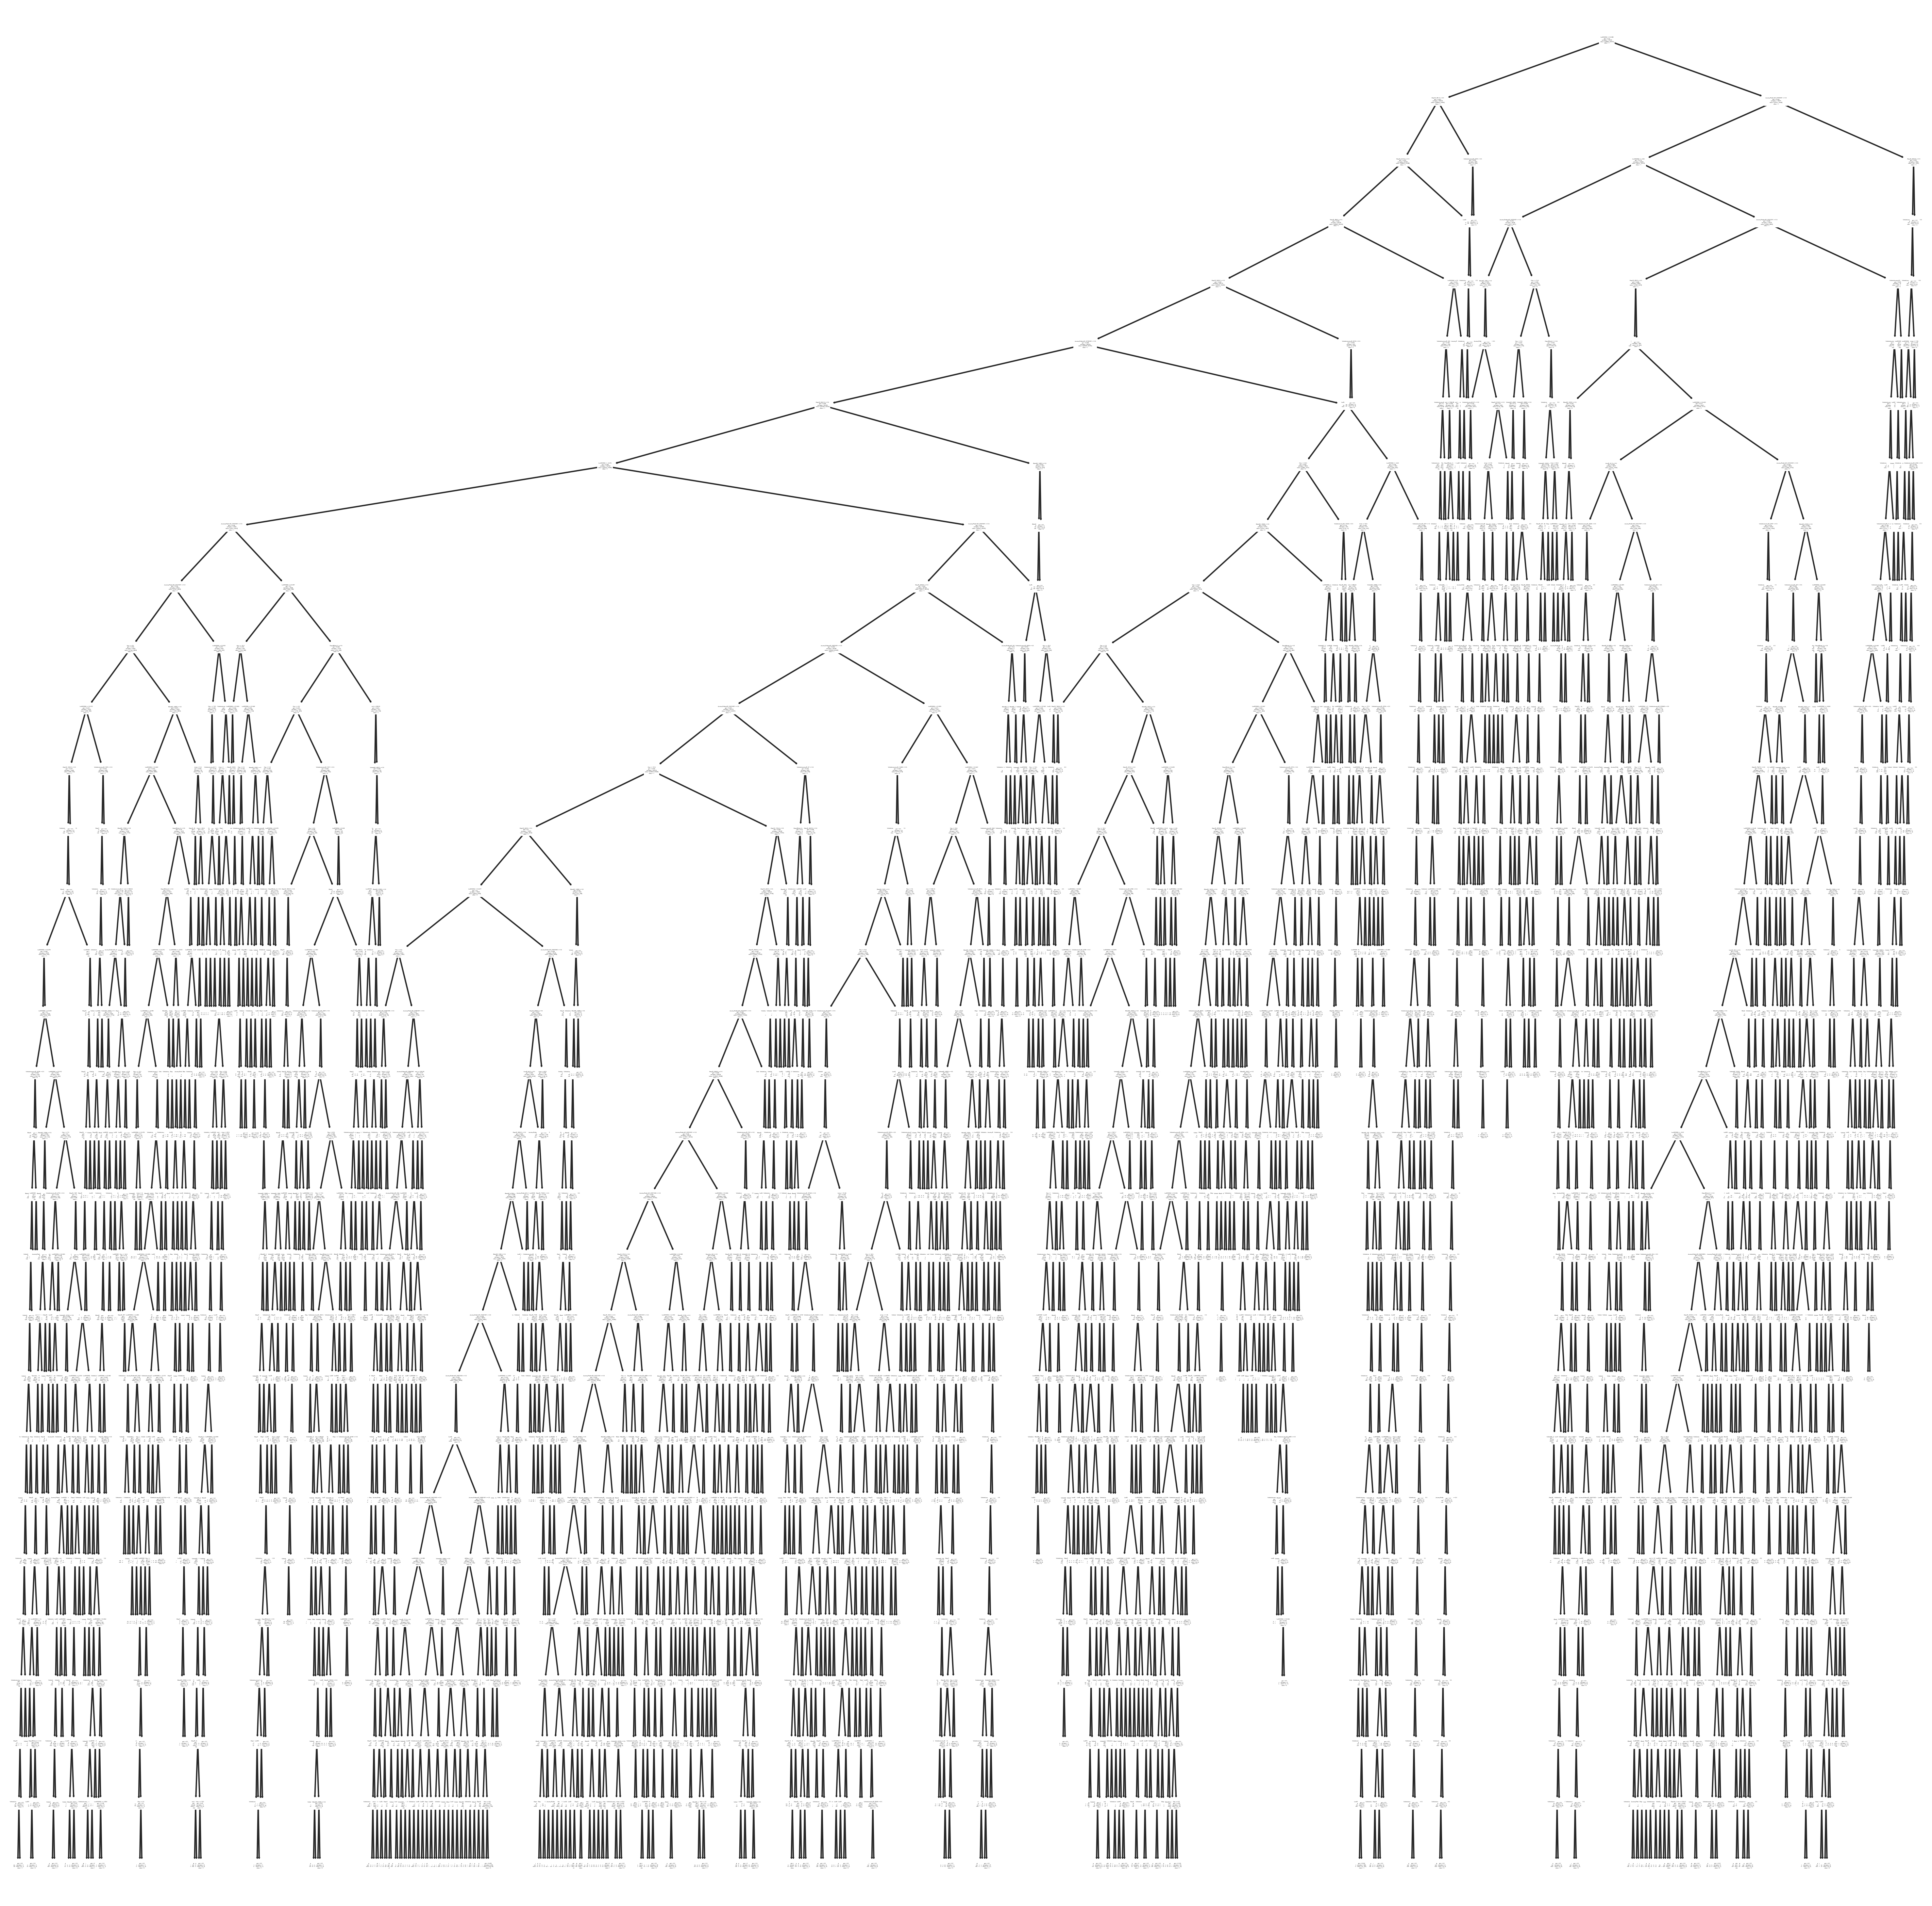

Random Forest

#Import Random Forest Model  
from sklearn.ensemble import RandomForestClassifier  
  
#Create a Gaussian Classifier  
RF_clf=RandomForestClassifier(n_estimators=100)  
  
#Train the model using the training sets y_pred=clf.predict(X_test)  
RF_clf.fit(X_train,y_train)  
  
y_pred=RF_clf.predict(X_test)

#Import scikit-learn metrics module for accuracy calculation  
from sklearn import metrics  
# Model Accuracy, how often is the classifier correct?  
print("Accuracy:",metrics.accuracy_score(y_test, y_pred))

Accuracy: 0.958343105065666

Accuracy: 0.9660500101646676 on the lineID = 14 Accuracy: 0.9791469194312796 on the lineID = 1 Accuracy: 0.9653900709219858 with LineID = 1 or 7

## Finding Important Features in Scikit-learn

We are finding important features or selecting features in the IRIS dataset. In scikit-learn, you can perform this task in the following steps:

1. First, you need to create a random forests model.
2. Second, use the feature importance variable to see feature importance scores.
3. Third, visualize these scores using the seaborn library.

feature_imp = pd.Series(RF_clf.feature_importances_,feature_names).sort_values(ascending=False)  
feature_imp

LatWGS84 0.066189  
LonWGS84 0.058992  
Hour 0.039230  
msl 0.037152  
temp 0.036633  
 ...   
VehicleID_33275 0.000000  
VehicleJourneyID_947525 0.000000  
StopID_7055.0 0.000000  
VehicleJourneyID_950648 0.000000  
VehicleJourneyID_4973 0.000000  
Length: 5534, dtype: float64

# Creating a bar plot  
sns.barplot(x=feature_imp.head(6).index, y=feature_imp.head(6))  
# Add labels to your graph  
  
plt.xlabel('Feature Importance Score')  
plt.ylabel('Features')  
plt.title("Visualizing Important Features")  
plt.legend()  
plt.show()

No artists with labels found to put in legend. Note that artists whose label start with an underscore are ignored when legend() is called with no argument.

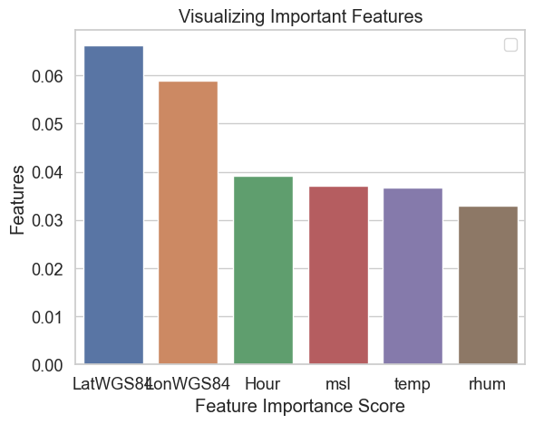

### Linear Regression

model = LinearRegression()  
lm_onTime = model.fit(X_train,y_train)

r_sq = lm_onTime.score(X_train, y_train)  
print(f"coefficient of determination: {r_sq}")  
print(f"intercept: {lm_onTime.intercept_}")  
print(f"coefficients: {lm_onTime.coef_}")

coefficient of determination: 0.4890050979799224  
intercept: -1232629.4639281179  
coefficients: [-0.00842189 -0.76118143 0.12687316 ... 0.03132865 0.15861925  
 0.07747483]

#### not very good at classifying using Linear regression

Now we have changed the target to be the continuous variable Delay - linear model without scaling

Y = mdf['Delay']  
X_train, X_test, y_train, y_test = train_test_split(X, Y,   
 train_size=0.7,  
 test_size = 0.3, random_state=100)

lm_Delay = model.fit(X_train,y_train)

r_sq = lm_Delay.score(X_train, y_train)  
print(f"coefficient of determination: {r_sq}")  
print(f"intercept: {lm_Delay.intercept_}")  
print(f"coefficients: {lm_Delay.coef_}")

coefficient of determination: 0.6192131578231018  
intercept: 4171020556.6859455  
coefficients: [176.58183404 -43.06178685 399.33484182 ... 64.86358643 156.6645813  
 100.1749115 ]

#### Ridge Regression

# list of alphas to tune  
params = {'alpha': [0.001, 0.01, 0.1,   
 1.0, 10.0, 50, 100]}  
  
  
ridge = Ridge()  
  
# cross validation  
folds = 5  
Ridge_model_cv = GridSearchCV(estimator = ridge,   
 param_grid = params,   
 scoring= 'neg_mean_absolute_error',   
 cv = folds,   
 return_train_score=True,  
 verbose = 1)   
Ridge_model_cv.fit(X_train, y_train)

Fitting 5 folds for each of 7 candidates, totalling 35 fits

GridSearchCV(cv=5, estimator=Ridge(),  
 param_grid={'alpha': [0.001, 0.01, 0.1, 1.0, 10.0, 50, 100]},  
 return_train_score=True, scoring='neg_mean_absolute_error',  
 verbose=1)

R_cv_results = pd.DataFrame(Ridge_model_cv.cv_results_)  
R_cv_results = R_cv_results[R_cv_results['param_alpha']<=1000]  
R_cv_results.head()

mean_fit_time std_fit_time mean_score_time std_score_time param_alpha \  
0 13.560845 0.535714 0.317848 0.047640 0.001   
1 13.348875 0.102206 0.392198 0.096162 0.01   
2 13.219187 0.193584 0.310286 0.054470 0.1   
3 13.269190 0.056343 0.299365 0.028001 1.0   
4 13.454347 0.308899 0.317422 0.031300 10.0   
  
 params split0_test_score split1_test_score split2_test_score \  
0 {'alpha': 0.001} -190.405401 -193.630764 -192.042977   
1 {'alpha': 0.01} -190.383259 -193.584481 -191.995508   
2 {'alpha': 0.1} -190.316183 -193.488010 -191.907510   
3 {'alpha': 1.0} -191.367086 -194.946645 -193.049685   
4 {'alpha': 10.0} -201.461723 -205.950374 -202.503338   
  
 split3_test_score ... mean_test_score std_test_score rank_test_score \  
0 -191.498857 ... -191.655207 1.145062 3   
1 -191.480057 ... -191.621316 1.137069 2   
2 -191.527838 ... -191.576929 1.115500 1   
3 -192.971920 ... -192.828436 1.243828 4   
4 -203.316207 ... -202.904424 1.690826 5   
  
 split0_train_score split1_train_score split2_train_score \  
0 -176.243433 -174.844135 -175.760444   
1 -176.264859 -174.875040 -175.780220   
2 -176.574795 -175.199683 -176.078611   
3 -179.410077 -178.020527 -178.749926   
4 -193.694898 -192.536175 -193.135345   
  
 split3_train_score split4_train_score mean_train_score std_train_score   
0 -175.583079 -176.309161 -175.748050 0.530034   
1 -175.605291 -176.328015 -175.770685 0.526204   
2 -175.915057 -176.623151 -176.078259 0.518071   
3 -178.557418 -179.258622 -178.799314 0.500291   
4 -192.830764 -193.472377 -193.133912 0.419155   
  
[5 rows x 21 columns]

# plotting mean test and train scoes with alpha   
R_cv_results['param_alpha'] = R_cv_results['param_alpha'].astype('int32')  
  
# plotting  
plt.plot(R_cv_results['param_alpha'], R_cv_results['mean_train_score'])  
plt.plot(R_cv_results['param_alpha'], R_cv_results['mean_test_score'])  
plt.xlabel('alpha')  
plt.ylabel('Negative Mean Absolute Error')  
plt.title("Negative Mean Absolute Error and alpha")  
plt.legend(['train score', 'test score'], loc='upper left')  
plt.show()

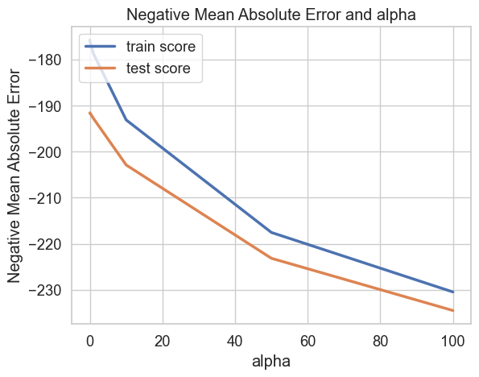

### Linear regression after scaling

### Scale the data before running the Regression models   
from sklearn.preprocessing import StandardScaler  
sc = StandardScaler()  
X_train = sc.fit_transform(X_train)  
X_test = sc.transform(X_test)

### Ridge V2 with scaled variables

#### Ridge Regression  
  
  
ridge = Ridge()  
  
# cross validation  
folds = 5  
RV2_model_cv = GridSearchCV(estimator = ridge,   
 param_grid = params,   
 scoring= 'neg_mean_absolute_error',   
 cv = folds,   
 return_train_score=True,  
 verbose = 1)   
RV2_model_cv.fit(X_train, y_train)

Fitting 5 folds for each of 7 candidates, totalling 35 fits

GridSearchCV(cv=5, estimator=Ridge(),  
 param_grid={'alpha': [0.001, 0.01, 0.1, 1.0, 10.0, 50, 100]},  
 return_train_score=True, scoring='neg_mean_absolute_error',  
 verbose=1)

RV2_cv_results = pd.DataFrame(RV2_model_cv.cv_results_)  
RV2_cv_results = RV2_cv_results[RV2_cv_results['param_alpha']<=1000]  
RV2_cv_results.head()  
# plotting mean test and train scoes with alpha   
RV2_cv_results['param_alpha'] = RV2_cv_results['param_alpha'].astype('int32')  
  
# plotting  
plt.plot(RV2_cv_results['param_alpha'], RV2_cv_results['mean_train_score'])  
plt.plot(RV2_cv_results['param_alpha'], RV2_cv_results['mean_test_score'])  
plt.xlabel('alpha')  
plt.ylabel('Negative Mean Absolute Error')  
plt.title("Negative Mean Absolute Error and alpha")  
plt.legend(['train score', 'test score'], loc='upper left')  
plt.show()

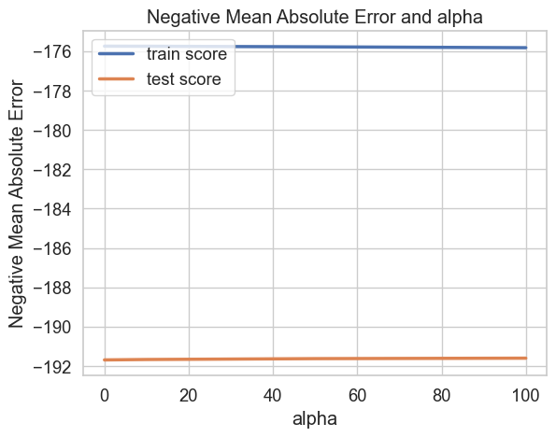

### Trying out a Stats Model Linear Model

import numpy as np  
import statsmodels.api as sm  
x = sm.add_constant(X_train)  
model = sm.OLS(y_train, x)  
results = model.fit()  
print(results.summary())

OLS Regression Results   
==============================================================================  
Dep. Variable: Delay R-squared: 0.619  
Model: OLS Adj. R-squared: 0.592  
Method: Least Squares F-statistic: 23.11  
Date: Wed, 16 Nov 2022 Prob (F-statistic): 0.00  
Time: 13:29:22 Log-Likelihood: -5.5242e+05  
No. Observations: 79593 AIC: 1.115e+06  
Df Residuals: 74364 BIC: 1.164e+06  
Df Model: 5228   
Covariance Type: nonrobust   
==============================================================================  
 coef std err t P>|t| [0.025 0.975]  
------------------------------------------------------------------------------  
const -86.1156 0.919 -93.743 0.000 -87.916 -84.315  
x1 17.9761 1.097 16.388 0.000 15.826 20.126  
x2 -3.2175 7.830 -0.411 0.681 -18.564 12.129  
x3 24.8023 7.716 3.215 0.001 9.680 39.925  
x4 6.5539 1.228 5.338 0.000 4.148 8.960  
x5 45.2550 2.341 19.328 0.000 40.666 49.844  
x6 7.8107 2.989 2.613 0.009 1.952 13.669  
x7 18.8729 1.129 16.712 0.000 16.659 21.086  
x8 -14.1433 1.200 -11.789 0.000 -16.495 -11.792  
x9 -0.7290 1.280 -0.569 0.569 -3.238 1.780  
x10 5.8622 2.124 2.760 0.006 1.700 10.025  
x11 -4.992e+13 5.78e+13 -0.863 0.388 -1.63e+14 6.34e+13  
x12 7.786e+13 1.66e+14 0.468 0.640 -2.48e+14 4.04e+14  
x13 6.344e+13 5.68e+13 1.118 0.264 -4.78e+13 1.75e+14  
x14 5.266e+13 6.86e+13 0.767 0.443 -8.19e+13 1.87e+14  
x15 2.547e+13 6e+13 0.424 0.671 -9.21e+13 1.43e+14  
x16 -9.469e+13 6.12e+13 -1.548 0.122 -2.15e+14 2.52e+13  
x17 9.345e+13 5.88e+13 1.588 0.112 -2.19e+13 2.09e+14  
x18 9.476e+13 6.47e+13 1.465 0.143 -3.2e+13 2.22e+14  
x19 -5.641e+13 6.02e+13 -0.937 0.349 -1.74e+14 6.16e+13  
x20 4.237e+13 4.01e+13 1.058 0.290 -3.61e+13 1.21e+14  
x21 -23.7427 9.687 -2.451 0.014 -42.729 -4.756  
x22 2.095e+13 4.52e+13 0.464 0.643 -6.76e+13 1.09e+14  
x23 -2.016e+13 3.72e+13 -0.542 0.588 -9.31e+13 5.28e+13  
x24 -1.236e+13 2.28e+13 -0.542 0.588 -5.71e+13 3.24e+13  
x25 -1.31e+13 2.42e+13 -0.542 0.588 -6.05e+13 3.43e+13  
x26 -4.565e+12 8.43e+12 -0.542 0.588 -2.11e+13 1.2e+13  
x27 -2.034e+13 3.76e+13 -0.542 0.588 -9.4e+13 5.33e+13  
x28 -1.107e+13 2.04e+13 -0.542 0.588 -5.11e+13 2.9e+13  
x29 -1.404e+13 2.59e+13 -0.542 0.588 -6.48e+13 3.68e+13  
x30 -6.215e+12 1.15e+13 -0.542 0.588 -2.87e+13 1.63e+13  
x31 -7.199e+12 1.33e+13 -0.542 0.588 -3.33e+13 1.89e+13  
x32 -8.487e+12 1.57e+13 -0.542 0.588 -3.92e+13 2.22e+13  
x33 7.559e+11 3e+13 0.025 0.980 -5.81e+13 5.96e+13  
x34 1.764e+13 5.13e+13 0.344 0.731 -8.29e+13 1.18e+14  
x35 1.375e+13 2.87e+13 0.479 0.632 -4.25e+13 7e+13  
x36 1.653e+13 4.8e+13 0.344 0.731 -7.76e+13 1.11e+14  
x37 4.228e+13 5.61e+13 0.754 0.451 -6.76e+13 1.52e+14  
x38 3.814e+13 3.41e+13 1.118 0.264 -2.87e+13 1.05e+14  
x39 3.953e+13 3.54e+13 1.118 0.264 -2.98e+13 1.09e+14  
x40 2.147e+12 1.92e+12 1.118 0.264 -1.62e+12 5.91e+12  
x41 3.023e+13 3.6e+13 0.839 0.401 -4.04e+13 1.01e+14  
x42 8.785e+12 1.05e+13 0.839 0.401 -1.17e+13 2.93e+13  
x43 5.534e+13 4.81e+13 1.151 0.250 -3.89e+13 1.5e+14  
x44 1.034e+14 9.47e+13 1.092 0.275 -8.21e+13 2.89e+14  
x45 3.278e+13 3.91e+13 0.839 0.401 -4.38e+13 1.09e+14  
x46 2.859e+13 3.69e+13 0.775 0.439 -4.38e+13 1.01e+14  
x47 -1.011e+13 5.96e+13 -0.170 0.865 -1.27e+14 1.07e+14  
x48 1.139e+14 6.38e+13 1.784 0.074 -1.12e+13 2.39e+14  
x49 6.157e+13 3.97e+13 1.549 0.121 -1.63e+13 1.39e+14  
x50 2.743e+13 3.54e+13 0.775 0.439 -4.2e+13 9.69e+13  
x51 8.807e+12 4.14e+13 0.213 0.831 -7.23e+13 8.99e+13  
x52 -6.229e+13 5.12e+13 -1.216 0.224 -1.63e+14 3.81e+13  
x53 5.514e+13 2.81e+13 1.965 0.049 1.42e+11 1.1e+14  
x54 2.265e+13 3.55e+13 0.638 0.523 -4.69e+13 9.22e+13  
x55 2.276e+13 3.56e+13 0.638 0.523 -4.71e+13 9.26e+13  
x56 8.787e+13 4.54e+13 1.934 0.053 -1.19e+12 1.77e+14  
x57 2.803e+13 4.59e+13 0.611 0.541 -6.19e+13 1.18e+14  
x58 7.053e+13 2.64e+13 2.667 0.008 1.87e+13 1.22e+14  
x59 9.554e+12 3.58e+12 2.667 0.008 2.53e+12 1.66e+13  
x60 -1.547e+14 7.91e+13 -1.957 0.050 -3.1e+14 2.64e+11  
x61 -2.404e+12 2.67e+13 -0.090 0.928 -5.47e+13 4.99e+13  
x62 4.981e+13 6.47e+13 0.770 0.441 -7.7e+13 1.77e+14  
x63 7.645e+13 2.87e+13 2.667 0.008 2.03e+13 1.33e+14  
x64 -2.311e+13 9.21e+13 -0.251 0.802 -2.04e+14 1.57e+14  
x65 -5.503e+13 4.4e+13 -1.250 0.211 -1.41e+14 3.12e+13  
x66 5.026e+12 1.88e+12 2.667 0.008 1.33e+12 8.72e+12  
x67 -6.956e+13 5.76e+13 -1.207 0.227 -1.82e+14 4.34e+13  
x68 1.789e+12 7.87e+13 0.023 0.982 -1.52e+14 1.56e+14  
x69 -6.149e+13 5.09e+13 -1.207 0.227 -1.61e+14 3.83e+13  
x70 1.178e+14 4.01e+13 2.940 0.003 3.93e+13 1.96e+14  
x71 -1.499e+13 3.25e+13 -0.461 0.645 -7.87e+13 4.87e+13  
x72 -1.9e+13 7.94e+13 -0.239 0.811 -1.75e+14 1.37e+14  
x73 -1.536e+13 3.33e+13 -0.461 0.645 -8.06e+13 4.99e+13  
x74 -7.88e+12 5.82e+13 -0.135 0.892 -1.22e+14 1.06e+14  
x75 -5.456e+12 2.59e+13 -0.211 0.833 -5.61e+13 4.52e+13  
x76 -6.966e+12 1.29e+13 -0.542 0.588 -3.22e+13 1.82e+13  
x77 -3.708e+12 6.85e+12 -0.542 0.588 -1.71e+13 9.71e+12  
x78 -2.667e+12 4.92e+12 -0.542 0.588 -1.23e+13 6.98e+12  
x79 -2.546e+12 4.7e+12 -0.542 0.588 -1.18e+13 6.67e+12  
x80 1.947e+10 4.28e+13 0.000 1.000 -8.38e+13 8.38e+13  
x81 3.995e+13 3.68e+13 1.085 0.278 -3.22e+13 1.12e+14  
x82 -6.02e+13 6.85e+13 -0.879 0.379 -1.94e+14 7.4e+13  
x83 1.643e+10 3.61e+13 0.000 1.000 -7.07e+13 7.07e+13  
x84 2.726e+13 5.38e+13 0.506 0.613 -7.83e+13 1.33e+14  
x85 1.459e+13 2.13e+13 0.683 0.494 -2.73e+13 5.64e+13  
x86 2.526e+12 2.26e+12 1.118 0.264 -1.9e+12 6.96e+12  
x87 4.836e+12 4.33e+12 1.118 0.264 -3.65e+12 1.33e+13  
x88 6.04e+12 5.4e+12 1.118 0.264 -4.55e+12 1.66e+13  
x89 3.766e+12 3.37e+12 1.118 0.264 -2.84e+12 1.04e+13  
x90 1.141e+13 3.7e+13 0.309 0.758 -6.1e+13 8.39e+13  
x91 2.811e+12 3.35e+12 0.839 0.401 -3.75e+12 9.38e+12  
x92 1.298e+13 3.78e+13 0.343 0.731 -6.11e+13 8.71e+13  
x93 1.292e+13 4.26e+13 0.304 0.761 -7.05e+13 9.64e+13  
x94 -3.191e+13 4.78e+13 -0.668 0.504 -1.26e+14 6.17e+13  
x95 -2.489e+13 3.2e+13 -0.779 0.436 -8.75e+13 3.78e+13  
x96 -3.568e+13 7.95e+13 -0.449 0.654 -1.92e+14 1.2e+14  
x97 8.706e+13 7.99e+13 1.090 0.276 -6.95e+13 2.44e+14  
x98 5.604e+13 8.18e+13 0.685 0.493 -1.04e+14 2.16e+14  
x99 -1.319e+13 1.69e+13 -0.779 0.436 -4.64e+13 2e+13  
x100 -1.442e+13 5.75e+13 -0.251 0.802 -1.27e+14 9.83e+13  
x101 -1.682e+13 2.16e+13 -0.779 0.436 -5.92e+13 2.55e+13  
x102 1.085e+14 9.96e+13 1.090 0.276 -8.66e+13 3.04e+14  
x103 3.751e+13 8.58e+13 0.437 0.662 -1.31e+14 2.06e+14  
x104 3.12e+13 1.34e+14 0.233 0.815 -2.31e+14 2.93e+14  
x105 -1.577e+13 6.93e+13 -0.227 0.820 -1.52e+14 1.2e+14  
x106 -4.248e+13 5.76e+13 -0.738 0.461 -1.55e+14 7.03e+13  
x107 -4.524e+12 5.81e+12 -0.779 0.436 -1.59e+13 6.86e+12  
x108 -1.27e+12 1.19e+13 -0.106 0.915 -2.47e+13 2.21e+13  
x109 -7.507e+13 4.01e+13 -1.872 0.061 -1.54e+14 3.54e+12  
x110 8.759e+13 5e+13 1.752 0.080 -1.04e+13 1.86e+14  
x111 6.94e+12 1.39e+14 0.050 0.960 -2.66e+14 2.8e+14  
x112 2.097e+13 7.86e+12 2.667 0.008 5.56e+12 3.64e+13  
x113 7.291e+13 2.73e+13 2.667 0.008 1.93e+13 1.26e+14  
x114 6.962e+13 2.61e+13 2.667 0.008 1.85e+13 1.21e+14  
x115 6.593e+13 1.3e+14 0.508 0.611 -1.88e+14 3.2e+14  
x116 3.012e+13 6.57e+13 0.459 0.646 -9.86e+13 1.59e+14  
x117 2.606e+13 8.11e+13 0.321 0.748 -1.33e+14 1.85e+14  
x118 2.418e+14 1.8e+14 1.345 0.178 -1.1e+14 5.94e+14  
x119 4.682e+13 6.7e+13 0.699 0.485 -8.45e+13 1.78e+14  
x120 3.842e+13 4.32e+13 0.890 0.373 -4.62e+13 1.23e+14  
x121 4.295e+12 3.75e+13 0.115 0.909 -6.91e+13 7.77e+13  
x122 1.595e+12 1.39e+13 0.115 0.909 -2.57e+13 2.89e+13  
x123 8.886e+09 1.95e+13 0.000 1.000 -3.82e+13 3.83e+13  
x124 -5.841e+13 3.45e+13 -1.695 0.090 -1.26e+14 9.12e+12  
x125 9.559e+09 2.1e+13 0.000 1.000 -4.11e+13 4.12e+13  
x126 -4.708e+13 5.16e+13 -0.913 0.361 -1.48e+14 5.4e+13  
x127 -1.7942 3.752 -0.478 0.633 -9.148 5.560  
x128 2.335e+13 4.92e+13 0.475 0.635 -7.31e+13 1.2e+14  
x129 -8.468e+12 1.61e+13 -0.524 0.600 -4.01e+13 2.32e+13  
x130 -7.555e+12 1.44e+13 -0.524 0.600 -3.58e+13 2.07e+13  
x131 1.559e+14 7.47e+13 2.087 0.037 9.5e+12 3.02e+14  
x132 -1.843e+13 3.76e+13 -0.491 0.624 -9.21e+13 5.52e+13  
x133 6.728e+12 4.86e+13 0.138 0.890 -8.85e+13 1.02e+14  
x134 1.749e+13 1.19e+13 1.468 0.142 -5.87e+12 4.08e+13  
x135 1.892e+13 1.29e+13 1.468 0.142 -6.35e+12 4.42e+13  
x136 2.079e+13 1.42e+13 1.468 0.142 -6.98e+12 4.86e+13  
x137 2.167e+13 1.48e+13 1.468 0.142 -7.27e+12 5.06e+13  
x138 1.592e+13 1.09e+13 1.468 0.142 -5.34e+12 3.72e+13  
x139 1.749e+13 1.19e+13 1.468 0.142 -5.87e+12 4.08e+13  
x140 1.811e+13 1.23e+13 1.468 0.142 -6.08e+12 4.23e+13  
x141 2.235e+13 1.52e+13 1.468 0.142 -7.5e+12 5.22e+13  
x142 1.811e+13 1.23e+13 1.468 0.142 -6.08e+12 4.23e+13  
x143 1.727e+13 1.18e+13 1.468 0.142 -5.8e+12 4.03e+13  
x144 2.007e+13 1.37e+13 1.468 0.142 -6.73e+12 4.69e+13  
x145 -1.896e+13 2.44e+13 -0.777 0.437 -6.68e+13 2.89e+13  
x146 7.113e+11 4.85e+13 0.015 0.988 -9.44e+13 9.58e+13  
x147 -2.435e+13 1.55e+13 -1.566 0.117 -5.48e+13 6.13e+12  
x148 -2.178e+13 1.39e+13 -1.566 0.117 -4.9e+13 5.48e+12  
x149 -2.103e+13 1.34e+13 -1.566 0.117 -4.73e+13 5.29e+12  
x150 -1.886e+13 1.2e+13 -1.566 0.117 -4.25e+13 4.75e+12  
x151 -1.997e+13 1.28e+13 -1.566 0.117 -4.5e+13 5.03e+12  
x152 -1.915e+13 1.22e+13 -1.566 0.117 -4.31e+13 4.82e+12  
x153 -2.153e+13 1.37e+13 -1.566 0.117 -4.85e+13 5.42e+12  
x154 -2.786e+13 1.78e+13 -1.566 0.117 -6.27e+13 7.01e+12  
x155 -1.97e+13 1.26e+13 -1.566 0.117 -4.44e+13 4.96e+12  
x156 -1.97e+13 1.26e+13 -1.566 0.117 -4.44e+13 4.96e+12  
x157 -2.479e+13 1.58e+13 -1.566 0.117 -5.58e+13 6.24e+12  
x158 -1.486e+13 1.3e+13 -1.140 0.254 -4.04e+13 1.07e+13  
x159 -1.44e+13 1.26e+13 -1.140 0.254 -3.92e+13 1.04e+13  
x160 -1.875e+13 1.64e+13 -1.140 0.254 -5.1e+13 1.35e+13  
x161 -1.343e+13 1.18e+13 -1.140 0.254 -3.65e+13 9.66e+12  
x162 -1.292e+13 1.13e+13 -1.140 0.254 -3.51e+13 9.29e+12  
x163 -1.546e+13 1.36e+13 -1.140 0.254 -4.2e+13 1.11e+13  
x164 9.581e+13 4.53e+13 2.115 0.034 7.02e+12 1.85e+14  
x165 9.457e+13 4.47e+13 2.115 0.034 6.93e+12 1.82e+14  
x166 1.082e+13 1.55e+13 0.700 0.484 -1.95e+13 4.11e+13  
x167 -3.666e+13 2.7e+13 -1.357 0.175 -8.96e+13 1.63e+13  
x168 -4.853e+13 1.98e+13 -2.450 0.014 -8.73e+13 -9.71e+12  
x169 -6.018e+13 3.92e+13 -1.536 0.124 -1.37e+14 1.66e+13  
x170 1.07e+13 1.53e+13 0.700 0.484 -1.93e+13 4.07e+13  
x171 1.094e+13 1.56e+13 0.700 0.484 -1.97e+13 4.16e+13  
x172 1.021e+13 1.46e+13 0.700 0.484 -1.84e+13 3.88e+13  
x173 1.457e+13 5.09e+13 0.286 0.775 -8.53e+13 1.14e+14  
x174 1.021e+13 1.46e+13 0.700 0.484 -1.84e+13 3.88e+13  
x175 1.334e+13 1.91e+13 0.700 0.484 -2.4e+13 5.07e+13  
x176 1.139e+13 1.63e+13 0.700 0.484 -2.05e+13 4.33e+13  
x177 1.021e+13 1.46e+13 0.700 0.484 -1.84e+13 3.88e+13  
x178 1.009e+13 1.44e+13 0.700 0.484 -1.82e+13 3.84e+13  
x179 1.183e+13 1.69e+13 0.700 0.484 -2.13e+13 4.5e+13  
x180 9.572e+12 1.37e+13 0.700 0.484 -1.72e+13 3.64e+13  
x181 1.094e+13 1.56e+13 0.700 0.484 -1.97e+13 4.16e+13  
x182 1.034e+13 1.48e+13 0.700 0.484 -1.86e+13 3.93e+13  
x183 1.702e+13 5.95e+13 0.286 0.775 -9.95e+13 1.34e+14  
x184 -1.107e+13 4.54e+13 -0.244 0.807 -1e+14 7.79e+13  
x185 1.659e+12 7.38e+12 0.225 0.822 -1.28e+13 1.61e+13  
x186 2.19e+12 9.75e+12 0.225 0.822 -1.69e+13 2.13e+13  
x187 1.902e+12 8.46e+12 0.225 0.822 -1.47e+13 1.85e+13  
x188 1.611e+12 7.17e+12 0.225 0.822 -1.24e+13 1.57e+13  
x189 1.752e+12 7.79e+12 0.225 0.822 -1.35e+13 1.7e+13  
x190 1.963e+12 8.74e+12 0.225 0.822 -1.52e+13 1.91e+13  
x191 1.635e+12 7.28e+12 0.225 0.822 -1.26e+13 1.59e+13  
x192 1.587e+12 7.06e+12 0.225 0.822 -1.23e+13 1.54e+13  
x193 1.86e+12 8.28e+12 0.225 0.822 -1.44e+13 1.81e+13  
x194 1.774e+12 7.89e+12 0.225 0.822 -1.37e+13 1.72e+13  
x195 3.938e+13 4.54e+13 0.867 0.386 -4.97e+13 1.28e+14  
x196 1.936e+13 2.23e+13 0.867 0.386 -2.44e+13 6.31e+13  
x197 -2.832e+13 4.59e+13 -0.618 0.537 -1.18e+14 6.16e+13  
x198 -1.432e+13 9.34e+12 -1.534 0.125 -3.26e+13 3.98e+12  
x199 -1.449e+13 9.45e+12 -1.534 0.125 -3.3e+13 4.03e+12  
x200 -1.465e+13 9.55e+12 -1.534 0.125 -3.34e+13 4.07e+12  
x201 -1.733e+13 1.13e+13 -1.534 0.125 -3.95e+13 4.82e+12  
x202 -1.216e+13 7.93e+12 -1.534 0.125 -2.77e+13 3.38e+12  
x203 -1.346e+13 8.78e+12 -1.534 0.125 -3.07e+13 3.74e+12  
x204 -1.761e+13 1.15e+13 -1.534 0.125 -4.01e+13 4.89e+12  
x205 -1.381e+13 9.01e+12 -1.534 0.125 -3.15e+13 3.84e+12  
x206 -1.381e+13 9.01e+12 -1.534 0.125 -3.15e+13 3.84e+12  
x207 -1.346e+13 8.78e+12 -1.534 0.125 -3.07e+13 3.74e+12  
x208 -1.449e+13 9.45e+12 -1.534 0.125 -3.3e+13 4.03e+12  
x209 -1.364e+13 8.89e+12 -1.534 0.125 -3.11e+13 3.79e+12  
x210 -3.902e+12 4.29e+13 -0.091 0.928 -8.8e+13 8.02e+13  
x211 -2.24e+13 1.55e+13 -1.447 0.148 -5.27e+13 7.95e+12  
x212 -2.938e+13 2.03e+13 -1.447 0.148 -6.92e+13 1.04e+13  
x213 -1.808e+13 1.25e+13 -1.447 0.148 -4.26e+13 6.42e+12  
x214 -2.021e+13 1.4e+13 -1.447 0.148 -4.76e+13 7.17e+12  
x215 -2.078e+13 1.44e+13 -1.447 0.148 -4.89e+13 7.37e+12  
x216 -2.533e+13 1.75e+13 -1.447 0.148 -5.97e+13 8.99e+12  
x217 -2.078e+13 1.44e+13 -1.447 0.148 -4.89e+13 7.37e+12  
x218 -2.05e+13 1.42e+13 -1.447 0.148 -4.83e+13 7.27e+12  
x219 -2.668e+13 1.84e+13 -1.447 0.148 -6.28e+13 9.47e+12  
x220 2.003e+12 8.91e+12 0.225 0.822 -1.55e+13 1.95e+13  
x221 1.51e+12 6.72e+12 0.225 0.822 -1.17e+13 1.47e+13  
x222 1.752e+12 7.79e+12 0.225 0.822 -1.35e+13 1.7e+13  
x223 1.635e+12 7.28e+12 0.225 0.822 -1.26e+13 1.59e+13  
x224 1.635e+12 7.28e+12 0.225 0.822 -1.26e+13 1.59e+13  
x225 1.611e+12 7.17e+12 0.225 0.822 -1.24e+13 1.57e+13  
x226 1.611e+12 7.17e+12 0.225 0.822 -1.24e+13 1.57e+13  
x227 2.312e+12 1.03e+13 0.225 0.822 -1.79e+13 2.25e+13  
x228 3.065e+12 1.97e+13 0.155 0.877 -3.56e+13 4.18e+13  
x229 2.497e+13 1.68e+13 1.488 0.137 -7.92e+12 5.79e+13  
x230 1.934e+13 1.3e+13 1.488 0.137 -6.13e+12 4.48e+13  
x231 1.606e+13 1.08e+13 1.488 0.137 -5.09e+12 3.72e+13  
x232 1.824e+13 1.23e+13 1.488 0.137 -5.78e+12 4.23e+13  
x233 2.446e+13 1.64e+13 1.488 0.137 -7.76e+12 5.67e+13  
x234 8.119e+13 3.84e+13 2.115 0.034 5.95e+12 1.56e+14  
x235 7.672e+13 3.63e+13 2.115 0.034 5.62e+12 1.48e+14  
x236 -6.41e+13 3.49e+13 -1.837 0.066 -1.33e+14 4.3e+12  
x237 -6.235e+13 3.39e+13 -1.837 0.066 -1.29e+14 4.18e+12  
x238 4.3504 3.478 1.251 0.211 -2.467 11.168  
x239 1.6742 4.649 0.360 0.719 -7.437 10.786  
x240 5.2309 4.546 1.151 0.250 -3.679 14.141  
x241 -9.7177 1.387 -7.008 0.000 -12.436 -7.000  
x242 -1.4467 4.535 -0.319 0.750 -10.336 7.443  
x243 0.7979 1.444 0.553 0.580 -2.031 3.627  
x244 -9.5140 4.272 -2.227 0.026 -17.888 -1.140  
x245 -12.7976 1.379 -9.282 0.000 -15.500 -10.095  
x246 -6.4729 3.502 -1.848 0.065 -13.338 0.392  
x247 -14.1885 1.433 -9.899 0.000 -16.998 -11.379  
x248 -12.3184 3.778 -3.260 0.001 -19.724 -4.913  
x249 -7.852e+12 1.64e+13 -0.480 0.632 -3.99e+13 2.42e+13  
x250 5.416e+13 2.97e+13 1.826 0.068 -3.96e+12 1.12e+14  
x251 -9.133e+12 1.9e+13 -0.480 0.632 -4.65e+13 2.82e+13  
x252 -8.41e+12 1.75e+13 -0.480 0.632 -4.28e+13 2.6e+13  
x253 -1.197e+13 2.5e+13 -0.480 0.632 -6.09e+13 3.69e+13  
x254 -8.41e+12 1.75e+13 -0.480 0.632 -4.28e+13 2.6e+13  
x255 -8.08e+12 1.68e+13 -0.480 0.632 -4.11e+13 2.49e+13  
x256 -8.932e+12 1.86e+13 -0.480 0.632 -4.54e+13 2.76e+13  
x257 -1.181e+13 2.46e+13 -0.480 0.632 -6.01e+13 3.65e+13  
x258 -8.83e+12 1.84e+13 -0.480 0.632 -4.49e+13 2.73e+13  
x259 9.717e+11 4.32e+12 0.225 0.822 -7.5e+12 9.45e+12  
x260 1.659e+12 7.38e+12 0.225 0.822 -1.28e+13 1.61e+13  
x261 2.426e+13 2.8e+13 0.867 0.386 -3.06e+13 7.91e+13  
x262 2.426e+13 2.8e+13 0.867 0.386 -3.06e+13 7.91e+13  
x263 -1.061e+13 2.02e+13 -0.524 0.600 -5.03e+13 2.91e+13  
x264 -7.158e+12 1.36e+13 -0.524 0.600 -3.39e+13 1.96e+13  
x265 -7.458e+12 1.42e+13 -0.524 0.600 -3.53e+13 2.04e+13  
x266 -7.259e+12 1.38e+13 -0.524 0.600 -3.44e+13 1.99e+13  
x267 -1.141e+13 2.18e+13 -0.524 0.600 -5.41e+13 3.12e+13  
x268 -8.025e+12 1.53e+13 -0.524 0.600 -3.8e+13 2.2e+13  
x269 -4.002e+13 1.63e+13 -2.450 0.014 -7.2e+13 -8.01e+12  
x270 -5.741e+13 2.34e+13 -2.450 0.014 -1.03e+14 -1.15e+13  
x271 -3.943e+13 1.61e+13 -2.450 0.014 -7.1e+13 -7.89e+12  
x272 -3.943e+13 1.61e+13 -2.450 0.014 -7.1e+13 -7.89e+12  
x273 -5.226e+13 2.13e+13 -2.450 0.014 -9.41e+13 -1.05e+13  
x274 -2.565e+13 3.3e+13 -0.777 0.437 -9.04e+13 3.91e+13  
x275 -1.589e+13 2.05e+13 -0.777 0.437 -5.6e+13 2.42e+13  
x276 -1.067e+13 1.74e+13 -0.612 0.540 -4.48e+13 2.35e+13  
x277 -1.039e+13 1.7e+13 -0.612 0.540 -4.36e+13 2.29e+13  
x278 -9.638e+12 1.57e+13 -0.612 0.540 -4.05e+13 2.12e+13  
x279 -1.538e+13 2.51e+13 -0.612 0.540 -6.46e+13 3.38e+13  
x280 -9.638e+12 1.57e+13 -0.612 0.540 -4.05e+13 2.12e+13  
x281 -1.135e+13 1.85e+13 -0.612 0.540 -4.77e+13 2.5e+13  
x282 -1.095e+13 1.79e+13 -0.612 0.540 -4.6e+13 2.41e+13  
x283 -1.095e+13 1.79e+13 -0.612 0.540 -4.6e+13 2.41e+13  
x284 -1.108e+13 1.81e+13 -0.612 0.540 -4.66e+13 2.44e+13  
x285 1.706e+13 1.15e+13 1.488 0.137 -5.41e+12 3.95e+13  
x286 1.778e+13 1.19e+13 1.488 0.137 -5.64e+12 4.12e+13  
x287 2.677e+13 6.27e+13 0.427 0.670 -9.62e+13 1.5e+14  
x288 1.824e+13 1.23e+13 1.488 0.137 -5.78e+12 4.23e+13  
x289 1.778e+13 1.19e+13 1.488 0.137 -5.64e+12 4.12e+13  
x290 1.801e+13 1.21e+13 1.488 0.137 -5.71e+12 4.17e+13  
x291 2.324e+13 1.56e+13 1.488 0.137 -7.37e+12 5.39e+13  
x292 -7.714e+12 2.35e+13 -0.328 0.743 -5.38e+13 3.84e+13  
x293 -7.926e+12 2.42e+13 -0.328 0.743 -5.53e+13 3.94e+13  
x294 -7.497e+12 2.29e+13 -0.328 0.743 -5.23e+13 3.73e+13  
x295 -8.814e+12 2.69e+13 -0.328 0.743 -6.15e+13 4.39e+13  
x296 -1.036e+13 3.16e+13 -0.328 0.743 -7.23e+13 5.16e+13  
x297 -8.907e+12 2.72e+13 -0.328 0.743 -6.21e+13 4.43e+13  
x298 -8.029e+12 2.45e+13 -0.328 0.743 -5.6e+13 4e+13  
x299 -5.772e+13 3.14e+13 -1.837 0.066 -1.19e+14 3.87e+12  
x300 -6.235e+13 3.39e+13 -1.837 0.066 -1.29e+14 4.18e+12  
x301 1.706e+12 7.59e+12 0.225 0.822 -1.32e+13 1.66e+13  
x302 1.86e+12 8.28e+12 0.225 0.822 -1.44e+13 1.81e+13  
x303 2.117e+12 9.42e+12 0.225 0.822 -1.63e+13 2.06e+13  
x304 -1.326e+13 1.16e+13 -1.140 0.254 -3.61e+13 9.54e+12  
x305 -1.36e+13 1.19e+13 -1.140 0.254 -3.7e+13 9.78e+12  
x306 -1.531e+13 1.34e+13 -1.140 0.254 -4.16e+13 1.1e+13  
x307 -1.408e+13 1.24e+13 -1.140 0.254 -3.83e+13 1.01e+13  
x308 -1.22e+13 1.07e+13 -1.140 0.254 -3.32e+13 8.77e+12  
x309 -1.486e+13 1.3e+13 -1.140 0.254 -4.04e+13 1.07e+13  
x310 -9.256e+12 8.12e+12 -1.140 0.254 -2.52e+13 6.66e+12  
x311 -3.481e+13 2.99e+13 -1.165 0.244 -9.34e+13 2.37e+13  
x312 -2.574e+13 2.21e+13 -1.165 0.244 -6.9e+13 1.76e+13  
x313 -2.284e+13 1.96e+13 -1.165 0.244 -6.13e+13 1.56e+13  
x314 -2.375e+13 2.04e+13 -1.165 0.244 -6.37e+13 1.62e+13  
x315 -2.19e+13 1.88e+13 -1.165 0.244 -5.87e+13 1.49e+13  
x316 -2.404e+13 2.06e+13 -1.165 0.244 -6.45e+13 1.64e+13  
x317 -2.375e+13 2.04e+13 -1.165 0.244 -6.37e+13 1.62e+13  
x318 -8.232e+12 2.51e+13 -0.328 0.743 -5.74e+13 4.1e+13  
x319 -8.332e+12 2.54e+13 -0.328 0.743 -5.81e+13 4.15e+13  
x320 -8.72e+12 2.66e+13 -0.328 0.743 -6.08e+13 4.34e+13  
x321 -2.689e+12 4.19e+13 -0.064 0.949 -8.48e+13 7.94e+13  
x322 -5.416e+13 4.11e+13 -1.318 0.188 -1.35e+14 2.64e+13  
x323 6.832e+12 1.93e+13 0.353 0.724 -3.11e+13 4.47e+13  
x324 -2.142e+13 6.07e+13 -0.353 0.724 -1.4e+14 9.75e+13  
x325 -2.81e+13 2.31e+13 -1.219 0.223 -7.33e+13 1.71e+13  
x326 -6.367e+12 2.34e+13 -0.272 0.786 -5.22e+13 3.95e+13  
x327 -1.101e+14 5.22e+13 -2.107 0.035 -2.12e+14 -7.69e+12  
x328 -2.972e+13 1.78e+13 -1.674 0.094 -6.45e+13 5.09e+12  
x329 -6.51e+13 6.24e+13 -1.044 0.297 -1.87e+14 5.72e+13  
x330 -2.321e+14 1.39e+14 -1.674 0.094 -5.04e+14 3.97e+13  
x331 -3.266e+12 4.15e+12 -0.787 0.431 -1.14e+13 4.87e+12  
x332 -3.349e+12 3.11e+12 -1.077 0.282 -9.44e+12 2.75e+12  
x333 -8.012e+13 5.42e+13 -1.479 0.139 -1.86e+14 2.6e+13  
x334 -3.284e+12 2.68e+12 -1.224 0.221 -8.54e+12 1.98e+12  
x335 1.183e+12 1.87e+13 0.063 0.949 -3.54e+13 3.78e+13  
x336 9.354e+11 1.48e+13 0.063 0.949 -2.8e+13 2.99e+13  
x337 5.01e+13 4.51e+13 1.110 0.267 -3.83e+13 1.39e+14  
x338 1.818e+12 1.25e+13 0.145 0.885 -2.27e+13 2.64e+13  
x339 1.991e+12 1.37e+13 0.145 0.885 -2.49e+13 2.89e+13  
x340 1.949e+12 1.34e+13 0.145 0.885 -2.44e+13 2.83e+13  
x341 1.863e+12 1.28e+13 0.145 0.885 -2.33e+13 2.7e+13  
x342 -2.707e+13 2.21e+13 -1.224 0.221 -7.04e+13 1.63e+13  
x343 -2.102e+13 1.72e+13 -1.224 0.221 -5.47e+13 1.27e+13  
x344 -1.083e+13 1.38e+13 -0.787 0.431 -3.78e+13 1.61e+13  
x345 -2.46e+13 2.28e+13 -1.077 0.282 -6.94e+13 2.02e+13  
x346 1.061e+13 2.8e+13 0.379 0.705 -4.43e+13 6.55e+13  
x347 1.31e+13 1.79e+13 0.731 0.464 -2.2e+13 4.82e+13  
x348 8.154e+12 1.11e+13 0.731 0.464 -1.37e+13 3e+13  
x349 -6.067e+13 4.01e+13 -1.514 0.130 -1.39e+14 1.79e+13  
x350 2.404e+12 1.66e+13 0.145 0.885 -3.01e+13 3.49e+13  
x351 1.863e+12 1.28e+13 0.145 0.885 -2.33e+13 2.7e+13  
x352 1.626e+12 1.12e+13 0.145 0.885 -2.03e+13 2.36e+13  
x353 2.092e+12 1.44e+13 0.145 0.885 -2.62e+13 3.04e+13  
x354 1.772e+12 1.22e+13 0.145 0.885 -2.22e+13 2.57e+13  
x355 -1.803e+13 1.67e+13 -1.077 0.282 -5.09e+13 1.48e+13  
x356 -2.064e+13 1.92e+13 -1.077 0.282 -5.82e+13 1.69e+13  
x357 1.025e+12 1.62e+13 0.063 0.949 -3.07e+13 3.27e+13  
x358 9.999e+11 1.58e+13 0.063 0.949 -2.99e+13 3.19e+13  
x359 -2.128e+13 1.74e+13 -1.224 0.221 -5.54e+13 1.28e+13  
x360 -1.674e+13 1.37e+13 -1.224 0.221 -4.36e+13 1.01e+13  
x361 8.664e+12 1.18e+13 0.731 0.464 -1.46e+13 3.19e+13  
x362 9.262e+12 1.27e+13 0.731 0.464 -1.56e+13 3.41e+13  
x363 -2.009e+13 1.87e+13 -1.077 0.282 -5.67e+13 1.65e+13  
x364 -1.952e+13 1.81e+13 -1.077 0.282 -5.51e+13 1.6e+13  
x365 2.131e+12 1.47e+13 0.145 0.885 -2.67e+13 3.09e+13  
x366 1.906e+12 1.31e+13 0.145 0.885 -2.39e+13 2.77e+13  
x367 2.633e+12 1.82e+13 0.145 0.885 -3.3e+13 3.82e+13  
x368 1.84e+12 1.27e+13 0.145 0.885 -2.3e+13 2.67e+13  
x369 1.012e+12 1.6e+13 0.063 0.949 -3.03e+13 3.23e+13  
x370 1.025e+12 1.62e+13 0.063 0.949 -3.07e+13 3.27e+13  
x371 1.676e+12 1.16e+13 0.145 0.885 -2.1e+13 2.43e+13  
x372 1.928e+12 1.33e+13 0.145 0.885 -2.41e+13 2.8e+13  
x373 2.726e+12 1.88e+13 0.145 0.885 -3.41e+13 3.96e+13  
x374 -2.344e+13 1.92e+13 -1.224 0.221 -6.1e+13 1.41e+13  
x375 -2.102e+13 1.72e+13 -1.224 0.221 -5.47e+13 1.27e+13  
x376 -2.344e+13 1.92e+13 -1.224 0.221 -6.1e+13 1.41e+13  
x377 1.795e+12 1.24e+13 0.145 0.885 -2.25e+13 2.61e+13  
x378 -7.84e+13 4.56e+13 -1.718 0.086 -1.68e+14 1.1e+13  
x379 5.399e+13 4.09e+13 1.321 0.187 -2.61e+13 1.34e+14  
x380 1.301e+13 1.78e+13 0.731 0.464 -2.19e+13 4.79e+13  
x381 8.908e+12 1.22e+13 0.731 0.464 -1.5e+13 3.28e+13  
x382 8.413e+12 1.15e+13 0.731 0.464 -1.41e+13 3.1e+13  
x383 -2.437e+13 2.26e+13 -1.077 0.282 -6.87e+13 2e+13  
x384 -2.8e+13 2.6e+13 -1.077 0.282 -7.9e+13 2.3e+13  
x385 -2.437e+13 2.26e+13 -1.077 0.282 -6.87e+13 2e+13  
x386 -5.8e+12 5.39e+12 -1.077 0.282 -1.64e+13 4.76e+12  
x387 1.574e+12 1.09e+13 0.145 0.885 -1.97e+13 2.29e+13  
x388 1.84e+12 1.27e+13 0.145 0.885 -2.3e+13 2.67e+13  
x389 1.521e+12 1.05e+13 0.145 0.885 -1.9e+13 2.21e+13  
x390 1.818e+12 1.25e+13 0.145 0.885 -2.27e+13 2.64e+13  
x391 2.649e+12 1.83e+13 0.145 0.885 -3.32e+13 3.84e+13  
x392 1.748e+12 1.21e+13 0.145 0.885 -2.19e+13 2.54e+13  
x393 1.7e+12 1.17e+13 0.145 0.885 -2.13e+13 2.47e+13  
x394 1.724e+12 1.19e+13 0.145 0.885 -2.16e+13 2.5e+13  
x395 2.052e+12 1.42e+13 0.145 0.885 -2.57e+13 2.98e+13  
x396 -3.493e+13 4.24e+13 -0.823 0.410 -1.18e+14 4.82e+13  
x397 -3.285e+13 3.99e+13 -0.823 0.410 -1.11e+14 4.54e+13  
x398 -4.167e+13 5.06e+13 -0.823 0.410 -1.41e+14 5.75e+13  
x399 5.42e+13 6.49e+13 0.835 0.404 -7.3e+13 1.81e+14  
x400 9.736e+12 1.17e+13 0.835 0.404 -1.31e+13 3.26e+13  
x401 5.966e+13 5.53e+13 1.080 0.280 -4.86e+13 1.68e+14  
x402 3.77e+13 4.52e+13 0.835 0.404 -5.08e+13 1.26e+14  
x403 2.177e+13 2.61e+13 0.835 0.404 -2.93e+13 7.29e+13  
x404 1.541e+13 1.43e+13 1.080 0.280 -1.26e+13 4.34e+13  
x405 -1.769e+13 1.28e+13 -1.378 0.168 -4.29e+13 7.47e+12  
x406 -1.769e+13 1.28e+13 -1.378 0.168 -4.29e+13 7.47e+12  
x407 -6.62e+13 4.8e+13 -1.378 0.168 -1.6e+14 2.8e+13  
x408 -3.064e+13 2.22e+13 -1.378 0.168 -7.42e+13 1.29e+13  
x409 -7.949e+13 6.77e+13 -1.173 0.241 -2.12e+14 5.33e+13  
x410 6.234e+12 2.87e+13 0.217 0.828 -5.01e+13 6.26e+13  
x411 2.482e+13 3.72e+13 0.667 0.505 -4.81e+13 9.78e+13  
x412 -5.211e+11 2.13e+12 -0.245 0.807 -4.69e+12 3.65e+12  
x413 -1.648e+12 6.73e+12 -0.245 0.807 -1.48e+13 1.15e+13  
x414 4.438e+13 4.04e+13 1.099 0.272 -3.48e+13 1.24e+14  
x415 -6.617e+13 4.32e+13 -1.533 0.125 -1.51e+14 1.84e+13  
x416 5.914e+13 3.21e+13 1.844 0.065 -3.73e+12 1.22e+14  
x417 9.941e+13 7.71e+13 1.290 0.197 -5.16e+13 2.5e+14  
x418 -5.412e+13 3.53e+13 -1.535 0.125 -1.23e+14 1.5e+13  
x419 -7.123e+13 7.8e+13 -0.914 0.361 -2.24e+14 8.16e+13  
x420 3.863e+13 3.47e+13 1.113 0.266 -2.94e+13 1.07e+14  
x421 2.748e+13 4.06e+13 0.677 0.499 -5.21e+13 1.07e+14  
x422 -3.609e+12 1.47e+13 -0.245 0.807 -3.25e+13 2.53e+13  
x423 -3.72e+12 1.52e+13 -0.245 0.807 -3.35e+13 2.61e+13  
x424 -3.967e+12 1.62e+13 -0.245 0.807 -3.57e+13 2.78e+13  
x425 -3.253e+12 1.33e+13 -0.245 0.807 -2.93e+13 2.28e+13  
x426 -3.336e+12 1.36e+13 -0.245 0.807 -3e+13 2.34e+13  
x427 -3.72e+12 1.52e+13 -0.245 0.807 -3.35e+13 2.61e+13  
x428 -3.792e+12 1.55e+13 -0.245 0.807 -3.42e+13 2.66e+13  
x429 -3.211e+12 1.31e+13 -0.245 0.807 -2.89e+13 2.25e+13  
x430 -3.416e+12 1.4e+13 -0.245 0.807 -3.08e+13 2.39e+13  
x431 -2.947e+12 1.2e+13 -0.245 0.807 -2.65e+13 2.07e+13  
x432 -3.253e+12 1.33e+13 -0.245 0.807 -2.93e+13 2.28e+13  
x433 -3.609e+12 1.47e+13 -0.245 0.807 -3.25e+13 2.53e+13  
x434 -3.494e+12 1.43e+13 -0.245 0.807 -3.15e+13 2.45e+13  
x435 -8.042e+13 4.35e+13 -1.847 0.065 -1.66e+14 4.93e+12  
x436 5.221e+12 1.26e+13 0.413 0.680 -1.96e+13 3e+13  
x437 6.287e+12 1.52e+13 0.413 0.680 -2.36e+13 3.61e+13  
x438 5.089e+12 1.23e+13 0.413 0.680 -1.91e+13 2.93e+13  
x439 7.428e+12 1.8e+13 0.413 0.680 -2.78e+13 4.27e+13  
x440 4.597e+12 1.11e+13 0.413 0.680 -1.72e+13 2.64e+13  
x441 7.382e+12 1.79e+13 0.413 0.680 -2.77e+13 4.24e+13  
x442 5.022e+12 1.22e+13 0.413 0.680 -1.88e+13 2.89e+13  
x443 7.428e+12 1.8e+13 0.413 0.680 -2.78e+13 4.27e+13  
x444 5.221e+12 1.26e+13 0.413 0.680 -1.96e+13 3e+13  
x445 5.089e+12 1.23e+13 0.413 0.680 -1.91e+13 2.93e+13  
x446 5.414e+12 1.31e+13 0.413 0.680 -2.03e+13 3.11e+13  
x447 6.232e+12 1.51e+13 0.413 0.680 -2.34e+13 3.58e+13  
x448 5.538e+12 1.34e+13 0.413 0.680 -2.08e+13 3.18e+13  
x449 1.479e+13 1.31e+13 1.126 0.260 -1.1e+13 4.06e+13  
x450 1.441e+13 1.28e+13 1.126 0.260 -1.07e+13 3.95e+13  
x451 1.168e+13 1.58e+13 0.738 0.461 -1.94e+13 4.27e+13  
x452 1.154e+13 1.57e+13 0.738 0.461 -1.91e+13 4.22e+13  
x453 1.154e+13 1.57e+13 0.738 0.461 -1.91e+13 4.22e+13  
x454 1.14e+13 1.55e+13 0.738 0.461 -1.89e+13 4.17e+13  
x455 1.14e+13 1.55e+13 0.738 0.461 -1.89e+13 4.17e+13  
x456 1.182e+13 1.6e+13 0.738 0.461 -1.96e+13 4.32e+13  
x457 1.196e+13 1.62e+13 0.738 0.461 -1.98e+13 4.37e+13  
x458 1.209e+13 1.64e+13 0.738 0.461 -2e+13 4.42e+13  
x459 -3.253e+12 1.33e+13 -0.245 0.807 -2.93e+13 2.28e+13  
x460 -3.455e+12 1.41e+13 -0.245 0.807 -3.11e+13 2.42e+13  
x461 -3.571e+12 1.46e+13 -0.245 0.807 -3.22e+13 2.5e+13  
x462 -4.629e+12 1.89e+13 -0.245 0.807 -4.17e+13 3.24e+13  
x463 -3.376e+12 1.38e+13 -0.245 0.807 -3.04e+13 2.37e+13  
x464 -3.211e+12 1.31e+13 -0.245 0.807 -2.89e+13 2.25e+13  
x465 -3.455e+12 1.41e+13 -0.245 0.807 -3.11e+13 2.42e+13  
x466 -3.376e+12 1.38e+13 -0.245 0.807 -3.04e+13 2.37e+13  
x467 -3.72e+12 1.52e+13 -0.245 0.807 -3.35e+13 2.61e+13  
x468 -3.494e+12 1.43e+13 -0.245 0.807 -3.15e+13 2.45e+13  
x469 -3.72e+12 1.52e+13 -0.245 0.807 -3.35e+13 2.61e+13  
x470 -3.169e+12 1.29e+13 -0.245 0.807 -2.85e+13 2.22e+13  
x471 -3.609e+12 1.47e+13 -0.245 0.807 -3.25e+13 2.53e+13  
x472 1.486e+13 1.76e+13 0.846 0.398 -1.96e+13 4.93e+13  
x473 1.639e+13 1.94e+13 0.846 0.398 -2.16e+13 5.44e+13  
x474 2.266e+13 2.68e+13 0.846 0.398 -2.98e+13 7.51e+13  
x475 1.382e+13 1.63e+13 0.846 0.398 -1.82e+13 4.59e+13  
x476 1.602e+13 1.89e+13 0.846 0.398 -2.11e+13 5.32e+13  
x477 2.116e+13 2.5e+13 0.846 0.398 -2.79e+13 7.02e+13  
x478 1.466e+13 1.73e+13 0.846 0.398 -1.93e+13 4.86e+13  
x479 2.03e+13 2.4e+13 0.846 0.398 -2.67e+13 6.73e+13  
x480 1.526e+13 1.8e+13 0.846 0.398 -2.01e+13 5.06e+13  
x481 2.33e+13 2.75e+13 0.846 0.398 -3.07e+13 7.73e+13  
x482 5.599e+12 1.36e+13 0.413 0.680 -2.1e+13 3.22e+13  
x483 6.552e+12 1.59e+13 0.413 0.680 -2.46e+13 3.77e+13  
x484 5.414e+12 1.31e+13 0.413 0.680 -2.03e+13 3.11e+13  
x485 5.66e+12 1.37e+13 0.413 0.680 -2.12e+13 3.25e+13  
x486 8.086e+12 1.96e+13 0.413 0.680 -3.03e+13 4.65e+13  
x487 5.221e+12 1.26e+13 0.413 0.680 -1.96e+13 3e+13  
x488 5.414e+12 1.31e+13 0.413 0.680 -2.03e+13 3.11e+13  
x489 5.089e+12 1.23e+13 0.413 0.680 -1.91e+13 2.93e+13  
x490 5.953e+12 1.44e+13 0.413 0.680 -2.23e+13 3.42e+13  
x491 1.419e+13 1.92e+13 0.738 0.461 -2.35e+13 5.19e+13  
x492 1.209e+13 1.64e+13 0.738 0.461 -2e+13 4.42e+13  
x493 1.126e+13 1.53e+13 0.738 0.461 -1.87e+13 4.12e+13  
x494 1.14e+13 1.55e+13 0.738 0.461 -1.89e+13 4.17e+13  
x495 2.037e+13 1.43e+13 1.425 0.154 -7.65e+12 4.84e+13  
x496 1.933e+13 1.36e+13 1.425 0.154 -7.26e+12 4.59e+13  
x497 2.655e+13 1.86e+13 1.425 0.154 -9.98e+12 6.31e+13  
x498 1.845e+13 1.29e+13 1.425 0.154 -6.93e+12 4.38e+13  
x499 1.889e+13 1.33e+13 1.425 0.154 -7.1e+12 4.49e+13  
x500 1.68e+13 1.18e+13 1.425 0.154 -6.31e+12 3.99e+13  
x501 1.752e+13 1.23e+13 1.425 0.154 -6.58e+12 4.16e+13  
x502 1.889e+13 1.33e+13 1.425 0.154 -7.1e+12 4.49e+13  
x503 2.097e+13 1.47e+13 1.425 0.154 -7.88e+12 4.98e+13  
x504 -3.391e+13 1.69e+13 -2.007 0.045 -6.7e+13 -8.02e+11  
x505 -2.597e+13 1.29e+13 -2.007 0.045 -5.13e+13 -6.14e+11  
x506 -2.635e+13 1.31e+13 -2.007 0.045 -5.21e+13 -6.23e+11  
x507 -4.2e+13 2.09e+13 -2.007 0.045 -8.3e+13 -9.94e+11  
x508 -2.781e+13 1.39e+13 -2.007 0.045 -5.5e+13 -6.58e+11  
x509 -4.293e+13 2.14e+13 -2.007 0.045 -8.49e+13 -1.02e+12  
x510 1.553e+13 1.38e+13 1.126 0.260 -1.15e+13 4.26e+13  
x511 2.051e+13 1.82e+13 1.126 0.260 -1.52e+13 5.62e+13  
x512 1.401e+13 1.25e+13 1.126 0.260 -1.04e+13 3.84e+13  
x513 2.145e+13 1.91e+13 1.126 0.260 -1.59e+13 5.88e+13  
x514 1.607e+13 1.43e+13 1.126 0.260 -1.19e+13 4.4e+13  
x515 1.571e+13 1.4e+13 1.126 0.260 -1.16e+13 4.31e+13  
x516 1.607e+13 1.43e+13 1.126 0.260 -1.19e+13 4.4e+13  
x517 1.517e+13 1.35e+13 1.126 0.260 -1.12e+13 4.16e+13  
x518 5.804e+12 5.16e+12 1.126 0.260 -4.3e+12 1.59e+13  
x519 4.506e+13 4.75e+13 0.948 0.343 -4.81e+13 1.38e+14  
x520 6.086e+13 6.42e+13 0.948 0.343 -6.5e+13 1.87e+14  
x521 1.489e+13 1.26e+13 1.180 0.238 -9.85e+12 3.96e+13  
x522 1.257e+13 1.07e+13 1.180 0.238 -8.31e+12 3.34e+13  
x523 1.301e+13 1.1e+13 1.180 0.238 -8.6e+12 3.46e+13  
x524 1.412e+13 1.2e+13 1.180 0.238 -9.34e+12 3.76e+13  
x525 1.147e+13 9.73e+12 1.180 0.238 -7.59e+12 3.05e+13  
x526 1.272e+13 1.08e+13 1.180 0.238 -8.41e+12 3.38e+13  
x527 1.67e+13 2.84e+13 0.587 0.557 -3.9e+13 7.24e+13  
x528 1.939e+13 9.66e+12 2.006 0.045 4.47e+11 3.83e+13  
x529 1.645e+13 1.39e+13 1.180 0.238 -1.09e+13 4.38e+13  
x530 5.987e+13 3.33e+13 1.800 0.072 -5.32e+12 1.25e+14  
x531 2.416e+13 1.21e+13 2.003 0.045 5.24e+11 4.78e+13  
x532 1.712e+13 1.45e+13 1.180 0.238 -1.13e+13 4.56e+13  
x533 1.379e+13 6.87e+12 2.006 0.045 3.18e+11 2.73e+13  
x534 7.04e+13 3.51e+13 2.003 0.045 1.53e+12 1.39e+14  
x535 -2.113e+13 3.94e+13 -0.536 0.592 -9.84e+13 5.61e+13  
x536 -7.372e+13 3.68e+13 -2.003 0.045 -1.46e+14 -1.57e+12  
x537 -5.776e+13 8.83e+13 -0.654 0.513 -2.31e+14 1.15e+14  
x538 -6.858e+12 1.05e+13 -0.654 0.513 -2.74e+13 1.37e+13  
x539 -4.559e+12 3.68e+13 -0.124 0.901 -7.66e+13 6.75e+13  
x540 -6.029e+13 3.41e+13 -1.769 0.077 -1.27e+14 6.51e+12  
x541 -5.253e+13 6.73e+13 -0.781 0.435 -1.84e+14 7.93e+13  
x542 -2.425e+13 3.22e+13 -0.752 0.452 -8.74e+13 3.89e+13  
x543 5.954e+12 8.99e+12 0.662 0.508 -1.17e+13 2.36e+13  
x544 3.608e+13 5.57e+13 0.647 0.517 -7.32e+13 1.45e+14  
x545 7.608e+12 1.15e+13 0.662 0.508 -1.49e+13 3.01e+13  
x546 7.21e+12 1.09e+13 0.662 0.508 -1.41e+13 2.86e+13  
x547 7.21e+12 1.09e+13 0.662 0.508 -1.41e+13 2.86e+13  
x548 7.987e+12 1.21e+13 0.662 0.508 -1.57e+13 3.16e+13  
x549 6.788e+12 1.03e+13 0.662 0.508 -1.33e+13 2.69e+13  
x550 6.7e+12 1.01e+13 0.662 0.508 -1.31e+13 2.65e+13  
x551 6.7e+12 1.01e+13 0.662 0.508 -1.31e+13 2.65e+13  
x552 1.019e+13 1.54e+13 0.662 0.508 -2e+13 4.04e+13  
x553 6.522e+12 9.85e+12 0.662 0.508 -1.28e+13 2.58e+13  
x554 6.612e+12 9.99e+12 0.662 0.508 -1.3e+13 2.62e+13  
x555 6.874e+12 1.04e+13 0.662 0.508 -1.35e+13 2.72e+13  
x556 6.338e+12 9.57e+12 0.662 0.508 -1.24e+13 2.51e+13  
x557 6.96e+12 1.05e+13 0.662 0.508 -1.36e+13 2.76e+13  
x558 6.716e+12 7.29e+12 0.921 0.357 -7.58e+12 2.1e+13  
x559 -7.535e+13 2.64e+13 -2.849 0.004 -1.27e+14 -2.35e+13  
x560 1.155e+12 1.71e+12 0.676 0.499 -2.19e+12 4.5e+12  
x561 1.676e+13 1.82e+13 0.921 0.357 -1.89e+13 5.24e+13  
x562 1.623e+13 1.76e+13 0.921 0.357 -1.83e+13 5.08e+13  
x563 1.07e+13 1.16e+13 0.921 0.357 -1.21e+13 3.35e+13  
x564 1.696e+13 1.84e+13 0.921 0.357 -1.91e+13 5.31e+13  
x565 1.418e+13 1.54e+13 0.921 0.357 -1.6e+13 4.44e+13  
x566 1.665e+13 1.81e+13 0.921 0.357 -1.88e+13 5.21e+13  
x567 1.317e+13 1.43e+13 0.921 0.357 -1.49e+13 4.12e+13  
x568 1.716e+13 1.86e+13 0.921 0.357 -1.94e+13 5.37e+13  
x569 1.192e+13 1.3e+13 0.921 0.357 -1.35e+13 3.73e+13  
x570 1.696e+13 1.84e+13 0.921 0.357 -1.91e+13 5.31e+13  
x571 2.371e+13 2.23e+13 1.065 0.287 -1.99e+13 6.73e+13  
x572 1.879e+13 1.76e+13 1.065 0.287 -1.58e+13 5.34e+13  
x573 2.475e+13 2.32e+13 1.065 0.287 -2.08e+13 7.03e+13  
x574 2.386e+13 2.24e+13 1.065 0.287 -2e+13 6.77e+13  
x575 2.46e+13 2.31e+13 1.065 0.287 -2.07e+13 6.99e+13  
x576 1.677e+13 1.57e+13 1.065 0.287 -1.41e+13 4.76e+13  
x577 2.325e+13 2.18e+13 1.065 0.287 -1.95e+13 6.6e+13  
x578 1.471e+13 1.38e+13 1.065 0.287 -1.23e+13 4.18e+13  
x579 2.431e+13 2.28e+13 1.065 0.287 -2.04e+13 6.9e+13  
x580 -6.152e+13 2.16e+13 -2.849 0.004 -1.04e+14 -1.92e+13  
x581 1.013e+13 1.5e+13 0.676 0.499 -1.93e+13 3.95e+13  
x582 1.019e+13 1.51e+13 0.676 0.499 -1.94e+13 3.98e+13  
x583 7.392e+12 1.09e+13 0.676 0.499 -1.41e+13 2.88e+13  
x584 1.131e+13 1.67e+13 0.676 0.499 -2.15e+13 4.41e+13  
x585 1.039e+13 1.54e+13 0.676 0.499 -1.97e+13 4.05e+13  
x586 1.089e+13 1.61e+13 0.676 0.499 -2.07e+13 4.25e+13  
x587 7.21e+12 1.07e+13 0.676 0.499 -1.37e+13 2.81e+13  
x588 1.095e+13 1.62e+13 0.676 0.499 -2.08e+13 4.27e+13  
x589 8.715e+12 1.29e+13 0.676 0.499 -1.66e+13 3.4e+13  
x590 2.085e+13 7.5e+13 0.278 0.781 -1.26e+14 1.68e+14  
x591 3.742e+13 2.25e+13 1.666 0.096 -6.61e+12 8.15e+13  
x592 4.119e+13 2.47e+13 1.666 0.096 -7.27e+12 8.97e+13  
x593 2.568e+13 1.54e+13 1.666 0.096 -4.53e+12 5.59e+13  
x594 3.808e+13 2.29e+13 1.666 0.096 -6.72e+12 8.29e+13  
x595 3.935e+13 2.36e+13 1.666 0.096 -6.95e+12 8.56e+13  
x596 2.503e+13 1.5e+13 1.666 0.096 -4.42e+12 5.45e+13  
x597 -1.337e+13 2.53e+13 -0.528 0.598 -6.3e+13 3.63e+13  
x598 -4.095e+12 7.76e+12 -0.528 0.598 -1.93e+13 1.11e+13  
x599 -1.438e+13 2.72e+13 -0.528 0.598 -6.78e+13 3.9e+13  
x600 -7.476e+12 1.42e+13 -0.528 0.598 -3.52e+13 2.03e+13  
x601 -1.295e+13 2.45e+13 -0.528 0.598 -6.1e+13 3.51e+13  
x602 -1.398e+13 2.65e+13 -0.528 0.598 -6.59e+13 3.8e+13  
x603 -1.568e+13 2.97e+13 -0.528 0.598 -7.39e+13 4.26e+13  
x604 -4.095e+12 7.76e+12 -0.528 0.598 -1.93e+13 1.11e+13  
x605 -1.083e+13 2.05e+13 -0.528 0.598 -5.11e+13 2.94e+13  
x606 -7.092e+12 1.34e+13 -0.528 0.598 -3.34e+13 1.92e+13  
x607 -9.156e+12 1.74e+13 -0.528 0.598 -4.32e+13 2.49e+13  
x608 -7.092e+12 1.34e+13 -0.528 0.598 -3.34e+13 1.92e+13  
x609 -4.703e+12 6.68e+12 -0.704 0.481 -1.78e+13 8.38e+12  
x610 3.75e+12 1.65e+12 2.270 0.023 5.13e+11 6.99e+12  
x611 5.303e+12 2.34e+12 2.270 0.023 7.25e+11 9.88e+12  
x612 4.651e+13 3.19e+13 1.459 0.145 -1.6e+13 1.09e+14  
x613 2.71e+12 1.31e+12 2.064 0.039 1.37e+11 5.28e+12  
x614 1.123e+14 4.94e+13 2.274 0.023 1.55e+13 2.09e+14  
x615 3.069e+12 2.14e+12 1.433 0.152 -1.13e+12 7.27e+12  
x616 -2.081e+12 1.54e+13 -0.136 0.892 -3.22e+13 2.8e+13  
x617 -1.664e+12 1.23e+13 -0.136 0.892 -2.57e+13 2.24e+13  
x618 -1.25e+12 9.22e+12 -0.136 0.892 -1.93e+13 1.68e+13  
x619 -1.621e+12 1.2e+13 -0.136 0.892 -2.51e+13 2.18e+13  
x620 -2.197e+12 1.62e+13 -0.136 0.892 -3.4e+13 2.96e+13  
x621 -1.484e+12 1.09e+13 -0.136 0.892 -2.29e+13 2e+13  
x622 -1.727e+12 1.27e+13 -0.136 0.892 -2.67e+13 2.33e+13  
x623 -1.664e+12 1.23e+13 -0.136 0.892 -2.57e+13 2.24e+13  
x624 -2.081e+12 1.54e+13 -0.136 0.892 -3.22e+13 2.8e+13  
x625 -1.884e+12 1.39e+13 -0.136 0.892 -2.91e+13 2.54e+13  
x626 -2.213e+12 1.63e+13 -0.136 0.892 -3.42e+13 2.98e+13  
x627 -1.685e+12 1.24e+13 -0.136 0.892 -2.61e+13 2.27e+13  
x628 -1.577e+12 1.16e+13 -0.136 0.892 -2.44e+13 2.12e+13  
x629 -2.797e+13 3.96e+13 -0.707 0.480 -1.06e+14 4.96e+13  
x630 2.261e+13 1.96e+13 1.156 0.248 -1.57e+13 6.1e+13  
x631 2.882e+13 2.49e+13 1.156 0.248 -2e+13 7.77e+13  
x632 2.285e+13 1.98e+13 1.156 0.248 -1.59e+13 6.16e+13  
x633 2.691e+13 2.33e+13 1.156 0.248 -1.87e+13 7.25e+13  
x634 2.19e+13 1.89e+13 1.156 0.248 -1.52e+13 5.9e+13  
x635 2.165e+13 1.87e+13 1.156 0.248 -1.51e+13 5.84e+13  
x636 2.549e+13 2.21e+13 1.156 0.248 -1.77e+13 6.87e+13  
x637 2.354e+13 2.04e+13 1.156 0.248 -1.64e+13 6.34e+13  
x638 2.788e+13 2.41e+13 1.156 0.248 -1.94e+13 7.52e+13  
x639 1.202e+13 3.5e+13 0.344 0.731 -5.65e+13 8.06e+13  
x640 7.449e+12 2.17e+13 0.344 0.731 -3.5e+13 4.99e+13  
x641 6.862e+12 2e+13 0.344 0.731 -3.23e+13 4.6e+13  
x642 -7.136e+12 1.13e+13 -0.634 0.526 -2.92e+13 1.49e+13  
x643 -8.05e+12 1.27e+13 -0.634 0.526 -3.29e+13 1.68e+13  
x644 -8.605e+12 1.36e+13 -0.634 0.526 -3.52e+13 1.8e+13  
x645 -6.544e+12 1.03e+13 -0.634 0.526 -2.68e+13 1.37e+13  
x646 -5.99e+12 9.45e+12 -0.634 0.526 -2.45e+13 1.25e+13  
x647 -6.972e+12 1.1e+13 -0.634 0.526 -2.85e+13 1.46e+13  
x648 -7.977e+12 1.26e+13 -0.634 0.526 -3.27e+13 1.67e+13  
x649 -6.804e+12 1.07e+13 -0.634 0.526 -2.78e+13 1.42e+13  
x650 -9.252e+12 1.46e+13 -0.634 0.526 -3.79e+13 1.94e+13  
x651 -6.718e+12 1.06e+13 -0.634 0.526 -2.75e+13 1.41e+13  
x652 -6.273e+12 9.9e+12 -0.634 0.526 -2.57e+13 1.31e+13  
x653 5.972e+12 2.3e+13 0.260 0.795 -3.91e+13 5.11e+13  
x654 4.626e+12 1.78e+13 0.260 0.795 -3.03e+13 3.96e+13  
x655 5.148e+12 1.98e+13 0.260 0.795 -3.37e+13 4.4e+13  
x656 -9.736e+12 1.77e+13 -0.549 0.583 -4.45e+13 2.5e+13  
x657 -1.094e+13 1.99e+13 -0.549 0.583 -5e+13 2.81e+13  
x658 -9.476e+12 1.73e+13 -0.549 0.583 -4.33e+13 2.44e+13  
x659 -9.607e+12 1.75e+13 -0.549 0.583 -4.39e+13 2.47e+13  
x660 -1.128e+13 2.05e+13 -0.549 0.583 -5.15e+13 2.9e+13  
x661 -9.209e+12 1.68e+13 -0.549 0.583 -4.21e+13 2.37e+13  
x662 -9.736e+12 1.77e+13 -0.549 0.583 -4.45e+13 2.5e+13  
x663 -1.421e+13 2.59e+13 -0.549 0.583 -6.5e+13 3.65e+13  
x664 -1.036e+13 1.89e+13 -0.549 0.583 -4.73e+13 2.66e+13  
x665 -1.048e+13 1.91e+13 -0.549 0.583 -4.79e+13 2.69e+13  
x666 -1.105e+13 2.01e+13 -0.549 0.583 -5.05e+13 2.84e+13  
x667 -8.054e+12 1.47e+13 -0.549 0.583 -3.68e+13 2.07e+13  
x668 -1.213e+13 2.21e+13 -0.549 0.583 -5.54e+13 3.12e+13  
x669 -2.02e+13 1.89e+13 -1.069 0.285 -5.72e+13 1.68e+13  
x670 -2.663e+13 2.49e+13 -1.069 0.285 -7.55e+13 2.22e+13  
x671 -1.519e+13 1.42e+13 -1.069 0.285 -4.3e+13 1.27e+13  
x672 -1.836e+13 1.72e+13 -1.069 0.285 -5.2e+13 1.53e+13  
x673 -1.762e+13 1.65e+13 -1.069 0.285 -4.99e+13 1.47e+13  
x674 -2.345e+13 2.19e+13 -1.069 0.285 -6.64e+13 1.96e+13  
x675 -1.711e+13 1.6e+13 -1.069 0.285 -4.85e+13 1.43e+13  
x676 -2.02e+13 1.89e+13 -1.069 0.285 -5.72e+13 1.68e+13  
x677 -2.147e+13 2.01e+13 -1.069 0.285 -6.09e+13 1.79e+13  
x678 -1.907e+13 1.78e+13 -1.069 0.285 -5.4e+13 1.59e+13  
x679 -1.86e+13 1.74e+13 -1.069 0.285 -5.27e+13 1.55e+13  
x680 -1.787e+13 1.67e+13 -1.069 0.285 -5.06e+13 1.49e+13  
x681 -1.428e+13 1.34e+13 -1.069 0.285 -4.05e+13 1.19e+13  
x682 -1.582e+13 1.51e+13 -1.045 0.296 -4.55e+13 1.39e+13  
x683 -1.64e+13 1.57e+13 -1.045 0.296 -4.72e+13 1.44e+13  
x684 4.206e+13 2.96e+13 1.421 0.155 -1.6e+13 1e+14  
x685 2.957e+13 2.08e+13 1.421 0.155 -1.12e+13 7.04e+13  
x686 4.387e+13 6.16e+13 0.713 0.476 -7.68e+13 1.65e+14  
x687 9.076e+12 2.64e+13 0.344 0.731 -4.27e+13 6.08e+13  
x688 1.174e+13 3.42e+13 0.344 0.731 -5.52e+13 7.87e+13  
x689 7.887e+12 2.29e+13 0.344 0.731 -3.71e+13 5.29e+13  
x690 5.929e+12 2.28e+13 0.260 0.795 -3.88e+13 5.07e+13  
x691 5.342e+12 2.06e+13 0.260 0.795 -3.5e+13 4.57e+13  
x692 4.949e+13 6.95e+13 0.713 0.476 -8.67e+13 1.86e+14  
x693 5.663e+13 7.95e+13 0.713 0.476 -9.92e+13 2.12e+14  
x694 6.297e+13 8.84e+13 0.713 0.476 -1.1e+14 2.36e+14  
x695 4.154e+13 2.92e+13 1.421 0.155 -1.58e+13 9.89e+13  
x696 3.498e+13 2.46e+13 1.421 0.155 -1.33e+13 8.32e+13  
x697 3.739e+13 2.63e+13 1.421 0.155 -1.42e+13 8.9e+13  
x698 -1.602e+13 1.53e+13 -1.045 0.296 -4.61e+13 1.4e+13  
x699 -2.151e+13 2.06e+13 -1.045 0.296 -6.19e+13 1.88e+13  
x700 -1.542e+13 1.48e+13 -1.045 0.296 -4.43e+13 1.35e+13  
x701 -1.562e+13 1.49e+13 -1.045 0.296 -4.49e+13 1.37e+13  
x702 -1.659e+13 1.59e+13 -1.045 0.296 -4.77e+13 1.45e+13  
x703 -2.004e+13 2.28e+13 -0.879 0.380 -6.47e+13 2.47e+13  
x704 -8.437e+11 1.61e+13 -0.052 0.958 -3.24e+13 3.07e+13  
x705 -9.974e+12 1.42e+13 -0.704 0.481 -3.77e+13 1.78e+13  
x706 -1.272e+11 2.43e+12 -0.052 0.958 -4.88e+12 4.63e+12  
x707 -1.244e+13 1.77e+13 -0.704 0.481 -4.71e+13 2.22e+13  
x708 7.893e+12 5.13e+12 1.537 0.124 -2.17e+12 1.8e+13  
x709 6.836e+12 4.45e+12 1.537 0.124 -1.88e+12 1.56e+13  
x710 7.343e+12 4.78e+12 1.537 0.124 -2.02e+12 1.67e+13  
x711 7.094e+12 4.61e+12 1.537 0.124 -1.95e+12 1.61e+13  
x712 6.383e+12 4.15e+12 1.537 0.124 -1.75e+12 1.45e+13  
x713 6.568e+12 4.27e+12 1.537 0.124 -1.81e+12 1.49e+13  
x714 6.748e+12 4.39e+12 1.537 0.124 -1.86e+12 1.54e+13  
x715 6.748e+12 4.39e+12 1.537 0.124 -1.86e+12 1.54e+13  
x716 7.178e+12 4.67e+12 1.537 0.124 -1.97e+12 1.63e+13  
x717 6.568e+12 4.27e+12 1.537 0.124 -1.81e+12 1.49e+13  
x718 7.009e+12 4.56e+12 1.537 0.124 -1.93e+12 1.59e+13  
x719 6.836e+12 4.45e+12 1.537 0.124 -1.88e+12 1.56e+13  
x720 7.094e+12 4.61e+12 1.537 0.124 -1.95e+12 1.61e+13  
x721 7.261e+12 4.72e+12 1.537 0.124 -2e+12 1.65e+13  
x722 -1.799e+11 3.43e+12 -0.052 0.958 -6.9e+12 6.55e+12  
x723 1.751e+13 2.17e+13 0.809 0.419 -2.49e+13 5.99e+13  
x724 1.714e+13 2.12e+13 0.809 0.419 -2.44e+13 5.87e+13  
x725 7.352e+11 3.05e+12 0.241 0.809 -5.24e+12 6.71e+12  
x726 2.543e+13 1.12e+13 2.270 0.023 3.48e+12 4.74e+13  
x727 2.624e+13 1.16e+13 2.270 0.023 3.59e+12 4.89e+13  
x728 2.25e+13 9.91e+12 2.270 0.023 3.07e+12 4.19e+13  
x729 2.341e+13 1.03e+13 2.270 0.023 3.2e+12 4.36e+13  
x730 2.401e+13 1.06e+13 2.270 0.023 3.28e+12 4.47e+13  
x731 2.487e+13 1.1e+13 2.270 0.023 3.4e+12 4.63e+13  
x732 2.515e+13 1.11e+13 2.270 0.023 3.44e+12 4.69e+13  
x733 1.984e+13 8.74e+12 2.270 0.023 2.71e+12 3.7e+13  
x734 3.114e+13 1.37e+13 2.270 0.023 4.26e+12 5.8e+13  
x735 1.677e+13 7.39e+12 2.270 0.023 2.29e+12 3.12e+13  
x736 2.25e+13 9.91e+12 2.270 0.023 3.07e+12 4.19e+13  
x737 2.186e+13 9.63e+12 2.270 0.023 2.99e+12 4.07e+13  
x738 2.543e+13 1.12e+13 2.270 0.023 3.48e+12 4.74e+13  
x739 2.515e+13 1.11e+13 2.270 0.023 3.44e+12 4.69e+13  
x740 2.597e+13 1.14e+13 2.270 0.023 3.55e+12 4.84e+13  
x741 1.052e+13 1.59e+13 0.661 0.509 -2.07e+13 4.17e+13  
x742 2.081e+13 1.01e+13 2.064 0.039 1.05e+12 4.06e+13  
x743 1.735e+13 8.4e+12 2.064 0.039 8.76e+11 3.38e+13  
x744 1.756e+13 8.51e+12 2.064 0.039 8.87e+11 3.42e+13  
x745 1.713e+13 8.3e+12 2.064 0.039 8.66e+11 3.34e+13  
x746 1.735e+13 8.4e+12 2.064 0.039 8.76e+11 3.38e+13  
x747 1.713e+13 8.3e+12 2.064 0.039 8.66e+11 3.34e+13  
x748 1.713e+13 8.3e+12 2.064 0.039 8.66e+11 3.34e+13  
x749 1.533e+13 7.42e+12 2.064 0.039 7.74e+11 2.99e+13  
x750 1.935e+13 9.37e+12 2.064 0.039 9.77e+11 3.77e+13  
x751 1.896e+13 9.19e+12 2.064 0.039 9.58e+11 3.7e+13  
x752 1.626e+13 7.87e+12 2.064 0.039 8.21e+11 3.17e+13  
x753 1.117e+13 5.41e+12 2.064 0.039 5.64e+11 2.18e+13  
x754 1.459e+13 7.07e+12 2.064 0.039 7.37e+11 2.84e+13  
x755 1.817e+13 8.8e+12 2.064 0.039 9.18e+11 3.54e+13  
x756 1.67e+13 8.09e+12 2.064 0.039 8.44e+11 3.26e+13  
x757 1.797e+13 8.71e+12 2.064 0.039 9.08e+11 3.5e+13  
x758 -2.046e+13 1.95e+13 -1.050 0.294 -5.87e+13 1.78e+13  
x759 -2.072e+13 1.97e+13 -1.050 0.294 -5.94e+13 1.8e+13  
x760 -1.041e+13 1.78e+13 -0.585 0.558 -4.53e+13 2.44e+13  
x761 -1.434e+12 1.54e+13 -0.093 0.926 -3.17e+13 2.88e+13  
x762 -1.434e+12 1.54e+13 -0.093 0.926 -3.17e+13 2.88e+13  
x763 -1.192e+12 1.28e+13 -0.093 0.926 -2.63e+13 2.39e+13  
x764 -1.382e+12 1.49e+13 -0.093 0.926 -3.05e+13 2.78e+13  
x765 -1.484e+12 1.6e+13 -0.093 0.926 -3.28e+13 2.98e+13  
x766 -1.399e+12 1.51e+13 -0.093 0.926 -3.09e+13 2.81e+13  
x767 -1.328e+12 1.43e+13 -0.093 0.926 -2.93e+13 2.67e+13  
x768 -1.417e+12 1.52e+13 -0.093 0.926 -3.13e+13 2.85e+13  
x769 -1.611e+12 1.73e+13 -0.093 0.926 -3.56e+13 3.24e+13  
x770 -1.468e+12 1.58e+13 -0.093 0.926 -3.24e+13 2.95e+13  
x771 -1.105e+13 1.8e+13 -0.616 0.538 -4.62e+13 2.41e+13  
x772 9.015e+12 1.37e+13 0.657 0.511 -1.79e+13 3.59e+13  
x773 8.146e+12 1.24e+13 0.657 0.511 -1.62e+13 3.25e+13  
x774 8.446e+12 1.29e+13 0.657 0.511 -1.68e+13 3.37e+13  
x775 7.511e+12 1.14e+13 0.657 0.511 -1.49e+13 2.99e+13  
x776 7.62e+12 1.16e+13 0.657 0.511 -1.51e+13 3.04e+13  
x777 7.172e+12 1.09e+13 0.657 0.511 -1.42e+13 2.86e+13  
x778 8.146e+12 1.24e+13 0.657 0.511 -1.62e+13 3.25e+13  
x779 8.044e+12 1.22e+13 0.657 0.511 -1.6e+13 3.21e+13  
x780 7.511e+12 1.14e+13 0.657 0.511 -1.49e+13 2.99e+13  
x781 8.923e+12 1.36e+13 0.657 0.511 -1.77e+13 3.56e+13  
x782 8.735e+12 1.33e+13 0.657 0.511 -1.73e+13 3.48e+13  
x783 8.543e+12 1.3e+13 0.657 0.511 -1.7e+13 3.4e+13  
x784 8.543e+12 1.3e+13 0.657 0.511 -1.7e+13 3.4e+13  
x785 9.198e+12 1.4e+13 0.657 0.511 -1.83e+13 3.66e+13  
x786 9.015e+12 1.37e+13 0.657 0.511 -1.79e+13 3.59e+13  
x787 -2.402e+13 1.75e+13 -1.374 0.169 -5.83e+13 1.02e+13  
x788 -1.466e+13 1.61e+13 -0.908 0.364 -4.63e+13 1.7e+13  
x789 -1.415e+13 1.56e+13 -0.908 0.364 -4.47e+13 1.64e+13  
x790 -1.398e+13 1.54e+13 -0.908 0.364 -4.42e+13 1.62e+13  
x791 -1.449e+13 1.6e+13 -0.908 0.364 -4.58e+13 1.68e+13  
x792 -1.398e+13 1.54e+13 -0.908 0.364 -4.42e+13 1.62e+13  
x793 -1.308e+13 1.44e+13 -0.908 0.364 -4.13e+13 1.52e+13  
x794 -1.289e+13 1.42e+13 -0.908 0.364 -4.07e+13 1.49e+13  
x795 -1.432e+13 1.58e+13 -0.908 0.364 -4.52e+13 1.66e+13  
x796 -1.415e+13 1.56e+13 -0.908 0.364 -4.47e+13 1.64e+13  
x797 -1.449e+13 1.6e+13 -0.908 0.364 -4.58e+13 1.68e+13  
x798 2.147e+13 1.02e+13 2.104 0.035 1.47e+12 4.15e+13  
x799 3.322e+13 1.58e+13 2.104 0.035 2.28e+12 6.42e+13  
x800 1.853e+13 8.8e+12 2.104 0.035 1.27e+12 3.58e+13  
x801 2.892e+13 1.37e+13 2.104 0.035 1.98e+12 5.58e+13  
x802 2.759e+13 1.31e+13 2.104 0.035 1.89e+12 5.33e+13  
x803 3.106e+13 1.48e+13 2.104 0.035 2.13e+12 6e+13  
x804 -1.793e+13 1.51e+13 -1.189 0.235 -4.75e+13 1.16e+13  
x805 -1.472e+13 1.24e+13 -1.189 0.235 -3.9e+13 9.55e+12  
x806 -1.803e+13 1.52e+13 -1.189 0.235 -4.77e+13 1.17e+13  
x807 -1.183e+13 9.95e+12 -1.189 0.235 -3.13e+13 7.67e+12  
x808 -1.693e+13 1.42e+13 -1.189 0.235 -4.48e+13 1.1e+13  
x809 -1.764e+13 1.48e+13 -1.189 0.235 -4.67e+13 1.14e+13  
x810 -1.888e+13 1.59e+13 -1.189 0.235 -5e+13 1.22e+13  
x811 -2.321e+11 1.69e+13 -0.014 0.989 -3.33e+13 3.29e+13  
x812 -2.87e+11 2.09e+13 -0.014 0.989 -4.12e+13 4.06e+13  
x813 -2.924e+11 2.13e+13 -0.014 0.989 -4.2e+13 4.14e+13  
x814 -2.805e+13 3.21e+13 -0.874 0.382 -9.1e+13 3.49e+13  
x815 -8.568e+13 7.32e+13 -1.171 0.242 -2.29e+14 5.78e+13  
x816 2.206e+13 2.68e+13 0.823 0.411 -3.05e+13 7.46e+13  
x817 2.078e+13 2.53e+13 0.823 0.411 -2.87e+13 7.03e+13  
x818 2.291e+13 2.78e+13 0.823 0.411 -3.17e+13 7.75e+13  
x819 2.012e+13 2.45e+13 0.823 0.411 -2.78e+13 6.8e+13  
x820 2.194e+13 2.67e+13 0.823 0.411 -3.03e+13 7.42e+13  
x821 2.039e+13 2.48e+13 0.823 0.411 -2.82e+13 6.9e+13  
x822 1.304e+13 1.51e+13 0.863 0.388 -1.66e+13 4.27e+13  
x823 1.312e+13 1.52e+13 0.863 0.388 -1.67e+13 4.29e+13  
x824 1.296e+13 1.5e+13 0.863 0.388 -1.65e+13 4.24e+13  
x825 1.254e+13 1.45e+13 0.863 0.388 -1.59e+13 4.1e+13  
x826 1.345e+13 1.56e+13 0.863 0.388 -1.71e+13 4.4e+13  
x827 1.353e+13 1.57e+13 0.863 0.388 -1.72e+13 4.43e+13  
x828 1.048e+13 1.21e+13 0.863 0.388 -1.33e+13 3.43e+13  
x829 -4.632e+13 4.11e+13 -1.126 0.260 -1.27e+14 3.43e+13  
x830 -5.144e+12 1.76e+13 -0.292 0.771 -3.97e+13 2.94e+13  
x831 -4.868e+12 1.67e+13 -0.292 0.771 -3.76e+13 2.79e+13  
x832 -5.054e+12 1.73e+13 -0.292 0.771 -3.9e+13 2.89e+13  
x833 -5.023e+12 1.72e+13 -0.292 0.771 -3.88e+13 2.87e+13  
x834 -5.114e+12 1.75e+13 -0.292 0.771 -3.95e+13 2.93e+13  
x835 -5.378e+12 1.84e+13 -0.292 0.771 -4.15e+13 3.08e+13  
x836 -5.378e+12 1.84e+13 -0.292 0.771 -4.15e+13 3.08e+13  
x837 -3.509e+12 1.2e+13 -0.292 0.771 -2.71e+13 2.01e+13  
x838 2.046e+13 1.67e+13 1.224 0.221 -1.23e+13 5.32e+13  
x839 2.996e+13 2.45e+13 1.224 0.221 -1.8e+13 7.79e+13  
x840 2.362e+13 1.93e+13 1.224 0.221 -1.42e+13 6.15e+13  
x841 2.574e+13 2.1e+13 1.224 0.221 -1.55e+13 6.7e+13  
x842 2.722e+13 2.22e+13 1.224 0.221 -1.64e+13 7.08e+13  
x843 2.923e+13 2.39e+13 1.224 0.221 -1.76e+13 7.6e+13  
x844 4.656e+12 1.47e+13 0.316 0.752 -2.42e+13 3.35e+13  
x845 7.769e+12 2.46e+13 0.316 0.752 -4.04e+13 5.59e+13  
x846 3.902e+12 1.23e+13 0.316 0.752 -2.03e+13 2.81e+13  
x847 5.433e+12 1.72e+13 0.316 0.752 -2.82e+13 3.91e+13  
x848 6.073e+12 1.92e+13 0.316 0.752 -3.16e+13 4.37e+13  
x849 5.802e+12 1.83e+13 0.316 0.752 -3.01e+13 4.18e+13  
x850 5.762e+12 1.82e+13 0.316 0.752 -2.99e+13 4.15e+13  
x851 1.747e+13 2.35e+13 0.743 0.457 -2.86e+13 6.35e+13  
x852 1.064e+13 1.43e+13 0.743 0.457 -1.74e+13 3.87e+13  
x853 1.616e+13 2.17e+13 0.743 0.457 -2.65e+13 5.88e+13  
x854 1.163e+13 1.57e+13 0.743 0.457 -1.91e+13 4.23e+13  
x855 1.673e+13 2.25e+13 0.743 0.457 -2.74e+13 6.09e+13  
x856 1.645e+13 2.21e+13 0.743 0.457 -2.69e+13 5.98e+13  
x857 1.05e+13 1.41e+13 0.743 0.457 -1.72e+13 3.82e+13  
x858 1.515e+13 2.04e+13 0.743 0.457 -2.48e+13 5.51e+13  
x859 1.242e+13 1.67e+13 0.743 0.457 -2.03e+13 4.52e+13  
x860 -2.649e+13 4.24e+13 -0.625 0.532 -1.1e+14 5.66e+13  
x861 2.408e+13 1.83e+13 1.315 0.188 -1.18e+13 6e+13  
x862 2.32e+13 1.76e+13 1.315 0.188 -1.14e+13 5.78e+13  
x863 1.714e+13 1.3e+13 1.315 0.188 -8.4e+12 4.27e+13  
x864 2.394e+13 1.82e+13 1.315 0.188 -1.17e+13 5.96e+13  
x865 2.978e+13 2.26e+13 1.315 0.188 -1.46e+13 7.42e+13  
x866 1.832e+13 1.39e+13 1.315 0.188 -8.98e+12 4.56e+13  
x867 2.522e+13 1.92e+13 1.315 0.188 -1.24e+13 6.28e+13  
x868 2.048e+13 1.56e+13 1.315 0.188 -1e+13 5.1e+13  
x869 6.509e+12 1.89e+13 0.344 0.731 -3.06e+13 4.36e+13  
x870 6.89e+12 2.01e+13 0.344 0.731 -3.24e+13 4.62e+13  
x871 6.39e+12 1.86e+13 0.344 0.731 -3.01e+13 4.28e+13  
x872 6.74e+12 1.96e+13 0.344 0.731 -3.17e+13 4.52e+13  
x873 6.852e+12 1.99e+13 0.344 0.731 -3.22e+13 4.59e+13  
x874 6.27e+12 1.82e+13 0.344 0.731 -2.95e+13 4.2e+13  
x875 -1.411e+13 3.19e+13 -0.443 0.658 -7.66e+13 4.84e+13  
x876 6.327e+12 1.37e+13 0.460 0.645 -2.06e+13 3.33e+13  
x877 6.468e+12 1.4e+13 0.460 0.645 -2.11e+13 3.4e+13  
x878 5.809e+12 1.26e+13 0.460 0.645 -1.89e+13 3.05e+13  
x879 6.327e+12 1.37e+13 0.460 0.645 -2.06e+13 3.33e+13  
x880 5.847e+12 1.27e+13 0.460 0.645 -1.9e+13 3.07e+13  
x881 6.433e+12 1.4e+13 0.460 0.645 -2.09e+13 3.38e+13  
x882 6.673e+12 1.45e+13 0.460 0.645 -2.17e+13 3.51e+13  
x883 4.599e+12 9.99e+12 0.460 0.645 -1.5e+13 2.42e+13  
x884 6.327e+12 1.37e+13 0.460 0.645 -2.06e+13 3.33e+13  
x885 5.261e+12 2.12e+13 0.248 0.804 -3.64e+13 4.69e+13  
x886 5.133e+12 2.07e+13 0.248 0.804 -3.55e+13 4.57e+13  
x887 4.934e+12 1.99e+13 0.248 0.804 -3.41e+13 4.4e+13  
x888 5.1e+12 2.06e+13 0.248 0.804 -3.53e+13 4.55e+13  
x889 5.067e+12 2.05e+13 0.248 0.804 -3.5e+13 4.52e+13  
x890 5.034e+12 2.03e+13 0.248 0.804 -3.48e+13 4.49e+13  
x891 -3.127e+13 4.92e+13 -0.635 0.525 -1.28e+14 6.52e+13  
x892 -2.718e+13 2.91e+13 -0.935 0.350 -8.41e+13 2.98e+13  
x893 -5.692e+13 2.74e+13 -2.078 0.038 -1.11e+14 -3.24e+12  
x894 -6.328e+13 3.04e+13 -2.078 0.038 -1.23e+14 -3.6e+12  
x895 -5.925e+13 2.85e+13 -2.078 0.038 -1.15e+14 -3.37e+12  
x896 -5.692e+13 2.74e+13 -2.078 0.038 -1.11e+14 -3.24e+12  
x897 -5.692e+13 2.74e+13 -2.078 0.038 -1.11e+14 -3.24e+12  
x898 -6.293e+13 3.03e+13 -2.078 0.038 -1.22e+14 -3.58e+12  
x899 -5.732e+13 2.76e+13 -2.078 0.038 -1.11e+14 -3.26e+12  
x900 -4.697e+13 2.26e+13 -2.078 0.038 -9.13e+13 -2.67e+12  
x901 -6.944e+12 1.11e+13 -0.627 0.531 -2.87e+13 1.48e+13  
x902 -6.018e+13 5.16e+13 -1.166 0.244 -1.61e+14 4.1e+13  
x903 -8.246e+12 3.01e+13 -0.274 0.784 -6.71e+13 5.07e+13  
x904 -3.847e+13 3.71e+13 -1.037 0.300 -1.11e+14 3.42e+13  
x905 2.639e+13 1.84e+13 1.433 0.152 -9.71e+12 6.25e+13  
x906 2.035e+13 1.42e+13 1.433 0.152 -7.49e+12 4.82e+13  
x907 2.639e+13 1.84e+13 1.433 0.152 -9.71e+12 6.25e+13  
x908 2.012e+13 1.4e+13 1.433 0.152 -7.4e+12 4.76e+13  
x909 1.815e+13 1.27e+13 1.433 0.152 -6.68e+12 4.3e+13  
x910 2.674e+13 1.87e+13 1.433 0.152 -9.84e+12 6.33e+13  
x911 1.815e+13 1.27e+13 1.433 0.152 -6.68e+12 4.3e+13  
x912 2.989e+13 2.09e+13 1.433 0.152 -1.1e+13 7.08e+13  
x913 3.257e+13 2.91e+13 1.119 0.263 -2.45e+13 8.96e+13  
x914 -2.499e+13 2.56e+13 -0.975 0.329 -7.52e+13 2.52e+13  
x915 -1.965e+13 1.3e+13 -1.513 0.130 -4.51e+13 5.81e+12  
x916 -2.66e+13 1.76e+13 -1.513 0.130 -6.11e+13 7.86e+12  
x917 -1.925e+13 4.66e+13 -0.413 0.680 -1.11e+14 7.21e+13  
x918 2.402e+12 2.89e+13 0.083 0.934 -5.43e+13 5.91e+13  
x919 3.159e+12 3.8e+13 0.083 0.934 -7.13e+13 7.77e+13  
x920 3.575e+12 4.3e+13 0.083 0.934 -8.07e+13 8.79e+13  
x921 3.531e+12 4.25e+13 0.083 0.934 -7.98e+13 8.68e+13  
x922 3.465e+12 4.17e+13 0.083 0.934 -7.82e+13 8.52e+13  
x923 -1.834e+13 1.88e+13 -0.974 0.330 -5.52e+13 1.86e+13  
x924 -2.375e+13 2.44e+13 -0.974 0.330 -7.15e+13 2.4e+13  
x925 -2.924e+11 2.13e+13 -0.014 0.989 -4.2e+13 4.14e+13  
x926 -2.96e+11 2.15e+13 -0.014 0.989 -4.25e+13 4.19e+13  
x927 -3.065e+11 2.23e+13 -0.014 0.989 -4.4e+13 4.34e+13  
x928 -2.081e+11 1.51e+13 -0.014 0.989 -2.99e+13 2.95e+13  
x929 -2.924e+11 2.13e+13 -0.014 0.989 -4.2e+13 4.14e+13  
x930 -2.456e+13 1.62e+13 -1.513 0.130 -5.64e+13 7.26e+12  
x931 -2.536e+13 1.68e+13 -1.513 0.130 -5.82e+13 7.5e+12  
x932 -1.748e+13 1.16e+13 -1.513 0.130 -4.01e+13 5.17e+12  
x933 -1.748e+13 1.16e+13 -1.513 0.130 -4.01e+13 5.17e+12  
x934 -2.616e+13 4.4e+13 -0.594 0.552 -1.12e+14 6.01e+13  
x935 -2.106e+13 5.1e+13 -0.413 0.680 -1.21e+14 7.89e+13  
x936 4.781e+13 3.55e+13 1.346 0.178 -2.18e+13 1.17e+14  
x937 -4.812e+12 7.59e+12 -0.634 0.526 -1.97e+13 1.01e+13  
x938 -4.565e+12 7.2e+12 -0.634 0.526 -1.87e+13 9.55e+12  
x939 -6.455e+12 1.02e+13 -0.634 0.526 -2.64e+13 1.35e+13  
x940 -6.544e+12 1.03e+13 -0.634 0.526 -2.68e+13 1.37e+13  
x941 -6.718e+12 1.06e+13 -0.634 0.526 -2.75e+13 1.41e+13  
x942 -6.718e+12 1.06e+13 -0.634 0.526 -2.75e+13 1.41e+13  
x943 -6.455e+12 1.02e+13 -0.634 0.526 -2.64e+13 1.35e+13  
x944 -6.804e+12 1.07e+13 -0.634 0.526 -2.78e+13 1.42e+13  
x945 -6.365e+12 1e+13 -0.634 0.526 -2.61e+13 1.33e+13  
x946 -6.804e+12 1.07e+13 -0.634 0.526 -2.78e+13 1.42e+13  
x947 -6.718e+12 1.06e+13 -0.634 0.526 -2.75e+13 1.41e+13  
x948 -7.136e+12 1.13e+13 -0.634 0.526 -2.92e+13 1.49e+13  
x949 -6.888e+12 1.09e+13 -0.634 0.526 -2.82e+13 1.44e+13  
x950 -4.69e+12 7.4e+12 -0.634 0.526 -1.92e+13 9.82e+12  
x951 -6.718e+12 1.06e+13 -0.634 0.526 -2.75e+13 1.41e+13  
x952 -6.804e+12 1.07e+13 -0.634 0.526 -2.78e+13 1.42e+13  
x953 -6.804e+12 1.07e+13 -0.634 0.526 -2.78e+13 1.42e+13  
x954 3.32e+13 4.03e+13 0.824 0.410 -4.58e+13 1.12e+14  
x955 2.402e+13 1.27e+13 1.889 0.059 -9.03e+11 4.9e+13  
x956 2.193e+13 1.16e+13 1.889 0.059 -8.24e+11 4.47e+13  
x957 2.459e+13 1.3e+13 1.889 0.059 -9.24e+11 5.01e+13  
x958 2.374e+13 1.26e+13 1.889 0.059 -8.92e+11 4.84e+13  
x959 2.064e+13 1.09e+13 1.889 0.059 -7.76e+11 4.21e+13  
x960 2.431e+13 1.29e+13 1.889 0.059 -9.14e+11 4.95e+13  
x961 2.315e+13 1.23e+13 1.889 0.059 -8.7e+11 4.72e+13  
x962 2.224e+13 1.18e+13 1.889 0.059 -8.36e+11 4.53e+13  
x963 2.315e+13 1.23e+13 1.889 0.059 -8.7e+11 4.72e+13  
x964 2.402e+13 1.27e+13 1.889 0.059 -9.03e+11 4.9e+13  
x965 2.193e+13 1.16e+13 1.889 0.059 -8.24e+11 4.47e+13  
x966 2.315e+13 1.23e+13 1.889 0.059 -8.7e+11 4.72e+13  
x967 1.854e+13 9.81e+12 1.889 0.059 -6.97e+11 3.78e+13  
x968 2.487e+13 1.32e+13 1.889 0.059 -9.35e+11 5.07e+13  
x969 2.595e+13 1.37e+13 1.889 0.059 -9.75e+11 5.29e+13  
x970 -1.696e+13 1.62e+13 -1.045 0.296 -4.88e+13 1.49e+13  
x971 -5.753e+12 4.95e+13 -0.116 0.908 -1.03e+14 9.13e+13  
x972 3.873e+13 4e+13 0.968 0.333 -3.97e+13 1.17e+14  
x973 -2.126e+13 2.4e+13 -0.887 0.375 -6.82e+13 2.57e+13  
x974 -2.341e+13 2.64e+13 -0.887 0.375 -7.51e+13 2.83e+13  
x975 -1.696e+13 1.62e+13 -1.045 0.296 -4.88e+13 1.49e+13  
x976 -8.134e+12 7e+13 -0.116 0.908 -1.45e+14 1.29e+14  
x977 1.715e+12 1.82e+13 0.094 0.925 -3.4e+13 3.74e+13  
x978 -1.053e+13 1.41e+13 -0.746 0.456 -3.82e+13 1.71e+13  
x979 -1.904e+13 2.55e+13 -0.746 0.456 -6.91e+13 3.1e+13  
x980 -1.004e+13 1.35e+13 -0.746 0.456 -3.64e+13 1.63e+13  
x981 -9.787e+12 1.31e+13 -0.746 0.456 -3.55e+13 1.59e+13  
x982 -1.28e+13 1.72e+13 -0.746 0.456 -4.64e+13 2.08e+13  
x983 -1.411e+13 1.89e+13 -0.746 0.456 -5.12e+13 2.3e+13  
x984 -7.855e+10 9.71e+11 -0.081 0.936 -1.98e+12 1.82e+12  
x985 -7.855e+10 9.71e+11 -0.081 0.936 -1.98e+12 1.82e+12  
x986 -7.855e+10 9.71e+11 -0.081 0.936 -1.98e+12 1.82e+12  
x987 3.725e+13 2.69e+13 1.386 0.166 -1.54e+13 8.99e+13  
x988 -7.855e+10 9.71e+11 -0.081 0.936 -1.98e+12 1.82e+12  
x989 8.124e+12 7.12e+12 1.142 0.254 -5.82e+12 2.21e+13  
x990 9.559e+12 8.37e+12 1.142 0.254 -6.85e+12 2.6e+13  
x991 1.37e+13 1.2e+13 1.142 0.254 -9.82e+12 3.72e+13  
x992 1.127e+13 9.87e+12 1.142 0.254 -8.08e+12 3.06e+13  
x993 2.365e+12 9.75e+12 0.243 0.808 -1.67e+13 2.15e+13  
x994 1.127e+13 9.87e+12 1.142 0.254 -8.08e+12 3.06e+13  
x995 8.124e+12 7.12e+12 1.142 0.254 -5.82e+12 2.21e+13  
x996 1.254e+13 1.1e+13 1.142 0.254 -8.99e+12 3.41e+13  
x997 9.013e+12 7.9e+12 1.142 0.254 -6.46e+12 2.45e+13  
x998 1.294e+13 1.13e+13 1.142 0.254 -9.28e+12 3.52e+13  
x999 8.431e+12 7.39e+12 1.142 0.254 -6.04e+12 2.29e+13  
x1000 1.213e+13 1.06e+13 1.142 0.254 -8.7e+12 3.3e+13  
x1001 2.225e+12 4.83e+12 0.460 0.645 -7.25e+12 1.17e+13  
x1002 6.747e+12 1.28e+13 0.526 0.599 -1.84e+13 3.19e+13  
x1003 5.41e+12 1.03e+13 0.526 0.599 -1.47e+13 2.56e+13  
x1004 5.981e+12 1.14e+13 0.526 0.599 -1.63e+13 2.83e+13  
x1005 1.671e+13 6.64e+12 2.517 0.012 3.7e+12 2.97e+13  
x1006 2.78e+13 1.1e+13 2.517 0.012 6.15e+12 4.94e+13  
x1007 1.966e+13 7.81e+12 2.517 0.012 4.35e+12 3.5e+13  
x1008 1.481e+13 1.17e+13 1.271 0.204 -8.03e+12 3.77e+13  
x1009 2.02e+13 8.02e+12 2.517 0.012 4.47e+12 3.59e+13  
x1010 1.219e+13 9.59e+12 1.271 0.204 -6.61e+12 3.1e+13  
x1011 1.095e+13 1.3e+13 0.841 0.400 -1.46e+13 3.64e+13  
x1012 2.452e+13 9.74e+12 2.517 0.012 5.42e+12 4.36e+13  
x1013 1.214e+13 1.44e+13 0.841 0.400 -1.61e+13 4.04e+13  
x1014 1.481e+13 1.17e+13 1.271 0.204 -8.03e+12 3.77e+13  
x1015 1.605e+13 6.38e+12 2.517 0.012 3.55e+12 2.86e+13  
x1016 2.407e+13 9.57e+12 2.517 0.012 5.33e+12 4.28e+13  
x1017 8.114e+11 4.74e+12 0.171 0.864 -8.47e+12 1.01e+13  
x1018 1.147e+12 6.7e+12 0.171 0.864 -1.2e+13 1.43e+13  
x1019 2.407e+13 2.62e+13 0.917 0.359 -2.73e+13 7.55e+13  
x1020 4.163e+13 2.29e+13 1.816 0.069 -3.3e+12 8.66e+13  
x1021 -2.359e+12 1.88e+13 -0.126 0.900 -3.92e+13 3.44e+13  
x1022 5.279e+12 1.63e+13 0.324 0.746 -2.66e+13 3.72e+13  
x1023 4.502e+12 1.39e+13 0.324 0.746 -2.27e+13 3.17e+13  
x1024 6.266e+12 1.93e+13 0.324 0.746 -3.16e+13 4.42e+13  
x1025 -1.701e+12 1.35e+13 -0.126 0.900 -2.82e+13 2.48e+13  
x1026 5.955e+12 1.84e+13 0.324 0.746 -3.01e+13 4.2e+13  
x1027 3.899e+12 1.2e+13 0.324 0.746 -1.97e+13 2.75e+13  
x1028 -4.482e+12 2.04e+13 -0.220 0.826 -4.44e+13 3.55e+13  
x1029 4.775e+12 1.47e+13 0.324 0.746 -2.41e+13 3.37e+13  
x1030 4.775e+12 1.47e+13 0.324 0.746 -2.41e+13 3.37e+13  
x1031 3.559e+12 1.1e+13 0.324 0.746 -1.8e+13 2.51e+13  
x1032 5.739e+12 1.77e+13 0.324 0.746 -2.9e+13 4.04e+13  
x1033 -1.286e+13 1.52e+13 -0.846 0.398 -4.27e+13 1.69e+13  
x1034 -1.311e+13 1.55e+13 -0.846 0.398 -4.35e+13 1.73e+13  
x1035 1.008e+13 2.42e+13 0.417 0.676 -3.73e+13 5.74e+13  
x1036 1.405e+12 8.21e+12 0.171 0.864 -1.47e+13 1.75e+13  
x1037 1.217e+12 7.11e+12 0.171 0.864 -1.27e+13 1.51e+13  
x1038 1.147e+12 6.7e+12 0.171 0.864 -1.2e+13 1.43e+13  
x1039 4.598e+12 8.74e+12 0.526 0.599 -1.25e+13 2.17e+13  
x1040 4.939e+12 9.39e+12 0.526 0.599 -1.35e+13 2.33e+13  
x1041 5.844e+12 1.11e+13 0.526 0.599 -1.59e+13 2.76e+13  
x1042 2.326e+13 3.67e+13 0.634 0.526 -4.86e+13 9.51e+13  
x1043 -1.409e+13 1.67e+13 -0.846 0.398 -4.67e+13 1.86e+13  
x1044 -1.029e+13 1.22e+13 -0.846 0.398 -3.41e+13 1.36e+13  
x1045 9.013e+12 7.9e+12 1.142 0.254 -6.46e+12 2.45e+13  
x1046 3.187e+12 2.79e+12 1.142 0.254 -2.28e+12 8.66e+12  
x1047 8.727e+12 7.64e+12 1.142 0.254 -6.26e+12 2.37e+13  
x1048 -9.939e+12 1.73e+13 -0.576 0.565 -4.38e+13 2.39e+13  
x1049 -8.511e+12 1.48e+13 -0.576 0.565 -3.75e+13 2.05e+13  
x1050 -8.115e+12 1.41e+13 -0.576 0.565 -3.58e+13 1.95e+13  
x1051 -8.115e+12 1.41e+13 -0.576 0.565 -3.58e+13 1.95e+13  
x1052 -7.699e+12 1.34e+13 -0.576 0.565 -3.39e+13 1.85e+13  
x1053 -8.115e+12 1.41e+13 -0.576 0.565 -3.58e+13 1.95e+13  
x1054 -8.511e+12 1.48e+13 -0.576 0.565 -3.75e+13 2.05e+13  
x1055 -6.79e+12 1.18e+13 -0.576 0.565 -2.99e+13 1.63e+13  
x1056 -8.511e+12 1.48e+13 -0.576 0.565 -3.75e+13 2.05e+13  
x1057 1.008e+13 8.83e+12 1.142 0.254 -7.22e+12 2.74e+13  
x1058 1.352e+13 1.18e+13 1.142 0.254 -9.69e+12 3.67e+13  
x1059 1.37e+13 1.2e+13 1.142 0.254 -9.82e+12 3.72e+13  
x1060 1.609e+13 1.41e+13 1.142 0.254 -1.15e+13 4.37e+13  
x1061 3.076e+12 1.27e+13 0.243 0.808 -2.18e+13 2.79e+13  
x1062 1.745e+13 1.53e+13 1.142 0.254 -1.25e+13 4.74e+13  
x1063 1.149e+13 1.01e+13 1.142 0.254 -8.24e+12 3.12e+13  
x1064 1.857e+13 1.63e+13 1.142 0.254 -1.33e+13 5.05e+13  
x1065 1.081e+13 9.47e+12 1.142 0.254 -7.75e+12 2.94e+13  
x1066 1.774e+13 1.55e+13 1.142 0.254 -1.27e+13 4.82e+13  
x1067 1.333e+13 1.17e+13 1.142 0.254 -9.56e+12 3.62e+13  
x1068 1.655e+13 1.45e+13 1.142 0.254 -1.19e+13 4.5e+13  
x1069 3.486e+12 7.57e+12 0.460 0.645 -1.14e+13 1.83e+13  
x1070 8.647e+12 1.64e+13 0.526 0.599 -2.36e+13 4.09e+13  
x1071 6.984e+12 1.33e+13 0.526 0.599 -1.9e+13 3.3e+13  
x1072 7.435e+12 1.41e+13 0.526 0.599 -2.03e+13 3.51e+13  
x1073 2.27e+13 9.02e+12 2.517 0.012 5.02e+12 4.04e+13  
x1074 3.002e+13 1.19e+13 2.517 0.012 6.64e+12 5.34e+13  
x1075 2.222e+13 8.83e+12 2.517 0.012 4.92e+12 3.95e+13  
x1076 2.094e+13 1.65e+13 1.271 0.204 -1.13e+13 5.32e+13  
x1077 2.222e+13 8.83e+12 2.517 0.012 4.92e+12 3.95e+13  
x1078 1.784e+13 1.4e+13 1.271 0.204 -9.67e+12 4.54e+13  
x1079 1.548e+13 1.84e+13 0.841 0.400 -2.06e+13 5.15e+13  
x1080 3.558e+13 1.41e+13 2.517 0.012 7.87e+12 6.33e+13  
x1081 1.288e+13 1.53e+13 0.841 0.400 -1.71e+13 4.29e+13  
x1082 1.937e+13 1.52e+13 1.271 0.204 -1.05e+13 4.92e+13  
x1083 1.853e+13 7.36e+12 2.517 0.012 4.1e+12 3.3e+13  
x1084 3.308e+13 1.31e+13 2.517 0.012 7.32e+12 5.88e+13  
x1085 9.072e+11 5.3e+12 0.171 0.864 -9.47e+12 1.13e+13  
x1086 1.673e+12 9.77e+12 0.171 0.864 -1.75e+13 2.08e+13  
x1087 2.537e+13 2.76e+13 0.917 0.359 -2.88e+13 7.96e+13  
x1088 4.532e+13 2.5e+13 1.816 0.069 -3.59e+12 9.42e+13  
x1089 -2.668e+12 2.12e+13 -0.126 0.900 -4.43e+13 3.9e+13  
x1090 6.164e+12 1.9e+13 0.324 0.746 -3.11e+13 4.34e+13  
x1091 5.033e+12 1.55e+13 0.324 0.746 -2.54e+13 3.55e+13  
x1092 8.036e+12 2.48e+13 0.324 0.746 -4.06e+13 5.66e+13  
x1093 -2.311e+12 1.84e+13 -0.126 0.900 -3.84e+13 3.37e+13  
x1094 7.796e+12 2.41e+13 0.324 0.746 -3.94e+13 5.49e+13  
x1095 4.906e+12 1.51e+13 0.324 0.746 -2.48e+13 3.46e+13  
x1096 -6.224e+12 2.83e+13 -0.220 0.826 -6.17e+13 4.92e+13  
x1097 4.775e+12 1.47e+13 0.324 0.746 -2.41e+13 3.37e+13  
x1098 5.514e+12 1.7e+13 0.324 0.746 -2.78e+13 3.89e+13  
x1099 4.641e+12 1.43e+13 0.324 0.746 -2.34e+13 3.27e+13  
x1100 6.266e+12 1.93e+13 0.324 0.746 -3.16e+13 4.42e+13  
x1101 -1.409e+13 1.67e+13 -0.846 0.398 -4.67e+13 1.86e+13  
x1102 -1.782e+13 2.11e+13 -0.846 0.398 -5.91e+13 2.35e+13  
x1103 1.426e+13 3.42e+13 0.417 0.676 -5.27e+13 8.12e+13  
x1104 1.945e+12 1.14e+13 0.171 0.864 -2.03e+13 2.42e+13  
x1105 1.217e+12 7.11e+12 0.171 0.864 -1.27e+13 1.51e+13  
x1106 1.346e+12 7.86e+12 0.171 0.864 -1.41e+13 1.67e+13  
x1107 7.213e+12 1.37e+13 0.526 0.599 -1.97e+13 3.41e+13  
x1108 6.867e+12 1.31e+13 0.526 0.599 -1.87e+13 3.24e+13  
x1109 5.41e+12 1.03e+13 0.526 0.599 -1.47e+13 2.56e+13  
x1110 3.876e+13 6.11e+13 0.634 0.526 -8.1e+13 1.59e+14  
x1111 -1.907e+13 2.25e+13 -0.846 0.398 -6.33e+13 2.51e+13  
x1112 -1.15e+13 1.36e+13 -0.846 0.398 -3.82e+13 1.52e+13  
x1113 1.192e+13 1.04e+13 1.142 0.254 -8.55e+12 3.24e+13  
x1114 2.253e+12 1.97e+12 1.142 0.254 -1.62e+12 6.12e+12  
x1115 1.171e+13 1.03e+13 1.142 0.254 -8.39e+12 3.18e+13  
x1116 -1.176e+13 2.04e+13 -0.576 0.565 -5.18e+13 2.83e+13  
x1117 -1.231e+13 2.14e+13 -0.576 0.565 -5.42e+13 2.96e+13  
x1118 -1.429e+13 2.48e+13 -0.576 0.565 -6.29e+13 3.44e+13  
x1119 -1.358e+13 2.36e+13 -0.576 0.565 -5.98e+13 3.27e+13  
x1120 -1.148e+13 1.99e+13 -0.576 0.565 -5.06e+13 2.76e+13  
x1121 -1.333e+13 2.32e+13 -0.576 0.565 -5.87e+13 3.21e+13  
x1122 -1.333e+13 2.32e+13 -0.576 0.565 -5.87e+13 3.21e+13  
x1123 -1.176e+13 2.04e+13 -0.576 0.565 -5.18e+13 2.83e+13  
x1124 -1.308e+13 2.27e+13 -0.576 0.565 -5.76e+13 3.15e+13  
x1125 1.127e+13 9.87e+12 1.142 0.254 -8.08e+12 3.06e+13  
x1126 3.187e+12 2.79e+12 1.142 0.254 -2.28e+12 8.66e+12  
x1127 1.008e+13 8.83e+12 1.142 0.254 -7.22e+12 2.74e+13  
x1128 1.008e+13 8.83e+12 1.142 0.254 -7.22e+12 2.74e+13  
x1129 8.727e+12 7.64e+12 1.142 0.254 -6.26e+12 2.37e+13  
x1130 3.903e+12 3.42e+12 1.142 0.254 -2.8e+12 1.06e+13  
x1131 1.008e+13 8.83e+12 1.142 0.254 -7.22e+12 2.74e+13  
x1132 1.644e+12 3.57e+12 0.460 0.645 -5.35e+12 8.64e+12  
x1133 -4.442e+11 5.49e+12 -0.081 0.936 -1.12e+13 1.03e+13  
x1134 -4.579e+11 5.66e+12 -0.081 0.936 -1.16e+13 1.06e+13  
x1135 -3.847e+11 4.76e+12 -0.081 0.936 -9.71e+12 8.94e+12  
x1136 -4.579e+11 5.66e+12 -0.081 0.936 -1.16e+13 1.06e+13  
x1137 -4.373e+11 5.4e+12 -0.081 0.936 -1.1e+13 1.02e+13  
x1138 -4.579e+11 5.66e+12 -0.081 0.936 -1.16e+13 1.06e+13  
x1139 -4.156e+11 5.14e+12 -0.081 0.936 -1.05e+13 9.65e+12  
x1140 -4.841e+11 5.98e+12 -0.081 0.936 -1.22e+13 1.12e+13  
x1141 -4.646e+11 5.74e+12 -0.081 0.936 -1.17e+13 1.08e+13  
x1142 -4.646e+11 5.74e+12 -0.081 0.936 -1.17e+13 1.08e+13  
x1143 -3.766e+11 4.66e+12 -0.081 0.936 -9.5e+12 8.75e+12  
x1144 -3.238e+11 4e+12 -0.081 0.936 -8.17e+12 7.52e+12  
x1145 -5.383e+11 6.65e+12 -0.081 0.936 -1.36e+13 1.25e+13  
x1146 -4.229e+11 5.23e+12 -0.081 0.936 -1.07e+13 9.82e+12  
x1147 -3.042e+11 3.76e+12 -0.081 0.936 -7.67e+12 7.07e+12  
x1148 -4.005e+11 4.95e+12 -0.081 0.936 -1.01e+13 9.3e+12  
x1149 -2.078e+11 2.57e+12 -0.081 0.936 -5.24e+12 4.83e+12  
x1150 -4.229e+11 5.23e+12 -0.081 0.936 -1.07e+13 9.82e+12  
x1151 -3.042e+11 3.76e+12 -0.081 0.936 -7.67e+12 7.07e+12  
x1152 -4.301e+11 5.32e+12 -0.081 0.936 -1.09e+13 9.99e+12  
x1153 -2.484e+11 3.07e+12 -0.081 0.936 -6.27e+12 5.77e+12  
x1154 -3.766e+11 4.66e+12 -0.081 0.936 -9.5e+12 8.75e+12  
x1155 -4.646e+11 5.74e+12 -0.081 0.936 -1.17e+13 1.08e+13  
x1156 -3.599e+11 4.45e+12 -0.081 0.936 -9.08e+12 8.36e+12  
x1157 -4.301e+11 5.32e+12 -0.081 0.936 -1.09e+13 9.99e+12  
x1158 -4.442e+11 5.49e+12 -0.081 0.936 -1.12e+13 1.03e+13  
x1159 -2.939e+11 3.63e+12 -0.081 0.936 -7.41e+12 6.83e+12  
x1160 -4.005e+11 4.95e+12 -0.081 0.936 -1.01e+13 9.3e+12  
x1161 -2.832e+11 3.5e+12 -0.081 0.936 -7.14e+12 6.58e+12  
x1162 -4.373e+11 5.4e+12 -0.081 0.936 -1.1e+13 1.02e+13  
x1163 -2.832e+11 3.5e+12 -0.081 0.936 -7.14e+12 6.58e+12  
x1164 -3.766e+11 4.66e+12 -0.081 0.936 -9.5e+12 8.75e+12  
x1165 -2.832e+11 3.5e+12 -0.081 0.936 -7.14e+12 6.58e+12  
x1166 -4.904e+11 6.06e+12 -0.081 0.936 -1.24e+13 1.14e+13  
x1167 -2.939e+11 3.63e+12 -0.081 0.936 -7.41e+12 6.83e+12  
x1168 -3.238e+11 4e+12 -0.081 0.936 -8.17e+12 7.52e+12  
x1169 -4.511e+11 5.58e+12 -0.081 0.936 -1.14e+13 1.05e+13  
x1170 -3.142e+11 3.88e+12 -0.081 0.936 -7.93e+12 7.3e+12  
x1171 -3.927e+11 4.85e+12 -0.081 0.936 -9.91e+12 9.12e+12  
x1172 -3.332e+11 4.12e+12 -0.081 0.936 -8.41e+12 7.74e+12  
x1173 -3.847e+11 4.76e+12 -0.081 0.936 -9.71e+12 8.94e+12  
x1174 -4.777e+11 5.9e+12 -0.081 0.936 -1.21e+13 1.11e+13  
x1175 -3.423e+11 4.23e+12 -0.081 0.936 -8.64e+12 7.95e+12  
x1176 -4.579e+11 5.66e+12 -0.081 0.936 -1.16e+13 1.06e+13  
x1177 -3.042e+11 3.76e+12 -0.081 0.936 -7.67e+12 7.07e+12  
x1178 -3.042e+11 3.76e+12 -0.081 0.936 -7.67e+12 7.07e+12  
x1179 -5.268e+11 6.51e+12 -0.081 0.936 -1.33e+13 1.22e+13  
x1180 -3.766e+11 4.66e+12 -0.081 0.936 -9.5e+12 8.75e+12  
x1181 -3.847e+11 4.76e+12 -0.081 0.936 -9.71e+12 8.94e+12  
x1182 -3.599e+11 4.45e+12 -0.081 0.936 -9.08e+12 8.36e+12  
x1183 -4.005e+11 4.95e+12 -0.081 0.936 -1.01e+13 9.3e+12  
x1184 -4.442e+11 5.49e+12 -0.081 0.936 -1.12e+13 1.03e+13  
x1185 -3.847e+11 4.76e+12 -0.081 0.936 -9.71e+12 8.94e+12  
x1186 -4.229e+11 5.23e+12 -0.081 0.936 -1.07e+13 9.82e+12  
x1187 -4.005e+11 4.95e+12 -0.081 0.936 -1.01e+13 9.3e+12  
x1188 -2.721e+11 3.36e+12 -0.081 0.936 -6.86e+12 6.32e+12  
x1189 -3.927e+11 4.85e+12 -0.081 0.936 -9.91e+12 9.12e+12  
x1190 -2.356e+11 2.91e+12 -0.081 0.936 -5.94e+12 5.47e+12  
x1191 -4.229e+11 5.23e+12 -0.081 0.936 -1.07e+13 9.82e+12  
x1192 -3.042e+11 3.76e+12 -0.081 0.936 -7.67e+12 7.07e+12  
x1193 -4.579e+11 5.66e+12 -0.081 0.936 -1.16e+13 1.06e+13  
x1194 -2.504e+12 1.29e+13 -0.195 0.846 -2.77e+13 2.27e+13  
x1195 -1.596e+12 8.2e+12 -0.195 0.846 -1.77e+13 1.45e+13  
x1196 -2.077e+12 1.07e+13 -0.195 0.846 -2.3e+13 1.88e+13  
x1197 -1.534e+12 7.87e+12 -0.195 0.846 -1.7e+13 1.39e+13  
x1198 -2.029e+12 1.04e+13 -0.195 0.846 -2.24e+13 1.84e+13  
x1199 -1.715e+12 8.8e+12 -0.195 0.846 -1.9e+13 1.55e+13  
x1200 -1.771e+12 9.09e+12 -0.195 0.846 -1.96e+13 1.6e+13  
x1201 -2.214e+12 1.14e+13 -0.195 0.846 -2.45e+13 2.01e+13  
x1202 -1.534e+12 7.87e+12 -0.195 0.846 -1.7e+13 1.39e+13  
x1203 -1.468e+12 7.54e+12 -0.195 0.846 -1.62e+13 1.33e+13  
x1204 -7.669e+11 3.94e+12 -0.195 0.846 -8.48e+12 6.95e+12  
x1205 -4.812e+12 2.26e+13 -0.213 0.831 -4.91e+13 3.95e+13  
x1206 -6.427e+11 7.94e+12 -0.081 0.936 -1.62e+13 1.49e+13  
x1207 -7.195e+11 8.89e+12 -0.081 0.936 -1.82e+13 1.67e+13  
x1208 -6.616e+11 8.18e+12 -0.081 0.936 -1.67e+13 1.54e+13  
x1209 -6.232e+11 7.7e+12 -0.081 0.936 -1.57e+13 1.45e+13  
x1210 -6.132e+11 7.58e+12 -0.081 0.936 -1.55e+13 1.42e+13  
x1211 -5.876e+11 7.26e+12 -0.081 0.936 -1.48e+13 1.36e+13  
x1212 -6.082e+11 7.52e+12 -0.081 0.936 -1.53e+13 1.41e+13  
x1213 -6.379e+11 7.88e+12 -0.081 0.936 -1.61e+13 1.48e+13  
x1214 -3.332e+11 4.12e+12 -0.081 0.936 -8.41e+12 7.74e+12  
x1215 -6.978e+11 8.63e+12 -0.081 0.936 -1.76e+13 1.62e+13  
x1216 -6.754e+11 8.35e+12 -0.081 0.936 -1.7e+13 1.57e+13  
x1217 -6.031e+11 7.45e+12 -0.081 0.936 -1.52e+13 1.4e+13  
x1218 -5.44e+11 6.72e+12 -0.081 0.936 -1.37e+13 1.26e+13  
x1219 -7.152e+11 8.84e+12 -0.081 0.936 -1.8e+13 1.66e+13  
x1220 -7.57e+11 9.36e+12 -0.081 0.936 -1.91e+13 1.76e+13  
x1221 -5.44e+11 6.72e+12 -0.081 0.936 -1.37e+13 1.26e+13  
x1222 -7.611e+11 9.41e+12 -0.081 0.936 -1.92e+13 1.77e+13  
x1223 -3.847e+11 4.76e+12 -0.081 0.936 -9.71e+12 8.94e+12  
x1224 -3.684e+11 4.55e+12 -0.081 0.936 -9.29e+12 8.56e+12  
x1225 -3.512e+11 4.34e+12 -0.081 0.936 -8.86e+12 8.16e+12  
x1226 -4.229e+11 5.23e+12 -0.081 0.936 -1.07e+13 9.82e+12  
x1227 -2.939e+11 3.63e+12 -0.081 0.936 -7.41e+12 6.83e+12  
x1228 -6.934e+11 8.57e+12 -0.081 0.936 -1.75e+13 1.61e+13  
x1229 -5.089e+11 6.29e+12 -0.081 0.936 -1.28e+13 1.18e+13  
x1230 -6.844e+11 8.46e+12 -0.081 0.936 -1.73e+13 1.59e+13  
x1231 -5.716e+11 7.07e+12 -0.081 0.936 -1.44e+13 1.33e+13  
x1232 -7.238e+11 8.95e+12 -0.081 0.936 -1.83e+13 1.68e+13  
x1233 -6.427e+11 7.94e+12 -0.081 0.936 -1.62e+13 1.49e+13  
x1234 -5.149e+11 6.36e+12 -0.081 0.936 -1.3e+13 1.2e+13  
x1235 -6.33e+11 7.82e+12 -0.081 0.936 -1.6e+13 1.47e+13  
x1236 -6.934e+11 8.57e+12 -0.081 0.936 -1.75e+13 1.61e+13  
x1237 -5.497e+11 6.79e+12 -0.081 0.936 -1.39e+13 1.28e+13  
x1238 -7.489e+11 9.26e+12 -0.081 0.936 -1.89e+13 1.74e+13  
x1239 -5.77e+11 7.13e+12 -0.081 0.936 -1.46e+13 1.34e+13  
x1240 -6.978e+11 8.63e+12 -0.081 0.936 -1.76e+13 1.62e+13  
x1241 -5.149e+11 6.36e+12 -0.081 0.936 -1.3e+13 1.2e+13  
x1242 -7.238e+11 8.95e+12 -0.081 0.936 -1.83e+13 1.68e+13  
x1243 -6.182e+11 7.64e+12 -0.081 0.936 -1.56e+13 1.44e+13  
x1244 -6.754e+11 8.35e+12 -0.081 0.936 -1.7e+13 1.57e+13  
x1245 -4.777e+11 5.9e+12 -0.081 0.936 -1.21e+13 1.11e+13  
x1246 -5.608e+11 6.93e+12 -0.081 0.936 -1.41e+13 1.3e+13  
x1247 -6.082e+11 7.52e+12 -0.081 0.936 -1.53e+13 1.41e+13  
x1248 -6.132e+11 7.58e+12 -0.081 0.936 -1.55e+13 1.42e+13  
x1249 -6.889e+11 8.52e+12 -0.081 0.936 -1.74e+13 1.6e+13  
x1250 -5.383e+11 6.65e+12 -0.081 0.936 -1.36e+13 1.25e+13  
x1251 -6.844e+11 8.46e+12 -0.081 0.936 -1.73e+13 1.59e+13  
x1252 -6.379e+11 7.88e+12 -0.081 0.936 -1.61e+13 1.48e+13  
x1253 -6.031e+11 7.45e+12 -0.081 0.936 -1.52e+13 1.4e+13  
x1254 -6.569e+11 8.12e+12 -0.081 0.936 -1.66e+13 1.53e+13  
x1255 -5.823e+11 7.2e+12 -0.081 0.936 -1.47e+13 1.35e+13  
x1256 -5.44e+11 6.72e+12 -0.081 0.936 -1.37e+13 1.26e+13  
x1257 -6.662e+11 8.23e+12 -0.081 0.936 -1.68e+13 1.55e+13  
x1258 -5.326e+11 6.58e+12 -0.081 0.936 -1.34e+13 1.24e+13  
x1259 -6.889e+11 8.52e+12 -0.081 0.936 -1.74e+13 1.6e+13  
x1260 -5.209e+11 6.44e+12 -0.081 0.936 -1.31e+13 1.21e+13  
x1261 -6.427e+11 7.94e+12 -0.081 0.936 -1.62e+13 1.49e+13  
x1262 -6.569e+11 8.12e+12 -0.081 0.936 -1.66e+13 1.53e+13  
x1263 -5.98e+11 7.39e+12 -0.081 0.936 -1.51e+13 1.39e+13  
x1264 -5.716e+11 7.07e+12 -0.081 0.936 -1.44e+13 1.33e+13  
x1265 -7.109e+11 8.79e+12 -0.081 0.936 -1.79e+13 1.65e+13  
x1266 -5.44e+11 6.72e+12 -0.081 0.936 -1.37e+13 1.26e+13  
x1267 -7.651e+11 9.46e+12 -0.081 0.936 -1.93e+13 1.78e+13  
x1268 -4.511e+11 5.58e+12 -0.081 0.936 -1.14e+13 1.05e+13  
x1269 -7.651e+11 9.46e+12 -0.081 0.936 -1.93e+13 1.78e+13  
x1270 -5.089e+11 6.29e+12 -0.081 0.936 -1.28e+13 1.18e+13  
x1271 -6.031e+11 7.45e+12 -0.081 0.936 -1.52e+13 1.4e+13  
x1272 -3.4e+12 1.75e+13 -0.195 0.846 -3.76e+13 3.08e+13  
x1273 -3.035e+12 1.56e+13 -0.195 0.846 -3.36e+13 2.75e+13  
x1274 -3.485e+12 1.79e+13 -0.195 0.846 -3.86e+13 3.16e+13  
x1275 -3.13e+12 1.61e+13 -0.195 0.846 -3.46e+13 2.84e+13  
x1276 -3.65e+12 1.87e+13 -0.195 0.846 -4.04e+13 3.31e+13  
x1277 -2.504e+12 1.29e+13 -0.195 0.846 -2.77e+13 2.27e+13  
x1278 -3.161e+12 1.62e+13 -0.195 0.846 -3.5e+13 2.86e+13  
x1279 -3.098e+12 1.59e+13 -0.195 0.846 -3.43e+13 2.81e+13  
x1280 -2.214e+12 1.14e+13 -0.195 0.846 -2.45e+13 2.01e+13  
x1281 -2.3e+12 1.18e+13 -0.195 0.846 -2.54e+13 2.08e+13  
x1282 -1.4e+12 7.19e+12 -0.195 0.846 -1.55e+13 1.27e+13  
x1283 -6.365e+12 2.99e+13 -0.213 0.831 -6.49e+13 5.22e+13  
x1284 -5.383e+11 6.65e+12 -0.081 0.936 -1.36e+13 1.25e+13  
x1285 -4.156e+11 5.14e+12 -0.081 0.936 -1.05e+13 9.65e+12  
x1286 -4.511e+11 5.58e+12 -0.081 0.936 -1.14e+13 1.05e+13  
x1287 -2.356e+11 2.91e+12 -0.081 0.936 -5.94e+12 5.47e+12  
x1288 -3.766e+11 4.66e+12 -0.081 0.936 -9.5e+12 8.75e+12  
x1289 -3.766e+11 4.66e+12 -0.081 0.936 -9.5e+12 8.75e+12  
x1290 -5.716e+11 7.07e+12 -0.081 0.936 -1.44e+13 1.33e+13  
x1291 -4.712e+11 5.82e+12 -0.081 0.936 -1.19e+13 1.09e+13  
x1292 -3.847e+11 4.76e+12 -0.081 0.936 -9.71e+12 8.94e+12  
x1293 -5.44e+11 6.72e+12 -0.081 0.936 -1.37e+13 1.26e+13  
x1294 -4.156e+11 5.14e+12 -0.081 0.936 -1.05e+13 9.65e+12  
x1295 -3.042e+11 3.76e+12 -0.081 0.936 -7.67e+12 7.07e+12  
x1296 -5.268e+11 6.51e+12 -0.081 0.936 -1.33e+13 1.22e+13  
x1297 -5.823e+11 7.2e+12 -0.081 0.936 -1.47e+13 1.35e+13  
x1298 -4.081e+11 5.04e+12 -0.081 0.936 -1.03e+13 9.48e+12  
x1299 -6.082e+11 7.52e+12 -0.081 0.936 -1.53e+13 1.41e+13  
x1300 -4.156e+11 5.14e+12 -0.081 0.936 -1.05e+13 9.65e+12  
x1301 -4.156e+11 5.14e+12 -0.081 0.936 -1.05e+13 9.65e+12  
x1302 -4.005e+11 4.95e+12 -0.081 0.936 -1.01e+13 9.3e+12  
x1303 -5.149e+11 6.36e+12 -0.081 0.936 -1.3e+13 1.2e+13  
x1304 -4.005e+11 4.95e+12 -0.081 0.936 -1.01e+13 9.3e+12  
x1305 -5.028e+11 6.22e+12 -0.081 0.936 -1.27e+13 1.17e+13  
x1306 -4.442e+11 5.49e+12 -0.081 0.936 -1.12e+13 1.03e+13  
x1307 -6.082e+11 7.52e+12 -0.081 0.936 -1.53e+13 1.41e+13  
x1308 -3.599e+11 4.45e+12 -0.081 0.936 -9.08e+12 8.36e+12  
x1309 -5.552e+11 6.86e+12 -0.081 0.936 -1.4e+13 1.29e+13  
x1310 -5.149e+11 6.36e+12 -0.081 0.936 -1.3e+13 1.2e+13  
x1311 -3.847e+11 4.76e+12 -0.081 0.936 -9.71e+12 8.94e+12  
x1312 -4.301e+11 5.32e+12 -0.081 0.936 -1.09e+13 9.99e+12  
x1313 -4.511e+11 5.58e+12 -0.081 0.936 -1.14e+13 1.05e+13  
x1314 -3.332e+11 4.12e+12 -0.081 0.936 -8.41e+12 7.74e+12  
x1315 -5.823e+11 7.2e+12 -0.081 0.936 -1.47e+13 1.35e+13  
x1316 -4.579e+11 5.66e+12 -0.081 0.936 -1.16e+13 1.06e+13  
x1317 -5.44e+11 6.72e+12 -0.081 0.936 -1.37e+13 1.26e+13  
x1318 -4.442e+11 5.49e+12 -0.081 0.936 -1.12e+13 1.03e+13  
x1319 -5.928e+11 7.33e+12 -0.081 0.936 -1.5e+13 1.38e+13  
x1320 -5.77e+11 7.13e+12 -0.081 0.936 -1.46e+13 1.34e+13  
x1321 -3.684e+11 4.55e+12 -0.081 0.936 -9.29e+12 8.56e+12  
x1322 -3.847e+11 4.76e+12 -0.081 0.936 -9.71e+12 8.94e+12  
x1323 -5.089e+11 6.29e+12 -0.081 0.936 -1.28e+13 1.18e+13  
x1324 -1.111e+11 1.37e+12 -0.081 0.936 -2.8e+12 2.58e+12  
x1325 -5.497e+11 6.79e+12 -0.081 0.936 -1.39e+13 1.28e+13  
x1326 -5.716e+11 7.07e+12 -0.081 0.936 -1.44e+13 1.33e+13  
x1327 -3.599e+11 4.45e+12 -0.081 0.936 -9.08e+12 8.36e+12  
x1328 -5.209e+11 6.44e+12 -0.081 0.936 -1.31e+13 1.21e+13  
x1329 -3.766e+11 4.66e+12 -0.081 0.936 -9.5e+12 8.75e+12  
x1330 -5.497e+11 6.79e+12 -0.081 0.936 -1.39e+13 1.28e+13  
x1331 -4.156e+11 5.14e+12 -0.081 0.936 -1.05e+13 9.65e+12  
x1332 -5.876e+11 7.26e+12 -0.081 0.936 -1.48e+13 1.36e+13  
x1333 -4.712e+11 5.82e+12 -0.081 0.936 -1.19e+13 1.09e+13  
x1334 -4.777e+11 5.9e+12 -0.081 0.936 -1.21e+13 1.11e+13  
x1335 -3.512e+11 4.34e+12 -0.081 0.936 -8.86e+12 8.16e+12  
x1336 -5.823e+11 7.2e+12 -0.081 0.936 -1.47e+13 1.35e+13  
x1337 -4.442e+11 5.49e+12 -0.081 0.936 -1.12e+13 1.03e+13  
x1338 -6.132e+11 7.58e+12 -0.081 0.936 -1.55e+13 1.42e+13  
x1339 -3.684e+11 4.55e+12 -0.081 0.936 -9.29e+12 8.56e+12  
x1340 -5.268e+11 6.51e+12 -0.081 0.936 -1.33e+13 1.22e+13  
x1341 -3.332e+11 4.12e+12 -0.081 0.936 -8.41e+12 7.74e+12  
x1342 -5.98e+11 7.39e+12 -0.081 0.936 -1.51e+13 1.39e+13  
x1343 -5.44e+11 6.72e+12 -0.081 0.936 -1.37e+13 1.26e+13  
x1344 -5.716e+11 7.07e+12 -0.081 0.936 -1.44e+13 1.33e+13  
x1345 -4.005e+11 4.95e+12 -0.081 0.936 -1.01e+13 9.3e+12  
x1346 -5.326e+11 6.58e+12 -0.081 0.936 -1.34e+13 1.24e+13  
x1347 -4.301e+11 5.32e+12 -0.081 0.936 -1.09e+13 9.99e+12  
x1348 -4.081e+11 5.04e+12 -0.081 0.936 -1.03e+13 9.48e+12  
x1349 -2.257e+12 1.16e+13 -0.195 0.846 -2.5e+13 2.05e+13  
x1350 -2.936e+12 1.51e+13 -0.195 0.846 -3.25e+13 2.66e+13  
x1351 -2.425e+12 1.24e+13 -0.195 0.846 -2.68e+13 2.2e+13  
x1352 -2.729e+12 1.4e+13 -0.195 0.846 -3.02e+13 2.47e+13  
x1353 -2.903e+12 1.49e+13 -0.195 0.846 -3.21e+13 2.63e+13  
x1354 2.011e+12 1e+12 2.006 0.045 4.63e+10 3.98e+12  
x1355 2.844e+12 1.42e+12 2.006 0.045 6.55e+10 5.62e+12  
x1356 2.844e+12 1.42e+12 2.006 0.045 6.55e+10 5.62e+12  
x1357 2.779e+13 3.95e+13 0.704 0.481 -4.96e+13 1.05e+14  
x1358 2.844e+12 1.42e+12 2.006 0.045 6.55e+10 5.62e+12  
x1359 2.011e+12 1e+12 2.006 0.045 4.63e+10 3.98e+12  
x1360 8.532e+12 4.25e+12 2.006 0.045 1.97e+11 1.69e+13  
x1361 8.292e+12 4.13e+12 2.006 0.045 1.91e+11 1.64e+13  
x1362 1.12e+13 5.58e+12 2.006 0.045 2.58e+11 2.21e+13  
x1363 9.645e+12 4.81e+12 2.006 0.045 2.22e+11 1.91e+13  
x1364 8.292e+12 4.13e+12 2.006 0.045 1.91e+11 1.64e+13  
x1365 1.045e+13 5.21e+12 2.006 0.045 2.41e+11 2.07e+13  
x1366 6.967e+12 3.47e+12 2.006 0.045 1.61e+11 1.38e+13  
x1367 6.034e+12 3.01e+12 2.006 0.045 1.39e+11 1.19e+13  
x1368 1.025e+13 5.11e+12 2.006 0.045 2.36e+11 2.03e+13  
x1369 7.789e+12 3.88e+12 2.006 0.045 1.79e+11 1.54e+13  
x1370 4.497e+12 2.24e+12 2.006 0.045 1.04e+11 8.89e+12  
x1371 4.497e+12 2.24e+12 2.006 0.045 1.04e+11 8.89e+12  
x1372 8.766e+12 4.37e+12 2.006 0.045 2.02e+11 1.73e+13  
x1373 7.251e+12 3.61e+12 2.006 0.045 1.67e+11 1.43e+13  
x1374 7.789e+12 3.88e+12 2.006 0.045 1.79e+11 1.54e+13  
x1375 9.852e+12 4.91e+12 2.006 0.045 2.27e+11 1.95e+13  
x1376 1.101e+13 5.49e+12 2.006 0.045 2.54e+11 2.18e+13  
x1377 8.292e+12 4.13e+12 2.006 0.045 1.91e+11 1.64e+13  
x1378 7.525e+12 3.75e+12 2.006 0.045 1.73e+11 1.49e+13  
x1379 7.789e+12 3.88e+12 2.006 0.045 1.79e+11 1.54e+13  
x1380 7.789e+12 3.88e+12 2.006 0.045 1.79e+11 1.54e+13  
x1381 6.967e+12 3.47e+12 2.006 0.045 1.61e+11 1.38e+13  
x1382 1.101e+13 5.49e+12 2.006 0.045 2.54e+11 2.18e+13  
x1383 7.251e+12 3.61e+12 2.006 0.045 1.67e+11 1.43e+13  
x1384 8.292e+12 4.13e+12 2.006 0.045 1.91e+11 1.64e+13  
x1385 8.994e+12 4.48e+12 2.006 0.045 2.07e+11 1.78e+13  
x1386 1.349e+13 6.72e+12 2.006 0.045 3.11e+11 2.67e+13  
x1387 8.292e+12 4.13e+12 2.006 0.045 1.91e+11 1.64e+13  
x1388 8.994e+12 4.48e+12 2.006 0.045 2.07e+11 1.78e+13  
x1389 1.223e+13 6.1e+12 2.006 0.045 2.82e+11 2.42e+13  
x1390 7.525e+12 3.75e+12 2.006 0.045 1.73e+11 1.49e+13  
x1391 7.789e+12 3.88e+12 2.006 0.045 1.79e+11 1.54e+13  
x1392 1.045e+13 5.21e+12 2.006 0.045 2.41e+11 2.07e+13  
x1393 7.789e+12 3.88e+12 2.006 0.045 1.79e+11 1.54e+13  
x1394 6.67e+12 3.32e+12 2.006 0.045 1.54e+11 1.32e+13  
x1395 1.138e+13 5.67e+12 2.006 0.045 2.62e+11 2.25e+13  
x1396 8.292e+12 4.13e+12 2.006 0.045 1.91e+11 1.64e+13  
x1397 1.223e+13 6.1e+12 2.006 0.045 2.82e+11 2.42e+13  
x1398 9.216e+12 4.59e+12 2.006 0.045 2.12e+11 1.82e+13  
x1399 7.251e+12 3.61e+12 2.006 0.045 1.67e+11 1.43e+13  
x1400 1.12e+13 5.58e+12 2.006 0.045 2.58e+11 2.21e+13  
x1401 6.36e+12 3.17e+12 2.006 0.045 1.47e+11 1.26e+13  
x1402 6.034e+12 3.01e+12 2.006 0.045 1.39e+11 1.19e+13  
x1403 1.006e+13 5.01e+12 2.006 0.045 2.32e+11 1.99e+13  
x1404 8.292e+12 4.13e+12 2.006 0.045 1.91e+11 1.64e+13  
x1405 8.994e+12 4.48e+12 2.006 0.045 2.07e+11 1.78e+13  
x1406 8.994e+12 4.48e+12 2.006 0.045 2.07e+11 1.78e+13  
x1407 8.045e+12 4.01e+12 2.006 0.045 1.85e+11 1.59e+13  
x1408 1.12e+13 5.58e+12 2.006 0.045 2.58e+11 2.21e+13  
x1409 9.433e+12 4.7e+12 2.006 0.045 2.17e+11 1.86e+13  
x1410 8.292e+12 4.13e+12 2.006 0.045 1.91e+11 1.64e+13  
x1411 7.251e+12 3.61e+12 2.006 0.045 1.67e+11 1.43e+13  
x1412 7.789e+12 3.88e+12 2.006 0.045 1.79e+11 1.54e+13  
x1413 7.525e+12 3.75e+12 2.006 0.045 1.73e+11 1.49e+13  
x1414 9.433e+12 4.7e+12 2.006 0.045 2.17e+11 1.86e+13  
x1415 1.025e+13 5.11e+12 2.006 0.045 2.36e+11 2.03e+13  
x1416 6.344e+12 1.92e+13 0.331 0.741 -3.13e+13 4.4e+13  
x1417 1.12e+13 5.58e+12 2.006 0.045 2.58e+11 2.21e+13  
x1418 8.766e+12 4.37e+12 2.006 0.045 2.02e+11 1.73e+13  
x1419 9.216e+12 4.59e+12 2.006 0.045 2.12e+11 1.82e+13  
x1420 1.083e+13 5.4e+12 2.006 0.045 2.5e+11 2.14e+13  
x1421 6.67e+12 3.32e+12 2.006 0.045 1.54e+11 1.32e+13  
x1422 6.67e+12 3.32e+12 2.006 0.045 1.54e+11 1.32e+13  
x1423 1.025e+13 5.11e+12 2.006 0.045 2.36e+11 2.03e+13  
x1424 7.525e+12 3.75e+12 2.006 0.045 1.73e+11 1.49e+13  
x1425 8.994e+12 4.48e+12 2.006 0.045 2.07e+11 1.78e+13  
x1426 8.766e+12 4.37e+12 2.006 0.045 2.02e+11 1.73e+13  
x1427 8.045e+12 4.01e+12 2.006 0.045 1.85e+11 1.59e+13  
x1428 9.852e+12 4.91e+12 2.006 0.045 2.27e+11 1.95e+13  
x1429 9.216e+12 4.59e+12 2.006 0.045 2.12e+11 1.82e+13  
x1430 6.67e+12 3.32e+12 2.006 0.045 1.54e+11 1.32e+13  
x1431 6.967e+12 3.47e+12 2.006 0.045 1.61e+11 1.38e+13  
x1432 9.645e+12 4.81e+12 2.006 0.045 2.22e+11 1.91e+13  
x1433 7.525e+12 3.75e+12 2.006 0.045 1.73e+11 1.49e+13  
x1434 1.12e+13 5.58e+12 2.006 0.045 2.58e+11 2.21e+13  
x1435 8.292e+12 4.13e+12 2.006 0.045 1.91e+11 1.64e+13  
x1436 7.525e+12 3.75e+12 2.006 0.045 1.73e+11 1.49e+13  
x1437 8.292e+12 4.13e+12 2.006 0.045 1.91e+11 1.64e+13  
x1438 1.319e+13 6.57e+12 2.006 0.045 3.04e+11 2.61e+13  
x1439 1.364e+13 6.8e+12 2.006 0.045 3.14e+11 2.7e+13  
x1440 1.729e+13 8.62e+12 2.006 0.045 3.99e+11 3.42e+13  
x1441 1.272e+13 6.34e+12 2.006 0.045 2.93e+11 2.51e+13  
x1442 1.379e+13 6.87e+12 2.006 0.045 3.18e+11 2.73e+13  
x1443 1.694e+13 8.44e+12 2.006 0.045 3.9e+11 3.35e+13  
x1444 1.531e+13 7.63e+12 2.006 0.045 3.53e+11 3.03e+13  
x1445 1.138e+13 5.67e+12 2.006 0.045 2.62e+11 2.25e+13  
x1446 1.544e+13 7.7e+12 2.006 0.045 3.56e+11 3.05e+13  
x1447 1.288e+13 6.42e+12 2.006 0.045 2.97e+11 2.55e+13  
x1448 1.379e+13 6.87e+12 2.006 0.045 3.18e+11 2.73e+13  
x1449 1.173e+13 5.84e+12 2.006 0.045 2.7e+11 2.32e+13  
x1450 1.393e+13 6.94e+12 2.006 0.045 3.21e+11 2.75e+13  
x1451 1.364e+13 6.8e+12 2.006 0.045 3.14e+11 2.7e+13  
x1452 1.303e+13 6.5e+12 2.006 0.045 3e+11 2.58e+13  
x1453 1.272e+13 6.34e+12 2.006 0.045 2.93e+11 2.51e+13  
x1454 1.741e+13 8.68e+12 2.006 0.045 4.01e+11 3.44e+13  
x1455 1.408e+13 7.02e+12 2.006 0.045 3.24e+11 2.78e+13  
x1456 1.334e+13 6.65e+12 2.006 0.045 3.07e+11 2.64e+13  
x1457 1.694e+13 8.44e+12 2.006 0.045 3.9e+11 3.35e+13  
x1458 1.478e+13 7.36e+12 2.006 0.045 3.4e+11 2.92e+13  
x1459 1.478e+13 7.36e+12 2.006 0.045 3.4e+11 2.92e+13  
x1460 1.741e+13 8.68e+12 2.006 0.045 4.01e+11 3.44e+13  
x1461 1.173e+13 5.84e+12 2.006 0.045 2.7e+11 2.32e+13  
x1462 1.408e+13 7.02e+12 2.006 0.045 3.24e+11 2.78e+13  
x1463 1.256e+13 6.26e+12 2.006 0.045 2.89e+11 2.48e+13  
x1464 1.718e+13 8.56e+12 2.006 0.045 3.96e+11 3.4e+13  
x1465 1.256e+13 6.26e+12 2.006 0.045 2.89e+11 2.48e+13  
x1466 1.518e+13 7.57e+12 2.006 0.045 3.5e+11 3e+13  
x1467 1.557e+13 7.76e+12 2.006 0.045 3.59e+11 3.08e+13  
x1468 1.633e+13 8.14e+12 2.006 0.045 3.76e+11 3.23e+13  
x1469 1.491e+13 7.43e+12 2.006 0.045 3.44e+11 2.95e+13  
x1470 1.658e+13 8.26e+12 2.006 0.045 3.82e+11 3.28e+13  
x1471 1.557e+13 7.76e+12 2.006 0.045 3.59e+11 3.08e+13  
x1472 1.19e+13 5.93e+12 2.006 0.045 2.74e+11 2.35e+13  
x1473 1.831e+13 9.13e+12 2.006 0.045 4.22e+11 3.62e+13  
x1474 1.207e+13 6.01e+12 2.006 0.045 2.78e+11 2.39e+13  
x1475 1.518e+13 7.57e+12 2.006 0.045 3.5e+11 3e+13  
x1476 1.379e+13 6.87e+12 2.006 0.045 3.18e+11 2.73e+13  
x1477 1.319e+13 6.57e+12 2.006 0.045 3.04e+11 2.61e+13  
x1478 1.557e+13 7.76e+12 2.006 0.045 3.59e+11 3.08e+13  
x1479 1.436e+13 7.16e+12 2.006 0.045 3.31e+11 2.84e+13  
x1480 1.173e+13 5.84e+12 2.006 0.045 2.7e+11 2.32e+13  
x1481 1.531e+13 7.63e+12 2.006 0.045 3.53e+11 3.03e+13  
x1482 1.45e+13 7.23e+12 2.006 0.045 3.34e+11 2.87e+13  
x1483 1.334e+13 6.65e+12 2.006 0.045 3.07e+11 2.64e+13  
x1484 1.633e+13 8.14e+12 2.006 0.045 3.76e+11 3.23e+13  
x1485 1.303e+13 6.5e+12 2.006 0.045 3e+11 2.58e+13  
x1486 1.464e+13 7.3e+12 2.006 0.045 3.37e+11 2.89e+13  
x1487 1.334e+13 6.65e+12 2.006 0.045 3.07e+11 2.64e+13  
x1488 1.334e+13 6.65e+12 2.006 0.045 3.07e+11 2.64e+13  
x1489 1.478e+13 7.36e+12 2.006 0.045 3.4e+11 2.92e+13  
x1490 1.436e+13 7.16e+12 2.006 0.045 3.31e+11 2.84e+13  
x1491 1.505e+13 7.5e+12 2.006 0.045 3.47e+11 2.97e+13  
x1492 1.207e+13 6.01e+12 2.006 0.045 2.78e+11 2.39e+13  
x1493 1.12e+13 5.58e+12 2.006 0.045 2.58e+11 2.21e+13  
x1494 7.171e+12 2.17e+13 0.331 0.741 -3.54e+13 4.97e+13  
x1495 1.364e+13 6.8e+12 2.006 0.045 3.14e+11 2.7e+13  
x1496 1.006e+13 5.01e+12 2.006 0.045 2.32e+11 1.99e+13  
x1497 1.12e+13 5.58e+12 2.006 0.045 2.58e+11 2.21e+13  
x1498 1.256e+13 6.26e+12 2.006 0.045 2.89e+11 2.48e+13  
x1499 9.216e+12 4.59e+12 2.006 0.045 2.12e+11 1.82e+13  
x1500 9.216e+12 4.59e+12 2.006 0.045 2.12e+11 1.82e+13  
x1501 1.408e+13 7.02e+12 2.006 0.045 3.24e+11 2.78e+13  
x1502 1.583e+13 7.89e+12 2.006 0.045 3.65e+11 3.13e+13  
x1503 1.349e+13 6.72e+12 2.006 0.045 3.11e+11 2.67e+13  
x1504 1.694e+13 8.44e+12 2.006 0.045 3.9e+11 3.35e+13  
x1505 1.256e+13 6.26e+12 2.006 0.045 2.89e+11 2.48e+13  
x1506 1.633e+13 8.14e+12 2.006 0.045 3.76e+11 3.23e+13  
x1507 1.436e+13 7.16e+12 2.006 0.045 3.31e+11 2.84e+13  
x1508 1.393e+13 6.94e+12 2.006 0.045 3.21e+11 2.75e+13  
x1509 1.408e+13 7.02e+12 2.006 0.045 3.24e+11 2.78e+13  
x1510 1.633e+13 8.14e+12 2.006 0.045 3.76e+11 3.23e+13  
x1511 1.288e+13 6.42e+12 2.006 0.045 2.97e+11 2.55e+13  
x1512 1.682e+13 8.38e+12 2.006 0.045 3.88e+11 3.33e+13  
x1513 1.288e+13 6.42e+12 2.006 0.045 2.97e+11 2.55e+13  
x1514 1.364e+13 6.8e+12 2.006 0.045 3.14e+11 2.7e+13  
x1515 1.303e+13 6.5e+12 2.006 0.045 3e+11 2.58e+13  
x1516 1.364e+13 6.8e+12 2.006 0.045 3.14e+11 2.7e+13  
x1517 1.288e+13 6.42e+12 2.006 0.045 2.97e+11 2.55e+13  
x1518 1.557e+13 7.76e+12 2.006 0.045 3.59e+11 3.08e+13  
x1519 1.658e+13 8.26e+12 2.006 0.045 3.82e+11 3.28e+13  
x1520 1.379e+13 6.87e+12 2.006 0.045 3.18e+11 2.73e+13  
x1521 1.288e+13 6.42e+12 2.006 0.045 2.97e+11 2.55e+13  
x1522 1.583e+13 7.89e+12 2.006 0.045 3.65e+11 3.13e+13  
x1523 1.303e+13 6.5e+12 2.006 0.045 3e+11 2.58e+13  
x1524 1.364e+13 6.8e+12 2.006 0.045 3.14e+11 2.7e+13  
x1525 1.422e+13 7.09e+12 2.006 0.045 3.28e+11 2.81e+13  
x1526 1.422e+13 7.09e+12 2.006 0.045 3.28e+11 2.81e+13  
x1527 1.025e+13 5.11e+12 2.006 0.045 2.36e+11 2.03e+13  
x1528 1.364e+13 6.8e+12 2.006 0.045 3.14e+11 2.7e+13  
x1529 1.006e+13 5.01e+12 2.006 0.045 2.32e+11 1.99e+13  
x1530 1.045e+13 5.21e+12 2.006 0.045 2.41e+11 2.07e+13  
x1531 9.852e+12 4.91e+12 2.006 0.045 2.27e+11 1.95e+13  
x1532 1.319e+13 6.57e+12 2.006 0.045 3.04e+11 2.61e+13  
x1533 1.025e+13 5.11e+12 2.006 0.045 2.36e+11 2.03e+13  
x1534 1.557e+13 7.76e+12 2.006 0.045 3.59e+11 3.08e+13  
x1535 1.349e+13 6.72e+12 2.006 0.045 3.11e+11 2.67e+13  
x1536 1.364e+13 6.8e+12 2.006 0.045 3.14e+11 2.7e+13  
x1537 1.288e+13 6.42e+12 2.006 0.045 2.97e+11 2.55e+13  
x1538 1.303e+13 6.5e+12 2.006 0.045 3e+11 2.58e+13  
x1539 9.433e+12 4.7e+12 2.006 0.045 2.17e+11 1.86e+13  
x1540 1.083e+13 5.4e+12 2.006 0.045 2.5e+11 2.14e+13  
x1541 1.24e+13 6.18e+12 2.006 0.045 2.86e+11 2.45e+13  
x1542 1.101e+13 5.49e+12 2.006 0.045 2.54e+11 2.18e+13  
x1543 1.101e+13 5.49e+12 2.006 0.045 2.54e+11 2.18e+13  
x1544 1.422e+13 7.09e+12 2.006 0.045 3.28e+11 2.81e+13  
x1545 1.045e+13 5.21e+12 2.006 0.045 2.41e+11 2.07e+13  
x1546 1.544e+13 7.7e+12 2.006 0.045 3.56e+11 3.05e+13  
x1547 9.645e+12 4.81e+12 2.006 0.045 2.22e+11 1.91e+13  
x1548 1.064e+13 5.3e+12 2.006 0.045 2.45e+11 2.1e+13  
x1549 1.45e+13 7.23e+12 2.006 0.045 3.34e+11 2.87e+13  
x1550 1.025e+13 5.11e+12 2.006 0.045 2.36e+11 2.03e+13  
x1551 1.064e+13 5.3e+12 2.006 0.045 2.45e+11 2.1e+13  
x1552 1.025e+13 5.11e+12 2.006 0.045 2.36e+11 2.03e+13  
x1553 9.645e+12 4.81e+12 2.006 0.045 2.22e+11 1.91e+13  
x1554 1.422e+13 7.09e+12 2.006 0.045 3.28e+11 2.81e+13  
x1555 1.19e+13 5.93e+12 2.006 0.045 2.74e+11 2.35e+13  
x1556 1.138e+13 5.67e+12 2.006 0.045 2.62e+11 2.25e+13  
x1557 1.364e+13 6.8e+12 2.006 0.045 3.14e+11 2.7e+13  
x1558 1.006e+13 5.01e+12 2.006 0.045 2.32e+11 1.99e+13  
x1559 1.19e+13 5.93e+12 2.006 0.045 2.74e+11 2.35e+13  
x1560 1.045e+13 5.21e+12 2.006 0.045 2.41e+11 2.07e+13  
x1561 1.025e+13 5.11e+12 2.006 0.045 2.36e+11 2.03e+13  
x1562 1.006e+13 5.01e+12 2.006 0.045 2.32e+11 1.99e+13  
x1563 1.223e+13 6.1e+12 2.006 0.045 2.82e+11 2.42e+13  
x1564 1.24e+13 6.18e+12 2.006 0.045 2.86e+11 2.45e+13  
x1565 1.006e+13 5.01e+12 2.006 0.045 2.32e+11 1.99e+13  
x1566 1.064e+13 5.3e+12 2.006 0.045 2.45e+11 2.1e+13  
x1567 1.173e+13 5.84e+12 2.006 0.045 2.7e+11 2.32e+13  
x1568 9.433e+12 4.7e+12 2.006 0.045 2.17e+11 1.86e+13  
x1569 1.518e+13 7.57e+12 2.006 0.045 3.5e+11 3e+13  
x1570 1.12e+13 5.58e+12 2.006 0.045 2.58e+11 2.21e+13  
x1571 1.083e+13 5.4e+12 2.006 0.045 2.5e+11 2.14e+13  
x1572 9.433e+12 4.7e+12 2.006 0.045 2.17e+11 1.86e+13  
x1573 1.408e+13 7.02e+12 2.006 0.045 3.24e+11 2.78e+13  
x1574 1.12e+13 5.58e+12 2.006 0.045 2.58e+11 2.21e+13  
x1575 1.518e+13 7.57e+12 2.006 0.045 3.5e+11 3e+13  
x1576 8.532e+12 4.25e+12 2.006 0.045 1.97e+11 1.69e+13  
x1577 1.045e+13 5.21e+12 2.006 0.045 2.41e+11 2.07e+13  
x1578 9.852e+12 4.91e+12 2.006 0.045 2.27e+11 1.95e+13  
x1579 1.272e+13 6.34e+12 2.006 0.045 2.93e+11 2.51e+13  
x1580 1.064e+13 5.3e+12 2.006 0.045 2.45e+11 2.1e+13  
x1581 1.083e+13 5.4e+12 2.006 0.045 2.5e+11 2.14e+13  
x1582 9.852e+12 4.91e+12 2.006 0.045 2.27e+11 1.95e+13  
x1583 1.025e+13 5.11e+12 2.006 0.045 2.36e+11 2.03e+13  
x1584 9.645e+12 4.81e+12 2.006 0.045 2.22e+11 1.91e+13  
x1585 1.025e+13 5.11e+12 2.006 0.045 2.36e+11 2.03e+13  
x1586 1.083e+13 5.4e+12 2.006 0.045 2.5e+11 2.14e+13  
x1587 1.045e+13 5.21e+12 2.006 0.045 2.41e+11 2.07e+13  
x1588 1.379e+13 6.87e+12 2.006 0.045 3.18e+11 2.73e+13  
x1589 1.101e+13 5.49e+12 2.006 0.045 2.54e+11 2.18e+13  
x1590 1.006e+13 5.01e+12 2.006 0.045 2.32e+11 1.99e+13  
x1591 1.155e+13 5.76e+12 2.006 0.045 2.66e+11 2.28e+13  
x1592 1.101e+13 5.49e+12 2.006 0.045 2.54e+11 2.18e+13  
x1593 1.349e+13 6.72e+12 2.006 0.045 3.11e+11 2.67e+13  
x1594 1.083e+13 5.4e+12 2.006 0.045 2.5e+11 2.14e+13  
x1595 1.045e+13 5.21e+12 2.006 0.045 2.41e+11 2.07e+13  
x1596 1.436e+13 7.16e+12 2.006 0.045 3.31e+11 2.84e+13  
x1597 9.216e+12 4.59e+12 2.006 0.045 2.12e+11 1.82e+13  
x1598 1.464e+13 7.3e+12 2.006 0.045 3.37e+11 2.89e+13  
x1599 4.575e+13 3.78e+13 1.210 0.226 -2.84e+13 1.2e+14  
x1600 -5.46e+13 4.05e+13 -1.350 0.177 -1.34e+14 2.47e+13  
x1601 1.421e+12 2.3e+13 0.062 0.951 -4.37e+13 4.65e+13  
x1602 -1.486e+13 1.97e+13 -0.752 0.452 -5.36e+13 2.38e+13  
x1603 5.832e+13 4.82e+13 1.210 0.226 -3.62e+13 1.53e+14  
x1604 -9.746e+13 7.22e+13 -1.350 0.177 -2.39e+14 4.41e+13  
x1605 1.85e+12 3e+13 0.062 0.951 -5.69e+13 6.06e+13  
x1606 3.356e+13 5.22e+13 0.643 0.520 -6.88e+13 1.36e+14  
x1607 3.863e+12 2.63e+12 1.468 0.142 -1.3e+12 9.02e+12  
x1608 3.679e+13 4.1e+13 0.897 0.370 -4.36e+13 1.17e+14  
x1609 6.219e+12 3.17e+13 0.196 0.844 -5.59e+13 6.83e+13  
x1610 -1.286e+12 3.92e+12 -0.328 0.743 -8.97e+12 6.4e+12  
x1611 -3.092e+13 2.37e+13 -1.307 0.191 -7.73e+13 1.55e+13  
x1612 -4.638e+13 3.55e+13 -1.307 0.191 -1.16e+14 2.32e+13  
x1613 -7.729e+13 5.91e+13 -1.307 0.191 -1.93e+14 3.86e+13  
x1614 2.416e+13 4.2e+13 0.575 0.565 -5.81e+13 1.06e+14  
x1615 2.802e+13 2.32e+13 1.210 0.226 -1.74e+13 7.34e+13  
x1616 -4.922e+13 3.65e+13 -1.350 0.177 -1.21e+14 2.23e+13  
x1617 9.827e+11 1.59e+13 0.062 0.951 -3.02e+13 3.22e+13  
x1618 -3.827e+12 7.3e+12 -0.524 0.600 -1.81e+13 1.05e+13  
x1619 -2.964e+12 5.65e+12 -0.524 0.600 -1.4e+13 8.11e+12  
x1620 -3.202e+12 6.1e+12 -0.524 0.600 -1.52e+13 8.76e+12  
x1621 -2.964e+12 5.65e+12 -0.524 0.600 -1.4e+13 8.11e+12  
x1622 -2.706e+12 5.16e+12 -0.524 0.600 -1.28e+13 7.41e+12  
x1623 -3.202e+12 6.1e+12 -0.524 0.600 -1.52e+13 8.76e+12  
x1624 -4.192e+12 7.99e+12 -0.524 0.600 -1.99e+13 1.15e+13  
x1625 -3.63e+12 6.92e+12 -0.524 0.600 -1.72e+13 9.94e+12  
x1626 -3.827e+12 7.3e+12 -0.524 0.600 -1.81e+13 1.05e+13  
x1627 -3.63e+12 6.92e+12 -0.524 0.600 -1.72e+13 9.94e+12  
x1628 -3.423e+12 6.53e+12 -0.524 0.600 -1.62e+13 9.37e+12  
x1629 8.637e+12 5.89e+12 1.468 0.142 -2.9e+12 2.02e+13  
x1630 6.69e+12 4.56e+12 1.468 0.142 -2.25e+12 1.56e+13  
x1631 8.637e+12 5.89e+12 1.468 0.142 -2.9e+12 2.02e+13  
x1632 8.637e+12 5.89e+12 1.468 0.142 -2.9e+12 2.02e+13  
x1633 7.725e+12 5.26e+12 1.468 0.142 -2.59e+12 1.8e+13  
x1634 6.69e+12 4.56e+12 1.468 0.142 -2.25e+12 1.56e+13  
x1635 7.226e+12 4.92e+12 1.468 0.142 -2.43e+12 1.69e+13  
x1636 7.226e+12 4.92e+12 1.468 0.142 -2.43e+12 1.69e+13  
x1637 6.69e+12 4.56e+12 1.468 0.142 -2.25e+12 1.56e+13  
x1638 7.226e+12 4.92e+12 1.468 0.142 -2.43e+12 1.69e+13  
x1639 8.194e+12 5.58e+12 1.468 0.142 -2.75e+12 1.91e+13  
x1640 8.637e+12 5.89e+12 1.468 0.142 -2.9e+12 2.02e+13  
x1641 6.69e+12 4.56e+12 1.468 0.142 -2.25e+12 1.56e+13  
x1642 5.463e+12 3.72e+12 1.468 0.142 -1.83e+12 1.28e+13  
x1643 7.226e+12 4.92e+12 1.468 0.142 -2.43e+12 1.69e+13  
x1644 5.463e+12 3.72e+12 1.468 0.142 -1.83e+12 1.28e+13  
x1645 -2.973e+13 1.96e+13 -1.516 0.130 -6.82e+13 8.72e+12  
x1646 2.663e+12 4.02e+12 0.662 0.508 -5.22e+12 1.05e+13  
x1647 3.261e+12 4.93e+12 0.662 0.508 -6.39e+12 1.29e+13  
x1648 3.438e+12 5.19e+12 0.662 0.508 -6.74e+12 1.36e+13  
x1649 3.075e+12 4.64e+12 0.662 0.508 -6.03e+12 1.22e+13  
x1650 2.663e+12 4.02e+12 0.662 0.508 -5.22e+12 1.05e+13  
x1651 2.174e+12 3.28e+12 0.662 0.508 -4.26e+12 8.61e+12  
x1652 2.663e+12 4.02e+12 0.662 0.508 -5.22e+12 1.05e+13  
x1653 3.075e+12 4.64e+12 0.662 0.508 -6.03e+12 1.22e+13  
x1654 3.92e+12 5.92e+12 0.662 0.508 -7.68e+12 1.55e+13  
x1655 2.174e+12 3.28e+12 0.662 0.508 -4.26e+12 8.61e+12  
x1656 -6.715e+12 5.89e+12 -1.140 0.254 -1.83e+13 4.83e+12  
x1657 -3.678e+12 3.23e+12 -1.140 0.254 -1e+13 2.65e+12  
x1658 -5.202e+12 4.56e+12 -1.140 0.254 -1.41e+13 3.74e+12  
x1659 -3.344e+12 2.49e+13 -0.135 0.893 -5.21e+13 4.54e+13  
x1660 -6.007e+12 5.27e+12 -1.140 0.254 -1.63e+13 4.32e+12  
x1661 -6.715e+12 5.89e+12 -1.140 0.254 -1.83e+13 4.83e+12  
x1662 -6.371e+12 5.59e+12 -1.140 0.254 -1.73e+13 4.58e+12  
x1663 -4.247e+12 3.73e+12 -1.140 0.254 -1.15e+13 3.05e+12  
x1664 -6.007e+12 5.27e+12 -1.140 0.254 -1.63e+13 4.32e+12  
x1665 -1.535e+13 6.26e+12 -2.450 0.014 -2.76e+13 -3.07e+12  
x1666 -2.277e+13 9.29e+12 -2.450 0.014 -4.1e+13 -4.55e+12  
x1667 -1.942e+13 7.92e+12 -2.450 0.014 -3.49e+13 -3.88e+12  
x1668 -1.942e+13 7.92e+12 -2.450 0.014 -3.49e+13 -3.88e+12  
x1669 -1.373e+13 5.6e+12 -2.450 0.014 -2.47e+13 -2.75e+12  
x1670 -1.373e+13 5.6e+12 -2.450 0.014 -2.47e+13 -2.75e+12  
x1671 -1.682e+13 6.86e+12 -2.450 0.014 -3.03e+13 -3.36e+12  
x1672 -2.171e+13 8.86e+12 -2.450 0.014 -3.91e+13 -4.34e+12  
x1673 -2.059e+13 8.41e+12 -2.450 0.014 -3.71e+13 -4.12e+12  
x1674 -1.682e+13 6.86e+12 -2.450 0.014 -3.03e+13 -3.36e+12  
x1675 -1.816e+13 7.41e+12 -2.450 0.014 -3.27e+13 -3.63e+12  
x1676 5.046e+12 7.21e+12 0.700 0.484 -9.09e+12 1.92e+13  
x1677 4.222e+12 6.03e+12 0.700 0.484 -7.61e+12 1.6e+13  
x1678 3.908e+12 5.59e+12 0.700 0.484 -7.04e+12 1.49e+13  
x1679 5.046e+12 7.21e+12 0.700 0.484 -9.09e+12 1.92e+13  
x1680 3.908e+12 5.59e+12 0.700 0.484 -7.04e+12 1.49e+13  
x1681 4.513e+12 6.45e+12 0.700 0.484 -8.13e+12 1.72e+13  
x1682 5.292e+12 7.56e+12 0.700 0.484 -9.54e+12 2.01e+13  
x1683 6.769e+12 9.68e+12 0.700 0.484 -1.22e+13 2.57e+13  
x1684 3.568e+12 5.1e+12 0.700 0.484 -6.43e+12 1.36e+13  
x1685 4.222e+12 6.03e+12 0.700 0.484 -7.61e+12 1.6e+13  
x1686 5.046e+12 7.21e+12 0.700 0.484 -9.09e+12 1.92e+13  
x1687 5.292e+12 7.56e+12 0.700 0.484 -9.54e+12 2.01e+13  
x1688 3.568e+12 5.1e+12 0.700 0.484 -6.43e+12 1.36e+13  
x1689 4.222e+12 6.03e+12 0.700 0.484 -7.61e+12 1.6e+13  
x1690 3.908e+12 5.59e+12 0.700 0.484 -7.04e+12 1.49e+13  
x1691 8.158e+12 5.48e+12 1.488 0.137 -2.59e+12 1.89e+13  
x1692 7.631e+12 5.13e+12 1.488 0.137 -2.42e+12 1.77e+13  
x1693 7.631e+12 5.13e+12 1.488 0.137 -2.42e+12 1.77e+13  
x1694 6.449e+12 4.33e+12 1.488 0.137 -2.05e+12 1.49e+13  
x1695 8.652e+12 5.81e+12 1.488 0.137 -2.74e+12 2e+13  
x1696 9.12e+12 6.13e+12 1.488 0.137 -2.89e+12 2.11e+13  
x1697 -8.369e+12 5.79e+12 -1.447 0.148 -1.97e+13 2.97e+12  
x1698 -1.025e+13 7.09e+12 -1.447 0.148 -2.41e+13 3.64e+12  
x1699 -9.04e+12 6.25e+12 -1.447 0.148 -2.13e+13 3.21e+12  
x1700 -9.04e+12 6.25e+12 -1.447 0.148 -2.13e+13 3.21e+12  
x1701 -6.549e+12 2.39e+13 -0.274 0.784 -5.34e+13 4.03e+13  
x1702 7.934e+11 3.53e+12 0.225 0.822 -6.13e+12 7.71e+12  
x1703 1.05e+12 4.67e+12 0.225 0.822 -8.1e+12 1.02e+13  
x1704 7.422e+11 3.3e+12 0.225 0.822 -5.73e+12 7.22e+12  
x1705 5.611e+11 2.5e+12 0.225 0.822 -4.33e+12 5.45e+12  
x1706 7.934e+11 3.53e+12 0.225 0.822 -6.13e+12 7.71e+12  
x1707 8.416e+11 3.74e+12 0.225 0.822 -6.5e+12 8.18e+12  
x1708 8.871e+11 3.95e+12 0.225 0.822 -6.85e+12 8.62e+12  
x1709 7.422e+11 3.3e+12 0.225 0.822 -5.73e+12 7.22e+12  
x1710 6.871e+11 3.06e+12 0.225 0.822 -5.31e+12 6.68e+12  
x1711 8.416e+11 3.74e+12 0.225 0.822 -6.5e+12 8.18e+12  
x1712 7.422e+11 3.3e+12 0.225 0.822 -5.73e+12 7.22e+12  
x1713 -4.041e+12 8.43e+12 -0.480 0.632 -2.06e+13 1.25e+13  
x1714 -4.259e+12 8.88e+12 -0.480 0.632 -2.17e+13 1.31e+13  
x1715 -4.259e+12 8.88e+12 -0.480 0.632 -2.17e+13 1.31e+13  
x1716 -4.041e+12 8.43e+12 -0.480 0.632 -2.06e+13 1.25e+13  
x1717 -4.259e+12 8.88e+12 -0.480 0.632 -2.17e+13 1.31e+13  
x1718 -4.666e+12 9.73e+12 -0.480 0.632 -2.37e+13 1.44e+13  
x1719 -1.905e+12 3.97e+12 -0.480 0.632 -9.69e+12 5.88e+12  
x1720 -4.259e+12 8.88e+12 -0.480 0.632 -2.17e+13 1.31e+13  
x1721 -3.299e+12 6.88e+12 -0.480 0.632 -1.68e+13 1.02e+13  
x1722 -5.039e+12 1.05e+13 -0.480 0.632 -2.56e+13 1.56e+13  
x1723 -2.333e+12 4.87e+12 -0.480 0.632 -1.19e+13 7.2e+12  
x1724 -3.012e+12 6.28e+12 -0.480 0.632 -1.53e+13 9.3e+12  
x1725 -4.041e+12 8.43e+12 -0.480 0.632 -2.06e+13 1.25e+13  
x1726 -3.564e+12 7.43e+12 -0.480 0.632 -1.81e+13 1.1e+13  
x1727 -3.564e+12 7.43e+12 -0.480 0.632 -1.81e+13 1.1e+13  
x1728 -6.242e+12 1.02e+13 -0.612 0.540 -2.62e+13 1.37e+13  
x1729 -4.897e+12 8e+12 -0.612 0.540 -2.06e+13 1.08e+13  
x1730 -5.742e+12 9.38e+12 -0.612 0.540 -2.41e+13 1.26e+13  
x1731 -5.475e+12 8.94e+12 -0.612 0.540 -2.3e+13 1.2e+13  
x1732 -4.897e+12 8e+12 -0.612 0.540 -2.06e+13 1.08e+13  
x1733 -1.58e+12 1.82e+13 -0.087 0.931 -3.72e+13 3.4e+13  
x1734 5.2571 1.357 3.875 0.000 2.598 7.917  
x1735 1.0857 1.642 0.661 0.509 -2.133 4.305  
x1736 -2.1328 2.170 -0.983 0.326 -6.386 2.121  
x1737 -1.2869 1.031 -1.248 0.212 -3.308 0.734  
x1738 -0.8860 1.666 -0.532 0.595 -4.152 2.380  
x1739 1.0414 1.123 0.928 0.354 -1.159 3.242  
x1740 1.0194 2.176 0.468 0.639 -3.246 5.285  
x1741 1.5225 1.039 1.466 0.143 -0.513 3.558  
x1742 -0.2678 2.287 -0.117 0.907 -4.751 4.215  
x1743 -3.0246 0.975 -3.101 0.002 -4.936 -1.113  
x1744 2.977e+12 2.83e+13 0.105 0.916 -5.25e+13 5.85e+13  
x1745 -3.8647 2.740 -1.411 0.158 -9.235 1.505  
x1746 -3.7082 1.894 -1.958 0.050 -7.421 0.004  
x1747 1.6598 2.138 0.776 0.437 -2.530 5.850  
x1748 -0.7822 1.668 -0.469 0.639 -4.052 2.488  
x1749 -0.9522 1.039 -0.916 0.359 -2.989 1.084  
x1750 -0.7496 2.382 -0.315 0.753 -5.418 3.919  
x1751 -5.586e+13 6.3e+13 -0.887 0.375 -1.79e+14 6.76e+13  
x1752 -1.534e+13 1.26e+13 -1.219 0.223 -4e+13 9.32e+12  
x1753 -1.16e+13 9.51e+12 -1.219 0.223 -3.02e+13 7.05e+12  
x1754 -1.16e+13 9.51e+12 -1.219 0.223 -3.02e+13 7.05e+12  
x1755 -1.085e+13 8.9e+12 -1.219 0.223 -2.83e+13 6.59e+12  
x1756 -1.16e+13 9.51e+12 -1.219 0.223 -3.02e+13 7.05e+12  
x1757 -1.085e+13 8.9e+12 -1.219 0.223 -2.83e+13 6.59e+12  
x1758 -4.1e+12 3.36e+12 -1.219 0.223 -1.07e+13 2.49e+12  
x1759 -6.553e+12 4.27e+12 -1.534 0.125 -1.49e+13 1.82e+12  
x1760 -5.351e+12 3.49e+12 -1.534 0.125 -1.22e+13 1.49e+12  
x1761 -5.78e+12 3.77e+12 -1.534 0.125 -1.32e+13 1.61e+12  
x1762 8.416e+11 3.74e+12 0.225 0.822 -6.5e+12 8.18e+12  
x1763 5.611e+11 2.5e+12 0.225 0.822 -4.33e+12 5.45e+12  
x1764 1.086e+12 4.83e+12 0.225 0.822 -8.39e+12 1.06e+13  
x1765 6.273e+11 2.79e+12 0.225 0.822 -4.84e+12 6.1e+12  
x1766 6.871e+11 3.06e+12 0.225 0.822 -5.31e+12 6.68e+12  
x1767 6.871e+11 3.06e+12 0.225 0.822 -5.31e+12 6.68e+12  
x1768 8.416e+11 3.74e+12 0.225 0.822 -6.5e+12 8.18e+12  
x1769 7.422e+11 3.3e+12 0.225 0.822 -5.73e+12 7.22e+12  
x1770 3.967e+11 1.77e+12 0.225 0.822 -3.06e+12 3.86e+12  
x1771 -6.894e+12 2.31e+13 -0.298 0.766 -5.22e+13 3.85e+13  
x1772 -1.127e+13 9.67e+12 -1.165 0.244 -3.02e+13 7.68e+12  
x1773 -1.127e+13 9.67e+12 -1.165 0.244 -3.02e+13 7.68e+12  
x1774 -1.062e+13 9.12e+12 -1.165 0.244 -2.85e+13 7.24e+12  
x1775 -9.2e+12 7.89e+12 -1.165 0.244 -2.47e+13 6.27e+12  
x1776 -1.062e+13 9.12e+12 -1.165 0.244 -2.85e+13 7.24e+12  
x1777 -1.127e+13 9.67e+12 -1.165 0.244 -3.02e+13 7.68e+12  
x1778 -9.937e+12 8.53e+12 -1.165 0.244 -2.66e+13 6.77e+12  
x1779 -5.689e+12 3.63e+12 -1.566 0.117 -1.28e+13 1.43e+12  
x1780 -8.69e+12 5.55e+12 -1.566 0.117 -1.96e+13 2.19e+12  
x1781 -9.289e+12 5.93e+12 -1.566 0.117 -2.09e+13 2.34e+12  
x1782 -1.138e+13 7.27e+12 -1.566 0.117 -2.56e+13 2.86e+12  
x1783 -3.284e+12 2.1e+12 -1.566 0.117 -7.4e+12 8.26e+11  
x1784 -9.289e+12 5.93e+12 -1.566 0.117 -2.09e+13 2.34e+12  
x1785 -9.853e+12 6.29e+12 -1.566 0.117 -2.22e+13 2.48e+12  
x1786 -9.853e+12 6.29e+12 -1.566 0.117 -2.22e+13 2.48e+12  
x1787 -9.289e+12 5.93e+12 -1.566 0.117 -2.09e+13 2.34e+12  
x1788 -1.039e+13 6.63e+12 -1.566 0.117 -2.34e+13 2.61e+12  
x1789 -8.69e+12 5.55e+12 -1.566 0.117 -1.96e+13 2.19e+12  
x1790 -2.572e+12 7.84e+12 -0.328 0.743 -1.79e+13 1.28e+13  
x1791 -2.227e+12 6.79e+12 -0.328 0.743 -1.55e+13 1.11e+13  
x1792 -3.15e+12 9.6e+12 -0.328 0.743 -2.2e+13 1.57e+13  
x1793 -3.858e+12 1.18e+13 -0.328 0.743 -2.69e+13 1.92e+13  
x1794 -4.066e+12 1.24e+13 -0.328 0.743 -2.84e+13 2.02e+13  
x1795 -4.066e+12 1.24e+13 -0.328 0.743 -2.84e+13 2.02e+13  
x1796 -3.15e+12 9.6e+12 -0.328 0.743 -2.2e+13 1.57e+13  
x1797 -3.15e+12 9.6e+12 -0.328 0.743 -2.2e+13 1.57e+13  
x1798 -3.15e+12 9.6e+12 -0.328 0.743 -2.2e+13 1.57e+13  
x1799 -3.402e+12 1.04e+13 -0.328 0.743 -2.37e+13 1.69e+13  
x1800 2.321e+13 1.97e+13 1.180 0.238 -1.53e+13 6.18e+13  
x1801 4.473e+11 7.06e+12 0.063 0.949 -1.34e+13 1.43e+13  
x1802 5.001e+11 7.89e+12 0.063 0.949 -1.5e+13 1.6e+13  
x1803 4.744e+11 7.49e+12 0.063 0.949 -1.42e+13 1.51e+13  
x1804 7.042e+11 4.86e+12 0.145 0.885 -8.81e+12 1.02e+13  
x1805 6.428e+11 4.43e+12 0.145 0.885 -8.04e+12 9.33e+12  
x1806 7.606e+11 5.24e+12 0.145 0.885 -9.52e+12 1.1e+13  
x1807 4.632e+12 6.33e+12 0.731 0.464 -7.78e+12 1.7e+13  
x1808 3.275e+12 4.48e+12 0.731 0.464 -5.5e+12 1.21e+13  
x1809 3.275e+12 4.48e+12 0.731 0.464 -5.5e+12 1.21e+13  
x1810 -2.608e+13 2.2e+13 -1.185 0.236 -6.92e+13 1.7e+13  
x1811 -1.16e+13 1.08e+13 -1.077 0.282 -3.27e+13 9.52e+12  
x1812 -8.859e+12 8.23e+12 -1.077 0.282 -2.5e+13 7.27e+12  
x1813 -7.488e+12 6.95e+12 -1.077 0.282 -2.11e+13 6.14e+12  
x1814 -1.005e+13 9.33e+12 -1.077 0.282 -2.83e+13 8.24e+12  
x1815 -8.859e+12 8.23e+12 -1.077 0.282 -2.5e+13 7.27e+12  
x1816 8.624e+11 5.95e+12 0.145 0.885 -1.08e+13 1.25e+13  
x1817 7.042e+11 4.86e+12 0.145 0.885 -8.81e+12 1.02e+13  
x1818 3.873e+11 6.11e+12 0.063 0.949 -1.16e+13 1.24e+13  
x1819 4.744e+11 7.49e+12 0.063 0.949 -1.42e+13 1.51e+13  
x1820 -4.644e+12 3.8e+12 -1.224 0.221 -1.21e+13 2.79e+12  
x1821 -1.089e+13 8.9e+12 -1.224 0.221 -2.83e+13 6.55e+12  
x1822 -7.343e+12 6e+12 -1.224 0.221 -1.91e+13 4.42e+12  
x1823 -8.688e+12 7.1e+12 -1.224 0.221 -2.26e+13 5.23e+12  
x1824 3.875e+12 5.3e+12 0.731 0.464 -6.51e+12 1.43e+13  
x1825 3.875e+12 5.3e+12 0.731 0.464 -6.51e+12 1.43e+13  
x1826 4.143e+12 5.66e+12 0.731 0.464 -6.96e+12 1.52e+13  
x1827 4.394e+12 6.01e+12 0.731 0.464 -7.38e+12 1.62e+13  
x1828 8.624e+11 5.95e+12 0.145 0.885 -1.08e+13 1.25e+13  
x1829 8.624e+11 5.95e+12 0.145 0.885 -1.08e+13 1.25e+13  
x1830 7.042e+11 4.86e+12 0.145 0.885 -8.81e+12 1.02e+13  
x1831 6.428e+11 4.43e+12 0.145 0.885 -8.04e+12 9.33e+12  
x1832 8.131e+11 5.61e+12 0.145 0.885 -1.02e+13 1.18e+13  
x1833 7.606e+11 5.24e+12 0.145 0.885 -9.52e+12 1.1e+13  
x1834 8.131e+11 5.61e+12 0.145 0.885 -1.02e+13 1.18e+13  
x1835 3.536e+11 5.58e+12 0.063 0.949 -1.06e+13 1.13e+13  
x1836 3.536e+11 5.58e+12 0.063 0.949 -1.06e+13 1.13e+13  
x1837 4.473e+11 7.06e+12 0.063 0.949 -1.34e+13 1.43e+13  
x1838 6.905e+12 2.31e+13 0.299 0.765 -3.84e+13 5.22e+13  
x1839 -5.881e+13 2.82e+13 -2.084 0.037 -1.14e+14 -3.51e+12  
x1840 -1.111e+13 1.03e+13 -1.077 0.282 -3.13e+13 9.11e+12  
x1841 -9.797e+12 1.24e+13 -0.787 0.431 -3.42e+13 1.46e+13  
x1842 -4.736e+12 4.4e+12 -1.077 0.282 -1.34e+13 3.89e+12  
x1843 -3.881e+13 2.1e+13 -1.852 0.064 -7.99e+13 2.26e+12  
x1844 7.606e+11 5.24e+12 0.145 0.885 -9.52e+12 1.1e+13  
x1845 -3.822e+13 2.87e+13 -1.330 0.184 -9.46e+13 1.81e+13  
x1846 -9.288e+12 7.59e+12 -1.224 0.221 -2.42e+13 5.59e+12  
x1847 -3.225e+12 2.4e+13 -0.134 0.893 -5.03e+13 4.38e+13  
x1848 -9.053e+12 1.2e+13 -0.752 0.452 -3.27e+13 1.45e+13  
x1849 3.791e+12 1e+13 0.379 0.705 -1.58e+13 2.34e+13  
x1850 6.818e+11 1.07e+13 0.064 0.949 -2.03e+13 2.17e+13  
x1851 6.905e+12 2.31e+13 0.299 0.765 -3.84e+13 5.22e+13  
x1852 7.623e+11 1.2e+13 0.064 0.949 -2.27e+13 2.43e+13  
x1853 3.255e+12 1.09e+13 0.299 0.765 -1.81e+13 2.46e+13  
x1854 -6.531e+12 8.3e+12 -0.787 0.431 -2.28e+13 9.74e+12  
x1855 -1.033e+13 1.31e+13 -0.787 0.431 -3.6e+13 1.54e+13  
x1856 1.803e+12 2.44e+12 0.738 0.461 -2.99e+12 6.6e+12  
x1857 6.242e+12 3.04e+13 0.205 0.837 -5.34e+13 6.59e+13  
x1858 6.913e+12 8.17e+12 0.846 0.398 -9.1e+12 2.29e+13  
x1859 6.913e+12 8.17e+12 0.846 0.398 -9.1e+12 2.29e+13  
x1860 5.987e+12 7.08e+12 0.846 0.398 -7.88e+12 1.99e+13  
x1861 7.333e+12 8.67e+12 0.846 0.398 -9.66e+12 2.43e+13  
x1862 6.913e+12 8.17e+12 0.846 0.398 -9.1e+12 2.29e+13  
x1863 6.913e+12 8.17e+12 0.846 0.398 -9.1e+12 2.29e+13  
x1864 7.333e+12 8.67e+12 0.846 0.398 -9.66e+12 2.43e+13  
x1865 7.333e+12 8.67e+12 0.846 0.398 -9.66e+12 2.43e+13  
x1866 4.234e+12 5e+12 0.846 0.398 -5.58e+12 1.4e+13  
x1867 8.812e+12 1.04e+13 0.846 0.398 -1.16e+13 2.92e+13  
x1868 7.729e+12 9.14e+12 0.846 0.398 -1.02e+13 2.56e+13  
x1869 6.467e+12 7.64e+12 0.846 0.398 -8.52e+12 2.14e+13  
x1870 2.477e+12 6e+12 0.413 0.680 -9.28e+12 1.42e+13  
x1871 2.611e+12 6.33e+12 0.413 0.680 -9.79e+12 1.5e+13  
x1872 2.477e+12 6e+12 0.413 0.680 -9.28e+12 1.42e+13  
x1873 2.477e+12 6e+12 0.413 0.680 -9.28e+12 1.42e+13  
x1874 3.123e+12 4.23e+12 0.738 0.461 -5.18e+12 1.14e+13  
x1875 6.501e+12 8.81e+12 0.738 0.461 -1.08e+13 2.38e+13  
x1876 5.98e+12 8.11e+12 0.738 0.461 -9.91e+12 2.19e+13  
x1877 4.417e+12 5.99e+12 0.738 0.461 -7.32e+12 1.62e+13  
x1878 5.98e+12 8.11e+12 0.738 0.461 -9.91e+12 2.19e+13  
x1879 8.258e+11 2e+12 0.413 0.680 -3.09e+12 4.75e+12  
x1880 2.477e+12 6e+12 0.413 0.680 -9.28e+12 1.42e+13  
x1881 2.477e+12 6e+12 0.413 0.680 -9.28e+12 1.42e+13  
x1882 2.336e+12 5.66e+12 0.413 0.680 -8.75e+12 1.34e+13  
x1883 2.977e+12 7.21e+12 0.413 0.680 -1.12e+13 1.71e+13  
x1884 2.477e+12 6e+12 0.413 0.680 -9.28e+12 1.42e+13  
x1885 2.477e+12 6e+12 0.413 0.680 -9.28e+12 1.42e+13  
x1886 2.739e+12 6.63e+12 0.413 0.680 -1.03e+13 1.57e+13  
x1887 2.611e+12 6.33e+12 0.413 0.680 -9.79e+12 1.5e+13  
x1888 2.477e+12 6e+12 0.413 0.680 -9.28e+12 1.42e+13  
x1889 5.298e+12 4.71e+12 1.126 0.260 -3.93e+12 1.45e+13  
x1890 7.108e+12 6.31e+12 1.126 0.260 -5.27e+12 1.95e+13  
x1891 6.269e+12 5.57e+12 1.126 0.260 -4.65e+12 1.72e+13  
x1892 9.477e+12 8.42e+12 1.126 0.260 -7.02e+12 2.6e+13  
x1893 7.108e+12 6.31e+12 1.126 0.260 -5.27e+12 1.95e+13  
x1894 7.108e+12 6.31e+12 1.126 0.260 -5.27e+12 1.95e+13  
x1895 2.611e+12 6.33e+12 0.413 0.680 -9.79e+12 1.5e+13  
x1896 3.09e+12 7.48e+12 0.413 0.680 -1.16e+13 1.78e+13  
x1897 2.023e+12 4.9e+12 0.413 0.680 -7.58e+12 1.16e+13  
x1898 2.185e+12 5.29e+12 0.413 0.680 -8.19e+12 1.26e+13  
x1899 2.977e+12 7.21e+12 0.413 0.680 -1.12e+13 1.71e+13  
x1900 2.477e+12 6e+12 0.413 0.680 -9.28e+12 1.42e+13  
x1901 2.336e+12 5.66e+12 0.413 0.680 -8.75e+12 1.34e+13  
x1902 2.977e+12 7.21e+12 0.413 0.680 -1.12e+13 1.71e+13  
x1903 1.652e+12 4e+12 0.413 0.680 -6.19e+12 9.49e+12  
x1904 -1.563e+12 6.39e+12 -0.245 0.807 -1.41e+13 1.1e+13  
x1905 -1.648e+12 6.73e+12 -0.245 0.807 -1.48e+13 1.15e+13  
x1906 -1.276e+12 5.21e+12 -0.245 0.807 -1.15e+13 8.94e+12  
x1907 -1.276e+12 5.21e+12 -0.245 0.807 -1.15e+13 8.94e+12  
x1908 -1.474e+12 6.02e+12 -0.245 0.807 -1.33e+13 1.03e+13  
x1909 -1.276e+12 5.21e+12 -0.245 0.807 -1.15e+13 8.94e+12  
x1910 -2.018e+12 8.24e+12 -0.245 0.807 -1.82e+13 1.41e+13  
x1911 -1.474e+12 6.02e+12 -0.245 0.807 -1.33e+13 1.03e+13  
x1912 -1.379e+12 5.63e+12 -0.245 0.807 -1.24e+13 9.66e+12  
x1913 -1.805e+12 7.37e+12 -0.245 0.807 -1.63e+13 1.26e+13  
x1914 -1.474e+12 6.02e+12 -0.245 0.807 -1.33e+13 1.03e+13  
x1915 -1.379e+12 5.63e+12 -0.245 0.807 -1.24e+13 9.66e+12  
x1916 -1.379e+12 5.63e+12 -0.245 0.807 -1.24e+13 9.66e+12  
x1917 -1.474e+12 6.02e+12 -0.245 0.807 -1.33e+13 1.03e+13  
x1918 -1.042e+12 4.26e+12 -0.245 0.807 -9.39e+12 7.3e+12  
x1919 -7.369e+11 3.01e+12 -0.245 0.807 -6.64e+12 5.16e+12  
x1920 -1.165e+12 4.76e+12 -0.245 0.807 -1.05e+13 8.17e+12  
x1921 -1.648e+12 6.73e+12 -0.245 0.807 -1.48e+13 1.15e+13  
x1922 7.058e+12 4.95e+12 1.425 0.154 -2.65e+12 1.68e+13  
x1923 8.15e+12 5.72e+12 1.425 0.154 -3.06e+12 1.94e+13  
x1924 8.645e+12 6.07e+12 1.425 0.154 -3.25e+12 2.05e+13  
x1925 9.112e+12 6.4e+12 1.425 0.154 -3.42e+12 2.16e+13  
x1926 8.15e+12 5.72e+12 1.425 0.154 -3.06e+12 1.94e+13  
x1927 7.624e+12 5.35e+12 1.425 0.154 -2.86e+12 1.81e+13  
x1928 -1.336e+13 6.66e+12 -2.007 0.045 -2.64e+13 -3.16e+11  
x1929 -1.091e+13 5.44e+12 -2.007 0.045 -2.16e+13 -2.58e+11  
x1930 -1.409e+13 7.02e+12 -2.007 0.045 -2.78e+13 -3.33e+11  
x1931 -1.26e+13 6.28e+12 -2.007 0.045 -2.49e+13 -2.98e+11  
x1932 -1.409e+13 7.02e+12 -2.007 0.045 -2.78e+13 -3.33e+11  
x1933 -1.26e+13 6.28e+12 -2.007 0.045 -2.49e+13 -2.98e+11  
x1934 -1.091e+13 5.44e+12 -2.007 0.045 -2.16e+13 -2.58e+11  
x1935 -8.909e+12 4.44e+12 -2.007 0.045 -1.76e+13 -2.11e+11  
x1936 -1.336e+13 6.66e+12 -2.007 0.045 -2.64e+13 -3.16e+11  
x1937 -1.474e+12 6.02e+12 -0.245 0.807 -1.33e+13 1.03e+13  
x1938 -1.474e+12 6.02e+12 -0.245 0.807 -1.33e+13 1.03e+13  
x1939 -1.563e+12 6.39e+12 -0.245 0.807 -1.41e+13 1.1e+13  
x1940 -1.276e+12 5.21e+12 -0.245 0.807 -1.15e+13 8.94e+12  
x1941 -1.648e+12 6.73e+12 -0.245 0.807 -1.48e+13 1.15e+13  
x1942 -1.563e+12 6.39e+12 -0.245 0.807 -1.41e+13 1.1e+13  
x1943 -3.74e+13 2.03e+13 -1.847 0.065 -7.71e+13 2.29e+12  
x1944 -2.387e+13 4.05e+13 -0.589 0.556 -1.03e+14 5.55e+13  
x1945 -5.55e+11 1.9e+12 -0.292 0.771 -4.29e+12 3.18e+12  
x1946 5.588e+12 6.07e+12 0.921 0.357 -6.31e+12 1.75e+13  
x1947 5.588e+12 6.07e+12 0.921 0.357 -6.31e+12 1.75e+13  
x1948 8.329e+12 9.05e+12 0.921 0.357 -9.4e+12 2.61e+13  
x1949 5.89e+12 6.4e+12 0.921 0.357 -6.65e+12 1.84e+13  
x1950 7.45e+12 8.09e+12 0.921 0.357 -8.41e+12 2.33e+13  
x1951 7.214e+12 7.84e+12 0.921 0.357 -8.14e+12 2.26e+13  
x1952 6.716e+12 7.29e+12 0.921 0.357 -7.58e+12 2.1e+13  
x1953 6.716e+12 7.29e+12 0.921 0.357 -7.58e+12 2.1e+13  
x1954 5.588e+12 6.07e+12 0.921 0.357 -6.31e+12 1.75e+13  
x1955 7.214e+12 7.84e+12 0.921 0.357 -8.14e+12 2.26e+13  
x1956 6.452e+12 7.01e+12 0.921 0.357 -7.28e+12 2.02e+13  
x1957 8.056e+12 7.56e+12 1.065 0.287 -6.76e+12 2.29e+13  
x1958 1.107e+13 1.04e+13 1.065 0.287 -9.3e+12 3.14e+13  
x1959 6.005e+12 5.64e+12 1.065 0.287 -5.04e+12 1.71e+13  
x1960 1.107e+13 1.04e+13 1.065 0.287 -9.3e+12 3.14e+13  
x1961 8.056e+12 7.56e+12 1.065 0.287 -6.76e+12 2.29e+13  
x1962 1.139e+13 1.07e+13 1.065 0.287 -9.57e+12 3.23e+13  
x1963 1.107e+13 1.04e+13 1.065 0.287 -9.3e+12 3.14e+13  
x1964 8.056e+12 7.56e+12 1.065 0.287 -6.76e+12 2.29e+13  
x1965 1.107e+13 1.04e+13 1.065 0.287 -9.3e+12 3.14e+13  
x1966 8.056e+12 7.56e+12 1.065 0.287 -6.76e+12 2.29e+13  
x1967 1.139e+13 1.07e+13 1.065 0.287 -9.57e+12 3.23e+13  
x1968 3.83e+12 5.67e+12 0.676 0.499 -7.28e+12 1.49e+13  
x1969 2.582e+12 3.82e+12 0.676 0.499 -4.91e+12 1.01e+13  
x1970 4.472e+12 6.62e+12 0.676 0.499 -8.5e+12 1.74e+13  
x1971 2.582e+12 3.82e+12 0.676 0.499 -4.91e+12 1.01e+13  
x1972 5.033e+12 7.45e+12 0.676 0.499 -9.57e+12 1.96e+13  
x1973 3.266e+12 4.83e+12 0.676 0.499 -6.21e+12 1.27e+13  
x1974 5.033e+12 7.45e+12 0.676 0.499 -9.57e+12 1.96e+13  
x1975 5.164e+12 7.64e+12 0.676 0.499 -9.81e+12 2.01e+13  
x1976 3.266e+12 4.83e+12 0.676 0.499 -6.21e+12 1.27e+13  
x1977 4.163e+12 6.16e+12 0.676 0.499 -7.91e+12 1.62e+13  
x1978 -6.368e+13 2.13e+13 -2.983 0.003 -1.06e+14 -2.18e+13  
x1979 -4.617e+11 3.41e+12 -0.136 0.892 -7.14e+12 6.22e+12  
x1980 -6.529e+11 4.82e+12 -0.136 0.892 -1.01e+13 8.79e+12  
x1981 -7.052e+11 5.2e+12 -0.136 0.892 -1.09e+13 9.49e+12  
x1982 -7.052e+11 5.2e+12 -0.136 0.892 -1.09e+13 9.49e+12  
x1983 -5.96e+11 4.4e+12 -0.136 0.892 -9.22e+12 8.02e+12  
x1984 -1.162e+12 8.57e+12 -0.136 0.892 -1.8e+13 1.56e+13  
x1985 -8.84e+11 6.52e+12 -0.136 0.892 -1.37e+13 1.19e+13  
x1986 -9.972e+11 7.36e+12 -0.136 0.892 -1.54e+13 1.34e+13  
x1987 -5.96e+11 4.4e+12 -0.136 0.892 -9.22e+12 8.02e+12  
x1988 -1.131e+12 8.34e+12 -0.136 0.892 -1.75e+13 1.52e+13  
x1989 -5.331e+11 3.93e+12 -0.136 0.892 -8.24e+12 7.18e+12  
x1990 -8.428e+11 6.22e+12 -0.136 0.892 -1.3e+13 1.13e+13  
x1991 -8.84e+11 6.52e+12 -0.136 0.892 -1.37e+13 1.19e+13  
x1992 -8.428e+11 6.22e+12 -0.136 0.892 -1.3e+13 1.13e+13  
x1993 -2.136e+13 3.02e+13 -0.707 0.480 -8.06e+13 3.79e+13  
x1994 4.617e+12 3.99e+12 1.156 0.248 -3.21e+12 1.24e+13  
x1995 4.617e+12 3.99e+12 1.156 0.248 -3.21e+12 1.24e+13  
x1996 8.638e+12 7.47e+12 1.156 0.248 -6.01e+12 2.33e+13  
x1997 9.234e+12 7.99e+12 1.156 0.248 -6.42e+12 2.49e+13  
x1998 5.655e+12 4.89e+12 1.156 0.248 -3.93e+12 1.52e+13  
x1999 1.083e+13 9.37e+12 1.156 0.248 -7.53e+12 2.92e+13  
x2000 9.794e+12 8.47e+12 1.156 0.248 -6.81e+12 2.64e+13  
x2001 1.083e+13 9.37e+12 1.156 0.248 -7.53e+12 2.92e+13  
x2002 9.794e+12 8.47e+12 1.156 0.248 -6.81e+12 2.64e+13  
x2003 7.997e+12 6.92e+12 1.156 0.248 -5.56e+12 2.16e+13  
x2004 7.997e+12 6.92e+12 1.156 0.248 -5.56e+12 2.16e+13  
x2005 6.53e+12 5.65e+12 1.156 0.248 -4.54e+12 1.76e+13  
x2006 7.997e+12 6.92e+12 1.156 0.248 -5.56e+12 2.16e+13  
x2007 1.032e+13 8.93e+12 1.156 0.248 -7.18e+12 2.78e+13  
x2008 2.594e+12 7.55e+12 0.344 0.731 -1.22e+13 1.74e+13  
x2009 4.301e+12 1.25e+13 0.344 0.731 -2.02e+13 2.88e+13  
x2010 2.9e+12 8.44e+12 0.344 0.731 -1.36e+13 1.94e+13  
x2011 3.891e+12 1.13e+13 0.344 0.731 -1.83e+13 2.61e+13  
x2012 -2.152e+12 3.4e+12 -0.634 0.526 -8.81e+12 4.5e+12  
x2013 -2.636e+12 4.16e+12 -0.634 0.526 -1.08e+13 5.52e+12  
x2014 -3.043e+12 4.8e+12 -0.634 0.526 -1.25e+13 6.37e+12  
x2015 -2.636e+12 4.16e+12 -0.634 0.526 -1.08e+13 5.52e+12  
x2016 -3.879e+12 6.12e+12 -0.634 0.526 -1.59e+13 8.12e+12  
x2017 -2.406e+12 3.8e+12 -0.634 0.526 -9.85e+12 5.04e+12  
x2018 -3.569e+12 5.63e+12 -0.634 0.526 -1.46e+13 7.47e+12  
x2019 -1.864e+12 2.94e+12 -0.634 0.526 -7.63e+12 3.9e+12  
x2020 -2.406e+12 3.8e+12 -0.634 0.526 -9.85e+12 5.04e+12  
x2021 -2.406e+12 3.8e+12 -0.634 0.526 -9.85e+12 5.04e+12  
x2022 -2.406e+12 3.8e+12 -0.634 0.526 -9.85e+12 5.04e+12  
x2023 -2.636e+12 4.16e+12 -0.634 0.526 -1.08e+13 5.52e+12  
x2024 -2.406e+12 3.8e+12 -0.634 0.526 -9.85e+12 5.04e+12  
x2025 -5.712e+12 9.48e+12 -0.603 0.547 -2.43e+13 1.29e+13  
x2026 2.944e+12 1.13e+13 0.260 0.795 -1.93e+13 2.52e+13  
x2027 2.02e+12 7.78e+12 0.260 0.795 -1.32e+13 1.73e+13  
x2028 2.856e+12 1.1e+13 0.260 0.795 -1.87e+13 2.44e+13  
x2029 -6.885e+12 1.25e+13 -0.549 0.583 -3.15e+13 1.77e+13  
x2030 -4.179e+12 7.61e+12 -0.549 0.583 -1.91e+13 1.07e+13  
x2031 -6.118e+12 1.11e+13 -0.549 0.583 -2.8e+13 1.57e+13  
x2032 -3.869e+12 7.05e+12 -0.549 0.583 -1.77e+13 9.95e+12  
x2033 -6.885e+12 1.25e+13 -0.549 0.583 -3.15e+13 1.77e+13  
x2034 -6.118e+12 1.11e+13 -0.549 0.583 -2.8e+13 1.57e+13  
x2035 -8.936e+12 8.36e+12 -1.069 0.285 -2.53e+13 7.45e+12  
x2036 -1.298e+13 1.21e+13 -1.069 0.285 -3.68e+13 1.08e+13  
x2037 -7.296e+12 6.83e+12 -1.069 0.285 -2.07e+13 6.09e+12  
x2038 -1.074e+13 1e+13 -1.069 0.285 -3.04e+13 8.96e+12  
x2039 -7.881e+12 7.37e+12 -1.069 0.285 -2.23e+13 6.57e+12  
x2040 -9.879e+12 9.24e+12 -1.069 0.285 -2.8e+13 8.24e+12  
x2041 -8.425e+12 7.88e+12 -1.069 0.285 -2.39e+13 7.03e+12  
x2042 -7.296e+12 6.83e+12 -1.069 0.285 -2.07e+13 6.09e+12  
x2043 -9.419e+12 8.81e+12 -1.069 0.285 -2.67e+13 7.86e+12  
x2044 -9.879e+12 9.24e+12 -1.069 0.285 -2.8e+13 8.24e+12  
x2045 3.431e+12 9.98e+12 0.344 0.731 -1.61e+13 2.3e+13  
x2046 4.676e+12 1.36e+13 0.344 0.731 -2.2e+13 3.13e+13  
x2047 2.9e+12 8.44e+12 0.344 0.731 -1.36e+13 1.94e+13  
x2048 8.666e+12 4.12e+12 2.104 0.035 5.94e+11 1.67e+13  
x2049 1.465e+13 6.96e+12 2.104 0.035 1e+12 2.83e+13  
x2050 1.269e+13 6.03e+12 2.104 0.035 8.69e+11 2.45e+13  
x2051 -3.551e+12 4.76e+12 -0.746 0.456 -1.29e+13 5.78e+12  
x2052 -6.351e+12 8.52e+12 -0.746 0.456 -2.3e+13 1.03e+13  
x2053 -4.764e+12 6.39e+12 -0.746 0.456 -1.73e+13 7.76e+12  
x2054 -6.921e+12 9.28e+12 -0.746 0.456 -2.51e+13 1.13e+13  
x2055 -5.941e+12 7.97e+12 -0.746 0.456 -2.16e+13 9.67e+12  
x2056 -6.921e+12 9.28e+12 -0.746 0.456 -2.51e+13 1.13e+13  
x2057 -3.551e+12 4.76e+12 -0.746 0.456 -1.29e+13 5.78e+12  
x2058 -6.921e+12 9.28e+12 -0.746 0.456 -2.51e+13 1.13e+13  
x2059 -1.078e+11 7.84e+12 -0.014 0.989 -1.55e+13 1.53e+13  
x2060 -9.194e+10 6.69e+12 -0.014 0.989 -1.32e+13 1.3e+13  
x2061 -1.259e+11 9.16e+12 -0.014 0.989 -1.81e+13 1.78e+13  
x2062 -8.969e+12 7.54e+12 -1.189 0.235 -2.38e+13 5.82e+12  
x2063 -5.914e+12 4.97e+12 -1.189 0.235 -1.57e+13 3.84e+12  
x2064 -6.479e+12 5.45e+12 -1.189 0.235 -1.72e+13 4.2e+12  
x2065 -5.914e+12 4.97e+12 -1.189 0.235 -1.57e+13 3.84e+12  
x2066 -7.243e+12 6.09e+12 -1.189 0.235 -1.92e+13 4.7e+12  
x2067 -7.711e+12 6.49e+12 -1.189 0.235 -2.04e+13 5e+12  
x2068 -7.481e+12 6.29e+12 -1.189 0.235 -1.98e+13 4.85e+12  
x2069 1.065e+13 8.7e+12 1.224 0.221 -6.41e+12 2.77e+13  
x2070 8.355e+12 6.83e+12 1.224 0.221 -5.03e+12 2.17e+13  
x2071 1.218e+13 9.95e+12 1.224 0.221 -7.33e+12 3.17e+13  
x2072 1.253e+13 1.02e+13 1.224 0.221 -7.54e+12 3.26e+13  
x2073 9.341e+12 7.63e+12 1.224 0.221 -5.62e+12 2.43e+13  
x2074 1.144e+13 9.35e+12 1.224 0.221 -6.88e+12 2.98e+13  
x2075 1.144e+13 9.35e+12 1.224 0.221 -6.88e+12 2.98e+13  
x2076 1.218e+13 9.95e+12 1.224 0.221 -7.33e+12 3.17e+13  
x2077 8.862e+12 7.24e+12 1.224 0.221 -5.33e+12 2.31e+13  
x2078 1.354e+13 1.11e+13 1.224 0.221 -8.14e+12 3.52e+13  
x2079 9.646e+12 1.17e+13 0.823 0.411 -1.33e+13 3.26e+13  
x2080 7.019e+12 8.53e+12 0.823 0.411 -9.7e+12 2.37e+13  
x2081 9.646e+12 1.17e+13 0.823 0.411 -1.33e+13 3.26e+13  
x2082 1.046e+13 1.27e+13 0.823 0.411 -1.45e+13 3.54e+13  
x2083 9.061e+12 1.1e+13 0.823 0.411 -1.25e+13 3.06e+13  
x2084 8.753e+12 1.06e+13 0.823 0.411 -1.21e+13 2.96e+13  
x2085 4.404e+12 5.11e+12 0.863 0.388 -5.6e+12 1.44e+13  
x2086 6.228e+12 7.22e+12 0.863 0.388 -7.92e+12 2.04e+13  
x2087 4.152e+12 4.81e+12 0.863 0.388 -5.28e+12 1.36e+13  
x2088 6.228e+12 7.22e+12 0.863 0.388 -7.92e+12 2.04e+13  
x2089 5.686e+12 6.59e+12 0.863 0.388 -7.23e+12 1.86e+13  
x2090 4.869e+12 5.64e+12 0.863 0.388 -6.19e+12 1.59e+13  
x2091 2.076e+12 2.41e+12 0.863 0.388 -2.64e+12 6.79e+12  
x2092 6.565e+12 7.61e+12 0.863 0.388 -8.35e+12 2.15e+13  
x2093 6.053e+12 7.02e+12 0.863 0.388 -7.7e+12 1.98e+13  
x2094 5.493e+12 6.37e+12 0.863 0.388 -6.99e+12 1.8e+13  
x2095 4.695e+12 6.32e+12 0.743 0.457 -7.69e+12 1.71e+13  
x2096 6.872e+12 9.25e+12 0.743 0.457 -1.13e+13 2.5e+13  
x2097 5.323e+12 7.16e+12 0.743 0.457 -8.72e+12 1.94e+13  
x2098 6.872e+12 9.25e+12 0.743 0.457 -1.13e+13 2.5e+13  
x2099 6.872e+12 9.25e+12 0.743 0.457 -1.13e+13 2.5e+13  
x2100 6.146e+12 8.27e+12 0.743 0.457 -1.01e+13 2.24e+13  
x2101 -1.665e+12 5.71e+12 -0.292 0.771 -1.29e+13 9.53e+12  
x2102 -2.354e+12 8.08e+12 -0.292 0.771 -1.82e+13 1.35e+13  
x2103 -2.076e+12 7.12e+12 -0.292 0.771 -1.6e+13 1.19e+13  
x2104 1.921e+12 6.07e+12 0.316 0.752 -9.98e+12 1.38e+13  
x2105 2.353e+12 7.44e+12 0.316 0.752 -1.22e+13 1.69e+13  
x2106 2.038e+12 6.44e+12 0.316 0.752 -1.06e+13 1.47e+13  
x2107 2.449e+12 7.74e+12 0.316 0.752 -1.27e+13 1.76e+13  
x2108 2.449e+12 7.74e+12 0.316 0.752 -1.27e+13 1.76e+13  
x2109 2.801e+12 8.85e+12 0.316 0.752 -1.46e+13 2.02e+13  
x2110 2.801e+12 8.85e+12 0.316 0.752 -1.46e+13 2.02e+13  
x2111 1.921e+12 6.07e+12 0.316 0.752 -9.98e+12 1.38e+13  
x2112 2.717e+12 8.59e+12 0.316 0.752 -1.41e+13 1.96e+13  
x2113 2.717e+12 8.59e+12 0.316 0.752 -1.41e+13 1.96e+13  
x2114 2.577e+12 7.5e+12 0.344 0.731 -1.21e+13 1.73e+13  
x2115 2.022e+12 5.88e+12 0.344 0.731 -9.51e+12 1.36e+13  
x2116 2.26e+12 6.58e+12 0.344 0.731 -1.06e+13 1.52e+13  
x2117 3.032e+12 8.83e+12 0.344 0.731 -1.43e+13 2.03e+13  
x2118 1.598e+12 4.65e+12 0.344 0.731 -7.52e+12 1.07e+13  
x2119 3.032e+12 8.83e+12 0.344 0.731 -1.43e+13 2.03e+13  
x2120 3.032e+12 8.83e+12 0.344 0.731 -1.43e+13 2.03e+13  
x2121 3.275e+12 9.53e+12 0.344 0.731 -1.54e+13 2.2e+13  
x2122 2.371e+12 6.9e+12 0.344 0.731 -1.12e+13 1.59e+13  
x2123 2.768e+12 8.06e+12 0.344 0.731 -1.3e+13 1.86e+13  
x2124 1.529e+12 6.17e+12 0.248 0.804 -1.06e+13 1.36e+13  
x2125 1.529e+12 6.17e+12 0.248 0.804 -1.06e+13 1.36e+13  
x2126 2.583e+12 1.04e+13 0.248 0.804 -1.79e+13 2.3e+13  
x2127 2.237e+12 9.03e+12 0.248 0.804 -1.55e+13 1.99e+13  
x2128 2.237e+12 9.03e+12 0.248 0.804 -1.55e+13 1.99e+13  
x2129 9.896e+12 7.52e+12 1.315 0.188 -4.85e+12 2.46e+13  
x2130 9.896e+12 7.52e+12 1.315 0.188 -4.85e+12 2.46e+13  
x2131 1.09e+13 8.29e+12 1.315 0.188 -5.34e+12 2.72e+13  
x2132 1.122e+13 8.53e+12 1.315 0.188 -5.5e+12 2.79e+13  
x2133 2.925e+12 6.35e+12 0.460 0.645 -9.52e+12 1.54e+13  
x2134 2.225e+12 4.83e+12 0.460 0.645 -7.25e+12 1.17e+13  
x2135 2.847e+12 6.18e+12 0.460 0.645 -9.27e+12 1.5e+13  
x2136 2.925e+12 6.35e+12 0.460 0.645 -9.52e+12 1.54e+13  
x2137 3.001e+12 6.52e+12 0.460 0.645 -9.77e+12 1.58e+13  
x2138 1.342e+12 2.91e+12 0.460 0.645 -4.37e+12 7.05e+12  
x2139 2.684e+12 5.83e+12 0.460 0.645 -8.74e+12 1.41e+13  
x2140 1.063e+13 7.42e+12 1.433 0.152 -3.91e+12 2.52e+13  
x2141 1.265e+13 8.83e+12 1.433 0.152 -4.66e+12 3e+13  
x2142 1.338e+13 9.34e+12 1.433 0.152 -4.92e+12 3.17e+13  
x2143 1.063e+13 7.42e+12 1.433 0.152 -3.91e+12 2.52e+13  
x2144 1.106e+13 7.72e+12 1.433 0.152 -4.07e+12 2.62e+13  
x2145 1.338e+13 9.34e+12 1.433 0.152 -4.92e+12 3.17e+13  
x2146 8.679e+12 6.06e+12 1.433 0.152 -3.19e+12 2.06e+13  
x2147 -2.677e+12 9.75e+12 -0.274 0.784 -2.18e+13 1.64e+13  
x2148 -3.901e+12 1.42e+13 -0.274 0.784 -3.18e+13 2.4e+13  
x2149 -4.125e+12 1.5e+13 -0.274 0.784 -3.36e+13 2.53e+13  
x2150 -2.356e+11 2.91e+12 -0.081 0.936 -5.94e+12 5.47e+12  
x2151 -2.078e+11 2.57e+12 -0.081 0.936 -5.24e+12 4.83e+12  
x2152 -2.832e+11 3.5e+12 -0.081 0.936 -7.14e+12 6.58e+12  
x2153 -2.939e+11 3.63e+12 -0.081 0.936 -7.41e+12 6.83e+12  
x2154 -3.142e+11 3.88e+12 -0.081 0.936 -7.93e+12 7.3e+12  
x2155 -2.484e+11 3.07e+12 -0.081 0.936 -6.27e+12 5.77e+12  
x2156 1.139e+13 1.72e+13 0.661 0.509 -2.24e+13 4.52e+13  
x2157 -1.135e+13 7.5e+12 -1.513 0.130 -2.6e+13 3.35e+12  
x2158 -1.236e+13 8.17e+12 -1.513 0.130 -2.84e+13 3.65e+12  
x2159 -7.506e+12 4.96e+12 -1.513 0.130 -1.72e+13 2.22e+12  
x2160 -1.099e+13 7.26e+12 -1.513 0.130 -2.52e+13 3.25e+12  
x2161 -3.238e+11 4e+12 -0.081 0.936 -8.17e+12 7.52e+12  
x2162 1.571e+13 7.46e+12 2.104 0.035 1.08e+12 3.03e+13  
x2163 1.086e+13 5.16e+12 2.104 0.035 7.45e+11 2.1e+13  
x2164 1.501e+13 7.13e+12 2.104 0.035 1.03e+12 2.9e+13  
x2165 -1.028e+11 7.48e+12 -0.014 0.989 -1.48e+13 1.46e+13  
x2166 -1.559e+11 1.13e+13 -0.014 0.989 -2.24e+13 2.21e+13  
x2167 -2.22e+12 7.61e+12 -0.292 0.771 -1.71e+13 1.27e+13  
x2168 -9.613e+11 3.3e+12 -0.292 0.771 -7.42e+12 5.5e+12  
x2169 -2.22e+12 7.61e+12 -0.292 0.771 -1.71e+13 1.27e+13  
x2170 -2.22e+12 7.61e+12 -0.292 0.771 -1.71e+13 1.27e+13  
x2171 1.05e+13 1.68e+13 0.627 0.531 -2.23e+13 4.34e+13  
x2172 -3.423e+11 4.23e+12 -0.081 0.936 -8.64e+12 7.95e+12  
x2173 -1.924e+11 2.38e+12 -0.081 0.936 -4.85e+12 4.47e+12  
x2174 -3.332e+11 4.12e+12 -0.081 0.936 -8.41e+12 7.74e+12  
x2175 -3.423e+11 4.23e+12 -0.081 0.936 -8.64e+12 7.95e+12  
x2176 2.682e+12 1.74e+12 1.537 0.124 -7.37e+11 6.1e+12  
x2177 2.897e+12 1.88e+12 1.537 0.124 -7.96e+11 6.59e+12  
x2178 2.897e+12 1.88e+12 1.537 0.124 -7.96e+11 6.59e+12  
x2179 3.462e+12 2.25e+12 1.537 0.124 -9.52e+11 7.88e+12  
x2180 3.097e+12 2.01e+12 1.537 0.124 -8.51e+11 7.05e+12  
x2181 3.285e+12 2.14e+12 1.537 0.124 -9.03e+11 7.47e+12  
x2182 3.462e+12 2.25e+12 1.537 0.124 -9.52e+11 7.88e+12  
x2183 3.285e+12 2.14e+12 1.537 0.124 -9.03e+11 7.47e+12  
x2184 2.19e+12 1.42e+12 1.537 0.124 -6.02e+11 4.98e+12  
x2185 3.285e+12 2.14e+12 1.537 0.124 -9.03e+11 7.47e+12  
x2186 3.462e+12 2.25e+12 1.537 0.124 -9.52e+11 7.88e+12  
x2187 2.448e+12 1.59e+12 1.537 0.124 -6.73e+11 5.57e+12  
x2188 2.448e+12 1.59e+12 1.537 0.124 -6.73e+11 5.57e+12  
x2189 3.097e+12 2.01e+12 1.537 0.124 -8.51e+11 7.05e+12  
x2190 3.462e+12 2.25e+12 1.537 0.124 -9.52e+11 7.88e+12  
x2191 3.462e+12 2.25e+12 1.537 0.124 -9.52e+11 7.88e+12  
x2192 8.385e+12 3.69e+12 2.270 0.023 1.15e+12 1.56e+13  
x2193 1.061e+13 4.67e+12 2.270 0.023 1.45e+12 1.98e+13  
x2194 9.921e+12 4.37e+12 2.270 0.023 1.36e+12 1.85e+13  
x2195 1.244e+13 5.48e+12 2.270 0.023 1.7e+12 2.32e+13  
x2196 1.125e+13 4.96e+12 2.270 0.023 1.54e+12 2.1e+13  
x2197 8.385e+12 3.69e+12 2.270 0.023 1.15e+12 1.56e+13  
x2198 1.125e+13 4.96e+12 2.270 0.023 1.54e+12 2.1e+13  
x2199 9.921e+12 4.37e+12 2.270 0.023 1.36e+12 1.85e+13  
x2200 1.186e+13 5.22e+12 2.270 0.023 1.62e+12 2.21e+13  
x2201 7.5e+12 3.3e+12 2.270 0.023 1.03e+12 1.4e+13  
x2202 1.186e+13 5.22e+12 2.270 0.023 1.62e+12 2.21e+13  
x2203 1.125e+13 4.96e+12 2.270 0.023 1.54e+12 2.1e+13  
x2204 1.061e+13 4.67e+12 2.270 0.023 1.45e+12 1.98e+13  
x2205 9.921e+12 4.37e+12 2.270 0.023 1.36e+12 1.85e+13  
x2206 1.186e+13 5.22e+12 2.270 0.023 1.62e+12 2.21e+13  
x2207 1.061e+13 4.67e+12 2.270 0.023 1.45e+12 1.98e+13  
x2208 7.169e+12 3.47e+12 2.064 0.039 3.62e+11 1.4e+13  
x2209 8.569e+12 4.15e+12 2.064 0.039 4.33e+11 1.67e+13  
x2210 7.169e+12 3.47e+12 2.064 0.039 3.62e+11 1.4e+13  
x2211 7.664e+12 3.71e+12 2.064 0.039 3.87e+11 1.49e+13  
x2212 8.129e+12 3.94e+12 2.064 0.039 4.11e+11 1.58e+13  
x2213 8.569e+12 4.15e+12 2.064 0.039 4.33e+11 1.67e+13  
x2214 8.569e+12 4.15e+12 2.064 0.039 4.33e+11 1.67e+13  
x2215 6.637e+12 3.22e+12 2.064 0.039 3.35e+11 1.29e+13  
x2216 6.637e+12 3.22e+12 2.064 0.039 3.35e+11 1.29e+13  
x2217 6.637e+12 3.22e+12 2.064 0.039 3.35e+11 1.29e+13  
x2218 -4.948e+11 5.33e+12 -0.093 0.926 -1.09e+13 9.94e+12  
x2219 -6.639e+11 7.15e+12 -0.093 0.926 -1.47e+13 1.33e+13  
x2220 -6.998e+11 7.53e+12 -0.093 0.926 -1.55e+13 1.41e+13  
x2221 -6.259e+11 6.74e+12 -0.093 0.926 -1.38e+13 1.26e+13  
x2222 -6.259e+11 6.74e+12 -0.093 0.926 -1.38e+13 1.26e+13  
x2223 -6.259e+11 6.74e+12 -0.093 0.926 -1.38e+13 1.26e+13  
x2224 -6.998e+11 7.53e+12 -0.093 0.926 -1.55e+13 1.41e+13  
x2225 -6.259e+11 6.74e+12 -0.093 0.926 -1.38e+13 1.26e+13  
x2226 -6.639e+11 7.15e+12 -0.093 0.926 -1.47e+13 1.33e+13  
x2227 -6.639e+11 7.15e+12 -0.093 0.926 -1.47e+13 1.33e+13  
x2228 -6.252e+12 6.89e+12 -0.908 0.364 -1.98e+13 7.25e+12  
x2229 -6.252e+12 6.89e+12 -0.908 0.364 -1.98e+13 7.25e+12  
x2230 -5.415e+12 5.97e+12 -0.908 0.364 -1.71e+13 6.28e+12  
x2231 -6.252e+12 6.89e+12 -0.908 0.364 -1.98e+13 7.25e+12  
x2232 -6.252e+12 6.89e+12 -0.908 0.364 -1.98e+13 7.25e+12  
x2233 -6.252e+12 6.89e+12 -0.908 0.364 -1.98e+13 7.25e+12  
x2234 -5.849e+12 6.44e+12 -0.908 0.364 -1.85e+13 6.78e+12  
x2235 -5.849e+12 6.44e+12 -0.908 0.364 -1.85e+13 6.78e+12  
x2236 -6.99e+12 7.7e+12 -0.908 0.364 -2.21e+13 8.1e+12  
x2237 -6.252e+12 6.89e+12 -0.908 0.364 -1.98e+13 7.25e+12  
x2238 -6.252e+12 6.89e+12 -0.908 0.364 -1.98e+13 7.25e+12  
x2239 3.644e+12 5.55e+12 0.657 0.511 -7.23e+12 1.45e+13  
x2240 3.644e+12 5.55e+12 0.657 0.511 -7.23e+12 1.45e+13  
x2241 3.865e+12 5.89e+12 0.657 0.511 -7.67e+12 1.54e+13  
x2242 3.408e+12 5.19e+12 0.657 0.511 -6.76e+12 1.36e+13  
x2243 4.074e+12 6.2e+12 0.657 0.511 -8.09e+12 1.62e+13  
x2244 3.644e+12 5.55e+12 0.657 0.511 -7.23e+12 1.45e+13  
x2245 2.881e+12 4.39e+12 0.657 0.511 -5.72e+12 1.15e+13  
x2246 3.408e+12 5.19e+12 0.657 0.511 -6.76e+12 1.36e+13  
x2247 4.074e+12 6.2e+12 0.657 0.511 -8.09e+12 1.62e+13  
x2248 3.865e+12 5.89e+12 0.657 0.511 -7.67e+12 1.54e+13  
x2249 3.408e+12 5.19e+12 0.657 0.511 -6.76e+12 1.36e+13  
x2250 1.477e+12 2.22e+12 0.666 0.505 -2.87e+12 5.82e+12  
x2251 2.089e+12 3.14e+12 0.666 0.505 -4.06e+12 8.24e+12  
x2252 3.133e+12 4.71e+12 0.666 0.505 -6.09e+12 1.24e+13  
x2253 3.133e+12 4.71e+12 0.666 0.505 -6.09e+12 1.24e+13  
x2254 2.763e+12 4.15e+12 0.666 0.505 -5.37e+12 1.09e+13  
x2255 2.763e+12 4.15e+12 0.666 0.505 -5.37e+12 1.09e+13  
x2256 2.763e+12 4.15e+12 0.666 0.505 -5.37e+12 1.09e+13  
x2257 2.954e+12 4.44e+12 0.666 0.505 -5.74e+12 1.16e+13  
x2258 2.335e+12 3.51e+12 0.666 0.505 -4.54e+12 9.21e+12  
x2259 3.303e+12 4.96e+12 0.666 0.505 -6.42e+12 1.3e+13  
x2260 3.133e+12 4.71e+12 0.666 0.505 -6.09e+12 1.24e+13  
x2261 2.558e+12 3.84e+12 0.666 0.505 -4.97e+12 1.01e+13  
x2262 3.133e+12 4.71e+12 0.666 0.505 -6.09e+12 1.24e+13  
x2263 3.133e+12 4.71e+12 0.666 0.505 -6.09e+12 1.24e+13  
x2264 2.763e+12 4.15e+12 0.666 0.505 -5.37e+12 1.09e+13  
x2265 2.954e+12 4.44e+12 0.666 0.505 -5.74e+12 1.16e+13  
x2266 3.133e+12 4.71e+12 0.666 0.505 -6.09e+12 1.24e+13  
x2267 2.954e+12 4.44e+12 0.666 0.505 -5.74e+12 1.16e+13  
x2268 3.133e+12 4.71e+12 0.666 0.505 -6.09e+12 1.24e+13  
x2269 3.303e+12 4.96e+12 0.666 0.505 -6.42e+12 1.3e+13  
x2270 3.133e+12 4.71e+12 0.666 0.505 -6.09e+12 1.24e+13  
x2271 3.303e+12 4.96e+12 0.666 0.505 -6.42e+12 1.3e+13  
x2272 2.089e+12 3.14e+12 0.666 0.505 -4.06e+12 8.24e+12  
x2273 2.089e+12 3.14e+12 0.666 0.505 -4.06e+12 8.24e+12  
x2274 2.335e+12 3.51e+12 0.666 0.505 -4.54e+12 9.21e+12  
x2275 2.335e+12 3.51e+12 0.666 0.505 -4.54e+12 9.21e+12  
x2276 2.558e+12 3.84e+12 0.666 0.505 -4.97e+12 1.01e+13  
x2277 2.763e+12 4.15e+12 0.666 0.505 -5.37e+12 1.09e+13  
x2278 0.4050 1.225 0.331 0.741 -1.996 2.806  
x2279 2.884e+12 1.94e+12 1.488 0.137 -9.15e+11 6.68e+12  
x2280 -1.373e+13 5.6e+12 -2.450 0.014 -2.47e+13 -2.75e+12  
x2281 1.087e+12 1.64e+12 0.662 0.508 -2.13e+12 4.31e+12  
x2282 6.373e+12 5.58e+12 1.142 0.254 -4.57e+12 1.73e+13  
x2283 7.473e+12 6.55e+12 1.142 0.254 -5.36e+12 2.03e+13  
x2284 2.272e+12 9.37e+12 0.243 0.808 -1.61e+13 2.06e+13  
x2285 1.122e+12 4.99e+12 0.225 0.822 -8.66e+12 1.09e+13  
x2286 2.175e+12 8.97e+12 0.243 0.808 -1.54e+13 1.98e+13  
x2287 6.871e+11 3.06e+12 0.225 0.822 -5.31e+12 6.68e+12  
x2288 2.272e+12 9.37e+12 0.243 0.808 -1.61e+13 2.06e+13  
x2289 7.934e+11 3.53e+12 0.225 0.822 -6.13e+12 7.71e+12  
x2290 6.373e+12 5.58e+12 1.142 0.254 -4.57e+12 1.73e+13  
x2291 1.05e+12 4.67e+12 0.225 0.822 -8.1e+12 1.02e+13  
x2292 5.519e+12 4.84e+12 1.142 0.254 -3.96e+12 1.5e+13  
x2293 8.124e+12 7.12e+12 1.142 0.254 -5.82e+12 2.21e+13  
x2294 2.599e+12 5.64e+12 0.460 0.645 -8.46e+12 1.37e+13  
x2295 3.124e+12 5.94e+12 0.526 0.599 -8.51e+12 1.48e+13  
x2296 3.607e+12 6.86e+12 0.526 0.599 -9.83e+12 1.7e+13  
x2297 5.558e+12 1.06e+13 0.526 0.599 -1.51e+13 2.63e+13  
x2298 3.826e+12 7.27e+12 0.526 0.599 -1.04e+13 1.81e+13  
x2299 4.772e+12 9.07e+12 0.526 0.599 -1.3e+13 2.25e+13  
x2300 3.607e+12 6.86e+12 0.526 0.599 -9.83e+12 1.7e+13  
x2301 4.23e+12 8.04e+12 0.526 0.599 -1.15e+13 2e+13  
x2302 3.826e+12 7.27e+12 0.526 0.599 -1.04e+13 1.81e+13  
x2303 -1.247e+12 1.3e+13 -0.096 0.924 -2.68e+13 2.43e+13  
x2304 2.852e+12 5.42e+12 0.526 0.599 -7.77e+12 1.35e+13  
x2305 4.418e+12 8.4e+12 0.526 0.599 -1.2e+13 2.09e+13  
x2306 3.826e+12 7.27e+12 0.526 0.599 -1.04e+13 1.81e+13  
x2307 8.942e+12 1.03e+13 0.869 0.385 -1.12e+13 2.91e+13  
x2308 -2.256e+12 6.77e+13 -0.033 0.973 -1.35e+14 1.3e+14  
x2309 -2.111e+12 6.34e+13 -0.033 0.973 -1.26e+14 1.22e+14  
x2310 1.897e+13 2.18e+13 0.869 0.385 -2.38e+13 6.17e+13  
x2311 4.985e+12 1.4e+13 0.357 0.721 -2.24e+13 3.24e+13  
x2312 -1.321e+13 5.51e+13 -0.240 0.811 -1.21e+14 9.49e+13  
x2313 2.35e+12 6.59e+12 0.357 0.721 -1.06e+13 1.53e+13  
x2314 1.449e+13 6.72e+12 2.158 0.031 1.33e+12 2.77e+13  
x2315 4.985e+12 1.4e+13 0.357 0.721 -2.24e+13 3.24e+13  
x2316 4.7e+12 1.32e+13 0.357 0.721 -2.11e+13 3.05e+13  
x2317 1.833e+13 8.5e+12 2.158 0.031 1.68e+12 3.5e+13  
x2318 2.878e+12 8.07e+12 0.357 0.721 -1.29e+13 1.87e+13  
x2319 1.588e+13 7.36e+12 2.158 0.031 1.45e+12 3.03e+13  
x2320 4.7e+12 1.32e+13 0.357 0.721 -2.11e+13 3.05e+13  
x2321 1.673e+13 1.92e+13 0.869 0.385 -2.1e+13 5.45e+13  
x2322 -2.256e+12 6.77e+13 -0.033 0.973 -1.35e+14 1.3e+14  
x2323 1.833e+13 8.5e+12 2.158 0.031 1.68e+12 3.5e+13  
x2324 1.833e+13 8.5e+12 2.158 0.031 1.68e+12 3.5e+13  
x2325 1.833e+13 8.5e+12 2.158 0.031 1.68e+12 3.5e+13  
x2326 1.296e+13 8.17e+12 1.587 0.112 -3.04e+12 2.9e+13  
x2327 -3.177e+13 2.92e+13 -1.087 0.277 -8.9e+13 2.55e+13  
x2328 -1.123e+13 1.03e+13 -1.087 0.277 -3.15e+13 9.01e+12  
x2329 -2.751e+13 2.53e+13 -1.087 0.277 -7.71e+13 2.21e+13  
x2330 -1.588e+13 1.46e+13 -1.087 0.277 -4.45e+13 1.27e+13  
x2331 -2.511e+13 2.31e+13 -1.087 0.277 -7.04e+13 2.02e+13  
x2332 -3.725e+13 3.43e+13 -1.087 0.277 -1.04e+14 2.99e+13  
x2333 -3.177e+13 2.92e+13 -1.087 0.277 -8.9e+13 2.55e+13  
x2334 -2.751e+13 2.53e+13 -1.087 0.277 -7.71e+13 2.21e+13  
x2335 -3.552e+13 3.27e+13 -1.087 0.277 -9.95e+13 2.85e+13  
x2336 -1.501e+13 7.22e+12 -2.078 0.038 -2.92e+13 -8.54e+11  
x2337 -2.42e+13 1.16e+13 -2.078 0.038 -4.7e+13 -1.38e+12  
x2338 -2.511e+13 1.21e+13 -2.078 0.038 -4.88e+13 -1.43e+12  
x2339 -2.925e+13 1.41e+13 -2.078 0.038 -5.68e+13 -1.66e+12  
x2340 -2.122e+13 1.02e+13 -2.078 0.038 -4.12e+13 -1.21e+12  
x2341 -2.325e+13 1.12e+13 -2.078 0.038 -4.52e+13 -1.32e+12  
x2342 -2.325e+13 1.12e+13 -2.078 0.038 -4.52e+13 -1.32e+12  
x2343 -6.712e+12 3.23e+12 -2.078 0.038 -1.3e+13 -3.82e+11  
x2344 -2.078e+11 2.57e+12 -0.081 0.936 -5.24e+12 4.83e+12  
x2345 -2.356e+11 2.91e+12 -0.081 0.936 -5.94e+12 5.47e+12  
x2346 -2.356e+11 2.91e+12 -0.081 0.936 -5.94e+12 5.47e+12  
x2347 -2.939e+11 3.63e+12 -0.081 0.936 -7.41e+12 6.83e+12  
x2348 -2.222e+11 2.75e+12 -0.081 0.936 -5.6e+12 5.16e+12  
x2349 -3.332e+11 4.12e+12 -0.081 0.936 -8.41e+12 7.74e+12  
x2350 -2.356e+11 2.91e+12 -0.081 0.936 -5.94e+12 5.47e+12  
x2351 -3.238e+11 4e+12 -0.081 0.936 -8.17e+12 7.52e+12  
x2352 -2.832e+11 3.5e+12 -0.081 0.936 -7.14e+12 6.58e+12  
x2353 -2.484e+11 3.07e+12 -0.081 0.936 -6.27e+12 5.77e+12  
x2354 -2.222e+11 2.75e+12 -0.081 0.936 -5.6e+12 5.16e+12  
x2355 -3.332e+11 4.12e+12 -0.081 0.936 -8.41e+12 7.74e+12  
x2356 -2.356e+11 2.91e+12 -0.081 0.936 -5.94e+12 5.47e+12  
x2357 -2.222e+11 2.75e+12 -0.081 0.936 -5.6e+12 5.16e+12  
x2358 -3.042e+11 3.76e+12 -0.081 0.936 -7.67e+12 7.07e+12  
x2359 -2.222e+11 2.75e+12 -0.081 0.936 -5.6e+12 5.16e+12  
x2360 -2.605e+11 3.22e+12 -0.081 0.936 -6.57e+12 6.05e+12  
x2361 -2.222e+11 2.75e+12 -0.081 0.936 -5.6e+12 5.16e+12  
x2362 -2.078e+11 2.57e+12 -0.081 0.936 -5.24e+12 4.83e+12  
x2363 -2.078e+11 2.57e+12 -0.081 0.936 -5.24e+12 4.83e+12  
x2364 -3.142e+11 3.88e+12 -0.081 0.936 -7.93e+12 7.3e+12  
x2365 -2.222e+11 2.75e+12 -0.081 0.936 -5.6e+12 5.16e+12  
x2366 -2.832e+11 3.5e+12 -0.081 0.936 -7.14e+12 6.58e+12  
x2367 -2.605e+11 3.22e+12 -0.081 0.936 -6.57e+12 6.05e+12  
x2368 -2.605e+11 3.22e+12 -0.081 0.936 -6.57e+12 6.05e+12  
x2369 -3.042e+11 3.76e+12 -0.081 0.936 -7.67e+12 7.07e+12  
x2370 -2.356e+11 2.91e+12 -0.081 0.936 -5.94e+12 5.47e+12  
x2371 -2.721e+11 3.36e+12 -0.081 0.936 -6.86e+12 6.32e+12  
x2372 -2.356e+11 2.91e+12 -0.081 0.936 -5.94e+12 5.47e+12  
x2373 -2.222e+11 2.75e+12 -0.081 0.936 -5.6e+12 5.16e+12  
x2374 -3.684e+11 4.55e+12 -0.081 0.936 -9.29e+12 8.56e+12  
x2375 -2.222e+11 2.75e+12 -0.081 0.936 -5.6e+12 5.16e+12  
x2376 -3.423e+11 4.23e+12 -0.081 0.936 -8.64e+12 7.95e+12  
x2377 -2.222e+11 2.75e+12 -0.081 0.936 -5.6e+12 5.16e+12  
x2378 -3.142e+11 3.88e+12 -0.081 0.936 -7.93e+12 7.3e+12  
x2379 -2.484e+11 3.07e+12 -0.081 0.936 -6.27e+12 5.77e+12  
x2380 -2.222e+11 2.75e+12 -0.081 0.936 -5.6e+12 5.16e+12  
x2381 -2.078e+11 2.57e+12 -0.081 0.936 -5.24e+12 4.83e+12  
x2382 -3.423e+11 4.23e+12 -0.081 0.936 -8.64e+12 7.95e+12  
x2383 -3.142e+11 3.88e+12 -0.081 0.936 -7.93e+12 7.3e+12  
x2384 -1.924e+11 2.38e+12 -0.081 0.936 -4.85e+12 4.47e+12  
x2385 -3.332e+11 4.12e+12 -0.081 0.936 -8.41e+12 7.74e+12  
x2386 -2.078e+11 2.57e+12 -0.081 0.936 -5.24e+12 4.83e+12  
x2387 -3.684e+11 4.55e+12 -0.081 0.936 -9.29e+12 8.56e+12  
x2388 -2.605e+11 3.22e+12 -0.081 0.936 -6.57e+12 6.05e+12  
x2389 -2.356e+11 2.91e+12 -0.081 0.936 -5.94e+12 5.47e+12  
x2390 1.112e+13 5.89e+12 1.889 0.059 -4.18e+11 2.27e+13  
x2391 1.173e+13 6.21e+12 1.889 0.059 -4.41e+11 2.39e+13  
x2392 9.671e+12 7.43e+12 1.301 0.193 -4.9e+12 2.42e+13  
x2393 9.671e+12 7.43e+12 1.301 0.193 -4.9e+12 2.42e+13  
x2394 8.573e+12 6.59e+12 1.301 0.193 -4.34e+12 2.15e+13  
x2395 7.311e+12 5.62e+12 1.301 0.193 -3.7e+12 1.83e+13  
x2396 9.671e+12 7.43e+12 1.301 0.193 -4.9e+12 2.42e+13  
x2397 -2.356e+11 2.91e+12 -0.081 0.936 -5.94e+12 5.47e+12  
x2398 -1.924e+11 2.38e+12 -0.081 0.936 -4.85e+12 4.47e+12  
x2399 -3.142e+11 3.88e+12 -0.081 0.936 -7.93e+12 7.3e+12  
x2400 -2.484e+11 3.07e+12 -0.081 0.936 -6.27e+12 5.77e+12  
x2401 -3.142e+11 3.88e+12 -0.081 0.936 -7.93e+12 7.3e+12  
x2402 -1.924e+11 2.38e+12 -0.081 0.936 -4.85e+12 4.47e+12  
x2403 -2.605e+11 3.22e+12 -0.081 0.936 -6.57e+12 6.05e+12  
x2404 -3.142e+11 3.88e+12 -0.081 0.936 -7.93e+12 7.3e+12  
x2405 -2.939e+11 3.63e+12 -0.081 0.936 -7.41e+12 6.83e+12  
x2406 -2.222e+11 2.75e+12 -0.081 0.936 -5.6e+12 5.16e+12  
x2407 -3.599e+11 4.45e+12 -0.081 0.936 -9.08e+12 8.36e+12  
x2408 -1.756e+11 2.17e+12 -0.081 0.936 -4.43e+12 4.08e+12  
x2409 -2.832e+11 3.5e+12 -0.081 0.936 -7.14e+12 6.58e+12  
x2410 -2.484e+11 3.07e+12 -0.081 0.936 -6.27e+12 5.77e+12  
x2411 -1.924e+11 2.38e+12 -0.081 0.936 -4.85e+12 4.47e+12  
x2412 -2.356e+11 2.91e+12 -0.081 0.936 -5.94e+12 5.47e+12  
x2413 -6.597e+12 4.76e+12 -1.385 0.166 -1.59e+13 2.74e+12  
x2414 -7.617e+12 5.5e+12 -1.385 0.166 -1.84e+13 3.16e+12  
x2415 -8.227e+12 5.94e+12 -1.385 0.166 -1.99e+13 3.41e+12  
x2416 -6.22e+12 4.49e+12 -1.385 0.166 -1.5e+13 2.58e+12  
x2417 -6.954e+12 5.02e+12 -1.385 0.166 -1.68e+13 2.88e+12  
x2418 -7.617e+12 5.5e+12 -1.385 0.166 -1.84e+13 3.16e+12  
x2419 -6.597e+12 4.76e+12 -1.385 0.166 -1.59e+13 2.74e+12  
x2420 -8.227e+12 5.94e+12 -1.385 0.166 -1.99e+13 3.41e+12  
x2421 -7.293e+12 5.26e+12 -1.385 0.166 -1.76e+13 3.02e+12  
x2422 -7.617e+12 5.5e+12 -1.385 0.166 -1.84e+13 3.16e+12  
x2423 -6.597e+12 4.76e+12 -1.385 0.166 -1.59e+13 2.74e+12  
x2424 -9.584e+12 6.92e+12 -1.385 0.166 -2.31e+13 3.97e+12  
x2425 -6.22e+12 4.49e+12 -1.385 0.166 -1.5e+13 2.58e+12  
x2426 5.321e+12 2.65e+12 2.006 0.045 1.23e+11 1.05e+13  
x2427 6.034e+12 3.01e+12 2.006 0.045 1.39e+11 1.19e+13  
x2428 7.789e+12 3.88e+12 2.006 0.045 1.79e+11 1.54e+13  
x2429 6.36e+12 3.17e+12 2.006 0.045 1.47e+11 1.26e+13  
x2430 6.034e+12 3.01e+12 2.006 0.045 1.39e+11 1.19e+13  
x2431 6.967e+12 3.47e+12 2.006 0.045 1.61e+11 1.38e+13  
x2432 8.532e+12 4.25e+12 2.006 0.045 1.97e+11 1.69e+13  
x2433 6.034e+12 3.01e+12 2.006 0.045 1.39e+11 1.19e+13  
x2434 5.689e+12 2.84e+12 2.006 0.045 1.31e+11 1.12e+13  
x2435 4.927e+12 2.46e+12 2.006 0.045 1.14e+11 9.74e+12  
x2436 8.045e+12 4.01e+12 2.006 0.045 1.85e+11 1.59e+13  
x2437 4.927e+12 2.46e+12 2.006 0.045 1.14e+11 9.74e+12  
x2438 6.034e+12 3.01e+12 2.006 0.045 1.39e+11 1.19e+13  
x2439 6.034e+12 3.01e+12 2.006 0.045 1.39e+11 1.19e+13  
x2440 4.927e+12 2.46e+12 2.006 0.045 1.14e+11 9.74e+12  
x2441 6.034e+12 3.01e+12 2.006 0.045 1.39e+11 1.19e+13  
x2442 6.034e+12 3.01e+12 2.006 0.045 1.39e+11 1.19e+13  
x2443 4.927e+12 2.46e+12 2.006 0.045 1.14e+11 9.74e+12  
x2444 4.927e+12 2.46e+12 2.006 0.045 1.14e+11 9.74e+12  
x2445 6.36e+12 3.17e+12 2.006 0.045 1.47e+11 1.26e+13  
x2446 7.525e+12 3.75e+12 2.006 0.045 1.73e+11 1.49e+13  
x2447 6.36e+12 3.17e+12 2.006 0.045 1.47e+11 1.26e+13  
x2448 4.497e+12 2.24e+12 2.006 0.045 1.04e+11 8.89e+12  
x2449 6.36e+12 3.17e+12 2.006 0.045 1.47e+11 1.26e+13  
x2450 7.789e+12 3.88e+12 2.006 0.045 1.79e+11 1.54e+13  
x2451 4.023e+12 2.01e+12 2.006 0.045 9.27e+10 7.95e+12  
x2452 8.292e+12 4.13e+12 2.006 0.045 1.91e+11 1.64e+13  
x2453 5.689e+12 2.84e+12 2.006 0.045 1.31e+11 1.12e+13  
x2454 5.321e+12 2.65e+12 2.006 0.045 1.23e+11 1.05e+13  
x2455 6.034e+12 3.01e+12 2.006 0.045 1.39e+11 1.19e+13  
x2456 8.532e+12 4.25e+12 2.006 0.045 1.97e+11 1.69e+13  
x2457 4.927e+12 2.46e+12 2.006 0.045 1.14e+11 9.74e+12  
x2458 6.36e+12 3.17e+12 2.006 0.045 1.47e+11 1.26e+13  
x2459 7.251e+12 3.61e+12 2.006 0.045 1.67e+11 1.43e+13  
x2460 5.321e+12 2.65e+12 2.006 0.045 1.23e+11 1.05e+13  
x2461 4.927e+12 2.46e+12 2.006 0.045 1.14e+11 9.74e+12  
x2462 4.497e+12 2.24e+12 2.006 0.045 1.04e+11 8.89e+12  
x2463 6.034e+12 3.01e+12 2.006 0.045 1.39e+11 1.19e+13  
x2464 4.927e+12 2.46e+12 2.006 0.045 1.14e+11 9.74e+12  
x2465 5.689e+12 2.84e+12 2.006 0.045 1.31e+11 1.12e+13  
x2466 5.689e+12 2.84e+12 2.006 0.045 1.31e+11 1.12e+13  
x2467 5.689e+12 2.84e+12 2.006 0.045 1.31e+11 1.12e+13  
x2468 5.689e+12 2.84e+12 2.006 0.045 1.31e+11 1.12e+13  
x2469 7.789e+12 3.88e+12 2.006 0.045 1.79e+11 1.54e+13  
x2470 6.67e+12 3.32e+12 2.006 0.045 1.54e+11 1.32e+13  
x2471 5.321e+12 2.65e+12 2.006 0.045 1.23e+11 1.05e+13  
x2472 7.251e+12 3.61e+12 2.006 0.045 1.67e+11 1.43e+13  
x2473 4.023e+12 2.01e+12 2.006 0.045 9.27e+10 7.95e+12  
x2474 7.525e+12 3.75e+12 2.006 0.045 1.73e+11 1.49e+13  
x2475 4.927e+12 2.46e+12 2.006 0.045 1.14e+11 9.74e+12  
x2476 6.034e+12 3.01e+12 2.006 0.045 1.39e+11 1.19e+13  
x2477 4.497e+12 2.24e+12 2.006 0.045 1.04e+11 8.89e+12  
x2478 7.789e+12 3.88e+12 2.006 0.045 1.79e+11 1.54e+13  
x2479 8.532e+12 4.25e+12 2.006 0.045 1.97e+11 1.69e+13  
x2480 6.36e+12 3.17e+12 2.006 0.045 1.47e+11 1.26e+13  
x2481 5.689e+12 2.84e+12 2.006 0.045 1.31e+11 1.12e+13  
x2482 6.034e+12 3.01e+12 2.006 0.045 1.39e+11 1.19e+13  
x2483 7.525e+12 3.75e+12 2.006 0.045 1.73e+11 1.49e+13  
x2484 6.36e+12 3.17e+12 2.006 0.045 1.47e+11 1.26e+13  
x2485 5.689e+12 2.84e+12 2.006 0.045 1.31e+11 1.12e+13  
x2486 6.36e+12 3.17e+12 2.006 0.045 1.47e+11 1.26e+13  
x2487 7.789e+12 3.88e+12 2.006 0.045 1.79e+11 1.54e+13  
x2488 4.497e+12 2.24e+12 2.006 0.045 1.04e+11 8.89e+12  
x2489 6.034e+12 3.01e+12 2.006 0.045 1.39e+11 1.19e+13  
x2490 6.034e+12 3.01e+12 2.006 0.045 1.39e+11 1.19e+13  
x2491 6.034e+12 3.01e+12 2.006 0.045 1.39e+11 1.19e+13  
x2492 6.67e+12 3.32e+12 2.006 0.045 1.54e+11 1.32e+13  
x2493 6.67e+12 3.32e+12 2.006 0.045 1.54e+11 1.32e+13  
x2494 6.67e+12 3.32e+12 2.006 0.045 1.54e+11 1.32e+13  
x2495 5.321e+12 2.65e+12 2.006 0.045 1.23e+11 1.05e+13  
x2496 7.251e+12 3.61e+12 2.006 0.045 1.67e+11 1.43e+13  
x2497 6.034e+12 3.01e+12 2.006 0.045 1.39e+11 1.19e+13  
x2498 4.927e+12 2.46e+12 2.006 0.045 1.14e+11 9.74e+12  
x2499 7.251e+12 3.61e+12 2.006 0.045 1.67e+11 1.43e+13  
x2500 7.525e+12 3.75e+12 2.006 0.045 1.73e+11 1.49e+13  
x2501 4.497e+12 2.24e+12 2.006 0.045 1.04e+11 8.89e+12  
x2502 4.497e+12 2.24e+12 2.006 0.045 1.04e+11 8.89e+12  
x2503 5.321e+12 2.65e+12 2.006 0.045 1.23e+11 1.05e+13  
x2504 6.36e+12 3.17e+12 2.006 0.045 1.47e+11 1.26e+13  
x2505 5.689e+12 2.84e+12 2.006 0.045 1.31e+11 1.12e+13  
x2506 7.525e+12 3.75e+12 2.006 0.045 1.73e+11 1.49e+13  
x2507 5.321e+12 2.65e+12 2.006 0.045 1.23e+11 1.05e+13  
x2508 5.689e+12 2.84e+12 2.006 0.045 1.31e+11 1.12e+13  
x2509 6.967e+12 3.47e+12 2.006 0.045 1.61e+11 1.38e+13  
x2510 6.034e+12 3.01e+12 2.006 0.045 1.39e+11 1.19e+13  
x2511 4.927e+12 2.46e+12 2.006 0.045 1.14e+11 9.74e+12  
x2512 4.927e+12 2.46e+12 2.006 0.045 1.14e+11 9.74e+12  
x2513 4.927e+12 2.46e+12 2.006 0.045 1.14e+11 9.74e+12  
x2514 6.36e+12 3.17e+12 2.006 0.045 1.47e+11 1.26e+13  
x2515 6.67e+12 3.32e+12 2.006 0.045 1.54e+11 1.32e+13  
x2516 7.789e+12 3.88e+12 2.006 0.045 1.79e+11 1.54e+13  
x2517 4.927e+12 2.46e+12 2.006 0.045 1.14e+11 9.74e+12  
x2518 5.321e+12 2.65e+12 2.006 0.045 1.23e+11 1.05e+13  
x2519 7.251e+12 3.61e+12 2.006 0.045 1.67e+11 1.43e+13  
x2520 6.67e+12 3.32e+12 2.006 0.045 1.54e+11 1.32e+13  
x2521 6.36e+12 3.17e+12 2.006 0.045 1.47e+11 1.26e+13  
x2522 5.689e+12 2.84e+12 2.006 0.045 1.31e+11 1.12e+13  
x2523 7.251e+12 3.61e+12 2.006 0.045 1.67e+11 1.43e+13  
x2524 6.034e+12 3.01e+12 2.006 0.045 1.39e+11 1.19e+13  
x2525 6.034e+12 3.01e+12 2.006 0.045 1.39e+11 1.19e+13  
x2526 3.484e+12 1.74e+12 2.006 0.045 8.03e+10 6.89e+12  
x2527 4.497e+12 2.24e+12 2.006 0.045 1.04e+11 8.89e+12  
x2528 5.321e+12 2.65e+12 2.006 0.045 1.23e+11 1.05e+13  
x2529 4.023e+12 2.01e+12 2.006 0.045 9.27e+10 7.95e+12  
x2530 4.927e+12 2.46e+12 2.006 0.045 1.14e+11 9.74e+12  
x2531 6.034e+12 3.01e+12 2.006 0.045 1.39e+11 1.19e+13  
x2532 5.689e+12 2.84e+12 2.006 0.045 1.31e+11 1.12e+13  
x2533 6.034e+12 3.01e+12 2.006 0.045 1.39e+11 1.19e+13  
x2534 8.045e+12 4.01e+12 2.006 0.045 1.85e+11 1.59e+13  
x2535 6.034e+12 3.01e+12 2.006 0.045 1.39e+11 1.19e+13  
x2536 5.321e+12 2.65e+12 2.006 0.045 1.23e+11 1.05e+13  
x2537 7.789e+12 3.88e+12 2.006 0.045 1.79e+11 1.54e+13  
x2538 5.321e+12 2.65e+12 2.006 0.045 1.23e+11 1.05e+13  
x2539 4.497e+12 2.24e+12 2.006 0.045 1.04e+11 8.89e+12  
x2540 7.525e+12 3.75e+12 2.006 0.045 1.73e+11 1.49e+13  
x2541 5.321e+12 2.65e+12 2.006 0.045 1.23e+11 1.05e+13  
x2542 5.321e+12 2.65e+12 2.006 0.045 1.23e+11 1.05e+13  
x2543 7.789e+12 3.88e+12 2.006 0.045 1.79e+11 1.54e+13  
x2544 5.689e+12 2.84e+12 2.006 0.045 1.31e+11 1.12e+13  
x2545 4.927e+12 2.46e+12 2.006 0.045 1.14e+11 9.74e+12  
x2546 6.36e+12 3.17e+12 2.006 0.045 1.47e+11 1.26e+13  
x2547 6.36e+12 3.17e+12 2.006 0.045 1.47e+11 1.26e+13  
x2548 6.034e+12 3.01e+12 2.006 0.045 1.39e+11 1.19e+13  
x2549 6.034e+12 3.01e+12 2.006 0.045 1.39e+11 1.19e+13  
x2550 7.525e+12 3.75e+12 2.006 0.045 1.73e+11 1.49e+13  
x2551 7.525e+12 3.75e+12 2.006 0.045 1.73e+11 1.49e+13  
x2552 4.927e+12 2.46e+12 2.006 0.045 1.14e+11 9.74e+12  
x2553 4.927e+12 2.46e+12 2.006 0.045 1.14e+11 9.74e+12  
x2554 5.321e+12 2.65e+12 2.006 0.045 1.23e+11 1.05e+13  
x2555 6.034e+12 3.01e+12 2.006 0.045 1.39e+11 1.19e+13  
x2556 2.844e+12 1.42e+12 2.006 0.045 6.55e+10 5.62e+12  
x2557 5.689e+12 2.84e+12 2.006 0.045 1.31e+11 1.12e+13  
x2558 6.67e+12 3.32e+12 2.006 0.045 1.54e+11 1.32e+13  
x2559 -5.211e+11 2.13e+12 -0.245 0.807 -4.69e+12 3.65e+12  
x2560 -1.089e+13 6.96e+12 -1.566 0.117 -2.45e+13 2.74e+12  
x2561 -7.409e+12 2.87e+13 -0.258 0.796 -6.37e+13 4.89e+13  
x2562 -1.138e+13 7.27e+12 -1.566 0.117 -2.56e+13 2.86e+12  
x2563 -9.853e+12 6.29e+12 -1.566 0.117 -2.22e+13 2.48e+12  
x2564 -9.853e+12 6.29e+12 -1.566 0.117 -2.22e+13 2.48e+12  
x2565 -2.42e+12 4.61e+12 -0.524 0.600 -1.15e+13 6.63e+12  
x2566 -4.528e+12 8.63e+12 -0.524 0.600 -2.14e+13 1.24e+13  
x2567 -3.63e+12 6.92e+12 -0.524 0.600 -1.72e+13 9.94e+12  
x2568 -4.013e+12 7.65e+12 -0.524 0.600 -1.9e+13 1.1e+13  
x2569 -8.057e+11 2.64e+13 -0.031 0.976 -5.26e+13 5.09e+13  
x2570 -3.63e+12 6.92e+12 -0.524 0.600 -1.72e+13 9.94e+12  
x2571 -3.63e+12 6.92e+12 -0.524 0.600 -1.72e+13 9.94e+12  
x2572 -3.827e+12 7.3e+12 -0.524 0.600 -1.81e+13 1.05e+13  
x2573 -3.423e+12 6.53e+12 -0.524 0.600 -1.62e+13 9.37e+12  
x2574 2.8007 2.036 1.376 0.169 -1.190 6.791  
x2575 -1.4665 2.040 -0.719 0.472 -5.464 2.531  
x2576 5.6414 2.731 2.066 0.039 0.289 10.993  
x2577 0.8515 1.514 0.562 0.574 -2.117 3.819  
x2578 -0.8302 1.051 -0.790 0.430 -2.891 1.231  
x2579 1.4230 2.051 0.694 0.488 -2.597 5.443  
x2580 -2.1764 0.969 -2.245 0.025 -4.076 -0.277  
x2581 -0.0830 1.874 -0.044 0.965 -3.756 3.590  
x2582 -4.7336 1.081 -4.377 0.000 -6.853 -2.614  
x2583 2.825e+12 2.69e+13 0.105 0.916 -4.98e+13 5.55e+13  
x2584 -4.013e+12 7.65e+12 -0.524 0.600 -1.9e+13 1.1e+13  
x2585 -4.363e+12 8.32e+12 -0.524 0.600 -2.07e+13 1.19e+13  
x2586 -2.964e+12 5.65e+12 -0.524 0.600 -1.4e+13 8.11e+12  
x2587 -3.63e+12 6.92e+12 -0.524 0.600 -1.72e+13 9.94e+12  
x2588 4.731e+12 3.22e+12 1.468 0.142 -1.59e+12 1.1e+13  
x2589 1.058e+13 7.21e+12 1.468 0.142 -3.55e+12 2.47e+13  
x2590 7.725e+12 5.26e+12 1.468 0.142 -2.59e+12 1.8e+13  
x2591 7.226e+12 4.92e+12 1.468 0.142 -2.43e+12 1.69e+13  
x2592 7.226e+12 4.92e+12 1.468 0.142 -2.43e+12 1.69e+13  
x2593 3.075e+12 4.64e+12 0.662 0.508 -6.03e+12 1.22e+13  
x2594 3.261e+12 4.93e+12 0.662 0.508 -6.39e+12 1.29e+13  
x2595 3.438e+12 5.19e+12 0.662 0.508 -6.74e+12 1.36e+13  
x2596 3.606e+12 5.45e+12 0.662 0.508 -7.07e+12 1.43e+13  
x2597 3.766e+12 5.69e+12 0.662 0.508 -7.38e+12 1.49e+13  
x2598 3.568e+12 5.1e+12 0.700 0.484 -6.43e+12 1.36e+13  
x2599 6.382e+12 9.12e+12 0.700 0.484 -1.15e+13 2.43e+13  
x2600 5.292e+12 7.56e+12 0.700 0.484 -9.54e+12 2.01e+13  
x2601 5.046e+12 7.21e+12 0.700 0.484 -9.09e+12 1.92e+13  
x2602 4.513e+12 6.45e+12 0.700 0.484 -8.13e+12 1.72e+13  
x2603 5.527e+12 7.9e+12 0.700 0.484 -9.96e+12 2.1e+13  
x2604 5.753e+12 8.22e+12 0.700 0.484 -1.04e+13 2.19e+13  
x2605 -4.666e+12 9.73e+12 -0.480 0.632 -2.37e+13 1.44e+13  
x2606 -4.467e+12 9.32e+12 -0.480 0.632 -2.27e+13 1.38e+13  
x2607 -4.467e+12 9.32e+12 -0.480 0.632 -2.27e+13 1.38e+13  
x2608 -4.467e+12 9.32e+12 -0.480 0.632 -2.27e+13 1.38e+13  
x2609 -4.259e+12 8.88e+12 -0.480 0.632 -2.17e+13 1.31e+13  
x2610 -4.856e+12 1.01e+13 -0.480 0.632 -2.47e+13 1.5e+13  
x2611 -4.259e+12 8.88e+12 -0.480 0.632 -2.17e+13 1.31e+13  
x2612 -3.564e+12 7.43e+12 -0.480 0.632 -1.81e+13 1.1e+13  
x2613 -4.066e+12 1.24e+13 -0.328 0.743 -2.84e+13 2.02e+13  
x2614 -1.286e+12 3.92e+12 -0.328 0.743 -8.97e+12 6.4e+12  
x2615 -4.811e+12 1.47e+13 -0.328 0.743 -3.36e+13 2.39e+13  
x2616 4.094e+13 4.96e+13 0.825 0.409 -5.63e+13 1.38e+14  
x2617 -4.066e+12 1.24e+13 -0.328 0.743 -2.84e+13 2.02e+13  
x2618 -6.715e+12 5.89e+12 -1.140 0.254 -1.83e+13 4.83e+12  
x2619 -6.007e+12 5.27e+12 -1.140 0.254 -1.63e+13 4.32e+12  
x2620 -6.007e+12 5.27e+12 -1.140 0.254 -1.63e+13 4.32e+12  
x2621 -6.715e+12 5.89e+12 -1.140 0.254 -1.83e+13 4.83e+12  
x2622 -5.619e+12 4.93e+12 -1.140 0.254 -1.53e+13 4.04e+12  
x2623 -6.715e+12 5.89e+12 -1.140 0.254 -1.83e+13 4.83e+12  
x2624 -6.007e+12 5.27e+12 -1.140 0.254 -1.63e+13 4.32e+12  
x2625 -6.715e+12 5.89e+12 -1.140 0.254 -1.83e+13 4.83e+12  
x2626 -6.371e+12 5.59e+12 -1.140 0.254 -1.73e+13 4.58e+12  
x2627 -7.657e+12 6.72e+12 -1.140 0.254 -2.08e+13 5.51e+12  
x2628 -6.371e+12 5.59e+12 -1.140 0.254 -1.73e+13 4.58e+12  
x2629 7.065e+12 4.75e+12 1.488 0.137 -2.24e+12 1.64e+13  
x2630 6.449e+12 4.33e+12 1.488 0.137 -2.05e+12 1.49e+13  
x2631 1.04e+13 6.99e+12 1.488 0.137 -3.3e+12 2.41e+13  
x2632 8.652e+12 5.81e+12 1.488 0.137 -2.74e+12 2e+13  
x2633 8.652e+12 5.81e+12 1.488 0.137 -2.74e+12 2e+13  
x2634 9.566e+12 6.43e+12 1.488 0.137 -3.03e+12 2.22e+13  
x2635 -2.475e+13 1.01e+13 -2.450 0.014 -4.45e+13 -4.95e+12  
x2636 -1.816e+13 7.41e+12 -2.450 0.014 -3.27e+13 -3.63e+12  
x2637 -2.171e+13 8.86e+12 -2.450 0.014 -3.91e+13 -4.34e+12  
x2638 -2.277e+13 9.29e+12 -2.450 0.014 -4.1e+13 -4.55e+12  
x2639 -1.816e+13 7.41e+12 -2.450 0.014 -3.27e+13 -3.63e+12  
x2640 -2.568e+13 1.05e+13 -2.450 0.014 -4.62e+13 -5.14e+12  
x2641 -1.189e+13 4.85e+12 -2.450 0.014 -2.14e+13 -2.38e+12  
x2642 -2.277e+13 9.29e+12 -2.450 0.014 -4.1e+13 -4.55e+12  
x2643 -2.475e+13 1.01e+13 -2.450 0.014 -4.45e+13 -4.95e+12  
x2644 -1.373e+13 5.6e+12 -2.450 0.014 -2.47e+13 -2.75e+12  
x2645 -1.535e+13 6.26e+12 -2.450 0.014 -2.76e+13 -3.07e+12  
x2646 -3.637e+12 1.11e+13 -0.328 0.743 -2.54e+13 1.81e+13  
x2647 -4.265e+12 1.3e+13 -0.328 0.743 -2.98e+13 2.12e+13  
x2648 -4.811e+12 1.47e+13 -0.328 0.743 -3.36e+13 2.39e+13  
x2649 -4.066e+12 1.24e+13 -0.328 0.743 -2.84e+13 2.02e+13  
x2650 -3.637e+12 1.11e+13 -0.328 0.743 -2.54e+13 1.81e+13  
x2651 -4.455e+12 1.36e+13 -0.328 0.743 -3.11e+13 2.22e+13  
x2652 -3.858e+12 1.18e+13 -0.328 0.743 -2.69e+13 1.92e+13  
x2653 -4.066e+12 1.24e+13 -0.328 0.743 -2.84e+13 2.02e+13  
x2654 3.261e+12 4.93e+12 0.662 0.508 -6.39e+12 1.29e+13  
x2655 3.606e+12 5.45e+12 0.662 0.508 -7.07e+12 1.43e+13  
x2656 3.92e+12 5.92e+12 0.662 0.508 -7.68e+12 1.55e+13  
x2657 4.731e+12 3.22e+12 1.468 0.142 -1.59e+12 1.1e+13  
x2658 8.194e+12 5.58e+12 1.468 0.142 -2.75e+12 1.91e+13  
x2659 9.848e+12 6.71e+12 1.468 0.142 -3.3e+12 2.3e+13  
x2660 8.194e+12 5.58e+12 1.468 0.142 -2.75e+12 1.91e+13  
x2661 9.059e+12 6.17e+12 1.468 0.142 -3.04e+12 2.12e+13  
x2662 9.059e+12 6.17e+12 1.468 0.142 -3.04e+12 2.12e+13  
x2663 8.637e+12 5.89e+12 1.468 0.142 -2.9e+12 2.02e+13  
x2664 8.194e+12 5.58e+12 1.468 0.142 -2.75e+12 1.91e+13  
x2665 9.461e+12 6.45e+12 1.468 0.142 -3.18e+12 2.21e+13  
x2666 -2.4469 2.672 -0.916 0.360 -7.684 2.790  
x2667 -5.9515 1.086 -5.482 0.000 -8.079 -3.824  
x2668 -1.0642 2.583 -0.412 0.680 -6.128 3.999  
x2669 0.4370 2.543 0.172 0.864 -4.548 5.422  
x2670 -2.7726 2.387 -1.161 0.246 -7.452 1.907  
x2671 -6.834e+12 4.72e+12 -1.447 0.148 -1.61e+13 2.43e+12  
x2672 -1.025e+13 7.09e+12 -1.447 0.148 -2.41e+13 3.64e+12  
x2673 -1.184e+13 8.18e+12 -1.447 0.148 -2.79e+13 4.2e+12  
x2674 -1.08e+13 7.47e+12 -1.447 0.148 -2.54e+13 3.83e+12  
x2675 -1.025e+13 7.09e+12 -1.447 0.148 -2.41e+13 3.64e+12  
x2676 7.631e+12 5.13e+12 1.488 0.137 -2.42e+12 1.77e+13  
x2677 9.566e+12 6.43e+12 1.488 0.137 -3.03e+12 2.22e+13  
x2678 8.652e+12 5.81e+12 1.488 0.137 -2.74e+12 2e+13  
x2679 -1.089e+13 6.96e+12 -1.566 0.117 -2.45e+13 2.74e+12  
x2680 -1.089e+13 6.96e+12 -1.566 0.117 -2.45e+13 2.74e+12  
x2681 1.011e+12 4.5e+12 0.225 0.822 -7.81e+12 9.83e+12  
x2682 6.871e+11 3.06e+12 0.225 0.822 -5.31e+12 6.68e+12  
x2683 9.304e+11 4.14e+12 0.225 0.822 -7.18e+12 9.04e+12  
x2684 1.074e+14 3.98e+13 2.695 0.007 2.93e+13 1.85e+14  
x2685 6.818e+11 1.07e+13 0.064 0.949 -2.03e+13 2.17e+13  
x2686 7.634e+12 2.55e+13 0.299 0.765 -4.24e+13 5.77e+13  
x2687 4.821e+11 7.58e+12 0.064 0.949 -1.44e+13 1.53e+13  
x2688 8.351e+11 1.31e+13 0.064 0.949 -2.49e+13 2.66e+13  
x2689 6.09e+12 2.04e+13 0.299 0.765 -3.38e+13 4.6e+13  
x2690 4.211e+12 1.33e+13 0.316 0.752 -2.19e+13 3.03e+13  
x2691 1.048e+12 1.31e+13 0.080 0.936 -2.47e+13 2.68e+13  
x2692 1.228e+12 1.54e+13 0.080 0.936 -2.89e+13 3.14e+13  
x2693 4.211e+12 1.33e+13 0.316 0.752 -2.19e+13 3.03e+13  
x2694 2.302e+12 7.7e+12 0.299 0.765 -1.28e+13 1.74e+13  
x2695 5.905e+11 9.28e+12 0.064 0.949 -1.76e+13 1.88e+13  
x2696 -6.674e+13 3.79e+13 -1.762 0.078 -1.41e+14 7.5e+12  
x2697 7.232e+11 1.14e+13 0.064 0.949 -2.16e+13 2.3e+13  
x2698 6.794e+11 2.15e+12 0.316 0.752 -3.53e+12 4.89e+12  
x2699 1.027e+13 2.33e+13 0.441 0.659 -3.54e+13 5.59e+13  
x2700 8.894e+12 2.02e+13 0.441 0.659 -3.07e+13 4.84e+13  
x2701 1.482e+13 4.56e+13 0.325 0.745 -7.46e+13 1.04e+14  
x2702 1.299e+13 4e+13 0.325 0.745 -6.54e+13 9.14e+13  
x2703 1.027e+13 2.33e+13 0.441 0.659 -3.54e+13 5.59e+13  
x2704 9.375e+12 2.13e+13 0.441 0.659 -3.23e+13 5.11e+13  
x2705 1.162e+13 3.58e+13 0.325 0.745 -5.85e+13 8.18e+13  
x2706 -2.475e+13 6.5e+13 -0.380 0.704 -1.52e+14 1.03e+14  
x2707 1.027e+13 2.33e+13 0.441 0.659 -3.54e+13 5.59e+13  
x2708 1.036e+13 9.76e+12 1.061 0.289 -8.78e+12 2.95e+13  
x2709 -1.314e+13 7.39e+13 -0.178 0.859 -1.58e+14 1.32e+14  
x2710 1.082e+13 1.02e+13 1.061 0.289 -9.17e+12 3.08e+13  
x2711 9.369e+12 8.83e+12 1.061 0.289 -7.94e+12 2.67e+13  
x2712 1.541e+12 2.55e+12 0.605 0.545 -3.45e+12 6.53e+12  
x2713 4.889e+12 5.78e+12 0.846 0.398 -6.44e+12 1.62e+13  
x2714 8.812e+12 1.04e+13 0.846 0.398 -1.16e+13 2.92e+13  
x2715 5.987e+12 7.08e+12 0.846 0.398 -7.88e+12 1.99e+13  
x2716 8.467e+12 1e+13 0.846 0.398 -1.11e+13 2.81e+13  
x2717 1.037e+13 1.23e+13 0.846 0.398 -1.37e+13 3.44e+13  
x2718 6.913e+12 8.17e+12 0.846 0.398 -9.1e+12 2.29e+13  
x2719 7.333e+12 8.67e+12 0.846 0.398 -9.66e+12 2.43e+13  
x2720 6.913e+12 8.17e+12 0.846 0.398 -9.1e+12 2.29e+13  
x2721 7.729e+12 9.14e+12 0.846 0.398 -1.02e+13 2.56e+13  
x2722 5.466e+12 6.46e+12 0.846 0.398 -7.2e+12 1.81e+13  
x2723 7.729e+12 9.14e+12 0.846 0.398 -1.02e+13 2.56e+13  
x2724 8.467e+12 1e+13 0.846 0.398 -1.11e+13 2.81e+13  
x2725 8.106e+12 9.58e+12 0.846 0.398 -1.07e+13 2.69e+13  
x2726 8.106e+12 9.58e+12 0.846 0.398 -1.07e+13 2.69e+13  
x2727 2.739e+12 6.63e+12 0.413 0.680 -1.03e+13 1.57e+13  
x2728 2.86e+12 6.93e+12 0.413 0.680 -1.07e+13 1.64e+13  
x2729 2.336e+12 5.66e+12 0.413 0.680 -8.75e+12 1.34e+13  
x2730 2.739e+12 6.63e+12 0.413 0.680 -1.03e+13 1.57e+13  
x2731 4.128e+12 1e+13 0.413 0.680 -1.55e+13 2.37e+13  
x2732 2.477e+12 6e+12 0.413 0.680 -9.28e+12 1.42e+13  
x2733 2.739e+12 6.63e+12 0.413 0.680 -1.03e+13 1.57e+13  
x2734 2.86e+12 6.93e+12 0.413 0.680 -1.07e+13 1.64e+13  
x2735 -1.165e+12 4.76e+12 -0.245 0.807 -1.05e+13 8.17e+12  
x2736 -1.379e+12 5.63e+12 -0.245 0.807 -1.24e+13 9.66e+12  
x2737 -1.276e+12 5.21e+12 -0.245 0.807 -1.15e+13 8.94e+12  
x2738 -1.474e+12 6.02e+12 -0.245 0.807 -1.33e+13 1.03e+13  
x2739 -1.474e+12 6.02e+12 -0.245 0.807 -1.33e+13 1.03e+13  
x2740 -1.728e+12 7.06e+12 -0.245 0.807 -1.56e+13 1.21e+13  
x2741 -1.563e+12 6.39e+12 -0.245 0.807 -1.41e+13 1.1e+13  
x2742 -1.276e+12 5.21e+12 -0.245 0.807 -1.15e+13 8.94e+12  
x2743 -1.563e+12 6.39e+12 -0.245 0.807 -1.41e+13 1.1e+13  
x2744 -1.165e+12 4.76e+12 -0.245 0.807 -1.05e+13 8.17e+12  
x2745 5.702e+12 7.73e+12 0.738 0.461 -9.45e+12 2.09e+13  
x2746 5.702e+12 7.73e+12 0.738 0.461 -9.45e+12 2.09e+13  
x2747 6.246e+12 8.47e+12 0.738 0.461 -1.04e+13 2.28e+13  
x2748 5.98e+12 8.11e+12 0.738 0.461 -9.91e+12 2.19e+13  
x2749 2.739e+12 6.63e+12 0.413 0.680 -1.03e+13 1.57e+13  
x2750 2.477e+12 6e+12 0.413 0.680 -9.28e+12 1.42e+13  
x2751 2.477e+12 6e+12 0.413 0.680 -9.28e+12 1.42e+13  
x2752 2.611e+12 6.33e+12 0.413 0.680 -9.79e+12 1.5e+13  
x2753 2.336e+12 5.66e+12 0.413 0.680 -8.75e+12 1.34e+13  
x2754 2.977e+12 7.21e+12 0.413 0.680 -1.12e+13 1.71e+13  
x2755 2.611e+12 6.33e+12 0.413 0.680 -9.79e+12 1.5e+13  
x2756 2.86e+12 6.93e+12 0.413 0.680 -1.07e+13 1.64e+13  
x2757 2.739e+12 6.63e+12 0.413 0.680 -1.03e+13 1.57e+13  
x2758 2.86e+12 6.93e+12 0.413 0.680 -1.07e+13 1.64e+13  
x2759 7.858e+12 6.98e+12 1.126 0.260 -5.82e+12 2.15e+13  
x2760 6.269e+12 5.57e+12 1.126 0.260 -4.65e+12 1.72e+13  
x2761 7.858e+12 6.98e+12 1.126 0.260 -5.82e+12 2.15e+13  
x2762 7.492e+12 6.66e+12 1.126 0.260 -5.55e+12 2.05e+13  
x2763 7.492e+12 6.66e+12 1.126 0.260 -5.55e+12 2.05e+13  
x2764 8.543e+12 7.59e+12 1.126 0.260 -6.33e+12 2.34e+13  
x2765 7.108e+12 6.31e+12 1.126 0.260 -5.27e+12 1.95e+13  
x2766 5.804e+12 5.16e+12 1.126 0.260 -4.3e+12 1.59e+13  
x2767 7.858e+12 6.98e+12 1.126 0.260 -5.82e+12 2.15e+13  
x2768 -1.474e+12 6.02e+12 -0.245 0.807 -1.33e+13 1.03e+13  
x2769 -1.474e+12 6.02e+12 -0.245 0.807 -1.33e+13 1.03e+13  
x2770 -1.949e+12 7.97e+12 -0.245 0.807 -1.76e+13 1.37e+13  
x2771 -1.648e+12 6.73e+12 -0.245 0.807 -1.48e+13 1.15e+13  
x2772 -1.474e+12 6.02e+12 -0.245 0.807 -1.33e+13 1.03e+13  
x2773 -1.165e+12 4.76e+12 -0.245 0.807 -1.05e+13 8.17e+12  
x2774 6.178e+12 6.71e+12 0.921 0.357 -6.97e+12 1.93e+13  
x2775 9.312e+12 1.01e+13 0.921 0.357 -1.05e+13 2.91e+13  
x2776 5.268e+12 5.72e+12 0.921 0.357 -5.95e+12 1.65e+13  
x2777 9.682e+12 9.09e+12 1.065 0.287 -8.13e+12 2.75e+13  
x2778 7.105e+12 6.67e+12 1.065 0.287 -5.97e+12 2.02e+13  
x2779 1.23e+13 1.15e+13 1.065 0.287 -1.03e+13 3.49e+13  
x2780 7.595e+12 7.13e+12 1.065 0.287 -6.38e+12 2.16e+13  
x2781 1.005e+13 9.43e+12 1.065 0.287 -8.44e+12 2.85e+13  
x2782 1.074e+13 1.01e+13 1.065 0.287 -9.02e+12 3.05e+13  
x2783 7.105e+12 6.67e+12 1.065 0.287 -5.97e+12 2.02e+13  
x2784 1.23e+13 1.15e+13 1.065 0.287 -1.03e+13 3.49e+13  
x2785 1.04e+13 9.76e+12 1.065 0.287 -8.73e+12 2.95e+13  
x2786 4.163e+12 6.16e+12 0.676 0.499 -7.91e+12 1.62e+13  
x2787 5.537e+12 8.19e+12 0.676 0.499 -1.05e+13 2.16e+13  
x2788 3.652e+12 5.4e+12 0.676 0.499 -6.94e+12 1.42e+13  
x2789 1.624e+13 9.75e+12 1.666 0.096 -2.87e+12 3.54e+13  
x2790 1.573e+13 9.44e+12 1.666 0.096 -2.78e+12 3.42e+13  
x2791 1.723e+13 1.03e+13 1.666 0.096 -3.04e+12 3.75e+13  
x2792 1.816e+13 1.09e+13 1.666 0.096 -3.21e+12 3.95e+13  
x2793 1.149e+13 6.89e+12 1.666 0.096 -2.03e+12 2.5e+13  
x2794 1.947e+13 1.17e+13 1.666 0.096 -3.44e+12 4.24e+13  
x2795 6.716e+12 7.29e+12 0.921 0.357 -7.58e+12 2.1e+13  
x2796 7.45e+12 8.09e+12 0.921 0.357 -8.41e+12 2.33e+13  
x2797 4.928e+12 5.35e+12 0.921 0.357 -5.56e+12 1.54e+13  
x2798 8.535e+12 9.27e+12 0.921 0.357 -9.63e+12 2.67e+13  
x2799 6.452e+12 7.01e+12 0.921 0.357 -7.28e+12 2.02e+13  
x2800 8.932e+12 9.7e+12 0.921 0.357 -1.01e+13 2.79e+13  
x2801 -9.233e+11 6.81e+12 -0.136 0.892 -1.43e+13 1.24e+13  
x2802 -7.539e+11 5.56e+12 -0.136 0.892 -1.17e+13 1.01e+13  
x2803 -9.233e+11 6.81e+12 -0.136 0.892 -1.43e+13 1.24e+13  
x2804 -1.066e+12 7.87e+12 -0.136 0.892 -1.65e+13 1.44e+13  
x2805 9.794e+12 8.47e+12 1.156 0.248 -6.81e+12 2.64e+13  
x2806 1.423e+13 1.23e+13 1.156 0.248 -9.9e+12 3.84e+13  
x2807 1.083e+13 9.37e+12 1.156 0.248 -7.53e+12 2.92e+13  
x2808 1.083e+13 9.37e+12 1.156 0.248 -7.53e+12 2.92e+13  
x2809 3.431e+12 9.98e+12 0.344 0.731 -1.61e+13 2.3e+13  
x2810 3.668e+12 1.07e+13 0.344 0.731 -1.73e+13 2.46e+13  
x2811 3.891e+12 1.13e+13 0.344 0.731 -1.83e+13 2.61e+13  
x2812 5.347e+12 1.56e+13 0.344 0.731 -2.51e+13 3.58e+13  
x2813 -3.228e+12 5.09e+12 -0.634 0.526 -1.32e+13 6.76e+12  
x2814 -5.046e+12 7.96e+12 -0.634 0.526 -2.07e+13 1.06e+13  
x2815 -3.727e+12 5.88e+12 -0.634 0.526 -1.53e+13 7.8e+12  
x2816 -4.167e+12 6.58e+12 -0.634 0.526 -1.71e+13 8.72e+12  
x2817 2.142e+12 8.25e+12 0.260 0.795 -1.4e+13 1.83e+13  
x2818 2.258e+12 8.7e+12 0.260 0.795 -1.48e+13 1.93e+13  
x2819 2.672e+12 1.03e+13 0.260 0.795 -1.75e+13 2.28e+13  
x2820 3.193e+12 1.23e+13 0.260 0.795 -2.09e+13 2.73e+13  
x2821 2.574e+12 9.92e+12 0.260 0.795 -1.69e+13 2.2e+13  
x2822 2.368e+12 9.12e+12 0.260 0.795 -1.55e+13 2.02e+13  
x2823 2.672e+12 1.03e+13 0.260 0.795 -1.75e+13 2.28e+13  
x2824 3.112e+12 1.2e+13 0.260 0.795 -2.04e+13 2.66e+13  
x2825 2.258e+12 8.7e+12 0.260 0.795 -1.48e+13 1.93e+13  
x2826 2.142e+12 8.25e+12 0.260 0.795 -1.4e+13 1.83e+13  
x2827 -5.239e+12 9.54e+12 -0.549 0.583 -2.39e+13 1.35e+13  
x2828 -5.472e+12 9.97e+12 -0.549 0.583 -2.5e+13 1.41e+13  
x2829 -4.995e+12 9.1e+12 -0.549 0.583 -2.28e+13 1.28e+13  
x2830 -6.318e+12 1.15e+13 -0.549 0.583 -2.89e+13 1.62e+13  
x2831 -4.468e+12 8.14e+12 -0.549 0.583 -2.04e+13 1.15e+13  
x2832 -4.995e+12 9.1e+12 -0.549 0.583 -2.28e+13 1.28e+13  
x2833 -4.179e+12 7.61e+12 -0.549 0.583 -1.91e+13 1.07e+13  
x2834 -6.513e+12 1.19e+13 -0.549 0.583 -2.98e+13 1.67e+13  
x2835 -1.114e+13 1.04e+13 -1.069 0.285 -3.16e+13 9.3e+12  
x2836 -1.264e+13 1.18e+13 -1.069 0.285 -3.58e+13 1.05e+13  
x2837 -8.425e+12 7.88e+12 -1.069 0.285 -2.39e+13 7.03e+12  
x2838 -8.425e+12 7.88e+12 -1.069 0.285 -2.39e+13 7.03e+12  
x2839 -8.936e+12 8.36e+12 -1.069 0.285 -2.53e+13 7.45e+12  
x2840 -1.228e+13 1.15e+13 -1.069 0.285 -3.48e+13 1.02e+13  
x2841 -8.936e+12 8.36e+12 -1.069 0.285 -2.53e+13 7.45e+12  
x2842 -1.471e+13 1.61e+13 -0.912 0.362 -4.63e+13 1.69e+13  
x2843 -9.233e+11 6.81e+12 -0.136 0.892 -1.43e+13 1.24e+13  
x2844 -7.539e+11 5.56e+12 -0.136 0.892 -1.17e+13 1.01e+13  
x2845 -7.052e+11 5.2e+12 -0.136 0.892 -1.09e+13 9.49e+12  
x2846 -1.221e+12 9.01e+12 -0.136 0.892 -1.89e+13 1.64e+13  
x2847 -9.233e+11 6.81e+12 -0.136 0.892 -1.43e+13 1.24e+13  
x2848 -7.539e+11 5.56e+12 -0.136 0.892 -1.17e+13 1.01e+13  
x2849 -1.066e+12 7.87e+12 -0.136 0.892 -1.65e+13 1.44e+13  
x2850 9.794e+12 8.47e+12 1.156 0.248 -6.81e+12 2.64e+13  
x2851 1.496e+13 1.29e+13 1.156 0.248 -1.04e+13 4.03e+13  
x2852 1.032e+13 8.93e+12 1.156 0.248 -7.18e+12 2.78e+13  
x2853 9.234e+12 7.99e+12 1.156 0.248 -6.42e+12 2.49e+13  
x2854 1.083e+13 9.37e+12 1.156 0.248 -7.53e+12 2.92e+13  
x2855 1.423e+13 1.23e+13 1.156 0.248 -9.9e+12 3.84e+13  
x2856 -1.285e+13 3.16e+13 -0.407 0.684 -7.48e+13 4.91e+13  
x2857 -5.725e+12 7.68e+12 -0.746 0.456 -2.08e+13 9.32e+12  
x2858 -7.276e+12 9.76e+12 -0.746 0.456 -2.64e+13 1.18e+13  
x2859 -7.276e+12 9.76e+12 -0.746 0.456 -2.64e+13 1.18e+13  
x2860 -5.725e+12 7.68e+12 -0.746 0.456 -2.08e+13 9.32e+12  
x2861 -7.276e+12 9.76e+12 -0.746 0.456 -2.64e+13 1.18e+13  
x2862 -7.101e+12 9.52e+12 -0.746 0.456 -2.58e+13 1.16e+13  
x2863 -5.021e+12 6.73e+12 -0.746 0.456 -1.82e+13 8.18e+12  
x2864 -5.725e+12 7.68e+12 -0.746 0.456 -2.08e+13 9.32e+12  
x2865 -5.266e+12 7.06e+12 -0.746 0.456 -1.91e+13 8.58e+12  
x2866 -8.57e+12 7.21e+12 -1.189 0.235 -2.27e+13 5.56e+12  
x2867 -4.581e+12 3.85e+12 -1.189 0.235 -1.21e+13 2.97e+12  
x2868 -7.711e+12 6.49e+12 -1.189 0.235 -2.04e+13 5e+12  
x2869 -8.57e+12 7.21e+12 -1.189 0.235 -2.27e+13 5.56e+12  
x2870 -7.243e+12 6.09e+12 -1.189 0.235 -1.92e+13 4.7e+12  
x2871 -1.078e+11 7.84e+12 -0.014 0.989 -1.55e+13 1.53e+13  
x2872 -1.126e+11 8.19e+12 -0.014 0.989 -1.62e+13 1.59e+13  
x2873 -1.454e+11 1.06e+13 -0.014 0.989 -2.09e+13 2.06e+13  
x2874 -1.417e+11 1.03e+13 -0.014 0.989 -2.03e+13 2.01e+13  
x2875 -9.752e+10 7.1e+12 -0.014 0.989 -1.4e+13 1.38e+13  
x2876 -1.454e+11 1.06e+13 -0.014 0.989 -2.09e+13 2.06e+13  
x2877 -1.417e+11 1.03e+13 -0.014 0.989 -2.03e+13 2.01e+13  
x2878 -1.028e+11 7.48e+12 -0.014 0.989 -1.48e+13 1.46e+13  
x2879 -1.417e+11 1.03e+13 -0.014 0.989 -2.03e+13 2.01e+13  
x2880 1.122e+13 1.36e+13 0.823 0.411 -1.55e+13 3.79e+13  
x2881 8.104e+12 9.85e+12 0.823 0.411 -1.12e+13 2.74e+13  
x2882 7.759e+12 9.43e+12 0.823 0.411 -1.07e+13 2.62e+13  
x2883 1.046e+13 1.27e+13 0.823 0.411 -1.45e+13 3.54e+13  
x2884 1.02e+13 1.24e+13 0.823 0.411 -1.41e+13 3.45e+13  
x2885 1.417e+13 1.16e+13 1.224 0.221 -8.52e+12 3.69e+13  
x2886 1.321e+13 1.08e+13 1.224 0.221 -7.95e+12 3.44e+13  
x2887 8.862e+12 7.24e+12 1.224 0.221 -5.33e+12 2.31e+13  
x2888 1.321e+13 1.08e+13 1.224 0.221 -7.95e+12 3.44e+13  
x2889 1.417e+13 1.16e+13 1.224 0.221 -8.52e+12 3.69e+13  
x2890 7.236e+12 5.91e+12 1.224 0.221 -4.35e+12 1.88e+13  
x2891 1.105e+13 9.03e+12 1.224 0.221 -6.65e+12 2.88e+13  
x2892 1.354e+13 1.11e+13 1.224 0.221 -8.14e+12 3.52e+13  
x2893 9.341e+12 7.63e+12 1.224 0.221 -5.62e+12 2.43e+13  
x2894 5.293e+12 6.14e+12 0.863 0.388 -6.73e+12 1.73e+13  
x2895 6.228e+12 7.22e+12 0.863 0.388 -7.92e+12 2.04e+13  
x2896 6.565e+12 7.61e+12 0.863 0.388 -8.35e+12 2.15e+13  
x2897 4.404e+12 5.11e+12 0.863 0.388 -5.6e+12 1.44e+13  
x2898 6.885e+12 7.98e+12 0.863 0.388 -8.76e+12 2.25e+13  
x2899 7.04e+12 8.16e+12 0.863 0.388 -8.95e+12 2.3e+13  
x2900 5.293e+12 6.14e+12 0.863 0.388 -6.73e+12 1.73e+13  
x2901 6.565e+12 7.61e+12 0.863 0.388 -8.35e+12 2.15e+13  
x2902 5.686e+12 6.59e+12 0.863 0.388 -7.23e+12 1.86e+13  
x2903 5.885e+12 7.92e+12 0.743 0.457 -9.64e+12 2.14e+13  
x2904 7.935e+12 1.07e+13 0.743 0.457 -1.3e+13 2.89e+13  
x2905 8.322e+12 1.12e+13 0.743 0.457 -1.36e+13 3.03e+13  
x2906 5.019e+12 6.75e+12 0.743 0.457 -8.22e+12 1.83e+13  
x2907 8.509e+12 1.15e+13 0.743 0.457 -1.39e+13 3.1e+13  
x2908 8.509e+12 1.15e+13 0.743 0.457 -1.39e+13 3.1e+13  
x2909 5.019e+12 6.75e+12 0.743 0.457 -8.22e+12 1.83e+13  
x2910 8.322e+12 1.12e+13 0.743 0.457 -1.36e+13 3.03e+13  
x2911 7.528e+12 1.01e+13 0.743 0.457 -1.23e+13 2.74e+13  
x2912 2.542e+12 8.04e+12 0.316 0.752 -1.32e+13 1.83e+13  
x2913 2.449e+12 7.74e+12 0.316 0.752 -1.27e+13 1.76e+13  
x2914 3.396e+12 1.07e+13 0.316 0.752 -1.76e+13 2.44e+13  
x2915 3.038e+12 9.6e+12 0.316 0.752 -1.58e+13 2.19e+13  
x2916 2.449e+12 7.74e+12 0.316 0.752 -1.27e+13 1.76e+13  
x2917 3.113e+12 9.84e+12 0.316 0.752 -1.62e+13 2.24e+13  
x2918 3.113e+12 9.84e+12 0.316 0.752 -1.62e+13 2.24e+13  
x2919 2.253e+12 7.12e+12 0.316 0.752 -1.17e+13 1.62e+13  
x2920 3.038e+12 9.6e+12 0.316 0.752 -1.58e+13 2.19e+13  
x2921 -1.755e+12 6.02e+12 -0.292 0.771 -1.36e+13 1e+13  
x2922 1.891e+12 5.5e+12 0.344 0.731 -8.9e+12 1.27e+13  
x2923 2.859e+12 8.32e+12 0.344 0.731 -1.35e+13 1.92e+13  
x2924 3.644e+12 1.06e+13 0.344 0.731 -1.71e+13 2.44e+13  
x2925 2.26e+12 6.58e+12 0.344 0.731 -1.06e+13 1.52e+13  
x2926 3.275e+12 9.53e+12 0.344 0.731 -1.54e+13 2.2e+13  
x2927 3.352e+12 9.76e+12 0.344 0.731 -1.58e+13 2.25e+13  
x2928 1.891e+12 5.5e+12 0.344 0.731 -8.9e+12 1.27e+13  
x2929 1.59e+13 1.84e+13 0.862 0.389 -2.02e+13 5.21e+13  
x2930 2.518e+12 1.02e+13 0.248 0.804 -1.74e+13 2.24e+13  
x2931 2.945e+12 1.19e+13 0.248 0.804 -2.04e+13 2.63e+13  
x2932 1.634e+12 6.6e+12 0.248 0.804 -1.13e+13 1.46e+13  
x2933 2.518e+12 1.02e+13 0.248 0.804 -1.74e+13 2.24e+13  
x2934 8.364e+12 6.36e+12 1.315 0.188 -4.1e+12 2.08e+13  
x2935 1.153e+13 8.76e+12 1.315 0.188 -5.65e+12 2.87e+13  
x2936 1.296e+13 9.85e+12 1.315 0.188 -6.35e+12 3.23e+13  
x2937 8.772e+12 6.67e+12 1.315 0.188 -4.3e+12 2.18e+13  
x2938 1.897e+12 1.23e+12 1.537 0.124 -5.21e+11 4.31e+12  
x2939 3.285e+12 2.14e+12 1.537 0.124 -9.03e+11 7.47e+12  
x2940 3.285e+12 2.14e+12 1.537 0.124 -9.03e+11 7.47e+12  
x2941 2.897e+12 1.88e+12 1.537 0.124 -7.96e+11 6.59e+12  
x2942 3.631e+12 2.36e+12 1.537 0.124 -9.98e+11 8.26e+12  
x2943 3.462e+12 2.25e+12 1.537 0.124 -9.52e+11 7.88e+12  
x2944 3.948e+12 2.57e+12 1.537 0.124 -1.09e+12 8.98e+12  
x2945 3.462e+12 2.25e+12 1.537 0.124 -9.52e+11 7.88e+12  
x2946 3.285e+12 2.14e+12 1.537 0.124 -9.03e+11 7.47e+12  
x2947 2.682e+12 1.74e+12 1.537 0.124 -7.37e+11 6.1e+12  
x2948 3.793e+12 2.47e+12 1.537 0.124 -1.04e+12 8.63e+12  
x2949 3.631e+12 2.36e+12 1.537 0.124 -9.98e+11 8.26e+12  
x2950 3.462e+12 2.25e+12 1.537 0.124 -9.52e+11 7.88e+12  
x2951 3.631e+12 2.36e+12 1.537 0.124 -9.98e+11 8.26e+12  
x2952 8.385e+12 3.69e+12 2.270 0.023 1.15e+12 1.56e+13  
x2953 1.244e+13 5.48e+12 2.270 0.023 1.7e+12 2.32e+13  
x2954 1.125e+13 4.96e+12 2.270 0.023 1.54e+12 2.1e+13  
x2955 1.244e+13 5.48e+12 2.270 0.023 1.7e+12 2.32e+13  
x2956 1.186e+13 5.22e+12 2.270 0.023 1.62e+12 2.21e+13  
x2957 1.186e+13 5.22e+12 2.270 0.023 1.62e+12 2.21e+13  
x2958 1.186e+13 5.22e+12 2.270 0.023 1.62e+12 2.21e+13  
x2959 1.186e+13 5.22e+12 2.270 0.023 1.62e+12 2.21e+13  
x2960 1.186e+13 5.22e+12 2.270 0.023 1.62e+12 2.21e+13  
x2961 8.385e+12 3.69e+12 2.270 0.023 1.15e+12 1.56e+13  
x2962 1.244e+13 5.48e+12 2.270 0.023 1.7e+12 2.32e+13  
x2963 1.061e+13 4.67e+12 2.270 0.023 1.45e+12 1.98e+13  
x2964 1.244e+13 5.48e+12 2.270 0.023 1.7e+12 2.32e+13  
x2965 1.299e+13 5.72e+12 2.270 0.023 1.78e+12 2.42e+13  
x2966 8.569e+12 4.15e+12 2.064 0.039 4.33e+11 1.67e+13  
x2967 8.129e+12 3.94e+12 2.064 0.039 4.11e+11 1.58e+13  
x2968 9.386e+12 4.55e+12 2.064 0.039 4.74e+11 1.83e+13  
x2969 8.987e+12 4.35e+12 2.064 0.039 4.54e+11 1.75e+13  
x2970 8.569e+12 4.15e+12 2.064 0.039 4.33e+11 1.67e+13  
x2971 9.386e+12 4.55e+12 2.064 0.039 4.74e+11 1.83e+13  
x2972 7.664e+12 3.71e+12 2.064 0.039 3.87e+11 1.49e+13  
x2973 8.987e+12 4.35e+12 2.064 0.039 4.54e+11 1.75e+13  
x2974 9.386e+12 4.55e+12 2.064 0.039 4.74e+11 1.83e+13  
x2975 8.129e+12 3.94e+12 2.064 0.039 4.11e+11 1.58e+13  
x2976 8.129e+12 3.94e+12 2.064 0.039 4.11e+11 1.58e+13  
x2977 8.569e+12 4.15e+12 2.064 0.039 4.33e+11 1.67e+13  
x2978 9.386e+12 4.55e+12 2.064 0.039 4.74e+11 1.83e+13  
x2979 2.577e+12 3.9e+12 0.661 0.509 -5.06e+12 1.02e+13  
x2980 -7.339e+11 7.9e+12 -0.093 0.926 -1.62e+13 1.47e+13  
x2981 -7.339e+11 7.9e+12 -0.093 0.926 -1.62e+13 1.47e+13  
x2982 -5.855e+11 6.3e+12 -0.093 0.926 -1.29e+13 1.18e+13  
x2983 -7.979e+11 8.59e+12 -0.093 0.926 -1.76e+13 1.6e+13  
x2984 -7.666e+11 8.25e+12 -0.093 0.926 -1.69e+13 1.54e+13  
x2985 -6.998e+11 7.53e+12 -0.093 0.926 -1.55e+13 1.41e+13  
x2986 -7.339e+11 7.9e+12 -0.093 0.926 -1.62e+13 1.47e+13  
x2987 -6.998e+11 7.53e+12 -0.093 0.926 -1.55e+13 1.41e+13  
x2988 -5.855e+11 6.3e+12 -0.093 0.926 -1.29e+13 1.18e+13  
x2989 -7.666e+11 8.25e+12 -0.093 0.926 -1.69e+13 1.54e+13  
x2990 -7.339e+11 7.9e+12 -0.093 0.926 -1.62e+13 1.47e+13  
x2991 -8.28e+11 8.91e+12 -0.093 0.926 -1.83e+13 1.66e+13  
x2992 -7.339e+11 7.9e+12 -0.093 0.926 -1.62e+13 1.47e+13  
x2993 3.133e+12 4.71e+12 0.666 0.505 -6.09e+12 1.24e+13  
x2994 3.303e+12 4.96e+12 0.666 0.505 -6.42e+12 1.3e+13  
x2995 3.303e+12 4.96e+12 0.666 0.505 -6.42e+12 1.3e+13  
x2996 3.303e+12 4.96e+12 0.666 0.505 -6.42e+12 1.3e+13  
x2997 3.133e+12 4.71e+12 0.666 0.505 -6.09e+12 1.24e+13  
x2998 3.618e+12 5.43e+12 0.666 0.505 -7.03e+12 1.43e+13  
x2999 3.464e+12 5.2e+12 0.666 0.505 -6.73e+12 1.37e+13  
x3000 3.464e+12 5.2e+12 0.666 0.505 -6.73e+12 1.37e+13  
x3001 3.464e+12 5.2e+12 0.666 0.505 -6.73e+12 1.37e+13  
x3002 2.558e+12 3.84e+12 0.666 0.505 -4.97e+12 1.01e+13  
x3003 3.133e+12 4.71e+12 0.666 0.505 -6.09e+12 1.24e+13  
x3004 3.464e+12 5.2e+12 0.666 0.505 -6.73e+12 1.37e+13  
x3005 2.763e+12 4.15e+12 0.666 0.505 -5.37e+12 1.09e+13  
x3006 3.133e+12 4.71e+12 0.666 0.505 -6.09e+12 1.24e+13  
x3007 1.337e+13 7.08e+12 1.889 0.059 -5.02e+11 2.72e+13  
x3008 1.23e+13 6.51e+12 1.889 0.059 -4.62e+11 2.51e+13  
x3009 1.112e+13 5.89e+12 1.889 0.059 -4.18e+11 2.27e+13  
x3010 1.173e+13 6.21e+12 1.889 0.059 -4.41e+11 2.39e+13  
x3011 1.112e+13 5.89e+12 1.889 0.059 -4.18e+11 2.27e+13  
x3012 1.284e+13 6.8e+12 1.889 0.059 -4.83e+11 2.62e+13  
x3013 1.112e+13 5.89e+12 1.889 0.059 -4.18e+11 2.27e+13  
x3014 1.049e+13 5.55e+12 1.889 0.059 -3.94e+11 2.14e+13  
x3015 1.112e+13 5.89e+12 1.889 0.059 -4.18e+11 2.27e+13  
x3016 8.291e+12 4.39e+12 1.889 0.059 -3.12e+11 1.69e+13  
x3017 1.284e+13 6.8e+12 1.889 0.059 -4.83e+11 2.62e+13  
x3018 1.173e+13 6.21e+12 1.889 0.059 -4.41e+11 2.39e+13  
x3019 1.23e+13 6.51e+12 1.889 0.059 -4.62e+11 2.51e+13  
x3020 3.006e+12 1.24e+13 0.243 0.808 -2.13e+13 2.73e+13  
x3021 5.962e+12 5.22e+12 1.142 0.254 -4.27e+12 1.62e+13  
x3022 2.175e+12 8.97e+12 0.243 0.808 -1.54e+13 1.98e+13  
x3023 1.157e+12 5.15e+12 0.225 0.822 -8.93e+12 1.12e+13  
x3024 6.373e+12 5.58e+12 1.142 0.254 -4.57e+12 1.73e+13  
x3025 6.373e+12 5.58e+12 1.142 0.254 -4.57e+12 1.73e+13  
x3026 1.081e+13 9.47e+12 1.142 0.254 -7.75e+12 2.94e+13  
x3027 8.431e+12 7.39e+12 1.142 0.254 -6.04e+12 2.29e+13  
x3028 6.76e+12 5.92e+12 1.142 0.254 -4.85e+12 1.84e+13  
x3029 1.081e+13 9.47e+12 1.142 0.254 -7.75e+12 2.94e+13  
x3030 7.473e+12 6.55e+12 1.142 0.254 -5.36e+12 2.03e+13  
x3031 7.805e+12 6.84e+12 1.142 0.254 -5.6e+12 2.12e+13  
x3032 1.311e+13 5.21e+12 2.517 0.012 2.9e+12 2.33e+13  
x3033 1.537e+13 6.11e+12 2.517 0.012 3.4e+12 2.73e+13  
x3034 1.671e+13 6.64e+12 2.517 0.012 3.7e+12 2.97e+13  
x3035 1.537e+13 6.11e+12 2.517 0.012 3.4e+12 2.73e+13  
x3036 8.588e+12 1.02e+13 0.841 0.400 -1.14e+13 2.86e+13  
x3037 1.097e+13 8.63e+12 1.271 0.204 -5.94e+12 2.79e+13  
x3038 1.537e+13 6.11e+12 2.517 0.012 3.4e+12 2.73e+13  
x3039 9.217e+12 7.25e+12 1.271 0.204 -4.99e+12 2.34e+13  
x3040 2.123e+13 8.44e+12 2.517 0.012 4.7e+12 3.78e+13  
x3041 1.311e+13 5.21e+12 2.517 0.012 2.9e+12 2.33e+13  
x3042 4.315e+12 3.77e+12 1.145 0.252 -3.07e+12 1.17e+13  
x3043 9.264e+12 4.4e+12 2.104 0.035 6.35e+11 1.79e+13  
x3044 1.764e+13 8.38e+12 2.104 0.035 1.21e+12 3.41e+13  
x3045 1.35e+13 6.42e+12 2.104 0.035 9.26e+11 2.61e+13  
x3046 1.036e+13 4.92e+12 2.104 0.035 7.1e+11 2e+13  
x3047 1.638e+13 7.78e+12 2.104 0.035 1.12e+12 3.16e+13  
x3048 1.571e+13 7.46e+12 2.104 0.035 1.08e+12 3.03e+13  
x3049 1.086e+13 5.16e+12 2.104 0.035 7.45e+11 2.1e+13  
x3050 1.501e+13 7.13e+12 2.104 0.035 1.03e+12 2.9e+13  
x3051 1.501e+13 7.13e+12 2.104 0.035 1.03e+12 2.9e+13  
x3052 5.673e+12 2.7e+12 2.104 0.035 3.89e+11 1.1e+13  
x3053 -2.222e+11 2.75e+12 -0.081 0.936 -5.6e+12 5.16e+12  
x3054 -2.939e+11 3.63e+12 -0.081 0.936 -7.41e+12 6.83e+12  
x3055 -3.423e+11 4.23e+12 -0.081 0.936 -8.64e+12 7.95e+12  
x3056 -2.605e+11 3.22e+12 -0.081 0.936 -6.57e+12 6.05e+12  
x3057 -2.484e+11 3.07e+12 -0.081 0.936 -6.27e+12 5.77e+12  
x3058 -2.484e+11 3.07e+12 -0.081 0.936 -6.27e+12 5.77e+12  
x3059 -3.238e+11 4e+12 -0.081 0.936 -8.17e+12 7.52e+12  
x3060 -2.939e+11 3.63e+12 -0.081 0.936 -7.41e+12 6.83e+12  
x3061 -3.332e+11 4.12e+12 -0.081 0.936 -8.41e+12 7.74e+12  
x3062 -2.356e+11 2.91e+12 -0.081 0.936 -5.94e+12 5.47e+12  
x3063 -2.356e+11 2.91e+12 -0.081 0.936 -5.94e+12 5.47e+12  
x3064 -2.605e+11 3.22e+12 -0.081 0.936 -6.57e+12 6.05e+12  
x3065 -3.042e+11 3.76e+12 -0.081 0.936 -7.67e+12 7.07e+12  
x3066 -2.605e+11 3.22e+12 -0.081 0.936 -6.57e+12 6.05e+12  
x3067 -2.222e+11 2.75e+12 -0.081 0.936 -5.6e+12 5.16e+12  
x3068 -2.222e+11 2.75e+12 -0.081 0.936 -5.6e+12 5.16e+12  
x3069 -2.078e+11 2.57e+12 -0.081 0.936 -5.24e+12 4.83e+12  
x3070 -3.332e+11 4.12e+12 -0.081 0.936 -8.41e+12 7.74e+12  
x3071 -2.832e+11 3.5e+12 -0.081 0.936 -7.14e+12 6.58e+12  
x3072 -2.484e+11 3.07e+12 -0.081 0.936 -6.27e+12 5.77e+12  
x3073 -2.356e+11 2.91e+12 -0.081 0.936 -5.94e+12 5.47e+12  
x3074 -5.386e+12 3.89e+12 -1.385 0.166 -1.3e+13 2.23e+12  
x3075 -6.22e+12 4.49e+12 -1.385 0.166 -1.5e+13 2.58e+12  
x3076 -9.584e+12 6.92e+12 -1.385 0.166 -2.31e+13 3.97e+12  
x3077 -7.293e+12 5.26e+12 -1.385 0.166 -1.76e+13 3.02e+12  
x3078 -6.954e+12 5.02e+12 -1.385 0.166 -1.68e+13 2.88e+12  
x3079 -7.617e+12 5.5e+12 -1.385 0.166 -1.84e+13 3.16e+12  
x3080 -8.516e+12 6.15e+12 -1.385 0.166 -2.06e+13 3.53e+12  
x3081 -8.516e+12 6.15e+12 -1.385 0.166 -2.06e+13 3.53e+12  
x3082 -6.954e+12 5.02e+12 -1.385 0.166 -1.68e+13 2.88e+12  
x3083 -8.795e+12 6.35e+12 -1.385 0.166 -2.12e+13 3.65e+12  
x3084 -2.356e+11 2.91e+12 -0.081 0.936 -5.94e+12 5.47e+12  
x3085 -2.721e+11 3.36e+12 -0.081 0.936 -6.86e+12 6.32e+12  
x3086 -2.484e+11 3.07e+12 -0.081 0.936 -6.27e+12 5.77e+12  
x3087 -2.605e+11 3.22e+12 -0.081 0.936 -6.57e+12 6.05e+12  
x3088 -2.721e+11 3.36e+12 -0.081 0.936 -6.86e+12 6.32e+12  
x3089 -2.078e+11 2.57e+12 -0.081 0.936 -5.24e+12 4.83e+12  
x3090 -1.924e+11 2.38e+12 -0.081 0.936 -4.85e+12 4.47e+12  
x3091 -2.222e+11 2.75e+12 -0.081 0.936 -5.6e+12 5.16e+12  
x3092 -2.832e+11 3.5e+12 -0.081 0.936 -7.14e+12 6.58e+12  
x3093 -2.356e+11 2.91e+12 -0.081 0.936 -5.94e+12 5.47e+12  
x3094 -2.484e+11 3.07e+12 -0.081 0.936 -6.27e+12 5.77e+12  
x3095 -2.484e+11 3.07e+12 -0.081 0.936 -6.27e+12 5.77e+12  
x3096 -3.332e+11 4.12e+12 -0.081 0.936 -8.41e+12 7.74e+12  
x3097 -2.939e+11 3.63e+12 -0.081 0.936 -7.41e+12 6.83e+12  
x3098 -3.423e+11 4.23e+12 -0.081 0.936 -8.64e+12 7.95e+12  
x3099 -2.078e+11 2.57e+12 -0.081 0.936 -5.24e+12 4.83e+12  
x3100 -2.484e+11 3.07e+12 -0.081 0.936 -6.27e+12 5.77e+12  
x3101 -3.042e+11 3.76e+12 -0.081 0.936 -7.67e+12 7.07e+12  
x3102 -3.332e+11 4.12e+12 -0.081 0.936 -8.41e+12 7.74e+12  
x3103 -2.222e+11 2.75e+12 -0.081 0.936 -5.6e+12 5.16e+12  
x3104 -2.484e+11 3.07e+12 -0.081 0.936 -6.27e+12 5.77e+12  
x3105 -1.571e+11 1.94e+12 -0.081 0.936 -3.96e+12 3.65e+12  
x3106 -2.832e+11 3.5e+12 -0.081 0.936 -7.14e+12 6.58e+12  
x3107 -2.721e+11 3.36e+12 -0.081 0.936 -6.86e+12 6.32e+12  
x3108 -2.356e+11 2.91e+12 -0.081 0.936 -5.94e+12 5.47e+12  
x3109 -3.332e+11 4.12e+12 -0.081 0.936 -8.41e+12 7.74e+12  
x3110 -2.605e+11 3.22e+12 -0.081 0.936 -6.57e+12 6.05e+12  
x3111 -2.484e+11 3.07e+12 -0.081 0.936 -6.27e+12 5.77e+12  
x3112 -3.766e+11 4.66e+12 -0.081 0.936 -9.5e+12 8.75e+12  
x3113 -2.222e+11 2.75e+12 -0.081 0.936 -5.6e+12 5.16e+12  
x3114 9.852e+12 4.91e+12 2.006 0.045 2.27e+11 1.95e+13  
x3115 5.321e+12 2.65e+12 2.006 0.045 1.23e+11 1.05e+13  
x3116 5.689e+12 2.84e+12 2.006 0.045 1.31e+11 1.12e+13  
x3117 5.689e+12 2.84e+12 2.006 0.045 1.31e+11 1.12e+13  
x3118 5.689e+12 2.84e+12 2.006 0.045 1.31e+11 1.12e+13  
x3119 6.034e+12 3.01e+12 2.006 0.045 1.39e+11 1.19e+13  
x3120 6.36e+12 3.17e+12 2.006 0.045 1.47e+11 1.26e+13  
x3121 6.67e+12 3.32e+12 2.006 0.045 1.54e+11 1.32e+13  
x3122 5.689e+12 2.84e+12 2.006 0.045 1.31e+11 1.12e+13  
x3123 6.967e+12 3.47e+12 2.006 0.045 1.61e+11 1.38e+13  
x3124 6.034e+12 3.01e+12 2.006 0.045 1.39e+11 1.19e+13  
x3125 1.025e+13 5.11e+12 2.006 0.045 2.36e+11 2.03e+13  
x3126 6.36e+12 3.17e+12 2.006 0.045 1.47e+11 1.26e+13  
x3127 6.67e+12 3.32e+12 2.006 0.045 1.54e+11 1.32e+13  
x3128 9.645e+12 4.81e+12 2.006 0.045 2.22e+11 1.91e+13  
x3129 7.251e+12 3.61e+12 2.006 0.045 1.67e+11 1.43e+13  
x3130 6.967e+12 3.47e+12 2.006 0.045 1.61e+11 1.38e+13  
x3131 8.994e+12 4.48e+12 2.006 0.045 2.07e+11 1.78e+13  
x3132 6.36e+12 3.17e+12 2.006 0.045 1.47e+11 1.26e+13  
x3133 6.67e+12 3.32e+12 2.006 0.045 1.54e+11 1.32e+13  
x3134 6.034e+12 3.01e+12 2.006 0.045 1.39e+11 1.19e+13  
x3135 9.852e+12 4.91e+12 2.006 0.045 2.27e+11 1.95e+13  
x3136 7.251e+12 3.61e+12 2.006 0.045 1.67e+11 1.43e+13  
x3137 6.36e+12 3.17e+12 2.006 0.045 1.47e+11 1.26e+13  
x3138 5.321e+12 2.65e+12 2.006 0.045 1.23e+11 1.05e+13  
x3139 6.034e+12 3.01e+12 2.006 0.045 1.39e+11 1.19e+13  
x3140 7.251e+12 3.61e+12 2.006 0.045 1.67e+11 1.43e+13  
x3141 1.006e+13 5.01e+12 2.006 0.045 2.32e+11 1.99e+13  
x3142 6.67e+12 3.32e+12 2.006 0.045 1.54e+11 1.32e+13  
x3143 7.251e+12 3.61e+12 2.006 0.045 1.67e+11 1.43e+13  
x3144 7.789e+12 3.88e+12 2.006 0.045 1.79e+11 1.54e+13  
x3145 7.525e+12 3.75e+12 2.006 0.045 1.73e+11 1.49e+13  
x3146 5.689e+12 2.84e+12 2.006 0.045 1.31e+11 1.12e+13  
x3147 5.321e+12 2.65e+12 2.006 0.045 1.23e+11 1.05e+13  
x3148 4.927e+12 2.46e+12 2.006 0.045 1.14e+11 9.74e+12  
x3149 6.36e+12 3.17e+12 2.006 0.045 1.47e+11 1.26e+13  
x3150 6.034e+12 3.01e+12 2.006 0.045 1.39e+11 1.19e+13  
x3151 7.251e+12 3.61e+12 2.006 0.045 1.67e+11 1.43e+13  
x3152 6.034e+12 3.01e+12 2.006 0.045 1.39e+11 1.19e+13  
x3153 7.251e+12 3.61e+12 2.006 0.045 1.67e+11 1.43e+13  
x3154 8.292e+12 4.13e+12 2.006 0.045 1.91e+11 1.64e+13  
x3155 6.36e+12 3.17e+12 2.006 0.045 1.47e+11 1.26e+13  
x3156 6.034e+12 3.01e+12 2.006 0.045 1.39e+11 1.19e+13  
x3157 4.927e+12 2.46e+12 2.006 0.045 1.14e+11 9.74e+12  
x3158 6.67e+12 3.32e+12 2.006 0.045 1.54e+11 1.32e+13  
x3159 6.967e+12 3.47e+12 2.006 0.045 1.61e+11 1.38e+13  
x3160 5.689e+12 2.84e+12 2.006 0.045 1.31e+11 1.12e+13  
x3161 6.36e+12 3.17e+12 2.006 0.045 1.47e+11 1.26e+13  
x3162 6.967e+12 3.47e+12 2.006 0.045 1.61e+11 1.38e+13  
x3163 8.994e+12 4.48e+12 2.006 0.045 2.07e+11 1.78e+13  
x3164 4.927e+12 2.46e+12 2.006 0.045 1.14e+11 9.74e+12  
x3165 6.36e+12 3.17e+12 2.006 0.045 1.47e+11 1.26e+13  
x3166 6.36e+12 3.17e+12 2.006 0.045 1.47e+11 1.26e+13  
x3167 6.034e+12 3.01e+12 2.006 0.045 1.39e+11 1.19e+13  
x3168 6.67e+12 3.32e+12 2.006 0.045 1.54e+11 1.32e+13  
x3169 6.67e+12 3.32e+12 2.006 0.045 1.54e+11 1.32e+13  
x3170 6.967e+12 3.47e+12 2.006 0.045 1.61e+11 1.38e+13  
x3171 4.927e+12 2.46e+12 2.006 0.045 1.14e+11 9.74e+12  
x3172 7.525e+12 3.75e+12 2.006 0.045 1.73e+11 1.49e+13  
x3173 6.034e+12 3.01e+12 2.006 0.045 1.39e+11 1.19e+13  
x3174 4.497e+12 2.24e+12 2.006 0.045 1.04e+11 8.89e+12  
x3175 6.967e+12 3.47e+12 2.006 0.045 1.61e+11 1.38e+13  
x3176 7.251e+12 3.61e+12 2.006 0.045 1.67e+11 1.43e+13  
x3177 7.251e+12 3.61e+12 2.006 0.045 1.67e+11 1.43e+13  
x3178 6.36e+12 3.17e+12 2.006 0.045 1.47e+11 1.26e+13  
x3179 6.967e+12 3.47e+12 2.006 0.045 1.61e+11 1.38e+13  
x3180 5.689e+12 2.84e+12 2.006 0.045 1.31e+11 1.12e+13  
x3181 6.36e+12 3.17e+12 2.006 0.045 1.47e+11 1.26e+13  
x3182 2.701e+13 1.35e+13 2.003 0.045 5.86e+11 5.34e+13  
x3183 2.833e+13 1.41e+13 2.003 0.045 6.15e+11 5.6e+13  
x3184 3.079e+13 1.54e+13 2.003 0.045 6.68e+11 6.09e+13  
x3185 2.833e+13 1.41e+13 2.003 0.045 6.15e+11 5.6e+13  
x3186 3.079e+13 1.54e+13 2.003 0.045 6.68e+11 6.09e+13  
x3187 2.092e+13 1.04e+13 2.003 0.045 4.54e+11 4.14e+13  
x3188 2.416e+13 1.21e+13 2.003 0.045 5.24e+11 4.78e+13  
x3189 2.701e+13 1.35e+13 2.003 0.045 5.86e+11 5.34e+13  
x3190 2.958e+13 1.48e+13 2.003 0.045 6.42e+11 5.85e+13  
x3191 2.562e+13 1.28e+13 2.003 0.045 5.56e+11 5.07e+13  
x3192 6.719e+12 5.7e+12 1.180 0.238 -4.44e+12 1.79e+13  
x3193 5.486e+12 4.65e+12 1.180 0.238 -3.63e+12 1.46e+13  
x3194 6.993e+12 5.93e+12 1.180 0.238 -4.63e+12 1.86e+13  
x3195 6.719e+12 5.7e+12 1.180 0.238 -4.44e+12 1.79e+13  
x3196 4.337e+12 3.68e+12 1.180 0.238 -2.87e+12 1.15e+13  
x3197 6.134e+12 5.2e+12 1.180 0.238 -4.06e+12 1.63e+13  
x3198 4.337e+12 3.68e+12 1.180 0.238 -2.87e+12 1.15e+13  
x3199 5.819e+12 4.93e+12 1.180 0.238 -3.85e+12 1.55e+13  
x3200 6.433e+12 5.45e+12 1.180 0.238 -4.25e+12 1.71e+13  
x3201 7.251e+12 3.61e+12 2.006 0.045 1.67e+11 1.43e+13  
x3202 6.67e+12 3.32e+12 2.006 0.045 1.54e+11 1.32e+13  
x3203 7.789e+12 3.88e+12 2.006 0.045 1.79e+11 1.54e+13  
x3204 7.789e+12 3.88e+12 2.006 0.045 1.79e+11 1.54e+13  
x3205 6.034e+12 3.01e+12 2.006 0.045 1.39e+11 1.19e+13  
x3206 6.36e+12 3.17e+12 2.006 0.045 1.47e+11 1.26e+13  
x3207 6.967e+12 3.47e+12 2.006 0.045 1.61e+11 1.38e+13  
x3208 7.251e+12 3.61e+12 2.006 0.045 1.67e+11 1.43e+13  
x3209 6.034e+12 3.01e+12 2.006 0.045 1.39e+11 1.19e+13  
x3210 -4.377e+13 5.88e+13 -0.745 0.456 -1.59e+14 7.14e+13  
x3211 6.36e+13 4.39e+13 1.449 0.147 -2.25e+13 1.5e+14  
x3212 9.532e+12 1.69e+13 0.564 0.573 -2.36e+13 4.26e+13  
x3213 -2.788e+13 2.58e+13 -1.081 0.280 -7.85e+13 2.27e+13  
x3214 2.087e+13 3.54e+13 0.589 0.556 -4.86e+13 9.03e+13  
x3215 4.168e+13 4.59e+13 0.908 0.364 -4.82e+13 1.32e+14  
x3216 4.868e+13 2.45e+13 1.986 0.047 6.26e+11 9.67e+13  
x3217 1.769e+13 2.43e+13 0.727 0.467 -3e+13 6.54e+13  
x3218 -1.775e+13 2.57e+13 -0.692 0.489 -6.81e+13 3.26e+13  
x3219 -9.114e+13 8.3e+13 -1.099 0.272 -2.54e+14 7.15e+13  
x3220 1.941e+13 5.91e+13 0.328 0.743 -9.65e+13 1.35e+14  
x3221 7.998e+12 2.24e+13 0.358 0.721 -3.58e+13 5.18e+13  
x3222 -4.5e+13 5.54e+13 -0.813 0.416 -1.53e+14 6.35e+13  
x3223 -5.798e+12 4.76e+12 -1.219 0.223 -1.51e+13 3.52e+12  
x3224 3.265e+13 2.21e+13 1.475 0.140 -1.07e+13 7.6e+13  
x3225 9.795e+12 2.74e+13 0.358 0.721 -4.39e+13 6.35e+13  
x3226 -4.957e+13 1.2e+14 -0.414 0.679 -2.84e+14 1.85e+14  
x3227 -4.537e+12 1.26e+13 -0.361 0.718 -2.92e+13 2.01e+13  
x3228 7.998e+12 2.24e+13 0.358 0.721 -3.58e+13 5.18e+13  
x3229 -6.112e+13 4.03e+13 -1.518 0.129 -1.4e+14 1.78e+13  
x3230 5.193e+13 3.58e+13 1.449 0.147 -1.83e+13 1.22e+14  
x3231 2.043e+13 2.59e+13 0.789 0.430 -3.03e+13 7.11e+13  
x3232 -1.485e+13 7.17e+12 -2.071 0.038 -2.89e+13 -7.98e+11  
x3233 -7.486e+12 6.78e+13 -0.110 0.912 -1.4e+14 1.25e+14  
x3234 6.885e+13 3.47e+13 1.986 0.047 8.85e+11 1.37e+14  
x3235 -8.823e+11 2.39e+13 -0.037 0.971 -4.78e+13 4.6e+13  
x3236 2.747e+13 4.12e+13 0.667 0.505 -5.32e+13 1.08e+14  
x3237 4.868e+13 2.45e+13 1.986 0.047 6.26e+11 9.67e+13  
x3238 2.747e+13 4.12e+13 0.667 0.505 -5.32e+13 1.08e+14  
x3239 -4.537e+12 1.26e+13 -0.361 0.718 -2.92e+13 2.01e+13  
x3240 1.205e+13 2.44e+13 0.493 0.622 -3.58e+13 5.99e+13  
x3241 3.442e+13 1.73e+13 1.986 0.047 4.42e+11 6.84e+13  
x3242 1.251e+13 1.72e+13 0.727 0.467 -2.12e+13 4.62e+13  
x3243 -6.416e+12 1.78e+13 -0.361 0.718 -4.13e+13 2.85e+13  
x3244 1.3e+13 2.57e+13 0.507 0.612 -3.73e+13 6.33e+13  
x3245 3.796e+12 1.86e+13 0.204 0.838 -3.26e+13 4.02e+13  
x3246 -9.05e+12 2e+13 -0.453 0.650 -4.82e+13 3.01e+13  
x3247 5.105e+13 2.64e+13 1.935 0.053 -6.47e+11 1.03e+14  
x3248 3.672e+13 2.53e+13 1.449 0.147 -1.3e+13 8.64e+13  
x3249 -1.502e+13 7.46e+12 -2.015 0.044 -2.96e+13 -4.07e+11  
x3250 -1.775e+13 2.57e+13 -0.692 0.489 -6.81e+13 3.26e+13  
x3251 3.442e+13 1.73e+13 1.986 0.047 4.42e+11 6.84e+13  
x3252 4.497e+13 3.1e+13 1.449 0.147 -1.59e+13 1.06e+14  
x3253 1.593e+13 3.14e+13 0.507 0.612 -4.57e+13 7.75e+13  
x3254 -1.819e+13 8.78e+12 -2.071 0.038 -3.54e+13 -9.77e+11  
x3255 -8.912e+13 5.96e+13 -1.496 0.135 -2.06e+14 2.76e+13  
x3256 -1.485e+13 7.17e+12 -2.071 0.038 -2.89e+13 -7.98e+11  
x3257 -6.529e+13 1.3e+14 -0.501 0.616 -3.21e+14 1.9e+14  
x3258 -1.147e+13 1.43e+13 -0.800 0.423 -3.96e+13 1.66e+13  
x3259 -1.289e+14 1.17e+14 -1.099 0.272 -3.59e+14 1.01e+14  
x3260 3.672e+13 2.53e+13 1.449 0.147 -1.3e+13 8.64e+13  
x3261 4.868e+13 2.45e+13 1.986 0.047 6.26e+11 9.67e+13  
x3262 -9.994e+13 5.83e+13 -1.713 0.087 -2.14e+14 1.44e+13  
x3263 -1.177e+14 9.15e+13 -1.287 0.198 -2.97e+14 6.16e+13  
x3264 1.401e+14 5.76e+13 2.431 0.015 2.71e+13 2.53e+14  
x3265 3.244e+13 2.22e+13 1.460 0.144 -1.11e+13 7.6e+13  
x3266 -2.007e+13 5.69e+13 -0.353 0.724 -1.32e+14 9.15e+13  
x3267 -4.626e+13 2.87e+13 -1.614 0.106 -1.02e+14 9.91e+12  
x3268 -4.728e+13 9.87e+13 -0.479 0.632 -2.41e+14 1.46e+14  
x3269 -1.432e+13 5.28e+13 -0.271 0.786 -1.18e+14 8.92e+13  
x3270 4.868e+13 2.45e+13 1.986 0.047 6.26e+11 9.67e+13  
x3271 2.127e+13 2.68e+13 0.793 0.428 -3.13e+13 7.39e+13  
x3272 4.868e+13 2.45e+13 1.986 0.047 6.26e+11 9.67e+13  
x3273 -4.537e+12 1.26e+13 -0.361 0.718 -2.92e+13 2.01e+13  
x3274 -1.419e+13 4.02e+13 -0.353 0.724 -9.31e+13 6.47e+13  
x3275 7.998e+12 2.24e+13 0.358 0.721 -3.58e+13 5.18e+13  
x3276 -1.819e+13 8.78e+12 -2.071 0.038 -3.54e+13 -9.77e+11  
x3277 -1.485e+13 7.17e+12 -2.071 0.038 -2.89e+13 -7.98e+11  
x3278 -1.139e+14 8.72e+13 -1.306 0.191 -2.85e+14 5.7e+13  
x3279 -1.025e+13 1.48e+13 -0.692 0.489 -3.93e+13 1.88e+13  
x3280 -1.764e+13 1.63e+13 -1.081 0.280 -4.96e+13 1.44e+13  
x3281 5.29e+13 3.71e+13 1.426 0.154 -1.98e+13 1.26e+14  
x3282 4.694e+13 3.82e+13 1.230 0.219 -2.78e+13 1.22e+14  
x3283 2.359e+13 2.99e+13 0.789 0.430 -3.5e+13 8.21e+13  
x3284 -1.304e+14 4.2e+13 -3.106 0.002 -2.13e+14 -4.81e+13  
x3285 -9.073e+12 2.52e+13 -0.361 0.718 -5.84e+13 4.02e+13  
x3286 -1.291e+13 3.39e+13 -0.381 0.703 -7.93e+13 5.35e+13  
x3287 2.596e+13 1.79e+13 1.449 0.147 -9.17e+12 6.11e+13  
x3288 1.873e+13 1.28e+13 1.460 0.144 -6.41e+12 4.39e+13  
x3289 -6.416e+12 1.78e+13 -0.361 0.718 -4.13e+13 2.85e+13  
x3290 3.796e+12 1.86e+13 0.204 0.838 -3.26e+13 4.02e+13  
x3291 -1.65e+13 6.07e+13 -0.272 0.786 -1.35e+14 1.02e+14  
x3292 2.596e+13 1.79e+13 1.449 0.147 -9.17e+12 6.11e+13  
x3293 2.294e+13 1.57e+13 1.460 0.144 -7.86e+12 5.37e+13  
x3294 4.168e+13 4.59e+13 0.908 0.364 -4.82e+13 1.32e+14  
x3295 -6.416e+12 1.78e+13 -0.361 0.718 -4.13e+13 2.85e+13  
x3296 3.672e+13 2.53e+13 1.449 0.147 -1.3e+13 8.64e+13  
x3297 2.294e+13 1.57e+13 1.460 0.144 -7.86e+12 5.37e+13  
x3298 5.962e+13 3e+13 1.986 0.047 7.66e+11 1.18e+14  
x3299 3.365e+13 5.04e+13 0.667 0.505 -6.52e+13 1.32e+14  
x3300 -6.416e+12 1.78e+13 -0.361 0.718 -4.13e+13 2.85e+13  
x3301 -7.858e+12 2.18e+13 -0.361 0.718 -5.06e+13 3.49e+13  
x3302 1.769e+13 2.43e+13 0.727 0.467 -3e+13 6.54e+13  
x3303 5.056e+13 5.8e+13 0.871 0.384 -6.32e+13 1.64e+14  
x3304 -1.775e+13 2.57e+13 -0.692 0.489 -6.81e+13 3.26e+13  
x3305 -8.407e+13 1.47e+14 -0.570 0.569 -3.73e+14 2.05e+14  
x3306 1.668e+13 2.11e+13 0.789 0.430 -2.47e+13 5.81e+13  
x3307 -4.15e+12 4.47e+13 -0.093 0.926 -9.18e+13 8.35e+13  
x3308 1.992e+13 5.52e+13 0.361 0.718 -8.83e+13 1.28e+14  
x3309 3.796e+12 1.86e+13 0.204 0.838 -3.26e+13 4.02e+13  
x3310 1.264e+13 3.54e+13 0.358 0.721 -5.67e+13 8.2e+13  
x3311 -7.858e+12 2.18e+13 -0.361 0.718 -5.06e+13 3.49e+13  
x3312 3.885e+13 5.82e+13 0.667 0.505 -7.52e+13 1.53e+14  
x3313 -2.572e+13 1.24e+13 -2.071 0.038 -5.01e+13 -1.38e+12  
x3314 2.043e+13 2.59e+13 0.789 0.430 -3.03e+13 7.11e+13  
x3315 -6.416e+12 1.78e+13 -0.361 0.718 -4.13e+13 2.85e+13  
x3316 -1.485e+13 7.17e+12 -2.071 0.038 -2.89e+13 -7.98e+11  
x3317 -8.823e+11 2.39e+13 -0.037 0.971 -4.78e+13 4.6e+13  
x3318 -1.449e+13 2.1e+13 -0.692 0.489 -5.56e+13 2.66e+13  
x3319 7.154e+13 3.93e+13 1.821 0.069 -5.47e+12 1.49e+14  
x3320 2.112e+13 3.88e+13 0.544 0.587 -5.5e+13 9.72e+13  
x3321 -5.331e+13 1.06e+14 -0.501 0.616 -2.62e+14 1.55e+14  
x3322 2.288e+13 3.86e+13 0.592 0.554 -5.29e+13 9.86e+13  
x3323 -2.058e+12 4.77e+13 -0.043 0.966 -9.55e+13 9.14e+13  
x3324 -1.819e+13 8.78e+12 -2.071 0.038 -3.54e+13 -9.77e+11  
x3325 3.74e+13 3.19e+13 1.171 0.241 -2.52e+13 1e+14  
x3326 1.229e+14 6.27e+13 1.961 0.050 4.51e+10 2.46e+14  
x3327 -6.416e+12 1.78e+13 -0.361 0.718 -4.13e+13 2.85e+13  
x3328 1.264e+13 3.54e+13 0.358 0.721 -5.67e+13 8.2e+13  
x3329 -5.094e+11 1.38e+13 -0.037 0.971 -2.76e+13 2.66e+13  
x3330 6.513e+13 5.35e+13 1.218 0.223 -3.97e+13 1.7e+14  
x3331 1.941e+13 5.91e+13 0.328 0.743 -9.65e+13 1.35e+14  
x3332 -6.431e+13 2.99e+13 -2.151 0.032 -1.23e+14 -5.7e+12  
x3333 3.477e+13 2.33e+13 1.490 0.136 -1.1e+13 8.05e+13  
x3334 3.672e+13 2.53e+13 1.449 0.147 -1.3e+13 8.64e+13  
x3335 2.294e+13 1.57e+13 1.460 0.144 -7.86e+12 5.37e+13  
x3336 2.056e+13 4.06e+13 0.507 0.612 -5.89e+13 1e+14  
x3337 -6.573e+13 5.87e+13 -1.119 0.263 -1.81e+14 4.94e+13  
x3338 -1.338e+13 2.41e+13 -0.556 0.578 -6.05e+13 3.38e+13  
x3339 7.998e+12 2.24e+13 0.358 0.721 -3.58e+13 5.18e+13  
x3340 -6.718e+12 3.16e+13 -0.212 0.832 -6.87e+13 5.53e+13  
x3341 -1.449e+13 2.1e+13 -0.692 0.489 -5.56e+13 2.66e+13  
x3342 6.575e+12 3.22e+13 0.204 0.838 -5.65e+13 6.96e+13  
x3343 9.752e+13 3.76e+13 2.594 0.009 2.38e+13 1.71e+14  
x3344 4.868e+13 2.45e+13 1.986 0.047 6.26e+11 9.67e+13  
x3345 -1.244e+13 3.56e+13 -0.349 0.727 -8.23e+13 5.74e+13  
x3346 -2.572e+13 1.24e+13 -2.071 0.038 -5.01e+13 -1.38e+12  
x3347 -9.049e+12 3.8e+13 -0.238 0.812 -8.36e+13 6.55e+13  
x3348 3.672e+13 2.53e+13 1.449 0.147 -1.3e+13 8.64e+13  
x3349 8.026e+11 2.96e+13 0.027 0.978 -5.72e+13 5.88e+13  
x3350 -9.968e+13 4.43e+13 -2.251 0.024 -1.86e+14 -1.29e+13  
x3351 2.166e+13 2.98e+13 0.727 0.467 -3.67e+13 8.01e+13  
x3352 -2.658e+13 5.24e+13 -0.508 0.612 -1.29e+14 7.6e+13  
x3353 1.769e+13 2.43e+13 0.727 0.467 -3e+13 6.54e+13  
x3354 -7.633e+13 7.26e+13 -1.052 0.293 -2.19e+14 6.59e+13  
x3355 -7.243e+13 4.1e+13 -1.765 0.078 -1.53e+14 8e+12  
x3356 -2.236e+13 1.82e+14 -0.123 0.902 -3.78e+14 3.34e+14  
x3357 3.201e+13 3.43e+13 0.933 0.351 -3.53e+13 9.93e+13  
x3358 1.173e+14 1.27e+14 0.923 0.356 -1.32e+14 3.66e+14  
x3359 7.039e+13 5.46e+13 1.290 0.197 -3.66e+13 1.77e+14  
x3360 -8.823e+11 2.39e+13 -0.037 0.971 -4.78e+13 4.6e+13  
x3361 -2.007e+13 5.69e+13 -0.353 0.724 -1.32e+14 9.15e+13  
x3362 -5.47e+13 2.98e+13 -1.837 0.066 -1.13e+14 3.66e+12  
x3363 -1.296e+14 7.78e+13 -1.666 0.096 -2.82e+14 2.29e+13  
x3364 1.873e+13 1.28e+13 1.460 0.144 -6.41e+12 4.39e+13  
x3365 1.63e+12 2.54e+13 0.064 0.949 -4.82e+13 5.15e+13  
x3366 -1.248e+12 3.38e+13 -0.037 0.971 -6.75e+13 6.5e+13  
x3367 1.769e+13 2.43e+13 0.727 0.467 -3e+13 6.54e+13  
x3368 -6.416e+12 1.78e+13 -0.361 0.718 -4.13e+13 2.85e+13  
x3369 7.188e+13 8.51e+13 0.845 0.398 -9.49e+13 2.39e+14  
x3370 -6.008e+13 2.98e+13 -2.015 0.044 -1.19e+14 -1.63e+12  
x3371 4.497e+13 3.1e+13 1.449 0.147 -1.59e+13 1.06e+14  
x3372 -1.485e+13 7.17e+12 -2.071 0.038 -2.89e+13 -7.98e+11  
x3373 4.319e+13 3.03e+13 1.426 0.154 -1.62e+13 1.03e+14  
x3374 1.769e+13 2.43e+13 0.727 0.467 -3e+13 6.54e+13  
x3375 -1.025e+13 1.48e+13 -0.692 0.489 -3.93e+13 1.88e+13  
x3376 1.155e+12 2.79e+13 0.041 0.967 -5.36e+13 5.59e+13  
x3377 5.256e+13 2.93e+13 1.794 0.073 -4.85e+12 1.1e+14  
x3378 -2.572e+13 1.24e+13 -2.071 0.038 -5.01e+13 -1.38e+12  
x3379 2.649e+13 1.81e+13 1.460 0.144 -9.07e+12 6.21e+13  
x3380 3.672e+13 2.53e+13 1.449 0.147 -1.3e+13 8.64e+13  
x3381 -1.24e+14 8.57e+13 -1.447 0.148 -2.92e+14 4.39e+13  
x3382 5.195e+13 3.8e+13 1.366 0.172 -2.26e+13 1.26e+14  
x3383 -1.449e+13 2.1e+13 -0.692 0.489 -5.56e+13 2.66e+13  
x3384 -2.044e+13 3.67e+13 -0.556 0.578 -9.25e+13 5.16e+13  
x3385 1.873e+13 1.28e+13 1.460 0.144 -6.41e+12 4.39e+13  
x3386 3.672e+13 2.53e+13 1.449 0.147 -1.3e+13 8.64e+13  
x3387 2.171e+13 1.09e+13 1.992 0.046 3.44e+11 4.31e+13  
x3388 1.245e+14 1.47e+14 0.845 0.398 -1.64e+14 4.13e+14  
x3389 2.294e+13 1.57e+13 1.460 0.144 -7.86e+12 5.37e+13  
x3390 -2.05e+13 2.96e+13 -0.692 0.489 -7.86e+13 3.76e+13  
x3391 3.672e+13 2.53e+13 1.449 0.147 -1.3e+13 8.64e+13  
x3392 4.868e+13 2.45e+13 1.986 0.047 6.26e+11 9.67e+13  
x3393 -8.227e+12 2.77e+13 -0.297 0.767 -6.26e+13 4.61e+13  
x3394 -2.007e+13 5.69e+13 -0.353 0.724 -1.32e+14 9.15e+13  
x3395 1.81e+13 3.27e+13 0.554 0.580 -4.6e+13 8.22e+13  
x3396 2.294e+13 1.57e+13 1.460 0.144 -7.86e+12 5.37e+13  
x3397 3.672e+13 2.53e+13 1.449 0.147 -1.3e+13 8.64e+13  
x3398 -1.283e+14 7.55e+13 -1.699 0.089 -2.76e+14 1.97e+13  
x3399 7.82e+13 3.08e+13 2.540 0.011 1.79e+13 1.39e+14  
x3400 2.354e+13 4.2e+13 0.561 0.575 -5.87e+13 1.06e+14  
x3401 -2.236e+13 4.12e+13 -0.542 0.588 -1.03e+14 5.84e+13  
x3402 1.36e+13 3.97e+13 0.342 0.732 -6.43e+13 9.15e+13  
x3403 -7.858e+12 2.18e+13 -0.361 0.718 -5.06e+13 3.49e+13  
x3404 4.868e+13 2.45e+13 1.986 0.047 6.26e+11 9.67e+13  
x3405 6.575e+12 3.22e+13 0.204 0.838 -5.65e+13 6.96e+13  
x3406 -1.025e+13 1.48e+13 -0.692 0.489 -3.93e+13 1.88e+13  
x3407 2.501e+13 3.44e+13 0.727 0.467 -4.24e+13 9.24e+13  
x3408 -8.823e+11 2.39e+13 -0.037 0.971 -4.78e+13 4.6e+13  
x3409 3.672e+13 2.53e+13 1.449 0.147 -1.3e+13 8.64e+13  
x3410 4.497e+13 3.1e+13 1.449 0.147 -1.59e+13 1.06e+14  
x3411 -6.416e+12 1.78e+13 -0.361 0.718 -4.13e+13 2.85e+13  
x3412 -6.416e+12 1.78e+13 -0.361 0.718 -4.13e+13 2.85e+13  
x3413 -2.007e+13 5.69e+13 -0.353 0.724 -1.32e+14 9.15e+13  
x3414 3.442e+13 1.73e+13 1.986 0.047 4.42e+11 6.84e+13  
x3415 3.558e+13 5.37e+13 0.663 0.507 -6.96e+13 1.41e+14  
x3416 3.672e+13 2.53e+13 1.449 0.147 -1.3e+13 8.64e+13  
x3417 1.3e+13 2.57e+13 0.507 0.612 -3.73e+13 6.33e+13  
x3418 1.873e+13 1.28e+13 1.460 0.144 -6.41e+12 4.39e+13  
x3419 -4.176e+13 3.46e+13 -1.208 0.227 -1.1e+14 2.6e+13  
x3420 -5.094e+11 1.38e+13 -0.037 0.971 -2.76e+13 2.66e+13  
x3421 3.575e+13 4.1e+13 0.871 0.384 -4.47e+13 1.16e+14  
x3422 -8.16e+13 4.76e+13 -1.713 0.087 -1.75e+14 1.18e+13  
x3423 6.885e+13 3.47e+13 1.986 0.047 8.85e+11 1.37e+14  
x3424 -1.2e+13 3.33e+13 -0.361 0.718 -7.72e+13 5.32e+13  
x3425 6.481e+13 3.57e+13 1.818 0.069 -5.07e+12 1.35e+14  
x3426 7.998e+12 2.24e+13 0.358 0.721 -3.58e+13 5.18e+13  
x3427 -3.851e+12 2.7e+13 -0.142 0.887 -5.68e+13 4.91e+13  
x3428 -8.962e+12 2.43e+13 -0.369 0.712 -5.66e+13 3.87e+13  
x3429 1.251e+13 1.72e+13 0.727 0.467 -2.12e+13 4.62e+13  
x3430 -2.16e+13 2e+13 -1.081 0.280 -6.08e+13 1.76e+13  
x3431 1.18e+13 5.43e+13 0.217 0.828 -9.47e+13 1.18e+14  
x3432 -1.449e+13 2.1e+13 -0.692 0.489 -5.56e+13 2.66e+13  
x3433 -1.775e+13 2.57e+13 -0.692 0.489 -6.81e+13 3.26e+13  
x3434 -1.05e+13 5.07e+12 -2.071 0.038 -2.04e+13 -5.64e+11  
x3435 2.801e+13 2.61e+13 1.073 0.283 -2.31e+13 7.92e+13  
x3436 -1.7231 4.722 -0.365 0.715 -10.978 7.532  
x3437 1.322e+14 5.41e+13 2.443 0.015 2.61e+13 2.38e+14  
x3438 3.729e+13 5.35e+13 0.697 0.486 -6.76e+13 1.42e+14  
x3439 -17.7402 8.470 -2.094 0.036 -34.342 -1.139  
x3440 -8.277e+13 5.04e+13 -1.643 0.100 -1.82e+14 1.6e+13  
x3441 -4.849e+13 3.73e+13 -1.299 0.194 -1.22e+14 2.47e+13  
x3442 3.63e+13 6.1e+13 0.595 0.552 -8.33e+13 1.56e+14  
x3443 -5.291e+12 5.11e+13 -0.104 0.918 -1.05e+14 9.49e+13  
x3444 7.641e+13 5.27e+13 1.451 0.147 -2.68e+13 1.8e+14  
x3445 -3.11e+13 2.22e+13 -1.401 0.161 -7.46e+13 1.24e+13  
x3446 -4.222e+11 1.44e+13 -0.029 0.977 -2.86e+13 2.78e+13  
x3447 -3.57e+11 1.22e+13 -0.029 0.977 -2.42e+13 2.35e+13  
x3448 -3.871e+11 1.32e+13 -0.029 0.977 -2.62e+13 2.54e+13  
x3449 -3.829e+11 1.3e+13 -0.029 0.977 -2.59e+13 2.52e+13  
x3450 -3.818e+11 1.3e+13 -0.029 0.977 -2.59e+13 2.51e+13  
x3451 -4.385e+11 1.49e+13 -0.029 0.977 -2.97e+13 2.88e+13  
x3452 -3.829e+11 1.3e+13 -0.029 0.977 -2.59e+13 2.52e+13  
x3453 -4.037e+11 1.37e+13 -0.029 0.977 -2.74e+13 2.65e+13  
x3454 -3.221e+11 1.1e+13 -0.029 0.977 -2.18e+13 2.12e+13  
x3455 -4.118e+11 1.4e+13 -0.029 0.977 -2.79e+13 2.71e+13  
x3456 -3.408e+11 1.16e+13 -0.029 0.977 -2.31e+13 2.24e+13  
x3457 -9.889e+13 5.93e+13 -1.668 0.095 -2.15e+14 1.73e+13  
x3458 1.192e+12 3.19e+13 0.037 0.970 -6.14e+13 6.38e+13  
x3459 -2.436e+11 8.3e+12 -0.029 0.977 -1.65e+13 1.6e+13  
x3460 -3.082e+11 1.05e+13 -0.029 0.977 -2.09e+13 2.03e+13  
x3461 -3.522e+11 1.2e+13 -0.029 0.977 -2.39e+13 2.32e+13  
x3462 -3.015e+11 1.03e+13 -0.029 0.977 -2.04e+13 1.98e+13  
x3463 -3.974e+11 1.35e+13 -0.029 0.977 -2.69e+13 2.61e+13  
x3464 -3.79e+11 1.29e+13 -0.029 0.977 -2.57e+13 2.49e+13  
x3465 -5.405e+13 6.48e+13 -0.834 0.405 -1.81e+14 7.3e+13  
x3466 1.613e+14 1.44e+14 1.124 0.261 -1.2e+14 4.43e+14  
x3467 1.212e+14 9.13e+13 1.328 0.184 -5.77e+13 3e+14  
x3468 -6.383e+13 4.8e+13 -1.331 0.183 -1.58e+14 3.02e+13  
x3469 1.526e+13 3.58e+13 0.427 0.670 -5.48e+13 8.53e+13  
x3470 -1.2e+14 6.28e+13 -1.913 0.056 -2.43e+14 2.97e+12  
x3471 -1.634e+14 6.36e+13 -2.569 0.010 -2.88e+14 -3.88e+13  
x3472 7.589e+13 4.11e+13 1.846 0.065 -4.7e+12 1.56e+14  
x3473 -6.757e+13 5.39e+13 -1.253 0.210 -1.73e+14 3.81e+13  
x3474 -1.086e+14 4.29e+13 -2.533 0.011 -1.93e+14 -2.46e+13  
x3475 -1.516e+12 4.38e+13 -0.035 0.972 -8.75e+13 8.44e+13  
x3476 -9.753e+13 6.94e+13 -1.405 0.160 -2.34e+14 3.85e+13  
x3477 -3.262e+13 7e+13 -0.466 0.641 -1.7e+14 1.05e+14  
x3478 1.935e+13 5.02e+13 0.385 0.700 -7.91e+13 1.18e+14  
x3479 -2.205e+13 5.2e+13 -0.424 0.672 -1.24e+14 7.99e+13  
x3480 3.452e+13 6.78e+13 0.509 0.611 -9.84e+13 1.67e+14  
x3481 7.243e+13 7.54e+13 0.960 0.337 -7.54e+13 2.2e+14  
x3482 3.995e+13 4.97e+13 0.804 0.421 -5.74e+13 1.37e+14  
x3483 -8.915e+13 4.85e+13 -1.840 0.066 -1.84e+14 5.83e+12  
x3484 -1.118e+14 1.48e+14 -0.754 0.451 -4.03e+14 1.79e+14  
x3485 -2.182e+13 2.68e+13 -0.814 0.416 -7.44e+13 3.08e+13  
x3486 1.236e+14 8.52e+13 1.450 0.147 -4.35e+13 2.91e+14  
x3487 5.036e+13 4.26e+13 1.182 0.237 -3.32e+13 1.34e+14  
x3488 4.163e+13 1.2e+14 0.345 0.730 -1.95e+14 2.78e+14  
x3489 -5.877e+13 7.73e+13 -0.760 0.447 -2.1e+14 9.27e+13  
x3490 1.747e+13 4.79e+13 0.364 0.716 -7.65e+13 1.11e+14  
x3491 1.29e+14 7.78e+13 1.658 0.097 -2.35e+13 2.82e+14  
x3492 4.696e+13 9.87e+13 0.476 0.634 -1.46e+14 2.4e+14  
x3493 2.866e+13 3.89e+13 0.737 0.461 -4.75e+13 1.05e+14  
x3494 2.342e+13 4.44e+13 0.527 0.598 -6.37e+13 1.11e+14  
x3495 6.031e+13 4.45e+13 1.356 0.175 -2.69e+13 1.48e+14  
x3496 -1.661e+12 1.42e+13 -0.117 0.907 -2.95e+13 2.61e+13  
x3497 -2.106e+12 1.8e+13 -0.117 0.907 -3.73e+13 3.31e+13  
x3498 -8.013e+13 5.85e+13 -1.369 0.171 -1.95e+14 3.46e+13  
x3499 -1.994e+12 1.7e+13 -0.117 0.907 -3.54e+13 3.14e+13  
x3500 -1.872e+12 1.6e+13 -0.117 0.907 -3.32e+13 2.95e+13  
x3501 -1.504e+12 1.28e+13 -0.117 0.907 -2.67e+13 2.37e+13  
x3502 -1.565e+12 1.34e+13 -0.117 0.907 -2.77e+13 2.46e+13  
x3503 5.647e+13 6.91e+13 0.817 0.414 -7.89e+13 1.92e+14  
x3504 -1.225e+12 1.05e+13 -0.117 0.907 -2.17e+13 1.93e+13  
x3505 6.979e+12 4.66e+13 0.150 0.881 -8.43e+13 9.82e+13  
x3506 -1.424e+12 1.22e+13 -0.117 0.907 -2.53e+13 2.24e+13  
x3507 7.647e+13 5.48e+13 1.395 0.163 -3.1e+13 1.84e+14  
x3508 1.279e+14 7.54e+13 1.697 0.090 -1.98e+13 2.76e+14  
x3509 8.396e+13 1.68e+14 0.500 0.617 -2.45e+14 4.13e+14  
x3510 -2.375e+13 4.18e+13 -0.568 0.570 -1.06e+14 5.82e+13  
x3511 -4.136e+13 5.18e+13 -0.799 0.424 -1.43e+14 6.01e+13  
x3512 5.248e+13 7.61e+13 0.690 0.490 -9.66e+13 2.02e+14  
x3513 4.928e+13 1.19e+14 0.413 0.680 -1.85e+14 2.83e+14  
x3514 4.352e+13 5.86e+13 0.742 0.458 -7.14e+13 1.58e+14  
x3515 -1.96e+12 1.67e+13 -0.117 0.907 -3.48e+13 3.08e+13  
x3516 -2e+12 1.71e+13 -0.117 0.907 -3.55e+13 3.15e+13  
x3517 -1.762e+12 1.5e+13 -0.117 0.907 -3.12e+13 2.77e+13  
x3518 -1.435e+12 1.23e+13 -0.117 0.907 -2.55e+13 2.26e+13  
x3519 -1.471e+12 1.26e+13 -0.117 0.907 -2.61e+13 2.32e+13  
x3520 4.983e+12 3.32e+13 0.150 0.881 -6.02e+13 7.01e+13  
x3521 -6.228e+13 7.1e+13 -0.877 0.380 -2.01e+14 7.69e+13  
x3522 -7.931e+13 3.77e+13 -2.106 0.035 -1.53e+14 -5.48e+12  
x3523 4.637e+13 5.1e+13 0.910 0.363 -5.35e+13 1.46e+14  
x3524 5.687e+13 4.31e+13 1.321 0.187 -2.75e+13 1.41e+14  
x3525 7.225e+12 6.57e+13 0.110 0.912 -1.22e+14 1.36e+14  
x3526 -5.485e+13 6.44e+13 -0.851 0.395 -1.81e+14 7.15e+13  
x3527 -7.501e+13 6.47e+13 -1.160 0.246 -2.02e+14 5.17e+13  
x3528 -3.529e+13 5.26e+13 -0.671 0.502 -1.38e+14 6.77e+13  
x3529 -4.41e+13 6.27e+13 -0.704 0.482 -1.67e+14 7.87e+13  
x3530 2.193e+13 5.24e+13 0.418 0.676 -8.08e+13 1.25e+14  
x3531 -1.267e+13 5.83e+13 -0.217 0.828 -1.27e+14 1.02e+14  
x3532 -1.353e+13 5.27e+13 -0.257 0.798 -1.17e+14 8.98e+13  
x3533 -8.606e+12 6.35e+13 -0.136 0.892 -1.33e+14 1.16e+14  
x3534 -6.741e+13 5.71e+13 -1.180 0.238 -1.79e+14 4.45e+13  
x3535 1.808e+14 8.66e+13 2.087 0.037 1.1e+13 3.51e+14  
x3536 -1.295e+13 4.39e+13 -0.295 0.768 -9.9e+13 7.31e+13  
x3537 -6.932e+13 5.5e+13 -1.259 0.208 -1.77e+14 3.86e+13  
x3538 8.007e+12 3.19e+13 0.251 0.802 -5.46e+13 7.06e+13  
x3539 1.643e+13 4.7e+13 0.349 0.727 -7.58e+13 1.09e+14  
x3540 6.29e+13 4.25e+13 1.480 0.139 -2.04e+13 1.46e+14  
x3541 8.181e+12 3.26e+13 0.251 0.802 -5.58e+13 7.21e+13  
x3542 -3.116e+12 8.62e+13 -0.036 0.971 -1.72e+14 1.66e+14  
x3543 -1.398e+14 5.75e+13 -2.434 0.015 -2.52e+14 -2.72e+13  
x3544 6.47e+13 3.01e+13 2.151 0.032 5.74e+12 1.24e+14  
x3545 7.665e+13 7.24e+13 1.059 0.290 -6.52e+13 2.19e+14  
x3546 -2.048e+13 3.47e+13 -0.589 0.556 -8.86e+13 4.76e+13  
x3547 2.51e+12 4.76e+13 0.053 0.958 -9.08e+13 9.58e+13  
x3548 1.142e+14 8.72e+13 1.310 0.190 -5.67e+13 2.85e+14  
x3549 6.286e+13 3.16e+13 1.988 0.047 8.7e+11 1.25e+14  
x3550 4.015e+13 3.73e+13 1.075 0.282 -3.3e+13 1.13e+14  
x3551 -3.107e+13 6.33e+13 -0.491 0.623 -1.55e+14 9.29e+13  
x3552 -2.66e+13 7.78e+13 -0.342 0.733 -1.79e+14 1.26e+14  
x3553 6.867e+13 3.08e+13 2.227 0.026 8.23e+12 1.29e+14  
x3554 6.574e+12 2.26e+13 0.291 0.771 -3.77e+13 5.09e+13  
x3555 8.43e+13 1.48e+14 0.571 0.568 -2.05e+14 3.73e+14  
x3556 1.7e+13 6.09e+13 0.279 0.780 -1.02e+14 1.36e+14  
x3557 1.476e+13 2.85e+13 0.519 0.604 -4.1e+13 7.05e+13  
x3558 -5.635e+12 4.54e+13 -0.124 0.901 -9.47e+13 8.34e+13  
x3559 -9.2e+12 3.28e+13 -0.280 0.779 -7.35e+13 5.51e+13  
x3560 6.971e+13 6.15e+13 1.134 0.257 -5.08e+13 1.9e+14  
x3561 -3.612e+13 4.04e+13 -0.895 0.371 -1.15e+14 4.3e+13  
x3562 -7.495e+12 2.67e+13 -0.280 0.779 -5.99e+13 4.49e+13  
x3563 6.078e+13 4.19e+13 1.451 0.147 -2.13e+13 1.43e+14  
x3564 -7.645e+12 2.73e+13 -0.280 0.779 -6.11e+13 4.58e+13  
x3565 -6.097e+12 2.17e+13 -0.280 0.779 -4.87e+13 3.65e+13  
x3566 6.553e+12 3.18e+13 0.206 0.837 -5.58e+13 6.9e+13  
x3567 1.303e+14 4.23e+13 3.083 0.002 4.74e+13 2.13e+14  
x3568 6.878e+13 5.96e+13 1.154 0.248 -4.8e+13 1.86e+14  
x3569 -1.523e+13 6.54e+13 -0.233 0.816 -1.43e+14 1.13e+14  
x3570 6.592e+13 5.71e+13 1.154 0.248 -4.6e+13 1.78e+14  
x3571 2.811e+13 4.3e+13 0.654 0.513 -5.61e+13 1.12e+14  
x3572 2.361e+12 4.98e+13 0.047 0.962 -9.53e+13 1e+14  
x3573 3.127e+13 4.78e+13 0.654 0.513 -6.24e+13 1.25e+14  
x3574 -1.182e+13 4.58e+13 -0.258 0.796 -1.02e+14 7.79e+13  
x3575 -2.144e+13 3.61e+13 -0.595 0.552 -9.21e+13 4.92e+13  
x3576 1.296e+14 4.36e+13 2.969 0.003 4.4e+13 2.15e+14  
x3577 -4.233e+13 4.76e+13 -0.889 0.374 -1.36e+14 5.1e+13  
x3578 4.768e+13 5.53e+13 0.862 0.389 -6.07e+13 1.56e+14  
x3579 -5.691e+12 5.61e+13 -0.101 0.919 -1.16e+14 1.04e+14  
x3580 -1.626e+14 8.57e+13 -1.898 0.058 -3.31e+14 5.3e+12  
x3581 -1.208e+13 3.12e+13 -0.387 0.699 -7.33e+13 4.92e+13  
x3582 2.505e+13 4.1e+13 0.610 0.542 -5.54e+13 1.05e+14  
x3583 -3.332e+13 5.92e+13 -0.563 0.574 -1.49e+14 8.27e+13  
x3584 -4.168e+13 3.07e+13 -1.356 0.175 -1.02e+14 1.85e+13  
x3585 -3.178e+13 5.44e+13 -0.585 0.559 -1.38e+14 7.48e+13  
x3586 -3.455e+13 2.09e+13 -1.652 0.099 -7.55e+13 6.44e+12  
x3587 5.446e+11 6.08e+13 0.009 0.993 -1.19e+14 1.2e+14  
x3588 -6.648e+13 5.3e+13 -1.253 0.210 -1.7e+14 3.75e+13  
x3589 -1.13e+14 5.27e+13 -2.143 0.032 -2.16e+14 -9.65e+12  
x3590 2.398e+12 9.12e+13 0.026 0.979 -1.76e+14 1.81e+14  
x3591 5.291e+13 4.63e+13 1.142 0.253 -3.79e+13 1.44e+14  
x3592 2.543e+13 5.67e+13 0.449 0.654 -8.56e+13 1.37e+14  
x3593 -8.207e+13 5.94e+13 -1.382 0.167 -1.98e+14 3.44e+13  
x3594 1.331e+14 6.35e+13 2.095 0.036 8.6e+12 2.58e+14  
x3595 4.16e+12 7.61e+13 0.055 0.956 -1.45e+14 1.53e+14  
x3596 -1.075e+14 5.14e+13 -2.093 0.036 -2.08e+14 -6.82e+12  
x3597 -2.914e+13 2.74e+13 -1.062 0.288 -8.29e+13 2.46e+13  
x3598 -3.497e+13 3.29e+13 -1.062 0.288 -9.95e+13 2.96e+13  
x3599 5.149e+13 5.06e+13 1.017 0.309 -4.77e+13 1.51e+14  
x3600 2.43e+13 3.24e+13 0.749 0.454 -3.93e+13 8.79e+13  
x3601 5.037e+13 5.79e+13 0.870 0.384 -6.31e+13 1.64e+14  
x3602 3.597e+13 3.79e+13 0.949 0.343 -3.83e+13 1.1e+14  
x3603 1.125e+13 5.08e+13 0.221 0.825 -8.83e+13 1.11e+14  
x3604 -2.485e+12 2.96e+13 -0.084 0.933 -6.06e+13 5.56e+13  
x3605 -4.061e+12 4.88e+13 -0.083 0.934 -9.97e+13 9.16e+13  
x3606 -6.632e+13 5.37e+13 -1.234 0.217 -1.72e+14 3.9e+13  
x3607 9.8e+13 4.41e+13 2.221 0.026 1.15e+13 1.84e+14  
x3608 2.452e+13 5.22e+13 0.470 0.638 -7.78e+13 1.27e+14  
x3609 2.117e+13 1.82e+14 0.117 0.907 -3.35e+14 3.77e+14  
x3610 4.388e+13 2.83e+13 1.548 0.122 -1.17e+13 9.94e+13  
x3611 -5.424e+13 2.91e+13 -1.866 0.062 -1.11e+14 2.72e+12  
x3612 5.426e+12 6.74e+13 0.080 0.936 -1.27e+14 1.38e+14  
x3613 -6.837e+13 9.68e+13 -0.706 0.480 -2.58e+14 1.21e+14  
x3614 -3.04e+12 6.14e+13 -0.050 0.960 -1.23e+14 1.17e+14  
x3615 -8.415e+13 5.28e+13 -1.593 0.111 -1.88e+14 1.94e+13  
x3616 -1.821e+14 1.2e+14 -1.517 0.129 -4.17e+14 5.32e+13  
x3617 2.245e+13 8.33e+13 0.269 0.788 -1.41e+14 1.86e+14  
x3618 1.264e+14 7.53e+13 1.679 0.093 -2.12e+13 2.74e+14  
x3619 7.601e+13 5.92e+13 1.284 0.199 -4e+13 1.92e+14  
x3620 -1.461e+14 1.7e+14 -0.858 0.391 -4.8e+14 1.88e+14  
x3621 -2.272e+13 5.46e+13 -0.416 0.677 -1.3e+14 8.43e+13  
x3622 -4.585e+13 5.17e+13 -0.887 0.375 -1.47e+14 5.54e+13  
x3623 -8.475e+11 4.18e+13 -0.020 0.984 -8.28e+13 8.11e+13  
x3624 -7.381e+13 5.59e+13 -1.319 0.187 -1.83e+14 3.58e+13  
x3625 2.419e+13 4.83e+13 0.500 0.617 -7.06e+13 1.19e+14  
x3626 -9.527e+12 4.67e+13 -0.204 0.838 -1.01e+14 8.19e+13  
x3627 1.616e+13 3.83e+13 0.422 0.673 -5.89e+13 9.12e+13  
x3628 -8.268e+13 5.99e+13 -1.380 0.168 -2e+14 3.48e+13  
x3629 2.943e+13 3.09e+13 0.952 0.341 -3.12e+13 9e+13  
x3630 2.051e+13 7.64e+13 0.269 0.788 -1.29e+14 1.7e+14  
x3631 3.379e+13 3.55e+13 0.952 0.341 -3.58e+13 1.03e+14  
x3632 8.159e+13 5.1e+13 1.599 0.110 -1.84e+13 1.82e+14  
x3633 -4.828e+13 2.61e+13 -1.850 0.064 -9.95e+13 2.88e+12  
x3634 -4.603e+13 2.99e+13 -1.540 0.123 -1.05e+14 1.25e+13  
x3635 6.727e+13 3.63e+13 1.851 0.064 -3.94e+12 1.38e+14  
x3636 -2.534e+13 3.03e+13 -0.837 0.402 -8.46e+13 3.4e+13  
x3637 -1.379e+13 3.7e+13 -0.373 0.709 -8.62e+13 5.86e+13  
x3638 -2.699e+13 3.88e+13 -0.695 0.487 -1.03e+14 4.91e+13  
x3639 8.025e+13 4.09e+13 1.963 0.050 1.31e+11 1.6e+14  
x3640 8.383e+13 7.52e+13 1.114 0.265 -6.36e+13 2.31e+14  
x3641 -8.507e+13 7.87e+13 -1.080 0.280 -2.39e+14 6.93e+13  
x3642 9.289e+13 4.1e+13 2.266 0.023 1.26e+13 1.73e+14  
x3643 2.94e+13 6.1e+13 0.482 0.630 -9.01e+13 1.49e+14  
x3644 7.254e+13 7.92e+13 0.915 0.360 -8.28e+13 2.28e+14  
x3645 -1.363e+13 2.95e+13 -0.462 0.644 -7.14e+13 4.41e+13  
x3646 9.765e+13 4.89e+13 1.995 0.046 1.72e+12 1.94e+14  
x3647 -1.076e+14 4.75e+13 -2.264 0.024 -2.01e+14 -1.45e+13  
x3648 1.05e+14 5.76e+13 1.824 0.068 -7.84e+12 2.18e+14  
x3649 -2.317e+13 4.83e+13 -0.480 0.631 -1.18e+14 7.14e+13  
x3650 -7.179e+13 5.67e+13 -1.266 0.205 -1.83e+14 3.93e+13  
x3651 -1.976e+13 4.5e+13 -0.439 0.661 -1.08e+14 6.85e+13  
x3652 4.743e+13 7.43e+13 0.639 0.523 -9.81e+13 1.93e+14  
x3653 4.476e+13 4.06e+13 1.101 0.271 -3.49e+13 1.24e+14  
x3654 3.123e+13 6.91e+13 0.452 0.651 -1.04e+14 1.67e+14  
x3655 -9.788e+12 2.73e+13 -0.359 0.720 -6.33e+13 4.37e+13  
x3656 -4.563e+13 3.62e+13 -1.260 0.208 -1.17e+14 2.54e+13  
x3657 3.016e+13 2.78e+13 1.086 0.278 -2.43e+13 8.46e+13  
x3658 -5.553e+13 7.87e+13 -0.706 0.480 -2.1e+14 9.86e+13  
x3659 -3.509e+13 3.94e+13 -0.891 0.373 -1.12e+14 4.21e+13  
x3660 9.758e+13 7.5e+13 1.300 0.193 -4.95e+13 2.45e+14  
x3661 2.278e+13 4.65e+13 0.490 0.624 -6.84e+13 1.14e+14  
x3662 -1.884e+14 8.45e+13 -2.230 0.026 -3.54e+14 -2.28e+13  
x3663 -7.134e+13 6.57e+13 -1.087 0.277 -2e+14 5.73e+13  
x3664 -1.772e+13 2.39e+13 -0.742 0.458 -6.46e+13 2.91e+13  
x3665 -2.013e+13 1.9e+13 -1.062 0.288 -5.73e+13 1.7e+13  
x3666 1.094e+14 6.78e+13 1.614 0.107 -2.35e+13 2.42e+14  
x3667 3.228e+13 6.1e+13 0.529 0.597 -8.73e+13 1.52e+14  
x3668 1.609e+13 3.2e+13 0.502 0.616 -4.67e+13 7.89e+13  
x3669 3.511e+13 4.03e+13 0.871 0.384 -4.39e+13 1.14e+14  
x3670 -2.6969 1.447 -1.864 0.062 -5.533 0.139  
x3671 0.8807 1.196 0.736 0.461 -1.463 3.224  
x3672 -0.4262 1.024 -0.416 0.677 -2.432 1.580  
x3673 2.1398 1.524 1.404 0.160 -0.846 5.126  
x3674 1.2813 1.383 0.926 0.354 -1.430 3.992  
x3675 -7.411e+11 2.54e+12 -0.292 0.770 -5.71e+12 4.23e+12  
x3676 -1.048e+12 3.59e+12 -0.292 0.770 -8.08e+12 5.98e+12  
x3677 -1.386e+12 4.74e+12 -0.292 0.770 -1.07e+13 7.91e+12  
x3678 -3.215e+12 1.48e+12 -2.166 0.030 -6.12e+12 -3.05e+11  
x3679 -8.351e+13 8.11e+13 -1.030 0.303 -2.42e+14 7.54e+13  
x3680 -2.875e+12 1.33e+12 -2.166 0.030 -5.48e+12 -2.73e+11  
x3681 -8.003e+12 3.7e+12 -2.166 0.030 -1.52e+13 -7.6e+11  
x3682 -4.546e+12 2.1e+12 -2.166 0.030 -8.66e+12 -4.32e+11  
x3683 -3.804e+12 1.76e+12 -2.166 0.030 -7.25e+12 -3.61e+11  
x3684 -9.091e+12 4.2e+12 -2.166 0.030 -1.73e+13 -8.63e+11  
x3685 -6.743e+12 3.11e+12 -2.166 0.030 -1.28e+13 -6.4e+11  
x3686 -3.804e+12 1.76e+12 -2.166 0.030 -7.25e+12 -3.61e+11  
x3687 -3.215e+12 1.48e+12 -2.166 0.030 -6.12e+12 -3.05e+11  
x3688 2.403e+12 2.24e+12 1.073 0.283 -1.99e+12 6.79e+12  
x3689 8.35e+11 7.78e+11 1.073 0.283 -6.9e+11 2.36e+12  
x3690 3.5380 7.701 0.459 0.646 -11.556 18.632  
x3691 6.6280 7.852 0.844 0.399 -8.761 22.017  
x3692 6.6477 8.426 0.789 0.430 -9.866 23.162  
x3693 3.6196 7.116 0.509 0.611 -10.327 17.566  
x3694 2.3636 7.621 0.310 0.756 -12.574 17.301  
x3695 5.8574 7.082 0.827 0.408 -8.024 19.739  
x3696 2.6295 5.120 0.514 0.608 -7.407 12.665  
x3697 -0.1780 5.309 -0.034 0.973 -10.584 10.228  
x3698 2.2855 5.678 0.403 0.687 -8.843 13.414  
x3699 4.2637 6.807 0.626 0.531 -9.078 17.606  
x3700 1.5620 8.308 0.188 0.851 -14.723 17.846  
x3701 0.9118 6.661 0.137 0.891 -12.143 13.967  
x3702 5.1538 7.500 0.687 0.492 -9.547 19.854  
x3703 0.9078 7.467 0.122 0.903 -13.728 15.544  
x3704 2.6062 7.677 0.339 0.734 -12.441 17.653  
x3705 -1.0928 4.593 -0.238 0.812 -10.094 7.909  
x3706 3.0846 8.318 0.371 0.711 -13.218 19.387  
x3707 3.6455 7.517 0.485 0.628 -11.087 18.378  
x3708 2.4332 8.820 0.276 0.783 -14.853 19.720  
x3709 2.6785 10.068 0.266 0.790 -17.054 22.411  
x3710 4.3652 7.262 0.601 0.548 -9.868 18.599  
x3711 2.8605 9.244 0.309 0.757 -15.258 20.979  
x3712 3.5284 8.644 0.408 0.683 -13.415 20.471  
x3713 4.6174 9.331 0.495 0.621 -13.672 22.907  
x3714 -1.305e+12 4.47e+12 -0.292 0.770 -1.01e+13 7.45e+12  
x3715 -6.629e+11 2.27e+12 -0.292 0.770 -5.11e+12 3.78e+12  
x3716 -2.352e+13 5.1e+13 -0.461 0.645 -1.24e+14 7.65e+13  
x3717 6.646e+12 6.19e+12 1.073 0.283 -5.49e+12 1.88e+13  
x3718 6.793e+12 6.33e+12 1.073 0.283 -5.61e+12 1.92e+13  
x3719 6.691e+12 6.23e+12 1.073 0.283 -5.53e+12 1.89e+13  
x3720 6.474e+12 6.03e+12 1.073 0.283 -5.35e+12 1.83e+13  
x3721 5.59e+12 5.21e+12 1.073 0.283 -4.62e+12 1.58e+13  
x3722 6.351e+12 5.92e+12 1.073 0.283 -5.25e+12 1.79e+13  
x3723 5.941e+12 5.54e+12 1.073 0.283 -4.91e+12 1.68e+13  
x3724 8.665e+12 8.07e+12 1.073 0.283 -7.16e+12 2.45e+13  
x3725 8.401e+12 7.83e+12 1.073 0.283 -6.94e+12 2.37e+13  
x3726 8.562e+12 7.98e+12 1.073 0.283 -7.07e+12 2.42e+13  
x3727 8.272e+12 7.71e+12 1.073 0.283 -6.83e+12 2.34e+13  
x3728 7.396e+12 6.89e+12 1.073 0.283 -6.11e+12 2.09e+13  
x3729 6.048e+12 5.64e+12 1.073 0.283 -5e+12 1.71e+13  
x3730 6.374e+12 5.94e+12 1.073 0.283 -5.27e+12 1.8e+13  
x3731 8.007e+12 7.46e+12 1.073 0.283 -6.62e+12 2.26e+13  
x3732 6.0969 10.206 0.597 0.550 -13.907 26.101  
x3733 9.3022 10.807 0.861 0.389 -11.879 30.483  
x3734 7.5874 10.634 0.714 0.476 -13.255 28.430  
x3735 6.4547 8.428 0.766 0.444 -10.063 22.973  
x3736 7.1134 9.750 0.730 0.466 -11.997 26.224  
x3737 6.9550 8.856 0.785 0.432 -10.402 24.312  
x3738 7.3859 10.090 0.732 0.464 -12.390 27.162  
x3739 8.1610 12.639 0.646 0.518 -16.612 32.934  
x3740 1.301e+12 1.21e+12 1.073 0.283 -1.07e+12 3.68e+12  
x3741 1.093e+12 1.02e+12 1.073 0.283 -9.03e+11 3.09e+12  
x3742 8.35e+11 7.78e+11 1.073 0.283 -6.9e+11 2.36e+12  
x3743 1.047e+12 9.75e+11 1.073 0.283 -8.65e+11 2.96e+12  
x3744 8.926e+11 8.32e+11 1.073 0.283 -7.37e+11 2.52e+12  
x3745 8.35e+11 7.78e+11 1.073 0.283 -6.9e+11 2.36e+12  
x3746 1.301e+12 1.21e+12 1.073 0.283 -1.07e+12 3.68e+12  
x3747 4.6538 11.138 0.418 0.676 -17.177 26.484  
x3748 3.8808 5.123 0.758 0.449 -6.160 13.922  
x3749 5.2369 12.514 0.418 0.676 -19.291 29.765  
x3750 4.3799 8.953 0.489 0.625 -13.169 21.928  
x3751 7.8090 6.839 1.142 0.254 -5.595 21.213  
x3752 6.7526 10.947 0.617 0.537 -14.703 28.208  
x3753 1.67e+12 1.56e+12 1.073 0.283 -1.38e+12 4.72e+12  
x3754 1.301e+12 1.21e+12 1.073 0.283 -1.07e+12 3.68e+12  
x3755 1.376e+12 1.28e+12 1.073 0.283 -1.14e+12 3.89e+12  
x3756 9.467e+11 8.82e+11 1.073 0.283 -7.82e+11 2.68e+12  
x3757 1.411e+12 1.31e+12 1.073 0.283 -1.17e+12 3.99e+12  
x3758 1.138e+12 1.06e+12 1.073 0.283 -9.4e+11 3.22e+12  
x3759 1.047e+12 9.75e+11 1.073 0.283 -8.65e+11 2.96e+12  
x3760 9.467e+11 8.82e+11 1.073 0.283 -7.82e+11 2.68e+12  
x3761 1.138e+12 1.06e+12 1.073 0.283 -9.4e+11 3.22e+12  
x3762 1.757e+12 1.64e+12 1.073 0.283 -1.45e+12 4.97e+12  
x3763 1.339e+12 1.25e+12 1.073 0.283 -1.11e+12 3.78e+12  
x3764 1.222e+12 1.14e+12 1.073 0.283 -1.01e+12 3.45e+12  
x3765 1.047e+12 9.75e+11 1.073 0.283 -8.65e+11 2.96e+12  
x3766 1.181e+12 1.1e+12 1.073 0.283 -9.76e+11 3.34e+12  
x3767 6.312e+11 5.88e+11 1.073 0.283 -5.21e+11 1.78e+12  
x3768 1.222e+12 1.14e+12 1.073 0.283 -1.01e+12 3.45e+12  
x3769 8.926e+11 8.32e+11 1.073 0.283 -7.37e+11 2.52e+12  
x3770 8.35e+11 7.78e+11 1.073 0.283 -6.9e+11 2.36e+12  
x3771 1.262e+12 1.18e+12 1.073 0.283 -1.04e+12 3.57e+12  
x3772 7.057e+11 6.58e+11 1.073 0.283 -5.83e+11 1.99e+12  
x3773 1.262e+12 1.18e+12 1.073 0.283 -1.04e+12 3.57e+12  
x3774 7.73e+11 7.2e+11 1.073 0.283 -6.39e+11 2.18e+12  
x3775 -7.188e+12 3.32e+12 -2.166 0.030 -1.37e+13 -6.82e+11  
x3776 5.6584 11.281 0.502 0.616 -16.453 27.769  
x3777 -1.326e+12 4.54e+12 -0.292 0.770 -1.02e+13 7.57e+12  
x3778 7.73e+11 7.2e+11 1.073 0.283 -6.39e+11 2.18e+12  
x3779 1.411e+12 1.31e+12 1.073 0.283 -1.17e+12 3.99e+12  
x3780 1.262e+12 1.18e+12 1.073 0.283 -1.04e+12 3.57e+12  
x3781 2.959e+12 2.76e+12 1.073 0.283 -2.44e+12 8.36e+12  
x3782 1.48e+12 1.38e+12 1.073 0.283 -1.22e+12 4.18e+12  
x3783 1.699e+12 1.58e+12 1.073 0.283 -1.4e+12 4.8e+12  
x3784 1.757e+12 1.64e+12 1.073 0.283 -1.45e+12 4.97e+12  
x3785 2.093e+12 1.95e+12 1.073 0.283 -1.73e+12 5.91e+12  
x3786 8.926e+11 8.32e+11 1.073 0.283 -7.37e+11 2.52e+12  
x3787 -5.568e+12 2.57e+12 -2.166 0.030 -1.06e+13 -5.29e+11  
x3788 6.922e+12 6.45e+12 1.073 0.283 -5.72e+12 1.96e+13  
x3789 -9.374e+11 3.21e+12 -0.292 0.770 -7.23e+12 5.35e+12  
x3790 -2.16e+12 7.39e+12 -0.292 0.770 -1.66e+13 1.23e+13  
x3791 -2.479e+12 8.48e+12 -0.292 0.770 -1.91e+13 1.41e+13  
x3792 -1.305e+12 4.47e+12 -0.292 0.770 -1.01e+13 7.45e+12  
x3793 -7.031e+11 2.41e+12 -0.292 0.770 -5.42e+12 4.01e+12  
x3794 -1.048e+12 3.59e+12 -0.292 0.770 -8.08e+12 5.98e+12  
x3795 -7.031e+11 2.41e+12 -0.292 0.770 -5.42e+12 4.01e+12  
x3796 2.7865 10.283 0.271 0.786 -17.367 22.940  
x3797 5.3456 10.058 0.531 0.595 -14.368 25.059  
x3798 6.0292 8.801 0.685 0.493 -11.220 23.279  
x3799 6.8473 9.751 0.702 0.483 -12.265 25.960  
x3800 6.3065 9.277 0.680 0.497 -11.877 24.490  
x3801 4.8417 6.111 0.792 0.428 -7.136 16.819  
x3802 5.599e+12 5.22e+12 1.073 0.283 -4.63e+12 1.58e+13  
x3803 5.002e+12 4.66e+12 1.073 0.283 -4.13e+12 1.41e+13  
x3804 5.42e+12 5.05e+12 1.073 0.283 -4.48e+12 1.53e+13  
x3805 4.288e+12 3.99e+12 1.073 0.283 -3.54e+12 1.21e+13  
x3806 7.376e+12 6.87e+12 1.073 0.283 -6.09e+12 2.08e+13  
x3807 6.527e+12 6.08e+12 1.073 0.283 -5.39e+12 1.84e+13  
x3808 6.72e+12 6.26e+12 1.073 0.283 -5.55e+12 1.9e+13  
x3809 6.843e+12 6.38e+12 1.073 0.283 -5.65e+12 1.93e+13  
x3810 7.553e+12 7.04e+12 1.073 0.283 -6.24e+12 2.13e+13  
x3811 6.296e+12 5.87e+12 1.073 0.283 -5.2e+12 1.78e+13  
x3812 5.051e+12 4.71e+12 1.073 0.283 -4.17e+12 1.43e+13  
x3813 8.926e+11 8.32e+11 1.073 0.283 -7.37e+11 2.52e+12  
x3814 7.082e+13 4.09e+13 1.733 0.083 -9.28e+12 1.51e+14  
x3815 1.047e+12 9.75e+11 1.073 0.283 -8.65e+11 2.96e+12  
x3816 8.926e+11 8.32e+11 1.073 0.283 -7.37e+11 2.52e+12  
x3817 1.301e+12 1.21e+12 1.073 0.283 -1.07e+12 3.68e+12  
x3818 9.98e+11 9.3e+11 1.073 0.283 -8.24e+11 2.82e+12  
x3819 7.73e+11 7.2e+11 1.073 0.283 -6.39e+11 2.18e+12  
x3820 1.138e+12 1.06e+12 1.073 0.283 -9.4e+11 3.22e+12  
x3821 1.339e+12 1.25e+12 1.073 0.283 -1.11e+12 3.78e+12  
x3822 -8.743e+12 4.04e+12 -2.166 0.030 -1.67e+13 -8.3e+11  
x3823 -8.382e+12 3.87e+12 -2.166 0.030 -1.6e+13 -7.96e+11  
x3824 -9.425e+12 4.35e+12 -2.166 0.030 -1.8e+13 -8.95e+11  
x3825 -1.085e+13 5.01e+12 -2.166 0.030 -2.07e+13 -1.03e+12  
x3826 -1.185e+13 5.47e+12 -2.166 0.030 -2.26e+13 -1.13e+12  
x3827 -6.266e+12 2.89e+12 -2.166 0.030 -1.19e+13 -5.95e+11  
x3828 -9.425e+12 4.35e+12 -2.166 0.030 -1.8e+13 -8.95e+11  
x3829 -8.625e+12 3.98e+12 -2.166 0.030 -1.64e+13 -8.19e+11  
x3830 -1.277e+13 5.9e+12 -2.166 0.030 -2.43e+13 -1.21e+12  
x3831 -9.204e+12 4.25e+12 -2.166 0.030 -1.75e+13 -8.74e+11  
x3832 -9.315e+12 4.3e+12 -2.166 0.030 -1.77e+13 -8.85e+11  
x3833 -7.873e+12 3.64e+12 -2.166 0.030 -1.5e+13 -7.48e+11  
x3834 -6.266e+12 2.89e+12 -2.166 0.030 -1.19e+13 -5.95e+11  
x3835 -3.804e+12 1.76e+12 -2.166 0.030 -7.25e+12 -3.61e+11  
x3836 -9.958e+12 4.6e+12 -2.166 0.030 -1.9e+13 -9.46e+11  
x3837 -1.074e+12 3.68e+12 -0.292 0.770 -8.28e+12 6.13e+12  
x3838 -1.074e+12 3.68e+12 -0.292 0.770 -8.28e+12 6.13e+12  
x3839 -1.124e+12 3.85e+12 -0.292 0.770 -8.66e+12 6.42e+12  
x3840 5.999e+12 5.59e+12 1.073 0.283 -4.96e+12 1.7e+13  
x3841 1.785e+12 1.66e+12 1.073 0.283 -1.47e+12 5.04e+12  
x3842 6.412e+12 5.97e+12 1.073 0.283 -5.3e+12 1.81e+13  
x3843 4.992e+12 4.65e+12 1.073 0.283 -4.12e+12 1.41e+13  
x3844 3.988e+12 3.72e+12 1.073 0.283 -3.29e+12 1.13e+13  
x3845 2.484e+12 2.31e+12 1.073 0.283 -2.05e+12 7.02e+12  
x3846 4.912e+12 4.58e+12 1.073 0.283 -4.06e+12 1.39e+13  
x3847 4.831e+12 4.5e+12 1.073 0.283 -3.99e+12 1.37e+13  
x3848 3.913e+12 3.65e+12 1.073 0.283 -3.23e+12 1.11e+13  
x3849 3.731e+12 3.48e+12 1.073 0.283 -3.08e+12 1.05e+13  
x3850 4.074e+12 3.8e+12 1.073 0.283 -3.37e+12 1.15e+13  
x3851 2.02e+12 1.88e+12 1.073 0.283 -1.67e+12 5.71e+12  
x3852 1.411e+12 1.31e+12 1.073 0.283 -1.17e+12 3.99e+12  
x3853 6.312e+11 5.88e+11 1.073 0.283 -5.21e+11 1.78e+12  
x3854 4.463e+11 4.16e+11 1.073 0.283 -3.69e+11 1.26e+12  
x3855 8.926e+11 8.32e+11 1.073 0.283 -7.37e+11 2.52e+12  
x3856 6.312e+11 5.88e+11 1.073 0.283 -5.21e+11 1.78e+12  
x3857 6.312e+11 5.88e+11 1.073 0.283 -5.21e+11 1.78e+12  
x3858 1.093e+12 1.02e+12 1.073 0.283 -9.03e+11 3.09e+12  
x3859 8.926e+11 8.32e+11 1.073 0.283 -7.37e+11 2.52e+12  
x3860 1.138e+12 1.06e+12 1.073 0.283 -9.4e+11 3.22e+12  
x3861 1.339e+12 1.25e+12 1.073 0.283 -1.11e+12 3.78e+12  
x3862 1.262e+12 1.18e+12 1.073 0.283 -1.04e+12 3.57e+12  
x3863 1.67e+12 1.56e+12 1.073 0.283 -1.38e+12 4.72e+12  
x3864 3.469e+12 3.23e+12 1.073 0.283 -2.87e+12 9.8e+12  
x3865 3.352e+12 3.12e+12 1.073 0.283 -2.77e+12 9.47e+12  
x3866 2.992e+12 2.79e+12 1.073 0.283 -2.47e+12 8.46e+12  
x3867 -1.301e+13 6.01e+12 -2.166 0.030 -2.48e+13 -1.24e+12  
x3868 -1.085e+13 5.01e+12 -2.166 0.030 -2.07e+13 -1.03e+12  
x3869 -5.379e+12 2.48e+12 -2.166 0.030 -1.02e+13 -5.11e+11  
x3870 -8.861e+12 4.09e+12 -2.166 0.030 -1.69e+13 -8.41e+11  
x3871 -6.588e+12 3.04e+12 -2.166 0.030 -1.25e+13 -6.26e+11  
x3872 -8.625e+12 3.98e+12 -2.166 0.030 -1.64e+13 -8.19e+11  
x3873 -1.085e+13 5.01e+12 -2.166 0.030 -2.07e+13 -1.03e+12  
x3874 -1.132e+13 5.23e+12 -2.166 0.030 -2.16e+13 -1.07e+12  
x3875 -1.15e+13 5.31e+12 -2.166 0.030 -2.19e+13 -1.09e+12  
x3876 1.446e+12 1.35e+12 1.073 0.283 -1.19e+12 4.09e+12  
x3877 1.138e+12 1.06e+12 1.073 0.283 -9.4e+11 3.22e+12  
x3878 1.785e+12 1.66e+12 1.073 0.283 -1.47e+12 5.04e+12  
x3879 1.047e+12 9.75e+11 1.073 0.283 -8.65e+11 2.96e+12  
x3880 -5.75e+12 2.66e+12 -2.166 0.030 -1.1e+13 -5.46e+11  
x3881 -1.021e+12 3.5e+12 -0.292 0.770 -7.87e+12 5.83e+12  
x3882 -1.572e+12 5.38e+12 -0.292 0.770 -1.21e+13 8.97e+12  
x3883 -1.444e+12 4.94e+12 -0.292 0.770 -1.11e+13 8.25e+12  
x3884 3.232e+12 3.01e+12 1.073 0.283 -2.67e+12 9.13e+12  
x3885 2.582e+12 2.41e+12 1.073 0.283 -2.13e+12 7.3e+12  
x3886 2.2931 3.405 0.673 0.501 -4.381 8.967  
x3887 2.658e+12 2.48e+12 1.073 0.283 -2.2e+12 7.51e+12  
x3888 2.677e+12 2.49e+12 1.073 0.283 -2.21e+12 7.56e+12  
x3889 7.73e+11 7.2e+11 1.073 0.283 -6.39e+11 2.18e+12  
x3890 2.942e+12 2.74e+12 1.073 0.283 -2.43e+12 8.31e+12  
x3891 1.093e+12 1.02e+12 1.073 0.283 -9.03e+11 3.09e+12  
x3892 8.343e+12 7.77e+12 1.073 0.283 -6.89e+12 2.36e+13  
x3893 5.721e+12 5.33e+12 1.073 0.283 -4.73e+12 1.62e+13  
x3894 7.865e+12 7.33e+12 1.073 0.283 -6.5e+12 2.22e+13  
x3895 3.81e+12 3.55e+12 1.073 0.283 -3.15e+12 1.08e+13  
x3896 8.459e+12 7.88e+12 1.073 0.283 -6.99e+12 2.39e+13  
x3897 8.505e+12 7.92e+12 1.073 0.283 -7.03e+12 2.4e+13  
x3898 7.495e+12 6.98e+12 1.073 0.283 -6.19e+12 2.12e+13  
x3899 7.727e+12 7.2e+12 1.073 0.283 -6.38e+12 2.18e+13  
x3900 7.884e+12 7.35e+12 1.073 0.283 -6.51e+12 2.23e+13  
x3901 7.89e+12 7.35e+12 1.073 0.283 -6.52e+12 2.23e+13  
x3902 5.858e+12 5.46e+12 1.073 0.283 -4.84e+12 1.66e+13  
x3903 7.436e+12 6.93e+12 1.073 0.283 -6.14e+12 2.1e+13  
x3904 7.579e+12 7.06e+12 1.073 0.283 -6.26e+12 2.14e+13  
x3905 8.465e+12 7.89e+12 1.073 0.283 -6.99e+12 2.39e+13  
x3906 7.302e+12 6.8e+12 1.073 0.283 -6.03e+12 2.06e+13  
x3907 6.587e+12 6.14e+12 1.073 0.283 -5.44e+12 1.86e+13  
x3908 -3.215e+12 1.48e+12 -2.166 0.030 -6.12e+12 -3.05e+11  
x3909 -8.861e+12 4.09e+12 -2.166 0.030 -1.69e+13 -8.41e+11  
x3910 -8.625e+12 3.98e+12 -2.166 0.030 -1.64e+13 -8.19e+11  
x3911 -8.258e+12 3.81e+12 -2.166 0.030 -1.57e+13 -7.84e+11  
x3912 -5.568e+12 2.57e+12 -2.166 0.030 -1.06e+13 -5.29e+11  
x3913 -1.285e+13 5.94e+12 -2.166 0.030 -2.45e+13 -1.22e+12  
x3914 -6.588e+12 3.04e+12 -2.166 0.030 -1.25e+13 -6.26e+11  
x3915 -7.741e+12 3.57e+12 -2.166 0.030 -1.47e+13 -7.35e+11  
x3916 -9.642e+12 4.45e+12 -2.166 0.030 -1.84e+13 -9.16e+11  
x3917 -2.875e+12 1.33e+12 -2.166 0.030 -5.48e+12 -2.73e+11  
x3918 -1.52e+13 7.02e+12 -2.166 0.030 -2.9e+13 -1.44e+12  
x3919 -1.168e+13 5.39e+12 -2.166 0.030 -2.22e+13 -1.11e+12  
x3920 -9.748e+12 4.5e+12 -2.166 0.030 -1.86e+13 -9.26e+11  
x3921 -7.188e+12 3.32e+12 -2.166 0.030 -1.37e+13 -6.82e+11  
x3922 1.513e+12 1.41e+12 1.073 0.283 -1.25e+12 4.28e+12  
x3923 1.181e+12 1.1e+12 1.073 0.283 -9.76e+11 3.34e+12  
x3924 7.84e+12 7.3e+12 1.073 0.283 -6.48e+12 2.22e+13  
x3925 7.488e+12 6.98e+12 1.073 0.283 -6.19e+12 2.12e+13  
x3926 1.376e+12 1.28e+12 1.073 0.283 -1.14e+12 3.89e+12  
x3927 1.222e+12 1.14e+12 1.073 0.283 -1.01e+12 3.45e+12  
x3928 8.35e+11 7.78e+11 1.073 0.283 -6.9e+11 2.36e+12  
x3929 8.35e+11 7.78e+11 1.073 0.283 -6.9e+11 2.36e+12  
x3930 1.222e+12 1.14e+12 1.073 0.283 -1.01e+12 3.45e+12  
x3931 1.376e+12 1.28e+12 1.073 0.283 -1.14e+12 3.89e+12  
x3932 7.73e+11 7.2e+11 1.073 0.283 -6.39e+11 2.18e+12  
x3933 -7.411e+11 2.54e+12 -0.292 0.770 -5.71e+12 4.23e+12  
x3934 7.676e+12 7.15e+12 1.073 0.283 -6.34e+12 2.17e+13  
x3935 6.915e+12 6.44e+12 1.073 0.283 -5.71e+12 1.95e+13  
x3936 5.392e+12 5.02e+12 1.073 0.283 -4.46e+12 1.52e+13  
x3937 5.832e+12 5.43e+12 1.073 0.283 -4.82e+12 1.65e+13  
x3938 5.071e+12 4.72e+12 1.073 0.283 -4.19e+12 1.43e+13  
x3939 3.849e+12 3.59e+12 1.073 0.283 -3.18e+12 1.09e+13  
x3940 5.374e+12 5.01e+12 1.073 0.283 -4.44e+12 1.52e+13  
x3941 -1.326e+12 4.54e+12 -0.292 0.770 -1.02e+13 7.57e+12  
x3942 -7.411e+11 2.54e+12 -0.292 0.770 -5.71e+12 4.23e+12  
x3943 -1.099e+12 3.76e+12 -0.292 0.770 -8.47e+12 6.27e+12  
x3944 -5.241e+11 1.79e+12 -0.292 0.770 -4.04e+12 2.99e+12  
x3945 -9.662e+11 3.31e+12 -0.292 0.770 -7.45e+12 5.52e+12  
x3946 -2.522e+12 8.63e+12 -0.292 0.770 -1.94e+13 1.44e+13  
x3947 -9.662e+11 3.31e+12 -0.292 0.770 -7.45e+12 5.52e+12  
x3948 -1.195e+12 4.09e+12 -0.292 0.770 -9.21e+12 6.82e+12  
x3949 -1.722e+12 5.89e+12 -0.292 0.770 -1.33e+13 9.83e+12  
x3950 -1.657e+12 5.67e+12 -0.292 0.770 -1.28e+13 9.46e+12  
x3951 -1.326e+12 4.54e+12 -0.292 0.770 -1.02e+13 7.57e+12  
x3952 -1.903e+12 6.51e+12 -0.292 0.770 -1.47e+13 1.09e+13  
x3953 -1.283e+12 4.39e+12 -0.292 0.770 -9.89e+12 7.33e+12  
x3954 -1.903e+12 6.51e+12 -0.292 0.770 -1.47e+13 1.09e+13  
x3955 -2.533e+12 8.67e+12 -0.292 0.770 -1.95e+13 1.45e+13  
x3956 7.73e+11 7.2e+11 1.073 0.283 -6.39e+11 2.18e+12  
x3957 7.73e+11 7.2e+11 1.073 0.283 -6.39e+11 2.18e+12  
x3958 1.513e+12 1.41e+12 1.073 0.283 -1.25e+12 4.28e+12  
x3959 -1.82e+12 4.68e+13 -0.039 0.969 -9.35e+13 8.99e+13  
x3960 4.463e+11 4.16e+11 1.073 0.283 -3.69e+11 1.26e+12  
x3961 9.98e+11 9.3e+11 1.073 0.283 -8.24e+11 2.82e+12  
x3962 7.057e+11 6.58e+11 1.073 0.283 -5.83e+11 1.99e+12  
x3963 2.423e+12 2.26e+12 1.073 0.283 -2e+12 6.85e+12  
x3964 1.64e+12 1.53e+12 1.073 0.283 -1.35e+12 4.63e+12  
x3965 8.35e+11 7.78e+11 1.073 0.283 -6.9e+11 2.36e+12  
x3966 6.312e+11 5.88e+11 1.073 0.283 -5.21e+11 1.78e+12  
x3967 6.312e+11 5.88e+11 1.073 0.283 -5.21e+11 1.78e+12  
x3968 1.138e+12 1.06e+12 1.073 0.283 -9.4e+11 3.22e+12  
x3969 1.093e+12 1.02e+12 1.073 0.283 -9.03e+11 3.09e+12  
x3970 8.35e+11 7.78e+11 1.073 0.283 -6.9e+11 2.36e+12  
x3971 1.093e+12 1.02e+12 1.073 0.283 -9.03e+11 3.09e+12  
x3972 2.423e+12 2.26e+12 1.073 0.283 -2e+12 6.85e+12  
x3973 1.48e+12 1.38e+12 1.073 0.283 -1.22e+12 4.18e+12  
x3974 7.73e+11 7.2e+11 1.073 0.283 -6.39e+11 2.18e+12  
x3975 -1.021e+12 3.5e+12 -0.292 0.770 -7.87e+12 5.83e+12  
x3976 6.201e+12 5.78e+12 1.073 0.283 -5.12e+12 1.75e+13  
x3977 5.206e+12 4.85e+12 1.073 0.283 -4.3e+12 1.47e+13  
x3978 4.922e+12 4.59e+12 1.073 0.283 -4.07e+12 1.39e+13  
x3979 5.883e+12 5.48e+12 1.073 0.283 -4.86e+12 1.66e+13  
x3980 4.135e+12 3.85e+12 1.073 0.283 -3.42e+12 1.17e+13  
x3981 4.379e+12 4.08e+12 1.073 0.283 -3.62e+12 1.24e+13  
x3982 4.942e+12 4.6e+12 1.073 0.283 -4.08e+12 1.4e+13  
x3983 4.6e+12 4.29e+12 1.073 0.283 -3.8e+12 1.3e+13  
x3984 1.138e+12 1.06e+12 1.073 0.283 -9.4e+11 3.22e+12  
x3985 5.09e+12 4.74e+12 1.073 0.283 -4.21e+12 1.44e+13  
x3986 4.738e+12 4.41e+12 1.073 0.283 -3.91e+12 1.34e+13  
x3987 5.492e+12 5.12e+12 1.073 0.283 -4.54e+12 1.55e+13  
x3988 4.6e+12 4.29e+12 1.073 0.283 -3.8e+12 1.3e+13  
x3989 3.9e+12 3.63e+12 1.073 0.283 -3.22e+12 1.1e+13  
x3990 3.784e+12 3.53e+12 1.073 0.283 -3.13e+12 1.07e+13  
x3991 1.446e+12 1.35e+12 1.073 0.283 -1.19e+12 4.09e+12  
x3992 4.098e+12 3.82e+12 1.073 0.283 -3.39e+12 1.16e+13  
x3993 3.106e+12 2.89e+12 1.073 0.283 -2.57e+12 8.78e+12  
x3994 3.771e+12 3.51e+12 1.073 0.283 -3.12e+12 1.07e+13  
x3995 3.308e+12 3.08e+12 1.073 0.283 -2.73e+12 9.35e+12  
x3996 9.98e+11 9.3e+11 1.073 0.283 -8.24e+11 2.82e+12  
x3997 9.467e+11 8.82e+11 1.073 0.283 -7.82e+11 2.68e+12  
x3998 6.129e+12 5.71e+12 1.073 0.283 -5.06e+12 1.73e+13  
x3999 2.423e+12 2.26e+12 1.073 0.283 -2e+12 6.85e+12  
x4000 3.988e+12 3.72e+12 1.073 0.283 -3.29e+12 1.13e+13  
x4001 2.942e+12 2.74e+12 1.073 0.283 -2.43e+12 8.31e+12  
x4002 -1.606e+13 7.42e+12 -2.166 0.030 -3.06e+13 -1.53e+12  
x4003 -8.131e+12 3.75e+12 -2.166 0.030 -1.55e+13 -7.72e+11  
x4004 -1.076e+13 4.97e+12 -2.166 0.030 -2.05e+13 -1.02e+12  
x4005 -8.382e+12 3.87e+12 -2.166 0.030 -1.6e+13 -7.96e+11  
x4006 -9.425e+12 4.35e+12 -2.166 0.030 -1.8e+13 -8.95e+11  
x4007 -5.568e+12 2.57e+12 -2.166 0.030 -1.06e+13 -5.29e+11  
x4008 -1.269e+13 5.86e+12 -2.166 0.030 -2.42e+13 -1.21e+12  
x4009 -1.046e+13 4.83e+12 -2.166 0.030 -1.99e+13 -9.94e+11  
x4010 -1.317e+13 6.08e+12 -2.166 0.030 -2.51e+13 -1.25e+12  
x4011 -7.042e+12 3.25e+12 -2.166 0.030 -1.34e+13 -6.69e+11  
x4012 -1.095e+13 5.05e+12 -2.166 0.030 -2.09e+13 -1.04e+12  
x4013 -8.504e+12 3.93e+12 -2.166 0.030 -1.62e+13 -8.07e+11  
x4014 -1.026e+13 4.74e+12 -2.166 0.030 -1.96e+13 -9.75e+11  
x4015 -8.743e+12 4.04e+12 -2.166 0.030 -1.67e+13 -8.3e+11  
x4016 -8.258e+12 3.81e+12 -2.166 0.030 -1.57e+13 -7.84e+11  
x4017 -2.005e+13 9.26e+12 -2.166 0.030 -3.82e+13 -1.9e+12  
x4018 -1.979e+13 9.14e+12 -2.166 0.030 -3.77e+13 -1.88e+12  
x4019 -1.458e+13 6.73e+12 -2.166 0.030 -2.78e+13 -1.38e+12  
x4020 -1.625e+13 7.51e+12 -2.166 0.030 -3.1e+13 -1.54e+12  
x4021 -2.056e+13 9.49e+12 -2.166 0.030 -3.92e+13 -1.95e+12  
x4022 -5.183e+12 2.39e+12 -2.166 0.030 -9.87e+12 -4.92e+11  
x4023 -1.777e+13 8.2e+12 -2.166 0.030 -3.38e+13 -1.69e+12  
x4024 -1.574e+13 7.27e+12 -2.166 0.030 -3e+13 -1.49e+12  
x4025 -4.066e+12 1.88e+12 -2.166 0.030 -7.75e+12 -3.86e+11  
x4026 -9.748e+12 4.5e+12 -2.166 0.030 -1.86e+13 -9.26e+11  
x4027 -7.873e+12 3.64e+12 -2.166 0.030 -1.5e+13 -7.48e+11  
x4028 -8.625e+12 3.98e+12 -2.166 0.030 -1.64e+13 -8.19e+11  
x4029 -1.085e+13 5.01e+12 -2.166 0.030 -2.07e+13 -1.03e+12  
x4030 -3.804e+12 1.76e+12 -2.166 0.030 -7.25e+12 -3.61e+11  
x4031 -1.228e+13 5.67e+12 -2.166 0.030 -2.34e+13 -1.17e+12  
x4032 -8.743e+12 4.04e+12 -2.166 0.030 -1.67e+13 -8.3e+11  
x4033 -1.277e+13 5.9e+12 -2.166 0.030 -2.43e+13 -1.21e+12  
x4034 -9.958e+12 4.6e+12 -2.166 0.030 -1.9e+13 -9.46e+11  
x4035 -9.534e+12 4.4e+12 -2.166 0.030 -1.82e+13 -9.05e+11  
x4036 -1.828e+13 8.44e+12 -2.166 0.030 -3.48e+13 -1.74e+12  
x4037 -5.379e+12 2.48e+12 -2.166 0.030 -1.02e+13 -5.11e+11  
x4038 -8.743e+12 4.04e+12 -2.166 0.030 -1.67e+13 -8.3e+11  
x4039 -7.469e+12 3.45e+12 -2.166 0.030 -1.42e+13 -7.09e+11  
x4040 -7.873e+12 3.64e+12 -2.166 0.030 -1.5e+13 -7.48e+11  
x4041 -1.632e+13 7.53e+12 -2.166 0.030 -3.11e+13 -1.55e+12  
x4042 -1.747e+13 8.07e+12 -2.166 0.030 -3.33e+13 -1.66e+12  
x4043 -1.587e+13 7.33e+12 -2.166 0.030 -3.02e+13 -1.51e+12  
x4044 -1.236e+13 5.71e+12 -2.166 0.030 -2.36e+13 -1.17e+12  
x4045 -4.98e+12 2.3e+12 -2.166 0.030 -9.49e+12 -4.73e+11  
x4046 -8.258e+12 3.81e+12 -2.166 0.030 -1.57e+13 -7.84e+11  
x4047 -1.845e+13 8.52e+12 -2.166 0.030 -3.51e+13 -1.75e+12  
x4048 3.938e+12 3.67e+12 1.073 0.283 -3.25e+12 1.11e+13  
x4049 3.744e+12 3.49e+12 1.073 0.283 -3.09e+12 1.06e+13  
x4050 3.106e+12 2.89e+12 1.073 0.283 -2.57e+12 8.78e+12  
x4051 3.009e+12 2.8e+12 1.073 0.283 -2.49e+12 8.5e+12  
x4052 3.849e+12 3.59e+12 1.073 0.283 -3.18e+12 1.09e+13  
x4053 4e+12 3.73e+12 1.073 0.283 -3.31e+12 1.13e+13  
x4054 4.759e+12 4.43e+12 1.073 0.283 -3.93e+12 1.34e+13  
x4055 4.643e+12 4.33e+12 1.073 0.283 -3.84e+12 1.31e+13  
x4056 5.537e+12 5.16e+12 1.073 0.283 -4.57e+12 1.56e+13  
x4057 1.047e+12 9.75e+11 1.073 0.283 -8.65e+11 2.96e+12  
x4058 1.446e+12 1.35e+12 1.073 0.283 -1.19e+12 4.09e+12  
x4059 1.411e+12 1.31e+12 1.073 0.283 -1.17e+12 3.99e+12  
x4060 2.992e+12 2.79e+12 1.073 0.283 -2.47e+12 8.46e+12  
x4061 1.376e+12 1.28e+12 1.073 0.283 -1.14e+12 3.89e+12  
x4062 6.389e+12 5.95e+12 1.073 0.283 -5.28e+12 1.81e+13  
x4063 5.95e+12 5.54e+12 1.073 0.283 -4.92e+12 1.68e+13  
x4064 8.296e+12 7.73e+12 1.073 0.283 -6.85e+12 2.34e+13  
x4065 8.007e+12 7.46e+12 1.073 0.283 -6.62e+12 2.26e+13  
x4066 8.183e+12 7.62e+12 1.073 0.283 -6.76e+12 2.31e+13  
x4067 4.675e+12 4.36e+12 1.073 0.283 -3.86e+12 1.32e+13  
x4068 4.882e+12 4.55e+12 1.073 0.283 -4.03e+12 1.38e+13  
x4069 7.007e+12 6.53e+12 1.073 0.283 -5.79e+12 1.98e+13  
x4070 7.534e+12 7.02e+12 1.073 0.283 -6.22e+12 2.13e+13  
x4071 7.903e+12 7.36e+12 1.073 0.283 -6.53e+12 2.23e+13  
x4072 6.901e+12 6.43e+12 1.073 0.283 -5.7e+12 1.95e+13  
x4073 7.214e+12 6.72e+12 1.073 0.283 -5.96e+12 2.04e+13  
x4074 5.243e+12 4.89e+12 1.073 0.283 -4.33e+12 1.48e+13  
x4075 3.455e+12 3.22e+12 1.073 0.283 -2.85e+12 9.76e+12  
x4076 5.262e+12 4.9e+12 1.073 0.283 -4.35e+12 1.49e+13  
x4077 3.718e+12 3.46e+12 1.073 0.283 -3.07e+12 1.05e+13  
x4078 4.159e+12 3.87e+12 1.073 0.283 -3.44e+12 1.18e+13  
x4079 5.272e+12 4.91e+12 1.073 0.283 -4.36e+12 1.49e+13  
x4080 3.677e+12 3.43e+12 1.073 0.283 -3.04e+12 1.04e+13  
x4081 4.557e+12 4.25e+12 1.073 0.283 -3.76e+12 1.29e+13  
x4082 4.632e+12 4.32e+12 1.073 0.283 -3.83e+12 1.31e+13  
x4083 3.595e+12 3.35e+12 1.073 0.283 -2.97e+12 1.02e+13  
x4084 4.81e+12 4.48e+12 1.073 0.283 -3.97e+12 1.36e+13  
x4085 1.301e+12 1.21e+12 1.073 0.283 -1.07e+12 3.68e+12  
x4086 1.813e+12 1.69e+12 1.073 0.283 -1.5e+12 5.12e+12  
x4087 2.231e+12 2.08e+12 1.073 0.283 -1.84e+12 6.31e+12  
x4088 1.301e+12 1.21e+12 1.073 0.283 -1.07e+12 3.68e+12  
x4089 1.945e+12 1.81e+12 1.073 0.283 -1.61e+12 5.5e+12  
x4090 2.62e+12 2.44e+12 1.073 0.283 -2.16e+12 7.41e+12  
x4091 1.578e+12 1.47e+12 1.073 0.283 -1.3e+12 4.46e+12  
x4092 1.339e+12 1.25e+12 1.073 0.283 -1.11e+12 3.78e+12  
x4093 1.84e+12 1.71e+12 1.073 0.283 -1.52e+12 5.2e+12  
x4094 1.376e+12 1.28e+12 1.073 0.283 -1.14e+12 3.89e+12  
x4095 -3.799e+13 7.58e+13 -0.501 0.616 -1.87e+14 1.11e+14  
x4096 -1.489e+13 3.91e+13 -0.381 0.703 -9.15e+13 6.17e+13  
x4097 -2.758e+13 5.01e+13 -0.550 0.582 -1.26e+14 7.07e+13  
x4098 -7.412e+12 5.22e+13 -0.142 0.887 -1.1e+14 9.5e+13  
x4099 9.471e+13 4.86e+13 1.947 0.051 -6.15e+11 1.9e+14  
x4100 -2.13e+13 2.16e+13 -0.987 0.323 -6.36e+13 2.1e+13  
x4101 -2.875e+12 1.33e+12 -2.166 0.030 -5.48e+12 -2.73e+11  
x4102 -3.804e+12 1.76e+12 -2.166 0.030 -7.25e+12 -3.61e+11  
x4103 -6.743e+12 3.11e+12 -2.166 0.030 -1.28e+13 -6.4e+11  
x4104 -9.315e+12 4.3e+12 -2.166 0.030 -1.77e+13 -8.85e+11  
x4105 -4.768e+12 2.2e+12 -2.166 0.030 -9.08e+12 -4.53e+11  
x4106 -8.258e+12 3.81e+12 -2.166 0.030 -1.57e+13 -7.84e+11  
x4107 -1.262e+12 4.32e+12 -0.292 0.770 -9.73e+12 7.2e+12  
x4108 -1.124e+12 3.85e+12 -0.292 0.770 -8.66e+12 6.42e+12  
x4109 -1.305e+12 4.47e+12 -0.292 0.770 -1.01e+13 7.45e+12  
x4110 -1.572e+12 5.38e+12 -0.292 0.770 -1.21e+13 8.97e+12  
x4111 1.222e+12 1.14e+12 1.073 0.283 -1.01e+12 3.45e+12  
x4112 3.338e+12 3.11e+12 1.073 0.283 -2.76e+12 9.43e+12  
x4113 5.447e+12 5.08e+12 1.073 0.283 -4.5e+12 1.54e+13  
x4114 4.206e+12 3.92e+12 1.073 0.283 -3.47e+12 1.19e+13  
x4115 1.893e+12 1.76e+12 1.073 0.283 -1.56e+12 5.35e+12  
x4116 3.554e+12 3.31e+12 1.073 0.283 -2.94e+12 1e+13  
x4117 3.262e+12 3.04e+12 1.073 0.283 -2.7e+12 9.22e+12  
x4118 3.664e+12 3.41e+12 1.073 0.283 -3.03e+12 1.04e+13  
x4119 2.504e+12 2.33e+12 1.073 0.283 -2.07e+12 7.08e+12  
x4120 1.996e+12 1.86e+12 1.073 0.283 -1.65e+12 5.64e+12  
x4121 2.563e+12 2.39e+12 1.073 0.283 -2.12e+12 7.24e+12  
x4122 2.992e+12 2.79e+12 1.073 0.283 -2.47e+12 8.46e+12  
x4123 4.356e+12 4.06e+12 1.073 0.283 -3.6e+12 1.23e+13  
x4124 2.839e+12 2.65e+12 1.073 0.283 -2.35e+12 8.02e+12  
x4125 3.042e+12 2.83e+12 1.073 0.283 -2.51e+12 8.6e+12  
x4126 7.73e+11 7.2e+11 1.073 0.283 -6.39e+11 2.18e+12  
x4127 7.057e+11 6.58e+11 1.073 0.283 -5.83e+11 1.99e+12  
x4128 1.945e+12 1.81e+12 1.073 0.283 -1.61e+12 5.5e+12  
x4129 2.02e+12 1.88e+12 1.073 0.283 -1.67e+12 5.71e+12  
x4130 1.48e+12 1.38e+12 1.073 0.283 -1.22e+12 4.18e+12  
x4131 7.73e+11 7.2e+11 1.073 0.283 -6.39e+11 2.18e+12  
x4132 9.98e+11 9.3e+11 1.073 0.283 -8.24e+11 2.82e+12  
x4133 1.047e+12 9.75e+11 1.073 0.283 -8.65e+11 2.96e+12  
x4134 1.699e+12 1.58e+12 1.073 0.283 -1.4e+12 4.8e+12  
x4135 8.926e+11 8.32e+11 1.073 0.283 -7.37e+11 2.52e+12  
x4136 7.057e+11 6.58e+11 1.073 0.283 -5.83e+11 1.99e+12  
x4137 8.926e+11 8.32e+11 1.073 0.283 -7.37e+11 2.52e+12  
x4138 9.467e+11 8.82e+11 1.073 0.283 -7.82e+11 2.68e+12  
x4139 1.047e+12 9.75e+11 1.073 0.283 -8.65e+11 2.96e+12  
x4140 1.047e+12 9.75e+11 1.073 0.283 -8.65e+11 2.96e+12  
x4141 5.466e+11 5.09e+11 1.073 0.283 -4.52e+11 1.54e+12  
x4142 1.093e+12 1.02e+12 1.073 0.283 -9.03e+11 3.09e+12  
x4143 8.35e+11 7.78e+11 1.073 0.283 -6.9e+11 2.36e+12  
x4144 1.047e+12 9.75e+11 1.073 0.283 -8.65e+11 2.96e+12  
x4145 1.262e+12 1.18e+12 1.073 0.283 -1.04e+12 3.57e+12  
x4146 1.64e+12 1.53e+12 1.073 0.283 -1.35e+12 4.63e+12  
x4147 2.62e+12 2.44e+12 1.073 0.283 -2.16e+12 7.41e+12  
x4148 3.862e+12 3.6e+12 1.073 0.283 -3.19e+12 1.09e+13  
x4149 1.222e+12 1.14e+12 1.073 0.283 -1.01e+12 3.45e+12  
x4150 9.98e+11 9.3e+11 1.073 0.283 -8.24e+11 2.82e+12  
x4151 3.232e+12 3.01e+12 1.073 0.283 -2.67e+12 9.13e+12  
x4152 3.025e+12 2.82e+12 1.073 0.283 -2.5e+12 8.55e+12  
x4153 3.17e+12 2.95e+12 1.073 0.283 -2.62e+12 8.96e+12  
x4154 3.849e+12 3.59e+12 1.073 0.283 -3.18e+12 1.09e+13  
x4155 4.589e+12 4.28e+12 1.073 0.283 -3.79e+12 1.3e+13  
x4156 4.194e+12 3.91e+12 1.073 0.283 -3.47e+12 1.19e+13  
x4157 -1.514e+13 6.99e+12 -2.166 0.030 -2.88e+13 -1.44e+12  
x4158 -1.669e+13 7.71e+12 -2.166 0.030 -3.18e+13 -1.58e+12  
x4159 -4.768e+12 2.2e+12 -2.166 0.030 -9.08e+12 -4.53e+11  
x4160 -1.113e+13 5.14e+12 -2.166 0.030 -2.12e+13 -1.06e+12  
x4161 -1.862e+13 8.6e+12 -2.166 0.030 -3.55e+13 -1.77e+12  
x4162 -1.889e+13 8.72e+12 -2.166 0.030 -3.6e+13 -1.79e+12  
x4163 -1.834e+13 8.47e+12 -2.166 0.030 -3.49e+13 -1.74e+12  
x4164 -9.091e+12 4.2e+12 -2.166 0.030 -1.73e+13 -8.63e+11  
x4165 -1.593e+13 7.36e+12 -2.166 0.030 -3.04e+13 -1.51e+12  
x4166 5.466e+11 5.09e+11 1.073 0.283 -4.52e+11 1.54e+12  
x4167 6.312e+11 5.88e+11 1.073 0.283 -5.21e+11 1.78e+12  
x4168 7.057e+11 6.58e+11 1.073 0.283 -5.83e+11 1.99e+12  
x4169 1.339e+12 1.25e+12 1.073 0.283 -1.11e+12 3.78e+12  
x4170 5.466e+11 5.09e+11 1.073 0.283 -4.52e+11 1.54e+12  
x4171 4.463e+11 4.16e+11 1.073 0.283 -3.69e+11 1.26e+12  
x4172 4.463e+11 4.16e+11 1.073 0.283 -3.69e+11 1.26e+12  
x4173 7.057e+11 6.58e+11 1.073 0.283 -5.83e+11 1.99e+12  
x4174 7.057e+11 6.58e+11 1.073 0.283 -5.83e+11 1.99e+12  
x4175 4.463e+11 4.16e+11 1.073 0.283 -3.69e+11 1.26e+12  
x4176 1.301e+12 1.21e+12 1.073 0.283 -1.07e+12 3.68e+12  
x4177 9.467e+11 8.82e+11 1.073 0.283 -7.82e+11 2.68e+12  
x4178 7.057e+11 6.58e+11 1.073 0.283 -5.83e+11 1.99e+12  
x4179 5.466e+11 5.09e+11 1.073 0.283 -4.52e+11 1.54e+12  
x4180 1.047e+12 9.75e+11 1.073 0.283 -8.65e+11 2.96e+12  
x4181 4.463e+11 4.16e+11 1.073 0.283 -3.69e+11 1.26e+12  
x4182 1.181e+12 1.1e+12 1.073 0.283 -9.76e+11 3.34e+12  
x4183 7.057e+11 6.58e+11 1.073 0.283 -5.83e+11 1.99e+12  
x4184 1.262e+12 1.18e+12 1.073 0.283 -1.04e+12 3.57e+12  
x4185 2.786e+12 2.6e+12 1.073 0.283 -2.3e+12 7.87e+12  
x4186 4.062e+12 3.78e+12 1.073 0.283 -3.36e+12 1.15e+13  
x4187 1.919e+12 1.79e+12 1.073 0.283 -1.59e+12 5.42e+12  
x4188 2.361e+12 2.2e+12 1.073 0.283 -1.95e+12 6.67e+12  
x4189 5.652e+12 5.27e+12 1.073 0.283 -4.67e+12 1.6e+13  
x4190 5.652e+12 5.27e+12 1.073 0.283 -4.67e+12 1.6e+13  
x4191 7.111e+12 6.63e+12 1.073 0.283 -5.88e+12 2.01e+13  
x4192 6.564e+12 6.12e+12 1.073 0.283 -5.42e+12 1.86e+13  
x4193 7.056e+12 6.57e+12 1.073 0.283 -5.83e+12 1.99e+13  
x4194 7.389e+12 6.88e+12 1.073 0.283 -6.1e+12 2.09e+13  
x4195 6.749e+12 6.29e+12 1.073 0.283 -5.58e+12 1.91e+13  
x4196 6.979e+12 6.5e+12 1.073 0.283 -5.77e+12 1.97e+13  
x4197 6.901e+12 6.43e+12 1.073 0.283 -5.7e+12 1.95e+13  
x4198 7.091e+12 6.61e+12 1.073 0.283 -5.86e+12 2e+13  
x4199 6.705e+12 6.25e+12 1.073 0.283 -5.54e+12 1.9e+13  
x4200 7.846e+12 7.31e+12 1.073 0.283 -6.48e+12 2.22e+13  
x4201 7.336e+12 6.83e+12 1.073 0.283 -6.06e+12 2.07e+13  
x4202 7.349e+12 6.85e+12 1.073 0.283 -6.07e+12 2.08e+13  
x4203 7.765e+12 7.23e+12 1.073 0.283 -6.42e+12 2.19e+13  
x4204 7.275e+12 6.78e+12 1.073 0.283 -6.01e+12 2.06e+13  
x4205 7.132e+12 6.65e+12 1.073 0.283 -5.89e+12 2.02e+13  
x4206 7.16e+12 6.67e+12 1.073 0.283 -5.92e+12 2.02e+13  
x4207 7.007e+12 6.53e+12 1.073 0.283 -5.79e+12 1.98e+13  
x4208 7.618e+12 7.1e+12 1.073 0.283 -6.29e+12 2.15e+13  
x4209 6.872e+12 6.4e+12 1.073 0.283 -5.68e+12 1.94e+13  
x4210 7.035e+12 6.55e+12 1.073 0.283 -5.81e+12 1.99e+13  
x4211 7.727e+12 7.2e+12 1.073 0.283 -6.38e+12 2.18e+13  
x4212 1.301e+12 1.21e+12 1.073 0.283 -1.07e+12 3.68e+12  
x4213 4.463e+11 4.16e+11 1.073 0.283 -3.69e+11 1.26e+12  
x4214 9.98e+11 9.3e+11 1.073 0.283 -8.24e+11 2.82e+12  
x4215 3.156e+11 2.94e+11 1.073 0.283 -2.61e+11 8.92e+11  
x4216 8.35e+11 7.78e+11 1.073 0.283 -6.9e+11 2.36e+12  
x4217 9.467e+11 8.82e+11 1.073 0.283 -7.82e+11 2.68e+12  
x4218 9.98e+11 9.3e+11 1.073 0.283 -8.24e+11 2.82e+12  
x4219 9.98e+11 9.3e+11 1.073 0.283 -8.24e+11 2.82e+12  
x4220 6.312e+11 5.88e+11 1.073 0.283 -5.21e+11 1.78e+12  
x4221 1.222e+12 1.14e+12 1.073 0.283 -1.01e+12 3.45e+12  
x4222 1.376e+12 1.28e+12 1.073 0.283 -1.14e+12 3.89e+12  
x4223 1.339e+12 1.25e+12 1.073 0.283 -1.11e+12 3.78e+12  
x4224 5.466e+11 5.09e+11 1.073 0.283 -4.52e+11 1.54e+12  
x4225 1.047e+12 9.75e+11 1.073 0.283 -8.65e+11 2.96e+12  
x4226 8.926e+11 8.32e+11 1.073 0.283 -7.37e+11 2.52e+12  
x4227 1.513e+12 1.41e+12 1.073 0.283 -1.25e+12 4.28e+12  
x4228 1.728e+12 1.61e+12 1.073 0.283 -1.43e+12 4.88e+12  
x4229 2.543e+12 2.37e+12 1.073 0.283 -2.1e+12 7.19e+12  
x4230 1.222e+12 1.14e+12 1.073 0.283 -1.01e+12 3.45e+12  
x4231 1.047e+12 9.75e+11 1.073 0.283 -8.65e+11 2.96e+12  
x4232 1.093e+12 1.02e+12 1.073 0.283 -9.03e+11 3.09e+12  
x4233 1.609e+12 1.5e+12 1.073 0.283 -1.33e+12 4.55e+12  
x4234 1.301e+12 1.21e+12 1.073 0.283 -1.07e+12 3.68e+12  
x4235 2.14e+12 1.99e+12 1.073 0.283 -1.77e+12 6.05e+12  
x4236 1.699e+12 1.58e+12 1.073 0.283 -1.4e+12 4.8e+12  
x4237 -5.188e+12 1.78e+13 -0.292 0.770 -4e+13 2.96e+13  
x4238 -5.896e+12 2.02e+13 -0.292 0.770 -4.55e+13 3.37e+13  
x4239 -4.641e+12 1.59e+13 -0.292 0.770 -3.58e+13 2.65e+13  
x4240 -5.342e+12 1.83e+13 -0.292 0.770 -4.12e+13 3.05e+13  
x4241 -6.169e+12 2.11e+13 -0.292 0.770 -4.76e+13 3.52e+13  
x4242 -5.681e+12 1.94e+13 -0.292 0.770 -4.38e+13 3.24e+13  
x4243 -2.952e+12 1.01e+13 -0.292 0.770 -2.28e+13 1.69e+13  
x4244 12.7740 2.142 5.964 0.000 8.576 16.972  
x4245 11.8173 1.618 7.301 0.000 8.645 14.990  
x4246 8.0541 1.576 5.110 0.000 4.965 11.144  
x4247 9.1266 1.913 4.771 0.000 5.377 12.876  
x4248 5.6345 2.011 2.802 0.005 1.693 9.576  
x4249 5.9387 1.460 4.066 0.000 3.076 8.801  
x4250 6.1332 1.877 3.268 0.001 2.455 9.811  
x4251 5.8116 1.960 2.966 0.003 1.971 9.652  
x4252 -0.2106 1.073 -0.196 0.844 -2.314 1.892  
x4253 1.1106 1.067 1.041 0.298 -0.981 3.202  
x4254 1.9077 1.037 1.840 0.066 -0.124 3.940  
x4255 3.8793 1.214 3.196 0.001 1.500 6.258  
x4256 -3.3125 1.029 -3.218 0.001 -5.330 -1.295  
x4257 -0.2947 0.956 -0.308 0.758 -2.169 1.579  
x4258 -0.2999 0.991 -0.303 0.762 -2.242 1.643  
x4259 2.5262 1.015 2.490 0.013 0.538 4.515  
x4260 2.6988 1.094 2.468 0.014 0.555 4.842  
x4261 4.2698 1.169 3.652 0.000 1.978 6.561  
x4262 1.2268 1.315 0.933 0.351 -1.351 3.805  
x4263 0.7452 1.072 0.695 0.487 -1.355 2.846  
x4264 -4.4081 1.085 -4.065 0.000 -6.534 -2.282  
x4265 -1.7195 0.992 -1.733 0.083 -3.664 0.225  
x4266 -7.5680 1.316 -5.749 0.000 -10.148 -4.988  
x4267 -2.2299 1.191 -1.873 0.061 -4.564 0.104  
x4268 -1.2674 1.040 -1.218 0.223 -3.306 0.772  
x4269 -1.5470 1.055 -1.466 0.143 -3.615 0.521  
x4270 1.2668 0.995 1.273 0.203 -0.684 3.218  
x4271 4.3620 1.660 2.628 0.009 1.109 7.615  
x4272 7.7545 1.794 4.324 0.000 4.239 11.270  
x4273 8.1367 1.652 4.925 0.000 4.898 11.375  
x4274 3.2301 1.547 2.088 0.037 0.198 6.263  
x4275 6.8251 1.846 3.696 0.000 3.206 10.444  
x4276 2.6751 1.766 1.515 0.130 -0.787 6.137  
x4277 1.4180 1.344 1.055 0.291 -1.216 4.051  
x4278 -0.9617 1.650 -0.583 0.560 -4.196 2.272  
x4279 -2.6184 2.689 -0.974 0.330 -7.888 2.651  
x4280 2.6373 1.789 1.474 0.140 -0.869 6.144  
x4281 2.5923 1.386 1.870 0.062 -0.125 5.310  
x4282 1.5305 1.706 0.897 0.370 -1.812 4.873  
x4283 0.4105 1.347 0.305 0.761 -2.229 3.050  
x4284 3.7318 1.911 1.953 0.051 -0.014 7.477  
x4285 2.1337 1.052 2.029 0.042 0.073 4.195  
x4286 3.9003 2.044 1.908 0.056 -0.107 7.907  
x4287 13.4357 2.562 5.245 0.000 8.415 18.456  
x4288 3.1603 1.126 2.806 0.005 0.953 5.368  
x4289 1.9026 0.986 1.929 0.054 -0.031 3.836  
x4290 -0.6894 0.955 -0.722 0.470 -2.561 1.182  
x4291 7.3092 1.648 4.434 0.000 4.078 10.540  
x4292 8.3870 1.900 4.414 0.000 4.662 12.112  
x4293 5.5913 1.518 3.682 0.000 2.615 8.567  
x4294 3.3021 1.241 2.662 0.008 0.870 5.734  
x4295 5.2727 1.464 3.601 0.000 2.403 8.142  
x4296 -0.7092 1.409 -0.503 0.615 -3.471 2.053  
x4297 -3.5992 1.464 -2.458 0.014 -6.470 -0.729  
x4298 -9.8583 1.902 -5.182 0.000 -13.587 -6.130  
x4299 -7.5063 1.143 -6.569 0.000 -9.746 -5.267  
x4300 -6.7313 1.090 -6.177 0.000 -8.867 -4.595  
x4301 -5.4727 1.061 -5.160 0.000 -7.551 -3.394  
x4302 -3.8599 0.976 -3.956 0.000 -5.772 -1.948  
x4303 -18.3064 1.496 -12.234 0.000 -21.239 -15.374  
x4304 -41.0259 3.906 -10.504 0.000 -48.681 -33.371  
x4305 -7.9222 1.211 -6.545 0.000 -10.295 -5.550  
x4306 -5.0230 1.034 -4.857 0.000 -7.050 -2.996  
x4307 -1.2428 0.987 -1.259 0.208 -3.177 0.692  
x4308 5.6994 1.828 3.118 0.002 2.117 9.282  
x4309 5.5089 1.239 4.445 0.000 3.080 7.938  
x4310 9.1545 1.368 6.692 0.000 6.473 11.836  
x4311 5.6295 1.230 4.575 0.000 3.218 8.041  
x4312 4.8791 1.194 4.088 0.000 2.540 7.218  
x4313 13.6182 1.731 7.866 0.000 10.225 17.011  
x4314 4.3999 1.312 3.353 0.001 1.828 6.972  
x4315 3.6165 1.210 2.988 0.003 1.244 5.989  
x4316 1.6418 1.216 1.351 0.177 -0.741 4.024  
x4317 2.8441 1.193 2.385 0.017 0.507 5.181  
x4318 2.4910 1.185 2.102 0.036 0.168 4.814  
x4319 -0.1357 2.158 -0.063 0.950 -4.365 4.094  
x4320 11.6373 3.209 3.627 0.000 5.348 17.926  
x4321 4.6438 1.271 3.653 0.000 2.152 7.135  
x4322 0.6466 0.959 0.674 0.500 -1.234 2.527  
x4323 3.2545 0.992 3.282 0.001 1.311 5.198  
x4324 4.3548 0.958 4.547 0.000 2.478 6.232  
x4325 6.9549 1.020 6.821 0.000 4.956 8.953  
x4326 3.7738 1.274 2.963 0.003 1.278 6.270  
x4327 -4.1261 1.679 -2.458 0.014 -7.417 -0.835  
x4328 0.0542 1.483 0.037 0.971 -2.853 2.962  
x4329 2.6822 1.978 1.356 0.175 -1.195 6.559  
x4330 6.9039 1.929 3.579 0.000 3.123 10.685  
x4331 2.6618 1.242 2.143 0.032 0.228 5.096  
x4332 12.2534 1.292 9.484 0.000 9.721 14.786  
x4333 -8.3184 2.420 -3.437 0.001 -13.062 -3.575  
x4334 11.5187 2.481 4.642 0.000 6.655 16.382  
x4335 -5.6102 1.246 -4.502 0.000 -8.052 -3.168  
x4336 -9.3844 3.953 -2.374 0.018 -17.132 -1.637  
x4337 8.9668 1.799 4.985 0.000 5.441 12.492  
x4338 17.2641 2.542 6.790 0.000 12.281 22.247  
x4339 8.7214 1.632 5.343 0.000 5.522 11.921  
x4340 8.8248 2.177 4.054 0.000 4.558 13.091  
x4341 13.4865 1.905 7.081 0.000 9.753 17.220  
x4342 8.0761 2.962 2.726 0.006 2.270 13.882  
x4343 3.5726 1.422 2.513 0.012 0.786 6.359  
x4344 -1.2791 1.050 -1.218 0.223 -3.337 0.779  
x4345 12.7844 2.714 4.710 0.000 7.465 18.104  
x4346 6.3606 1.612 3.947 0.000 3.202 9.519  
x4347 -0.6531 1.377 -0.474 0.635 -3.353 2.047  
x4348 -2.0622 1.586 -1.300 0.194 -5.171 1.046  
x4349 -2.4286 1.448 -1.677 0.093 -5.266 0.409  
x4350 -5.0210 1.565 -3.208 0.001 -8.089 -1.953  
x4351 -6.8146 1.736 -3.925 0.000 -10.218 -3.412  
x4352 -8.3083 1.598 -5.198 0.000 -11.441 -5.175  
x4353 -9.1725 1.452 -6.319 0.000 -12.018 -6.327  
x4354 9.4966 1.036 9.165 0.000 7.466 11.527  
x4355 -8.3666 1.238 -6.757 0.000 -10.794 -5.940  
x4356 -8.2252 1.183 -6.952 0.000 -10.544 -5.906  
x4357 -12.0177 1.469 -8.179 0.000 -14.898 -9.138  
x4358 -11.4532 1.447 -7.913 0.000 -14.290 -8.616  
x4359 -5.0135 1.024 -4.898 0.000 -7.020 -3.007  
x4360 -8.2162 1.101 -7.460 0.000 -10.375 -6.057  
x4361 -13.0852 1.345 -9.729 0.000 -15.721 -10.449  
x4362 -17.5578 1.437 -12.221 0.000 -20.374 -14.742  
x4363 -55.0677 4.640 -11.867 0.000 -64.163 -45.973  
x4364 -13.6773 1.405 -9.732 0.000 -16.432 -10.923  
x4365 -2.4373 0.944 -2.582 0.010 -4.287 -0.587  
x4366 4.829e+12 2.36e+13 0.205 0.838 -4.14e+13 5.1e+13  
x4367 3.3062 0.949 3.484 0.000 1.446 5.166  
x4368 -9.7947 1.397 -7.010 0.000 -12.533 -7.056  
x4369 4.2786 0.985 4.342 0.000 2.347 6.210  
x4370 12.5463 1.178 10.650 0.000 10.237 14.855  
x4371 6.1772 1.020 6.058 0.000 4.178 8.176  
x4372 11.4890 1.190 9.651 0.000 9.156 13.822  
x4373 12.1881 1.291 9.438 0.000 9.657 14.719  
x4374 9.5989 1.195 8.035 0.000 7.257 11.940  
x4375 7.5550 1.076 7.019 0.000 5.445 9.665  
x4376 7.5769 1.157 6.551 0.000 5.310 9.844  
x4377 3.2745 1.717 1.907 0.057 -0.091 6.640  
x4378 3.2182 1.390 2.315 0.021 0.494 5.943  
x4379 11.9806 1.365 8.777 0.000 9.305 14.656  
x4380 -4.4701 1.499 -2.981 0.003 -7.409 -1.531  
x4381 12.7398 1.933 6.592 0.000 8.952 16.528  
x4382 12.3436 1.629 7.576 0.000 9.150 15.537  
x4383 2.0813 0.974 2.137 0.033 0.172 3.990  
x4384 5.3218 1.236 4.305 0.000 2.899 7.745  
x4385 5.0407 1.365 3.693 0.000 2.365 7.716  
x4386 2.8175 1.177 2.393 0.017 0.510 5.125  
x4387 2.3993 1.444 1.662 0.097 -0.431 5.229  
x4388 2.2865 1.092 2.093 0.036 0.146 4.427  
x4389 3.3086 1.229 2.693 0.007 0.900 5.717  
x4390 2.6208 1.121 2.338 0.019 0.424 4.818  
x4391 3.4149 1.271 2.687 0.007 0.924 5.906  
x4392 7.1075 1.200 5.921 0.000 4.755 9.460  
x4393 4.6829 1.117 4.191 0.000 2.493 6.873  
x4394 4.3740 1.088 4.021 0.000 2.242 6.506  
x4395 3.2153 1.067 3.013 0.003 1.124 5.307  
x4396 3.8426 1.133 3.393 0.001 1.623 6.063  
x4397 6.4923 1.311 4.952 0.000 3.923 9.062  
x4398 5.8888 1.152 5.113 0.000 3.631 8.146  
x4399 6.3920 1.235 5.175 0.000 3.971 8.813  
x4400 3.2610 1.147 2.843 0.004 1.013 5.509  
x4401 2.5705 1.128 2.279 0.023 0.360 4.781  
x4402 2.6269 1.222 2.150 0.032 0.232 5.021  
x4403 2.3830 1.169 2.039 0.041 0.093 4.673  
x4404 1.6563 1.125 1.472 0.141 -0.549 3.862  
x4405 4.5555 1.363 3.341 0.001 1.883 7.228  
x4406 -1.7966 1.192 -1.508 0.132 -4.132 0.539  
x4407 -2.4467 1.185 -2.065 0.039 -4.769 -0.124  
x4408 -1.5821 1.117 -1.416 0.157 -3.771 0.607  
x4409 -0.0690 1.078 -0.064 0.949 -2.182 2.044  
x4410 -0.8485 1.124 -0.755 0.450 -3.052 1.355  
x4411 3.3052 0.971 3.404 0.001 1.402 5.208  
x4412 -1.3708 0.994 -1.379 0.168 -3.320 0.578  
x4413 -3.2017 1.020 -3.139 0.002 -5.201 -1.203  
x4414 1.0988 1.186 0.927 0.354 -1.225 3.423  
x4415 0.3216 1.021 0.315 0.753 -1.680 2.323  
x4416 2.4221 1.017 2.382 0.017 0.429 4.415  
x4417 4.1184 0.971 4.241 0.000 2.215 6.022  
x4418 5.3108 2.408 2.206 0.027 0.592 10.029  
x4419 1.9993 1.420 1.408 0.159 -0.785 4.783  
x4420 5.7526 1.046 5.499 0.000 3.702 7.803  
x4421 5.2819 0.991 5.332 0.000 3.340 7.224  
x4422 3.2675 0.951 3.435 0.001 1.403 5.132  
x4423 2.3005 0.999 2.303 0.021 0.343 4.259  
x4424 3.6548 1.052 3.474 0.001 1.593 5.717  
x4425 3.8937 0.983 3.960 0.000 1.967 5.821  
x4426 -0.5998 1.035 -0.580 0.562 -2.628 1.428  
x4427 0.0026 1.092 0.002 0.998 -2.138 2.143  
x4428 2.1026 1.004 2.095 0.036 0.136 4.070  
x4429 -2.6494 1.186 -2.233 0.026 -4.975 -0.324  
x4430 5.7441 1.120 5.130 0.000 3.549 7.939  
x4431 5.1385 1.041 4.937 0.000 3.099 7.178  
x4432 8.3640 1.050 7.969 0.000 6.307 10.421  
x4433 4.6315 1.074 4.314 0.000 2.527 6.736  
x4434 4.9014 1.078 4.547 0.000 2.789 7.014  
x4435 6.0955 1.097 5.559 0.000 3.946 8.245  
x4436 3.9640 1.054 3.761 0.000 1.898 6.030  
x4437 8.8698 1.128 7.862 0.000 6.658 11.081  
x4438 6.5707 1.117 5.880 0.000 4.380 8.761  
x4439 6.8917 1.156 5.962 0.000 4.626 9.157  
x4440 4.7660 1.024 4.653 0.000 2.758 6.774  
x4441 2.4382 1.011 2.412 0.016 0.457 4.420  
x4442 3.0856 1.038 2.974 0.003 1.052 5.119  
x4443 7.1463 1.224 5.840 0.000 4.748 9.545  
x4444 2.4985 1.201 2.080 0.038 0.144 4.853  
x4445 2.8331 1.140 2.486 0.013 0.600 5.067  
x4446 -0.1568 1.055 -0.149 0.882 -2.224 1.911  
x4447 1.1053 1.105 1.001 0.317 -1.060 3.270  
x4448 -0.4138 1.103 -0.375 0.707 -2.575 1.748  
x4449 2.4352 1.023 2.381 0.017 0.430 4.440  
x4450 -0.3703 1.049 -0.353 0.724 -2.427 1.687  
x4451 2.6367 1.092 2.414 0.016 0.496 4.778  
x4452 1.5670 1.156 1.355 0.175 -0.699 3.833  
x4453 0.1662 1.099 0.151 0.880 -1.987 2.320  
x4454 9.7941 1.255 7.801 0.000 7.333 12.255  
x4455 8.5605 1.354 6.322 0.000 5.906 11.214  
x4456 9.1701 1.282 7.154 0.000 6.658 11.683  
x4457 9.4453 1.135 8.322 0.000 7.221 11.670  
x4458 3.6245 1.177 3.078 0.002 1.317 5.932  
x4459 4.3892 1.308 3.355 0.001 1.825 6.953  
x4460 6.6390 1.229 5.404 0.000 4.231 9.047  
x4461 5.4034 1.470 3.676 0.000 2.522 8.284  
x4462 0.9471 1.138 0.833 0.405 -1.283 3.177  
x4463 0.4166 1.163 0.358 0.720 -1.863 2.696  
x4464 3.3803 1.136 2.976 0.003 1.154 5.606  
x4465 8.1627 1.130 7.224 0.000 5.948 10.377  
x4466 4.6902 1.184 3.962 0.000 2.370 7.010  
x4467 1.6204 1.049 1.545 0.122 -0.435 3.676  
x4468 4.5725 1.250 3.658 0.000 2.122 7.023  
x4469 4.3018 1.165 3.693 0.000 2.019 6.585  
x4470 3.9959 1.251 3.193 0.001 1.543 6.449  
x4471 5.3991 1.352 3.993 0.000 2.749 8.050  
x4472 3.9788 1.270 3.134 0.002 1.490 6.467  
x4473 1.5724 1.215 1.294 0.196 -0.809 3.954  
x4474 1.9418 1.136 1.710 0.087 -0.284 4.168  
x4475 2.2104 1.233 1.793 0.073 -0.206 4.627  
x4476 0.9899 1.132 0.874 0.382 -1.229 3.209  
x4477 6.5218 1.136 5.739 0.000 4.294 8.749  
x4478 3.1980 1.218 2.625 0.009 0.810 5.586  
x4479 -0.9768 1.222 -0.800 0.424 -3.371 1.418  
x4480 6.6976 1.534 4.366 0.000 3.691 9.704  
x4481 5.5049 1.586 3.470 0.001 2.396 8.614  
x4482 2.1266 1.321 1.610 0.107 -0.463 4.716  
x4483 4.0083 1.232 3.253 0.001 1.593 6.424  
x4484 4.1872 1.491 2.808 0.005 1.264 7.110  
x4485 4.4301 1.613 2.747 0.006 1.269 7.591  
x4486 12.6697 2.610 4.855 0.000 7.555 17.785  
x4487 4.9598 0.984 5.039 0.000 3.031 6.889  
x4488 -1.3727 0.971 -1.414 0.157 -3.275 0.530  
x4489 0.8780 0.979 0.897 0.370 -1.040 2.796  
x4490 5.7275 1.098 5.218 0.000 3.576 7.879  
x4491 7.2158 1.081 6.674 0.000 5.097 9.335  
x4492 2.9984 1.039 2.886 0.004 0.962 5.035  
x4493 8.3837 1.233 6.797 0.000 5.966 10.801  
x4494 8.0810 1.281 6.308 0.000 5.570 10.592  
x4495 1.0420 1.344 0.775 0.438 -1.592 3.676  
x4496 2.4786 1.076 2.303 0.021 0.369 4.588  
x4497 1.3269 1.065 1.246 0.213 -0.760 3.414  
x4498 0.0300 0.949 0.032 0.975 -1.830 1.890  
x4499 0.2895 0.987 0.293 0.769 -1.645 2.224  
x4500 6.6293 1.114 5.953 0.000 4.447 8.812  
x4501 -0.1344 1.123 -0.120 0.905 -2.336 2.067  
x4502 2.0062 1.134 1.769 0.077 -0.217 4.229  
x4503 -2.1408 1.278 -1.675 0.094 -4.646 0.364  
x4504 -1.0437 0.986 -1.059 0.290 -2.975 0.888  
x4505 -1.6245 0.978 -1.662 0.097 -3.540 0.292  
x4506 2.8350 1.371 2.068 0.039 0.148 5.522  
x4507 7.1602 1.757 4.076 0.000 3.717 10.604  
x4508 3.3317 1.606 2.075 0.038 0.184 6.479  
x4509 -1.2562 2.495 -0.503 0.615 -6.147 3.634  
x4510 8.0649 1.444 5.584 0.000 5.234 10.896  
x4511 -3.1900 0.948 -3.364 0.001 -5.049 -1.331  
x4512 -7.1325 1.057 -6.745 0.000 -9.205 -5.060  
x4513 0.9933 1.603 0.619 0.536 -2.150 4.136  
x4514 11.8464 2.169 5.463 0.000 7.596 16.097  
x4515 8.0573 1.454 5.543 0.000 5.208 10.906  
x4516 7.7668 1.476 5.261 0.000 4.873 10.661  
x4517 1.8921 1.142 1.657 0.097 -0.345 4.130  
x4518 1.8960 1.275 1.487 0.137 -0.603 4.394  
x4519 4.1219 1.357 3.038 0.002 1.463 6.781  
x4520 4.2739 1.368 3.125 0.002 1.593 6.954  
x4521 2.5223 1.278 1.973 0.048 0.017 5.027  
x4522 0.3078 1.271 0.242 0.809 -2.184 2.799  
x4523 5.5346 1.415 3.911 0.000 2.761 8.308  
x4524 0.0689 1.121 0.061 0.951 -2.128 2.266  
x4525 0.9137 1.346 0.679 0.497 -1.725 3.552  
x4526 6.6515 1.397 4.761 0.000 3.913 9.390  
x4527 2.5334 1.138 2.226 0.026 0.303 4.764  
x4528 3.7955 1.259 3.015 0.003 1.328 6.263  
x4529 4.9582 1.251 3.963 0.000 2.506 7.410  
x4530 4.0987 1.083 3.786 0.000 1.977 6.221  
x4531 3.9692 1.127 3.521 0.000 1.760 6.179  
x4532 1.6625 1.142 1.456 0.145 -0.575 3.900  
x4533 -0.8683 1.049 -0.828 0.408 -2.925 1.188  
x4534 3.6488 1.153 3.166 0.002 1.390 5.908  
x4535 4.5569 1.171 3.891 0.000 2.261 6.852  
x4536 6.0265 1.101 5.473 0.000 3.868 8.184  
x4537 -0.6459 1.002 -0.645 0.519 -2.610 1.318  
x4538 0.7023 0.937 0.750 0.453 -1.133 2.538  
x4539 -0.7962 1.005 -0.793 0.428 -2.765 1.173  
x4540 0.0832 1.039 0.080 0.936 -1.953 2.119  
x4541 0.8507 1.083 0.786 0.432 -1.272 2.973  
x4542 4.0620 0.975 4.165 0.000 2.151 5.973  
x4543 3.9389 0.976 4.035 0.000 2.026 5.852  
x4544 1.2462 1.058 1.178 0.239 -0.828 3.320  
x4545 3.1228 1.095 2.851 0.004 0.976 5.270  
x4546 0.8130 1.246 0.652 0.514 -1.630 3.256  
x4547 0.7187 1.431 0.502 0.615 -2.085 3.523  
x4548 1.5183 1.055 1.439 0.150 -0.550 3.587  
x4549 1.0372 1.131 0.917 0.359 -1.179 3.254  
x4550 3.7390 1.096 3.412 0.001 1.591 5.887  
x4551 2.9092 1.046 2.780 0.005 0.858 4.960  
x4552 3.4390 1.036 3.320 0.001 1.409 5.469  
x4553 3.6235 1.187 3.052 0.002 1.297 5.950  
x4554 0.4027 1.146 0.351 0.725 -1.844 2.649  
x4555 1.6028 1.283 1.249 0.212 -0.913 4.118  
x4556 2.5384 1.461 1.737 0.082 -0.325 5.402  
x4557 4.0239 1.681 2.394 0.017 0.729 7.319  
x4558 3.4754 1.152 3.016 0.003 1.217 5.734  
x4559 2.7728 1.221 2.271 0.023 0.379 5.166  
x4560 -1.4406 1.039 -1.386 0.166 -3.477 0.596  
x4561 -0.5412 1.038 -0.522 0.602 -2.575 1.493  
x4562 0.6631 1.109 0.598 0.550 -1.510 2.836  
x4563 2.2709 1.131 2.007 0.045 0.053 4.488  
x4564 1.9046 1.153 1.652 0.099 -0.355 4.164  
x4565 2.3092 1.426 1.619 0.105 -0.486 5.104  
x4566 0.7926 1.442 0.549 0.583 -2.034 3.620  
x4567 -1.9618 1.324 -1.481 0.138 -4.557 0.634  
x4568 -0.4878 1.136 -0.429 0.668 -2.715 1.739  
x4569 -1.1531 1.037 -1.112 0.266 -3.186 0.879  
x4570 -0.1723 1.128 -0.153 0.879 -2.383 2.038  
x4571 -0.6471 1.234 -0.524 0.600 -3.066 1.772  
x4572 6.5609 1.281 5.120 0.000 4.049 9.073  
x4573 4.8629 1.155 4.210 0.000 2.599 7.127  
x4574 4.3577 1.226 3.554 0.000 1.955 6.761  
x4575 4.5415 1.470 3.090 0.002 1.661 7.422  
x4576 -3.8801 1.396 -2.779 0.005 -6.616 -1.144  
x4577 -1.4336 1.110 -1.292 0.196 -3.608 0.741  
x4578 -1.8554 1.071 -1.732 0.083 -3.955 0.244  
x4579 -1.6404 1.120 -1.464 0.143 -3.837 0.556  
x4580 -1.9208 1.216 -1.580 0.114 -4.304 0.462  
x4581 2.8599 1.274 2.246 0.025 0.364 5.356  
x4582 1.9566 1.211 1.616 0.106 -0.416 4.330  
x4583 -2.1997 1.143 -1.924 0.054 -4.440 0.041  
x4584 5.9831 1.151 5.199 0.000 3.727 8.239  
x4585 9.8678 1.243 7.941 0.000 7.432 12.303  
x4586 9.0936 1.311 6.936 0.000 6.524 11.663  
x4587 8.8354 1.430 6.177 0.000 6.032 11.639  
x4588 4.4368 1.140 3.893 0.000 2.203 6.670  
x4589 5.1517 1.220 4.224 0.000 2.761 7.542  
x4590 5.2370 1.207 4.339 0.000 2.871 7.603  
x4591 6.0321 1.109 5.440 0.000 3.859 8.205  
x4592 9.0589 1.542 5.875 0.000 6.037 12.081  
x4593 6.8525 1.769 3.874 0.000 3.386 10.319  
x4594 0.1709 1.331 0.128 0.898 -2.439 2.780  
x4595 1.8662 1.282 1.456 0.145 -0.646 4.379  
x4596 -1.4747 1.318 -1.119 0.263 -4.059 1.109  
x4597 0.3276 1.103 0.297 0.766 -1.834 2.489  
x4598 -0.5434 1.205 -0.451 0.652 -2.906 1.819  
x4599 -0.4160 1.372 -0.303 0.762 -3.104 2.273  
x4600 3.3272 1.059 3.143 0.002 1.252 5.402  
x4601 1.3302 0.973 1.367 0.172 -0.578 3.238  
x4602 1.1286 0.994 1.136 0.256 -0.819 3.077  
x4603 2.2459 1.051 2.137 0.033 0.186 4.305  
x4604 1.4851 1.062 1.399 0.162 -0.596 3.566  
x4605 0.6697 1.141 0.587 0.557 -1.567 2.906  
x4606 0.0802 1.037 0.077 0.938 -1.952 2.112  
x4607 -1.0878 1.390 -0.783 0.434 -3.813 1.637  
x4608 2.2111 1.456 1.519 0.129 -0.642 5.064  
x4609 2.8929 1.108 2.612 0.009 0.722 5.064  
x4610 2.2612 1.106 2.044 0.041 0.093 4.429  
x4611 2.3653 1.077 2.196 0.028 0.254 4.476  
x4612 4.9001 1.266 3.872 0.000 2.419 7.381  
x4613 6.0753 1.231 4.934 0.000 3.662 8.489  
x4614 -5.1248 1.313 -3.904 0.000 -7.698 -2.552  
x4615 3.5018 1.156 3.030 0.002 1.236 5.767  
x4616 7.6257 1.342 5.684 0.000 4.996 10.255  
x4617 5.4329 1.929 2.816 0.005 1.651 9.214  
x4618 2.9948 1.416 2.115 0.034 0.219 5.770  
x4619 -0.7048 1.231 -0.572 0.567 -3.118 1.709  
x4620 0.4990 1.175 0.425 0.671 -1.804 2.802  
x4621 2.6306 1.212 2.170 0.030 0.255 5.007  
x4622 3.3606 1.141 2.946 0.003 1.124 5.597  
x4623 4.7871 1.344 3.561 0.000 2.152 7.422  
x4624 4.6541 1.100 4.230 0.000 2.498 6.810  
x4625 7.1569 1.139 6.283 0.000 4.924 9.389  
x4626 8.1695 1.172 6.972 0.000 5.873 10.466  
x4627 6.0182 1.110 5.420 0.000 3.842 8.194  
x4628 8.6232 1.376 6.266 0.000 5.926 11.321  
x4629 10.6763 1.592 6.705 0.000 7.556 13.797  
x4630 -2.8188 1.591 -1.772 0.076 -5.936 0.299  
x4631 4.6500 1.226 3.794 0.000 2.248 7.052  
x4632 -1.1618 1.466 -0.793 0.428 -4.035 1.711  
x4633 -1.5693 1.527 -1.028 0.304 -4.563 1.424  
x4634 -7.5446 1.780 -4.238 0.000 -11.034 -4.055  
x4635 -1.5267 1.272 -1.200 0.230 -4.021 0.967  
x4636 -4.5154 1.167 -3.870 0.000 -6.802 -2.228  
x4637 -2.7085 1.356 -1.997 0.046 -5.367 -0.050  
x4638 -2.9483 1.311 -2.249 0.025 -5.518 -0.378  
x4639 -2.8914 1.241 -2.329 0.020 -5.325 -0.458  
x4640 -4.8641 1.196 -4.066 0.000 -7.209 -2.519  
x4641 -6.1726 1.242 -4.971 0.000 -8.606 -3.739  
x4642 -9.0182 1.377 -6.551 0.000 -11.716 -6.320  
x4643 -2.3812 1.191 -1.999 0.046 -4.716 -0.046  
x4644 -1.7199 1.219 -1.410 0.158 -4.110 0.670  
x4645 -5.0293 1.093 -4.601 0.000 -7.172 -2.887  
x4646 -9.1223 1.329 -6.863 0.000 -11.727 -6.517  
x4647 -6.6294 1.374 -4.825 0.000 -9.322 -3.936  
x4648 -5.4246 1.396 -3.885 0.000 -8.161 -2.688  
x4649 -5.8985 1.183 -4.986 0.000 -8.217 -3.580  
x4650 -6.6335 1.268 -5.231 0.000 -9.119 -4.148  
x4651 -6.2296 1.118 -5.570 0.000 -8.422 -4.038  
x4652 -6.9211 1.365 -5.069 0.000 -9.597 -4.245  
x4653 -7.9054 1.472 -5.369 0.000 -10.791 -5.019  
x4654 1.0841 1.122 0.966 0.334 -1.115 3.283  
x4655 1.0520 1.049 1.003 0.316 -1.004 3.107  
x4656 0.0906 1.031 0.088 0.930 -1.930 2.111  
x4657 1.1449 1.188 0.963 0.335 -1.184 3.474  
x4658 3.2184 1.425 2.258 0.024 0.425 6.012  
x4659 2.6569 1.235 2.151 0.031 0.236 5.078  
x4660 1.2543 1.128 1.112 0.266 -0.957 3.465  
x4661 1.6483 1.309 1.259 0.208 -0.917 4.214  
x4662 4.6980 1.191 3.945 0.000 2.364 7.032  
x4663 8.9872 1.802 4.989 0.000 5.456 12.518  
x4664 5.1124 1.215 4.208 0.000 2.731 7.494  
x4665 3.8091 1.174 3.245 0.001 1.508 6.110  
x4666 4.3703 1.134 3.853 0.000 2.147 6.593  
x4667 3.7209 1.055 3.528 0.000 1.654 5.788  
x4668 -6.5672 1.273 -5.160 0.000 -9.062 -4.073  
x4669 -5.9750 1.148 -5.205 0.000 -8.225 -3.725  
x4670 -0.7992 1.140 -0.701 0.483 -3.033 1.434  
x4671 -3.3375 1.141 -2.926 0.003 -5.573 -1.102  
x4672 -4.3960 1.196 -3.674 0.000 -6.741 -2.051  
x4673 5.7645 1.019 5.659 0.000 3.768 7.761  
x4674 3.9607 1.084 3.654 0.000 1.836 6.085  
x4675 2.4208 0.977 2.477 0.013 0.505 4.336  
x4676 9.3078 1.252 7.435 0.000 6.854 11.762  
x4677 10.1734 1.360 7.480 0.000 7.508 12.839  
x4678 11.5464 1.702 6.783 0.000 8.210 14.883  
x4679 8.7410 1.538 5.682 0.000 5.726 11.756  
x4680 8.9900 1.376 6.535 0.000 6.294 11.686  
x4681 5.1072 1.396 3.657 0.000 2.370 7.844  
x4682 7.2681 1.310 5.549 0.000 4.701 9.835  
x4683 1.4319 1.125 1.272 0.203 -0.774 3.638  
x4684 5.5962 1.407 3.978 0.000 2.839 8.354  
x4685 4.4327 1.095 4.048 0.000 2.287 6.579  
x4686 4.8526 1.138 4.265 0.000 2.623 7.083  
x4687 4.0006 1.110 3.603 0.000 1.825 6.177  
x4688 5.0297 1.196 4.206 0.000 2.686 7.374  
x4689 4.8970 1.298 3.772 0.000 2.352 7.442  
x4690 3.4340 1.175 2.922 0.003 1.130 5.738  
x4691 3.0853 1.534 2.012 0.044 0.080 6.091  
x4692 1.4059 1.250 1.125 0.261 -1.044 3.856  
x4693 4.2661 1.385 3.081 0.002 1.552 6.980  
x4694 1.2294 1.377 0.893 0.372 -1.470 3.929  
x4695 4.7618 1.281 3.718 0.000 2.251 7.272  
x4696 5.2832 1.219 4.334 0.000 2.894 7.672  
x4697 1.3938 1.437 0.970 0.332 -1.423 4.211  
x4698 2.5422 1.223 2.079 0.038 0.145 4.939  
x4699 4.5000 1.352 3.328 0.001 1.850 7.150  
x4700 2.7841 1.165 2.390 0.017 0.501 5.067  
x4701 4.2481 1.346 3.155 0.002 1.609 6.887  
x4702 5.0492 1.685 2.996 0.003 1.746 8.352  
x4703 4.6454 1.355 3.429 0.001 1.990 7.301  
x4704 1.8343 1.414 1.297 0.195 -0.937 4.606  
x4705 2.2106 1.386 1.594 0.111 -0.507 4.928  
x4706 -4.3160 1.645 -2.623 0.009 -7.541 -1.091  
x4707 -2.6658 1.273 -2.094 0.036 -5.161 -0.171  
x4708 -2.0300 1.083 -1.874 0.061 -4.153 0.093  
x4709 -0.2452 1.162 -0.211 0.833 -2.523 2.032  
x4710 0.9178 1.108 0.828 0.407 -1.254 3.089  
x4711 -0.2309 1.157 -0.200 0.842 -2.498 2.036  
x4712 -1.8787 1.003 -1.873 0.061 -3.844 0.087  
x4713 0.1527 0.973 0.157 0.875 -1.754 2.060  
x4714 -0.1301 0.981 -0.133 0.895 -2.053 1.793  
x4715 -2.0670 1.180 -1.751 0.080 -4.380 0.246  
x4716 2.3781 1.030 2.309 0.021 0.359 4.397  
x4717 8.1892 1.431 5.724 0.000 5.385 10.994  
x4718 6.9980 1.545 4.530 0.000 3.970 10.026  
x4719 11.0432 1.928 5.729 0.000 7.265 14.822  
x4720 6.7623 1.266 5.340 0.000 4.280 9.244  
x4721 11.4212 1.514 7.542 0.000 8.453 14.389  
x4722 18.7997 2.199 8.548 0.000 14.489 23.110  
x4723 0.8124 0.998 0.814 0.416 -1.144 2.768  
x4724 10.1731 1.782 5.710 0.000 6.681 13.665  
x4725 4.7880 1.356 3.531 0.000 2.130 7.446  
x4726 14.2244 2.068 6.879 0.000 10.171 18.277  
x4727 -6.1643 1.820 -3.387 0.001 -9.731 -2.598  
x4728 -3.2473 1.267 -2.563 0.010 -5.731 -0.764  
x4729 -5.9092 1.678 -3.521 0.000 -9.199 -2.620  
x4730 -10.7430 1.852 -5.802 0.000 -14.372 -7.114  
x4731 -6.6577 1.325 -5.025 0.000 -9.254 -4.061  
x4732 -6.7169 1.582 -4.247 0.000 -9.817 -3.617  
x4733 -3.9873 1.322 -3.017 0.003 -6.578 -1.397  
x4734 -2.7747 1.352 -2.053 0.040 -5.424 -0.125  
x4735 -6.9318 1.798 -3.856 0.000 -10.455 -3.408  
x4736 -8.5098 2.516 -3.382 0.001 -13.441 -3.579  
x4737 3.0317 1.165 2.603 0.009 0.749 5.314  
x4738 6.3482 1.058 5.999 0.000 4.274 8.422  
x4739 7.0248 1.289 5.449 0.000 4.498 9.551  
x4740 3.7740 1.100 3.431 0.001 1.618 5.930  
x4741 9.5867 1.419 6.758 0.000 6.806 12.367  
x4742 13.3835 1.598 8.376 0.000 10.252 16.515  
x4743 14.7985 1.654 8.946 0.000 11.556 18.041  
x4744 13.4308 1.958 6.860 0.000 9.594 17.268  
x4745 8.3104 1.893 4.391 0.000 4.601 12.020  
x4746 3.8535 1.726 2.232 0.026 0.470 7.237  
x4747 4.9014 1.372 3.572 0.000 2.212 7.591  
x4748 7.7526 1.538 5.039 0.000 4.737 10.768  
x4749 10.9501 1.748 6.264 0.000 7.524 14.376  
x4750 9.3460 1.560 5.992 0.000 6.289 12.403  
x4751 8.1485 1.741 4.680 0.000 4.736 11.561  
x4752 3.8187 1.032 3.702 0.000 1.797 5.840  
x4753 4.3180 1.067 4.048 0.000 2.227 6.409  
x4754 5.9549 1.212 4.912 0.000 3.579 8.331  
x4755 4.9653 1.362 3.646 0.000 2.296 7.634  
x4756 4.9558 1.260 3.933 0.000 2.486 7.425  
x4757 11.5874 1.805 6.420 0.000 8.050 15.125  
x4758 10.2106 1.382 7.391 0.000 7.503 12.918  
x4759 10.5140 1.447 7.267 0.000 7.678 13.350  
x4760 8.2601 1.289 6.407 0.000 5.733 10.787  
x4761 8.7659 1.279 6.852 0.000 6.258 11.274  
x4762 8.7846 1.319 6.661 0.000 6.200 11.369  
x4763 10.8659 1.540 7.058 0.000 7.848 13.883  
x4764 6.5348 1.329 4.916 0.000 3.929 9.140  
x4765 7.3112 1.275 5.736 0.000 4.813 9.809  
x4766 9.0239 1.472 6.130 0.000 6.138 11.909  
x4767 6.5280 1.562 4.180 0.000 3.467 9.589  
x4768 5.8478 1.309 4.468 0.000 3.283 8.413  
x4769 6.2153 1.521 4.087 0.000 3.235 9.196  
x4770 4.7384 1.700 2.787 0.005 1.406 8.070  
x4771 4.2452 1.420 2.990 0.003 1.462 7.028  
x4772 3.2428 1.581 2.051 0.040 0.144 6.342  
x4773 3.5660 1.441 2.475 0.013 0.742 6.390  
x4774 0.7824 1.197 0.654 0.513 -1.564 3.129  
x4775 3.3011 1.423 2.319 0.020 0.511 6.091  
x4776 2.3133 1.355 1.708 0.088 -0.342 4.968  
x4777 0.6644 1.632 0.407 0.684 -2.534 3.863  
x4778 1.7032 1.477 1.153 0.249 -1.192 4.598  
x4779 1.9092 1.705 1.120 0.263 -1.433 5.251  
x4780 2.8064 1.932 1.453 0.146 -0.980 6.593  
x4781 1.9308 1.570 1.230 0.219 -1.146 5.008  
x4782 5.0284 2.176 2.311 0.021 0.763 9.294  
x4783 6.0763 1.758 3.456 0.001 2.630 9.522  
x4784 9.6011 2.230 4.305 0.000 5.230 13.972  
x4785 10.8231 1.871 5.784 0.000 7.156 14.491  
x4786 6.8117 1.425 4.780 0.000 4.019 9.605  
x4787 6.5406 1.376 4.755 0.000 3.844 9.237  
x4788 5.5540 1.198 4.634 0.000 3.205 7.903  
x4789 4.7353 1.213 3.903 0.000 2.358 7.113  
x4790 9.2961 1.610 5.773 0.000 6.140 12.452  
x4791 10.4041 1.773 5.868 0.000 6.929 13.879  
x4792 7.3112 1.554 4.706 0.000 4.266 10.356  
x4793 6.3477 1.484 4.277 0.000 3.439 9.257  
x4794 4.3637 1.205 3.621 0.000 2.001 6.726  
x4795 8.3626 1.531 5.461 0.000 5.361 11.364  
x4796 10.5839 1.733 6.108 0.000 7.188 13.980  
x4797 10.5071 1.605 6.546 0.000 7.361 13.653  
x4798 8.5838 1.567 5.479 0.000 5.513 11.655  
x4799 11.7082 1.806 6.485 0.000 8.169 15.247  
x4800 8.2498 1.446 5.703 0.000 5.415 11.085  
x4801 9.8353 1.712 5.747 0.000 6.481 13.190  
x4802 9.5507 1.636 5.839 0.000 6.345 12.757  
x4803 9.9706 1.552 6.424 0.000 6.929 13.013  
x4804 8.0365 1.364 5.894 0.000 5.364 10.709  
x4805 7.9468 1.452 5.472 0.000 5.100 10.793  
x4806 10.5197 1.551 6.781 0.000 7.479 13.560  
x4807 12.5901 1.903 6.615 0.000 8.860 16.321  
x4808 10.6963 1.874 5.709 0.000 7.024 14.369  
x4809 6.3737 1.391 4.582 0.000 3.647 9.100  
x4810 6.0772 1.454 4.180 0.000 3.227 8.927  
x4811 16.4524 2.362 6.964 0.000 11.822 21.083  
x4812 4.2503 1.157 3.675 0.000 1.983 6.517  
x4813 9.5371 1.811 5.266 0.000 5.987 13.087  
x4814 0.8315 1.279 0.650 0.515 -1.675 3.338  
x4815 -0.6774 1.159 -0.585 0.559 -2.949 1.594  
x4816 0.8690 1.143 0.761 0.447 -1.371 3.108  
x4817 0.5191 1.111 0.467 0.640 -1.658 2.696  
x4818 5.9484 1.021 5.824 0.000 3.947 7.950  
x4819 1.0831 1.412 0.767 0.443 -1.685 3.852  
x4820 -1.3199 1.439 -0.917 0.359 -4.141 1.501  
x4821 -1.2580 1.651 -0.762 0.446 -4.494 1.978  
x4822 11.1904 1.228 9.115 0.000 8.784 13.597  
x4823 0.8779 0.996 0.882 0.378 -1.074 2.830  
x4824 -13.1543 1.479 -8.896 0.000 -16.053 -10.256  
x4825 0.8056 1.025 0.786 0.432 -1.203 2.814  
x4826 1.6437 1.092 1.506 0.132 -0.496 3.783  
x4827 4.3709 1.039 4.208 0.000 2.335 6.407  
x4828 0.5021 1.032 0.487 0.626 -1.520 2.524  
x4829 3.3124 1.159 2.859 0.004 1.042 5.583  
x4830 -1.6503 1.112 -1.484 0.138 -3.830 0.529  
x4831 -0.1354 1.137 -0.119 0.905 -2.363 2.093  
x4832 -7.2694 1.564 -4.647 0.000 -10.335 -4.203  
x4833 5.1566 1.499 3.439 0.001 2.218 8.095  
x4834 1.5677 1.613 0.972 0.331 -1.593 4.728  
x4835 2.0784 1.185 1.753 0.080 -0.245 4.402  
x4836 1.9180 1.036 1.852 0.064 -0.112 3.948  
x4837 1.9431 1.000 1.943 0.052 -0.017 3.903  
x4838 4.2145 1.137 3.705 0.000 1.985 6.444  
x4839 1.0107 1.153 0.877 0.381 -1.248 3.270  
x4840 1.2716 1.046 1.216 0.224 -0.778 3.322  
x4841 2.1576 1.299 1.661 0.097 -0.388 4.703  
x4842 0.5585 1.525 0.366 0.714 -2.430 3.547  
x4843 -0.5789 0.979 -0.592 0.554 -2.497 1.339  
x4844 0.6786 1.078 0.630 0.529 -1.434 2.791  
x4845 1.0802 1.380 0.783 0.434 -1.624 3.784  
x4846 2.6463 1.025 2.583 0.010 0.638 4.655  
x4847 2.9546 0.988 2.989 0.003 1.017 4.892  
x4848 1.9653 1.087 1.809 0.071 -0.165 4.095  
x4849 3.9862 0.981 4.062 0.000 2.063 5.909  
x4850 -6.0791 1.073 -5.668 0.000 -8.181 -3.977  
x4851 6.9526 1.398 4.973 0.000 4.212 9.693  
x4852 3.6460 1.166 3.128 0.002 1.361 5.931  
x4853 2.3041 1.428 1.614 0.107 -0.494 5.102  
x4854 -0.7109 1.198 -0.594 0.553 -3.058 1.636  
x4855 0.5157 1.253 0.411 0.681 -1.941 2.972  
x4856 -0.2439 1.124 -0.217 0.828 -2.446 1.958  
x4857 3.0734 1.070 2.871 0.004 0.975 5.171  
x4858 3.9182 1.109 3.532 0.000 1.744 6.093  
x4859 4.4224 1.091 4.055 0.000 2.285 6.560  
x4860 4.9708 1.097 4.530 0.000 2.820 7.121  
x4861 5.1199 1.116 4.589 0.000 2.933 7.306  
x4862 3.8985 1.085 3.595 0.000 1.773 6.024  
x4863 4.5410 1.193 3.806 0.000 2.202 6.879  
x4864 3.7225 1.055 3.529 0.000 1.655 5.790  
x4865 5.1939 0.953 5.447 0.000 3.325 7.063  
x4866 15.2265 3.882 3.922 0.000 7.617 22.836  
x4867 10.0258 1.122 8.933 0.000 7.826 12.226  
x4868 9.1637 1.031 8.886 0.000 7.142 11.185  
x4869 7.3144 0.996 7.341 0.000 5.362 9.267  
x4870 10.5254 1.020 10.319 0.000 8.526 12.525  
x4871 10.6027 1.021 10.384 0.000 8.601 12.604  
x4872 6.9486 1.256 5.532 0.000 4.487 9.411  
x4873 11.0311 1.077 10.241 0.000 8.920 13.142  
x4874 7.3031 1.075 6.796 0.000 5.197 9.409  
x4875 5.4839 0.933 5.875 0.000 3.655 7.313  
x4876 2.9195 0.965 3.024 0.002 1.027 4.812  
x4877 2.3492 0.950 2.473 0.013 0.487 4.211  
x4878 2.6820 0.981 2.734 0.006 0.759 4.605  
x4879 2.4970 0.999 2.500 0.012 0.539 4.455  
x4880 1.4557 1.012 1.439 0.150 -0.528 3.439  
x4881 -0.1438 1.098 -0.131 0.896 -2.296 2.009  
x4882 7.1423 1.057 6.759 0.000 5.071 9.213  
x4883 3.3232 1.005 3.306 0.001 1.353 5.293  
x4884 4.2686 1.057 4.038 0.000 2.197 6.341  
x4885 3.0963 1.026 3.018 0.003 1.085 5.107  
x4886 3.8362 1.001 3.832 0.000 1.874 5.798  
x4887 5.6358 1.118 5.042 0.000 3.445 7.826  
x4888 5.5797 1.202 4.642 0.000 3.224 7.935  
x4889 5.2713 1.199 4.395 0.000 2.921 7.622  
x4890 3.2573 1.141 2.854 0.004 1.020 5.494  
x4891 6.5852 1.393 4.726 0.000 3.854 9.316  
x4892 1.0231 1.166 0.877 0.380 -1.263 3.309  
x4893 0.3301 1.174 0.281 0.779 -1.971 2.631  
x4894 1.5300 1.196 1.279 0.201 -0.814 3.874  
x4895 -0.3725 1.171 -0.318 0.750 -2.667 1.922  
x4896 2.4658 1.174 2.100 0.036 0.164 4.768  
x4897 -1.4022 1.116 -1.257 0.209 -3.589 0.785  
x4898 -1.9533 1.160 -1.684 0.092 -4.227 0.320  
x4899 -2.5784 1.270 -2.031 0.042 -5.067 -0.090  
x4900 0.5945 0.972 0.612 0.541 -1.310 2.499  
x4901 -0.2783 1.107 -0.251 0.801 -2.448 1.891  
x4902 -2.4540 1.204 -2.038 0.042 -4.814 -0.094  
x4903 -2.1112 1.274 -1.658 0.097 -4.608 0.385  
x4904 -9.1056 2.309 -3.944 0.000 -13.630 -4.581  
x4905 9.0452 1.403 6.445 0.000 6.295 11.796  
x4906 1.7619 1.294 1.362 0.173 -0.774 4.298  
x4907 -1.5794 1.243 -1.271 0.204 -4.016 0.857  
x4908 -1.5969 1.163 -1.374 0.170 -3.876 0.682  
x4909 -2.4026 1.102 -2.180 0.029 -4.563 -0.243  
x4910 -2.0366 1.186 -1.717 0.086 -4.361 0.288  
x4911 -1.1075 1.073 -1.032 0.302 -3.210 0.995  
x4912 -4.3851 1.365 -3.213 0.001 -7.060 -1.710  
x4913 -4.9733 1.259 -3.950 0.000 -7.441 -2.506  
x4914 0.3325 1.255 0.265 0.791 -2.127 2.792  
x4915 0.3483 1.147 0.304 0.761 -1.900 2.597  
x4916 -1.3211 1.105 -1.195 0.232 -3.487 0.845  
x4917 -3.1331 1.374 -2.280 0.023 -5.827 -0.439  
x4918 -4.2844 1.709 -2.507 0.012 -7.634 -0.935  
x4919 -2.5323 1.325 -1.912 0.056 -5.129 0.064  
x4920 2.0959 1.069 1.961 0.050 0.002 4.190  
x4921 1.3031 1.036 1.258 0.208 -0.727 3.333  
x4922 1.3014 0.983 1.323 0.186 -0.626 3.229  
x4923 1.1683 1.011 1.156 0.248 -0.813 3.150  
x4924 1.3521 1.066 1.268 0.205 -0.737 3.442  
x4925 1.6148 1.192 1.355 0.175 -0.721 3.951  
x4926 -0.1119 1.019 -0.110 0.913 -2.109 1.885  
x4927 1.9318 1.057 1.828 0.068 -0.140 4.003  
x4928 -0.8793 1.075 -0.818 0.413 -2.986 1.228  
x4929 5.1818 1.062 4.880 0.000 3.101 7.263  
x4930 -21.0993 1.495 -14.117 0.000 -24.029 -18.170  
x4931 -8.6953 1.031 -8.432 0.000 -10.717 -6.674  
x4932 1.0914 0.967 1.128 0.259 -0.805 2.988  
x4933 -1.68e+13 1.37e+13 -1.227 0.220 -4.36e+13 1e+13  
x4934 -2.4883 0.964 -2.581 0.010 -4.378 -0.599  
x4935 0.8919 0.993 0.898 0.369 -1.055 2.838  
x4936 0.0971 0.945 0.103 0.918 -1.755 1.949  
x4937 -0.2495 0.980 -0.255 0.799 -2.171 1.672  
x4938 1.7660 1.067 1.655 0.098 -0.326 3.858  
x4939 6.4258 1.719 3.739 0.000 3.057 9.794  
x4940 2.4383 1.499 1.627 0.104 -0.499 5.376  
x4941 3.5266 1.136 3.103 0.002 1.299 5.754  
x4942 -5.3514 2.866 -1.867 0.062 -10.968 0.266  
x4943 -9.8006 3.198 -3.065 0.002 -16.069 -3.533  
x4944 -3.1720 1.328 -2.389 0.017 -5.775 -0.569  
x4945 -7.6436 1.169 -6.536 0.000 -9.936 -5.352  
x4946 -6.3581 1.103 -5.762 0.000 -8.521 -4.195  
x4947 -6.3660 1.088 -5.852 0.000 -8.498 -4.234  
x4948 -7.3059 1.071 -6.822 0.000 -9.405 -5.207  
x4949 -12.0439 1.276 -9.439 0.000 -14.545 -9.543  
x4950 -10.2706 1.400 -7.335 0.000 -13.015 -7.526  
x4951 -27.4445 3.243 -8.462 0.000 -33.802 -21.087  
x4952 7.3547 1.278 5.755 0.000 4.850 9.860  
x4953 3.9107 1.046 3.739 0.000 1.861 5.961  
x4954 -0.2830 1.053 -0.269 0.788 -2.347 1.781  
x4955 2.4883 1.435 1.734 0.083 -0.324 5.301  
x4956 9.8956 1.001 9.884 0.000 7.933 11.858  
x4957 5.5514 0.957 5.798 0.000 3.675 7.428  
x4958 -1.2759 0.960 -1.329 0.184 -3.158 0.606  
x4959 -4.5095 1.363 -3.309 0.001 -7.181 -1.838  
x4960 -3.6255 1.243 -2.916 0.004 -6.062 -1.189  
x4961 3.6421 0.964 3.777 0.000 1.752 5.532  
x4962 4.1804 0.956 4.372 0.000 2.306 6.054  
x4963 -1.3426 0.976 -1.376 0.169 -3.255 0.570  
x4964 3.3965 1.213 2.801 0.005 1.020 5.773  
x4965 2.6526 1.141 2.325 0.020 0.417 4.888  
x4966 3.4999 1.156 3.029 0.002 1.235 5.765  
x4967 6.0751 1.040 5.840 0.000 4.036 8.114  
x4968 2.6814 1.260 2.129 0.033 0.213 5.150  
x4969 4.2270 1.054 4.011 0.000 2.161 6.293  
x4970 3.8099 1.176 3.239 0.001 1.505 6.115  
x4971 6.4801 1.155 5.613 0.000 4.217 8.743  
x4972 5.8802 1.091 5.391 0.000 3.742 8.018  
x4973 9.4084 1.121 8.395 0.000 7.212 11.605  
x4974 8.6589 1.257 6.889 0.000 6.195 11.123  
x4975 3.5962 1.098 3.275 0.001 1.444 5.749  
x4976 0.9096 1.036 0.878 0.380 -1.121 2.940  
x4977 1.8610 1.049 1.775 0.076 -0.194 3.916  
x4978 0.1178 1.048 0.112 0.910 -1.936 2.171  
x4979 0.1353 1.043 0.130 0.897 -1.910 2.180  
x4980 3.1467 0.988 3.184 0.001 1.210 5.084  
x4981 0.7602 1.036 0.734 0.463 -1.271 2.791  
x4982 2.3509 1.097 2.144 0.032 0.202 4.500  
x4983 3.2776 1.166 2.811 0.005 0.992 5.563  
x4984 1.7657 1.358 1.300 0.194 -0.897 4.428  
x4985 2.1899 1.178 1.860 0.063 -0.118 4.498  
x4986 2.6913 1.391 1.935 0.053 -0.035 5.417  
x4987 -1.6138 1.242 -1.299 0.194 -4.049 0.821  
x4988 -1.5699 1.437 -1.092 0.275 -4.387 1.247  
x4989 3.2387 1.400 2.314 0.021 0.495 5.982  
x4990 2.4516 1.733 1.415 0.157 -0.945 5.848  
x4991 2.7527 1.568 1.756 0.079 -0.320 5.825  
x4992 0.3697 1.122 0.330 0.742 -1.829 2.569  
x4993 2.1234 1.187 1.788 0.074 -0.204 4.451  
x4994 0.7154 1.183 0.605 0.545 -1.604 3.035  
x4995 1.7927 1.198 1.496 0.135 -0.556 4.141  
x4996 4.2058 1.359 3.095 0.002 1.543 6.869  
x4997 2.2267 1.120 1.988 0.047 0.031 4.422  
x4998 1.0830 1.418 0.764 0.445 -1.696 3.862  
x4999 -1.4268 1.040 -1.372 0.170 -3.466 0.612  
x5000 -1.0447 1.382 -0.756 0.450 -3.753 1.664  
x5001 -1.4721 0.979 -1.504 0.133 -3.390 0.446  
x5002 -1.5889 0.979 -1.624 0.104 -3.507 0.329  
x5003 -2.0421 1.102 -1.854 0.064 -4.201 0.117  
x5004 5.6363 1.777 3.172 0.002 2.153 9.120  
x5005 2.7946 1.181 2.365 0.018 0.479 5.110  
x5006 1.2486 1.089 1.147 0.252 -0.886 3.383  
x5007 0.1335 0.937 0.143 0.887 -1.703 1.970  
x5008 -0.2328 1.314 -0.177 0.859 -2.809 2.343  
x5009 10.5932 1.138 9.308 0.000 8.363 12.824  
x5010 9.5845 1.242 7.719 0.000 7.151 12.018  
x5011 15.2467 1.448 10.529 0.000 12.408 18.085  
x5012 8.5247 1.067 7.991 0.000 6.434 10.616  
x5013 12.9840 1.158 11.209 0.000 10.714 15.254  
x5014 12.5355 1.149 10.908 0.000 10.283 14.788  
x5015 6.6066 1.011 6.532 0.000 4.624 8.589  
x5016 9.7512 1.114 8.755 0.000 7.568 11.934  
x5017 7.2159 1.010 7.143 0.000 5.236 9.196  
x5018 22.2520 1.510 14.738 0.000 19.293 25.211  
x5019 12.3083 1.224 10.056 0.000 9.909 14.707  
x5020 12.2530 1.311 9.346 0.000 9.683 14.823  
x5021 17.7644 1.478 12.023 0.000 14.868 20.660  
x5022 6.3698 1.122 5.678 0.000 4.171 8.569  
x5023 -1.1336 1.180 -0.961 0.337 -3.446 1.179  
x5024 10.2943 1.124 9.161 0.000 8.092 12.497  
x5025 -0.3954 2.796 -0.141 0.888 -5.875 5.084  
x5026 5.3727 1.254 4.283 0.000 2.914 7.831  
x5027 -6.5720 1.132 -5.807 0.000 -8.790 -4.354  
x5028 -5.7186 1.298 -4.406 0.000 -8.263 -3.174  
x5029 5.6700 0.966 5.870 0.000 3.777 7.563  
x5030 8.3673 1.098 7.622 0.000 6.216 10.519  
x5031 9.2274 1.075 8.585 0.000 7.121 11.334  
x5032 5.7307 0.982 5.836 0.000 3.806 7.655  
x5033 4.8772 1.034 4.717 0.000 2.851 6.904  
x5034 12.1644 1.163 10.462 0.000 9.885 14.443  
x5035 7.5055 1.007 7.454 0.000 5.532 9.479  
x5036 4.0873 0.989 4.133 0.000 2.149 6.026  
x5037 7.5296 1.046 7.196 0.000 5.479 9.580  
x5038 5.6315 1.017 5.535 0.000 3.637 7.626  
x5039 13.9160 1.381 10.075 0.000 11.209 16.623  
x5040 14.2639 1.435 9.943 0.000 11.452 17.076  
x5041 9.1946 1.181 7.788 0.000 6.880 11.509  
x5042 17.0622 1.491 11.445 0.000 14.140 19.984  
x5043 8.1262 1.174 6.923 0.000 5.826 10.427  
x5044 6.2800 1.113 5.641 0.000 4.098 8.462  
x5045 5.1486 1.093 4.712 0.000 3.007 7.290  
x5046 4.4738 1.117 4.005 0.000 2.284 6.663  
x5047 10.4842 1.716 6.111 0.000 7.121 13.847  
x5048 1.1140 1.368 0.815 0.415 -1.566 3.794  
x5049 1.0830 1.356 0.799 0.425 -1.575 3.741  
x5050 -0.9923 1.208 -0.821 0.411 -3.360 1.375  
x5051 -0.6386 1.327 -0.481 0.630 -3.240 1.963  
x5052 0.9769 1.132 0.863 0.388 -1.243 3.197  
x5053 -3.7642 1.323 -2.845 0.004 -6.357 -1.171  
x5054 -3.4436 1.206 -2.855 0.004 -5.807 -1.080  
x5055 -6.6192 1.382 -4.788 0.000 -9.329 -3.910  
x5056 -4.5091 1.138 -3.963 0.000 -6.739 -2.279  
x5057 -8.1798 1.601 -5.109 0.000 -11.318 -5.042  
x5058 -1.3726 1.055 -1.301 0.193 -3.441 0.696  
x5059 -1.2027 1.049 -1.146 0.252 -3.260 0.854  
x5060 0.8085 1.225 0.660 0.509 -1.592 3.209  
x5061 0.8692 1.121 0.776 0.438 -1.327 3.066  
x5062 -0.9608 1.152 -0.834 0.404 -3.219 1.297  
x5063 1.1164 1.107 1.009 0.313 -1.053 3.286  
x5064 0.0935 1.109 0.084 0.933 -2.080 2.267  
x5065 0.2931 1.201 0.244 0.807 -2.061 2.647  
x5066 -1.1056 1.130 -0.979 0.328 -3.320 1.108  
x5067 -0.2843 1.102 -0.258 0.796 -2.445 1.876  
x5068 -0.4014 1.398 -0.287 0.774 -3.141 2.338  
x5069 -1.1000 1.291 -0.852 0.394 -3.630 1.430  
x5070 -1.4794 1.025 -1.443 0.149 -3.489 0.530  
x5071 0.2981 1.098 0.272 0.786 -1.854 2.450  
x5072 0.2140 1.101 0.194 0.846 -1.945 2.373  
x5073 2.3639 1.030 2.294 0.022 0.344 4.384  
x5074 0.5084 1.092 0.465 0.642 -1.632 2.649  
x5075 1.2134 1.165 1.041 0.298 -1.071 3.497  
x5076 0.3921 1.012 0.387 0.698 -1.592 2.376  
x5077 -2.8665 1.314 -2.182 0.029 -5.442 -0.291  
x5078 -2.9253 1.095 -2.671 0.008 -5.072 -0.779  
x5079 -4.6302 1.299 -3.564 0.000 -7.176 -2.084  
x5080 -2.8734 1.028 -2.794 0.005 -4.889 -0.858  
x5081 -4.2687 1.130 -3.776 0.000 -6.484 -2.053  
x5082 -2.1901 1.146 -1.911 0.056 -4.436 0.056  
x5083 -2.9942 1.172 -2.555 0.011 -5.292 -0.697  
x5084 -1.4417 1.064 -1.355 0.175 -3.527 0.643  
x5085 -2.7290 1.116 -2.445 0.014 -4.916 -0.542  
x5086 -6.6006 1.434 -4.602 0.000 -9.412 -3.789  
x5087 -2.7463 1.253 -2.193 0.028 -5.201 -0.291  
x5088 -2.1103 1.484 -1.422 0.155 -5.019 0.799  
x5089 -3.7048 1.246 -2.974 0.003 -6.146 -1.263  
x5090 -5.3113 1.174 -4.524 0.000 -7.612 -3.010  
x5091 -2.3988 1.088 -2.205 0.027 -4.531 -0.267  
x5092 -3.3369 1.179 -2.831 0.005 -5.647 -1.027  
x5093 -6.2834 1.385 -4.536 0.000 -8.999 -3.568  
x5094 -6.2487 1.311 -4.765 0.000 -8.819 -3.678  
x5095 -4.3195 1.587 -2.723 0.006 -7.429 -1.210  
x5096 -16.7392 1.664 -10.059 0.000 -20.001 -13.478  
x5097 37.1078 2.120 17.505 0.000 32.953 41.263  
x5098 10.7164 1.172 9.142 0.000 8.419 13.014  
x5099 10.1855 1.045 9.744 0.000 8.137 12.234  
x5100 8.3839 1.073 7.810 0.000 6.280 10.488  
x5101 5.4172 1.116 4.856 0.000 3.231 7.604  
x5102 4.8349 1.021 4.734 0.000 2.833 6.837  
x5103 3.4563 1.076 3.211 0.001 1.347 5.566  
x5104 3.8039 1.028 3.699 0.000 1.788 5.820  
x5105 11.4599 1.082 10.593 0.000 9.339 13.580  
x5106 0.7170 0.934 0.767 0.443 -1.114 2.548  
x5107 5.2944 0.967 5.474 0.000 3.399 7.190  
x5108 2.3140 0.934 2.478 0.013 0.484 4.144  
x5109 9.8914 1.013 9.761 0.000 7.905 11.878  
x5110 13.1106 1.108 11.831 0.000 10.939 15.283  
x5111 13.4741 1.207 11.166 0.000 11.109 15.839  
x5112 19.4758 1.372 14.197 0.000 16.787 22.165  
x5113 9.3512 1.065 8.781 0.000 7.264 11.438  
x5114 12.6799 1.325 9.569 0.000 10.083 15.277  
x5115 12.2996 1.261 9.751 0.000 9.827 14.772  
x5116 -0.0272 1.002 -0.027 0.978 -1.992 1.938  
x5117 1.006e+13 1.11e+13 0.910 0.363 -1.16e+13 3.17e+13  
x5118 -0.7179 0.933 -0.769 0.442 -2.547 1.111  
x5119 -0.6892 0.932 -0.739 0.460 -2.516 1.138  
x5120 -0.1347 0.977 -0.138 0.890 -2.050 1.781  
x5121 -1.5813 1.091 -1.449 0.147 -3.720 0.558  
x5122 5.8035 1.238 4.687 0.000 3.377 8.230  
x5123 3.7743 1.007 3.748 0.000 1.801 5.748  
x5124 -2.0148 1.073 -1.877 0.060 -4.119 0.089  
x5125 -2.3370 1.096 -2.132 0.033 -4.485 -0.189  
x5126 -2.4436 1.147 -2.130 0.033 -4.692 -0.195  
x5127 -3.1670 1.239 -2.555 0.011 -5.596 -0.738  
x5128 -0.1119 1.000 -0.112 0.911 -2.071 1.847  
x5129 -0.4559 0.988 -0.461 0.644 -2.392 1.481  
x5130 -0.4605 1.079 -0.427 0.670 -2.575 1.654  
x5131 -3.7337 1.035 -3.608 0.000 -5.762 -1.705  
x5132 1.0986 1.245 0.882 0.378 -1.342 3.539  
x5133 7.6484 1.005 7.613 0.000 5.679 9.617  
x5134 11.2184 1.129 9.935 0.000 9.005 13.432  
x5135 8.1045 1.058 7.662 0.000 6.031 10.178  
x5136 2.7887 0.954 2.924 0.003 0.920 4.658  
x5137 5.0155 1.065 4.710 0.000 2.928 7.103  
x5138 2.7382 1.093 2.505 0.012 0.596 4.881  
x5139 0.6405 1.084 0.591 0.555 -1.484 2.765  
x5140 2.9637 1.131 2.620 0.009 0.746 5.181  
x5141 2.1982 1.121 1.960 0.050 0.000 4.396  
x5142 0.8698 1.108 0.785 0.432 -1.302 3.041  
x5143 -0.6008 1.091 -0.551 0.582 -2.738 1.537  
x5144 1.8280 0.986 1.855 0.064 -0.104 3.760  
x5145 -2.2214 1.061 -2.093 0.036 -4.302 -0.141  
x5146 5.6060 0.963 5.823 0.000 3.719 7.493  
x5147 9.8979 1.041 9.505 0.000 7.857 11.939  
x5148 9.0285 1.025 8.808 0.000 7.020 11.037  
x5149 10.1433 1.086 9.343 0.000 8.016 12.271  
x5150 5.9864 1.054 5.681 0.000 3.921 8.052  
x5151 3.0815 0.990 3.113 0.002 1.141 5.021  
x5152 6.5302 1.836 3.556 0.000 2.931 10.130  
x5153 4.3107 1.319 3.268 0.001 1.726 6.896  
x5154 4.3196 1.524 2.834 0.005 1.333 7.307  
x5155 4.0341 1.211 3.332 0.001 1.661 6.407  
x5156 3.0054 1.052 2.856 0.004 0.943 5.068  
x5157 4.3276 1.168 3.706 0.000 2.039 6.616  
x5158 8.6001 1.651 5.209 0.000 5.364 11.836  
x5159 4.6758 1.283 3.645 0.000 2.162 7.190  
x5160 7.0826 1.466 4.830 0.000 4.209 9.956  
x5161 9.1636 1.694 5.410 0.000 5.844 12.484  
x5162 7.7768 1.627 4.779 0.000 4.587 10.966  
x5163 4.7981 1.456 3.294 0.001 1.944 7.653  
x5164 4.9714 1.369 3.632 0.000 2.289 7.654  
x5165 5.0022 1.375 3.638 0.000 2.307 7.697  
x5166 4.0112 1.281 3.131 0.002 1.500 6.523  
x5167 6.4651 1.466 4.409 0.000 3.591 9.339  
x5168 5.9641 1.921 3.105 0.002 2.199 9.729  
x5169 4.4110 1.502 2.937 0.003 1.467 7.355  
x5170 0.9487 2.204 0.430 0.667 -3.372 5.269  
x5171 -0.2375 1.817 -0.131 0.896 -3.799 3.324  
x5172 1.6615 2.385 0.697 0.486 -3.013 6.336  
x5173 -0.7297 0.930 -0.784 0.433 -2.553 1.094  
x5174 -0.9307 0.931 -1.000 0.317 -2.754 0.893  
x5175 -1.3124 1.145 -1.146 0.252 -3.557 0.932  
x5176 1.6016 1.653 0.969 0.333 -1.638 4.841  
x5177 2.153e+13 2.77e+13 0.777 0.437 -3.28e+13 7.59e+13  
x5178 -2.8722 1.095 -2.622 0.009 -5.019 -0.725  
x5179 5.2254 1.199 4.359 0.000 2.876 7.575  
x5180 0.4273 1.574 0.271 0.786 -2.658 3.512  
x5181 0.7112 1.436 0.495 0.620 -2.103 3.525  
x5182 2.9822 1.503 1.984 0.047 0.036 5.928  
x5183 -0.5843 1.225 -0.477 0.633 -2.986 1.817  
x5184 -3.8200 1.743 -2.192 0.028 -7.236 -0.405  
x5185 -4.8377 1.222 -3.958 0.000 -7.233 -2.442  
x5186 -7.3853 1.619 -4.562 0.000 -10.559 -4.212  
x5187 -7.0386 1.443 -4.878 0.000 -9.867 -4.210  
x5188 -12.7061 1.582 -8.033 0.000 -15.806 -9.606  
x5189 -14.1126 1.618 -8.724 0.000 -17.283 -10.942  
x5190 -5.9622 1.222 -4.881 0.000 -8.356 -3.568  
x5191 -7.6481 1.397 -5.473 0.000 -10.387 -4.909  
x5192 2.5175 1.839 1.369 0.171 -1.087 6.122  
x5193 7.1719 1.947 3.683 0.000 3.355 10.989  
x5194 8.3848 1.658 5.056 0.000 5.134 11.635  
x5195 2.4673 1.153 2.140 0.032 0.207 4.727  
x5196 4.7283 1.530 3.090 0.002 1.729 7.727  
x5197 4.8820 1.387 3.521 0.000 2.164 7.600  
x5198 3.8923 1.368 2.844 0.004 1.210 6.574  
x5199 1.2810 1.213 1.056 0.291 -1.097 3.659  
x5200 5.4295 2.115 2.567 0.010 1.283 9.576  
x5201 4.5443 1.263 3.598 0.000 2.069 7.020  
x5202 4.4462 1.260 3.529 0.000 1.977 6.915  
x5203 6.2888 1.407 4.470 0.000 3.531 9.047  
x5204 6.7264 1.622 4.146 0.000 3.547 9.906  
x5205 -4.1639 1.096 -3.800 0.000 -6.312 -2.016  
x5206 -7.5652 1.403 -5.393 0.000 -10.315 -4.816  
x5207 -4.5468 1.141 -3.985 0.000 -6.783 -2.311  
x5208 -7.1824 1.173 -6.124 0.000 -9.481 -4.884  
x5209 -7.2709 1.204 -6.037 0.000 -9.632 -4.910  
x5210 -4.2506 1.047 -4.062 0.000 -6.302 -2.199  
x5211 -5.0068 1.159 -4.321 0.000 -7.278 -2.736  
x5212 -0.1139 1.294 -0.088 0.930 -2.650 2.423  
x5213 -0.7058 1.053 -0.670 0.503 -2.770 1.359  
x5214 -6.1782 1.136 -5.440 0.000 -8.404 -3.952  
x5215 -8.3110 1.324 -6.277 0.000 -10.906 -5.716  
x5216 -6.3177 2.861 -2.208 0.027 -11.925 -0.710  
x5217 -5.2592 1.174 -4.481 0.000 -7.560 -2.959  
x5218 1.3658 1.634 0.836 0.403 -1.837 4.569  
x5219 1.8645 1.168 1.597 0.110 -0.424 4.154  
x5220 -0.9794 1.063 -0.921 0.357 -3.063 1.104  
x5221 -0.2304 0.991 -0.232 0.816 -2.173 1.712  
x5222 -2.3711 1.129 -2.101 0.036 -4.583 -0.159  
x5223 -0.5833 1.023 -0.570 0.568 -2.588 1.421  
x5224 -0.7660 1.137 -0.674 0.500 -2.994 1.462  
x5225 -3.5822 1.045 -3.427 0.001 -5.631 -1.533  
x5226 -4.7280 1.177 -4.016 0.000 -7.035 -2.421  
x5227 -12.0965 1.446 -8.366 0.000 -14.931 -9.262  
x5228 0.8467 4.643 0.182 0.855 -8.253 9.946  
x5229 -16.5716 2.978 -5.565 0.000 -22.409 -10.735  
x5230 -11.0512 2.719 -4.064 0.000 -16.381 -5.721  
x5231 -1.1116 1.188 -0.936 0.349 -3.440 1.217  
x5232 -3.9136 1.582 -2.473 0.013 -7.015 -0.812  
x5233 -1.6811 1.097 -1.532 0.125 -3.832 0.469  
x5234 -3.1387 1.353 -2.320 0.020 -5.791 -0.487  
x5235 -12.5527 2.619 -4.794 0.000 -17.685 -7.420  
x5236 -0.6645 1.261 -0.527 0.598 -3.135 1.806  
x5237 -3.9206 1.326 -2.956 0.003 -6.520 -1.321  
x5238 -2.5103 1.121 -2.240 0.025 -4.707 -0.314  
x5239 1.2162 3.285 0.370 0.711 -5.222 7.655  
x5240 1.1439 0.990 1.156 0.248 -0.796 3.084  
x5241 1.5027 1.001 1.502 0.133 -0.459 3.464  
x5242 4.1076 0.940 4.368 0.000 2.264 5.951  
x5243 -3.059e+11 1.64e+11 -1.860 0.063 -6.28e+11 1.64e+10  
x5244 1.7712 1.101 1.609 0.108 -0.387 3.929  
x5245 0.2319 1.002 0.231 0.817 -1.733 2.196  
x5246 0.2308 1.000 0.231 0.817 -1.729 2.191  
x5247 -1.9753 1.241 -1.592 0.111 -4.407 0.456  
x5248 -1.3101 1.197 -1.094 0.274 -3.657 1.037  
x5249 -0.1888 1.056 -0.179 0.858 -2.258 1.880  
x5250 -0.8286 1.662 -0.498 0.618 -4.087 2.430  
x5251 5.0191 1.155 4.347 0.000 2.756 7.282  
x5252 9.2628 1.056 8.773 0.000 7.193 11.332  
x5253 11.0981 1.348 8.231 0.000 8.455 13.741  
x5254 -1.4812 1.119 -1.324 0.186 -3.675 0.712  
x5255 -1.5136 1.158 -1.307 0.191 -3.783 0.756  
x5256 -0.9348 1.107 -0.845 0.398 -3.104 1.235  
x5257 4.5110 1.313 3.436 0.001 1.938 7.084  
x5258 8.2644 1.414 5.845 0.000 5.493 11.036  
x5259 7.9676 1.332 5.982 0.000 5.357 10.578  
x5260 1.1092 1.363 0.814 0.416 -1.563 3.781  
x5261 1.7933 2.122 0.845 0.398 -2.366 5.952  
x5262 2.2873 3.188 0.718 0.473 -3.960 8.535  
x5263 18.8364 3.355 5.614 0.000 12.261 25.412  
x5264 11.8410 1.673 7.077 0.000 8.562 15.120  
x5265 4.4026 1.547 2.846 0.004 1.371 7.434  
x5266 0.4856 0.984 0.494 0.622 -1.442 2.413  
x5267 2.0772 1.547 1.343 0.179 -0.955 5.110  
x5268 1.5813 1.589 0.995 0.320 -1.532 4.695  
x5269 0.1468 1.505 0.098 0.922 -2.803 3.096  
x5270 -4.6560 3.876 -1.201 0.230 -12.252 2.940  
x5271 -7.5212 3.104 -2.423 0.015 -13.605 -1.437  
x5272 -10.1400 2.309 -4.392 0.000 -14.666 -5.614  
x5273 1.0882 3.122 0.349 0.727 -5.030 7.206  
x5274 2.8995 3.093 0.938 0.348 -3.162 8.961  
x5275 1.3032 1.753 0.743 0.457 -2.133 4.740  
x5276 0.4813 1.466 0.328 0.743 -2.391 3.354  
x5277 6.0027 1.286 4.669 0.000 3.483 8.523  
x5278 2.0116 1.278 1.573 0.116 -0.494 4.517  
x5279 -1.9555 1.164 -1.680 0.093 -4.238 0.327  
x5280 -2.3544 1.183 -1.991 0.047 -4.673 -0.036  
x5281 -2.7931 1.211 -2.306 0.021 -5.167 -0.419  
x5282 -3.7792 1.220 -3.097 0.002 -6.171 -1.388  
x5283 6.6821 1.122 5.957 0.000 4.483 8.881  
x5284 12.7920 1.360 9.405 0.000 10.126 15.458  
x5285 6.8981 1.146 6.018 0.000 4.651 9.145  
x5286 9.8775 1.419 6.962 0.000 7.097 12.658  
x5287 14.1553 1.373 10.310 0.000 11.464 16.846  
x5288 10.4745 0.999 10.488 0.000 8.517 12.432  
x5289 3.0626 1.060 2.890 0.004 0.986 5.140  
x5290 6.5348 1.069 6.112 0.000 4.439 8.630  
x5291 5.6429 0.978 5.772 0.000 3.727 7.559  
x5292 6.7162 1.363 4.927 0.000 4.044 9.388  
x5293 2.7342 1.060 2.579 0.010 0.656 4.812  
x5294 6.8628 1.130 6.073 0.000 4.648 9.078  
x5295 5.2720 1.086 4.854 0.000 3.143 7.401  
x5296 6.4651 1.281 5.047 0.000 3.954 8.976  
x5297 10.8793 1.085 10.026 0.000 8.752 13.006  
x5298 11.9424 1.150 10.386 0.000 9.689 14.196  
x5299 15.6059 1.150 13.573 0.000 13.352 17.859  
x5300 7.1871 1.147 6.266 0.000 4.939 9.435  
x5301 8.3539 1.058 7.896 0.000 6.280 10.427  
x5302 9.8127 1.051 9.333 0.000 7.752 11.873  
x5303 7.4154 1.032 7.187 0.000 5.393 9.438  
x5304 8.4728 1.050 8.068 0.000 6.415 10.531  
x5305 10.4237 1.141 9.139 0.000 8.188 12.659  
x5306 9.4306 1.066 8.843 0.000 7.340 11.521  
x5307 8.6071 1.181 7.286 0.000 6.292 10.923  
x5308 2.1793 0.948 2.299 0.022 0.321 4.038  
x5309 6.1794 1.009 6.125 0.000 4.202 8.157  
x5310 6.8799 1.019 6.752 0.000 4.883 8.877  
x5311 6.2310 1.020 6.107 0.000 4.231 8.231  
x5312 4.3270 1.005 4.306 0.000 2.358 6.296  
x5313 14.4362 1.333 10.831 0.000 11.824 17.049  
x5314 11.0783 1.253 8.842 0.000 8.622 13.534  
x5315 9.6724 1.204 8.035 0.000 7.313 12.032  
x5316 12.9171 1.386 9.318 0.000 10.200 15.634  
x5317 10.7870 1.457 7.404 0.000 7.931 13.642  
x5318 5.8755 1.289 4.558 0.000 3.349 8.402  
x5319 -9.8807 1.842 -5.363 0.000 -13.492 -6.270  
x5320 -6.1267 1.452 -4.221 0.000 -8.972 -3.281  
x5321 4.0146 0.999 4.020 0.000 2.057 5.972  
x5322 3.6175 1.013 3.572 0.000 1.633 5.602  
x5323 2.36e+13 1.27e+13 1.860 0.063 -1.27e+12 4.85e+13  
x5324 3.1388 1.103 2.845 0.004 0.976 5.301  
x5325 4.2280 1.015 4.164 0.000 2.238 6.218  
x5326 3.2192 1.007 3.196 0.001 1.245 5.193  
x5327 5.4503 1.097 4.970 0.000 3.301 7.600  
x5328 3.9644 1.066 3.720 0.000 1.876 6.053  
x5329 3.0552 1.015 3.009 0.003 1.065 5.045  
x5330 3.1152 1.004 3.102 0.002 1.147 5.084  
x5331 2.7181 1.033 2.631 0.009 0.693 4.743  
x5332 4.4873 1.124 3.991 0.000 2.283 6.691  
x5333 6.4805 1.003 6.463 0.000 4.515 8.446  
x5334 3.2340 1.094 2.957 0.003 1.091 5.377  
x5335 0.9444 1.011 0.934 0.350 -1.037 2.926  
x5336 1.7326 0.970 1.786 0.074 -0.168 3.634  
x5337 2.0735 1.125 1.843 0.065 -0.131 4.278  
x5338 6.3861 1.165 5.481 0.000 4.102 8.670  
x5339 0.6871 1.145 0.600 0.549 -1.558 2.932  
x5340 -0.5602 1.155 -0.485 0.628 -2.824 1.703  
x5341 1.4312 0.987 1.450 0.147 -0.503 3.366  
x5342 -0.1978 0.962 -0.206 0.837 -2.084 1.688  
x5343 -0.2662 1.337 -0.199 0.842 -2.886 2.354  
x5344 2.4273 1.155 2.102 0.036 0.164 4.691  
x5345 -0.0890 1.051 -0.085 0.933 -2.148 1.970  
x5346 -13.6837 1.859 -7.361 0.000 -17.327 -10.040  
x5347 1.5644 1.154 1.355 0.175 -0.698 3.826  
x5348 0.1870 1.002 0.187 0.852 -1.777 2.151  
x5349 7.6687 1.470 5.215 0.000 4.787 10.551  
x5350 1.9143 1.141 1.677 0.093 -0.322 4.151  
x5351 -2.3697 1.904 -1.245 0.213 -6.101 1.362  
x5352 1.5318 1.237 1.238 0.216 -0.893 3.957  
x5353 7.0023 1.228 5.701 0.000 4.595 9.410  
x5354 -0.3110 1.530 -0.203 0.839 -3.310 2.688  
x5355 6.6170 1.100 6.014 0.000 4.461 8.773  
x5356 13.9677 1.467 9.519 0.000 11.092 16.844  
x5357 7.5477 1.599 4.721 0.000 4.414 10.681  
x5358 2.2920 1.324 1.731 0.083 -0.303 4.887  
x5359 2.0117 1.928 1.043 0.297 -1.767 5.790  
x5360 4.0341 2.398 1.683 0.092 -0.665 8.734  
x5361 2.1346 1.416 1.508 0.132 -0.640 4.909  
x5362 0.9857 1.875 0.526 0.599 -2.689 4.661  
x5363 7.9586 1.835 4.337 0.000 4.362 11.556  
x5364 -5.6587 1.037 -5.455 0.000 -7.692 -3.625  
x5365 -3.4124 1.341 -2.545 0.011 -6.041 -0.784  
x5366 4.2276 1.123 3.766 0.000 2.027 6.428  
x5367 2.1493 0.934 2.301 0.021 0.319 3.980  
x5368 12.2434 1.055 11.603 0.000 10.175 14.312  
x5369 7.2544 1.018 7.129 0.000 5.260 9.249  
x5370 -2.5695 1.410 -1.823 0.068 -5.332 0.193  
x5371 -0.9583 1.260 -0.761 0.447 -3.427 1.511  
x5372 2.2117 1.244 1.778 0.075 -0.226 4.649  
x5373 8.9566 1.252 7.155 0.000 6.503 11.410  
x5374 -1.1506 1.428 -0.806 0.420 -3.949 1.648  
x5375 1.8039 1.086 1.662 0.097 -0.324 3.932  
x5376 4.1749 1.402 2.977 0.003 1.426 6.924  
x5377 -0.3231 1.264 -0.256 0.798 -2.801 2.155  
x5378 1.8907 1.439 1.314 0.189 -0.929 4.710  
x5379 4.0851 1.230 3.320 0.001 1.674 6.497  
x5380 4.6949 1.050 4.471 0.000 2.637 6.753  
x5381 5.8610 1.291 4.541 0.000 3.331 8.391  
x5382 4.9270 1.280 3.848 0.000 2.418 7.436  
x5383 5.2877 1.290 4.100 0.000 2.760 7.815  
x5384 -3.6204 1.307 -2.769 0.006 -6.183 -1.058  
x5385 -0.1886 1.130 -0.167 0.867 -2.404 2.027  
x5386 8.8314 1.068 8.271 0.000 6.739 10.924  
x5387 6.0490 1.043 5.800 0.000 4.005 8.093  
x5388 2.4321 1.013 2.401 0.016 0.447 4.417  
x5389 0.7721 1.047 0.738 0.461 -1.280 2.824  
x5390 -4.417e+13 2.24e+13 -1.972 0.049 -8.81e+13 -2.76e+11  
x5391 -0.4938 4.544 -0.109 0.913 -9.400 8.412  
x5392 1.4138 1.148 1.232 0.218 -0.836 3.663  
x5393 3.2072 1.552 2.066 0.039 0.164 6.250  
x5394 -2.4004 1.211 -1.981 0.048 -4.775 -0.026  
x5395 -24.5270 3.397 -7.219 0.000 -31.186 -17.868  
x5396 9.5162 1.422 6.693 0.000 6.729 12.303  
x5397 23.5324 2.750 8.556 0.000 18.142 28.923  
x5398 -1.7315 1.385 -1.250 0.211 -4.447 0.983  
x5399 -0.2453 1.272 -0.193 0.847 -2.739 2.249  
x5400 0.7964 1.725 0.462 0.644 -2.584 4.177  
x5401 3.1916 1.141 2.798 0.005 0.956 5.427  
x5402 1.8975 1.077 1.763 0.078 -0.213 4.008  
x5403 5.3993 1.744 3.096 0.002 1.981 8.818  
x5404 -12.5419 1.769 -7.089 0.000 -16.010 -9.074  
x5405 -3.5201 1.101 -3.198 0.001 -5.677 -1.363  
x5406 -1.0034 0.945 -1.061 0.289 -2.856 0.850  
x5407 -0.3594 0.937 -0.384 0.701 -2.195 1.476  
x5408 -0.5897 1.172 -0.503 0.615 -2.886 1.707  
x5409 -3.8717 1.070 -3.618 0.000 -5.969 -1.774  
x5410 -5.1155 1.109 -4.613 0.000 -7.289 -2.942  
x5411 -8.3761 1.236 -6.778 0.000 -10.798 -5.954  
x5412 -7.5242 1.173 -6.416 0.000 -9.823 -5.226  
x5413 -6.9664 1.405 -4.959 0.000 -9.720 -4.213  
x5414 -11.4093 1.800 -6.339 0.000 -14.937 -7.881  
x5415 -5.7149 1.342 -4.258 0.000 -8.345 -3.084  
x5416 -5.4116 1.221 -4.431 0.000 -7.805 -3.018  
x5417 -6.4838 1.174 -5.525 0.000 -8.784 -4.184  
x5418 -7.6462 1.301 -5.876 0.000 -10.197 -5.096  
x5419 -3.8368 1.150 -3.337 0.001 -6.090 -1.583  
x5420 -0.7111 1.505 -0.472 0.637 -3.662 2.239  
x5421 -2.2050 1.524 -1.447 0.148 -5.192 0.782  
x5422 -1.1960 1.469 -0.814 0.416 -4.076 1.684  
x5423 -1.6332 1.395 -1.170 0.242 -4.368 1.102  
x5424 -9.9052 1.249 -7.931 0.000 -12.353 -7.457  
x5425 -8.6156 1.298 -6.640 0.000 -11.159 -6.072  
x5426 6.4504 1.779 3.625 0.000 2.963 9.938  
x5427 25.8752 3.208 8.065 0.000 19.587 32.163  
x5428 -24.1323 2.628 -9.183 0.000 -29.283 -18.982  
x5429 -0.6669 1.074 -0.621 0.535 -2.772 1.438  
x5430 29.9459 2.272 13.181 0.000 25.493 34.399  
x5431 -2.6914 1.113 -2.419 0.016 -4.872 -0.511  
x5432 -14.3174 1.901 -7.532 0.000 -18.043 -10.592  
x5433 3.5017 1.076 3.255 0.001 1.393 5.610  
x5434 1.1619 1.132 1.026 0.305 -1.057 3.381  
x5435 7.9439 1.523 5.216 0.000 4.959 10.929  
x5436 5.5809 1.423 3.921 0.000 2.791 8.371  
x5437 -5.3840 1.123 -4.796 0.000 -7.584 -3.184  
x5438 -8.4819 1.368 -6.198 0.000 -11.164 -5.800  
x5439 13.2036 1.688 7.823 0.000 9.896 16.512  
x5440 -1.7816 1.275 -1.397 0.162 -4.281 0.718  
x5441 4.6951 1.018 4.610 0.000 2.699 6.691  
x5442 2.6320 1.823 1.444 0.149 -0.941 6.205  
x5443 27.0494 1.738 15.561 0.000 23.642 30.457  
x5444 -4.3995 1.294 -3.399 0.001 -6.937 -1.862  
x5445 -20.8943 1.908 -10.948 0.000 -24.635 -17.154  
x5446 7.5765 1.319 5.742 0.000 4.990 10.163  
x5447 -5.8140 1.354 -4.293 0.000 -8.469 -3.159  
x5448 -7.1613 1.288 -5.558 0.000 -9.686 -4.636  
x5449 -5.5151 1.226 -4.499 0.000 -7.918 -3.112  
x5450 -6.7322 1.194 -5.638 0.000 -9.072 -4.392  
x5451 -10.3818 1.653 -6.281 0.000 -13.621 -7.142  
x5452 3.0394 1.064 2.856 0.004 0.954 5.125  
x5453 6.5726 1.497 4.390 0.000 3.638 9.507  
x5454 -0.1677 1.401 -0.120 0.905 -2.913 2.578  
x5455 4.3383 1.012 4.286 0.000 2.354 6.322  
x5456 7.8703 1.229 6.406 0.000 5.462 10.278  
x5457 22.7022 2.860 7.938 0.000 17.097 28.307  
x5458 8.6003 2.071 4.153 0.000 4.542 12.659  
x5459 6.2217 1.538 4.047 0.000 3.208 9.235  
x5460 -4.9655 1.205 -4.122 0.000 -7.327 -2.604  
x5461 35.6833 2.524 14.135 0.000 30.735 40.631  
x5462 -0.5174 2.174 -0.238 0.812 -4.779 3.744  
x5463 -6.0797 1.197 -5.079 0.000 -8.426 -3.733  
x5464 2.6610 1.707 1.559 0.119 -0.684 6.006  
x5465 -1.9591 1.002 -1.956 0.050 -3.922 0.004  
x5466 3.6433 1.320 2.760 0.006 1.056 6.230  
x5467 4.8771 1.033 4.722 0.000 2.853 6.902  
x5468 -3.9985 1.072 -3.729 0.000 -6.100 -1.897  
x5469 2.1533 0.928 2.320 0.020 0.334 3.973  
x5470 -0.6007 1.064 -0.565 0.572 -2.686 1.485  
x5471 3.9145 0.939 4.167 0.000 2.073 5.755  
x5472 4.4703 0.969 4.612 0.000 2.570 6.370  
x5473 4.3043 0.962 4.476 0.000 2.419 6.189  
x5474 6.2358 1.390 4.486 0.000 3.512 8.960  
x5475 -0.1693 0.946 -0.179 0.858 -2.023 1.684  
x5476 5.6636 2.987 1.896 0.058 -0.190 11.517  
x5477 13.8954 1.372 10.125 0.000 11.206 16.585  
x5478 -9.6929 2.908 -3.333 0.001 -15.393 -3.993  
x5479 -3.1221 1.339 -2.332 0.020 -5.746 -0.498  
x5480 -0.3711 1.088 -0.341 0.733 -2.504 1.761  
x5481 6.7256 3.141 2.141 0.032 0.569 12.882  
x5482 1.5829 1.385 1.143 0.253 -1.131 4.297  
x5483 -2.5359 1.264 -2.006 0.045 -5.014 -0.058  
x5484 -8.598e-16 4.55e-16 -1.891 0.059 -1.75e-15 3.12e-17  
x5485 1.4059 1.255 1.120 0.263 -1.054 3.866  
x5486 -2.9544 4.304 -0.686 0.492 -11.390 5.481  
x5487 -9.0573 1.102 -8.222 0.000 -11.216 -6.898  
x5488 -1.1192 0.982 -1.140 0.254 -3.043 0.805  
x5489 3.2167 1.592 2.020 0.043 0.096 6.338  
x5490 -5.3781 1.141 -4.712 0.000 -7.615 -3.141  
x5491 -7.1086 1.728 -4.114 0.000 -10.495 -3.722  
x5492 -1.2909 1.193 -1.082 0.279 -3.629 1.047  
x5493 6.0689 0.971 6.247 0.000 4.165 7.973  
x5494 -0.1607 1.084 -0.148 0.882 -2.284 1.963  
x5495 16.6494 1.900 8.761 0.000 12.925 20.374  
x5496 -0.5456 0.972 -0.561 0.575 -2.450 1.359  
x5497 -3.2408 1.287 -2.518 0.012 -5.763 -0.719  
x5498 3.3384 2.881 1.159 0.247 -2.308 8.985  
x5499 3.2843 1.590 2.065 0.039 0.167 6.402  
x5500 4.6995 1.476 3.185 0.001 1.807 7.592  
x5501 -3.7094 1.257 -2.950 0.003 -6.174 -1.245  
x5502 0.3031 1.426 0.213 0.832 -2.492 3.098  
x5503 -1.4234 0.989 -1.440 0.150 -3.361 0.514  
x5504 13.0297 1.688 7.721 0.000 9.722 16.337  
x5505 5.9285 1.195 4.961 0.000 3.586 8.271  
x5506 1.4755 1.931 0.764 0.445 -2.309 5.260  
x5507 2.9892 0.971 3.078 0.002 1.086 4.893  
x5508 11.1998 2.464 4.545 0.000 6.370 16.030  
x5509 0.9050 2.792 0.324 0.746 -4.568 6.378  
x5510 6.5907 4.957 1.330 0.184 -3.125 16.306  
x5511 -0.6234 1.628 -0.383 0.702 -3.815 2.568  
x5512 5.1659 1.263 4.091 0.000 2.691 7.641  
x5513 10.2019 1.105 9.229 0.000 8.035 12.369  
x5514 5.5694 1.115 4.997 0.000 3.385 7.754  
x5515 0.0588 1.467 0.040 0.968 -2.817 2.935  
x5516 10.8023 1.065 10.143 0.000 8.715 12.890  
x5517 4.3713 1.220 3.583 0.000 1.980 6.762  
x5518 1.9577 1.182 1.656 0.098 -0.359 4.275  
x5519 12.8932 1.570 8.213 0.000 9.816 15.970  
x5520 8.2013 1.336 6.139 0.000 5.583 10.820  
x5521 3.1452 1.116 2.818 0.005 0.958 5.333  
x5522 3.1352 1.115 2.812 0.005 0.950 5.320  
x5523 -1.3851 1.000 -1.385 0.166 -3.345 0.574  
x5524 1.6067 1.121 1.434 0.152 -0.590 3.803  
x5525 1.5802 1.157 1.365 0.172 -0.688 3.849  
x5526 4.8075 0.995 4.830 0.000 2.857 6.758  
x5527 1.4469 0.958 1.510 0.131 -0.431 3.325  
x5528 6.5784 0.949 6.930 0.000 4.718 8.439  
x5529 9.9714 1.420 7.023 0.000 7.189 12.754  
x5530 9.9594 1.372 7.257 0.000 7.270 12.649  
x5531 23.8041 1.420 16.762 0.000 21.021 26.588  
x5532 23.5083 1.352 17.386 0.000 20.858 26.158  
x5533 49.3362 5.635 8.755 0.000 38.292 60.381  
x5534 26.6469 2.594 10.272 0.000 21.563 31.731  
==============================================================================  
Omnibus: 7791.115 Durbin-Watson: 1.994  
Prob(Omnibus): 0.000 Jarque-Bera (JB): 36219.724  
Skew: 0.381 Prob(JB): 0.00  
Kurtosis: 6.215 Cond. No. 2.03e+17  
==============================================================================  
  
Notes:  
[1] Standard Errors assume that the covariance matrix of the errors is correctly specified.  
[2] The smallest eigenvalue is 1.46e-29. This might indicate that there are  
strong multicollinearity problems or that the design matrix is singular.

### Poisson distribution

df = pd.read_parquet('./Data/CleanedBusData.parquet')  
df['StopID'].unique()  
df = df[df['StopID'] == 319]  
df = df[df['AtStop'] == 1]  
df = df[df['Hour'].isin([8,9])]  
df = df.sort_values(by=['Day','Hour','Minute','LineID'])  
df.head()  
df.describe()

LineID VehicleJourneyID Congestion LonWGS84 LatWGS84 \  
count 2376.000000 2376.000000 2376.0 2376.000000 2376.000000   
mean 45.705808 6397.468855 0.0 -6.259273 53.345901   
std 46.129764 27066.194327 0.0 0.000010 0.000078   
min 1.000000 3279.000000 0.0 -6.259483 53.345501   
25% 9.000000 3615.000000 0.0 -6.259277 53.345840   
50% 40.000000 5534.000000 0.0 -6.259269 53.345840   
75% 83.000000 5756.000000 0.0 -6.259269 53.345966   
max 140.000000 934773.000000 0.0 -6.258983 53.347916   
  
 Delay BlockID VehicleID StopID AtStop Day \  
count 2376.000000 2376.000000 2376.000000 2376.0 2376.0 2376.000000   
mean 154.516414 45740.932239 35743.203283 319.0 1.0 17.034091   
std 529.954509 46121.382412 3495.221585 0.0 0.0 8.455910   
min -1506.000000 1001.000000 33018.000000 319.0 1.0 1.000000   
25% -208.500000 9012.000000 33334.000000 319.0 1.0 10.000000   
50% 94.000000 40011.000000 33501.000000 319.0 1.0 17.000000   
75% 528.000000 83004.000000 40004.500000 319.0 1.0 24.000000   
max 1397.000000 140070.000000 43078.000000 319.0 1.0 31.000000   
  
 Hour Minute DayofWeek Ontime   
count 2376.000000 2376.000000 2376.000000 2376.000000   
mean 8.530303 30.497054 2.318182 0.447811   
std 0.499186 17.324907 1.624478 0.497374   
min 8.000000 0.000000 0.000000 0.000000   
25% 8.000000 16.000000 1.000000 0.000000   
50% 9.000000 32.000000 2.000000 0.000000   
75% 9.000000 46.000000 4.000000 1.000000   
max 9.000000 59.000000 6.000000 1.000000

import scipy.stats  
from scipy.stats import poisson  
n_buses = df.shape[0]  
n_days = max(df['Day'])  
avgperhour = round(n_buses/n_days)  
#Probability values Using poisson() method  
poisson_pd = poisson.pmf([50,60,70,80,90,100,110], avgperhour)

fig, ax = plt.subplots(1, 1, figsize=(8, 6))  
ax.plot([50,60,70,80,90,100,110], poisson_pd, 'bo', ms=7, label='poisson pmf')  
plt.ylabel("Probability", fontsize="18")  
plt.xlabel("No. of Buses", fontsize="18")  
plt.title("Poisson Distribution - No. of Buses per hour Vs Probability", fontsize="18")  
ax.vlines([50,60,70,80,90,100,110], 0, poisson_pd, lw=5, alpha=0.5)  
plt.show()

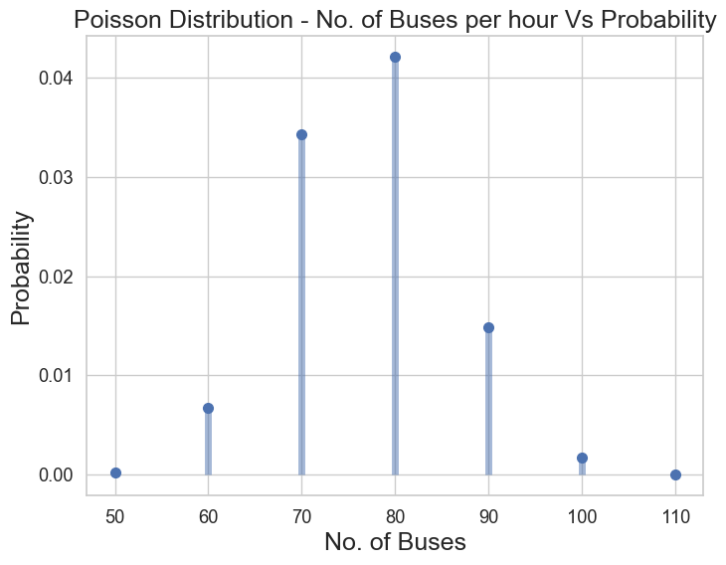

#### Lasso   
# using the same params as Ridge model  
lasso = Lasso()  
  
# cross validation  
model_cv = GridSearchCV(estimator = lasso,   
 param_grid = params,   
 scoring= 'neg_mean_absolute_error',   
 cv = folds,   
 return_train_score=True,  
 verbose = 1)   
  
model_cv.fit(X_train, y_train)  
L_cv_results = pd.DataFrame(model_cv.cv_results_)  
L_cv_results.head()  
# plotting mean test and train scoes with alpha   
L_cv_results['param_alpha'] = L_cv_results['param_alpha'].astype('float32')  
  
# plotting  
plt.plot(L_cv_results['param_alpha'], L_cv_results['mean_train_score'])  
plt.plot(L_cv_results['param_alpha'], L_cv_results['mean_test_score'])  
plt.xlabel('alpha')  
plt.ylabel('Negative Mean Absolute Error')  
  
plt.title("Negative Mean Absolute Error and alpha")  
plt.legend(['train score', 'test score'], loc='upper left')  
plt.show()

Fitting 5 folds for each of 7 candidates, totalling 35 fits